Supplementary information (SI)

Trustworthy and Self-explanatory Artificial Intelligence for the Classification of Non-Hodgkin Lymphoma by Immunophenotype
Michael C. Thrun¹*, Jörg Hoffmann², Stefan W. Krause³, Nicole Weit⁴, Peter Krawitz⁵, Quirin Stier¹, Andreas Neubauer², Cornelia Brendel^{2#} and Alfred Ultsch^{1#}

¹Mathematics and Computer Science, Philipps University Marburg, Hans-Meerwein-Strasse 6, 35032 Marburg, Germany
²Department of Hematology, Oncology and Immunology, Philipps University Marburg, University Hospital Giessen and Marburg, Baldingerstrasse, 35043 Marburg, Germany
³Department of Medicine 5, Universitätsklinikum Erlangen, Ulmenweg 18, 91054 Erlangen, Germany
⁴Beckman Coulter, Inc., Global Strategic Marketing Flow Cytometry Business Unit, Europark Fichtenhain B 13 D-47807 Krefeld
⁵Institute for Genomic Statistics and Bioinformatics, University Bonn, Venusberg-Campus 1, 53127 Bonn, Germany

*Corresponding author
Michael C. Thrun
E-mail: mthrun@informatik.uni-marburg.de

#AU and CB contributed equally and share the last author title.
Supplementary A: Materials and methods

Tile Mining (TM)
For the immunophenotyping process, we used a stepwise four-level approach to mirror the diagnostic strategies of human experts. The first step, level zero (L0), evaluates whether the data quality within a given sample is sufficient for use as a (typical) diagnostic case or represents atypical cases that may be due to poor biological or laboratory quality or other analysis flaws. All samples passing the patient sample quality check in L0 were further classified as either B-NHL or NC at the first level of XAI.
We used a new algorithm called TM for flow cytometry (FACS) data for the patient sample quality evaluation. It can detect and identify relevant structures in data to select representative cases. The approach uses nine hypercubes on all possible bivariate density plots.
Let the n-tube panel have d markers per tube; then, the sample is divided into H hypercubes $H\left(d\right)=9*\frac{d(d-1)}{2}$. Hence, in a typical d=11 marker tube, TM defines $H\left(d\right)=495$ hypercubes. For each hypercube h, the density p(h) is defined as
$$p\left(h\right)=\sum_{e }{f_{e}},f_{e}=\left\{\begin{matrix}1 & f ϵ h \\ 0 & f∉h\end{matrix}\right.$$
where the number of events within h is $f_{e}$. For each patient i with a sample file of tube t, the cell densities within all hypercubes are combined to measure strangeness s for each case per tube as follows:
$$s_{i,t}=\sum_{h}^{H(d)}{p(h)}$$
The central limit theorem states that the sum of independent random variables (of almost any type) follows a normal distribution. Therefore, the distribution of $s_{t}$ follows a Gaussian distribution ${N_{s}}_{t}(m,σ)$. Cases are defined as atypical if their values $s_{i,t}$ lie outside a robustly estimated Gaussian distribution or if the probability of having a larger (resp. smaller) value falls beyond a threshold limit. Cases are defined as representative if the strangeness of the sample lies close to the mean m of the Gaussian distribution ${N_{s}}_{t}(m,σ)$.

Algorithmic population description (ALPODS) committee
The Flow XAI system consists of several AI experts. The algorithmic population descriptions (ALPODS) learn the relevant populations for the diagnosis of B-NHL using representative samples as follows. ALPODS is designed as a Bayes decision network in the form of a directed acyclic graph (DAG). The decision network is built recursively:
First, a variable for the current node o in the DAG is chosen. The Simpson index is subsequently used to analyze conditional dependencies when picking a variable (S). S is the predicted joint probability that two items drawn from the population are either in the same or different categories. Conditional dependencies are represented using the Bayes theorem on the probability distributions of the parent node (prior) and the descendant node (posterior). Using Bayesian decision-making provides the best alternative in terms of costs (risk)⁴⁴.
Second, edges are formed and coupled with conditional dependencies to descendant nodes. Finally, recursion terminates either when a stop criterion is met or when the DAG construction is applied recursively to all descendant nodes. The starting population for recursion is the entire dataset. When the class labels for all members of a subpopulation are identical, or the subpopulation's size is less than a preset proportion of the data, which is often one percent, recursion ceases. The above-described procedure produces a Bayesian decision network that identifies subpopulations within cells. The decisions are consolidated into explanations to understand the subpopulations (for example, see Fig. 3).
The sequence of decisions for a population is simplified into an algorithmic population description using the notion of fast-and-frugal trees¹⁸: all Bayesian decisions, i.e., conditions that employ the same marker, are simplified into a single condition, and each defines an interval inside this marker's range. Finally, an measure of effect size is used to assess the significance of a subgroup to the diagnosis; by default, the absolute value of Cohen's value d is selected¹⁹.
Fig. 4a shows the process flow in extracting the case of ALPODS populations from an array of events per patient. TM identifies typical cases, from which 32 cases per diagnosis (512) serve to define representatives per diagnosis. In the first step, ALPODS XAIs learn the relevant populations for the specific task described below and store the frequencies within tables. This means that each ALPODS model is an expert that answers a specific question for a particular tube of a patient sample. All ALPODS experts learn populations for each tube separately for a specific task. The L1 task distinguishes whether the sample is an NC or B-cell lymphoma.
After the populations are identified, they are divided into two groups per tube using computed ABC analysis⁴³. The ABC curve of the computed ABC analysis can be used to visualize the data by graphically representing the cumulative distribution function closely related to the Lorenz curve. Using the ABC curve, the algorithm calculates optimal limits by exploiting mathematical properties pertaining to the distribution of the analyzed populations. The first group of populations has large frequencies (set A in the computed ABC analysis) and are analyzed by the first ALPODS expert. The second group of populations is identified as sets B and C within the algorithm. Populations in the second group have smaller frequencies and are used by the second ALPODS expert. Both ALPODS experts learn to distinguish the NC from B-cell lymphoma. In sum, six (four) experts are employed for the L1 task since the MLL9F dataset (PUM2 dataset) consists of three (two) tubes. Here, expert opinions on samples from tube two are weighted more than those from tube one, and those from tube one are weighted more than those from tube three by the ALPODS experts for the L1 task. This leads to the self-competency estimation of the AI as the likelihood of a case being correctly classified as either an NC sample or a B-cell lymphoma sample varying in increments of 0.1, from zero to one. The probability of zero/one defines the confident degree of trustworthiness. The probable degree is defined in the range $(1,0.8] \& (0,0.2)$, and the challenging degree represents all the other probabilities. Four experts are used for the PUM2 dataset, which incorporates only two tubes.
In case of L2 and L3, more ALPODS experts are trained on the populations extracted for specific tasks. Three experts investigated the three tubes for CLL-like lymphoma, while three other ALPODS experts investigated the tubes for other types of lymphoma. One ALPODS expert determines whether a patient has HCL, using samples from tube two, the samples from other tubes not being useful to human expert when diagnosing HCL. In summary, ALPODS experts at specific levels (L1, L2 and L3) diagnose the samples context-specific and separately. Their opinions are combined to an AI committee to form a mixture of experts. The opinion of the full committee that provides the final diagnosis is generated by a decision tree using an impurity function that is applicable to categorical data⁴⁷.
Supplementary Fig. 1 shows the process flow of the ALPODS populations used within the committee of experts to judge the degree of trustworthiness and yield of the final diagnosis.
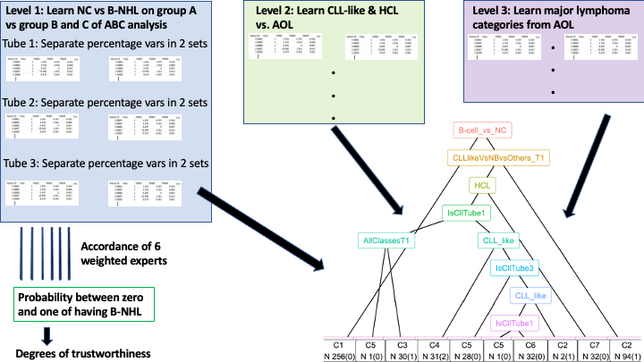
Supplementary Fig. 1. Process flow for learning classification defined by various levels based on ALPODS populations per patient sample and learning the final diagnosis of the case.

Generation of the U-Matrix for lymphomas
The relevant populations of the ALPODS experts per level were used as input data for unsupervised machine learning. The Databionic swarm dimensionality reduction method is applied since swarm intelligence obviates the need for using a global objective function ³³ and allows the usage of specific dissimilarity measures. The dissimilarity measure of one minus Spearman rank correlation was selected. The generalized U-Matrix technique allowed the visual evaluation of the overlap of lymphoma identities with dimensionality reduction³⁴.

Description of the datasets
Two different datasets were used: the previously published MLL9F dataset consisting of 19,493 cases⁶ and a university-center dataset from the Philipps-University Marburg, PUM2, which was published in^{4,22}. The dataset contains sample files of N=638 patients whose data were measured in two tubes, as described earlier^{4,56}. The B-cell and T-cell antigens measured in three tubes for the MLL9F dataset are also described above⁶.
A flow cytometer measured a sample consisting of approximately N=100,000 events for each tube. We define a case as the combination of an array of samples measured for a specific patient. Each case was mapped to a diagnosis, as shown in Supplementary Table 1, and a class number was assigned to each patient, which was used in the learning process of Flow XAI. An overview of the number of diagnoses received for typical cases is also provided in Supplementary Table 1. In both datasets, peripheral blood was drawn from patients for sample measurement with the intended diagnostic purpose.

Supplementary Table 1. PUM2 = Philipps-University Marburg data, MLL9F = Munich Leukemia Laboratory data. CLL, MBL, and PL are classified as CLL-like. In the first column, the table shows the diagnoses that were combined with the class numbers used for the learning task for the MLL9F data. Because of the small number of patients, only the NC and B-cell lymphoma patient data were trained for the PUM2 dataset, and the HCLV entity was disregarded⁶. NOS = not otherwise specifiable, NC = normal controls. *: these diagnoses were considered for distinguishing NC and B-NHL samples in L1 but not in L2 or L3.
Class No | Entity | MLL9F Typical No. | MLL9F Atypical No. | PUM2  Typical No. | PUM2  Atypical No.
1 | NC | 8,692 | 1,967 | 193 | 32
2 | CLL | 3,325 | 949 | 223 | 45
3 | MCL | 237 | 60 | 20 | 16
4 | FL | 195 | 38 | 10 | 5
5 | MZL | 867 | 170 | 14 | 5
6 | LPL | 555 | 120 | 10 | 3
7 | HCL | 171 | 31 | 15 | 7
(2*) | DLBCL | 0 | 0 | 3 | 4
(2*) | BL | 0 | 0 | 2 | 0
2 | MBL | 1,267 | 247 | 13 | 3
2 | PL | 432 | 121 | 0 | 0
(2*) | HCLv | 50 | 10 | 0 | 0
(2*) | NOS | 0 | 0 | 15 | 1

Supplementary B: Tables
To compensate for the highly imbalanced class sizes, the class-balanced split performance is indicated in percent values normalized by the number of test cases. Then, 80/20 splits of training and test data were performed per diagnosis class. As a consequence, the same (high) number of patients in the test and training sets corresponded to the NC and CLL-like lymphoma classes, respectively. The average number of test cases per diagnosis is similar to the expected case frequency; hence, it is a faithful representation of the performance of Flow XAI. According to the contingency tables for the three degrees of trustworthiness (Supplementary Information D, Supplementary Tables 2-5), the expected number of cases per class does not correspond equally to the expected number of cases in the training data. Obviously, some malignant lymphoma entities are more likely to be judged as either confident or challenging by Flow XAI. CLL-like samples were more likely to be judged as confident than challenging. Notably, in the confident degree of trustworthiness, all HCL cases were classified correctly, and no HCL case was considered challenging by Flow XAI.

Supplementary Table 2. Average contingency table in L3 for the probable and confident classes.
Diagnosis  \Flow XAI | NC | CLL-like | MCL | FL | MZL | LPL | HCL | No | Percent
NC | 55.7 | 1 | 0.1 | 0.5 | 1.1 | 1.1 | 0.1 | 2081 | 59.6
CLL-like | 0.2 | 31.4 | 0.6 | 0 | 0.4 | 0.3 | 0 | 1149 | 32.9
MCL | 0 | 0.3 | 0.4 | 0 | 0.1 | 0 | 0 | 28 | 0.8
FL | 0 | 0 | 0 | 0.2 | 0 | 0 | 0 | 7 | 0.2
MZL | 0.2 | 0.3 | 0.1 | 0.1 | 2.3 | 0.7 | 0 | 129 | 3.7
LPL | 0.3 | 0.1 | 0 | 0.1 | 0.4 | 0.6 | 0 | 52 | 1.5
HCL | 0.1 | 0 | 0 | 0 | 0.1 | 0 | 1 | 42 | 1.2
No | 1973 | 1156 | 42 | 31 | 154 | 94 | 38 | 3488 | 99.9
Percent | 56.2 | 33.1 | 1.2 | 0.9 | 4.4 | 2.7 | 1.1 | 99.9 | 85.1%

The average Flow XAI performance for all test cases with either a confident or probable degree of trustworthiness reached an MCC of 85.1%. The columns depict the diagnoses according to the MLL9 dataset, and the rows present the predictions given by Flow XAI. The sum of the cross-validation trials was taken per table entry and then normalized to the sum of all entries. For the case numbers, the percentages per entry were multiplied by the average number of cases. (Corresponding to the red dot in Fig. 2b).

Supplementary Table 3. Average contingency table in L3 for the confident class.
Diagnosis  \Flow XAI | NC | CLL-like | MCL | FL | MZL | LPL | HCL | No | Percent
NC | 56.4 | 0.7 | 0.1 | 0.3 | 0.8 | 0.8 | 0 | 1362 | 59.1
CLL-like | 0.1 | 35.1 | 0.5 | 0 | 0.4 | 0.2 | 0 | 836 | 36.3
MCL | 0 | 0.2 | 0.3 | 0 | 0 | 0 | 0 | 12 | 0.5
FL | 0 | 0 | 0 | 0.1 | 0 | 0 | 0 | 2 | 0.1
MZL | 0.1 | 0.3 | 0.1 | 0.1 | 1.7 | 0.5 | 0 | 65 | 2.8
LPL | 0.1 | 0.1 | 0 | 0.1 | 0.2 | 0.3 | 0 | 18 | 0.8
HCL | 0 | 0 | 0 | 0 | 0 | 0 | 0.3 | 7 | 0.3
No | 1307 | 839 | 23 | 14 | 71 | 41 | 7 | 2302 | 99.9
Percent | 56.7 | 36.4 | 1 | 0.6 | 3.1 | 1.8 | 0.3 | 99.9 | 89.3%

The average Flow XAI performance in percent for all test cases with a confident degree of trustworthiness is shown in Fig. 2b, with an average MCC of 89.3%. The columns depict the diagnoses according to the MLL9 dataset, and the rows present the predictions given by Flow XAI. For percentages, the sum of the cross-validation trials was taken per table entry and then normalized to the sum of all entries.

Supplementary Table 4. Average contingency table in L3 for the probable class.
Diagnosis  \Flow XAI | NC | CLL-like | MCL | FL | MZL | LPL | HCL | No | Percent
NC | 54.2 | 1.5 | 0.2 | 0.8 | 1.7 | 1.7 | 0.1 | 715 | 60.2
CLL-like | 0.4 | 24.2 | 0.8 | 0.1 | 0.5 | 0.4 | 0 | 313 | 26.4
MCL | 0 | 0.4 | 0.6 | 0 | 0.1 | 0.1 | 0 | 14 | 1.2
FL | 0 | 0 | 0 | 0.3 | 0 | 0 | 0 | 4 | 0.3
MZL | 0.5 | 0.4 | 0.1 | 0.2 | 3.5 | 1.1 | 0 | 69 | 5.8
LPL | 0.5 | 0.2 | 0.1 | 0.2 | 0.8 | 1.3 | 0 | 37 | 3.1
HCL | 0.3 | 0.1 | 0 | 0 | 0.3 | 0.1 | 2.2 | 36 | 3
No | 664 | 318 | 21 | 19 | 82 | 56 | 27 | 1186 | 100
Percent | 55.9 | 26.8 | 1.8 | 1.6 | 6.9 | 4.7 | 2.3 | 100 | 76.9%
The average Flow XAI performance in percent for all test cases with a probable degree of trustworthiness using an 80/20 split is shown in Fig. 2b, with an average MCC of 76.9%. The columns depict the diagnoses according to the MLL9 dataset, and the rows present the predictions given by Flow XAI. For percentages, the sum of the cross-validation trials was taken per table entry and then normalized to the sum of all entries.

Supplementary Table 5. Average contingency table in percent in L3 for the challenging class.
Diagnosis  \Flow XAI | NC | CLL-like | MCL | FL | MZL | LPL | HCL | No | Percent
NC | 33.1 | 1.9 | 0.5 | 1.1 | 2.7 | 2.3 | 0.1 | 165 | 41.7
CLL-like | 2.2 | 25.3 | 1.6 | 0.2 | 0.9 | 0.9 | 0 | 123 | 31.1
MCL | 0.3 | 0.8 | 1.3 | 0 | 0.1 | 0.2 | 0 | 11 | 2.7
FL | 0.3 | 0.1 | 0 | 0.7 | 0.1 | 0.2 | 0 | 6 | 1.4
MZL | 2.6 | 0.7 | 0.3 | 0.5 | 7.4 | 2.6 | 0.1 | 56 | 14.2
LPL | 1.8 | 0.5 | 0.3 | 0.7 | 2 | 3.9 | 0 | 36 | 9.2
HCL | 0 | 0 | 0 | 0 | 0 | 0 | 0 | 0 | 0
No | 160 | 116 | 16 | 13 | 52 | 40 | 1 | 395 | 100.3
Percent | 40.3 | 29.3 | 4 | 3.2 | 13.2 | 10.1 | 0.2 | 100.3 | 60.1%

The average Flow XAI performance in percent for all test cases with challenging degrees of trustworthiness using an 80/20 split is shown in Fig. 2b, with an average MCC of 60.1%. The columns depict the diagnoses according to the MLL9 dataset, and the rows present the predictions given by Flow XAI. For percentages, the sum of the cross-validation trials was taken per table entry and then normalized to the sum of all entries.

Supplementary Table 6. Contingency table for 512 training cases in L3 for the confident class.
Diagnosis  \Flow XAI | NC | CLL-like | MCL | FL | MZL | LPL | HCL | No | Percent
NC | 49.64 | 0.61 | 0.03 | 0.14 | 0.56 | 0.31 | 0.08 | 3818 | 49.69
CLL-like | 0 | 39.76 | 0.29 | 0.04 | 0.55 | 0.18 | 0.03 | 3262 | 42.45
MCL | 0 | 1.11 | 0.52 | 0.01 | 0.21 | 0.05 | 0 | 82 | 1.07
FL | 0.01 | 0.52 | 0.16 | 0.3 | 0.85 | 0.42 | 0.01 | 48 | 0.62
MZL | 0.01 | 0.34 | 0.03 | 0.08 | 1.08 | 0.38 | 0.04 | 281 | 3.66
LPL | 0.03 | 0.1 | 0.05 | 0.05 | 0.35 | 0.16 | 0 | 115 | 1.5
HCL | 0 | 0.01 | 0 | 0 | 0.07 | 0 | 0.86 | 78 | 1.02
No | 3947 | 3138 | 146 | 174 | 150 | 57 | 72 | 7684 | 100.0
Percent | 51.37 | 40.84 | 1.90 | 2.26 | 1.95 | 0.74 | 0.94 | 100.0 | 86.6%

The Flow XAI performance in percent trained with 512 cases, and for all test cases judged as probable by Flow XAI is shown in Fig. 5; the MCC was 86.6%. The columns depict the diagnosis, and the rows present the predictions made by Flow XAI. It covers 49% (N=7684) of the whole test data. The third level of diagnosis (consisting of additional B-NHL diagnoses 3, 4, 5, and 6) cannot be distinguished by human experts based only on flow cytometry data.

Supplementary Table 7. Contingency table for 512 training cases in L3 for the probable class.
Diagnosis  \Flow XAI | NC | CLL-like | MCL | FL | MZL | LPL | HCL | No | Percent
NC | 53.36 | 1.47 | 0.17 | 0.33 | 1.65 | 1.14 | 0.21 | 3099 | 63.65
CLL-like | 0.06 | 31.44 | 0.26 | 0.03 | 0.43 | 0.15 | 0.02 | 1111 | 22.82
MCL | 0.18 | 1.02 | 0.43 | 0.02 | 0.17 | 0.05 | 0 | 60 | 1.23
FL | 0.56 | 0.45 | 0.16 | 0.31 | 0.79 | 0.46 | 0.01 | 52 | 1.07
MZL | 0.46 | 0.34 | 0.04 | 0.06 | 0.97 | 0.35 | 0.02 | 283 | 5.81
LPL | 0.34 | 0.11 | 0.07 | 0.06 | 0.4 | 0.38 | 0 | 205 | 4.21
HCL | 0.14 | 0.01 | 0 | 0 | 0.09 | 0.02 | 0.84 | 59 | 1.21
No | 3373 | 929 | 87 | 169 | 132 | 114 | 65 | 4869 | 100.0
Percent | 63.65 | 22.82 | 1.23 | 1.07 | 5.81 | 4.21 | 1.21 | 100.0 | 62.4%

The Flow XAI performance in percent, trained with 512 samples, for all test samples was judged as probable by the XAI, as shown in Fig. 5, resulting in an MCC of 62.4%. It covers 30% (N=4869) of the test data. The columns depict the physician’s manual diagnosis according to⁶, and the rows show the predictions made by XAI. The percentages of correct diagnoses of the L3 lymphoma entities are highlighted in green, and the MCC is marked in blue.

Supplementary Table 8. Contingency table for 512 training cases in L3 for the challenging class.
Diagnosis  \Flow XAI | NC | CLL-like | MCL | FL | MZL | LPL | HCL | No | Percent
NC | 45.43 | 12.14 | 1.43 | 1.47 | 7.96 | 5.24 | 0.59 | 2025 | 74.26
CLL-like | 0.59 | 7 | 0.07 | 0 | 0.11 | 0.15 | 0 | 216 | 7.92
MCL | 0.92 | 0.48 | 0.51 | 0.07 | 0.26 | 0.22 | 0 | 67 | 2.46
FL | 3.37 | 0.18 | 0.18 | 0.55 | 0.4 | 0.44 | 0 | 140 | 5.12
MZL | 2.31 | 0.33 | 0.07 | 0 | 0.84 | 0.51 | 0 | 111 | 4.06
LPL | 2.27 | 0.22 | 0.07 | 0.22 | 0.33 | 0.88 | 0 | 109 | 3.99
HCL | 0.84 | 0.04 | 0 | 0.04 | 0.15 | 0.04 | 1.06 | 59 | 2.17
No | 1520 | 556 | 64 | 64 | 274 | 204 | 45 | 2727 | 100.0
Percent | 55.73 | 20.39 | 2.33 | 2.35 | 10.05 | 7.48 | 1.65 | 100.0 | 23.6%

Supplementary Table 9. Confusion matrix between clusters and lymphoma identities of Figure 6 a and b.
 | CLL | FL | HCL | LPL | MBL | ML | MZL | NC | PL
Cluster1 | 2990 | 116 | 114 | 217 | 946 | 307 | 597 | 3 | 548
Cluster2 | 9 | 62 | 10 | 8 | 41 | 57 | 32 | 2995 | 10
OutlierGroup | 0 | 8 | 0 | 5 | 4 | 5 | 2 | 0 | 3
OutlierGroup | 0 | 0 | 0 | 0 | 10 | 1 | 3 | 0 | 2
VariousOutlier | 1 | 0 | 4 | 6 | 5 | 2 | 3 | 2 | 0

Supplementary Table 10. Confusion matrix between clusters and lymphoma identities of Figure 6c and 6d.
 | CLL | FL | HCL | LPL | MBL | MCL | MZL | PL
Cluster1 | 9 | 166 | 64 | 490 | 132 | 140 | 747 | 159
Cluster2 | 491 | 1 | 0 | 21 | 365 | 75 | 23 | 264
Cluster3 | 0 | 1 | 82 | 2 | 0 | 1 | 25 | 1
Outliers1 | 0 | 1 | 0 | 0 | 1 | 1 | 0 | 0
Outliers2 | 0 | 0 | 0 | 0 | 2 | 0 | 0 | 0
Outliers3 | 0 | 0 | 0 | 0 | 0 | 2 | 0 | 0
Outliers4 | 0 | 0 | 0 | 0 | 0 | 2 | 0 | 0

Supplementary C: Explanations for HCL misdiagnosis using bivariate dot plots in log scale
Supplementary Fig. 2. Three false positive results for distinguishing HCL patients from NCs.
Supplementary Fig. 3. Three false negative results for distinguishing HCL patients from NCs.
Supplementary D: Quality control
Manual validation was performed on 100 samples, confirming that TM reliably distinguished typical samples from atypical ones. All 100 evaluated samples are available as fcs files at 10.5281/zenodo.7744104.
A B
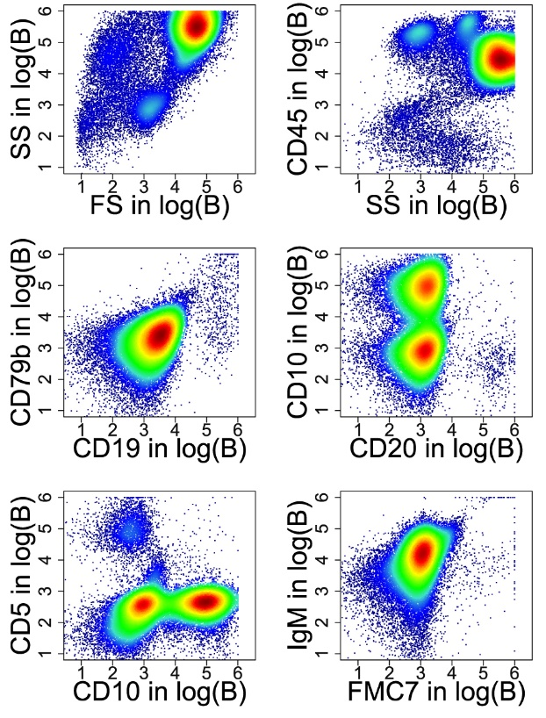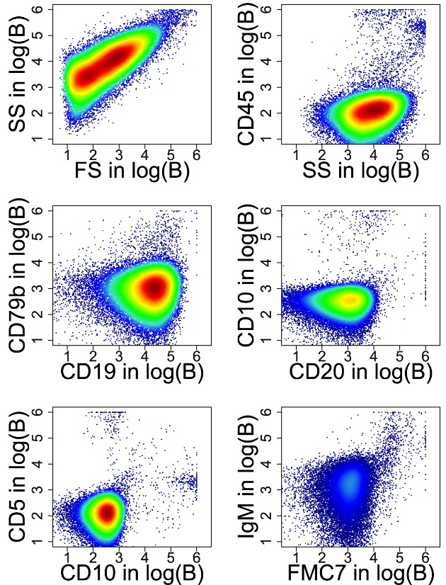
Supplementary Fig. 4. Quality control of sample files identified with TM revealed that 19% of the samples within the MLL9F sample files were atypical. For example, within the normal controls, tube 1 of a typical three-tube panel for a typical patient (A; left) and an atypical patient (B; right) are presented here in log scale. Human experts assume that red blood cells are predominant in atypical samples for the reason that most recorded events do not stain positive for CD45 or other leukocyte antigens.

Supplementary E: Performance for Atypical samples with the three degree of trustworthiness using 512 samples for training
The atypical cases are plotted, and the performance of Flow XAI is calculated based on 256 training cases derived from 3710 data points corresponding to 19% of the atypical cases within the MLL9F sample files. The result is shown in supplementary Fig. 3. The magenta line depict the physicians’ manual diagnoses according to⁶. Again, some lymphoma entities are more likely to be judged as confident, probable or challenging by Flow XAI (see supplementary B).
Hence, although our general approach excludes atypical L0 samples, XAI is able to address these samples with a low amount of training data and can still rate its own confidence by the degrees of trustworthiness, i.e., confident, probable or challenging.

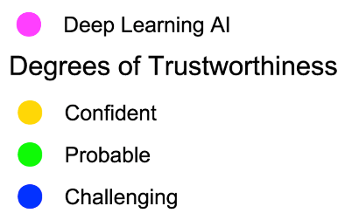
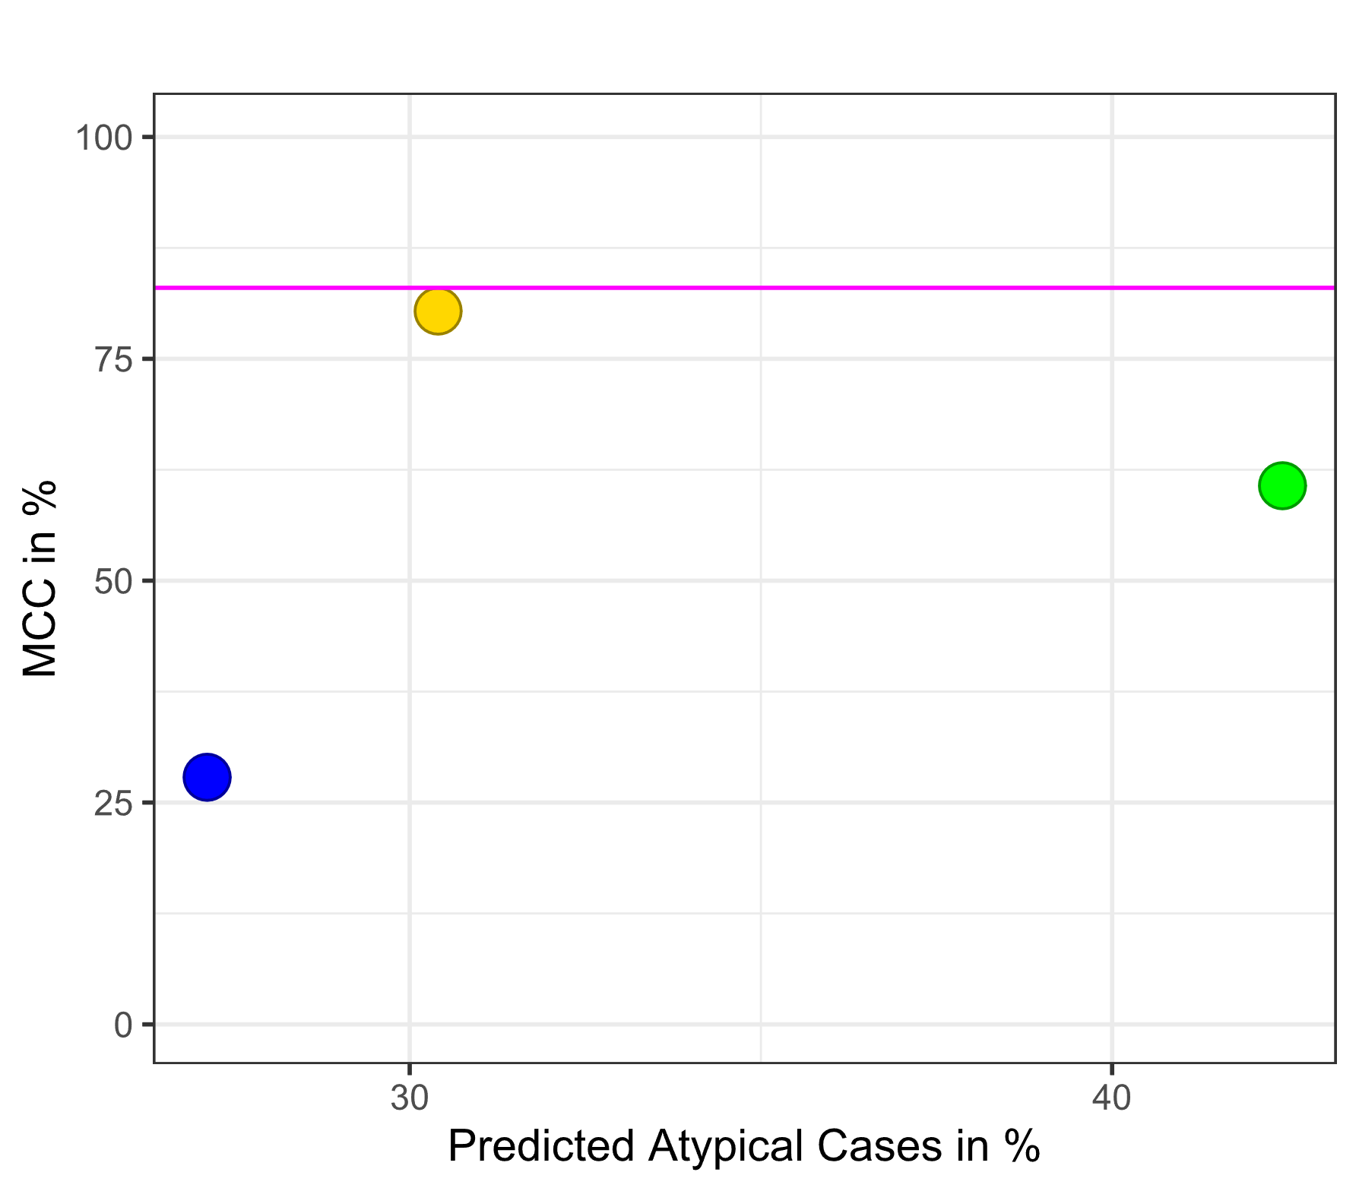
Supplementary Fig. 5. The MCC of different degrees of trustworthiness compared to the performance of the deep learning AI system, which is considered the typical trustworthiness level of medical experts⁴⁴ ¹, for L3 and for atypical cases. The Y-axis shows the MCC and the x-axis shows the percentage of test cases (see Supplementary Table 1 for an overview). Here, our XAI model uses 512 training samples, and TM identifies atypical cases. The deep learning ML system uses 18274 training samples and 2348 test samples⁶. Although our general approach excludes atypical samples at L0, XAI can address these samples with a low amount of training data, and it determines its own confidence by the degrees of trustworthiness: “confident”, “probable” or “challenging”. Atypical cases were not used in the training set, and 100% indicates 3710 atypical cases.

Supplementary F: PUM 2
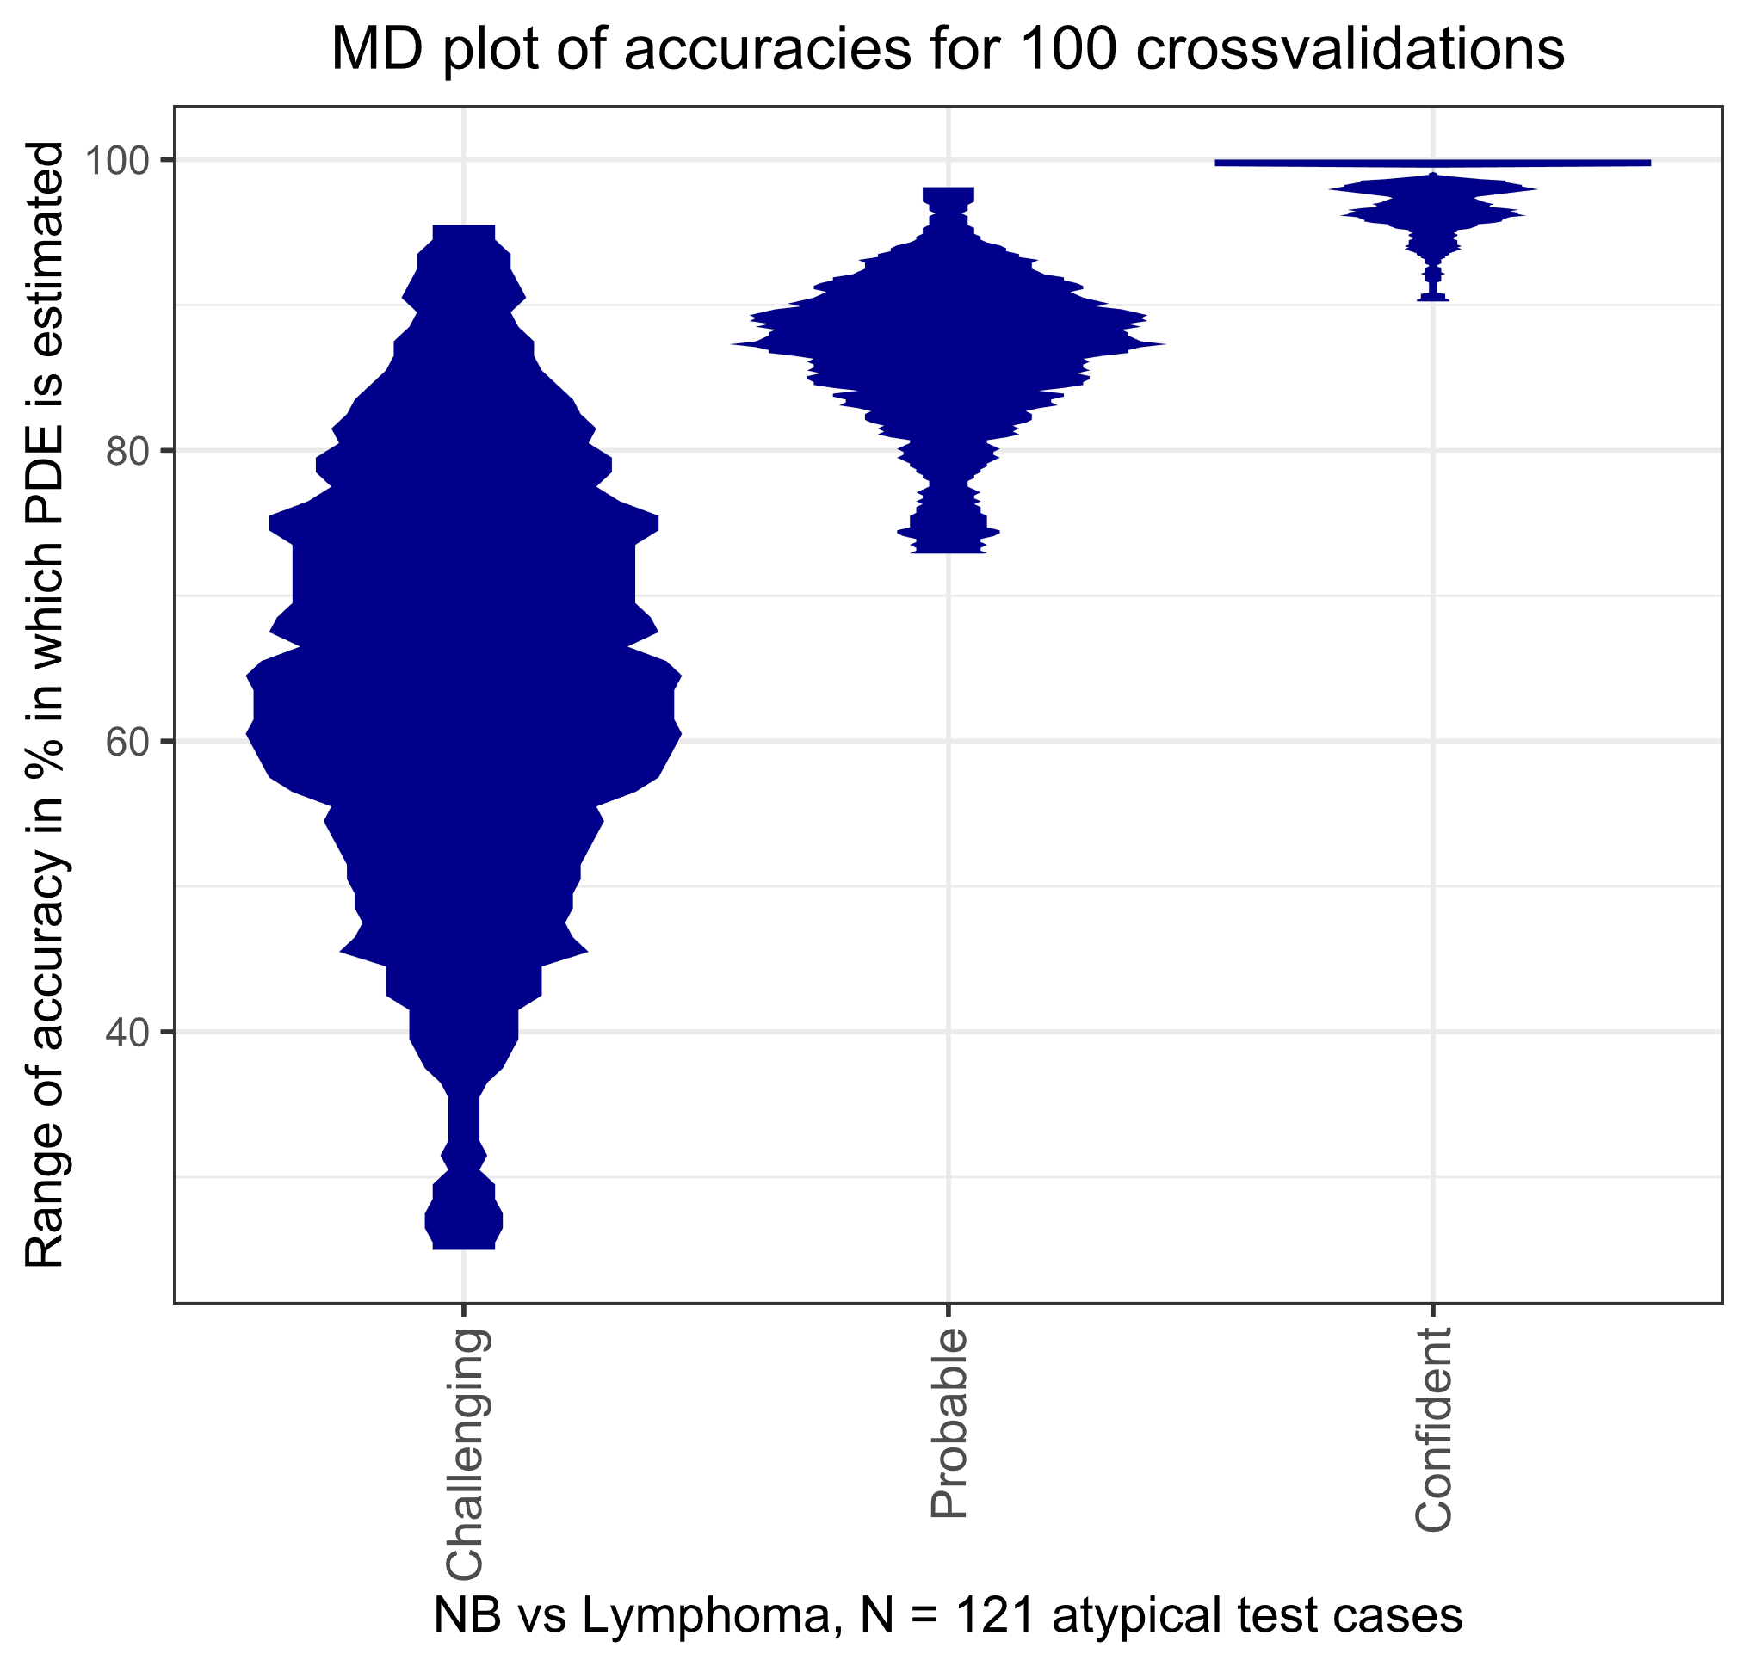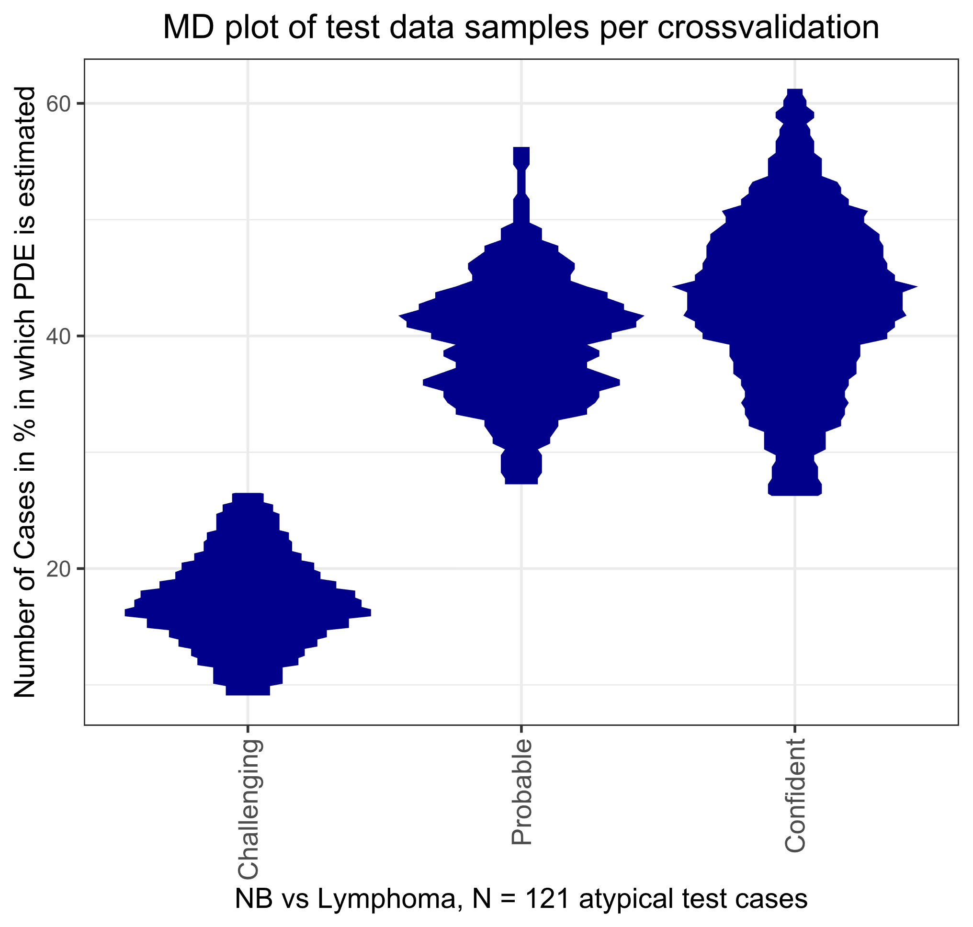
Supplementary Fig. 6. One hundred cross-validation steps were visualized with an MD-plot for the three degrees of trustworthiness. MD-plots were used to estimate and visualize the probability density function (pdf). If there is no magenta overlay, the PDFs are not statistically normally distributed²⁷. Right: Performance evaluation of the accuracy in identifying atypical cases. Left: Percentage of cases with this degree of trustworthiness.
Supplementary G: Choice of algorithms
To assess and demonstrate the performance of Flow XAI, we compared it with algorithms designed for similar or related tasks. With the focus on automated lymphoma immunophenotyping, we chose to compare Flow XAI with a deep learning AI system and the CITRUS algorithm¹ in regard to the key aspects: performance in level one (L1) and level three (L3) and the sizes of the training and test data cohorts for L1 and L3. Although there are many interesting approaches for identifying cell frequencies or statistical sample properties that can be theoretically used in supervised approaches (e.g.,^{2,3,48,50-52}), we chose CITRUS and deep learning AI⁷ for two reasons in particular.
The CITRUS algorithm was developed to identify cell populations of potential interest for risk stratification in clinical settings. Among the many interesting approaches for identifying cell frequencies or statistical sample properties that can be theoretically used in supervised approaches (e.g.,^{2,3,57-60}), we chose CITRUS because it seems to be most closely related to population description and lymphoma immunophenotyping, and it has been shown that ALPODS or CITRUS outperforms other approaches^{1,22}.
Zhao et al.'s deep learning AI system⁷ transforms flow cytometric lymphoma data with self‐organizing maps (SOMs) into a single image file and interprets the data with deep convolutional neural networks (CNNs). However, an imbalanced training to test split was performed in a single trial, which could lead to overestimation of performance.
There are other well-known algorithms for identifying cell populations within data, which, in theory, could be used for immunophenotyping. For example, the Flow Type algorithm⁴⁸ is a brute force approach that exhaustively enumerates all potential population descriptions specified by all features based on the markers. The RchyOptimyx method minimizes the number of cell populations³. FAUST is mainly an unsupervised algorithm that was applied to discover and visualize candidate biomarkers, although it allows targeted hypothesis testing for prespecified phenotypes². However, FAUST and FlowType+RchyOptimyx were not published with the intention of diagnosing lymphoma. Therefore, we considered these algorithms unfeasible for this task. In addition, we showed in previous work that ALPODS outperforms FAUST and FlowType+RchyOptimyx^{19,61}.

Supplementary information H
A comprehensive literature screening was conducted to identify relevant sources about cell population gating in flow cytometry. Special attention was given to seminal studies, recent advancements, and established gating methodologies. While the primary focus of the selection of gating algorithms, widely utilized gating software, including FlowJo, FCS Express, WinMDI, CytoPaint, Leukobyte, VenturiOne, CellQuest Pro, and Cytospec, was acknowledged. However, the primary investigation did not extend to these proprietary gating software programs. To select a subset of algorithms, a systematic search was performed on Google Scholar using the keywords "gating" and "flow cytometry" to identify relevant publications and research in the field. Citations from the identified publications were meticulously followed to ensure a comprehensive understanding of the current landscape and recent advancements in gating methodologies.
In addition, algorithms used in the FlowCap challenges were thoroughly examined. These challenges provided valuable insights into the evaluation of gating algorithms and their performance across various datasets, contributing to a robust assessment of the efficacy and applicability of the proposed gating algorithm. A relevance assessment was conducted to ascertain the significance and impact of the identified literature by normalizing citations through the number of years until 2023. This approach facilitated a comprehensive evaluation of each publication's enduring contributions and relevance within the context of cell population gating in contemporary flow cytometry research. In the next step, only publications referencing open-source code in R or Python were considered.
On the remaining publications, a recursive ABC analysis ⁶² using the R package “ABCanalysis” available on CRAN (http://cran.r-project.org/web/packages/ABCanalysis/index.html) was applied to prioritize key publications and gating methodologies. The ABC curve can visualize the data by graphically representing the cumulative distribution function closely related to the Lorenz curve. Using the ABC curve, the algorithm calculates the optimal limits by exploiting the mathematical properties of the distribution of analyzed items. This method allows for systematical identification of the most effective and innovative gating techniques based on their normalizing citations, which then can be identified in group A. In analogy to ⁶³, ABC analysis was applied recursively for group A until the eight most influential publications could be identified.
The investigation revealed that a significant proportion, approximately 70% of 95 algorithms in 68 publications of the identified algorithms, employed unsupervised techniques. The analysis of auto-gating publications delineated distinct "waves" of prominent research activity, notably in the years 2001, 2009/2010, and 2019. These pivotal periods marked heightened interest in developing and applying automated gating methodologies within the field of flow cytometry. Next, recursive ABCanalysis on normalized citations was employed. Consequently, among the identified algorithms, eight were deemed highly relevant by recursive ABCanalysis, with the added advantage of being open-source software. Notable algorithms included PhenoGraph, Citrus, FlowSOM, CellCNN, diffCyt, FLAME, FlowPeak, and FlowClust, each presenting unique features and approaches to streamline and enhance the accuracy of automated gating procedures. Diffcyt does not provide the necessary functionality. Citrus and CellCNN mention the required capabilities, but in their open-source code, they need a class per sample file and return a class per sample file, which did not fit the problem structure we defined. FlowSOM, PhenoGraph, FlowClust, and FlowPeak were tried out, but we could not generate a sufficient B-cell gate on the two given datasets.

