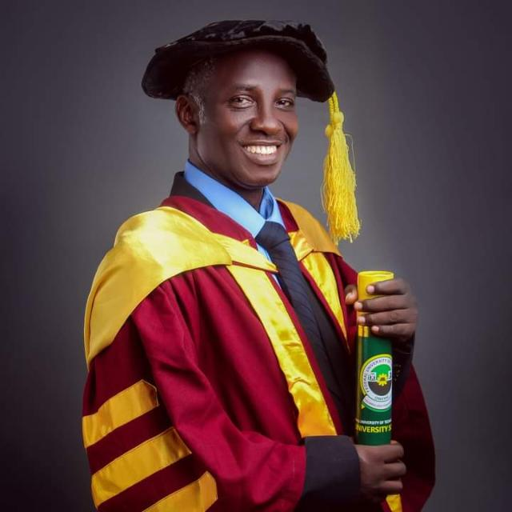 | Dr. Chidiebere Njoku obtained his BEng and MSc degrees in Civil Engineering from the University of Nigeria, Nsukka and PhD degree in Civil Engineering, from the Federal University of Technology, Owerri, Nigeria. He is a Senior Lecturer in Civil Engineering at Federal University of Technology, Owerri, and a Lecturer in Procurement Management at the World Bank sponsored Center of Excellence in Sustainable Procurement, Environmental and Social Standards (CE-sPESS) in Federal University of Technology, Owerri, Nigeria. He is a textbook author and has published several engineering articles. His research interests include (1) soil mechanics and foundation engineering; (2) structural materials analysis and design; and (3) project management.

