Supplementary materials:
Topological organization of the brain network in patients with primary angle-closure glaucoma through graph theory analysis.

Validation Analysis via AAL116 Template
3.5. Validation Analysis via AAL116 Template
3.5.1. Global Metrics
In the examination of global indicators, a detailed investigation was conducted into the small-world property and network efficiency property. However, the statistical results indicate that these two indicators did not demonstrate significant differences, with p-values exceeding 0.05. This suggests that the similarities between the PACG group and the healthy control group cannot be disregarded with regard to these global indicators. (Supplementary Figure 1).small-world properties and network efficiency properties. small-world properties included clustering coefficient (Cp), (Supplementary Figure 1A) normalized clustering coefficient (Gamma) (Supplementary Figure 1B), normalized characteristic path length (Lambda) (Supplementary Figure 1C), characteristic path length (Lp) (Supplementary Figure 1D), and small-worldness (Sigma) (Supplementary Figure 1E). Network efficiency properties comprised global efficiency (Eg) (Supplementary Figure 1F) and local efficiency (Eloc) (Supplementary Figure 1G).

3.5.2. Nodal Metrics
The study of local metrics revealed some interesting findings. In the region of the right middle temporal gyrus (MTG.R), there was a significant difference between the PACG group and the healthy control group. Specifically, there was a significant increase in network node centrality in the MTG.R region (t-value = 4.195465, p-value = 0.000066), as well as a significant increase in network node efficiency (t-value = 3.939366, p-value = 0.000166). These data imply that the PACG group exhibited stronger network connectivity in the right middle temporal gyrus region compared to the healthy control group. (Supplementary Figure 2, Supplementary Table 4).

3.5.3. Network-Based Statistics Analysis
NBS analysis revealed a significant alteration in the strength of functional brain network connectivity in the PACG group compared to healthy controls, with a p-value of less than 0.05. This alteration involved 38 network nodes and 64 functional connections in the prefrontal, frontal, occipital, temporal, parietal, subcortical brain regions and cerebellum.
In terms of positive connectivity, the enhanced connections were mainly located in Prefrontal, Temporal, Occipital, and Cerebellum regions. In particular, the connections between Prefrontal zone and Occipital zone, Prefrontal zone and Temporal zone, Temporal zone and Cerebellum zone, and Occipital zone and Cerebellum zone were significantly enhanced. (Supplementary Figure 3A, Supplementary Table 5).
In contrast, in terms of negative connections, weakened connections were mainly found between Prefrontal area and Temporal area, Prefrontal area and Subcortical area, Frontal area and Temporal area, Frontal area and Cerebellum area, Temporal area and Subcortical area, Temporal zone with Occipital zone. (Supplementary Figure 3B, Supplementary Table 5).

Supplementary Table 1: AAL 90 template
Label | Name | Label | Name | Label | Name
1 | Precentral_L | 31 | Cingulum_Ant_L | 61 | Parietal_Inf_L
2 | Precentral_R | 32 | Cingulum_Ant_R | 62 | Parietal_Inf_R
3 | Frontal_Sup_L | 33 | Cingulum_Mid_L | 63 | SupraMarginal_L
4 | Frontal_Sup_R | 34 | Cingulum_Mid_R | 64 | SupraMarginal_R
5 | Frontal_Sup_Orb_L | 35 | Cingulum_Post_L | 65 | Angular_L
6 | Frontal_Sup_Orb_R | 36 | Cingulum_Post_R | 66 | Angular_R
7 | Frontal_Mid_L | 37 | Hippocampus_L | 67 | Precuneus_L
8 | Frontal_Mid_R | 38 | Hippocampus_R | 68 | Precuneus_R
9 | Frontal_Mid_Orb_L | 39 | ParaHippocampal_L | 69 | Paracentral_Lobule_L
10 | Frontal_Mid_Orb_R | 40 | ParaHippocampal_R | 70 | Paracentral_Lobule_R
11 | Frontal_Inf_Oper_L | 41 | Amygdala_L | 71 | Caudate_L
12 | Frontal_Inf_Oper_R | 42 | Amygdala_R | 72 | Caudate_R
13 | Frontal_Inf_Tri_L | 43 | Calcarine_L | 73 | Putamen_L
14 | Frontal_Inf_Tri_R | 44 | Calcarine_R | 74 | Putamen_R
15 | Frontal_Inf_Orb_L | 45 | Cuneus_L | 75 | Pallidum_L
16 | Frontal_Inf_Orb_R | 46 | Cuneus_R | 76 | Pallidum_R
17 | Rolandic_Oper_L | 47 | Lingual_L | 77 | Thalamus_L
18 | Rolandic_Oper_R | 48 | Lingual_R | 78 | Thalamus_R
19 | Supp_Motor_Area_L | 49 | Occipital_Sup_L | 79 | Heschl_L
20 | Supp_Motor_Area_R | 50 | Occipital_Sup_R | 80 | Heschl_R
21 | Olfactory_L | 51 | Occipital_Mid_L | 81 | Temporal_Sup_L
22 | Olfactory_R | 52 | Occipital_Mid_R | 82 | Temporal_Sup_R
23 | Frontal_Sup_Medial_L | 53 | Occipital_Inf_L | 83 | Temporal_Pole_Sup_L
24 | Frontal_Sup_Medial_R | 54 | Occipital_Inf_R | 84 | Temporal_Pole_Sup_R
25 | Frontal_Mid_Orb_L | 55 | Fusiform_L | 85 | Temporal_Mid_L
26 | Frontal_Mid_Orb_R | 56 | Fusiform_R | 86 | Temporal_Mid_R
27 | Rectus_L | 57 | Postcentral_L | 87 | Temporal_Pole_Mid_L
28 | Rectus_R | 58 | Postcentral_R | 88 | Temporal_Pole_Mid_R
29 | Insula_L | 59 | Parietal_Sup_L | 89 | Temporal_Inf_L
30 | Insula_R | 60 | Parietal_Sup_R | 90 | Temporal_Inf_R

Supplementary Table 2: Modular Partitioning
Module | Region | Module | Region | Module | Region | Module | Region
1.Left frontal | Precentral_L | 3.Frontal-subcortical | Rectus_R | 5.Occipital | Cuneus_R | 8.Left parieto-temporal | ParaHippocampal_L
 | Frontal_Sup_L |  | Insula_L |  | Occipital_Sup_R |  | Amygdala_L
 | Frontal_Mid_L |  | Cingulum_Ant_L |  | Occipital_Mid_R |  | Lingual_L
 | Frontal_Inf_Oper_L |  | Cingulum_Ant_R | 6.Frontoorbital | Frontal_Sup_Orb_R |  | Occipital_Inf_L
 | Frontal_Inf_Tri_L |  | Caudate_L |  | Frontal_Mid_Orb_R |  | Occipital_Inf_R
 | Frontal_Sup_Medial_L |  | Putamen_L |  | Frontal_Inf_Orb_R |  | Fusiform_L
 | Postcentral_L |  | Pallidum_L | 7.Right parieto-temporal | Rolandic_Oper_R |  | PostcentraLR
2.Right frontal | Precentral_R |  | Thalamus_L |  | Insula_R |  | Parietal_Sup_R
 | Frontal_Sup_R | 4.Central | Supp_Motor_Area_L |  | Occipital_Mid_L |  | Parietal Inf_R
 | Frontal_Mid_R |  | Supp_Motor_Area_R |  | Parietal_Sup_L |  | Angular_R
 | Frontal_Inf_Oper_R |  | Cingulum_Mid_L |  | Parietal_Inf_L |  | Heschl_R
 | Frontal_Inf_Tri_R |  | Cingulum_Mid_R |  | SupraMarginal_L |  | Temporal_Sup_R
 | Frontal_Sup_Medial_R |  | Cingulum_Post_L |  | SupraMarginal_R |  | Temporal_Pole_Sup_L
3.Frontal-subcortical | Frontal_Sup_Orb_L |  | Cingulum_Post_R |  | Angular_L |  | Temporal_Mid_R
 | Frontal_Mid_Orb_L |  | Calcarine_L |  | Caudate_R |  | Temporal_Pole_Mid_L
 | Frontal_Inf_Orb_L |  | Cuneus_L |  | Putamen_R |  | Temporal_Inf_L
 | Rolandic_Oper_L |  | Occipital_Sup_L |  | Pallidum_R | 9.Temporal | Temporal_Inf_R
 | Olfactory_L |  | Precuneus_L |  | Thalamus_R |  | Hippocampus_R
 | Olfactory_R |  | Precuneus_R |  | Heschl_L |  | ParaHippocampal_R
 | Frontal_Mid_Orb_L |  | Paracentral_Lobule_L |  | Temporal_Sup_L |  | Amygdala_R
 | Frontal_Mid_Orb_R |  | Paracentral_Lobule_R |  | Temporal_Mid_L |  | Lingual_R
 | Rectus_L | 5.Occipital | Calcarine_R | 8.Left parieto-temporal | Hippocampus_L |  | Fusiform_R

Supplementary Table 3: AAL 116 template
Label | Name | Label | Name | Label | Name | Label | Name
1 | Precentral_L | 30 | Insula_R | 59 | Parietal_Sup_L | 88 | Tem_Pole_Mid_R
2 | Precentral_R | 31 | Cingulum_Ant_L | 60 | Parietal_Sup_R | 89 | Temporal_Inf_L
3 | Frontal_Sup_L | 32 | Cingulum_Ant_R | 61 | Parietal_Inf_L | 90 | Temporall_Inf_R
4 | FrontalL_Sup_R | 33 | Cingulum_Mid_L | 62 | Parietal_Inf_R | 91 | Cerebelm_Crus1_L
5 | FrontalL_Sup_Orb_L | 34 | Cingulum_Mid_R | 63 | SupraMarginal_L | 92 | Cerebelm_Crus1_R
6 | Frontal_Sup_Orb_R | 35 | Cingulum_Post_L | 64 | SupraMarginal_R | 93 | Cerebelm_Crus2_L
7 | Frontal_Mid_L | 36 | Cingulum_Post_R | 65 | Angular_L | 94 | Cerebelm_Crus2_R
8 | FrontaL_Mid_R | 37 | Hippocampus_L | 66 | Angular_R | 95 | Cerebelum_3_L
9 | Frontal_Mid_Orb_L | 38 | Hippocampus_R | 67 | Precuneus_L | 96 | Cerebelum_3_R
10 | Frontal_Mid_Orb_R | 39 | ParaHippo_L | 68 | Precuneus_R | 97 | Cerebelum_4_5_L
11 | Frontal_Inf_Oper_L | 40 | ParaHippo_R | 69 | Paracentral_Lob_L | 98 | Cerebelum_4_5_R
12 | Frontal_Inf_Oper_R | 41 | Amygdala_L | 70 | Paracentral_Lob_R | 99 | Cerebelum_6_L
13 | Frontal_Inf_Tri_L | 42 | Amygdala_R | 71 | Caudate_L | 100 | Cerebelum_6_R
14 | Frontal_Inf_Tri_R | 43 | Calcarine_L | 72 | Caudate_R | 101 | Cerebelum_7b_L
15 | Frontal_Inf_Orb_L | 44 | Calcarine_R | 73 | Putamen_L | 102 | Cerebelum_7b_R
16 | Frontal_Inf_Orb_R | 45 | Cuneus_L | 74 | Putamen_R | 103 | Cerebelum_8_I
17 | Rolandic_Oper_L | 46 | Cuneus_R | 75 | Pallidum_L | 104 | Cerebelum_8_R
18 | Rolandic_Oper_R | 47 | LinguaL_L | 76 | Pallidum_R | 105 | Cerebelum_9_L
19 | Supp_Motor_L | 48 | Lingual_R | 77 | Thalamus_L | 106 | Cerebelum_9_R
20 | Supp_Motor_R | 49 | OccipitaL_Sup_L | 78 | Thalamus_R | 107 | Cerebelum_10_L
21 | Olfactory_L | 50 | OccipitaL_Sup_R | 79 | Heschl_L | 108 | Cerebelum_10_R
22 | Olfactory_R | 51 | Occipital_Mid_L | 80 | Heschl_R | 109 | Vermis_1_2
23 | Frontl_Sup_MedL_L | 52 | Occipital_Mid_R | 81 | Temporal_Sup_L | 110 | Vermis_3
24 | FrontL_Sup_Med_R | 53 | Occipital_Inf_L | 82 | Temporal_Sup_R | 111 | Vermis_4_5
25 | Frontal_Mid_Orb_L | 54 | Occipital_Inf_R | 83 | Templ_Pole_Sup_L | 112 | Vermis_6
26 | Frontal_Mid_Orb_R | 55 | Fusiform_L | 84 | Templ_Pole_Sup_R | 113 | Vermis_7
27 | Rectus_L | 56 | Fusiform_R | 85 | Temporal_Midl_L | 114 | Vermis_8
28 | Rectus_R | 57 | Postcentral_L | 86 | Temporal_Mid_R | 115 | Vermis_9
29 | Insula_L | 58 | Postcentral_R | 87 | Tem_Pole_Mid_L | 116 | Vermis_10

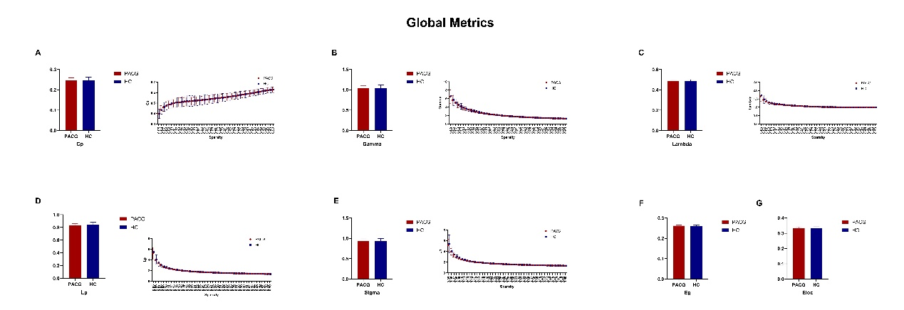
Supplementary Figure 1: Differences in Global metrics for validation analysis
Note: Figures 2A-2E illustrate that both the PACG and HC groups demonstrate small-world properties, while Figures 2F and 2G show that both groups exhibit network efficiency properties.
Histogram graphs present the AUC values for small-world properties and network efficiency (shown on the left side of Figures A-E, F, and G).
Bar charts depict that both the PACG and HC groups display small-world properties within the defined sparsity range of 0.05<S<0.50. Mean values for each group are denoted by circles (PACG) and squares (HC), with error bars indicating the standard error for each subject group in every state (shown on the right side of Figures A-E).
Abbreviations: Cp, clustering coefficient; Gamma, normalized clustering coefficient; Lambda, normalized shortest path length; Lp, characteristic path length; Sigma, small-worldness; Eg, global efficiency; Eloc, local efficiency; AUC, area under curve; PACG, primary angle-closure glaucoma; HC, healthy control.

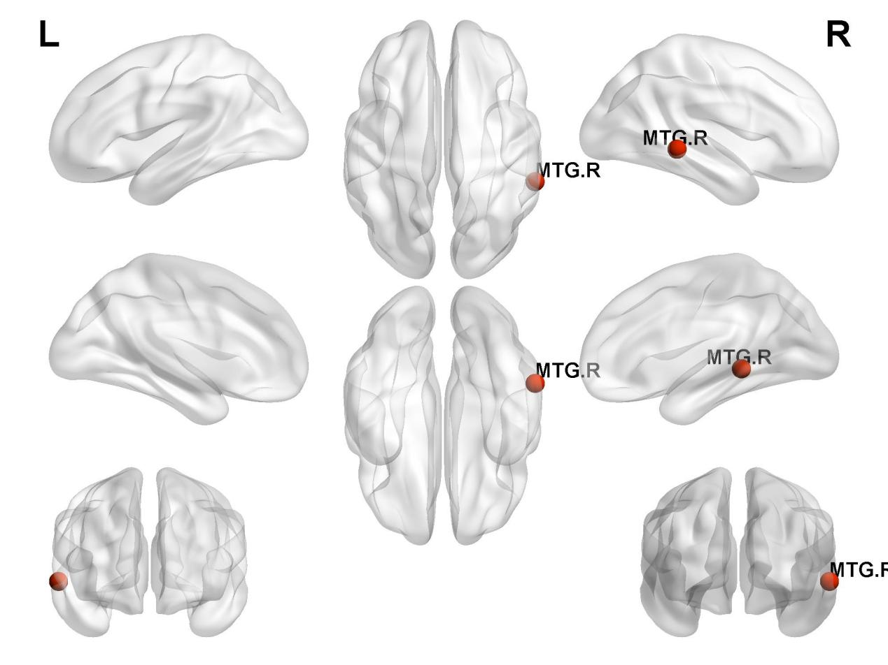
Supplementary Figure 2: Differences in nodal metrics for validation analysis
Note: A significant increase in both network node centrality and network node efficiency was observed in the MTG-R regions among PACG patients in comparison to healthy controls (PACG>HC). (P<0.05, Bonferroni-corrected).
Abbreviations: MTG.R, right middle temporal gyrus.

Supplementary Table 4: Differences in nodal metrics between patients with PACG and healthy controls
 | Brain Region | Degree Centrality |  | Nodal efficiency
 | Brain Region | t-Values | p-Values | t-Values | p-Values
PACG>HC | MTG.R | 4.195465 | 0.000066 | 3.939366 | 0.000166
Abbreviations: MTG.R, right middle temporal gyrus.

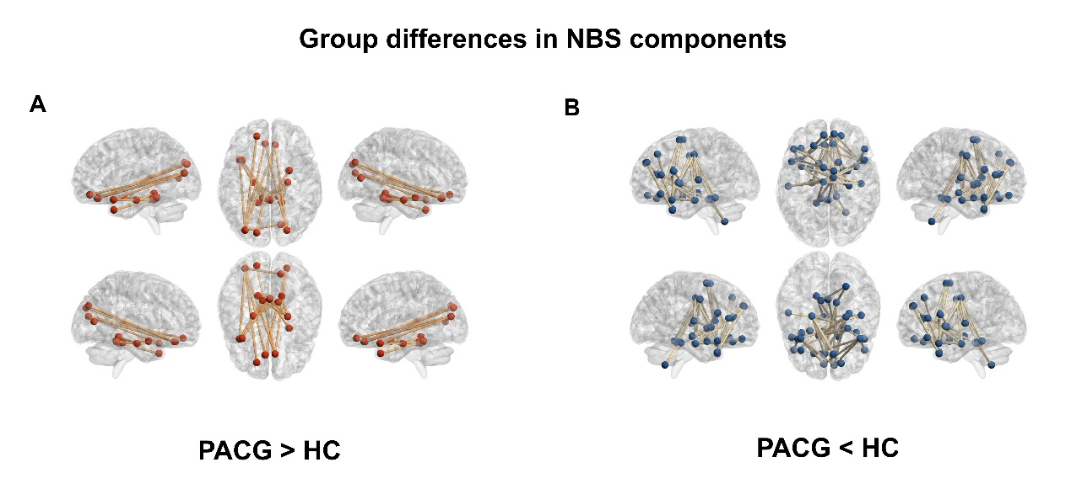
Supplementary Figure 3: Group differences in NBS components for validation
Note: NBS analysis identified a significantly altered network (both positive and negative) in PACG group relative to HC group.
Abbreviations: PACG, primary angle-closure glaucoma; HC, healthy control.

Supplementary Table 5: Significant alterations in functional connectivities observed in PACG patients compared to HCs for validation analysis.

 | Region 1 | Category | Region 2 | Category | p-Values | t-Values
Positive | REC-R | Prefontal | SOG-L | Occipital | 0.000190 | 3.900372
 | REC-L | Prefontal | SOG-R | Occipital | 0.000180 | 3.915268
 | REC-R | Prefontal | SOG-R | Occipital | 0.000278 | 3.791095
 | ORBsup-L | Prefontal | MOG-L | Occipital | 0.000986 | 3.411795
 | REC-L | Prefontal | MOG-L | Occipital | 0.000268 | 3.802043
 | REC-R | Prefontal | MOG-L | Occipital | 0.000797 | 3.477073
 | CAL-R | Occipital | MOG-L | Occipital | 0.000275 | 3.794489
 | PHG-L | Temporal | TPOsup-L | Temporal | 0.000015 | 4.583946
 | MOG-L | Occipital | TPOsup-L | Temporal | 0.000249 | 3.822278
 | PHG-L | Temporal | Crus3_L | Cerebellum Frontal | 0.000052 | 4.258737
 | PHG-R | Temporal | Crus3_L | Cerebellum Frontal | 0.000088 | 4.115239
 | PHG-L | Temporal | Crus3_R | Cerebellum Frontal | 0.000150 | 3.968129
 | PHG-R | Temporal | Simplex_R | Cerebellum Motor | 0.000885 | 3.445057
 | PHG-L | Temporal | Vermal_4_5 | Cerebellum Sensorimotor | 0.000002 | 5.062215
 | PHG-R | Temporal | Vermal_4_5 | Cerebellum Sensorimotor | 0.000016 | 4.567812
 | AMYG-R | Temporal | Vermal_4_5 | Cerebellum Sensorimotor | 0.000445 | 3.652998
 | TPOmid-L | Temporal | Vermal_4_5 | Cerebellum Sensorimotor | 0.000084 | 4.128176
 | Simplex_L | Cerebellum Motor | Vermal_4_5 | Cerebellum Sensorimotor | 0.000085 | 4.127383
 | PHG-L | Temporal | Vermal_6 | Cerebellum Sensorimotor | 0.000031 | 4.400071
 | PHG-R | Temporal | Vermal_6 | Cerebellum Sensorimotor | 0.000122 | 4.024450
Negative | ORBinf-L | Prefontal | SMA-L | Prefontal | 0.000234 | -3.840999
 | INS-L | Subcortical | DCG-L | Frontal | 0.000063 | -4.210209
 | INS-R | Subcortical | DCG-L | Frontal | 0.000442 | -3.654754
 | INS-L | Subcortical | DCG-R | Frontal | 0.000174 | -3.925042
 | ORBsup-R | Prefontal | PHG-L | Temporal | 0.000681 | -3.525294
 | SFGmed-R | Prefontal | PHG-L | Temporal | 0.000797 | -3.477034
 | REC-R | Prefontal | PHG-L | Temporal | 0.000602 | -3.562249
 | ACG-L | Prefontal | PHG-L | Temporal | 0.000084 | -4.130455
 | DCG-L | Frontal | PHG-L | Temporal | 0.000042 | -4.318366
 | DCG-R | Frontal | PHG-L | Temporal | 0.000002 | -5.143405
 | SFGmed-R | Prefontal | PHG-R | Temporal | 0.000213 | -3.868214
 | ACG-L | Prefontal | PHG-R | Temporal | 0.000134 | -3.998533
 | HIP-R | Temporal | CAU-L | Subcortical | 0.000050 | -4.269656
 | PHG-R | Temporal | CAU-L | Subcortical | 0.000049 | -4.278866
 | AMYG-R | Temporal | CAU-L | Subcortical | 0.000102 | -4.075842
 | HIP-R | Temporal | CAU-R | Subcortical | 0.000039 | -4.334760
 | AMYG-R | Temporal | CAU-R | Subcortical | 0.000729 | -3.504382
 | IFGoperc-L | Prefontal | PAL-R | Subcortical | 0.000805 | -3.474173
 | IFGoperc-R | Prefontal | PAL-R | Subcortical | 0.000241 | -3.832409
 | IFGtriang-L | Prefontal | PAL-R | Subcortical | 0.000013 | -4.622485
 | ACG-R | Prefontal | PAL-R | Subcortical | 0.000330 | -3.740598
 | CAU-L | Subcortical | PAL-R | Subcortical | 0.000165 | -3.940358
 | DCG-L | Frontal | HES-R | Temporal | 0.000794 | -3.478215
 | PUT-L | Subcortical | HES-R | Temporal | 0.000051 | -4.264613
 | DCG-L | Frontal | STG-L | Temporal | 0.000412 | -3.675556
 | DCG-R | Frontal | STG-L | Temporal | 0.000749 | -3.496267
 | IFGoperc-L | Prefontal | TPOsup-L | Temporal | 0.000635 | -3.546113
 | IFGtriang-L | Prefontal | TPOsup-L | Temporal | 0.000374 | -3.704562
 | SMA-L | Frontal | TPOsup-L | Temporal | 0.000001 | -5.345547
 | SMA-R | Frontal | TPOsup-L | Temporal | 0.000021 | -4.501363
 | DCG-L | Frontal | TPOsup-R | Temporal | 0.000403 | -3.681919
 | SFGmed-L | Prefontal | TPOmid-L | Temporal | 0.000002 | -5.075402
 | SFGmed-R | Prefontal | TPOmid-L | Temporal | 0.000056 | -4.241922
 | SFGdor-L | Prefontal | TPOmid-R | Temporal | 0.000093 | -4.100319
 | IFGtriang-R | Prefontal | TPOmid-R | Temporal | 0.000714 | -3.510565
 | SFGmed-L | Prefontal | TPOmid-R | Temporal | 0.000047 | -4.287020
 | SFGmed-R | Prefontal | TPOmid-R | Temporal | 0.000034 | -4.371879
 | ACG-L | Prefontal | Crus3_R | Cerebellum Frontal | 0.000065 | -4.200983
 | ACG-R | Prefontal | Crus3_R | Cerebellum Frontal | 0.000727 | -3.505443
 | DCG-L | Frontal | Simplex_L | Cerebellum Motor | 0.000437 | -3.658370
 | DCG-R | Frontal | Simplex_L | Cerebellum Motor | 0.000989 | -3.410768
 | Crus3_L | Cerebellum Frontal | Dentate_R | Cerebellum Motor | 0.000019 | -4.523432
 | Crus3_R | Cerebellum Frontal | Dentate_R | Cerebellum Motor | 0.000469 | -3.637498
 | DCG-R | Frontal | Vermal_4_5 | Cerebellum Sensorimotor | 0.000871 | -3.450117
Note: NBS analysis results show that in the PACG group compared to the HC group, a significantly altered network consisting of 38 nodes and 64 connections was identified.
Abbreviations: REC-R, Right Rectus Gyrus; SOG-L, Left Superior Occipital Gyrus; REC-L, Left Rectus Gyrus; SOG-R, Right Superior Occipital Gyrus; ORBsup-L, Left Superior Orbital Gyrus; MOG-L, Left Middle Occipital Gyrus; CAL-R, Right Calcarine Fissure and Surrounding Cortex; PHG-L, Left Parahippocampal Gyrus; TPOsup-L, Left Superior Temporal Pole; Crus3_L, Left Lobule VI (Crus I) of the Cerebellum; Crus3_R, Right Lobule VI (Crus I) of the Cerebellum; Simplex_R, Right Simple Lobule of the Cerebellum; Vermal_4_5, Vermis Lobules IV-V of the Cerebellum; Vermal_6, Vermis Lobule VI of the Cerebellum; SMA-L, Left Supplementary Motor Area; ORBinf-L, Left Inferior Orbital Gyrus; INS-L, Left Insula; DCG-L, Left Dorsal Cingulate Gyrus; DCG-R, Right Dorsal Cingulate Gyrus; ORBsup-R, Right Superior Orbital Gyrus; SFGmed-R, Right Medial Superior Frontal Gyrus; ACG-L, Left Anterior Cingulate Gyrus; HIP-R, Right Hippocampus; CAU-L, Left Caudate Nucleus; CAU-R, Right Caudate Nucleus; PAL-R, Right Pallidum; HES-R, Right Heschl's Gyrus; PUT-L, Left Putamen; STG-L, Left Superior Temporal Gyrus; TPOsup-R, Right Superior Temporal Pole; SFGmed-L, Left Medial Superior Frontal Gyrus; TPOmid-L, Left Middle Temporal Pole; SFGdor-L, Left Dorsal Superior Frontal Gyrus; TPOmid-R, Right Middle Temporal Pole; IFGtriang-R, Right Inferior Frontal Gyrus, Triangular Part; ACG-R, Right Anterior Cingulate Gyrus; SFGmed-L, Left Medial Superior Frontal Gyrus; Dentate_R, Right Dentate Nucleus; PACG, primary angle-closure glaucoma; HC, healthy control.

