Appendix I – Maps produced using AI models GPT-4 and GPT Data Analyst

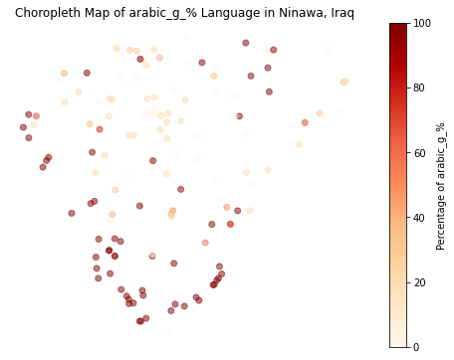
Map 1 – A choropleth map showing the distribution of Gelet Arabic in al-Hamdaniyah district.
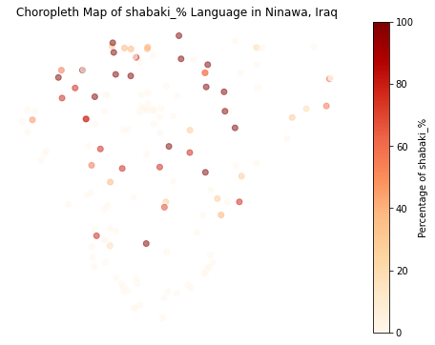

Map 2 - A choropleth map showing the distribution of Shabaki in al-Hamdaniyah district.

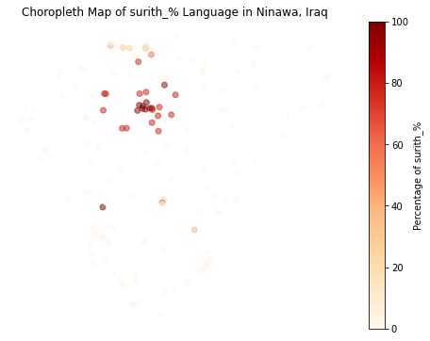

Map 3 - A choropleth map showing the distribution of Surith in al-Hamdaniyah district.

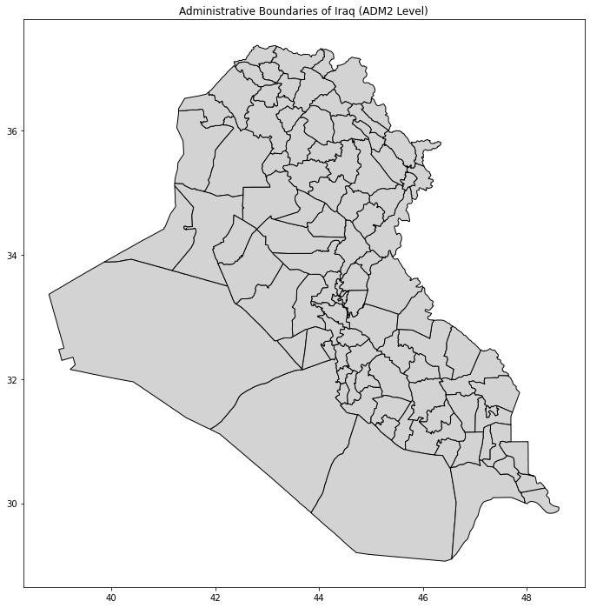

Map 4 – The administrative boundaries of Iraq after applying the models’ mapping skills on the GeoJSON shape file.

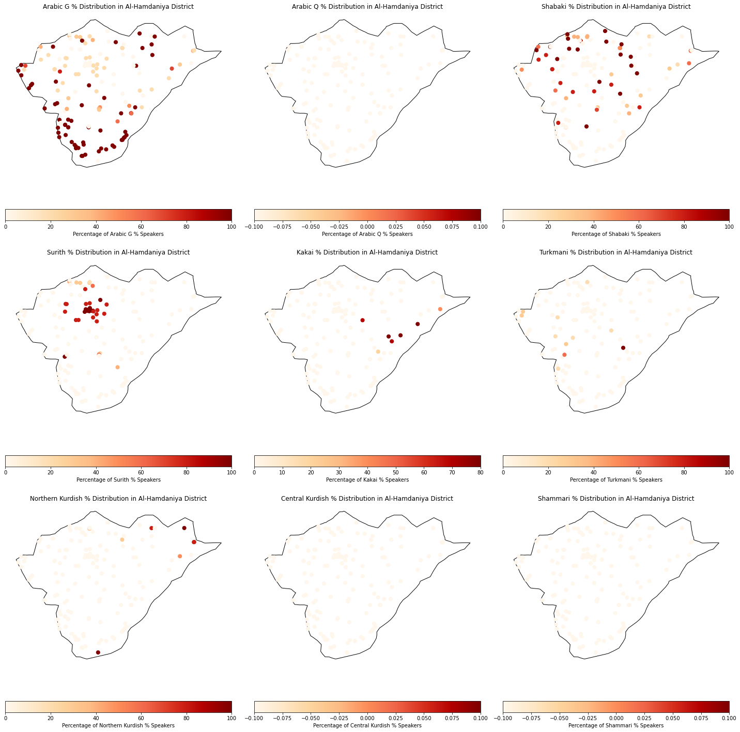

Map 5 – A group of maps that show the distribution of each of the languages in al-Hamdaniyah district. These maps were produced in a batch mapping process.

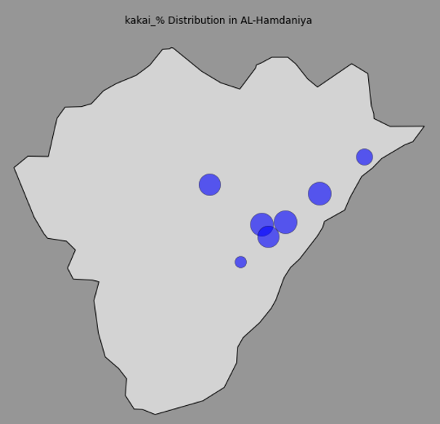
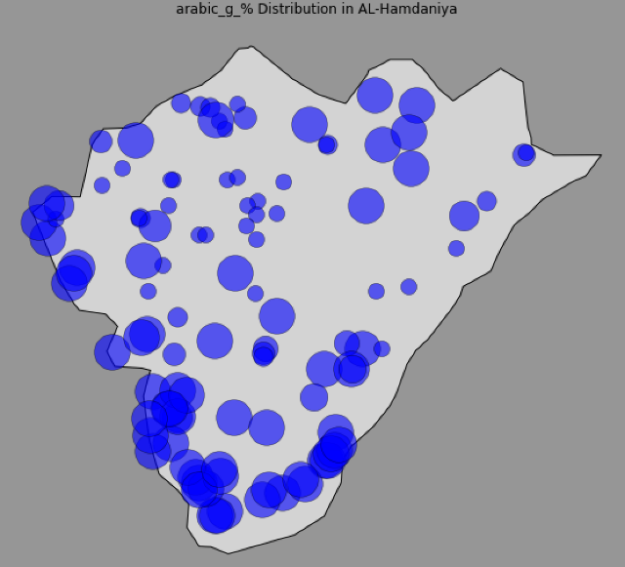
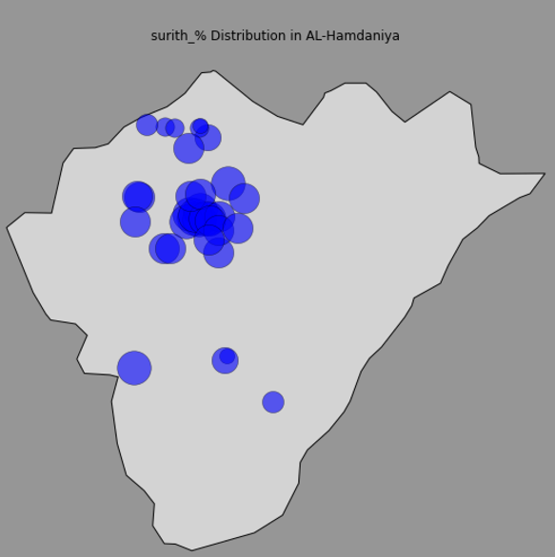

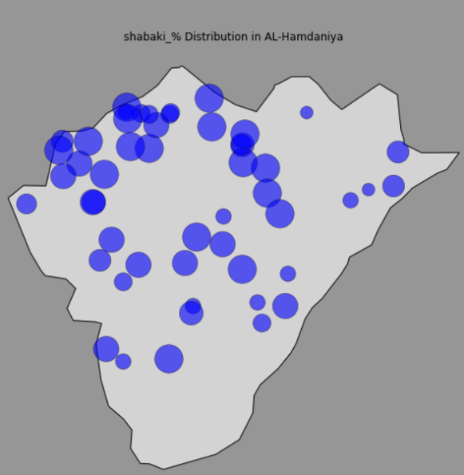

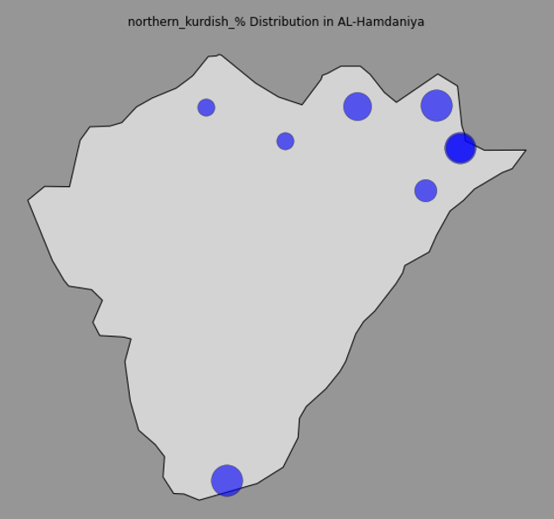
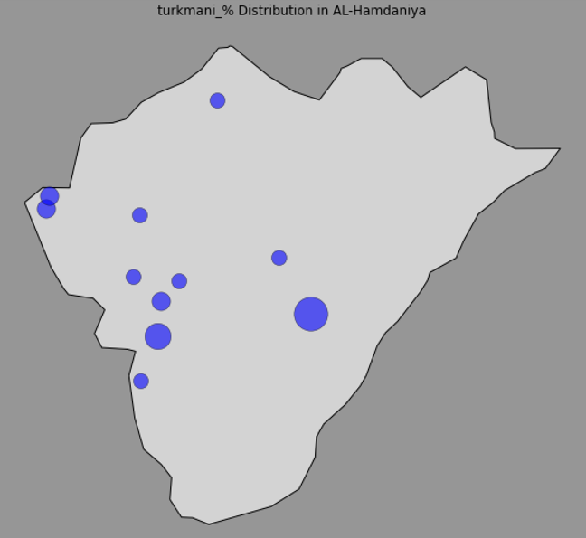

Map 6-11- These maps show the how the AI models produced maps using the map of al-hamdaniyah district from the GeoJSON shape file and applied the CSV file data on it to plot the distribution of languages in al-Hamdaniyah. The percentages of the languages are represented by the size of the circle.
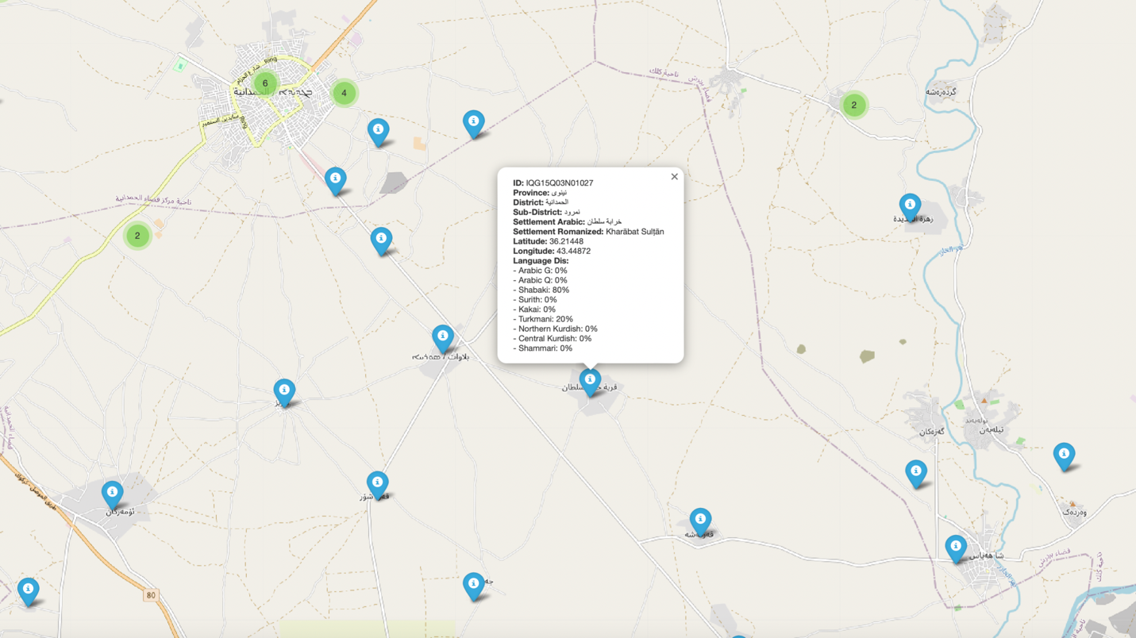

Map 12 – An interactive web map that shows the settlements of al-Hamdaniyah district and once we click on the pin, we can see all the information embedded in the hover data. Note here that we can manipulate the Python code to included whatever data we like to show.

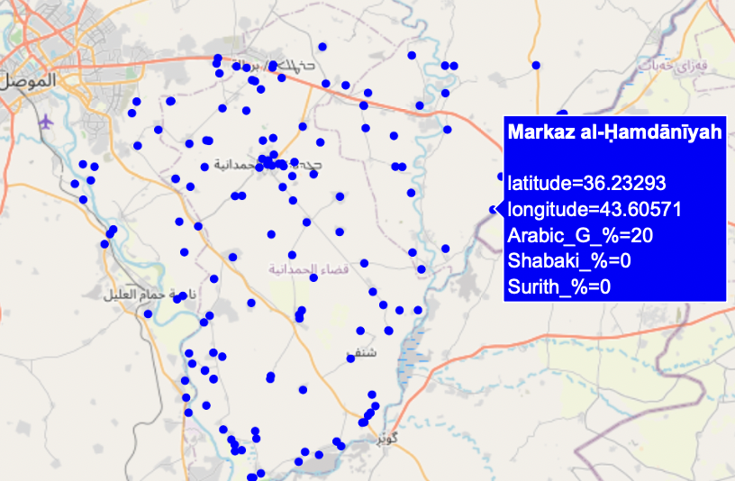

Map 13 – This is another interactive web map that shows the AI models’ ability to change the way data is visualized on the map. For instance, in this map, they used points instead of pins, and once we click on these points we can see the hover data related to each settlement.
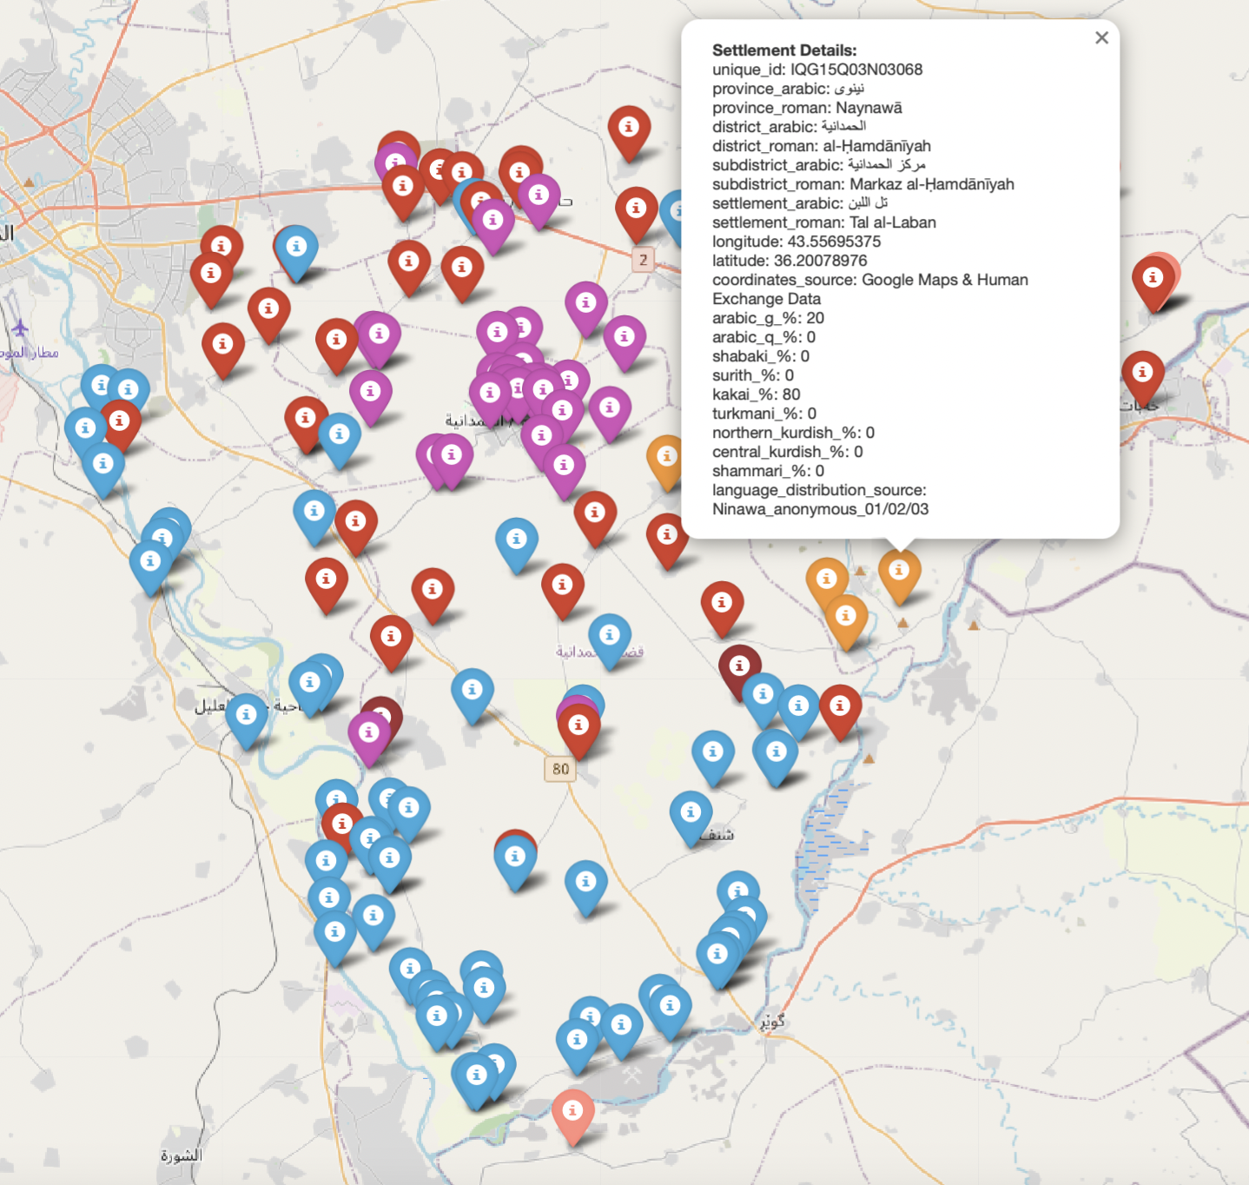

Map 14 – this map shows the settlements in pined in different colors based on the language spoken in them. Once we click on the pin, we can see all the hover data we choose to include such as place names in English and Arabic, language distribution data, and other location information. It can be noted here that there is no legend to explain which language is represented by each of the colors. This was one of the limitations of the AI models, not being able to provide a legend within the map even after addressing that the problem, the models gave a rectified code that still did not work.

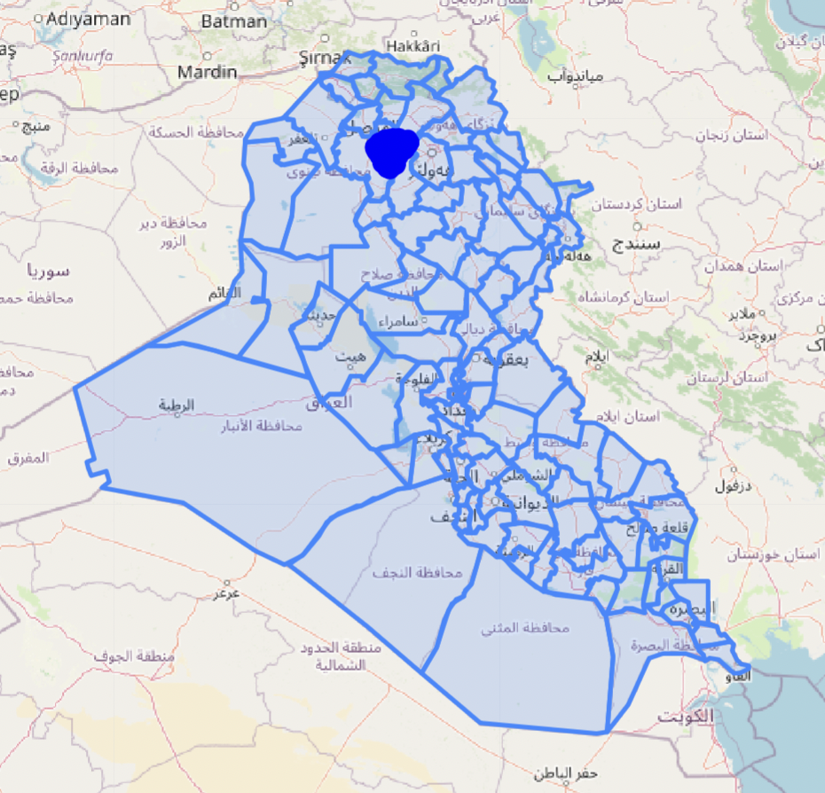

Map 15 – This map shows how the GeoJSON shape file is overlaid on the base maps, here Open Street Map, to show the administrative borders because it was difficult to see the borders on the base map. This map is interactive, which means that we can zoom it in so we can see the plotted data as points on the settlements. Once we click on a point, we can see the hover data related to it.

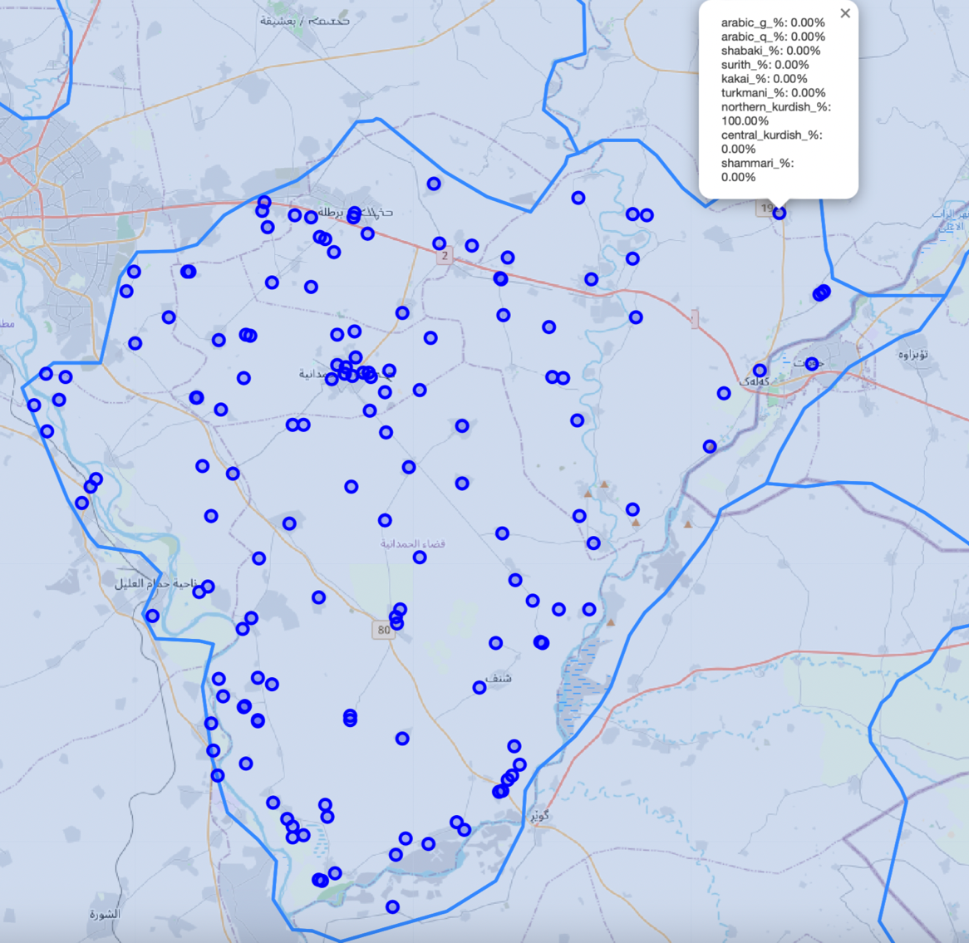

Map 16 – This is a zoomed version of the map above (Map 15), it can be seen that after zooming the map, we can see the points on the settlements and the hover data on one of them.

Appendix II

General information
(to be filled out by the field researcher before or after fieldwork)
Name of person filling out this questionnaire: _________________________
Email address: _________________________
Location where the questionnaire was filled out: _________________________
Date filled out: _________________________
Name of person(s) checking / analyzing the questionnaire data (checker to fill this in):
_________________________
Date checked / analyzed (checker to fill this in): _________________________
Date approved for upload (editors to fill this in): _________________________
Language variety (language, dialect, subdialect, etc.): _________________________
Language data from which province and which exact village(s)/town(s) _________________________
Is the data from your own fieldwork and/or from a published source? _________________________
If the data is from your own existing field notes, please ensure that it is from a single settlement. Then fill in the following details:

Permission text and speaker details

My name is .... I come from .... I am a linguist from the University of .... I want to study and learn about the languages and dialects of [region] and help preserve knowledge about these languages for the future. I use the things that I learn for research and eventual publication in print, online in the Atlas of the Languages of Iraq, and in an online language archive. Do you give me the permission to ask you questions about your language, and to record and freely use what I learn?
[make sure the answer is loud and clear enough to be audible on the recording]

If the speakers have given their consent, say:
If you wish to discontinue this interview at any point or withdraw your consent for me to use anything that you’ve shared, including audio or video recordings, you are free to do so. I am able to withdraw your contributions until the point when they are published or archived.

Then, you can continue with the following questions, and the rest of the interview:

Would you like us to write your name(s) down, or would you like to remain anonymous?
______________________________

Name of speaker(s) (only put this if speakers have requested that their names be used):
(speaker 1) ____________________________
(speaker 2) ____________________________
(speaker 3) ____________________________

Other details about the speakers (include this information for all speakers):
Age: Gender: Profession:
(speaker 1) _________ _________ ______________________
(speaker 2) _________ _________ ______________________
(speaker 3) _________ _________ ______________________

Languages spoken, along with:
a) speaker’s L1 (first language learned from parents in the home), or L2+ (an additional language)?
b) speaker’s stated degree of oral proficiency in each language (full = 5 / good = 4 / some = 3 / little = 2 / very little = 1)
c) frequency of usage in the past year (every day / at least once every week / at least once every month / at least once in the past year / never in the past year)
Language: L1 or L2+? Proficiency: Frequency:
(speaker 1) _____________ ________ _________ ________________
_____________ ________ _________ ________________
_____________ ________ _________ ________________
_____________ ________ _________ ________________
_____________ ________ _________ ________________
(speaker 2) _____________ ________ _________ ________________
_____________ ________ _________ ________________
_____________ ________ _________ ________________
_____________ ________ _________ ________________
_____________ ________ _________ ________________
(speaker 3) _____________ ________ _________ ________________
_____________ ________ _________ ________________
_____________ ________ _________ ________________
_____________ ________ _________ ________________
_____________ ________ _________ ________________

Languages the speaker can read and write, and the speaker’s stated degree of written proficiency in each language (full = 5 / good = 4 / some = 3 / little = 2 / very little = 1)

(speaker 1) ______________________________________________________
(speaker 2) ______________________________________________________
(speaker 3) ______________________________________________________

Level of education (none / elementary / secondary / post-secondary):
(speaker 1) ______________________________________________________
(speaker 2) ______________________________________________________
(speaker 3) ______________________________________________________

Sociolinguistic information

The following portion of the questionnaire, which deals with language use in the context of a single settlement, is adapted from Anonby & Yousefian’s (2011) sociolinguistic study.
Please answer the questions as you are able, providing estimates if necessary. You may mark any item for which you are unable to provide an answer, with “?”.
1. What is the name of your community (city, town, village, etc.)? _________________________________
2. What languages are spoken in the community as a mother tongue (that is, the first language a person learns at home as a child)?
____________________________________________________________________
3. What proportion (approximate percentage) of the population in the community speaks each of these languages as a mother tongue?
____________________________________________________________________
4. What do the people in the community call their own language(s) [the most general language grouping possible] and dialect(s) [more local groupings at the regional and local level, i.e., their particular variety of the language they mention] in their own language(s)?
____________________________________________________________________
5. What do the people in the community call their own ethnic group(s) in their own language(s)? [Ask the speaker to give ethnic group names at all relevant levels, from most general to most specific, as far as they are known, and specify each level in parentheses beside each of the ethnic names. ____________________________________________________________________
6. What is the name of the community (city, town, village, etc.) in each of the languages that are spoken there?
____________________________________________________________________
7. What proportion of the population (circle one answer for each):
speaks Arabic fluently? all most some a few none
speaks some Arabic? all most some a few none
speaks no Arabic? all most some a few none
8. Besides their mother tongue(s) and Arabic, what additional languages and dialects do the people of the community speak?
____________________________________________________________________
9. What proportion (all/most/some/a few/none) of the children in the community are not learning the mother tongue of their parents as their mother tongue? ___________
10. Which language communities do these children come from? (At the same time, specify the proportion of children – all/most/some/a few/none – who are not learning the mother tongue of their parents, for each language community.)
____________________________________________________________________
11. What language(s) are these children now learning as a mother tongue?
____________________________________________________________________

