Supplementary Table 1. Comparison of select individual and household characteristics by year and travel area. Characteristics were selected a priori because of their relationship with malaria transmission.
 | Low Travel EAs |  | High Travel EAs |  | All
Variable | 2019 | 2020 | 2019 | 2020 | 2019 | 2020
Individual Variables (sample size) | n ind = 2355 | n ind = 1958 | n ind = 4514 | n ind = 4345 | n ind = 6891 | n ind = 6304
Age (years) | 25.1 (21.6); 0.1-110 | 26.5 (21.8); 0.1-90 | 21.4 (18.0); 0.1-110 | 21.9 (18.1); 0.1-95 | 21.8 (18.1); 0.1-110 | 22.0 (18.1); 0.1-95
Average trips off island | 0.0 (0.1); 0-1 | 0.0 (0.0); 0-1 | 0.1 (0.2); 0-1 | 0.0 (0.1); 0-1 | 0.1 (0.2); 0-1 | 0.0 (0.1); 0-1
Female | 1209 (51.3%) | 994 (50.8%) | 2353 (52.1%) | 2369 (54.5%) | 3635 (52.7%) | 3386 (53.7%)
Permanent resident of household | 2124 (90.2%) | -- | 4269 (94.6%) | -- | 6518 (94.6%) | --
Is employed | 549 (38.7%) | 493 (42.7%) | 1002 (37.8%) | 994 (40.0%) | 1596 (38.6%) | 1449 (40.1%)
Travelled off-island in past 8-weeks | 56 (2.4%) | 5 (0.3%) | 330 (7.3%) | 36 (0.9%) | 514 (7.5%) | 60 (1.0%)
Slept in household previous night | 2262 (96.1%) | 1789 (97.1%) | 4379 (97.0%) | 4029 (97.4%) | 6666 (96.7%) | 5860 (97.3%)
Slept under a bednet previous night | 1008 (44.6%) | 736 (41.2%) | 1686 (38.5%) | 1507 (37.5%) | 2606 (39.1%) | 2154 (36.8%)
Sick in past two-weeks | 262 (11.2%) | 166 (9.0%) | 462 (10.3%) | 314 (7.6%) | 736 (10.7%) | 457 (7.6%)
Go inside before 7pm | 511 (22.5%) | 812 (47.2%) | 1208 (28.1%) | 1953 (50.4%) | 1755 (26.9%) | 2865 (51.0%)
Go to sleep before 9pm | 618 (28.6%) | 495 (29.6%) | 850 (20.9%) | 749 (20.0%) | 1256 (20.4%) | 1106 (20.3%)
Household Variables (sample size) | n hh = 825 | n hh = 813 | n hh = 1696 | n hh = 1674 | n hh = 2521 | n hh = 2487
Household size | 3.9 (2.9); 1-16 | 3.3 (2.4); 1-18 | 4.2 (2.8); 1-16 | 3.9 (2.6); 1-16 | 4.1 (2.8); 1-16 | 3.7 (2.6); 1-18
Number of visitors in house | 0.1 (0.2); 0-1 | 0.1 (0.2); 0-1 | 0.0 (0.2); 0-1 | 0.1 (0.2); 0-1 | 0.0 (0.2); 0-1 | 0.1 (0.2); 0-1
Has the following item:
Sofa | 569 (69.1%) | 600 (73.8%) | 1425 (84.0%) | 1426 (85.2%) | 1994 (79.1%) | 2026 (81.5%)
Table | 634 (76.8%) | 664 (81.7%) | 1355 (79.9%) | 1392 (83.2%) | 1989 (78.9%) | 2056 (82.7%)
Armoire | 365 (44.2%) | 358 (44.0%) | 1108 (65.4%) | 1000 (59.7%) | 1473 (58.5%) | 1358 (54.6%)
Air conditioning | 59 (7.2%) | 65 (8.0%) | 555 (32.7%) | 644 (38.5%) | 614 (24.4%) | 709 (28.5%)
Stove | 417 (50.5%) | 442 (54.4%) | 1375 (81.1%) | 1418 (84.7%) | 1792 (71.1%) | 1860 (74.8%)
Washing Machine | 145 (17.6%) | 149 (18.3%) | 549 (32.4%) | 626 (37.4%) | 694 (27.5%) | 775 (31.2%)
Car | 129 (15.6%) | 127 (15.6%) | 567 (33.5%) | 568 (33.9%) | 696 (27.6%) | 695 (27.9%)
Household sprayed in past 6-months | 358 (46.9%) | 274 (35.1%) | 418 (28.3%) | 897 (57.2%) | 776 (34.6%) | 1171 (49.8%)
Own bednets | 181 (46.2%) | 196 (43.9%) | 259 (26.1%) | 341 (34.6%) | 440 (31.8%) | 537 (37.5%)
Housing type:
Social housing | 11 (1.3%) | 13 (1.6%) | 200 (11.8%) | 161 (9.6%) | 211 (8.4%) | 174 (7.0%)
Barracks | 125 (15.2%) | 152 (18.7%) | 594 (35.0%) | 617 (36.9%) | 719 (28.5%) | 769 (30.9%)
Apartment | 19 (2.3%) | 14 (1.7%) | 136 (8.0%) | 114 (6.8%) | 155 (6.1%) | 128 (5.1%)

Supplementary Table 2. Plasmodium falciparum (Pf) prevalence by year and travel area in individuals who indicated traveling to the mainland in the past 8-weeks compared to those who did not report recent travel.
 |  | Pf prevalence (95% CI)
Year | Traveled on Island | Overall | High travel areas | Low travel areas
2019 | No | 13.3% (12.2, 14.4) | 13.9% (12.5, 15.2) | 7.2% (4.3, 10.0)
2019 | Yes | 13.5% (11.5, 15.6) | 12.8% (10.1, 15.6) | 9.3% (4.2, 14.6)
2020 | No | 11.8% (10.5, 13.1) | 11.6% (9.8, 13.5) | 12.4% (7.3, 17.6)
2020 | Yes | 13.1% (10.6, 15.4) | 13.9% (10.6, 15.4) | 13.8% (3.1, 24.5)

Supplementary Table 3. Plasmodium falciparum (Pf) prevalence in 2019 and 2020 for three enumeration areas with known land use changes during the study period.
 | EA | Prevalence
Community | EA | 2019 | 2020
All low travel areas | - | 7.50% | 12.80%
Basupu | 502 | 17.5% | 45.5%
Baloeri | 792 | 22.9% | 32.8%
Baticopo | 1028 | 7.9% | 7.8%

Supplementary Table 4. Prevalence differences (PD) comparing high and low travel areas by year. Results show for the main model, and when removing three sites know to have large land use changes between the two study years.
 | Main Model |  | Sensitivity Analysis (removed 3 EAs with land use changes)
Comparison | Unadjusted model  PD (95% CI) | Adjusted Model*  PD (95% CI) | Unadjusted model  PD (95% CI) | Adjusted Model*  PD (95% CI)
High travel areas 2020-High travel 2019 | -1.9 (-3.2,-0.6) | -3.0 (-4.7,-1.3) | -1.9 (-3.2,-0.6) | -2.8 (-4.5,-1.1)
Low travel 2020-Low travel 2019 | 5.3 (0.6,10) | 2.1 (-1.1,5.3) | 3.3 (-0.1,6.7) | 1.8 (-1.2,4.8)
High travel 2020-Low travel 2019 | 4.3 (0.9,7.7) | 1.5 (-1.3,4.3) | 5.7 (2.5,8.9) | 2.4 (-0.5,5.3)
High travel 2020-Low travel 2020 | -0.9 (-7,5.2) | -0.6 (-4.1,2.9) | 2.4 (-1.2,6) | 0.6 (-1.6,2.8)
High travel 2019-Low travel 2019 | 6.3 (3,9.6) | 4.6 (1.8,7.4) | 7.6 (4.5,10.7) | 5.2 (2.2,8.2)
High travel areas 2020-high travel areas 2019) - (Low travel areas 2020-low travel areas 2019) | -7.2 (-12.1,-2.3) | -5.1 (-8.9,-1.3) | -5.2 (-8.9,-1.5) | -4.6 (-8.1,-1.1)
* Adjusted for spray coverage and going indoors before 7pm

Supplementary Table 5. Odds ratios of infection comparing high and low travel areas by year. Results shown for the main model, and when removing three sites known to have large land use changes between the two study years.
 | Main Model |  |  | Sensitivity Analysis (removed 3 EAs with land use changes)
Comparison | Unadjusted model  OR (95% CI) | Adjusted Model*  OR (95% CI) |  | Unadjusted model  OR (95% CI) |  | Adjusted Model*  OR (95% CI)
High travel areas 2020/High travel 2019 | 0.84 (0.75,0.95) | 0.75 (0.64,0.89) |  | 0.843 (0.748, 0.95) |  | 0.768 (0.635, 0.893)
Low travel 2020/Low travel 2019 | 1.8 (1.17,2.76) | 1.22 (0.91,1.63) |  | 1.586 (1.174, 2.756) |  | 1.203 (0.913, 1.633)
High travel 2020/Low travel 2019 | 1.65 (1.05,2.61) | 1.15 (0.88,1.51) |  | 2.05 (1.048, 2.611) |  | 1.275 (0.881, 1.508)
High travel 2020/Low travel 2020 | 0.92 (0.53,1.6) | 0.94 (0.68,1.3) |  | 1.292 (0.529, 1.597) |  | 1.061 (0.684, 1.302)
High travel 2019/Low travel 2019 | 1.96 (1.26,3.06) | 1.53 (1.17,2.01) |  | 2.432 (1.259, 3.057) |  | 1.661 (1.167, 2.006)
High travel areas 2020/high travel areas 2019 to Low travel areas 2020/low travel areas 2019 | 0.49 (0.30, 0.73) | 0.61 (0.43, 0.88) |  | 0.531 (0.319, 0.886) |  | 0.683 (0.443, 0.921)
* Adjusted for spray coverage and going indoors before 7pm

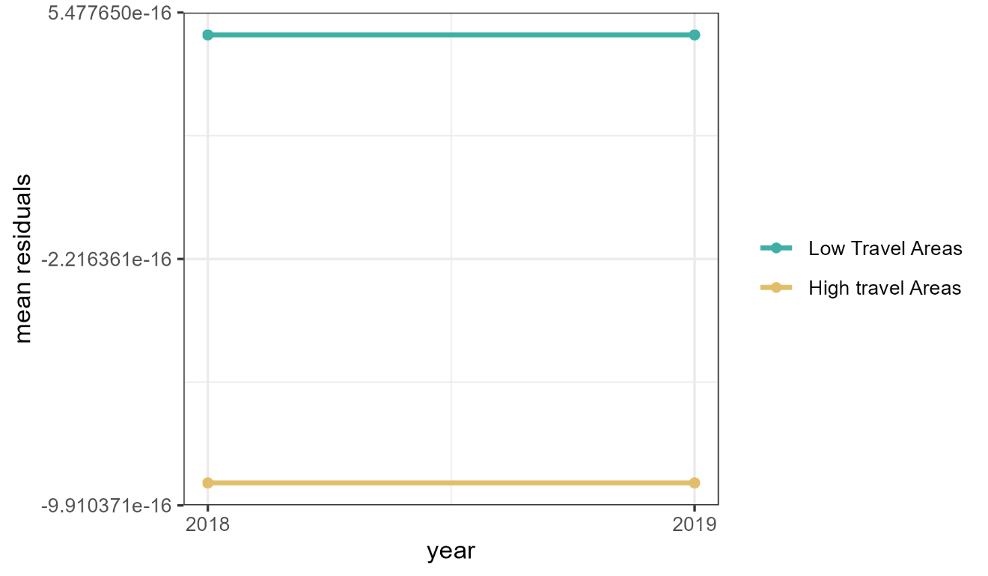
Supplementary Figure 1. Plot of mean residuals of linear regression of Pf infection over time to test the robustness of the parallel trends assumption.
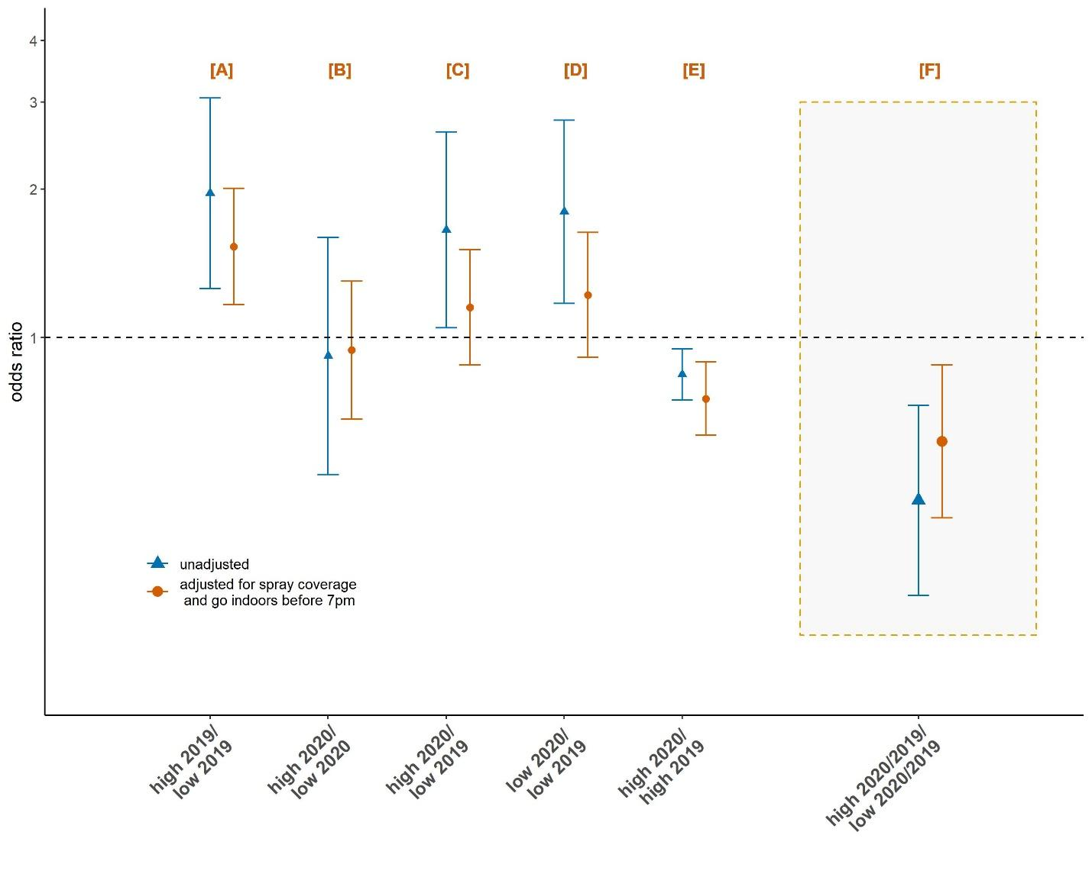
Supplementary Figure 2. Comparison of odds of infection in different years and travel areas (high or low) on Bioko Island [panels A-E]. Adjusted odds ratios (orange circles) are from models adjusted for spray coverage and whether an individual went inside before 7PM. The ratio of ratios comparing the change in odds in high travel areas between 2019 and 2020 relative to the change in low areas is shown in the gray box [panel F].

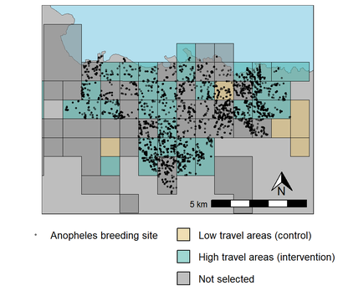
Supplementary Figure 3. Areas in urban Malabo, Bioko Island, Equatorial Guinea where Anopheles larvae were identified by vector control teams.

