Population | # of Lines | # of SNPs | Sequencing Depth |  |  |  | Missing Data
Population | # of Lines | # of SNPs | Mean | S.D. | Min | Max | Total | Per Marker |  |  | Per Individual
 |  |  |  |  |  |  |  | S.D. | Min | Max | S.D. | Min | Max
ALL | 1237 | 7,137,085 | 13.33 | 8.27 | 0.05 | 65.54 | 6.32% | 7.81% | 0.00% | 50% | 6.38% | 0.26% | 46.68%
Wild | 51 | 5,979,677 | 12.96 | 4.72 | 3.46 | 23.39 | 4.09% | 8.10% | 0.00% | 49.02% | 3.38% | 1.65% | 23.25%
Landrace | 455 | 4,497,817 | 13.76 | 9.25 | 5.85 | 64.54 | 5.57% | 8.47% | 0.00% | 49.89% | 4.50% | 0.65% | 34.95%
East Asia | 352 | 3,790,485 | 12.96 | 6.81 | 5.77 | 37.63 | 5.14% | 8.37% | 0.00% | 50.00% | 3.43% | 0.40% | 27.54%
Canada | 112 | 2,533,440 | 14.26 | 6.79 | 3.44 | 39.56 | 7.86% | 7.85% | 0.00% | 50.00% | 8.20% | 0.46% | 39.49%
United States (non-Nebraska) | 64 | 1,723,191 | 22.71 | 9.85 | 6.92 | 55.75 | 3.22% | 6.48% | 0.00% | 50.00% | 2.65% | 0.36% | 14.80%
Nebraska | 204 | 2,640,097 | 9.27 | 5.83 | 0.05 | 33.00 | 10.53% | 9.72% | 0.00% | 50.00% | 9.78% | 0.18% | 45.74%
Supplementary Table 1: In total, whole genome sequence data from 1237 lines across six populations of soybean were analyzed in this study. Sequencing depth ranged from 9.27 to 22.71, and missing data rates ranged from 3.22% to 10.53% based upon the SNP calls.

Site | Variance Component
Site | Genotype | Environment | Genotype x Environment | Residual
2017 Phillips | 8.39% | 52.02% | 11.08% | 28.52%
2017 Stevens Creek | 8.86% | 54.95% | 11.70% | 24.49%
2018 Cotesfield | 8.75% | 54.27% | 11.56% | 25.42%
2018 Mead | 10.01% | 62.09% | 13.22% | 14.67%
2018 Phillips | 8.32% | 51.61% | 10.99% | 29.07%
2018 Stevens Creek | 9.03% | 55.98% | 11.92% | 23.07%
2018 Wymore | 9.87% | 61.18% | 13.03% | 15.93%
2019 Cotesfield | 9.53% | 59.09% | 12.58% | 18.80%
2019 Mead | 8.56% | 53.08% | 11.31% | 27.05%
2019 Phillips | 8.36% | 51.85% | 11.04% | 28.75%
2019 Stevens Creek | 10.21% | 63.30% | 13.48% | 13.01%
Supplementary Table 2: Environmental effects explained the most variance at any location using a multi-section mixed effects model, followed by GxE interactions, and finally the constitutive genotype effects.

 |  | Summary Statistics for Proportion of Yield Variance Explained per Genomic Window
 |  | Mean | Median | S.D. | Min | Max
Main |  | 1.00E-05 | 3.90E-06 | 1.81E-05 | 4.94E-14 | 4.19E-04
GxE |  | 1.01E-05 | 5.63E-06 | 1.29E-05 | 4.74E-08 | 2.71E-04
GxE per Environment | 2017 Phillips | 1.11E-06 | 4.17E-07 | 2.03E-06 | 1.10E-15 | 5.87E-05
GxE per Environment | 2017 Stevens Creek | 3.77E-07 | 1.50E-07 | 7.01E-07 | 2.5-e-16 | 2.68E-05
GxE per Environment | 2018 Cotesfield | 1.15E-07 | 4.27E-08 | 2.11E-07 | 4.15E-17 | 4.96E-06
GxE per Environment | 2018 Mead | 2.45E-07 | 9.84E-08 | 4.26E-07 | 3.63E-16 | 1.62E-05
GxE per Environment | 2018 Phillips | 1.02E-06 | 3.67E-07 | 1.99E-06 | 7.54E-20 | 5.52E-05
GxE per Environment | 2018 Stevens Creek | 2.62E-07 | 1.03E-07 | 4.66E-07 | 2.04E-16 | 1.13E-05
GxE per Environment | 2018 Wymore | 5.19E-07 | 2.08E-07 | 9.81E-07 | 9.02E-17 | 5.39E-05
GxE per Environment | 2019 Cotesfield | 3.93E-07 | 1.54E-07 | 6.98E-07 | 1.293-16 | 3.18E-05
GxE per Environment | 2019 Mead | 1.32E-07 | 5.16E-08 | 2.35E-07 | 1.07E-16 | 5.49E-06
GxE per Environment | 2019 Phillips | 2.90E-06 | 1.13E-06 | 5.21E-06 | 2.47E-15 | 1.24E-04
GxE per Environment | 2019 Stevens Creek | 2.25E-07 | 8.72E-08 | 4.15E-07 | 8.82E-17 | 1.25E-05
Supplementary Table 3: The average proportion of variance explained by either main or GxE effects was approximately the same among all windows, however the median GxE effects were markedly higher than median main effects. Among the individual locations, the largest contributions to yield variance were seen at the Phillips locations.

 |  | Summary Statistics for Yield Effect (kg/ha) per Genomic Window
 |  | Mean | Median | S.D. | Min | Max | Range
Main |  | 8.57E-05 | -5.93E-05 | 1.09E-02 | -0.18 | 0.19 | 0.37
Environment | 2017 Phillips | 4.32E-04 | 1.66E-04 | 1.26E-02 | -0.23 | 0.17 | 0.4
Environment | 2017 Stevens Creek | -2.93E-05 | 8.21E-06 | 7.90E-03 | -0.15 | 0.17 | 0.32
Environment | 2018 Cotesfield | 1.82-E4 | 4.58E-06 | 9.19E-03 | -0.16 | 0.15 | 0.31
Environment | 2018 Mead | 7.67E-05 | 3.24-e05 | 1.25E-02 | -0.14 | 0.27 | 0.41
Environment | 2018 Phillips | 1.19E-04 | 5.04E-05 | 1.46E-02 | -0.28 | 0.29 | 0.57
Environment | 2018 Stevens Creek | 4.38E-04 | 1.65E-04 | 8.55E-03 | -0.12 | 0.12 | 0.24
Environment | 2018 Wymore | 8.31E-05 | -4.22E-05 | 1.18E-02 | -0.32 | 0.16 | 0.48
Environment | 2019 Cotesfield | 1.68E-04 | -1.42E-04 | 1.71E-02 | -0.29 | 0.5 | 0.79
Environment | 2019 Mead | 1.01E-04 | 4.29E-05 | 7.24E-03 | -0.12 | 0.11 | 0.23
Environment | 2019 Phillips | 8.08E-05 | -5.47E-05 | 1.09E-02 | -0.18 | 0.19 | 0.37
Environment | 2019 Stevens Creek | 2.32e-04 | -7.83E-05 | 6.43E-03 | -0.13 | 9.32e-02 | 0.22
Supplementary Table 4: The average effect size for GxE effects in any environment was approximately the same or larger than the main effects. The widest range of effect sizes was not consistent by sight, with the top three seen at the 2019 Cotesfield location, 2018 Phillips, and 2018 Wymore sites.

Supplementary Table 5: Trends in overall and windowed F_{st} were as expected, with the highest value found in comparison to the wild lines and the lowest in comparison to a broad population of other elite US lines.
Population | Overall Weighted F_{st} Estimate | Windowed Weighted F_{st}
Population | Overall Weighted F_{st} Estimate | Mean | Median | S.D. | Min | Max
Wild | 0.4867 | 0.4193 | 0.4132 | 0.1749 | -0.1255 | 0.9665
Landrace | 0.2079 | 0.1745 | 0.1396 | 0.1373 | -0.0066 | 0.8695
East Asia | 0.1873 | 0.1521 | 0.1152 | 0.1313 | -0.0072 | 0.7589
Canada | 0.1931 | 0.1484 | 0.0972 | 0.1511 | -0.1280 | 0.8547
United States (non-Nebraska) | 0.1261 | 0.1080 | 0.0722 | 0.1124 | -0.0152 | 0.6790

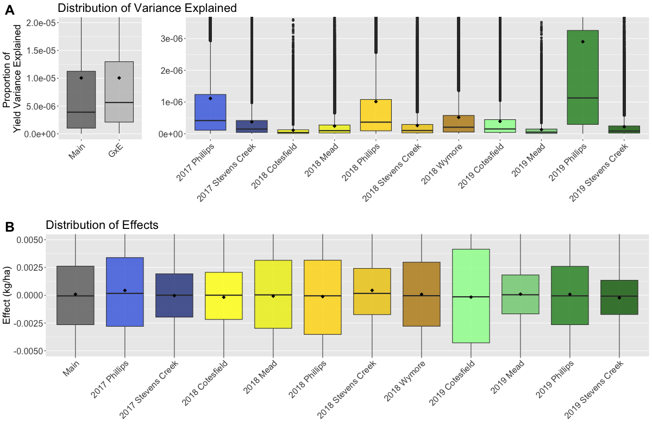

Supplementary Figure 1: A) The distribution of proportion of variance explained by GxE effects per window is skewed slightly higher than main effects. This is made up of a variety of per environment variance distributions B) The distribution of per window effect sizes is varied among environments.

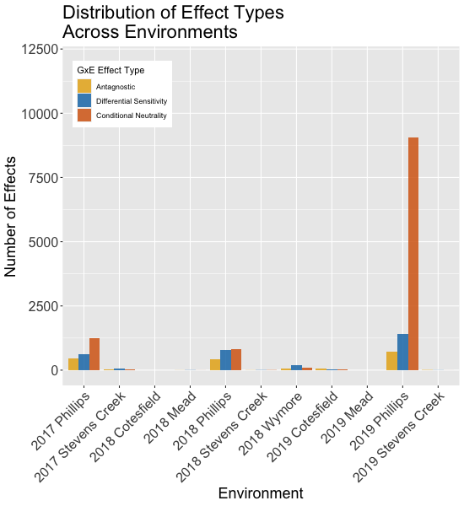

Supplementary Figure 2: A) The overwhelming majority of GxE interactions occur in the 2019 Phillips location.

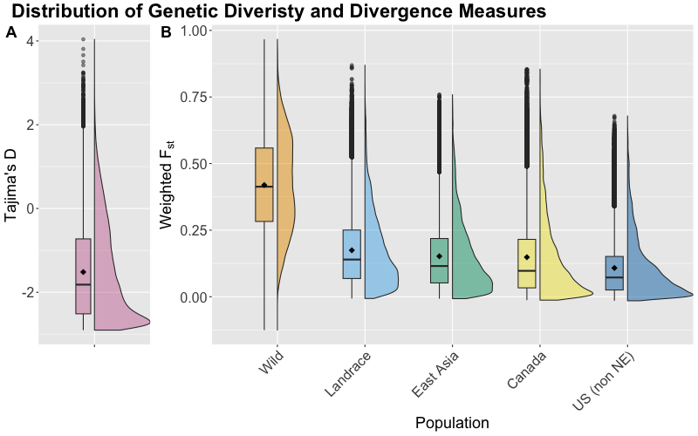
Supplementary Figure 3: A) The distribution of per window Tajima’s D values is skewed towards the negative. B) The distribution of per window weighted pairwise F_{st} values is skewed continuously lower as the comparison is made to theoretically more related material.

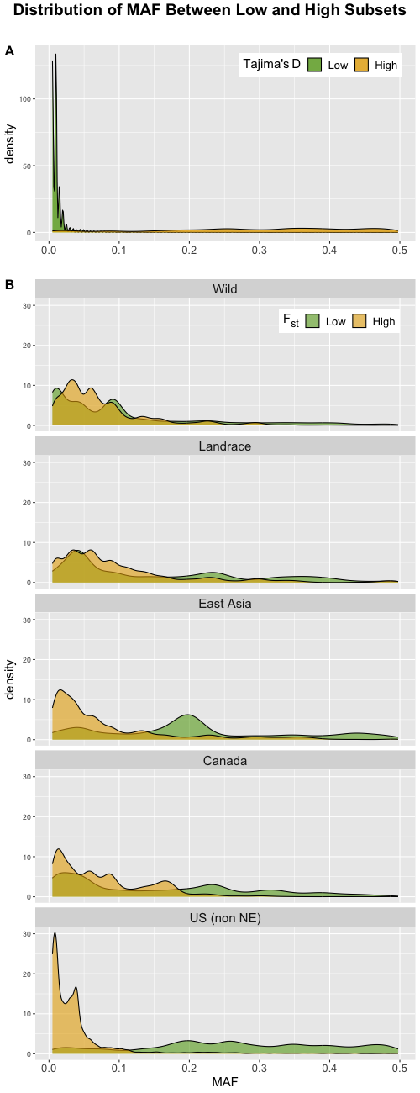

Supplementary Figure 4: The minor allele frequency distribution of markers in windows for the top and bottom 5% of Tajima’s D (A) and pairwise weighted F_{st} values (B) shows clear differences, which is an important confounding factor to control for in this type of analysis.

