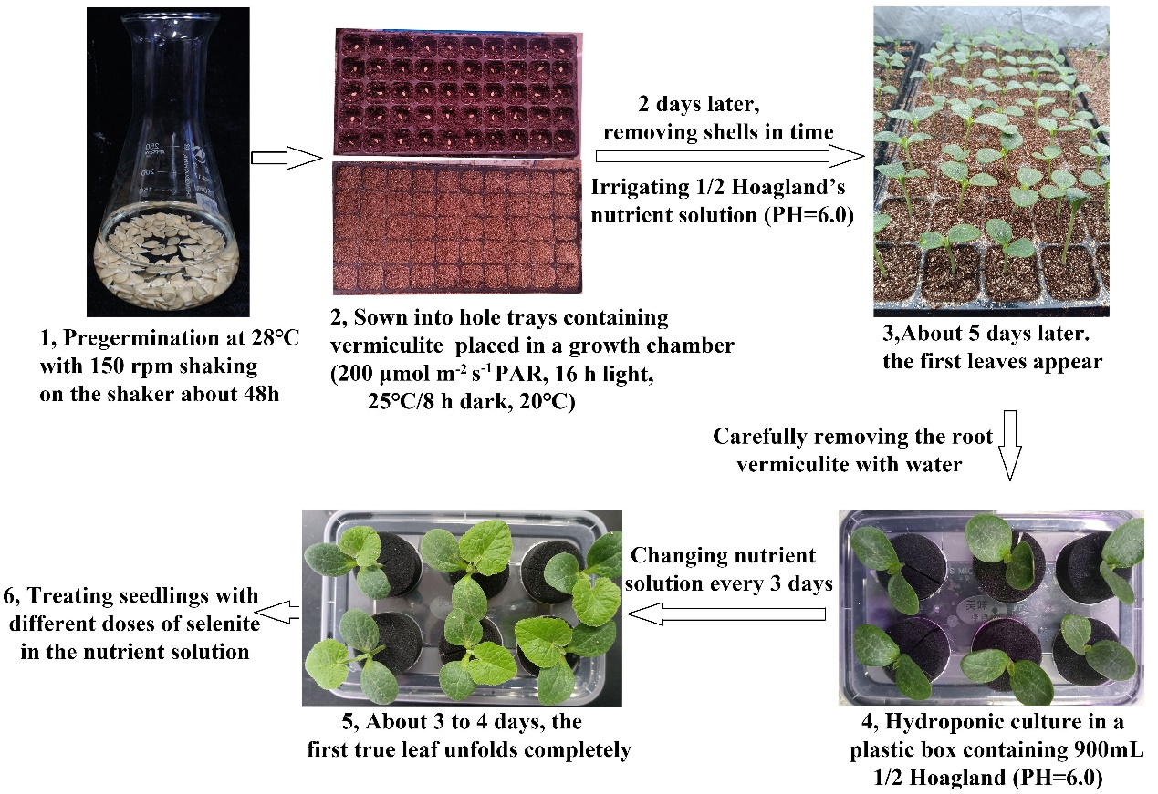
Figure S1 Flow chart of C. moschata seedling culture in this study.

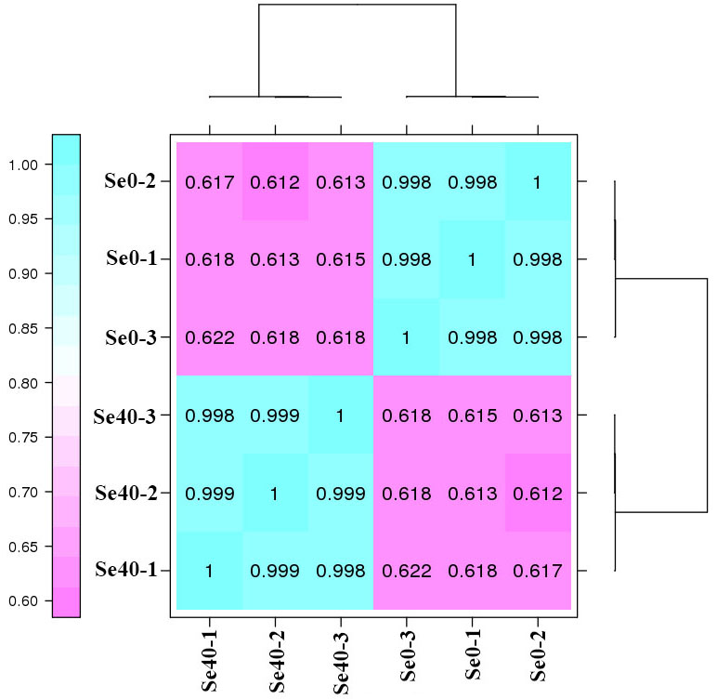
Figure S2 The Pearson's correlation coefficients (R) between the three biological replicates of each sample.
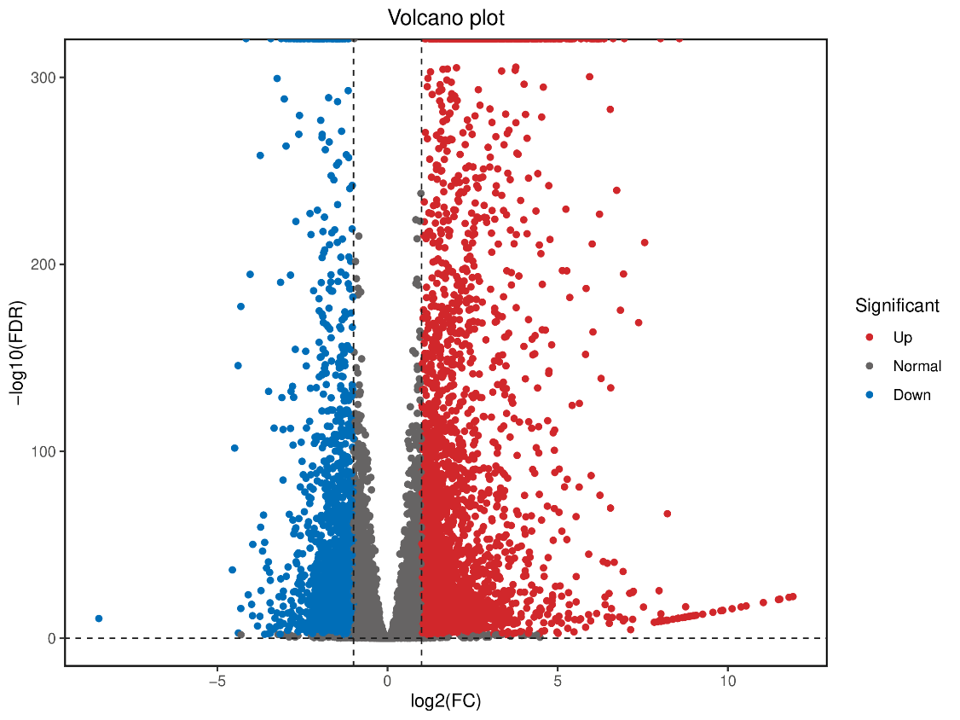
Figure S3 Volcano plot of differentially expressed genes (DEGs) in Se0 vs Se40. Horizontal axis means Log₂(fold change) value, and vertical axis means the level of significance with false discovery rate (FDR). |log2 FC (fold change)|≥1 and FDR <0.01 were used as thresholds for significantly up- or down-regulated genes.
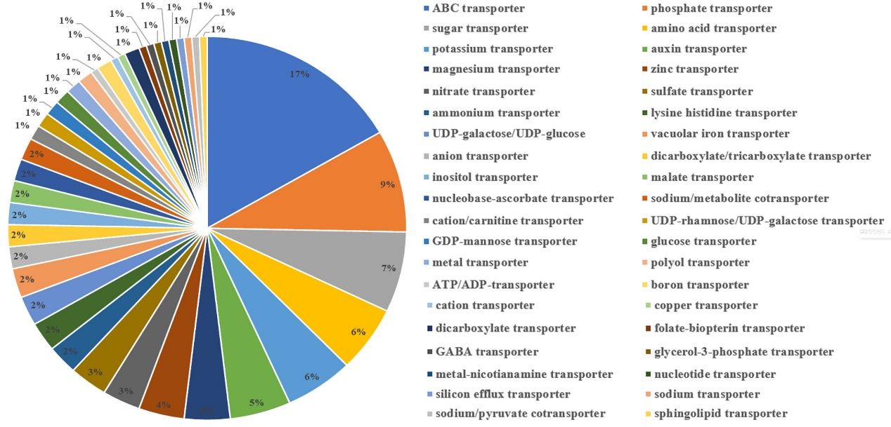
Figure S4 Pie Graph showing the DEGs in Se0 vs Se40 annotated as different transporters in NR database. The proportions of different transporters were presented.

