SUPPLEMENTARY FILE

Evaluation of ChatGPT and Gemini Large Language Models for Pharmacometrics with NONMEM

Euibeom Shin, Yifan Yu, Robert R. Bies, and Murali Ramanathan

Department of Pharmaceutical Sciences, University at Buffalo, The State University of New York, Buffalo, NY, USA.

CORRESPONDING AUTHOR: Murali Ramanathan
355 Pharmacy, Department of Pharmaceutical Sciences
State University of New York, Buffalo, Buffalo, NY 14214-8033.
(716)-645-4846 and FAX 716-829-6569. E-mail Murali@Buffalo.Edu
Running Head: ChatGPT for Pharmacometrics with NONMEM
Keywords: Pharmacometrics, ChatGPT, Pharmacokinetics, Drug Development, Artificial intelligence, Generative AI, Modeling, Nonlinear mixed effects, NONMEM

CONTROL STREAM REVIEW
The NONMEM control stream produced by ChatGPT was assessed with a stepwise approach. A NONMEM readable dataset was simulated using R (4.3.2) and mrgsolve package (1.3.0). After simulation, we executed the ChatGPT generated NONMEM control stream using NONMEM (7.5.0) and Perl-Speaks-NONMEM (PsN, 4.9.0).
We interactively refined the control stream, addressing any error messages encountered during NONMEM execution sequentially, until the model executed successfully without error messages.
CASE 3A
NONMEM Dataset Simulation
A data set was simulated for a study where a single dose (100 mg) was given orally to 20 subjects. A one-compartment model with first-order absorption was used to simulate data. The parameter values were TVCL = 20 L/h, TVV = 50 L, TVKA = 1 h⁻¹, ${ω^{2}}_{CL}$ = 0.01, ${ω^{2}}_{V}$ = 0.04, ${ω^{2}}_{KA}$ = 0.04, ${σ^{2}}_{PROP}$ = 0.04, ${σ^{2}}_{ADD}$ = 100 ng/mL. The sampling times were 0.5, 1, 2, 4, 6, 8, 12, and 24 hours after dose.
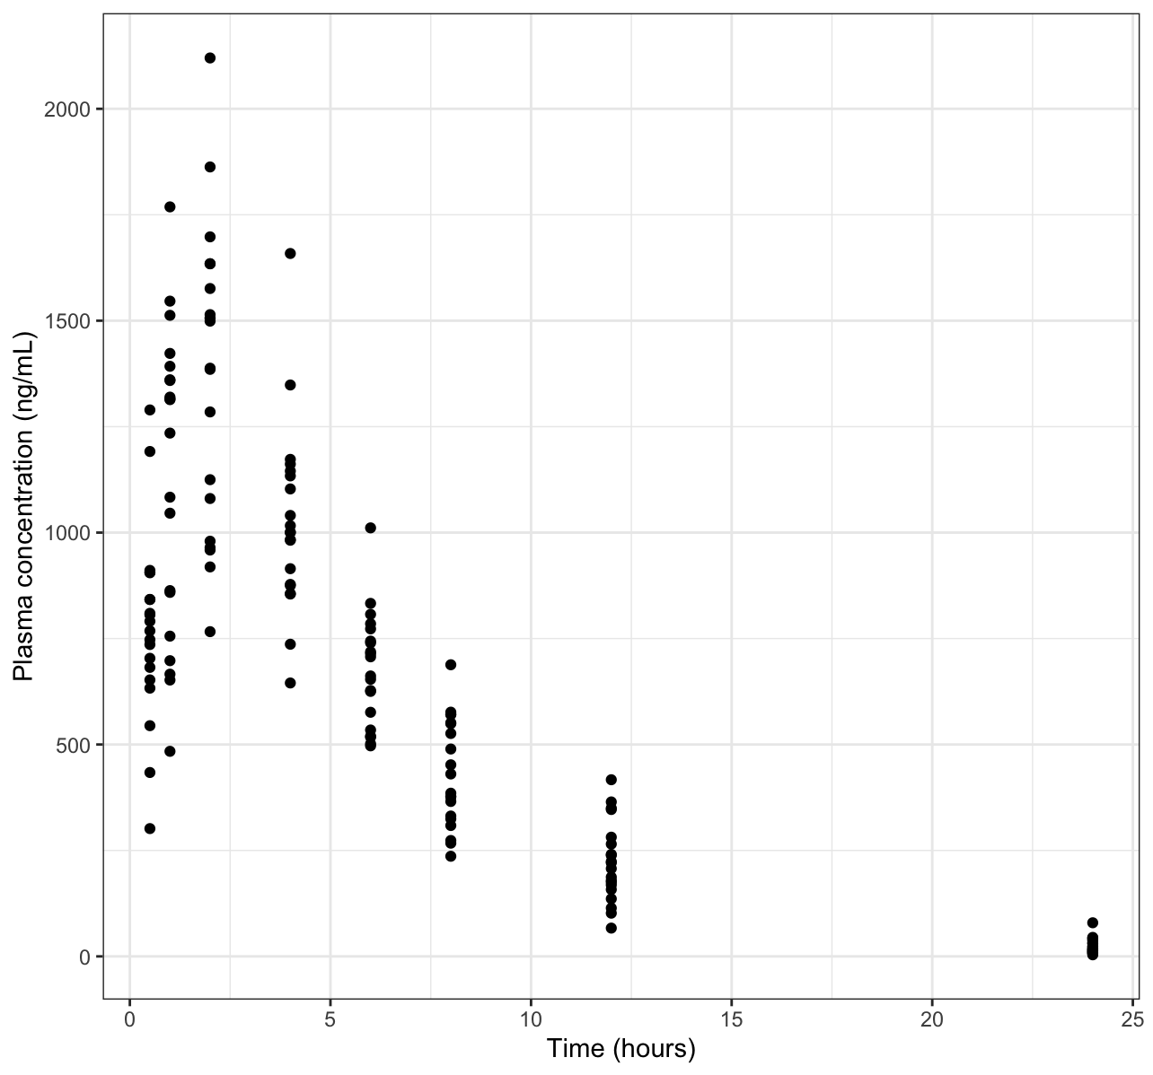
ChatGPT-Generated NM Control Stream Corrections
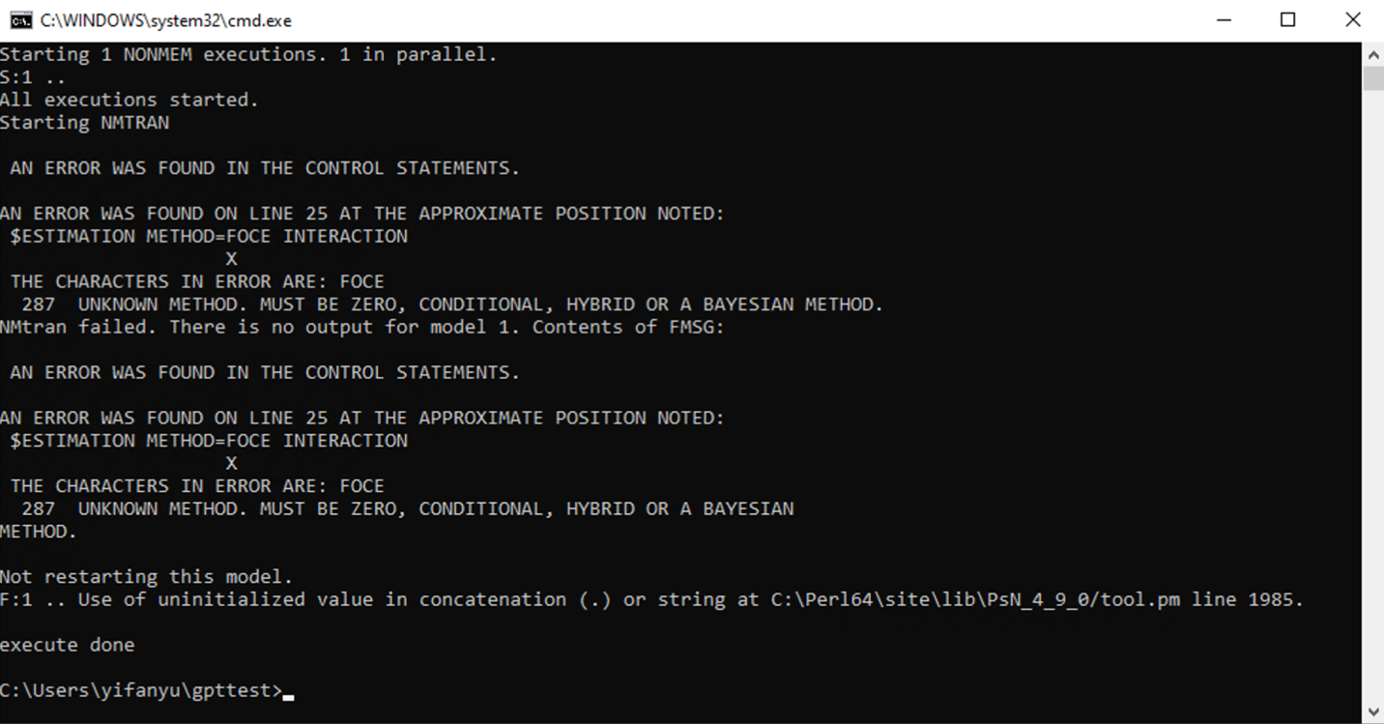
This run was terminated due to an error in $\$ESTIMATION$. Since $METHOD=FOCE$ is an unknown method name in NONMEM, it was corrected to $METHOD=1$.
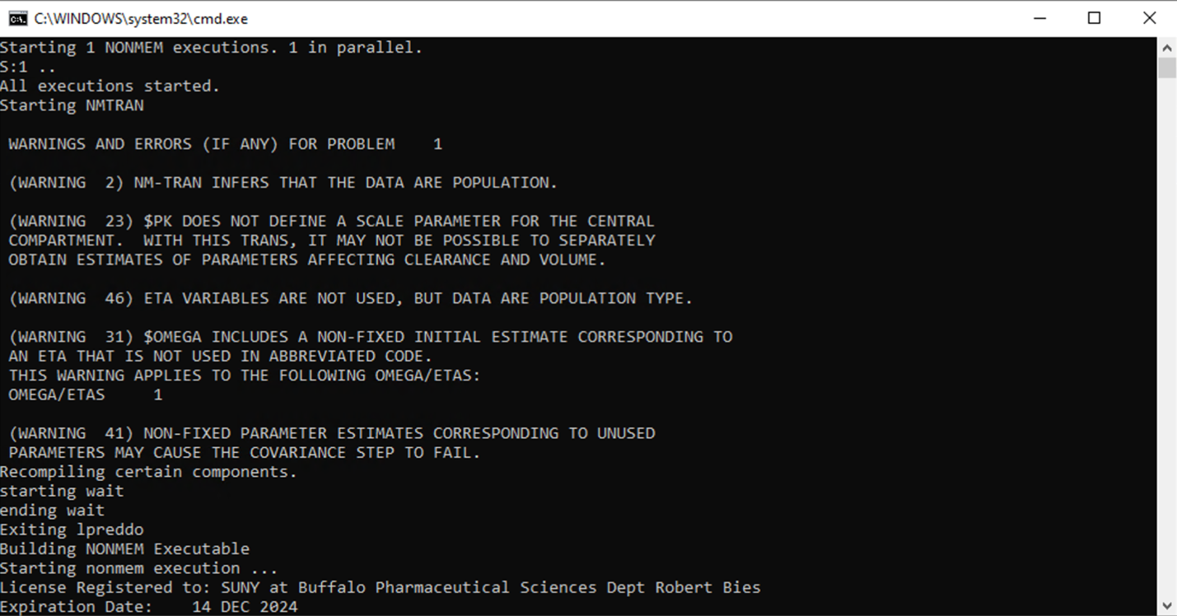
After the correction, no error was flagged. However, four warning messages occurred.
NONMEM did not define the scale parameters for the central compartment in $\$PK$ (warning 23). To address this issue, $S2=V$ was introduced in $\$PK$.
Several warnings were caused (warning 31, 41, and 46) because initial estimate was provided for the $OMEGA$ matrix in $\$OMEGA$ but $ETA$ parameters were not included in $\$PK$. To address this, an exponential between subject variability on $CL$ was added.

After fixing the issues mentioned above, the model executed successfully without any error or warning messages. However, the error model in $\$ERROR$ remained incorrect.
Gemini-Generated NM Control Stream Corrections
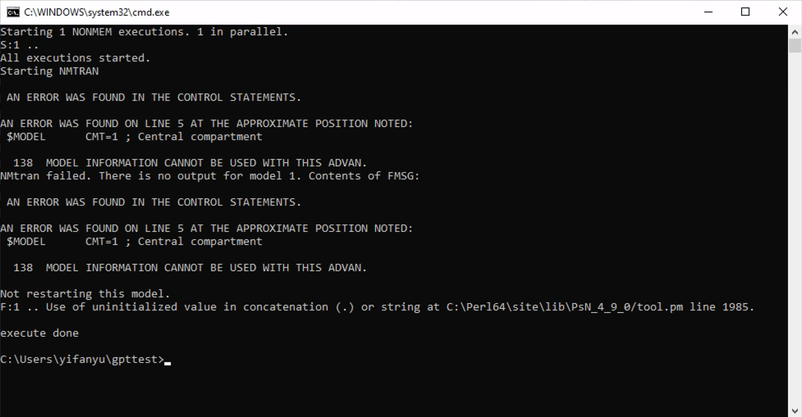
The first run was terminated due to a redundant $MODEL record, which was subsequently removed to correct this error.
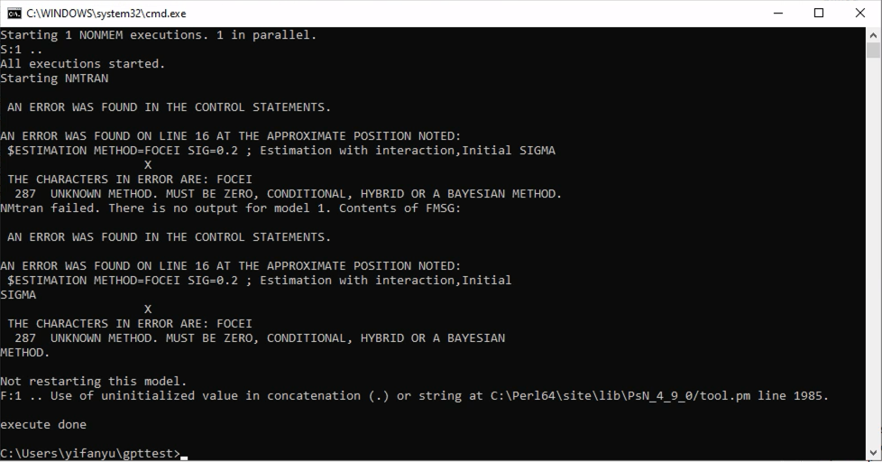
The second run was terminated due to the error in $ESTIMATION. It was corrected to $METHOD=1 INTERACTION$.
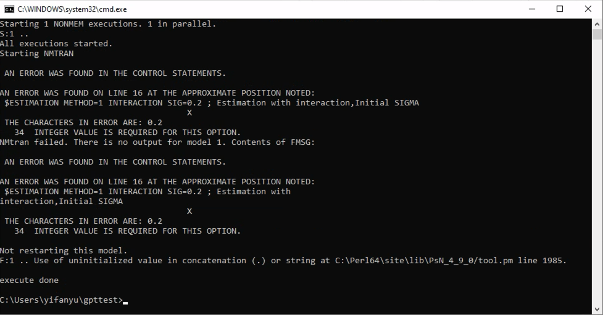
During the third run, an error occurred in $\$ESTIMATION$, where a non-integer value was used on SIG, which represents the number of significant digits required in the final parameter estimates. This issue was addressed with setting $SIG=3$.
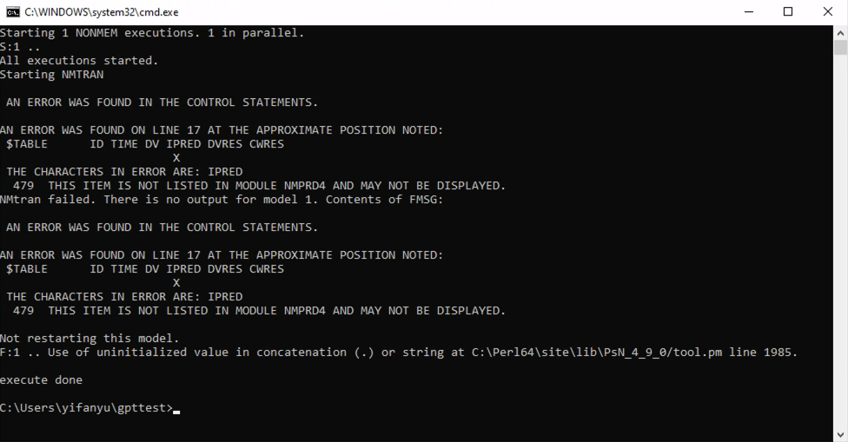
In the fourth run, an error was found in $TABLE, as an undefined variable $IPRED$ was listed as an output. To address this issue, $IPRED=F$ was included in $\$ERROR$.
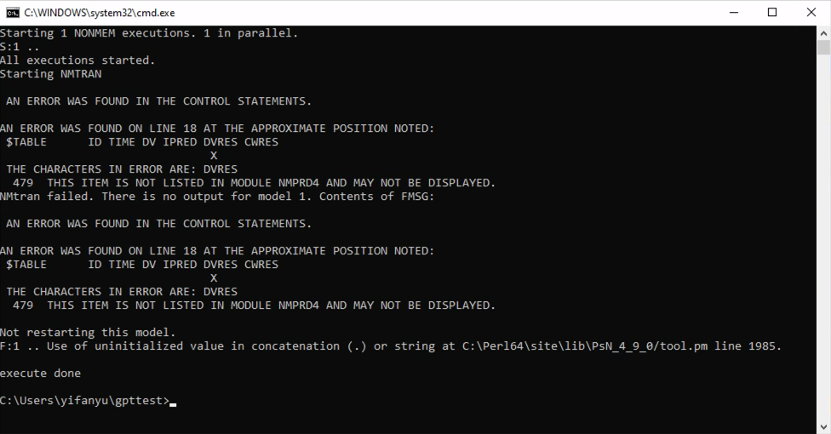
During the fifth run, an error was found in $TABLE again, where an undefined variable $DVRES$ was listed as an output. It was corrected to $RES$, a pre-defined variable in NONMEM.
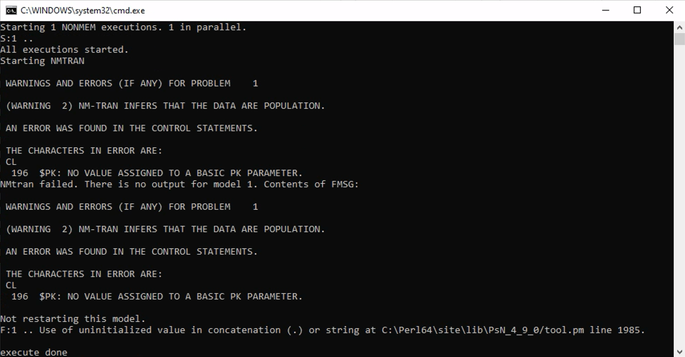
The sixth run was terminated due to the incorrect basic PK parameter names in $\$PK$ block. To address this, $TVCL$, $TVV$, and $TVKA$ were corrected to $CL$, $V$, and $KA$.
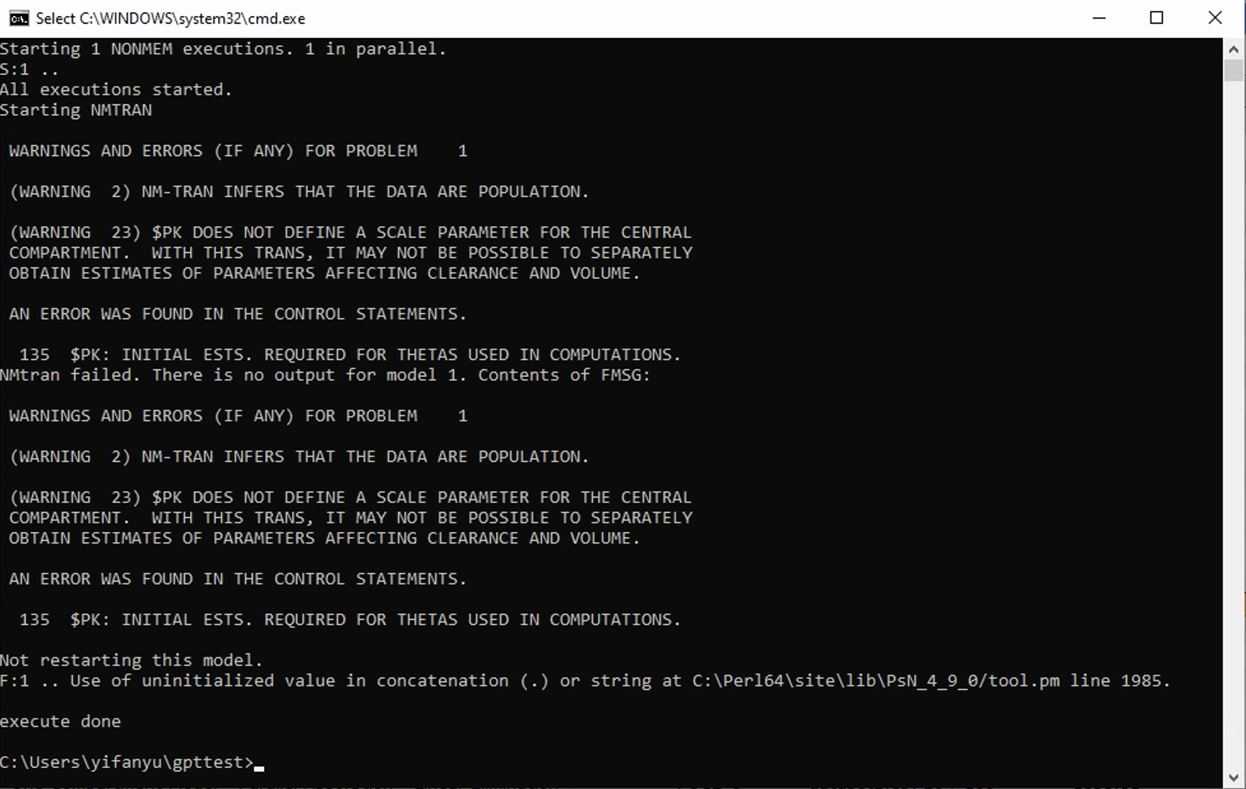
The seventh run was terminated due to the absence of $\$THETA$, $\$OMEGA$, and $\$SIGMA$ blocks. Additionally, a warning occurred due to the missing of scale factor in $\$PK$. $\$THETA$, $\$OMEGA$, and a $\$SIGMA$ blocks with initial estimates for fixed and random effects parameters were included. To address the warning, we also included $S2=V$ in $\$PK$.
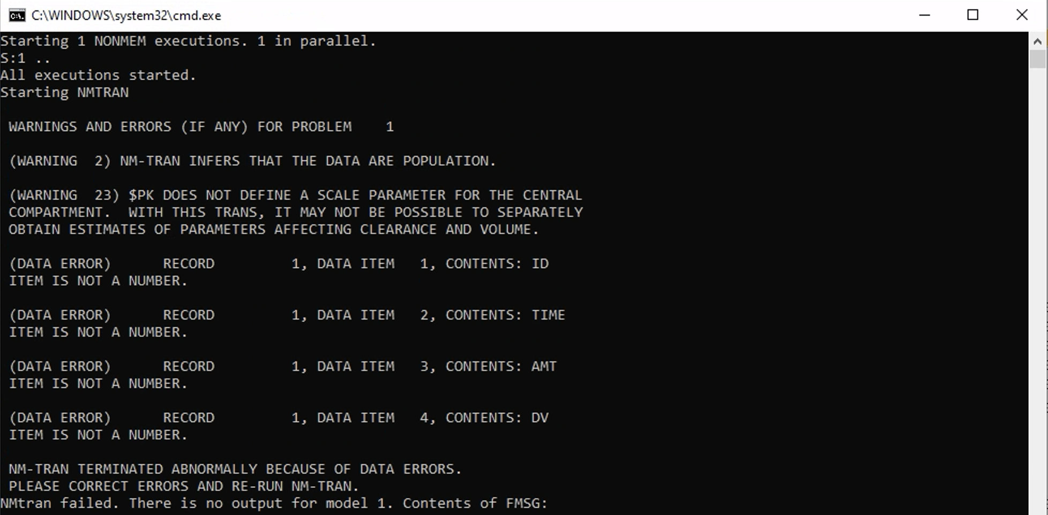
The eighth run was terminated due to the incorrect exclusion setting. To fix this issue, IGNORE=@ was added to $DATA to drop any data record having an alphabetic character as its first non-blank character.
After the correction of the above errors, the model ran successfully without any error or warnings.
CASE 3B
NONMEM Dataset Simulation:
A NONMEM readable dataset (n = 20) was simulated for a study where a single dose (100 mg) was administered to 20 subjects. The simulation utilized a one compartment model with two parallel first-order absorptions. In this simulation, 70% of administered dose was absorbed via a faster pathway while the remaining 30% was absorbed through a slower pathway. The parameter values were $TVCL = 20 L/h$, $TVV = 70 L$, $TVKA1 = 1 h^{-1}$, $TVKA2 = 0.5 h^{-1}$, F1=0.7, ${ω^{2}}_{CL}$ = 0.01, ${ω^{2}}_{V}$ = 0.01, ${ω^{2}}_{KA1}$ = 0.01, ${ω^{2}}_{KA2}$ = 0.01, ${σ^{2}}_{PROP}$ = 0.04, ${σ^{2}}_{ADD}$ = 100 ng/mL. The sampling times were 0.5, 1, 2, 4, 6, 8, 12, and 24 hours after dose.
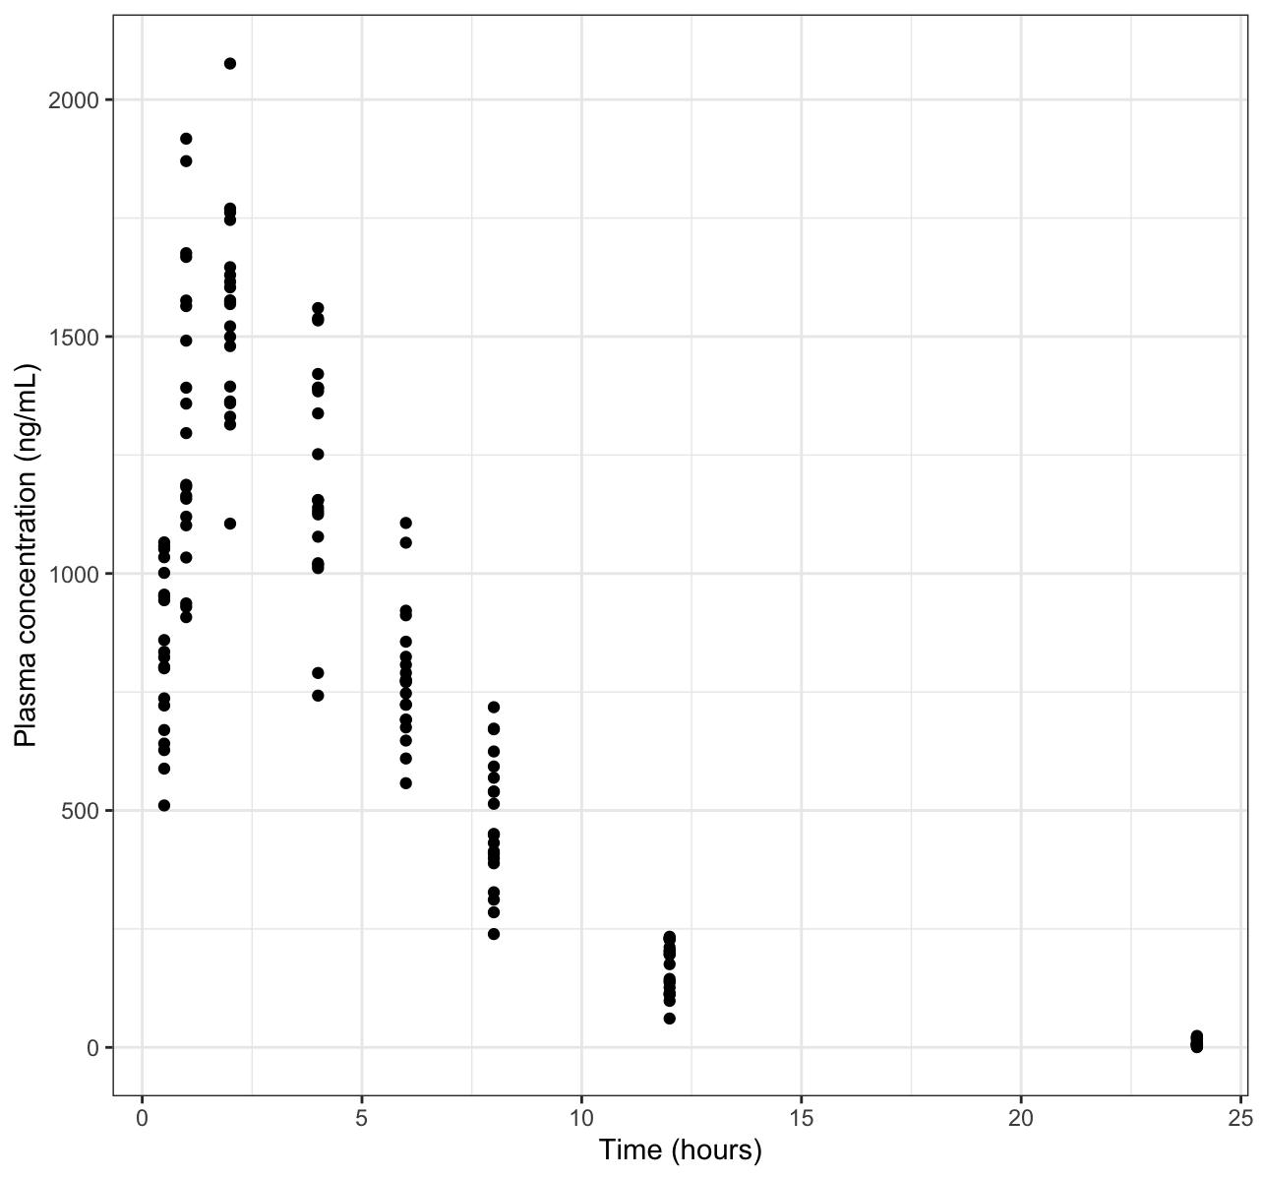
ChatGPT-Generated NM Control Stream Corrections
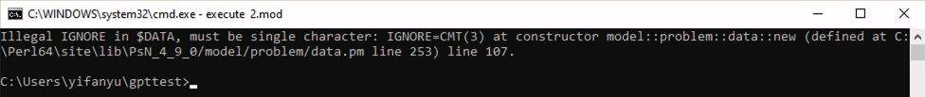
The initial run was terminated due to the incorrect data exclusion. To fix this issue, $IGNORE=@$ was added to $\$DATA$ to drop any data record having an alphabetic character as its first non-blank character.
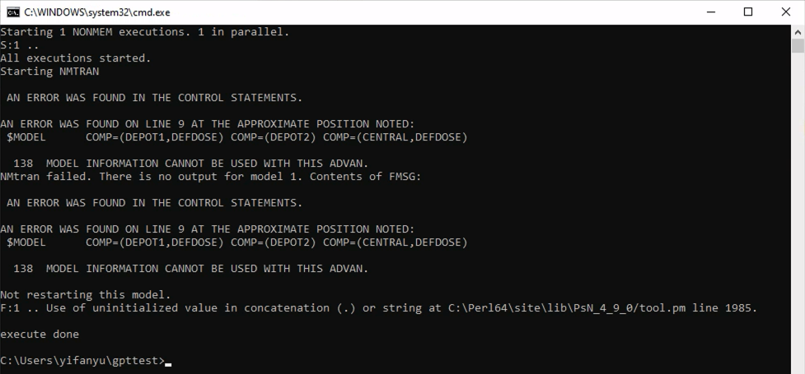
In the second run, an error occurred in $\$SUBROUTINE$. Because ChatGPT used $ADVAN2$ $TRANS2$, the information provided in $\$MODEL$ can not be used correctly. This issue was addressed with the correction $ADVAN6 TOL=5$.
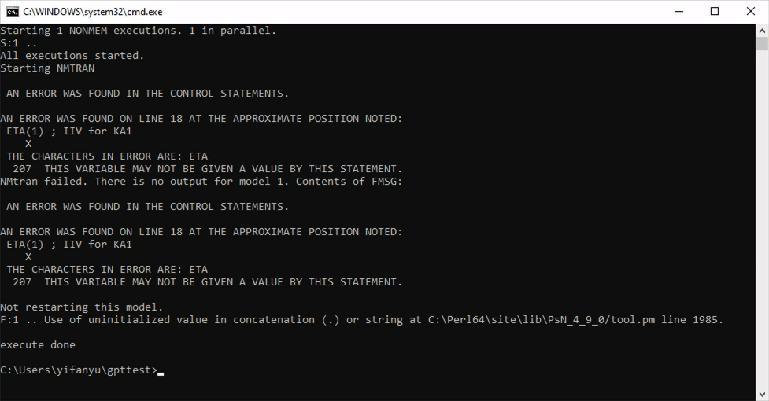
In the third execution, an error occurred due to unnecessary code lines for inter-individual variability in $\$PK$. These lines were removed.
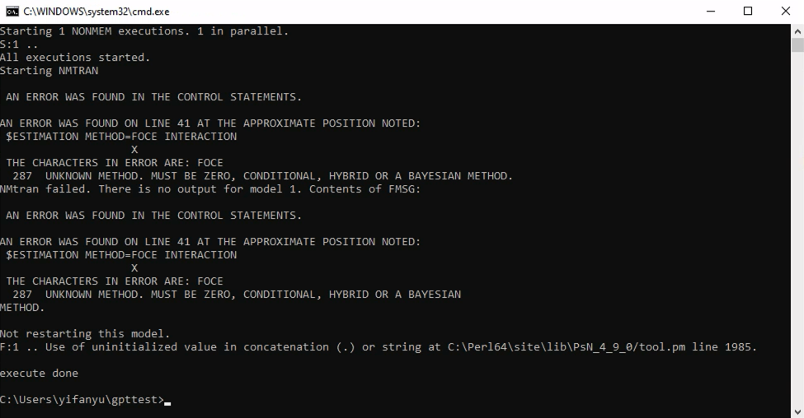
In the fourth run, an error was reported due to $METHOD=FOCE$ for first-order conditional estimation method in $\$ESTIMATION$. This was corrected to $METHOD=1$.
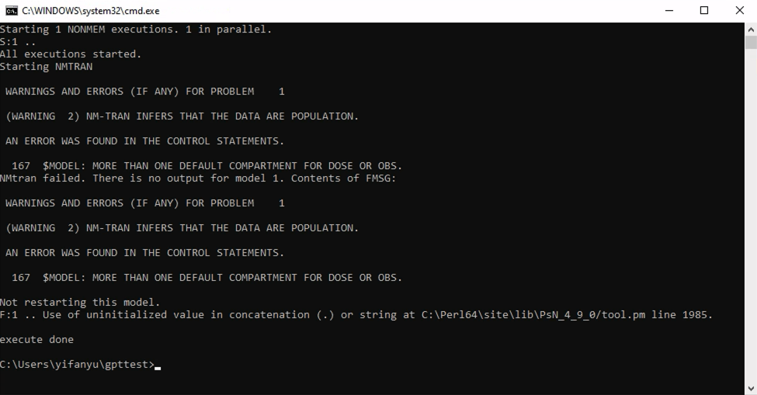
The fifth execution terminated due to the definition of more than one default compartment for dose in $\$MODEL$. To address this, the central compartment was set to $DEFOBS$ (default compartment for observation).
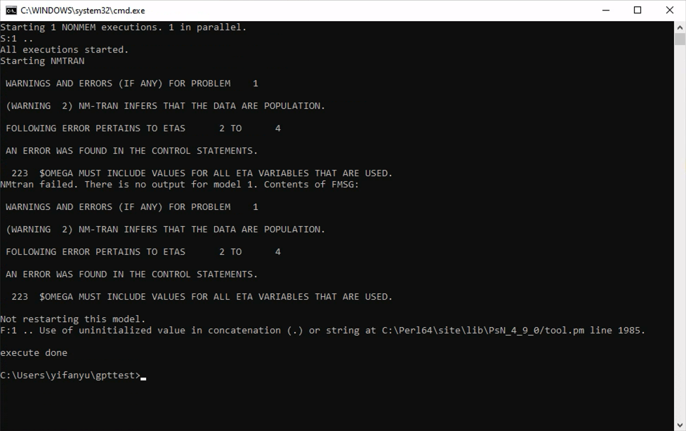
The sixth run terminated because the control stream included between subject variability on four PK parameters in $\$PK$, while only provided a single initial estimate in the $\$OMEGA$ block. To solve this, three more initial estimates for the $OMEGA$ matrix were included.
After the correction of the above errors, the model ran successfully without any error or warnings. However, the control stream did not correctly define the fraction of the dose absorbed through each pathway, and the error model remained incorrect.
Gemini-Generated NM Control Stream Corrections
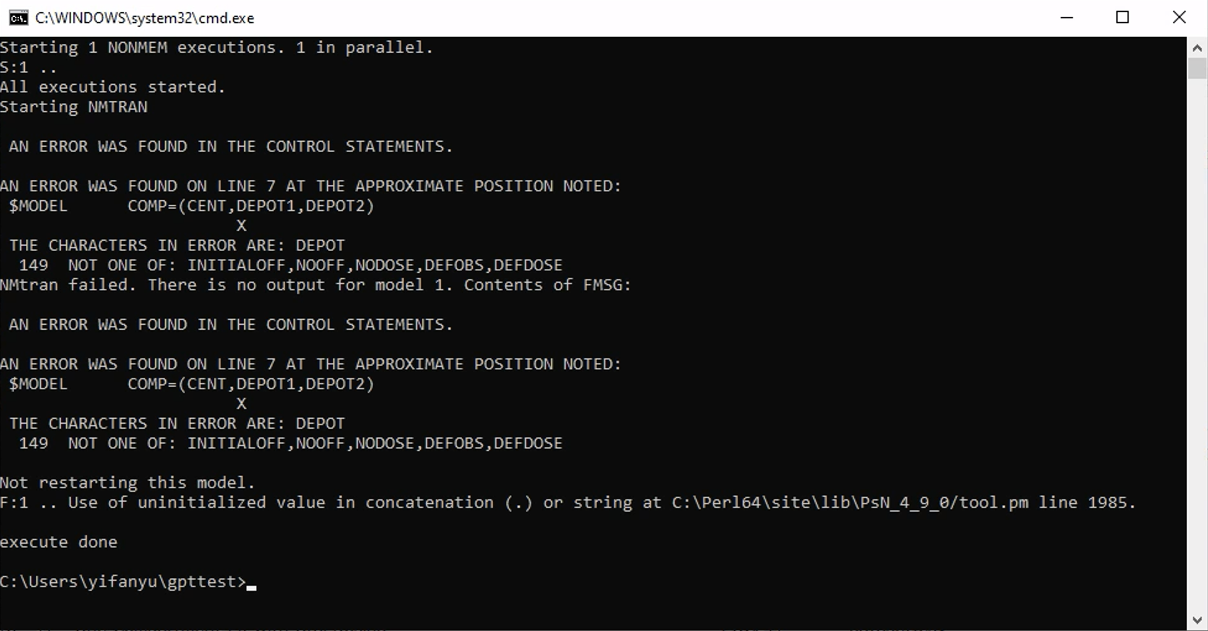
The first run terminated due to the incorrected $\$MODEL$ format. The $\$MODEL$ block was corrected to $COMP=(DEPOT1) COMP=(DEPOT2) COMP=(CENT)$.
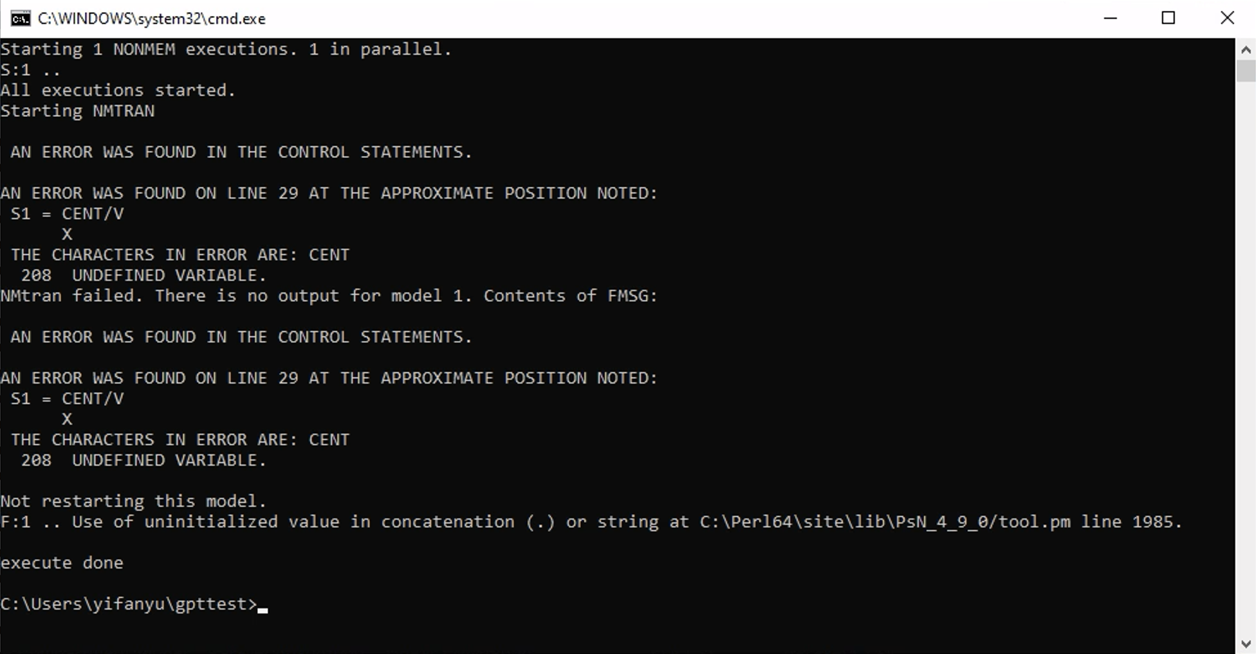
In the second run, an error occurred in $\$PK$, as an incorrect scale factor was used. The scale factor was corrected to $S3=V$.
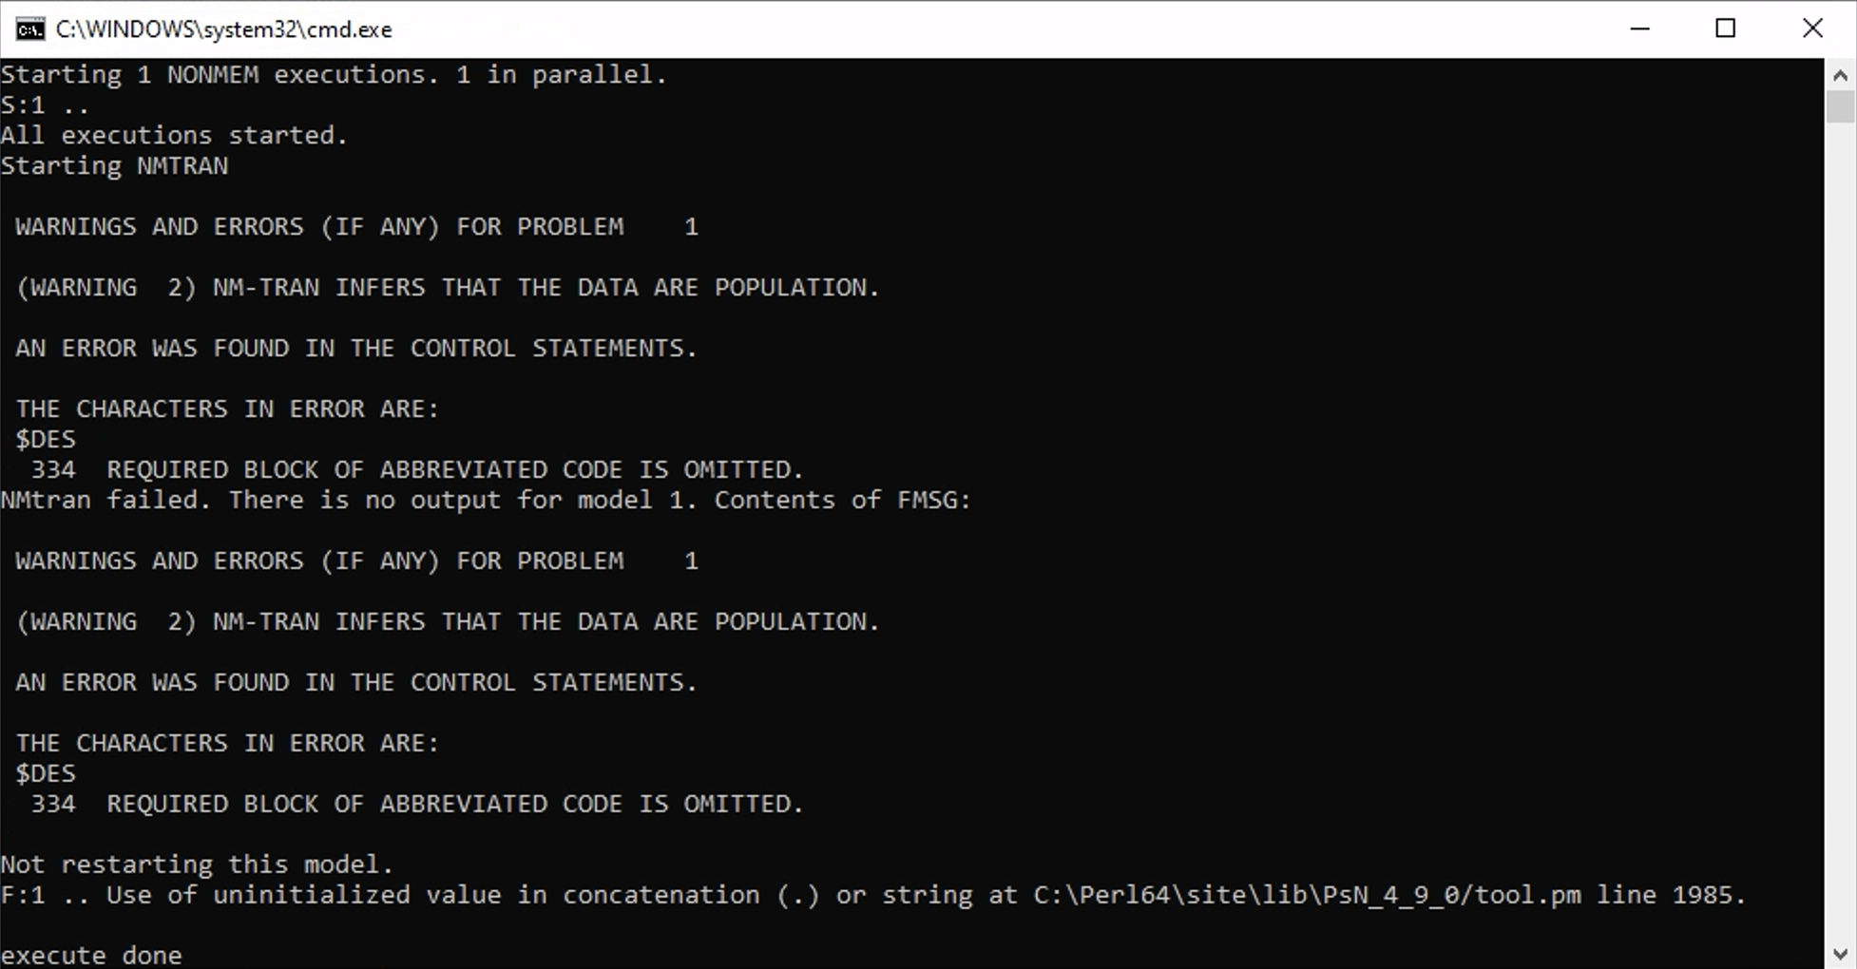
The third run was terminated due to the omitted $\$DES$ block. Correct differential equations were supplied to address this issue.
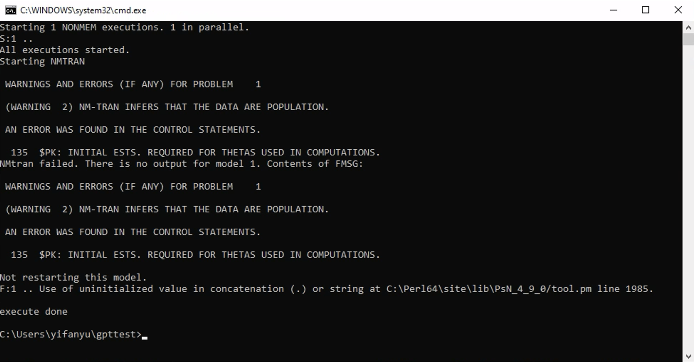
The fourth run was terminated due to the absence of the $THETA block and the lack of initial estimates provided in the $OMEGA block. To correct this, we introduced a $THETA block containing initial estimates for $V$ and $CL$, along with a $\$OMEGA$ block containing initial estimates for their between-subject variability. Corresponding updates were made to $PK.
After the correction of the above errors, the model ran successfully without any error or warnings.

