Figures (supplementary)
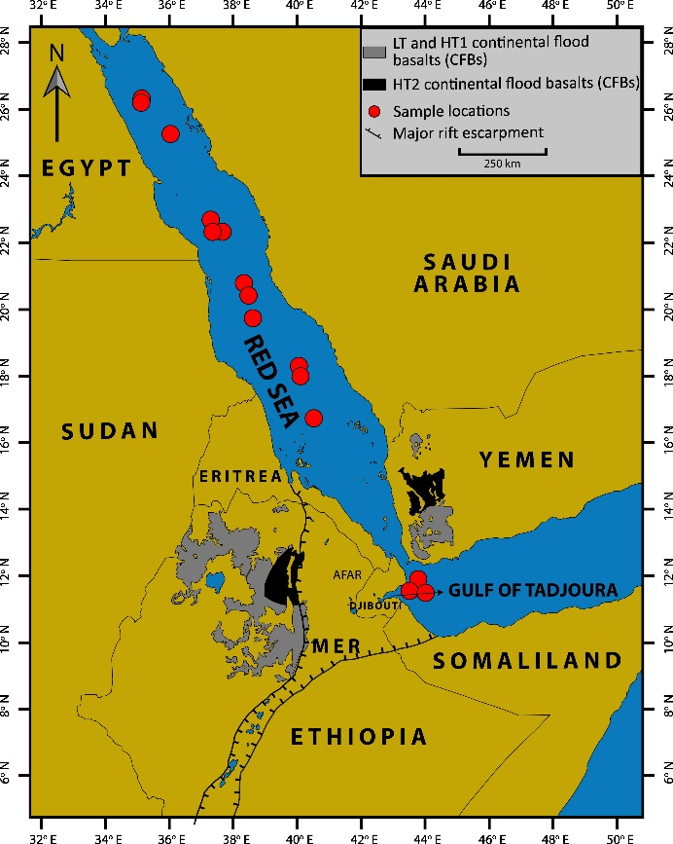
Figure S1: Map showing the location of basalt glasses from the Red Sea and Gulf of Tadjoura used in this study (red circles). The ~30 Ma Afar flood basalts in Ethiopia and Yemen are also shown in the map, including the distribution of the high ³He/⁴He HT2 picrites. MER: Main Ethiopian Rift. The diagram is modified from Beccaluva et al. (2011).

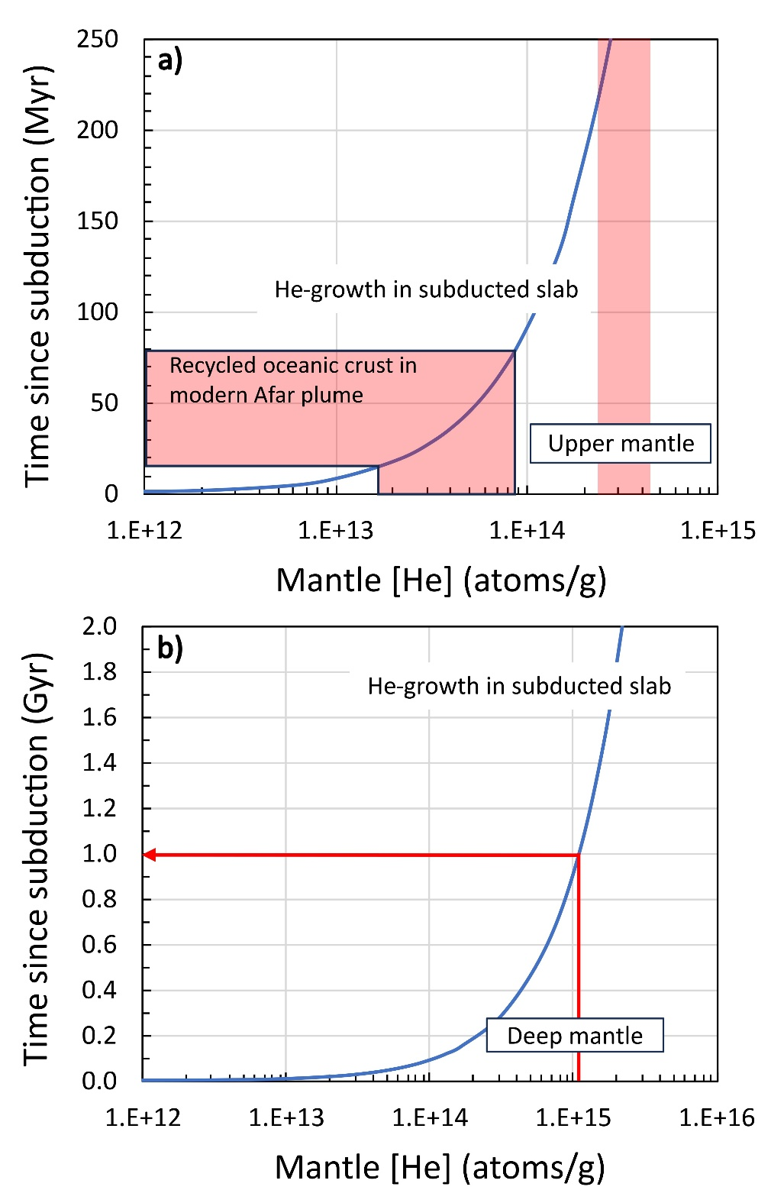
Figure S2: (a) Radiogenic He ingrowth into a subducted slab with time is shown in the blue curve, using U and Th concentrations from Staudigel et al. (1996). The He in the recycled oceanic crust incorporated into the Afar has been generated in less than 100 Myr. Panel (b) shows that it takes ~1 Gyr to grow in radiogenic He in subducted oceanic crust to match the concentration in the deep mantle (Marty et al., 1996; Porcelli & Wasserburg, 1995).

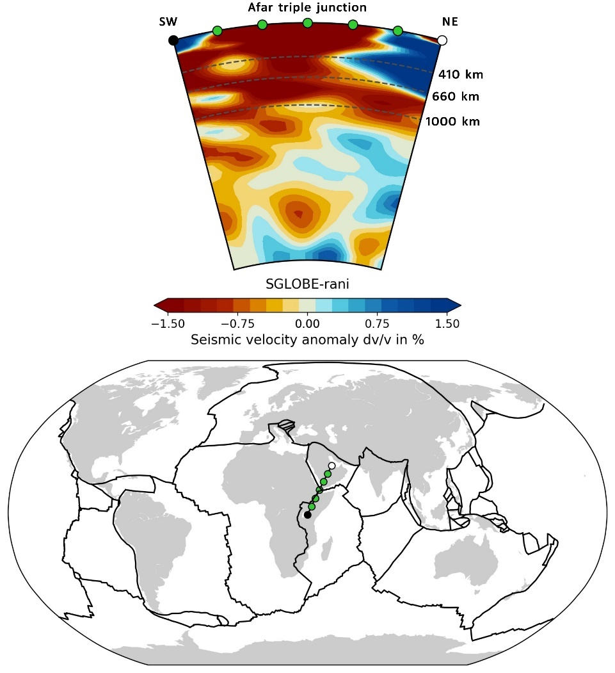
Figure S3: Seismic profile of a cross-section along EAR to Zagros Mountains. The image is created using the Submachine portal website (Hosseini et al., 2023). Low-velocity zones shown as red represent hot Afar plume upwelling, whereas high-velocity zones illustrated by blue colour in north-east of Afar plume represent cold subducted slabs.

