Integrative analyses of DNA methylase expression and related immune landscape in Prostate Cancer
Jialong Zhang^{1,3} Hongzhi Wang^{1,3} Cong Huang^{1,3} Ying Zhang^{2,4} Chaozhao Liang^{1, 5*}
¹ Department of Urology, First Affiliated Hospital of Anhui Medical University, Institute of Urology, Anhui Medical University, Anhui Province Key Laboratory of Genitourinary Diseases, Hefei,230022, China,
² Department of pathology, First Affiliated Hospital of Anhui Medical University, Hefei 230022.
³These authors contributed equally: Jialong Zhang, Hongzhi Wang, Cong Huang.
⁴ email: zy1122812@163.com.
⁵* email: liang_chaozhao@ahmu.edu.cn.
SUPPLEMENTARY METHODS
Data Collection
RNA-sequencing transcriptomic data and corresponding clinical information for patients with PCa were obtained from TCGA (https://portal.gdc.cancer.gov/; until July 23, 2023). A total of 502 PCa cases and 52 normal adjacent tumor tissues were included for further analysis. Eight currently known DNA methylase, including DNMT1, TRDMT1, DNMT3A, DNMT3B, DNMT3L, TET1, TET2, TET3, were used for analysis¹⁹. Of these, the first five genes belong to DNA methyltransferase and the last three belong to DNA demethylase. The expression data of these 8 genes were extracted from the PCa cohort of the TCGA database. For external validation, we used an independent cohort (GSE26126) containing 95 prostate tumors and 86 healthy prostate tissue samples with corresponding gene expression data and the recurrence information, which were obtained from the GEO (http://www.ncbi.nlm.nih.gov/geo). Genetic mutation data were obtained from cbioportal ( https://www.cbioportal.org/).
Analysis of Differentially-Expressed Genes
The results were obtained by comparing 52 normal and 502 PCa tissues and the filter criteria was |log Foldchange (FC) | > 1 and false discovery rate (FDR) < 0.05.
Cluster Analysis
To assess the link between genes expression and PCa prognosis, PCa cohort was clustered into two different subgroups using the “ConsensusClusterPlus” R package. T-Distributed Stochastic Neighbor Embedding (t-SNE) was then carried out using the “ggplot2” and “limma” package to verify the results of the classification. A survival curve was plotted to compare survival between subgroups based on the Kaplan– Meier analysis log-rank test. The difference in clinical parameters between the two clusters was determined using the Chi-square test. In order to conduct functional annotation of the genes with different expression in two subgroups, we performed Gene ontology (GO) and Kyoto Encyclopedia of Genes and Genomes (KEGG) analyses.
Immune Landscape Analysis
Four immune-related algorithms were used to analyze the immune landscape between the high- and low-risk groups. The activity of immune cell or immune function, immune pathway of each sample was calculated by single sample GSEA (ssGSEA). ESTIMATE algorithm was used to calculate the immune score, stromal score, estimate score and tumour purity according to the proportion of immune cells and stromal cells. Prediction of the composition of infiltrating immune cells in each tumour sample was derived from the TIMER database and CIBERSORT algorithm. We also compared the expression of MHC molecules based on the cluster analysis and the signature.
Gene Mutation Analysis
Based on the somatic mutation data from a public database, we conducted gene mutation through “maftools” package. We then calculated tumor mutation burden (TMB) of each patient and compared TMB between the high- and low-risk groups. Survival analysis was also performed according to TMB score. At the same time, somatic mutations of the selected genes in the signature were displayed through the cBioPortal database.
Chemotherapy Response and Small Molecule Drugs
We predicted chemotherapy response of the chemotherapy drugs for PCa patients through the Genomics of Drug Sensitivity in Cancer (GDSC) database. The half maximal inhibitory concentration (IC50) was calculated by package “pRRophetic” and used to evaluate the response of patients to chemotherapy drugs. The connectivity map (cMap) database is a bio-application database combining small-molecule drugs, gene expression and disease. Based on the up-regulated and downregulated genes compared between the low- and high-risk groups, we obtained predicting drugs that might induce or reverse tumor biological process. P-value < 0.05 and the enrichment score ranged from -1 to 0 indicated that the potential drug may be the potential new target candidates for PCa patients. Secondly, Cancer Cell Line Encyclopedia (CCLE) project and drug susceptibility results (PRISM and CTRP datasets) were used to predict drug susceptibility results of cancer samples²⁰.
Statistical Analysis
R software (version 4.1.2) was utilized for all statistical analyses, and p < 0.05 was the significance threshold.

SUPPLEMENTARY FIGURES
Supplementary Figure 1. Functional and immune characteristics of different clusters. (A) Function annotation on higher expressed genes in cluster 2 using KEGG pathway. (B) Function annotation on higher expressed genes in cluster 2 using GO terms. (C) Immune and stromal scores use ESTIMATE. Blue represents cluster 1 and red represent cluster 2. (D) The immune infiltration was different in different clusters. Blue represents cluster 1 and orange represent cluster 2. (E) MHC and HLA molecules expression level in different clusters. *p<0.05, **p<0.01, ***p<0.001.
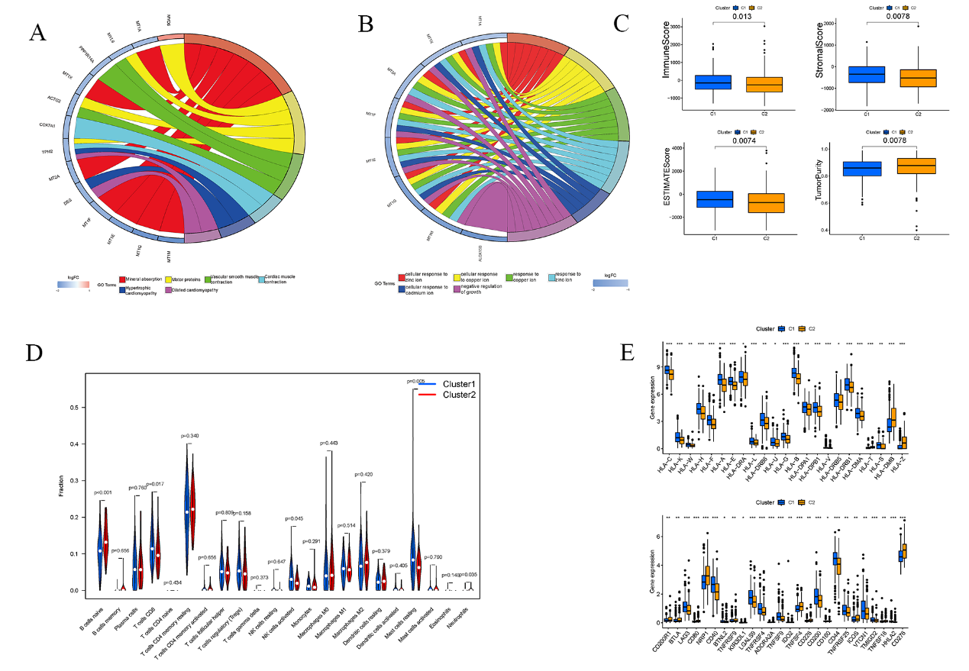
Supplementary Figure 2. Clinical analysis of the model. (A) Heatmap shows the distribution of clinicopathological features and the expression of 3 DNA methylase modification regulators in high- and low-risk groups. (B) Univariate Cox regression analyses of clinicopathological parameters. (C) Multivariate Cox regression analyses of clinicopathological parameters. (D) Association of cluster with high - and low-risk groups and pathology.

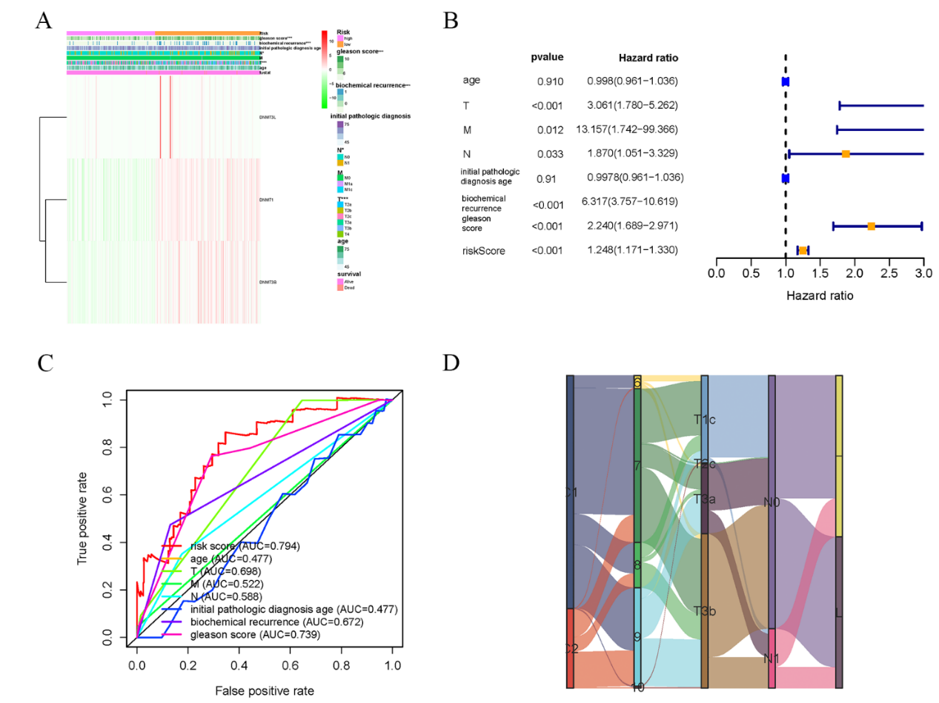
Supplementary Figure 3. The differences in the chemotherapy response of chemotherapy drugs between the high- and low-risk groups(A-B). The results of Spearman’s correlation analysis and differential drug response analysis of 6 CTRP-derived compounds(C). The results of Spearman’s correlation analysis and differential drug response analysis of 3 PRISM-derived compounds(D). Note that lower values on the y-axis of boxplots imply greater drug sensitivity.

