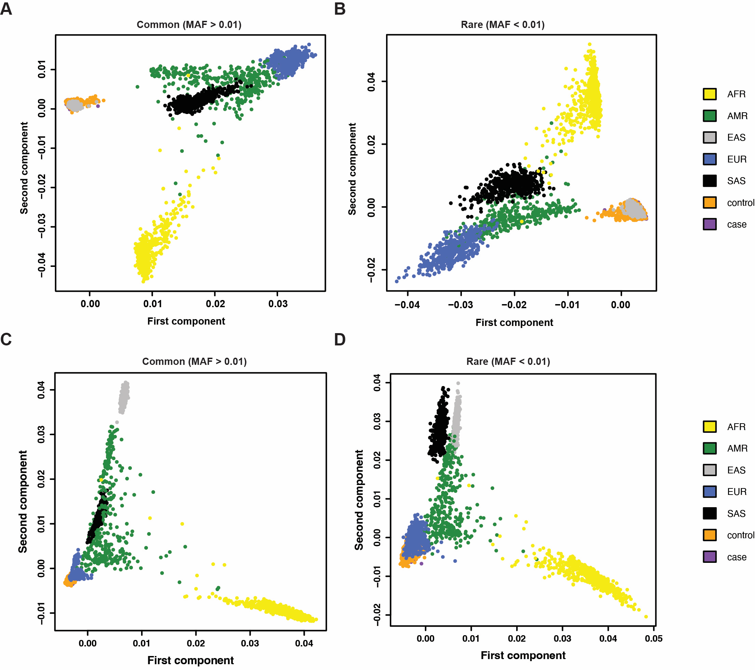
Supplementary Figure 1. Principal Component Analysis plot of individuals compared to 1000 Genomes populations. (A) PCA of MAGIC samples and 1000G populations using common SNPs. (B) PCA of MAGIC samples and 1000G populations using rare SNPs. (C) PCA of UKB samples and 1000G populations using common SNPs. (D) PCA of UKB samples and 1000G populations using rare SNPs. AFR, African; AMR, Ad Mixed American; EAS, East Asian; EUR, European; SAS, South Asian.

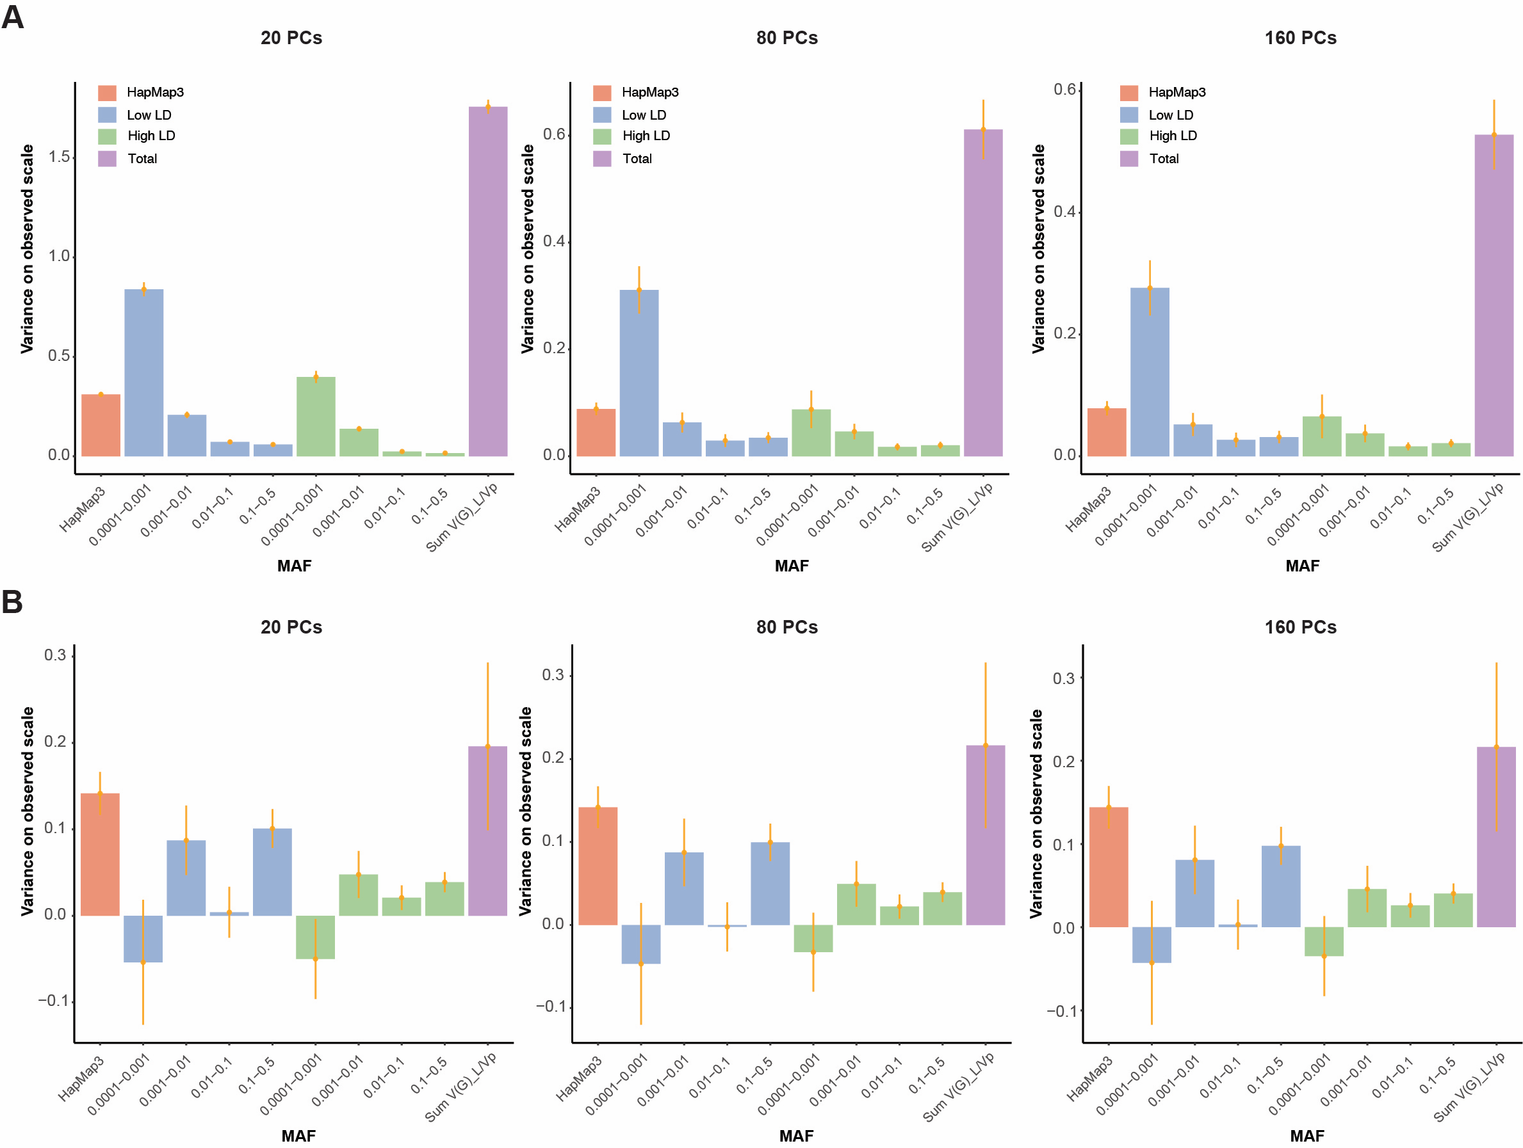
Supplementary Figure 2. GREML-LDMS estimates from WES data stratified in 8 bins (4 MAF bins in 2 LD bins) with correction for 20 PCs (on HM3 SNPs), 80 PCs (10 * 8 bins) or 160 PCs (20 * 8 bins). (A) Estimates heritability for HM in MAGIC. (B) Estimates heritability for HM in UKB. Error bars indicate standard errors (SE).

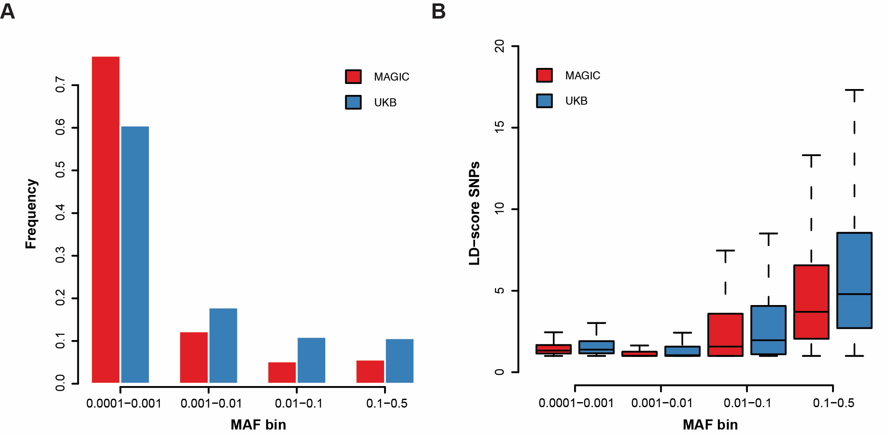
Supplementary Figure 3. (A) Fraction of the variants as a percentage of the total number of variants in the four MAF bin. (B) Boxplot of the distribution of individual SNPs LD values within each bin. Lower and upper hinges correspond to the first and third quartiles and whiskers extend to +/- 1.5 * inter-quartile range.

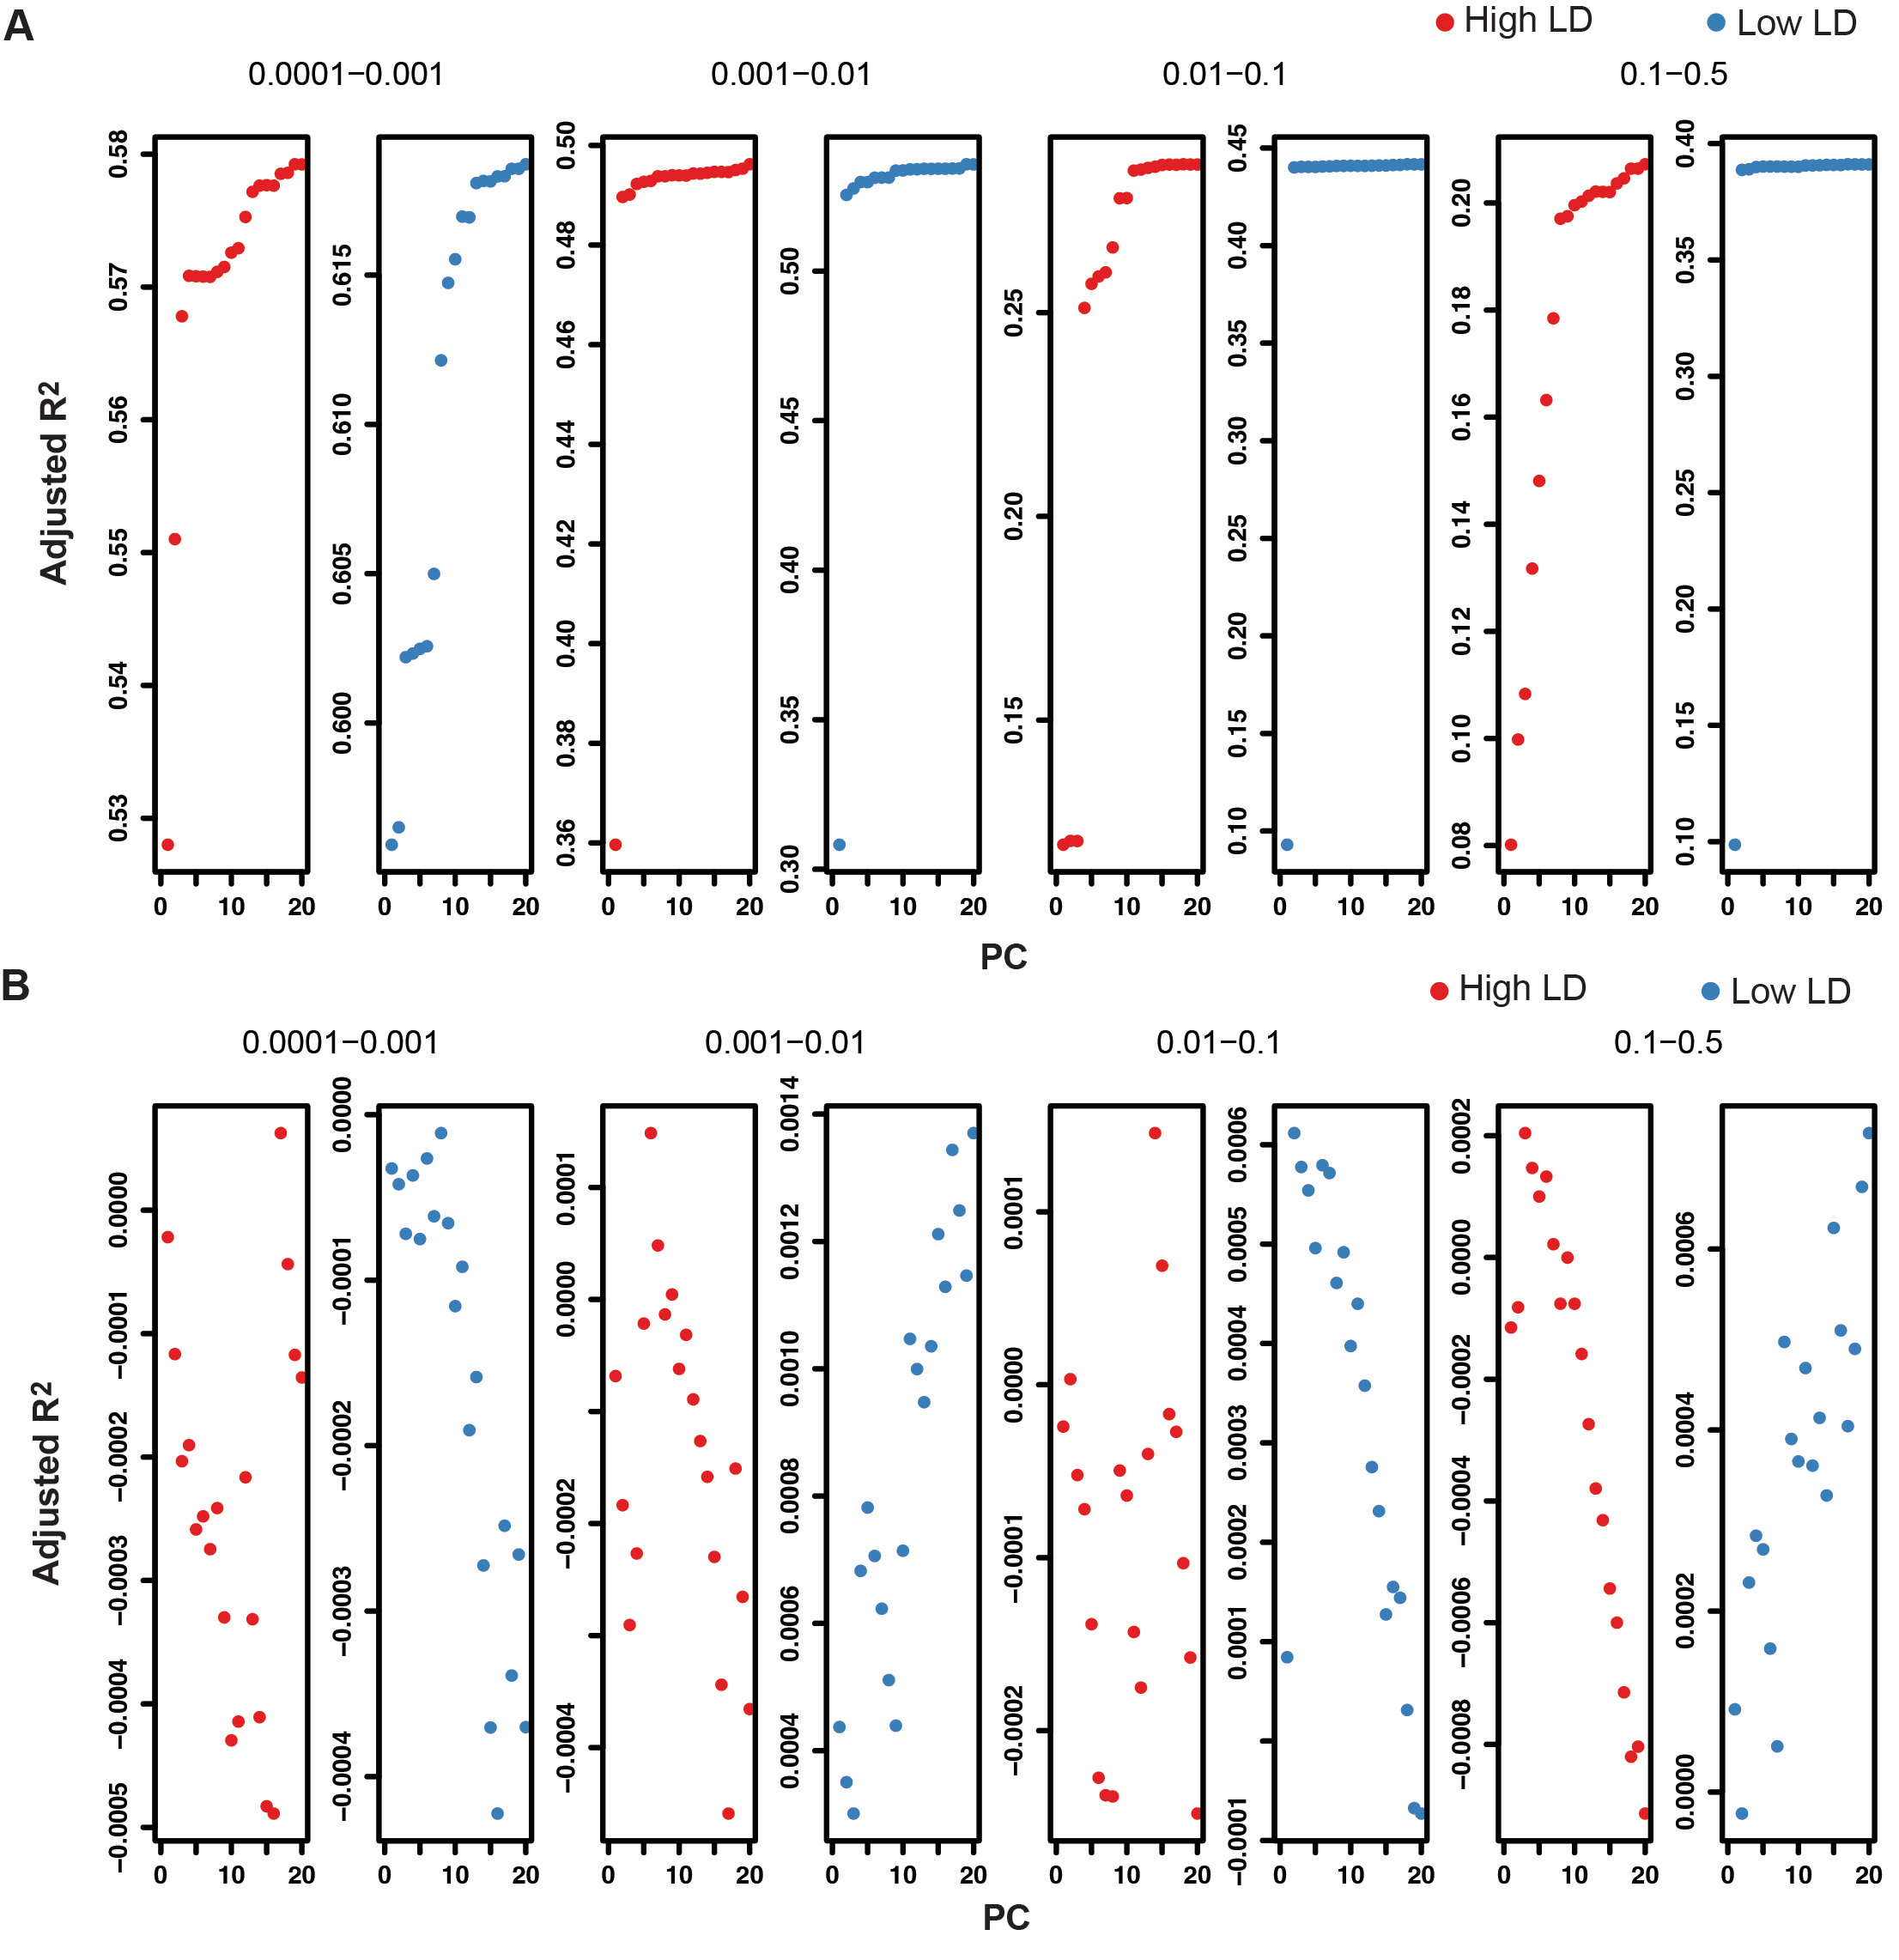
Supplementary Figure 4. Adjusted R² from fitting 20 PCs computemagId from LD-pruned SNPs for different MAF and LD bins. (A) Adjusted R² for the 12,000 MAGIC Exome samples. (B) Adjusted R² for the N= 8,682 UKB Exome samples.

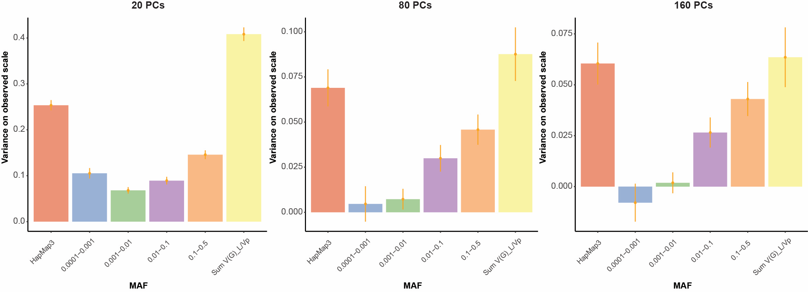
Supplementary Figure 5. GREML-LDMS estimates for overlapped variant between MAGIC and UKB with correction for 20 PCs (on HM3 SNPs), 80 PCs (10 * 8 bins) or 160 PCs (20 * 8 bins).

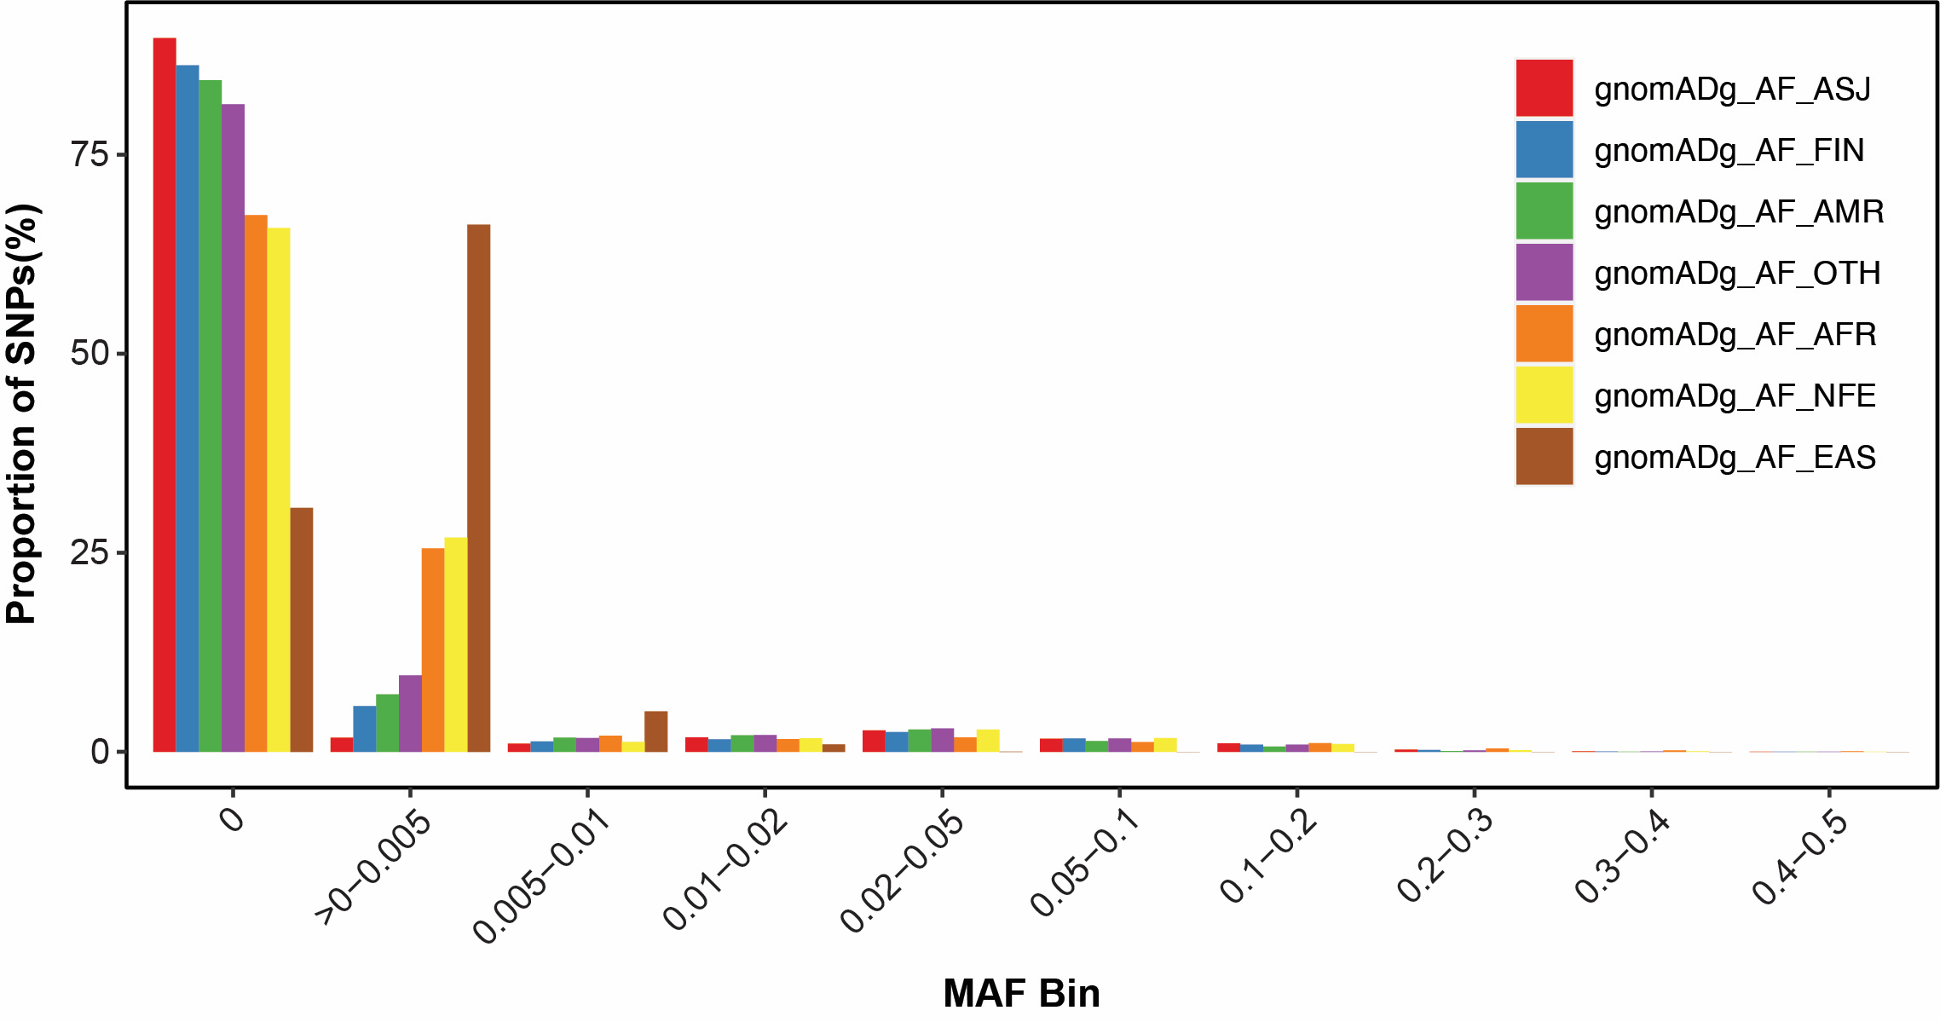
Supplementary Figure 6. MAF distribution for MAGIC specific rare variants across ancestries in gnomAD. Proportion of polymorphic variants (as a % of total) are described on the y-axis with the x-axis illustrating bins of the minor allele frequencies (MAF) for seven different ancestries.

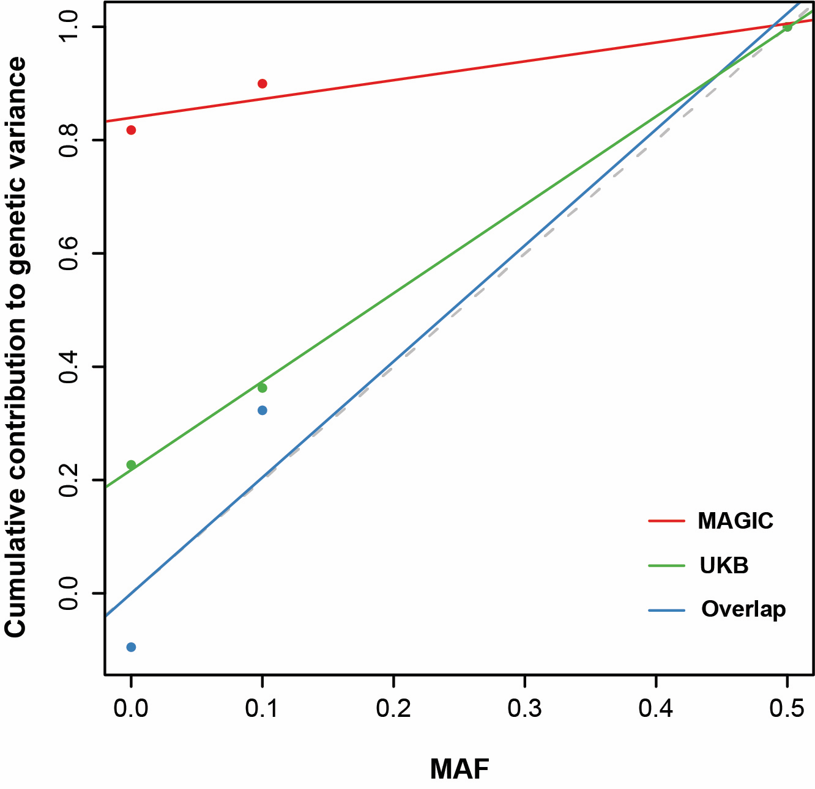
Supplementary Figure 7. Estimate of the cumulative contribution of variants, for HM, from GREML-LDMS analysis. The dash line represents the expected contribution under a neutral evolutionary model. The deviation from this dash line suggests that HM in UKB and MAGIC are under negative selection. The first bin represents variants with MAF < 0.01 (cumulative contribution to genetic variance for HM) when second bin shows all variants with MAF < 0.1. The third MAF bin includes all variants in the dataset.

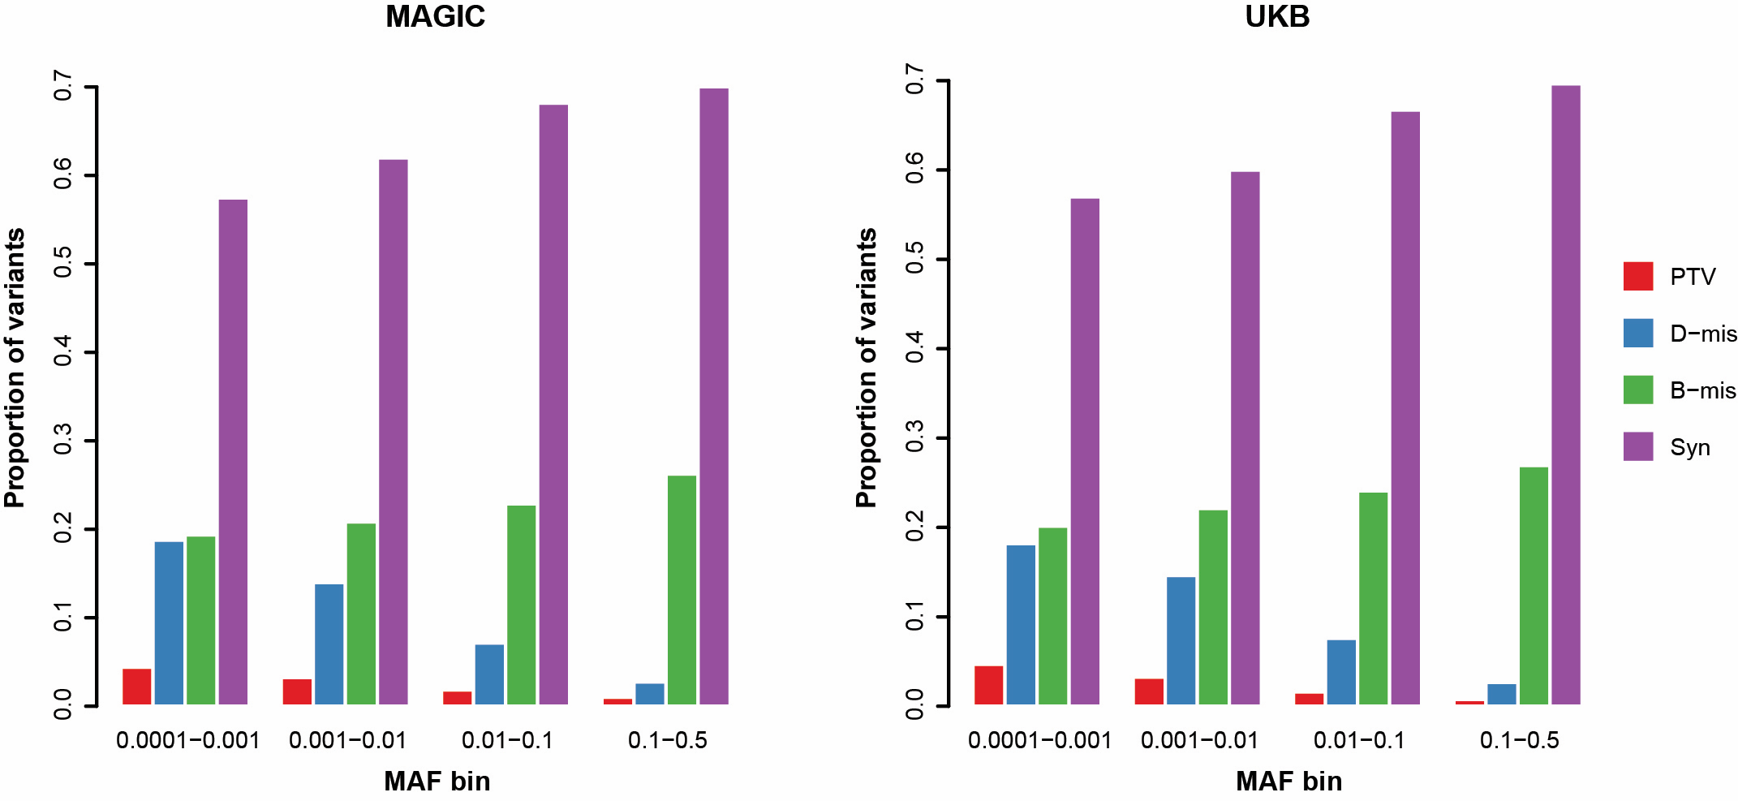
Supplementary Figure 8. Proportion of the variants categorized by annotations as a percentage of the total number of variants in the four MAF bin.

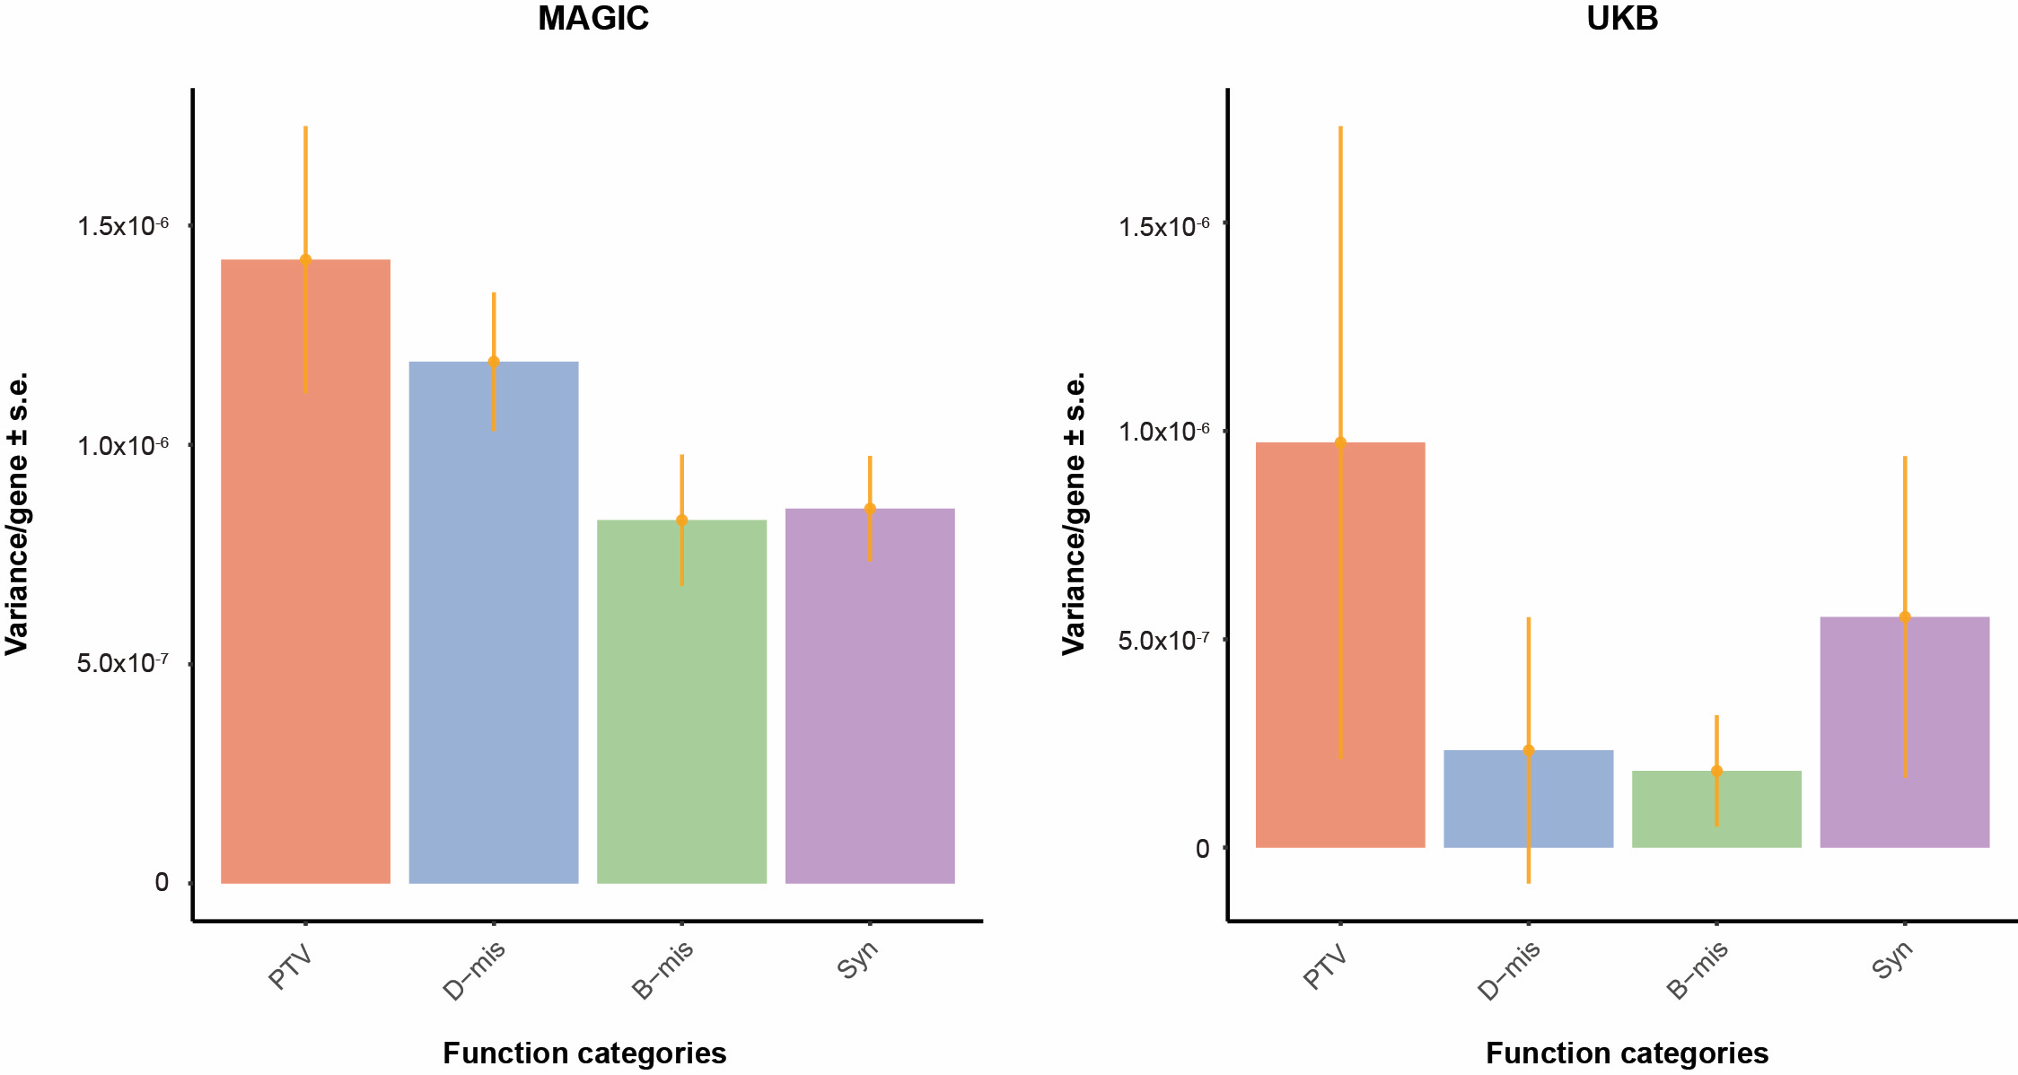
Supplementary Figure 9. Variance explained per genes (the estimate of genetic variance divided by the number of genes in each bin) from burden heritability regression (BHR) with the rare variant partitioned into four distinct categories according to the VEP putative effect of the variant. Error bars indicate s.e.

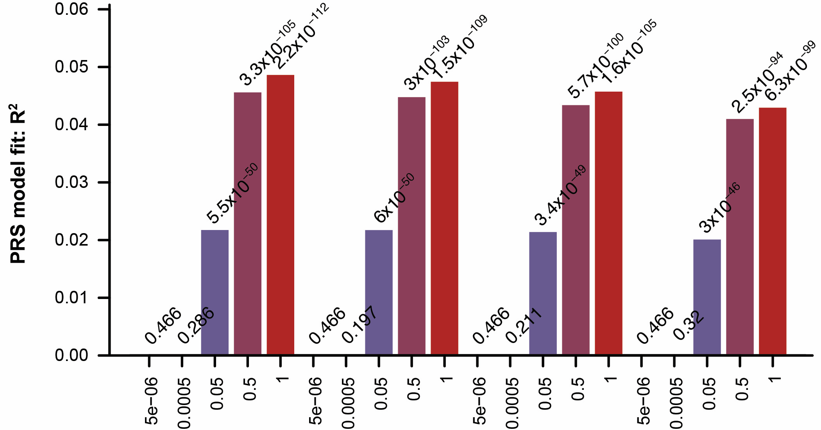
Supplementary Figure 10. Evaluation of predictive power of GRS derived from all common variants on HM. GRSs were derived from MAGIC cohort by plink.

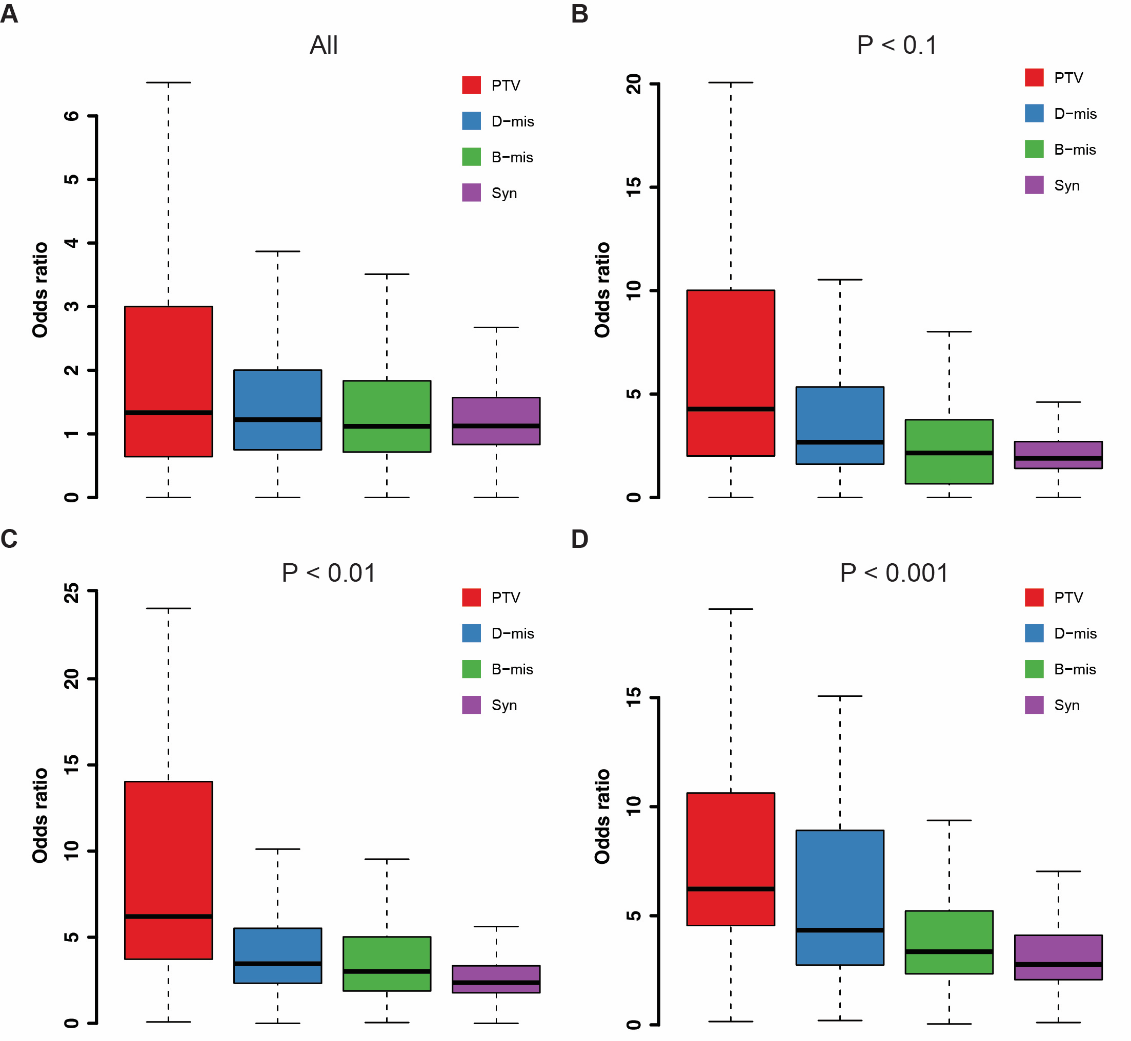
Supplementary Figure 11. Odds ratio of HM-associated gene in rare variant association study under different P value threshold.

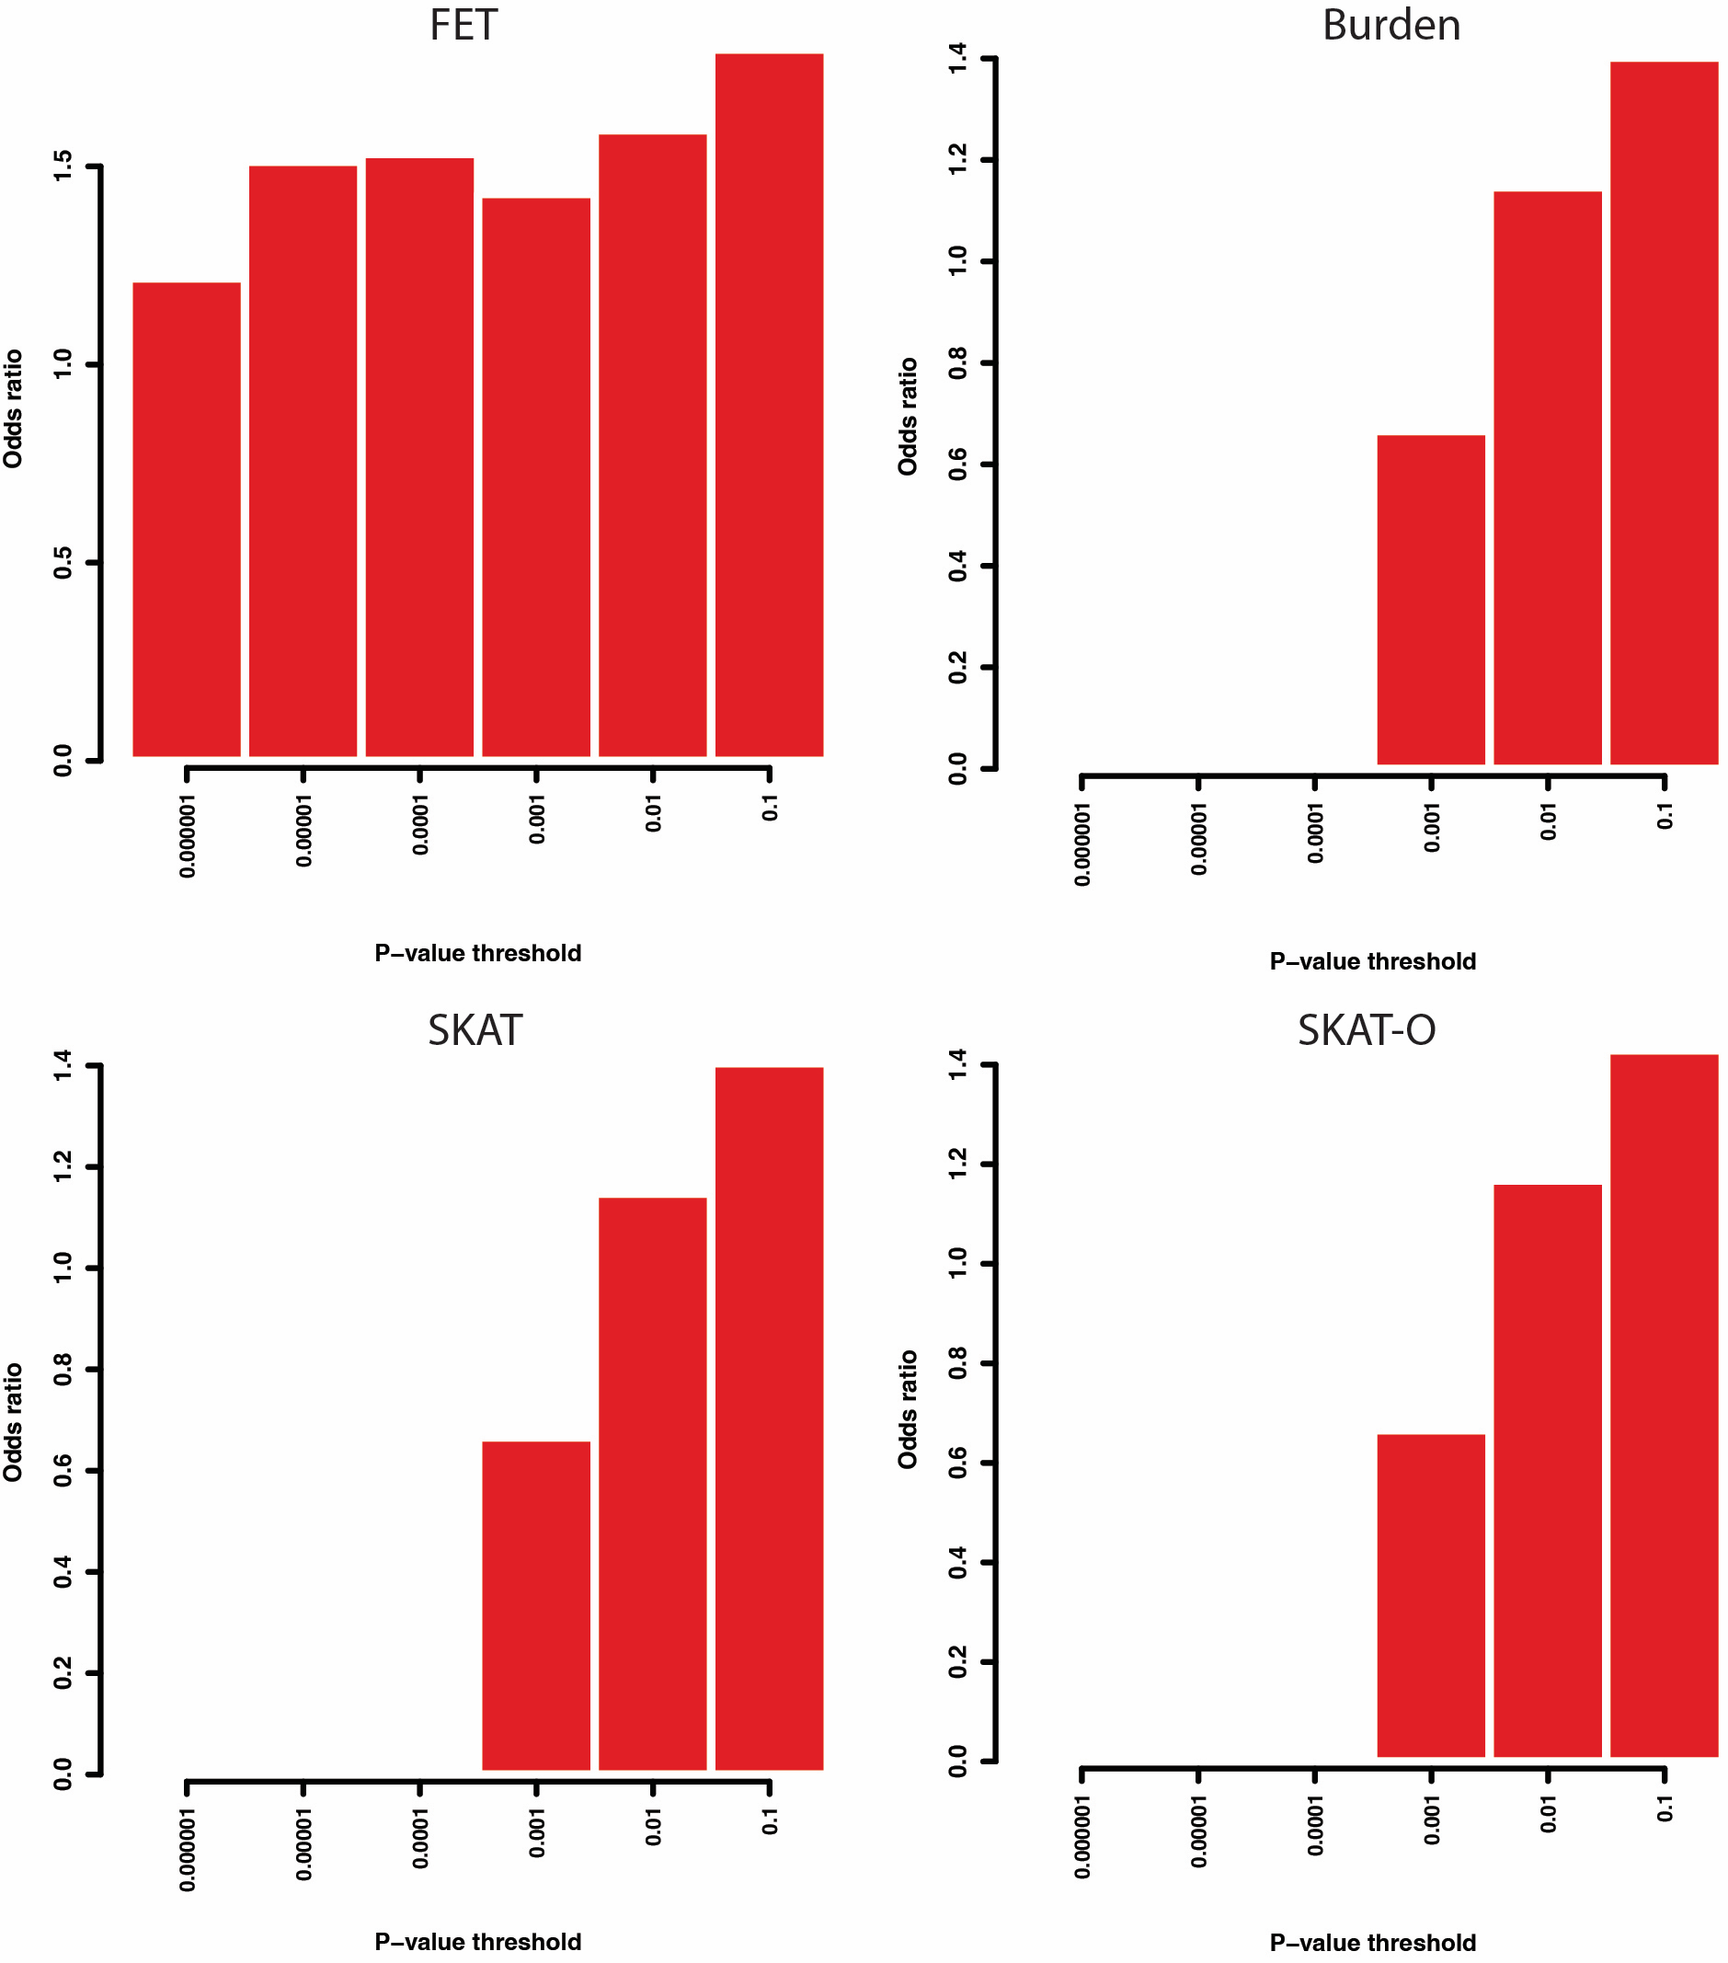
Supplementary Figure 12. Odds ratio for rvGRS model derived from HM-associated gene in rare variant association study by using different Methods.

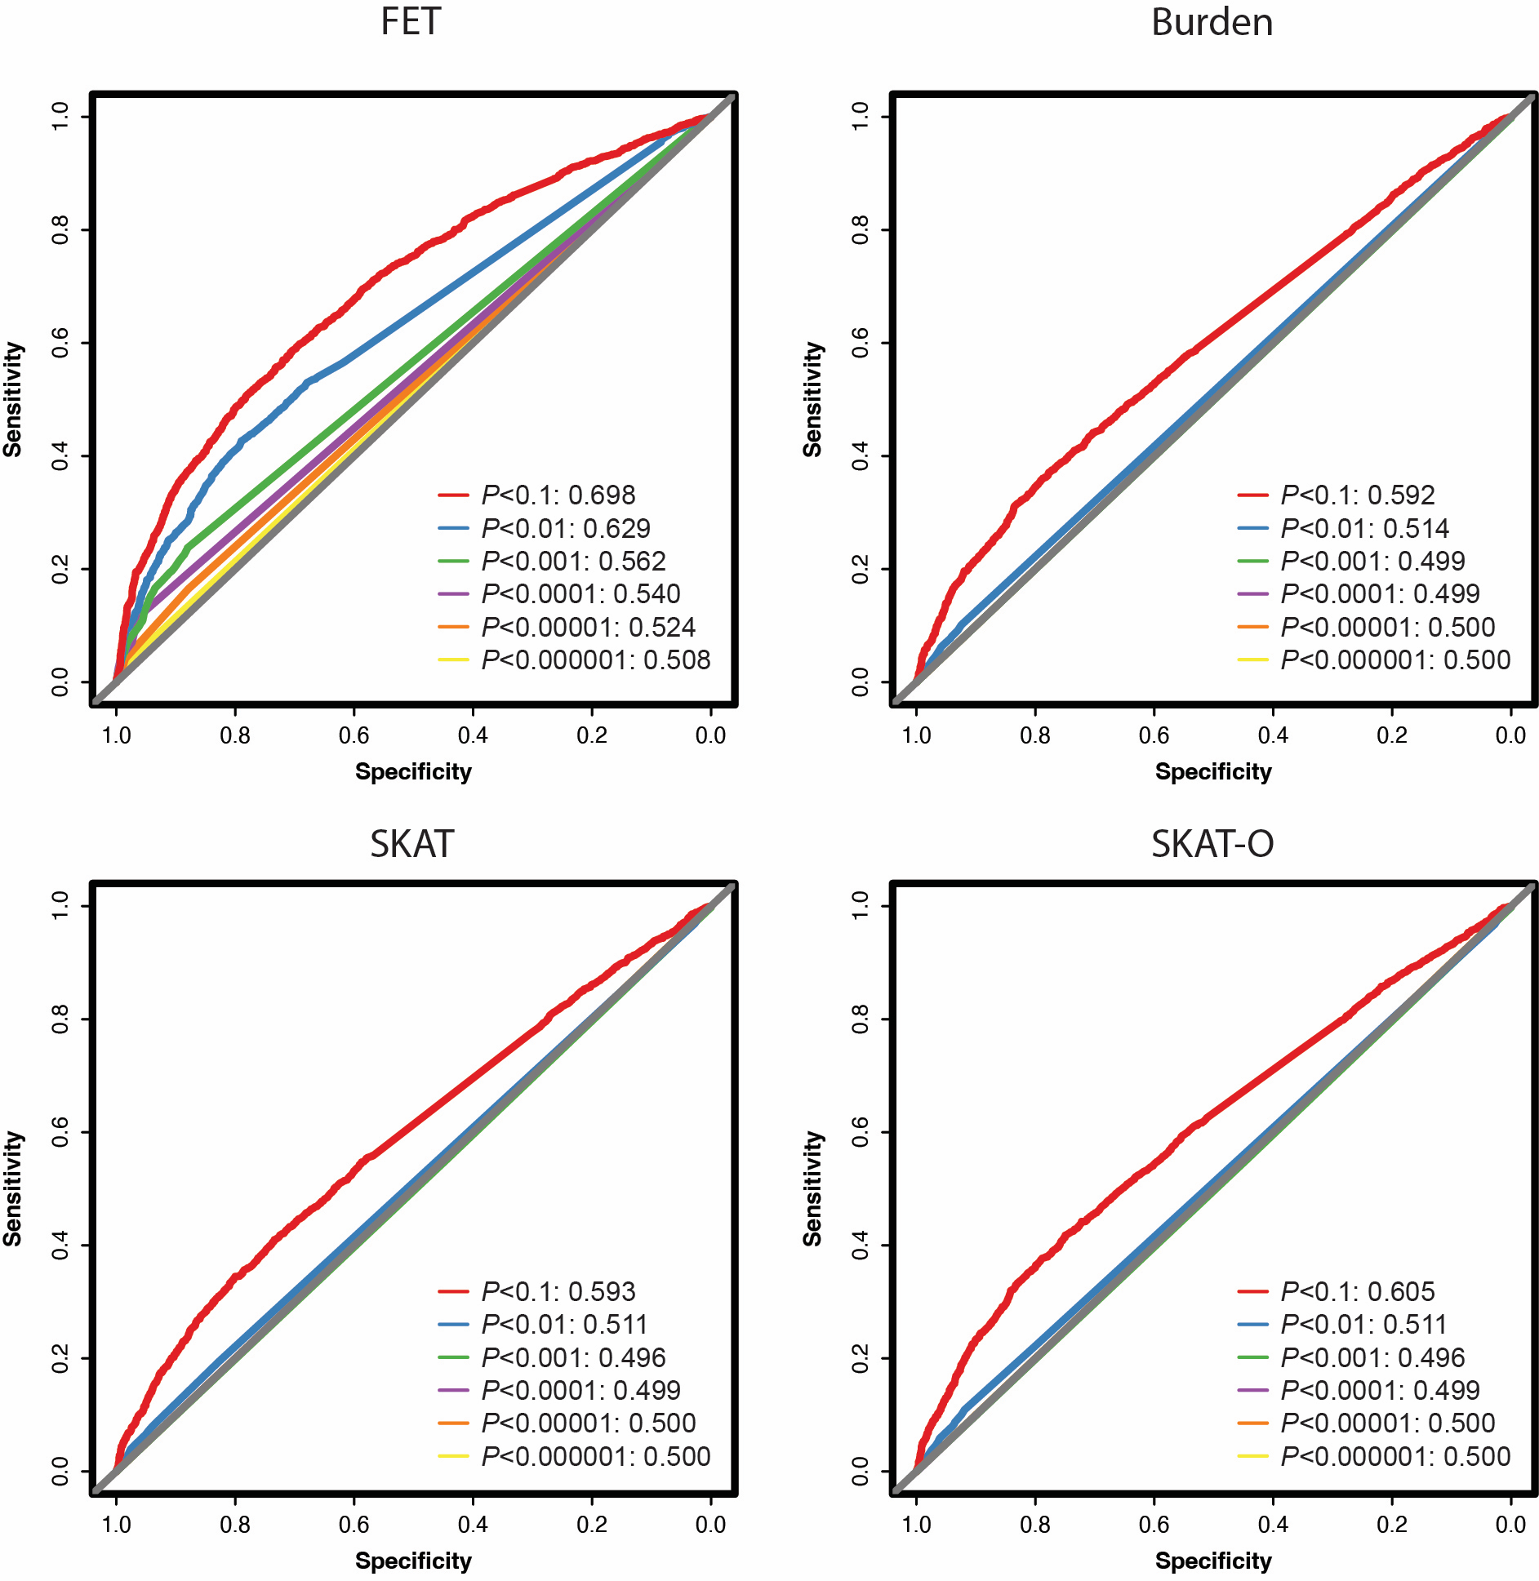
Supplementary Figure 13. ROC curve and AUC for rvGRS model derived from HM-associated genes with rare PTV.

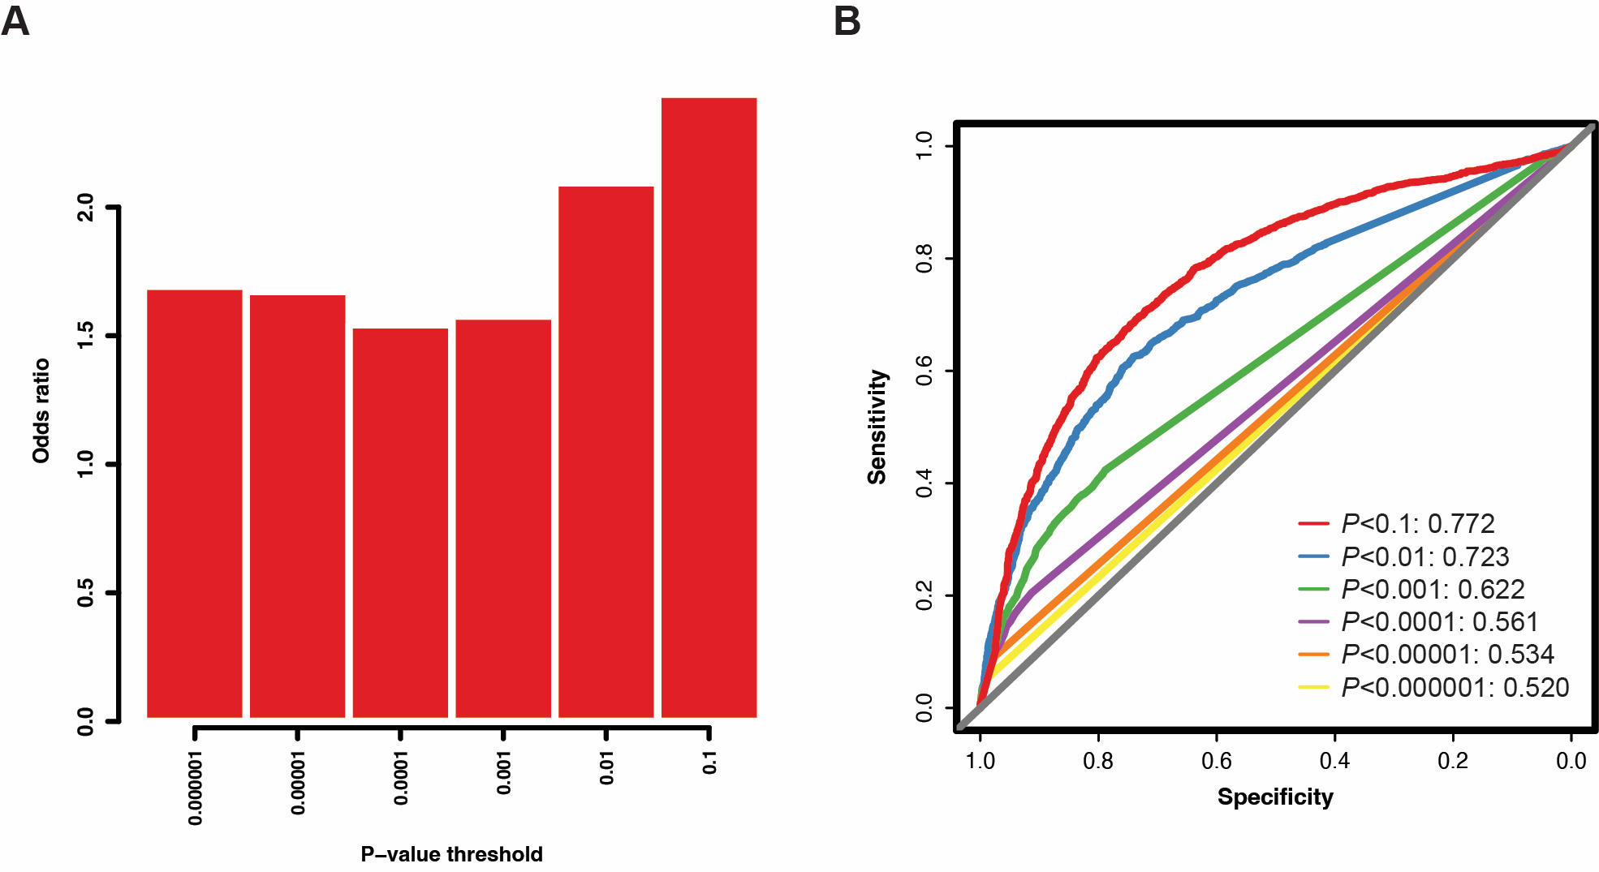
Supplementary Figure 14. Evaluated performance of rvGRS model derived from HM-associated genes with rare D-mis selected by Fisher's exact test. (A) Odds ratio for rvGRS model; (B) ROC curve and AUC for rvGRS model.

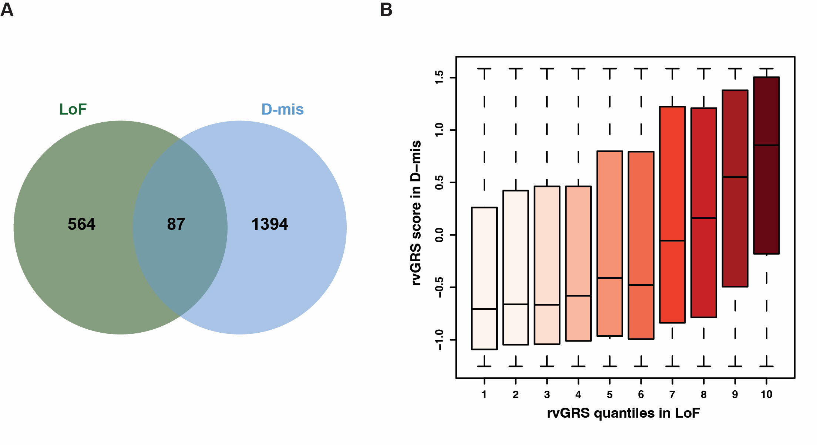
Supplementary Figure 15. Comparison of performance of rvGRS model with PTVs or D-mis. (A) Comparison of the PTV and D-mis on the number of rare variant association study under matched significance thresholds. (B) rvGRS in D-mis for each individual according to 10 groups of the validation dataset binned according to the quantiles of the rvGRS in PTVs.

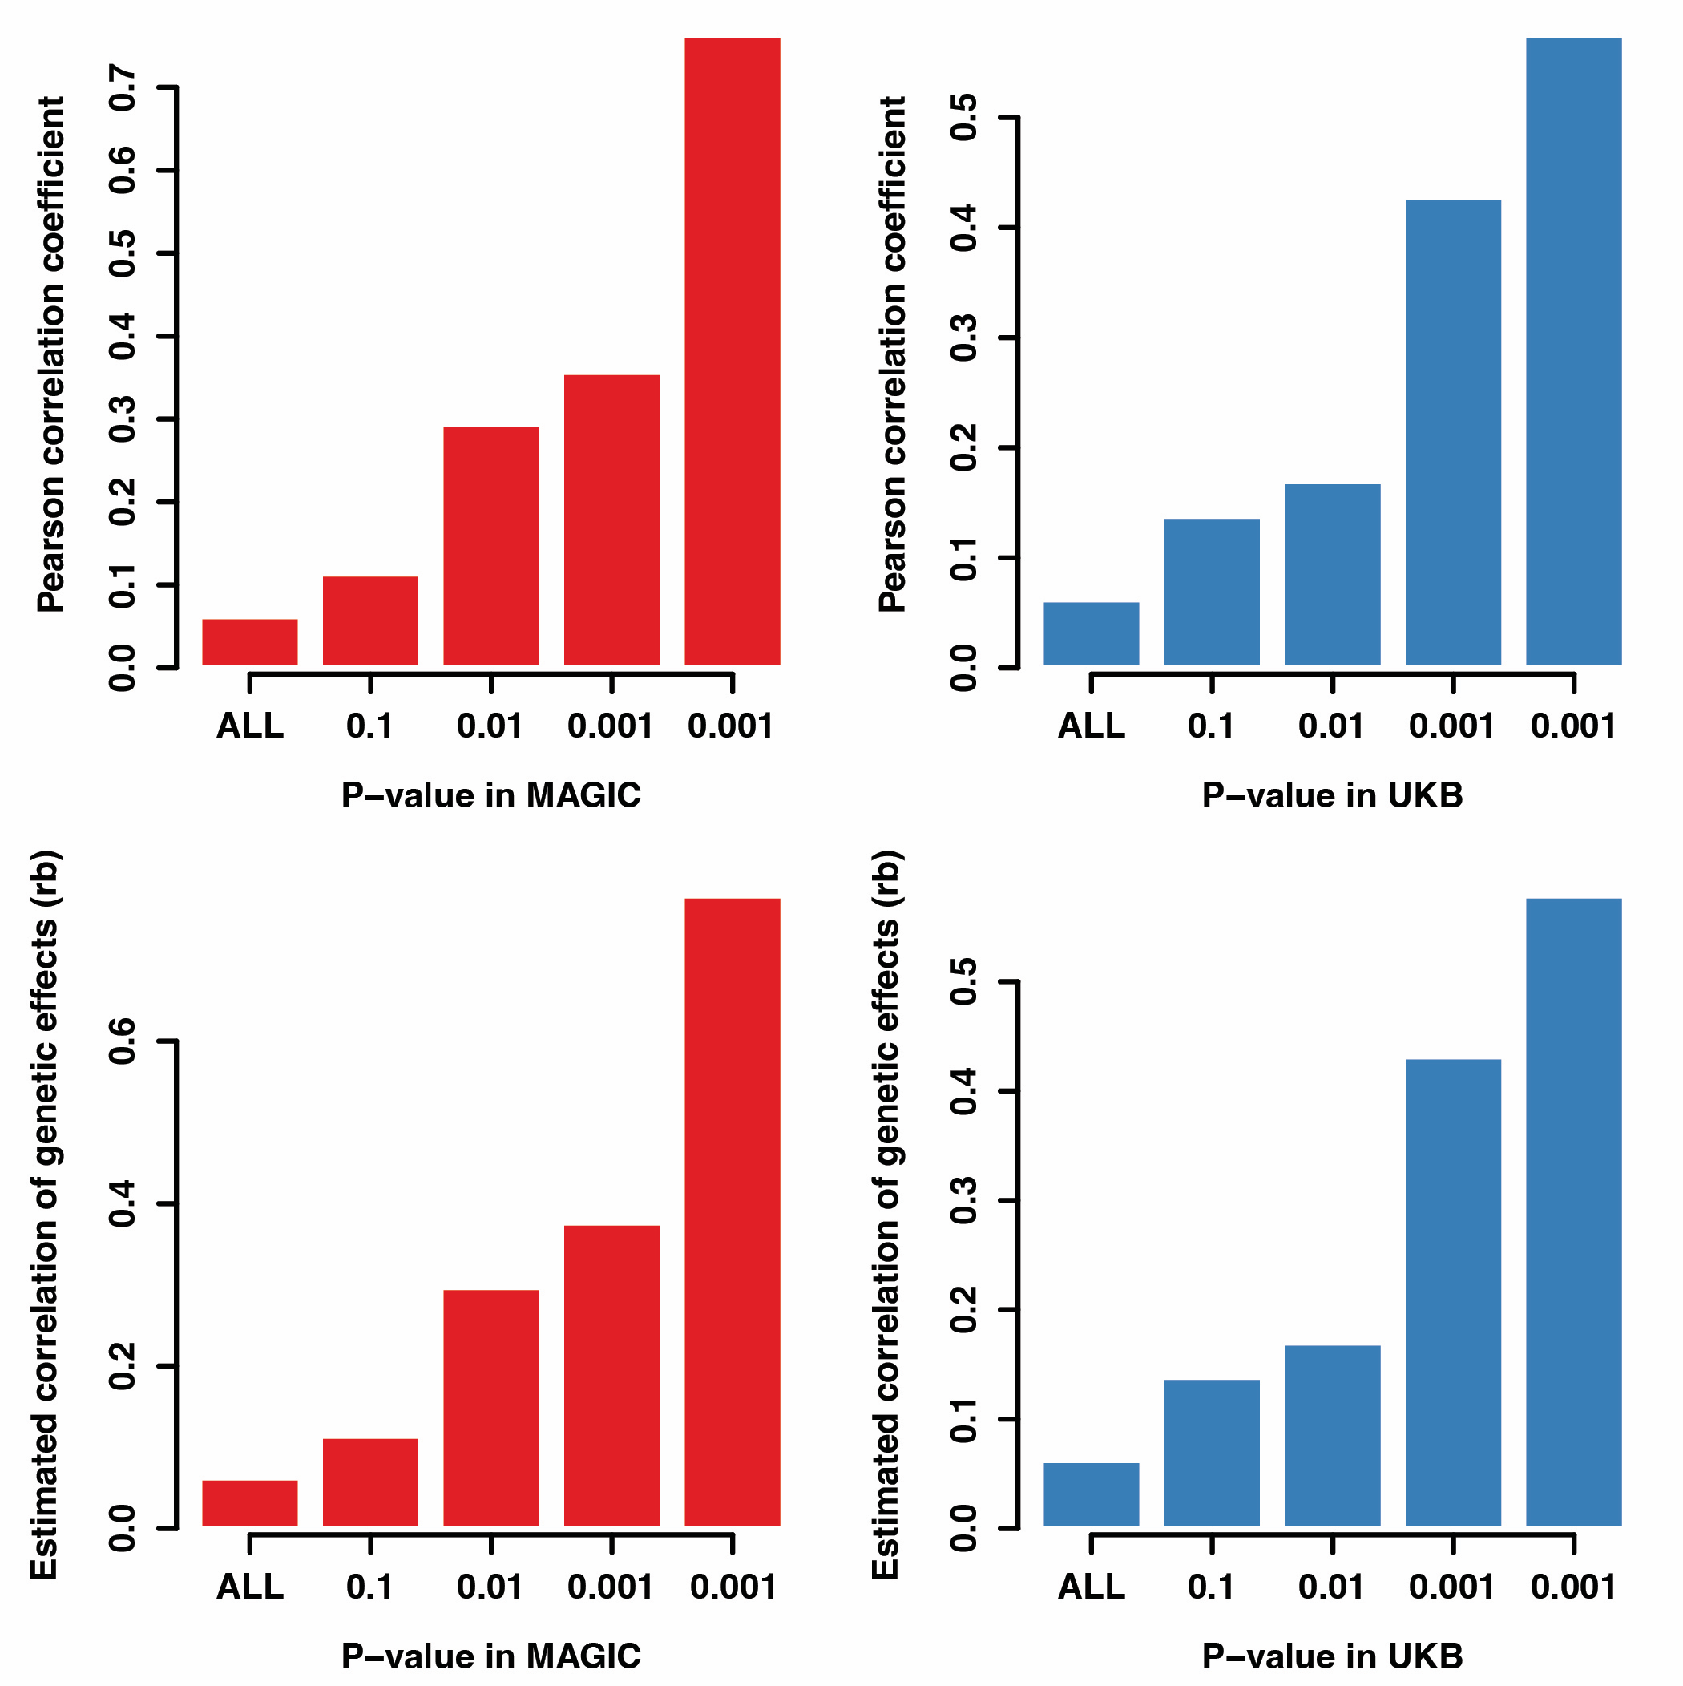
Supplementary Figure 16. Comparisons of the effect sizes (ORs) at different ExWAS P-value thresholds in the MAGIC (left) and UKB (right). Bar plot displaying the Pearson correlation coefficient (up panel) and rb (bottom pane) of log(ORs) at P-value threshold. The x-axis indicates the P-value thresholds used to filter the variants to be included in the correlation computation.

