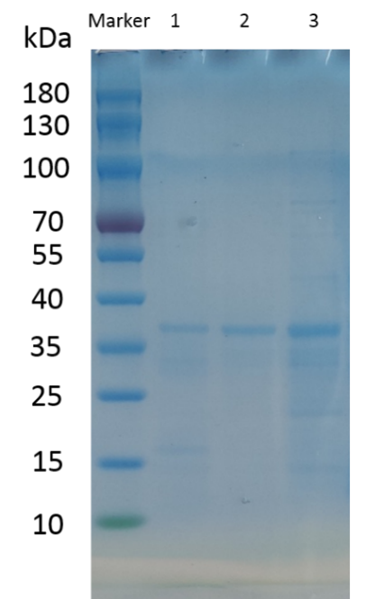
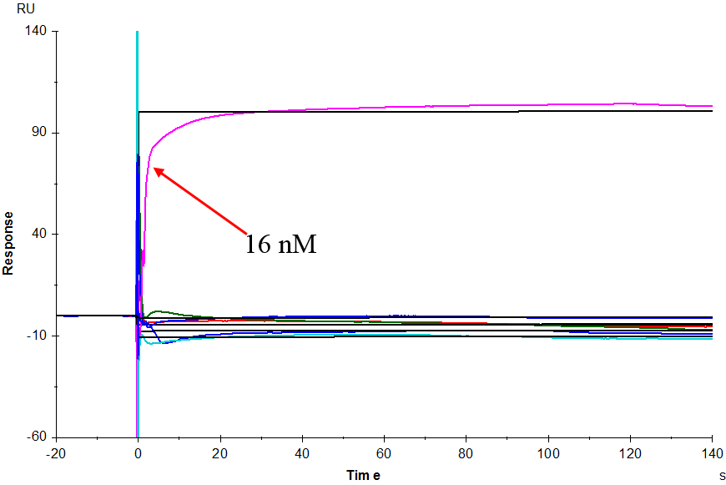
Supplementary Figure 8. Binding analysis of CtMYB1 with DNA elements. SDS-PAGE analysis of CtMYB1 fusion protein after purification by Ni-NTA Resin column, 1-6：insoluble，flowthrough，wash buffer containing 40, 80, 160mM imidazole，Elution Buffer，marker.
A
B

We found the gel and blot images from the original data, the original image includes a total of five lanes, in addition to the three bands eluted by the gradient in the article, there are also total proteins and ultrasonically fragmented proteins, in order to emphasize the efficiency of the elution, we only intercepted the three bands eluted by the gradient and put them into the article. We have uploaded the original image to the Supplementary file without cropping the original image, which we believe meets the requirements, so please ask the expert editors to review it and get back in touch if there are any further questions.

