Supplementary Information
Supplementary Methods
Office blood pressure and heart rate
Office blood pressure and heart rate were measured twice in a seated position using a semiautomatic blood pressure measurement device (Boso Carat Professional, Bosch + Son GmbH and Co. KG, Juningen, Germany) under standardized conditions in accordance with European and American guidelines^{1,2}.

Indirect calorimetry
For determination of whole-body resting energy expenditure (REE) and substrate oxidation via measurement of carbon dioxide production and oxygen consumption, indirect calorimetry was performed, using Quark-RMR® (Cosmed, Fridolfing, Germany) with a coefficient of variation of < 10 %³. REE was multiplied by 1.5 (physical activity level, PAL) to calculate the total energy expenditure.

Nutrition and lifestyle assessments
Self-reported data on participant characteristics, including sex, age, disease, use of medications and dietary supplements, habitual diet, physical activity, sleeping behavior, and socioeconomic status were collected by questionnaire. The habitual diet was characterized using a Food Frequency Questionnaire (FFQ) over 12 months. Physical activity (7-day total metabolic equivalent of task score) was assessed at baseline using the short version of the validated international physical activity questionnaire (IPAQ)^{4,5}. For the evaluation of the sleeping behavior (circadian rhythm), the validated Munich chronotype questionnaire (MCTQ) was used^{6,7}. Socio-economic status was obtained using a questionnaire based on the parent questionnaire to measure socioeconomic status in the study on the health of children and adolescents in Germany (KiGGS) Wave 2⁸.

Oral glucose tolerance test (OGTT)
OGTT was performed after an overnight fast with 75 g glucose and 300 ml water (Dextrose O.G-T.; Roche Diagnostics, GmbH, Mannheim, Germany). Venous blood samples were collected via a venous catheter before ingestion and at 15, 30, 45, 60, 120, and 180 min postprandially to analyze the time course of plasma glucose, serum insulin, serum triglyceride and serum NEFA concentrations.
Various indices were calculated to assess the diet-induced effects on glucose control and insulin resistance. Insulin sensitivity was evaluated using the oral glucose insulin sensitivity index (OGIS)^{9,10} and the insulin sensitivity index (ISI), which provide a measurement of insulin-mediated glucose clearance¹¹. β-Cell function was assessed using insulinogenic index^{9,10}, disposition index^{12–14} and HOMA-β¹⁵. In addition, insulin resistance was evaluated using quantitative insulin sensitivity check index (QUICKI)^{16,17} and triglyceride-glucose index (TyG)^{18,19} based on fasting concentrations. Moreover, the area under the curve (AUC) of the glucose and insulin concentration over 180 minutes, calculated using the trapezoidal rule and considering only complete data sets, was used to measure differences in glucose tolerance upon intervention. The AUCs of the NEFA and TG concentration were calculated in the same way over 120 minutes. Furthermore, the presence of metabolic dysfunction-associated steatotic liver disease (MASLD) was estimated using the fatty liver index (FLI ≥ 60)^{20,21}.

Analysis of oat-induced changes in gut microbiome
NBZIMM. Regression analysis for the identification of the microbial taxa that had changed significantly as a result of the oat diet was performed with negative binomial and zero-inflated mixed models (NBZIMM). NBZIMM makes use of a logistic model to predict excess zeros, which is an issue in some taxa with low occurrence. Furthermore, a negative binomial distribution addresses the over-dispersed count data²². The random effects were used to account for the repeated measures design of the intervention study, where each participant's microbiota was repeatedly sampled. The model was applied individually to each taxon and adjusted for the different total number of sequences in each sample, and for the confounding factors age, sex, and BMI. The model was defined as taxon ~ time*group + offset(log(totalreads) + age + sex + BMI. To correct for multiple testing, false discovery rate correction (FDR) was applied using the Benjamini/Hochberg method²³ (q < 0.05).
LinDA. Linear models for differential abundance analysis (LinDA) were used as a control to confirm the microbial taxa identified using NBZIMM and sPLS-DA (formula: taxon ~ time*group + age + sex + BMI, with the covariate of interest time*group), as the LinDA method is considered to be more robust and has better FDR control compared to generalized linear models, and performs well in the presence of strong compositional effects²⁴.

Analysis of oat-induced changes in global metabolomic profiles
Ordinary least squares (OLS) regression was used to identify the plasma and fecal metabolites that were significantly affected by the oat diet, compared to the baseline and CG. The model was adjusted for age (continuous), sex (boolean), and BMI (continuous), resulting in the regression model “y_1 ~ y_0 + diet + age + sex + BMI” with metabolite “y” at baseline (y_0) and after intervention (y_1), transformed with the natural logarithm (log); and the categorical variable “diet”, corresponding to the OG and CG. Metabolites were selected by a significant (p < 0.05) effect of “diet” after adjusting for multiple testing using the false discovery rate (Benjamini/Hochberg method²³).

Sparse partial least squares-discriminant analysis (sPLS-DA)
Data processing. For the targeted plasma metabolomic profile, DHFA concentrations below the limit of quantitation, but above the peak area of the background DHFA peak in the blank samples, or concentrations above the limit of quantitation were extrapolated. Missing values in the global metabolomics profiles were imputed with the minimum observed value for each compound. Metabolic and metabolomics data were transformed with the natural logarithm prior to the analysis. Microbiome data were normalized by using centered-log-ratio transformation (CLR) with an offset of 1. The logarithmic fold change (log fold change) was calculated for all data sets and used as the input to the models.
Procedure. The number of features and PLS components was chosen via stratified 5-fold cross-validation with 50 random repeats, according to the best-balanced classification error rate (BER). Model was calibrated using the least absolute shrinkage and selection operator (LASSO)²⁵ to minimize the number of features per component while maximizing class discrimination. The set of the clinical markers, which comprised 26 variables, was transformed into two components with three and 19 clinical markers, respectively. The microbiome data set, which comprised 143 genera, was transformed into two components with one and 41 genera, respectively. For the KEGG pathway data set, two components with ten and five features were selected. The model for the global plasma metabolomic profile comprised two components with 30 and 95 metabolites, respectively. For the global fecal metabolomic profile, two components with 91 and 971 metabolites were selected as the best model. The performance of the final sPLS-DA models was assessed on the classification error rate and the area under the curve of the receiver operating characteristic (AUC). The results were visualized using sample plot and loadings. Further detailed information on the workflow can be found in the tutorials of mixOmics (http://mixomics.org/case-studies/).

Integrative Analysis for Biomarker discovery using Latent cOmponents
Data Integration Analysis for Biomarker discovery using Latent cOmponents (DIABLO) is a novel framework for the integration of multiple data sets in a supervised analysis that aims to identify key variables/common information across different data sets (e.g., clinical marker, metabolomic profiles, microbiome data) during integration process while distinguishing between different phenotypes (e.g., study groups)²⁶. Thus, the correlated information between multiple datasets is maximized. DIABLO extends sparse generalized canonical correlation analysis (sGCCA)²⁷ to the sPLS-DA framework for selecting co-expressed (correlated) variables from different datasets.
To account for the repeated-measure design of the intervention study, log fold change of the preprocessed data as described above was used as an input to the models. An initial partial least square analysis between the five data sets of model 1 including clinical marker, microbiome data (genera), targeted plasma metabolomic profile ((DH)FA), and global plasma and fecal metabolomic profiles showed correlations in the range of 0.658 to 0.963, therefore a square matrix filled with 0.75 and diagonal set to zeros was used as an input to the design parameter of the DIABLO model. The correlations for model 2, which included KEGG pathways instead of microbiome genera, ranged from 0.633 to 0.963, so that the same input was used for the design parameters of the DIABLO model.
Tuning of the DIABLO model was done similar to the tuning of the sPLS-DA model as described above. The final model 1 consisted of two components. Component one comprised one metabolite form the targeted plasma profile (FA), three clinical markers (LDL, TC, DBP), four microbial genera (Erysipelotrichaceae UCG-003, Marvinbryantia, Eggerthella, Intestinimonas) and 15 metabolites each from global plasma and global fecal metabolomic profile. Component two comprised one metabolite form the targeted plasma profile (DHFA), 15 clinical markers, one microbial genus ([Erysipelotrichaceae] uncultured) and 15 metabolites each from global plasma and global fecal metabolomic profile (Supplementary Table S3-6). The final model 2 consisted of two components. Component one comprised one metabolite form the targeted plasma profile (FA), one clinical marker (LDL), five KEGG pathways (naphthalene degradation, carbohydrate digestion and absorption, novobiocin biosynthesis, aminobenzoate degradation, nitrogen metabolism) and 15 metabolites each from global plasma and global fecal metabolomic profile. Component two comprised one metabolite form the targeted plasma profile (DHFA), three clinical markers (bilirubin, NEFAs, uric acid), two KEGG pathways (aminobenzoate degradation, riboflavin metabolism) and 15 metabolites each from global plasma and global fecal metabolomic profile (Supplementary Table S3-7).
The performance of the final models was assessed using AUC and BER. Model 1 had an AUC of 0.94 (P = 5.03 x 10⁻³) and a BER of 0.07. Model 2 had an AUC of 0.92 (P = 5.11 x 10⁻³) and a BER of 0.04. The results from the DIABLO model were visualized using sample plot, loadings and Circos plot. Further detailed information on the workflow can be found in the tutorials of mixOmics (http://mixomics.org/mixdiablo/ diablo-tcga-case-study/).

References
1. Pickering, T. G. et al. Recommendations for blood pressure measurement in humans and experimental animals: part 1: blood pressure measurement in humans: a statement for professionals from the Subcommittee of Professional and Public Education of the American Heart Association Council on High Blood Pressure Research. Circulation 111, 697–716 (2005).
2. O'Brien, E. et al. Practice guidelines of the European Society of Hypertension for clinic, ambulatory and self blood pressure measurement. Journal of hypertension 23, 697–701 (2005).
3. Compher, C., Frankenfield, D., Keim, N. & Roth-Yousey, L. Best practice methods to apply to measurement of resting metabolic rate in adults: a systematic review. Journal of the American Dietetic Association 106, 881–903 (2006).
4. Craig, C. L. et al. International physical activity questionnaire: 12-country reliability and validity. Medicine and science in sports and exercise 35, 1381–1395 (2003).
5. Mäder, U., Martin, B. W., Schutz, Y. & Marti, B. Validity of four short physical activity questionnaires in middle-aged persons. Medicine and science in sports and exercise 38, 1255–1266 (2006).
6. Roenneberg, T., Wirz-Justice, A. & Merrow, M. Life between clocks: daily temporal patterns of human chronotypes. Journal of biological rhythms 18, 80–90 (2003).
7. Levandovski, R., Sasso, E. & Hidalgo, M. P. Chronotype: a review of the advances, limits and applicability of the main instruments used in the literature to assess human phenotype. Trends in psychiatry and psychotherapy 35, 3–11 (2013).
8. Lampert, T., Hoebel, J., Kuntz, B., Müters, S. & Kroll, L. E. Messung des sozioökonomischen Status und des subjektiven sozialen Status in KiGGS Welle 2. Journal of Health Monitoring, 114–133 (2018).
9. Mari, A., Pacini, G., Murphy, E., Ludvik, B. & Nolan, J. J. A model-based method for assessing insulin sensitivity from the oral glucose tolerance test. Diabetes care 24, 539–548 (2001).
10. Mari, A., Pacini, G., Brazzale, A. R. & Ahrén, B. Comparative evaluation of simple insulin sensitivity methods based on the oral glucose tolerance test. Diabetologia 48, 748–751 (2005).
11. Matsuda, M. & DeFronzo, R. A. Insulin sensitivity indices obtained from oral glucose tolerance testing: comparison with the euglycemic insulin clamp. Diabetes care 22, 1462–1470 (1999).
12. Ahrén, B. & Pacini, G. Impaired adaptation of first-phase insulin secretion in postmenopausal women with glucose intolerance. The American journal of physiology 273, E701-7 (1997).
13. Kahn, S. E. et al. Quantification of the relationship between insulin sensitivity and beta-cell function in human subjects. Evidence for a hyperbolic function. Diabetes 42, 1663–1672 (1993).
14. Pacini, G. The hyperbolic equilibrium between insulin sensitivity and secretion. Nutrition, metabolism, and cardiovascular diseases : NMCD 16 Suppl 1, S22-7 (2006).
15. Matthews, D. R. et al. Homeostasis model assessment: insulin resistance and beta-cell function from fasting plasma glucose and insulin concentrations in man. Diabetologia 28, 412–419 (1985).
16. Katz, A. et al. Quantitative insulin sensitivity check index: a simple, accurate method for assessing insulin sensitivity in humans. The Journal of clinical endocrinology and metabolism 85, 2402–2410 (2000).
17. Placzkowska, S., Pawlik-Sobecka, L., Kokot, I. & Piwowar, A. Indirect insulin resistance detection: Current clinical trends and laboratory limitations. Biomedical papers of the Medical Faculty of the University Palacky, Olomouc, Czechoslovakia 163, 187–199 (2019).
18. Alizargar, J., Hsieh, N.-C. & Wu, S.-F. V. The correct formula to calculate triglyceride-glucose index (TyG). Journal of pediatric endocrinology & metabolism : JPEM 33, 945–946 (2020).
19. Araújo, S. P., Juvanhol, L. L., Bressan, J. & Hermsdorff, H. H. M. Triglyceride glucose index: A new biomarker in predicting cardiovascular risk. Preventive medicine reports 29, 101941 (2022).
20. Bedogni, G. et al. The Fatty Liver Index: a simple and accurate predictor of hepatic steatosis in the general population. BMC gastroenterology 6, 33 (2006).
21. Khang, A. R., Lee, H. W., Yi, D., Kang, Y. H. & Son, S. M. The fatty liver index, a simple and useful predictor of metabolic syndrome: analysis of the Korea National Health and Nutrition Examination Survey 2010-2011. Diabetes, metabolic syndrome and obesity : targets and therapy 12, 181–190 (2019).
22. Zhang, X. & Yi, N. NBZIMM: negative binomial and zero-inflated mixed models, with application to microbiome/metagenomics data analysis. BMC bioinformatics 21, 488 (2020).
23. Benjamini, Y. & Hochberg, Y. Controlling the False Discovery Rate: A Practical and Powerful Approach to Multiple Testing. Journal of the Royal Statistical Society: Series B (Methodological) 57, 289–300 (1995).
24. Yang, L. & Chen, J. Benchmarking differential abundance analysis methods for correlated microbiome sequencing data. Briefings in bioinformatics 24 (2023).
25. Tibshirani, R. Regression Shrinkage and Selection via the Lasso. Journal of the Royal Statistical Society 58, 267–288 (1996).
26. Singh, A. et al. DIABLO: an integrative approach for identifying key molecular drivers from multi-omics assays. Bioinformatics (Oxford, England) 35, 3055–3062 (2019).
27. Tenenhaus, A. et al. Variable selection for generalized canonical correlation analysis. Biostatistics (Oxford, England) 15, 569–583 (2014).

Supplementary Figures
Supplementary Fig. S1 Diet-induced changes in postprandial metabolism. Change during the OGTT in plasma glucose concentration in CG (a) and OG (b) over 180 minutes, serum insulin concentration in CG (c) and OG (d) over 180 minutes, serum triglycerides levels in CG (e) and OG (f) over 120 minutes, and in serum NEFAs levels in CG (g) and OG (h) over 120 minutes. Data are shown as mean ± SEM. The circle markers show the measurements before the two-day intervention (pre), square markers indicate the time course after the intervention (post), lines are linearly interpolated between subsequent data. Blue lines refer to CG, orange lines refer to OG. a - f: n = 31, g + h: n = 30. Abbreviations: CG, control group; OG, oat group; OGTT, oral glucose tolerance test; NEFAs, non-esterified fatty acids.

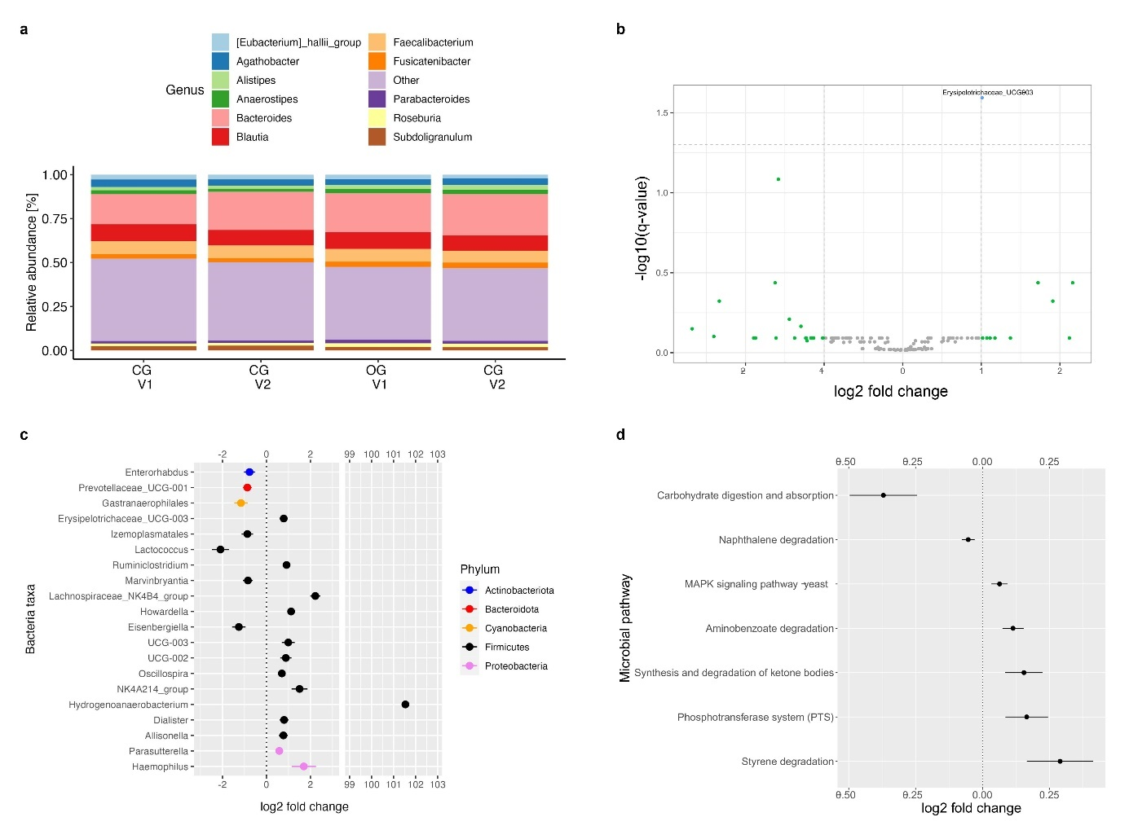
Supplementary Fig. S2 Diet-induced changes in microbial composition.
a The taxonomy bar plot shows the top 11 abundant genera in CG and OG pre- (V1) and post-intervention (V2). b Significant changes in microbial composition on genus level identified using LinDA models adjusted for age, sex, and BMI (n = 28), presented as the log2 fold change of each genus against its statistical significance, reported as −log10(q-value), for the interaction of diet group and time point (pre- and post-intervention). The blue dot refers to the genus Erysipelotrichaceae UCG-003 with a significant log2 fold change of 1.01 (q = 0.03); green dots refer to genera with a non-significant log2 fold change >I1I; gray dots refer to genera with a non-significant log2 fold change of <I1I. c Significant changes (q < 0.05) in microbial composition on genus level revealed by NBZIMM models adjusted for age, sex, and BMI (n = 28), presented as log2 fold change of each genus. d Changes in microbial pathways identified using linear mixed model adjusted for age, sex, and BMI (n = 28), presented as the log2 fold change of each pathway (P < 0.05). Abbreviations: CG, control group; OG, oat group.

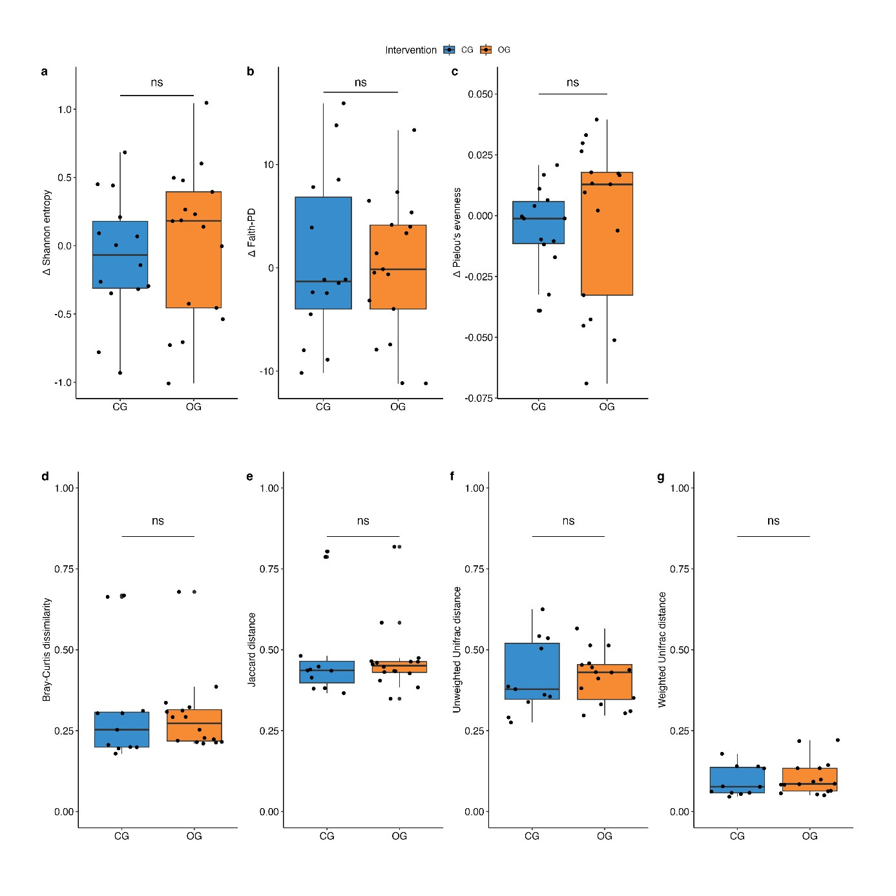
Supplementary Fig. S3 Diet-induced changes in microbial diversity. Alpha diversity metrics by a Shannon entropy, b Faith-PD and c Pielou’s evenness. Beta diversity metrics by d Bray Curtis dissimilarity, e Jaccard distance, f unweighted Unifrac distance and g weighted Unifrac distance. Diversity scores are shown per individual as black dots, as median (center line) and quartiles (box limits: Q1, Q3) for CG (blue) and OG orange) (whiskers extend to 1.5x interquartile range). Differences between the two diet groups were analyzed using linear mixed models adjusted for age, sex and BMI. ns: P > 0.05. a - c: n = 31, d - f: n = 28. Abbreviations: CG, control group; OG, oat group.

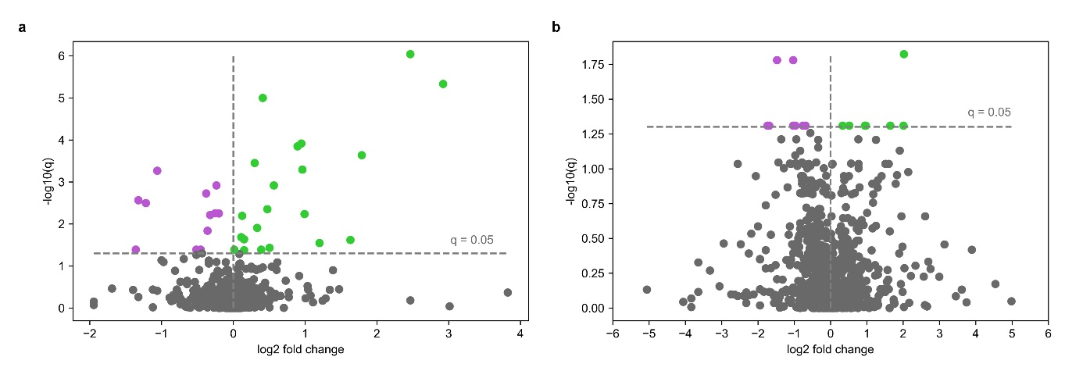
Supplementary Fig. S4 Diet-induced changes in global metabolomic profiles.
Volcano plot for (a) plasma and (b) fecal metabolomic profiles. The volcano plots show the log2-fold change by significance level of oat diet-induced change from the OLS regression model, reported as negative log10-transformed q value. Colored dots indicate metabolites with a significant decrease (purple) or increase (green) in OG compared to CG. Gray dots refer to all other metabolites identified in the dataset which are not significantly different between OG and CG. a: n = 32, b: n = 28. Abbreviations: CG, control group; OG, oat group.

