Supplement A. PoLA's commands and syntax
Command / format / example | Function | Layout | Example
Procedure flow
INSTRUCTION  INSTRUCTION;HEADER_TEXT;BODY_TEXT;BUTTON_TEXT  INSTRUCTION;Instruction;You are required… ;CONTINUE | Displays header, body, and a button with text. Waits until the participant reads the text and taps the button. Used to present information to the participants (e.g., instructions). | 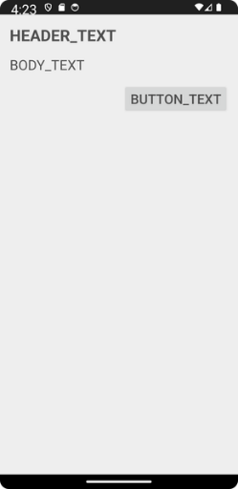 | 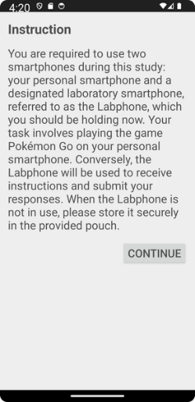
TAP_INSTRUCTION  TAP_INSTRUCTION;HEADER_TEXT;BODY_TEXT;BUTTON_TEXT  TAP_INSTRUCTION;Triple Taps for Key Moments in the Study;During the study…;CONTINUE | The same as INSTRUCTION but involves an particular action (triple tap) before the button appears, to ascertain that the user does not skip this slide unintentionally. The button is hidden until the user triple-taps the screen. Used for time-sensitive moments, e.g. before setting the timer or while synchronizing action of two participants. The participant must be instructed on to handled this slide. | 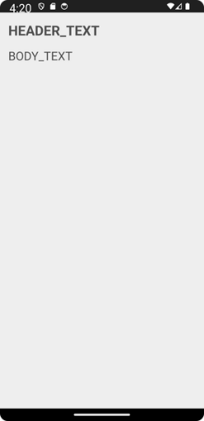 | 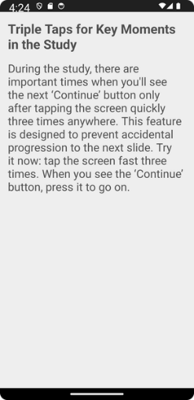
TIMER  TIMER;HeaderText;BodyText;ButtonText;Seconds  TIMER;Session 1;Walk through the park for the next 10 minutes;Stop alarm;600 | This allows researchers to schedule auditory and vibratory alarms. This feature prompts participants to complete assessments or engage in specific behaviors at predetermined intervals. | 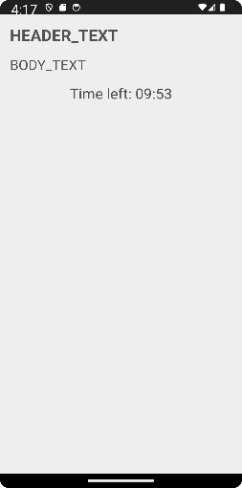 | 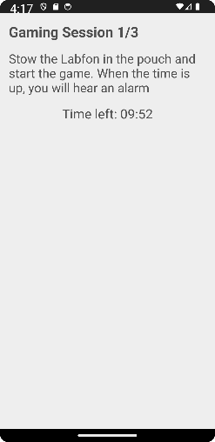
Surveys
SCALE  SCALE;HEADER_TEXT;BODY_TEXT;ITEM_TEXT;RESPONSE1_TEXT;RESPONSE2_TEXT;(up to RESPONSE9_TEXT)  SCALE;Arousal Scale;Please report your arousal level right now;Arousal;Very low;Low;Medium;High;Very high | Displays a header, scale introduction, item, and up to nine labeled response buttons. It asks a single question. | 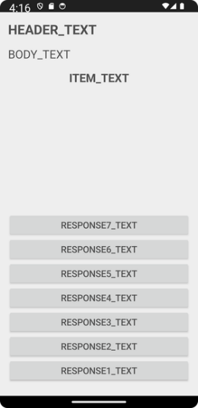 | 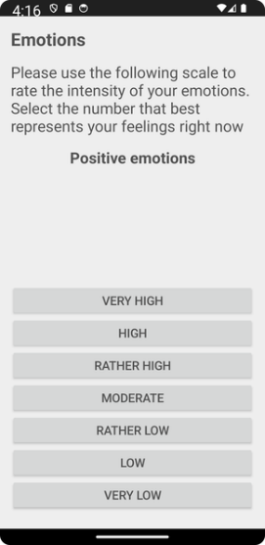
MULTISCALE  MULTISCALE;HEADER;INTRO; [ITEM1,ITEM2,ITEM3,ITEM4];LABEL#1;LABEL#2;(up to LABEL#9)  MULTISCALE;AFFECT SCALE;Please report your affect levels;[Valence,Arousal,Approach-avoidance motivation]Very low;Low;Medium;High;Very high | The same as SCALE but includes a list of items rather than a single item. The items are presented in the listed order.
RANDOMIZED_MULTISCALE  RANDOMIZED_MULTISCALE; HEADER;INTRO;[ITEM1,ITEM2,ITEM3,ITEM4];LABEL#1;LABEL#2;(up to LABEL#9)  RANDOMIZED_MULTISCALE;AFFECT SCALE;Please report your affect levels;[Valence,Arousal,Approach-avoidance motivation]Very low;Low;Medium;High;Very high | The same as MULTISCALE but the listed items are randomized upon each application start.
INPUTFIELD  INPUTFIELD;HEADER_TEXT;BODY_TEXT;BUTTON_TEXT;INPUTFIELD1_TEXT;INPUTFIELD2_TEXT  INPUTFIELD;Study Data;Please enter data for this session;START THE STUDY;ResearcherID;ParticipantID;Session Nr;Additional comments | Displays a header, text, up to 10 input fields, and a button with text. The user taps the field and inputs text data. This can be used by the participant (e.g., to provide qualitative data) or by the researcher (e.g., to enter a participant's ID). | 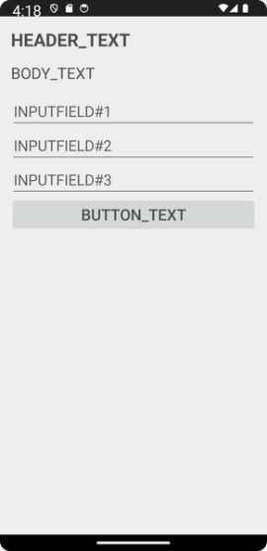 | 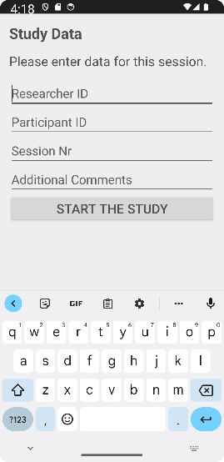
Metadata
LOG  LOG;Text  LOG;The first block starts here | Logs any predefined text in the output and when this part of the protocol was reached. It can be used to increase the readability of the output.
STUDY_ID  STUDY_ID;Text  STUDY_ID;MyFirstOutdoorStudy_lab phone1 | Optional. If used, each generated output file will start with this text. It helps to organize the collected data, mainly if more lab phones are used (e.g., social experiments)
// This is ignored  --- This is also ignored  This is also ignored because anything that does not start with a command is ignored. | Lines that do not start with any command will be ignored. Thus, any characters can be used for commenting and syntax readability in line with personal preferences.
END | Optional. Commands placed after this command will not be executed. It is helpful when the user wants to retain some commands in the bottom part of the protocol file, e.g., for later use during protocol development or testing.

