Supplementary Information for

Evolutionary bet-hedging at the nanoscale
Mikhail Kryuchkov^{1,}*, Marc Jobin², Vladimir Savitsky³, Stanislav Smirnov⁴, and Vladimir L. Katanaev^{1,5,}*

¹Department of Cell Physiology and Metabolism, Faculty of Medicine, University of Geneva, Rue Michel Servet 1, CH-1211 Geneva, Switzerland.
²HEPIA, University of Applied Sciences of Western Switzerland (HES-SO), 4 Rue de la Prairie, CH-1202 Geneva, Switzerland.
³Zoological Museum of the Lomonosov Moscow State University, Bol'shaya Nikitskaya Street 2, Moscow 125009, Russian Federation.
⁴Section of Mathematics, University of Geneva, Rue du Conseil-Général 7-9, CH-1205 Geneva, Switzerland.
⁵School of Medicine and Life Sciences, Far Eastern Federal University, Sukhanova Street 8, Vladivostok 690922, Russian Federation.
*Correspondence to: Mikhail.Kryuchkov@unige.ch and Vladimir.Katanaev@unige.ch

This Supplementary Information consists of Supplementary Tables S1-S6, Supplementary Figures S1-S8, Supplementary Notes 1-4, Supplemental Methods and Supplementary References, altogether providing exhaustive description of details of the technical aspects of our work.

Supplementary Table S1. Screening of different Coleopteras' corneal nanocoatings.
# | Suborder and series | Superfamily | Family | Species | nanostructures type | AFM (2x2μm)
1 | suborder Archostemata |  | Cupedidae | Cupes mucidus | dimples to maze-type | 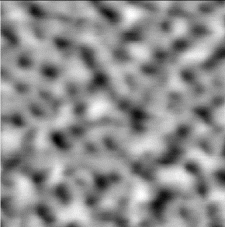
 | suborder Adephaga
2 | Carabiformia | Caraboidea | Carabidae | Calomena littoralis | smooth | _
3 | Carabiformia | Caraboidea | Carabidae | Megacephala euphratica | smooth | _
4 | Carabiformia | Caraboidea | Carabidae | Carabus (Archicarabus) nemoralis | smooth | _
5 | Carabiformia | Caraboidea | Carabidae | Carabus (Archiplectes) starcki | smooth | _
6 | Carabiformia | Caraboidea | Carabidae | Carabus (Cechenochilus) heydenianus | smooth | _
7 | Carabiformia | Caraboidea | Carabidae | Nebria bonelli | smooth | _
8 | Carabiformia | Caraboidea | Carabidae | Elaphrus cupreus | maze-type to nipples-like | 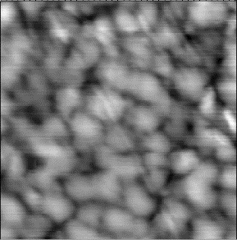
9 | Carabiformia | Caraboidea | Carabidae | Elaphrus riparius | maze-type to nipples-like | 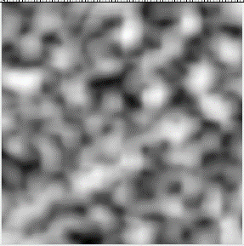
10 | Carabiformia | Caraboidea | Carabidae | Chlaenius spoliatus | smooth | _
11 | Carabiformia | Caraboidea | Carabidae | Pterostichus niger | smooth | _
12 | Carabiformia | Caraboidea | Noteridae | Noterus crassicornis | smooth to dimples | 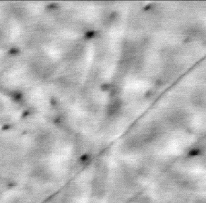
13 | Dytisciformia | Dytiscoidea | Dytiscidae | Agabus glacialis | smooth | _
14 | Dytisciformia | Dytiscoidea | Dytiscidae | Cybister lateralimarginalis | smooth | _
 | suborder Polyphaga
15 | Dytisciformia | Dytiscoidea | Dytiscidae | Hydrotus enneagrammus | smooth | _
16 | Staphyliniformia | Hydrophiloidea | Hydrophilidae | Hydrophilus piceus | smooth | _
17 | Staphyliniformia | Hydrophiloidea | Hydrophilidae | Hydrochara affinis | smooth | _
18 | Staphyliniformia | Hydrophiloidea | Hydrophilidae | Sphaeridium sp. | smooth | _
19 | Staphyliniformia | Histeroidea | Histeridae | Onthophilus striatus | smooth | _
20 | Staphyliniformia | Staphylinoidea | Hydraenidae | Hydraena sp. | smooth | _
21 | Staphyliniformia | Staphylinoidea | Silphidae | Necrophorus vespillo | smooth | _
22 | Staphyliniformia | Staphylinoidea | Silphidae | Oiceoptoma thoracicum | rough (smooth) | _
23 | Staphyliniformia | Staphylinoidea | Leiodidae | Agathidium sp. | dimples | 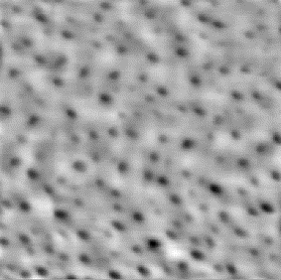
24 | Staphyliniformia | Staphylinoidea | Staphylinidae | Oxyporus mannerheimi | dimples | 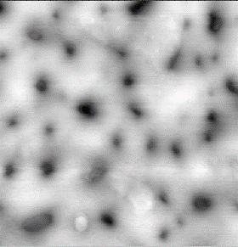
25 | Staphyliniformia | Staphylinoidea | Staphylinidae | Ontholestes tesselatus | rough (smooth) | _
26 | Staphyliniformia | Staphylinoidea | Staphylinidae | Creophilus maxillosus | smooth | _
27 | Staphyliniformia | Staphylinoidea | Scydmaenidae | Mastigus sp. | maze-type to nipples-like | 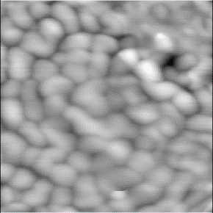
28 | Scarabaeiformia | Scarabaeoidea | Lucanidae | Dorcus parallelopipedus | smooth (polished) | _
29 | Scarabaeiformia | Scarabaeoidea | Lucanidae | Sinodendron cylindricum | smooth | _
30 | Scarabaeiformia | Scarabaeoidea | Scarabaeidae | Geotrupes inermis | smooth | _
31 | Scarabaeiformia | Scarabaeoidea | Scarabaeidae | Copris lunaris | smooth | _
32 | Scarabaeiformia | Scarabaeoidea | Scarabaeidae | Scarabaeus pius | smooth | _
33 | Scarabaeiformia | Scarabaeoidea | Scarabaeidae | Anisoplia agricola | smooth | _
34 | Scarabaeiformia | Scarabaeoidea | Scarabaeidae | Phyllopertha horticola | smooth | _
35 | Scarabaeiformia | Scarabaeoidea | Scarabaeidae | Hoplia parvula | smooth | _
36 | Scarabaeiformia | Scarabaeoidea | Scarabaeidae | Epicomethis hirta | smooth | _
37 | Scarabaeiformia | Scarabaeoidea | Scarabaeidae | Eucetonia magnifica | smooth | _
38 | Elateriformia | Dascilloidea | Dascillidae | Escalerina microcephala | smooth | _
39 | Elateriformia | Buprestoidea | Buprestidae | Chalcophora mariana | dimples | 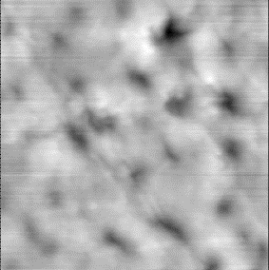
40 | Elateriformia | Buprestoidea | Buprestidae | Dicerca alni | rough (smooth) | _
41 | Elateriformia | Buprestoidea | Buprestidae | Sphenoptera cuprina | rough (smooth) | _
42 | Elateriformia | Byrrhoidea | Byrrhidae | Byrrhus pilula | smooth | _
43 | Elateriformia | Byrrhoidea | Byrrhidae | Curimus sp. | smooth | _
44 | Elateriformia | Byrrhoidea | Elmidae | Elmis sp. | smooth | _
45 | Elateriformia | Byrrhoidea | Heteroceridae | Heterocerus parallelus | smooth | _
46 | Elateriformia | Elateroidea | Throscidae | Throscus sp. | smooth | _
47 | Elateriformia | Elateroidea | Elateridae | Prosternon tessellatum | smooth to dimples | 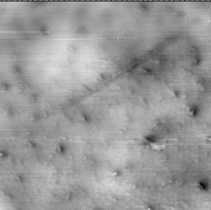
48 | Elateriformia | Elateroidea | Elateridae | Athous subfuscus | smooth to dimples | 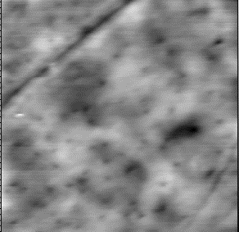
49 | Elateriformia | Cantharoidea | Lycidae | Dictyoptera aurora | maze-type to nipples-like | 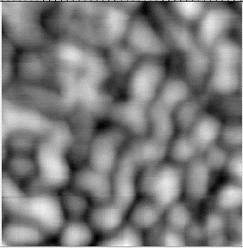
50 | Elateriformia | Cantharoidea | Phengodidae | Cydistus sp. | smooth | _
51 | Elateriformia | Cantharoidea | Lampyridae | Luciola mingrelica | paving stones-like structures | 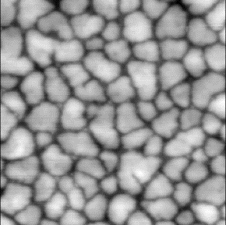
52 | Elateriformia | Cantharoidea | Lampyridae | Lampyris noctiluca | maze-type to nipples-like | 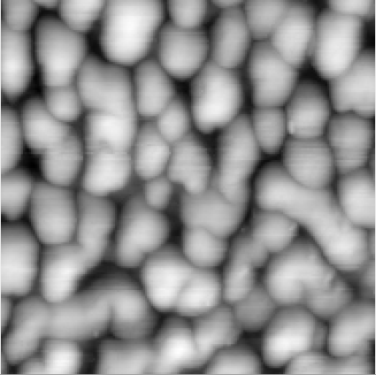
53 | Bostrychiformia | Bostrychoidea | Dermestidae | Dermestes laniarius | smooth | _
54 | Bostrychiformia | Bostrychoidea | Dermestidae | Attagenus schaefferi | smooth | _
55 | Bostrychiformia | Bostrychoidea | Bostrichidae | Bostrychus capucinus | smooth | _
56 | Cucujiformia | Lymexyloidea | Lymexylidae | Elateroides dermestoides | smooth to dimples | 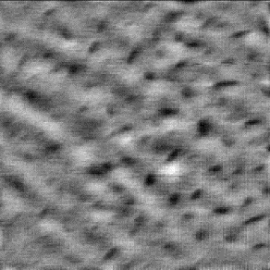
57 | Cucujiformia | Cleroidea | Cleridae | Thanassimus formicarius | dimples | 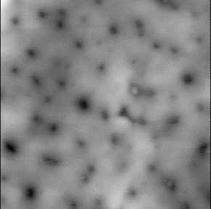
58 | Cucujiformia | Cleroidea | Cleridae | Trichodes apiarius | smooth | _
59 | Cucujiformia | Cleroidea | Malachiidae | Malachius bipustulatus | smooth | _
60 | Cucujiformia | Cleroidea | Melyridae | Enicopus pilosus | rough (smooth) | _
61 | Cucujiformia | Cleroidea | Melyridae | Dolichosoma lineare | smooth | _
62 | Cucujiformia | Cucujoidea | Byturidae | Byturus ochraceus | maze type | 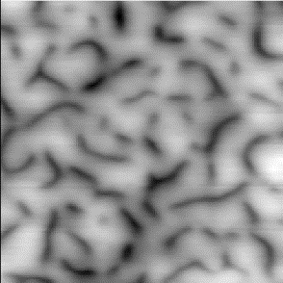
63 | Cucujiformia | Cucujoidea | Erotylidae | Episcapha morawitzi | smooth to dimples | 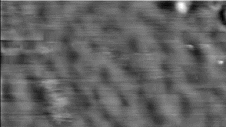
64 | Cucujiformia | Cucujoidea | Erotylidae | Tritoma subbasalis | smooth | _
65 | Cucujiformia | Cucujoidea | Nitidulidae | Cyllodes ater | smooth | _
66 | Cucujiformia | Cucujoidea | Cucujidae | Cucujus haematodes | smooth | _
67 | Cucujiformia | Cucujoidea | Endomychidae | Endomychus armeniacus | smooth | _
68 | Cucujiformia | Cucujoidea | Endomychidae | Mycetina marginalis | smooth | _
69 | Cucujiformia | Cucujoidea | Coccinellidae | Calvia quatuordecimguttata | dimples | 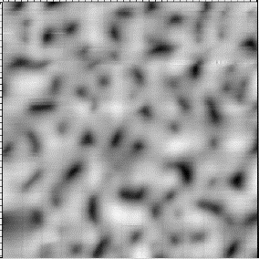
70 | Cucujiformia | Cucujoidea | Coccinellidae | Henosepilachna vigintioctomaculata | dimples to maze-type | 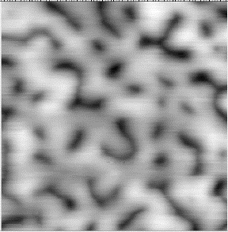
71 | Cucujiformia | Tenebrionoidea | Mycetophagidae | Mycetophagus quadripustulatus | dimples | 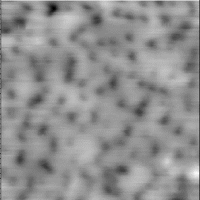
72 | Cucujiformia | Tenebrionoidea | Mycteridae | Mycterus tibialis | maze-type to nipples-like | 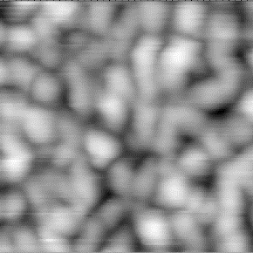
73 | Cucujiformia | Tenebrionoidea | Colydiidae | Bitoma crenata | smooth | _
74 | Cucujiformia | Tenebrionoidea | Anthicidae | Anthelephila pedestris | smooth | _
75 | Cucujiformia | Tenebrionoidea | Salpingidae | Salpingus caucasicus | smooth | _
76 | Cucujiformia | Tenebrionoidea | Meloidae | Cerocoma schreberi | smooth | _
77 | Cucujiformia | Tenebrionoidea | Meloidae | Rhampholissa steveni | dimples | 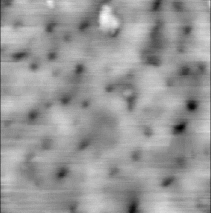
78 | Cucujiformia | Tenebrionoidea | Meloidae | Mylabris calida | dimples | 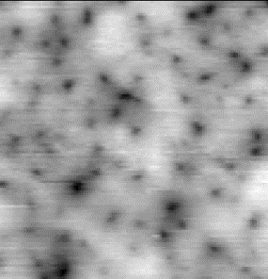
79 | Cucujiformia | Tenebrionoidea | Meloidae | Epicauta erythrocephala | dimples to maze-type | 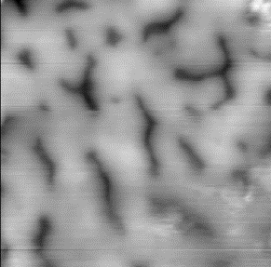
80 | Cucujiformia | Tenebrionoidea | Tenebrionidae | Diaphanidus ferrugineus | dimples to maze-type | 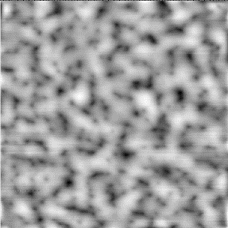
81 | Cucujiformia | Tenebrionoidea | Tenebrionidae | Tentyria nomas | smooth to dimples | 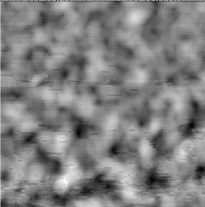
82 | Cucujiformia | Tenebrionoidea | Tenebrionidae | Pimelia subglobosa | smooth | _
83 | Cucujiformia | Tenebrionoidea | Tenebrionidae | Diaperis boleti | smooth | _
84 | Cucujiformia | Tenebrionoidea | Tenebrionidae | Bolitophagus reticulatus | maze-type | 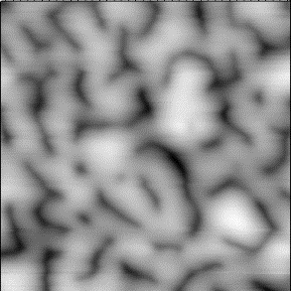
85 | Cucujiformia | Tenebrionoidea | Alleculidae | Isomira murina | smooth | _
86 | Cucujiformia | Tenebrionoidea | Alleculidae | Omophlus sp. | dimples | 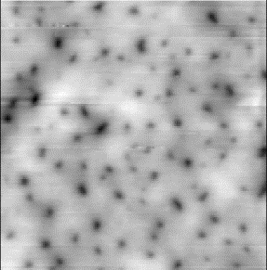
87 | Cucujiformia | Chrysomeloidea | Cerambycidae | Rhagium mordax | smooth | _
88 | Cucujiformia | Chrysomeloidea | Cerambycidae | Cortodera sp. | smooth to dimples | 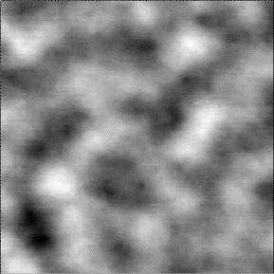
89 | Cucujiformia | Chrysomeloidea | Cerambycidae | Pachyta quadrimaculata | maze type to nipples-like | 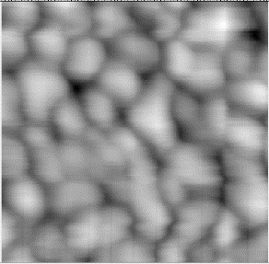
90 | Cucujiformia | Chrysomeloidea | Cerambycidae | Strangalia attenuata | nipples-like | 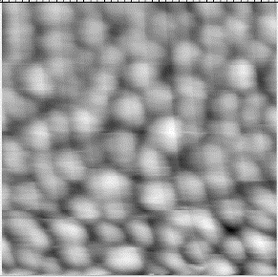
91 | Cucujiformia | Chrysomeloidea | Cerambycidae | Dorcadion carinatum | smooth | _
92 | Cucujiformia | Chrysomeloidea | Cerambycidae | Agapanthia subchalybaea | smooth | _
93 | Cucujiformia | Chrysomeloidea | Chrysomelidae | Oulema melanopus | smooth to dimples | 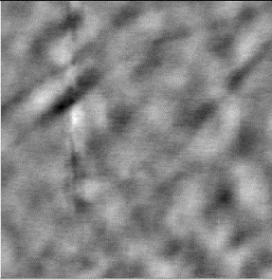
94 | Cucujiformia | Chrysomeloidea | Chrysomelidae | Chrysochares asiatica | smooth | _
95 | Cucujiformia | Chrysomeloidea | Chrysomelidae | Chrysolina porphyrea | smooth | _
96 | Cucujiformia | Chrysomeloidea | Chrysomelidae | Chrysomela populi | smooth | _
97 | Cucujiformia | Chrysomeloidea | Chrysomelidae | Theone silphoides | smooth | _

Supplementary Table S2. Previously studied Coleoptera species.
# | Infraorder | Superfamily | Family | Species | nanostructures type | ref.
98 | Cucujiformia | Tenebrionoidea | Oedemeridae | Xanthochroa luteipennis | maze-type | ¹
99 | Adephaga | Gyrinoidea | Gyrinidae | Gyrinus sp. | maze-type (overwater) / smooth (underwater eyes) | ²
100 | Adephaga | Gyrinoidea | Gyrinidae | Orectochilus sp. | maze-type (overwater) / smooth (underwater eyes) | ²
101 | Cucujiformia | Cucujoidea | Coccinellidae | Psyllobora vigintiduopunctata | maze-type | ³
102 | Staphyliniformia | Staphylinoidea | Staphylinidae | Nudobius sp. | maze-type | ³
103 | Carabiformia | Caraboidea | Carabidae | non-identified species | dimples | ³
104 | Scarabaeiformia | Scarabaeoidea | Scarabaeidae | non-identified species | smooth | ³

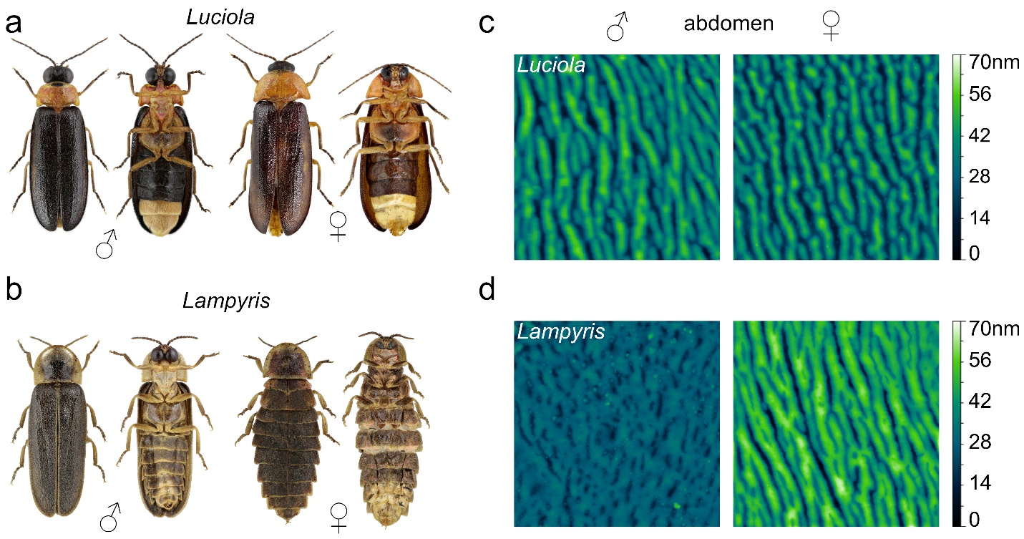
Supplementary Fig. S1. Fireflies' sexual dimorphism at the micro- and nano-levels. (a, b) Representative photographs of the dorsal and ventral views of the investigated fireflies Luciola lusitanica (a) and Lampyris noctiluca (b). Lanterns are seen as light segments of the abdomina (ventrites 5-6). (c, d) AFM scans of the abdomen cuticles (ventrite 5) of Luciola (c) and Lampyris (d), 3x3μm. A clear difference between Lampyris males' and females' nanostructures could be seen. The color scale next to the image indicates the surface height.

Supplementary Note 1. Anti-wettability.
Wenzel and Cassie-Baxter models are applied to describe the wettability of surfaces^{4,5}. According to the Wenzel model, the difference in the hydrophobicity between the Lampyris males' and females' eyes (Fig. 1e) can be either due to different roughness ratios (r) of their surfaces, or their different chemical nature. In the first scenario, the equation:
cosϴ_{M}=r ×cosϴ_{Y} Eq.1
applies, where ϴ_{M} is the experimentally measured water droplet contact angle and ϴ_{Y} is the Young contact angle, characteristic for this material in case of a smooth surface. Given the contact angles we measured (Fig. 1e), the calculated r_{male}/r_{female} ratio should equal 6.3. The measured roughness ratios derived from AFM measurements, however, are very close for the two samples: 1.013 (Lampyris male) and 1.006 (Lampyris female), which cannot explain the wettability properties of these surfaces (Supplementary Fig. 2a). From these data, we can also take that ϴ_{Y} is essentially equal to ϴ for Lampyris.
As a probe towards potentially different chemical nature of the material dominating the corneal surfaces of Lampyris males vs. females, we assessed their adhesiveness and elasticity parameters, finding that, indeed, the female corneae are less adhesive and more elastic, than those of the males (Fig. 1c and Supplementary Fig. S2b). We thus conclude that it is the difference in the chemical composition of the Lampyris corneal surfaces in the two sexes that contributes to the observed difference in their hydrophobicities, following the Wenzel model. This sexual dimorphism of the chemical composition in Lampyris is most likely due to the different relative content of protein vs. waxes as the main components of corneal nanocoatings⁶⁻⁸.
In contrast to Lampyris, it is the Cassie-Baxter model that takes into account small air bubbles trapped by the paving stones-like corneal nanostructures of Luciola that explains their superb hydrophobicity (Supplementary Fig. 2d).
To seek the formal proof of the applicability the Cassie-Baxter model to the experimental data we obtained with Luciola fireflies, we introduce the following additional parameters:
σ_{air} – fraction of the water droplet surface area covered by air gaps;
σ – fraction of the water droplet surface area not covered by air gaps (σ = 1 - σ_{air});
Adh_{σ} – adhesion force of the air-free surface (note when σ_{air} equals zero, Adh_{σ} = Adh, the measured adhesion force of the surface);
ϴ – the calculated parameter corresponding to the contact angle that the surface not covered with air would give when interacting with the water droplet. Note that when σ_{air} equals zero, ϴ = ϴ_{M.}
There are two ways of finding ϴ. One is the direct application of the Cassie-Baxter equation:
cosϴ × (1 - σ_{air}) - σ_{air} = cosϴ_{M} Eq.2.
The blue graph in Supplementary Fig. S2e shows that for a given experimentally measured contact angle ϴ_{M}, ϴ is calculated to gradually decrease upon the growth in the area covered by air, σ_{air}.
Another approach to obtain ϴ builds on the following assumptions. First, the contact angle of the material is inversely proportional to its adhesion force in the range of the contact angles from ca. 35° to ca. 90°, as shown for several plastic materials⁹:
ϴ ∝ 1/ Adh_{σ} Eq.3.
Having measured the average adhesion and contact angles for Lampyris male and female corneal surfaces, we deduced the empirical formula:
ϴ = 162.4 - 2.45 Adh Eq.4,
where ϴ is given in ° and Adh in nN. We remind that the Lampyris hydrophobicity is explained by the Wenzel model and does not presume formation of any air gaps. As similar adhesion force and Young modulus values are obtained for the corneal surfaces of Luciola and Lampyris (males, Fig. 1b, c and Supplementary Fig. S2b, c), we must conclude on the similar chemical content of these surfaces, permitting us to apply Eq.4 also to the Luciola surfaces, with Adh becoming Adh_{σ}.
The format of the adhesion force data as obtained by the AFM measurements permitted us to process the data in the manner, whereas Adh values could be separately obtained for selected regions of the scanned surface. We reasoned that for the paving stones-like structures, air bubbles could be trapped in the depth between the individual nanostructures (Supplementary Fig. S2d, f). Manual exclusion of the contact zones (grooves) between the paving stones from the adhesion force measured areas produced the Adh_{σ} values calculated for the remaining zones; step-by-step incrementation of the excluded area, corresponding to the increased σ_{air}, then permitted to calculate the Adh_{σ} values in their dependence to the possible σ_{air} (Supplementary Fig. S2f). We note that this operation progressively reduced the calculated Adh_{σ}, as the grooves contain more adhesive, and the hills of the nanostructures – less adhesive material (Fig. 1b, Supplementary Fig. S2d, gray scale in Supplementary Fig. S2f). The resultant Adh_{σ} values were next transformed into the contact angles with Eq.4, and the final result was plotted as the orange graph in Supplementary Fig. S2e.
The two graphs (blue and organge, Supplementary Fig. S2e) intersect at the σ_{air} value of 0.11, the value that appears physiologically reasonable. This analysis thus permits us to propose that the hydrophobicity of the Luciola corneal surfaces indeed obeys the Cassie-Baxter model, and that ca. 11% of these surfaces are covered by air bubbles (Supplementary Fig. 2d).

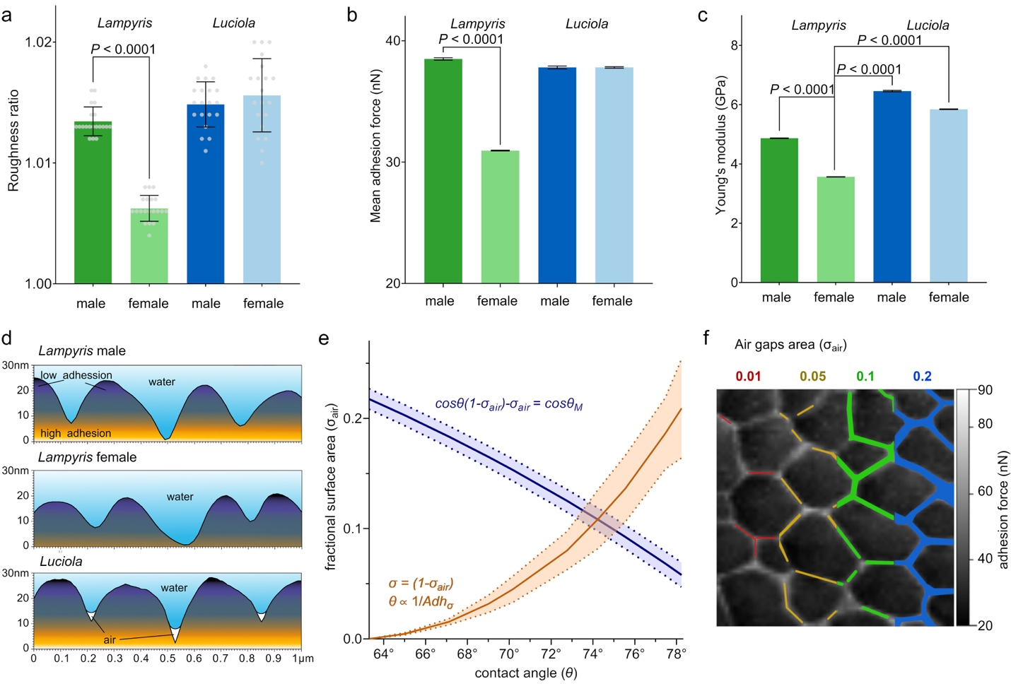
Supplementary Fig. S2. The strong anti-wetting properties of paving stones-like nanocoatings through the Cassie-Baxter model. (a) Quantification of the surface roughness ratio of the investigated corneal nanocoatings. Data are shown as mean ± SD ; n=20. (b) Quantification of the adhesion force (nN) of the corneal nanocoatings. Data are mean ± SEM, n=25'000-30'000. (c) Quantification of the Young modulus (GPa) of the corneal nanocoatings. Data are mean ± SEM, n=40'000-60’000. (d) Representative AFM data cross-sections of nanocoatings show differences in their interaction with water. Note the tighter contacts between Luciola nanostructures that can trap air due to the water surface tension. (e) Contact angle dependence on the air gaps area, counted by the Cassie-Baxter law (blue), and by approximation of adhesion of the air-free areas (orange). The intersection of these graphs detects the possible fraction of the surface covered by air in Luciola (11%). Mean ± SD, n=3. (f) Schematic representation of air gaps formed in grooves of Luciola nanostructures. Different amounts of surface area coverage (σ_{air}) is shown in red (0.01), yellow (0.05), green (0.1) and blue (0.2). Adhesion force measurement scan (1x1μm) is shown as background. Statistical significance in (a-c) is shown with t-test.

Supplementary Note 2. Turing simulation parameters and numerical solutions.
The following system of equations describes the Turing reaction-diffusion model^{6,10,11}:
$\left\{\begin{aligned}\frac{∂a}{∂t}=max\left(0, min\left(a_{a}∙a+b_{a}∙b, F_{max}\right)\right)-d_{a}∙a+D_{a}∙Δa+d∙nsu \\ \frac{∂b}{∂t}=max\left(0, min\left(a_{b}∙a+b_{b}∙b, G_{max}\right)\right)-d_{b}∙b+D_{b}∙Δb+d∙nsv\end{aligned}\right.$ Eq.5,
where a and b are the concentrations of the Turing Activator and Inhibitor morphogens, respectively. The Activator can degrade (d_{a}), self-activate (a_{a}) and activate the Inhibitor (a_{b}), while having a low diffusion rate (D_{a}). The Inhibitor can degrade (d_{b}), be self-inhibited (b_{b}), or inhibit the Activator (b_{a}), and has a high diffusion rate (D_{b}). Their secretion level coefficients (nsu and nsv for Activator and Inhibitor, respectively) depend on the random noise (d), emanating from the secretion area. Coefficients F_{max} and G_{max} are needed to control the maximum level of incoming to the system reagents and stabilize the simulation.
Previously^{6,12}, the broadness of nanostructures (ω) has been shown to depend on such parameters as the Turing morphogen diffusion coefficient (D) and the turnover/reaction rate (f), following the equation:
$D∝fω^{2}/4π^{2}$ Eq. 6.
We find that the individual corneal nanostructures in Luciola are significantly narrower than those of Lampyris (239nm vs. 296nm, respectively, Supplementary Fig. S3a). Thus, compared to the Lampyris nanostructures, those of Luciola should have lower diffusion coefficient or an increased reaction rate. Additionally, closely adhering but not merging structures evolve from nipple-like structures upon a decrease in the Activator's diffusion coefficient^{3,13}. In agreement with these considerations, Luciola-like paving stones nanostructures could be generated from the Lampyris-like nipples nanostructures by a two-fold decrease in the activators' diffusion coefficient (Supplementary Fig. S3b, c, Supplementary Table S3).
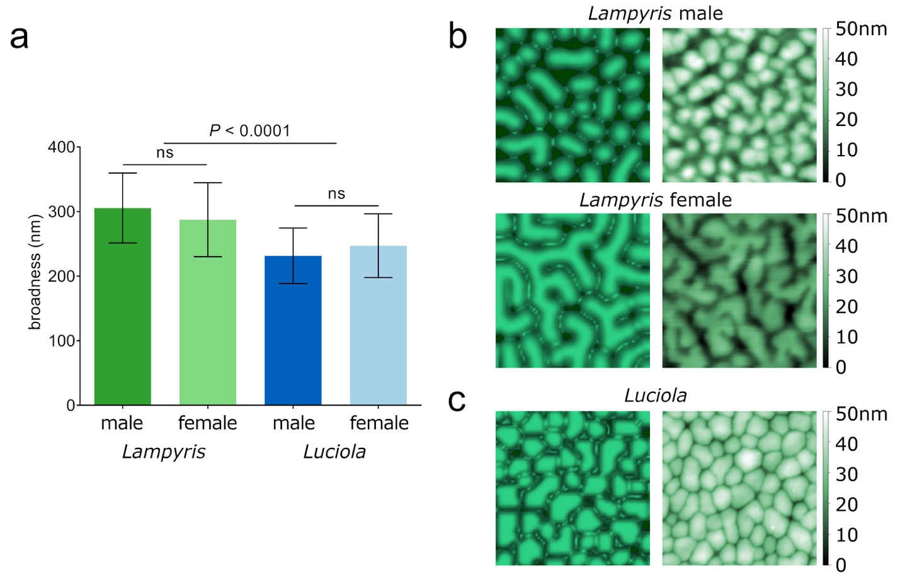

Supplementary Fig. S3. Firefly nanostructures’ comparative broadness as the entry point to set the Turing modeling parameters. (a) The size of the paving stones-like structures is significantly narrower than that of the nipples-like and maze-like structures, hinting at a lower activator diffusion parameter. Data are shown as mean ± SD, n=60, "ns" indicates the absence of significant difference, t-test. (b) Turing modeling (left panels) efficiently recapitulates experimentally observed (right panels) Lampyris male (nipples) and female (maze-like) corneal nanocoatings. For the AFM scans, surface height is indicated by the colour scale shown next to the images. (c) Similarly, the Luciola paving stone-like pattern (experimental image on the right) is faithfully recapitulated by simulation (on the left) using the activator diffusion coefficient twice as low as that used to model Lampyris structures. The exact parameters applied in the simulations in (b, c) are provided in Supplementary Table S3.

Supplementary Table S3. Equations and parameters used for the reaction-diffusion simulations of different nanostructures. 1, Lampyris female; 2, Lampyris male; 3, Luciola female; 4, Luciola male.
 | a_{a} | b_{a} | d_{a} | D_{a} | a_{b} | b_{b} | d_{b} | D_{b} | timestep | F_{max} | G_{max} | nsu | nsv
1 | 0.071 | -0.08 | 0.03 | 0.02 | 0.09 | -0.07 | 0.08 | 0.25 | 0.1 | 0.2 | 0.5 | 1.53 | 2.2
2 | 0.071 | -0.08 | 0.03 | 0.02 | 0.09 | -0.07 | 0.08 | 0.25 | 0.1 | 0.2 | 0.5 | 1.4 | 2.2
3 | 0.071 | -0.08 | 0.03 | 0.01 | 0.09 | -0.07 | 0.08 | 0.25 | 0.1 | 0.2 | 0.5 | 1.55 | 4.3
4 | 0.071 | -0.08 | 0.03 | 0.01 | 0.09 | -0.07 | 0.08 | 0.25 | 0.1 | 0.2 | 0.5 | 1.5 | 4.3

Supplementary Note 3. Turing simulation parameters and analytical solution.
In order to determine the possibility of the Turing pattern formation at different distances from the secretion area, we introduce 3D coordinates $x, y, z,$ with secretion localized in layers $z<0$.
We start by analyzing our system in the secretion area $z<0$. Assuming that secretion occurs at a constant rate without any interactions between reagents⁶, and taking $d$ to be the average value of the noise, we get a system
$\left\{\begin{aligned}0=-d_{a}∙a_{0}+d∙nsu \\ 0=-d_{b}∙b_{0}+d∙nsv\end{aligned}\right.$ Eq. 7,
with a solution $a_{0}=d∙nsu/d_{a},b_{0}=d∙nsu /d_{b}.$
It can be then argued that constant secretion amounts to imposing Dirichlet boundary conditions $a\left(x,y,0\right)=a_{0}, b\left(x,y,0\right)=b_{0}$ for the reaction-diffusion equation solved in the half-space $z>0$:
$\left\{\begin{aligned}\frac{∂a}{∂t}=max\left(0, min\left(a_{a}∙a+b_{a}∙b, F_{max}\right)\right)-d_{a}∙a+D_{a}∙Δa \\ \frac{∂b}{∂t}=max\left(0, min\left(a_{b}∙a+b_{b}∙b, G_{max}\right)\right)-d_{b}∙b+D_{b}∙Δb\end{aligned}\right.$ Eq. 8.
Note that the equation is piecewise linear, with linear coefficients in the nine domains depending on the values of $\left(a_{a}∙A+b_{a}∙B, F_{max}\right)$ compared to ${0, F}_{max}$and $a_{b}∙A+b_{b}∙B, G_{max}$compared to ${0, G}_{max}$. Writing the four conditions for Turing instability:
$\left\{ \begin{aligned}f_{a}≔ \frac{∂}{∂A}\left(-d_{a}⋅A+max\left(0, min\left(a_{a}∙A+b_{a}∙B, F_{max}\right)\right)\right)={-d}_{a}+{〈a_{a}〉}_{only in the middle region} \\ g_{b}≔ \frac{∂}{∂B}\left(-d_{b}⋅B+max\left(0, min\left(a_{b}∙A+b_{b}∙B, G_{max}\right)\right)\right)={-d}_{b}+{〈b_{b}〉}_{only in the middle region}\end{aligned}\right.$ Eq. 9.
We see that for all four of our regimes, we have
- $f_{a}>0$ only in the middle region $0<a_{a}∙A+b_{a}∙B<F_{max}$
- $g_{b}<0$ always
- $f_{a}+g_{b}<0$ always
- ${D_{b}f_{a}+D_{a}g}_{b}>0$always
So the instability occurs when $0<a_{a}∙A+b_{a}∙B<F_{max}$, that is in 3 out of 9 domains.
Now assume existence of a homogenous (in 2D layers, so depending only on $z$) steady state
$A\left(z\right),B\left(z\right),$defined on the half-line $z>0,$ which then satisfies $A\left(0\right)=a_{0}, B\left(0\right)=b_{0}$ and
$\left\{ \begin{aligned}0=D_{a}\frac{∂^{2}A}{∂z^{2}}-d_{a}∙A+max\left(0, min\left(a_{a}∙A+b_{a}∙B, F_{max}\right)\right) \\ 0=D_{b}\frac{∂^{2}B}{∂z^{2}}-d_{b}∙B+max\left(0, min\left(a_{b}∙A+b_{b}∙B, F_{max}\right)\right)\end{aligned}\right.$ Eq. 10.
We can treat this as an ODE system with time parameter$z$ and solve it with given boundary conditions until the solution enters the Turing instability domain, where the patterning occurs (and also prevents us from continuing the analysis in $z$.
Below we analyze the equation in the six stable domains, and then plug in numerical values of the coefficients. This allows us to plot trajectories $A\left(z\right), B(z)$until they hit the instability domain.
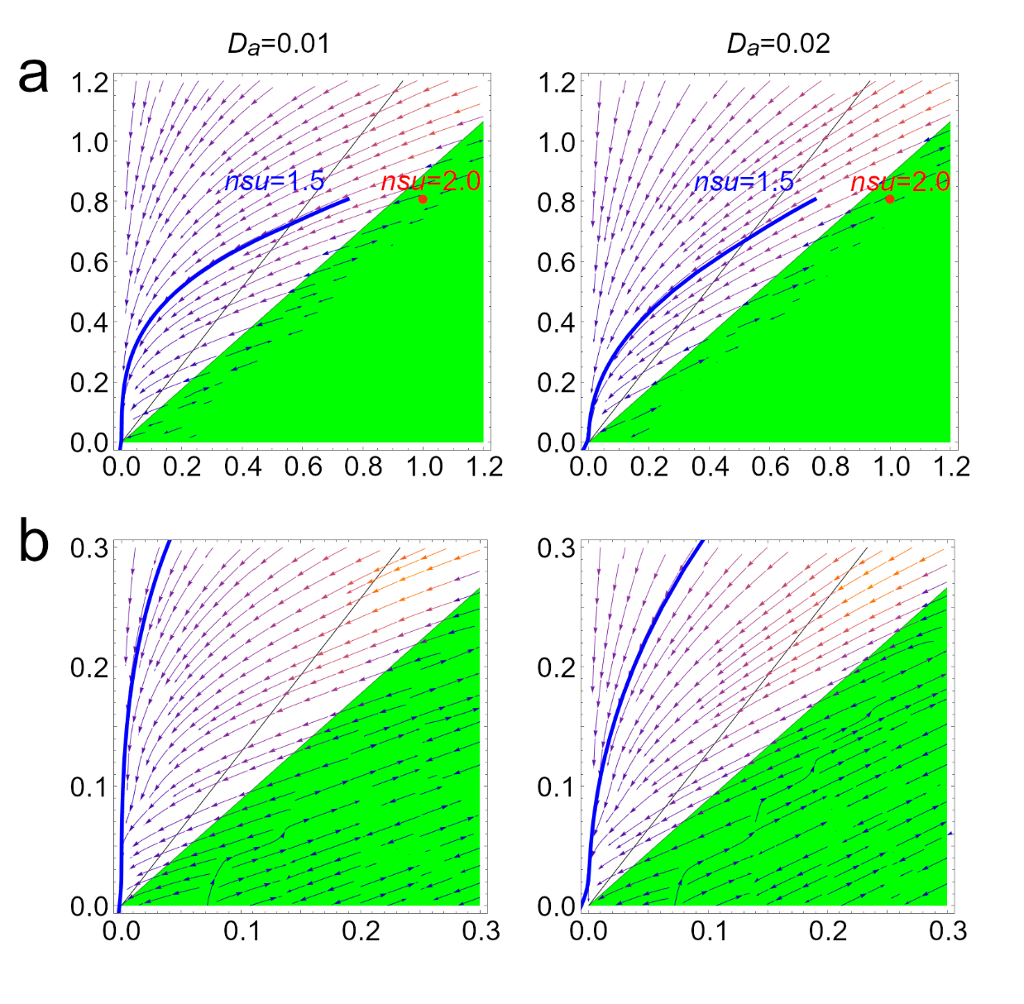
Supplementary Fig. S4. a, Graphs showing a behavior of the system with given parameters: activators diffusion equal to 0.01 (left) and 0.02 (right). Blue and red curves show different activator secretion levels (1.5 for blue and 2.0 for red). The coordinates A and B are plotted. Black lines are boundaries of 9 regions, and the 3 Turing unstable areas are colored green. When z increases, initial coordinates follow the vector field unless they reach the instability region. It can be seen that the red curve (nsu=2.0) starts from the Turing region, whereas the blue curves moves towards it but never reaching. b. A magnified view of these graphs shows that with a lower diffusion coefficient, the curve almost reaches the Turing region, and with a reasonable level of noise, the system can form Turing patterns. In the case of a higher diffusion coefficient (0.02), the curve does not reach proximity with the Turing region, and patterns cannot be formed. This data perfectly corresponds with the simulation data (Figure 2c).
Six stable domains and solutions
We write solutions as a function of $z$ assuming $A_{0}=A\left(z_{0}\right), B_{0}=B\left(z_{0}\right).$
$\left\{ \begin{aligned}D_{a}\frac{∂^{2}A}{∂z^{2}}=d_{a}∙A-max\left(0, min\left(a_{a}∙A+b_{a}∙B, F_{max}\right)\right) \\ D_{b}\frac{∂^{2}B}{∂z^{2}}=d_{b}∙B-max\left(0, min\left(a_{b}∙A+b_{b}∙B, G_{max}\right)\right)\end{aligned}\right.$ Eq. 11.

- $R_{11}=\left\{A,B: a_{a}∙A+b_{a}∙B<0, a_{b}∙A+b_{b}∙B<0\right\}$

$\left\{ \begin{aligned}D_{a}\frac{∂^{2}A}{∂z^{2}}=d_{a}∙A \\ D_{b}\frac{∂^{2}B}{∂z^{2}}=d_{b}∙B\end{aligned}\right.$ Eq. 12.
Solution
$\left\{ \begin{aligned}A(z_{0}+z)=A_{0} exp\left(-\sqrt{{d_{a}}/{D_{a}}} z\right) \\ B(z_{0}+z)=B_{0} exp\left(-\sqrt{{d_{b}}/{D_{b}}} z\right)\end{aligned}\right.$ Eq. 13.
Vector field tangent to trajectories at $A,B$ (obtain by differentiating in $z$ at $z=0$)
$$\left(-A\sqrt{{d_{a}}/{D_{a}}}, -B\sqrt{{d_{b}}/{D_{b}}}\right)$$

- $R_{12 }=\left\{A,B: a_{a}∙A+b_{a}∙B<0, 0<a_{b}∙A+b_{b}∙B< G_{max}\right\}$

$\left\{ \begin{aligned}D_{a}\frac{∂^{2}A}{∂z^{2}}=d_{a}∙A \\ D_{b}\frac{∂^{2}B}{∂z^{2}}={-a_{b}∙A+ (d}_{b}-b_{b}) ∙B\end{aligned}\right.$ Eq. 14.
Solution
$\left\{\begin{aligned}A(z_{0}+z)=A_{0} exp\left(-\sqrt{{d_{a}}/{D_{a}}} z\right) \\ B\left(z_{0}+z\right)= A exp\left(-\sqrt{{d_{a}}/{D_{a}}} z\right) {a_{b}D_{a}}/{\left(D_{a}d_{b}-D_{a}b_{b}-D_{b}d_{a}\right)}+ \\ +\left(B-{A a_{b}D_{a}}/{\left(D_{a}d_{b}-D_{a}b_{b}-D_{b}d_{a}\right)}\right) exp\left(-\sqrt{{\left(d_{b}-b_{b}\right)}/{D_{b}}} z\right) \end{aligned}\right.$ Eq. 15.
Vector field tangent to trajectories at $A,B$
$$\left(-A\sqrt{{d_{a}}/{D_{a}}}, -A \sqrt{{d_{a}}/{D_{a}}} {a_{b}D_{a}}/{\left(D_{a}d_{b}-D_{a}b_{b}-D_{b}d_{a}\right)}-\left(B-{{A a}_{b}D_{a}}/{\left(D_{a}d_{b}-D_{a}b_{b}-D_{b}d_{a}\right)}\right) \sqrt{{\left(d_{b}-b_{b}\right)}/{D_{b}}}\right)$$

- $R_{13}=\left\{A,B: a_{a}∙A+b_{a}∙B<0, G_{max}< a_{b}∙A+b_{b}∙B\right\}$

$\left\{ \begin{aligned}D_{a}\frac{∂^{2}A}{∂z^{2}}=d_{a}∙A \\ D_{b}\frac{∂^{2}B}{∂z^{2}}=d_{b}∙B-G_{max}\end{aligned}\right.$ Eq. 16.
Solution
$\left\{ \begin{aligned}A(z_{0}+z)=A_{0} exp\left(-\sqrt{{d_{a}}/{D_{a}}} z\right) \\ B(z_{0}+z)=\left(B_{0}-{G_{max}}/{d_{b}}\right) exp\left(-\sqrt{{d_{b}}/{D_{b}}} z\right)+{G_{max}}/{d_{b}}\end{aligned}\right.$ Eq. 17.
Vector field tangent to trajectories at $A,B$
$$\left(-\sqrt{{d_{a}}/{D_{a}}}A, -\left(B-{G_{max}}/{d_{b}}\right)\sqrt{{d_{b}}/{D_{b}}}\right)$$

- $R_{31}=\left\{A,B: F_{max}<a_{a}∙A+b_{a}∙B, a_{b}∙A+b_{b}∙B<0\right\}$

$\left\{ \begin{aligned}D_{a}\frac{∂^{2}A}{∂z^{2}}=d_{a}∙A-F_{max} \\ D_{b}\frac{∂^{2}B}{∂z^{2}}=d_{b}∙B\end{aligned}\right.$ Eq. 18.
Solution
$\left\{ \begin{aligned}A(z_{0}+z)=\left(A_{0}-{F_{max}}/{d_{a}}\right) exp\left(-\sqrt{{d_{a}}/{D_{a}}} z\right)+{F_{max}}/{d_{a}} \\ B\left(z_{0}+z\right)=B_{0} exp\left(-\sqrt{{d_{b}}/{D_{b}}} z\right)\end{aligned}\right.$ Eq. 19.
Vector field tangent to trajectories at $A,B$
$$\left(-\left(A-{F_{max}}/{d_{a}}\right)\sqrt{{d_{a}}/{D_{a}}}, -B\sqrt{{d_{b}}/{D_{b}}}\right)$$

- $R_{32 }=\left\{A,B: F_{max}<a_{a}∙A+b_{a}∙B, 0<a_{b}∙A+b_{b}∙B< G_{max}\right\}$

$\left\{ \begin{aligned}D_{a}\frac{∂^{2}A}{∂z^{2}}=d_{a}∙A -F_{max} \\ D_{b}\frac{∂^{2}B}{∂z^{2}}={-a_{b}∙A+ (d}_{b}-b_{b}) ∙B\end{aligned}\right.$ Eq. 20.
Solution
$\left\{\begin{aligned}A(z_{0}+z)=\left(A_{0}-{F_{max}}/{d_{a}}\right) exp\left(-\sqrt{{d_{a}}/{D_{a}}} z\right)+{F_{max}}/{d_{a}} \\ B\left(z_{0}+z\right)=a_{b}D_{a}\left(A_{0}-{F_{max}}/{d_{a}}\right) / \left(D_{a}d_{b}-D_{a}b_{b}-D_{b}d_{a}\right) exp\left(-\sqrt{{d_{a}}/{D_{a}}} z\right)+a_{b}{F_{max}}/{\left(d_{a}\left(d_{b}-b_{b}\right)\right)}+ \\ + \left(B_{0}-a_{b}{F_{max}}/{\left(d_{a}\left(d_{b}-b_{b}\right)\right)}-a_{b}D_{a}\left(A_{0}-{F_{max}}/{d_{a}}\right) / \left(D_{a}d_{b}-D_{a}b_{b}-D_{b}d_{a}\right)\right) exp\left(-\sqrt{{\left(d_{b}-b_{b}\right)}/{D_{b}}} z\right)\end{aligned}\right.$ Eq. 21.
Vector field tangent to trajectories at $A,B$
$$\left(-\left(A-{F_{max}}/{d_{a}}\right)\sqrt{{d_{a}}/{D_{a}}}, -\sqrt{{d_{a}}/{D_{a}}}a_{b}D_{a}\left(A-{F_{max}}/{d_{a}}\right) / \left(D_{a}d_{b}-D_{a}b_{b}-D_{b}d_{a}\right)-\sqrt{{\left(d_{b}-b_{b}\right)}/{D_{b}}}\left(B-a_{b}{F_{max}}/{\left(d_{a}\left(d_{b}-b_{b}\right)\right)}-a_{b}D_{a}\left(A-{F_{max}}/{d_{a}}\right) / \left(D_{a}d_{b}-D_{a}b_{b}-D_{b}d_{a}\right)\right)\right)$$

- $R_{33}=\left\{A,B: F_{max}<a_{a}∙A+b_{a}∙B, G_{max}< a_{b}∙A+b_{b}∙B\right\}$

$\left\{ \begin{aligned}D_{a}\frac{∂^{2}A}{∂z^{2}}=d_{a}∙A-F_{max} \\ D_{b}\frac{∂^{2}B}{∂z^{2}}=d_{b}∙B-G_{max}\end{aligned}\right.$ Eq. 22.
Solution
$\left\{ \begin{aligned}A(z_{0}+z)=\left(A_{0}-{F_{max}}/{d_{a}}\right) exp\left(-\sqrt{{d_{a}}/{D_{a}}} z\right)+{F_{max}}/{d_{a}} \\ B(z_{0}+z)=\left(B_{0}-{G_{max}}/{d_{b}}\right) exp\left(-\sqrt{{d_{b}}/{D_{b}}} z\right)+{G_{max}}/{d_{b}}\end{aligned}\right.$ Eq. 23.
Vector field tangent to trajectories at $A,B$
$$\left(-\left(A-{F_{max}}/{d_{a}}\right)\sqrt{{d_{a}}/{D_{a}}}, -\left(B-{G_{max}}/{d_{b}}\right)\sqrt{{d_{b}}/{D_{b}}}\right)$$

Supplementary Note 4. Temperature dependence.

To prove the sensitivity of the nanopattern formation to temperatures, we used the Arrhenius equation:
$k=Ae^{\frac{E_{a}}{RT}}$ Eq.24, where E_{a} is the activation energy, which has different values for different reactions. For example, according to meta-analysis¹⁴, the mean value of the activation energy of diffusion is equal to -30000 kJ/mol, whereas the mean activation energy for chemical reactions is -65000 kJ/mol. Further, the activation energy of protein secretion could be defined as -90000 kJ/mol^{15,16}; this value is lower for wax-like molecules equaling -115000 kJ/mol¹⁷. In modeling the secretion processes, we posited that temperature changes do not affect the secretion parameters immediately, introducing a delay of 2 hours for protein production¹⁸ and 2.5 hours for wax production given the enzymatic synthesis of waxes.
As an equation for temperature changes during the day, we used a simple sinusoidal:
$T=\frac{1}{2ΔT}\sin\left(\frac{2π}{24t_{s}}\right)+\overline{T}$ Eq.25,
where $\overline{T}$ is the average temperature during the 24 hours, and ΔT is the difference between the minimal and the maximal temperatures during the 24 hours. As an example of the resultant modeling, for a spring day with $\overline{T}$ = 15°C and ΔT = 20°C, nonstability of the investigated system breaks in the case of Luciola but not in the case of Lampyris (Fig. 2e, Supplementary Fig. S5, Supplementary Table S4).

Supplementary Table S4. Simulations of the nanopattern formation at different weather conditions. $\overline{T}$: average temperature, ΔT: difference between minimal and maximal temperatures during 24 hours. The following color coding applies:
Purple – firefly nanocoatings-like patterns form in all time periods (each period is 2 hours in the modeling);
Magenta – patterns form, and for the majority of the time periods their topographies correspond to those of the fireflies;
Red – patterns form but their topographies (and hence functionalities) differ from those of the fireflies (Luciola and Lampyris, respectively; both males and females);
Orange – patterns form but do not cover the whole corneal surface;
White – no pattern formation possible at least in one time period;
Grey – combinations of $\overline{T}$ and ΔT that produce temperatures below 0°C in at least some time periods.
Luciola
$$\overline{T}$$ |  | 40°
 |  | 35°
 |  | 30°
 |  | 25°
 |  | 20°
 |  | 15°
 |  | 10°
 |  | 5°
 |  | 0°
 |  |  | 0° |  | 2.5° | 5° | 7.5° | 10° | 12.5° | 15° | 17.5° | 20° | 22.5° | 25° | 27.5° | 30°
 |  |  | ΔT
Lampyris
$$\overline{T}$$ |  | 40°
 |  | 35°
 |  | 30°
 |  | 25°
 |  | 20°
 |  | 15°
 |  | 10°
 |  | 5°
 |  | 0°
 |  |  | 0° |  | 2.5° | 5° | 7.5° | 10° | 12.5° | 15° | 17.5° | 20° | 22.5° | 25° | 27.5° | 30°
 |  |  | ΔT

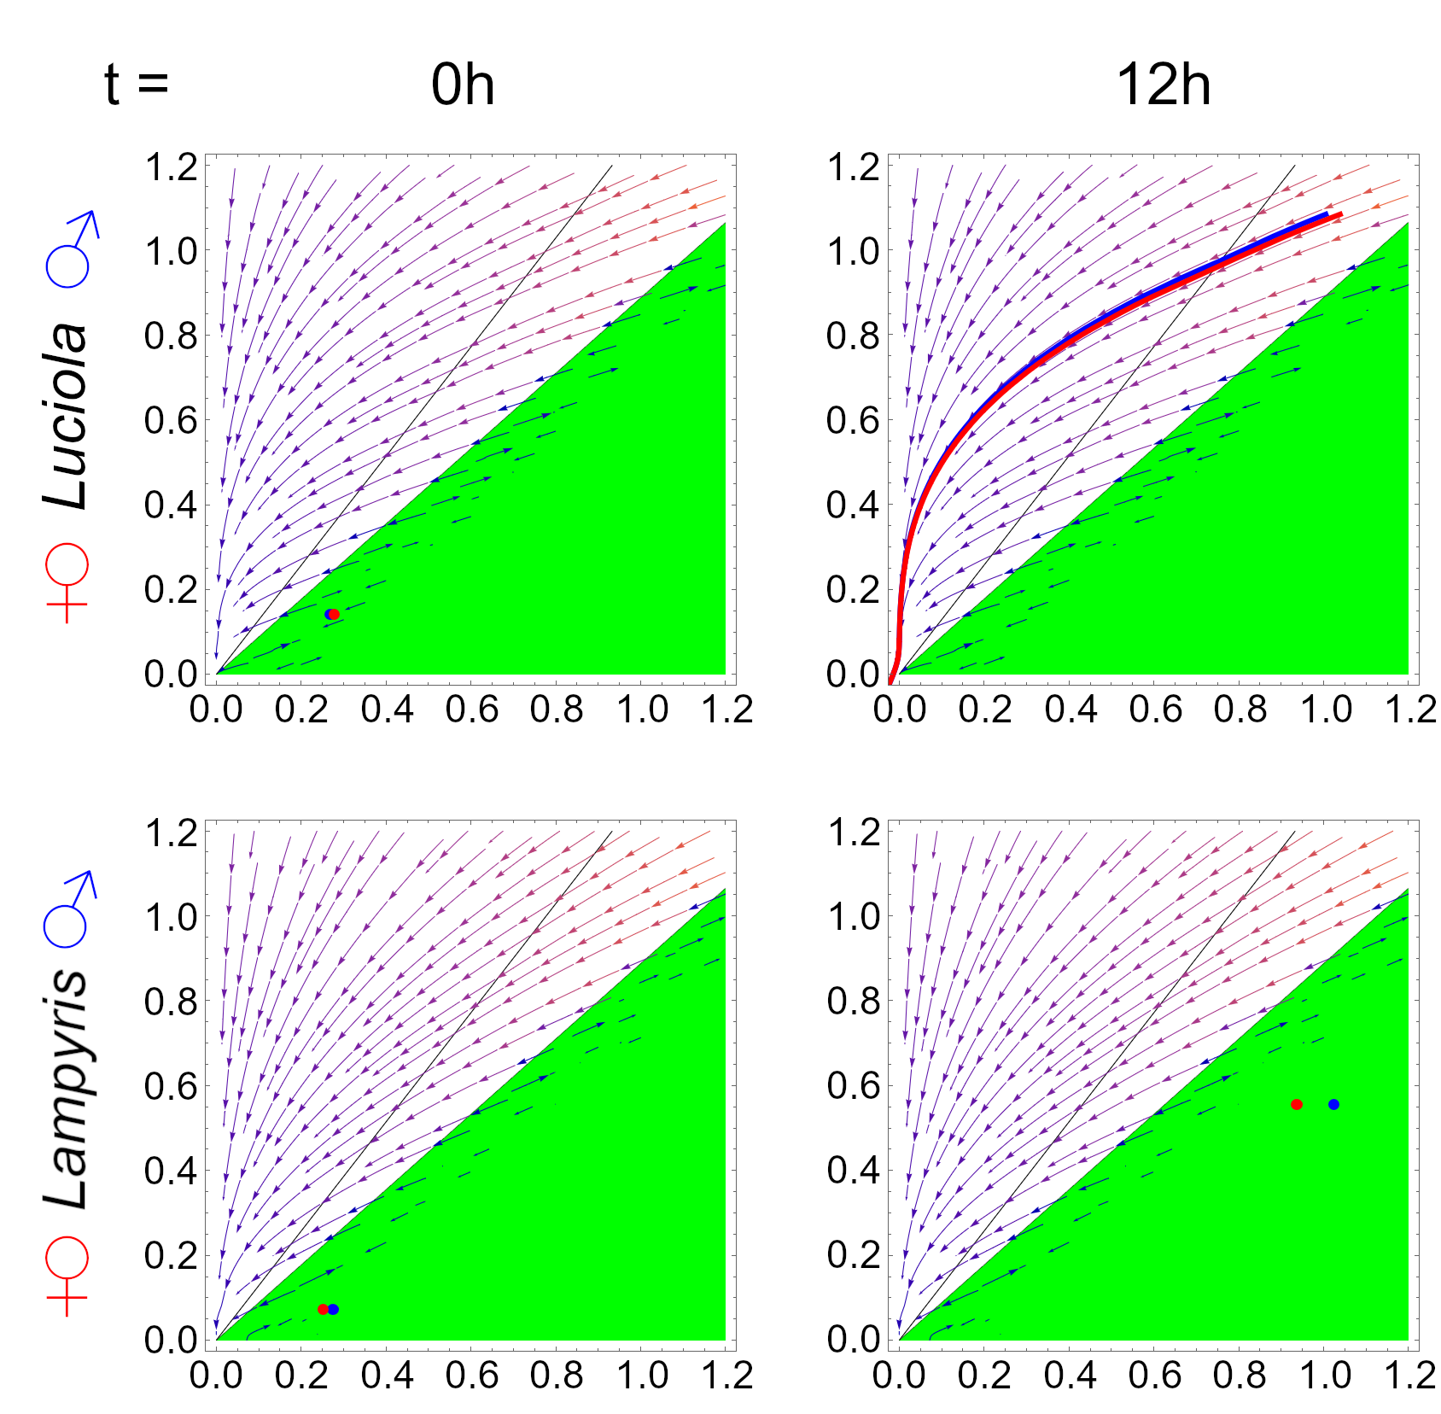
Supplementary Fig. S5. Mathematical analysis shows the sensitivity of the pattern formation to temperature. An exemplary spring day with the average temperature $\overline{T}$ = 15°C and the difference between the minimal and maximal temperatures ΔT = 20°C. The Turing region is shown in green. Two time periods are shown. At the 12h-time point, the Luciola curves do not reach proximity with the Turing region, which leads to the absence of nanopattern appearance (Figure 2e).

Supplementary Table S5. Places, altitudes and dates of firefly sample collections. Lamryis: Lampyris noctiluca; Luciola: Luciola lusitanica; ZMMU: collection of the Zoological Museum of the Lomonosov Moscow State University.
species | altitude, m | coordinates | collection date | N: male/ female/ total | data source
Lampyris | 100-200 | 41º25'25" N, 48º44'10" E | 28/06/1981 | 1 / 0 / 1 | ¹⁹
Lampyris | 2000 | 40º37'30" N, 44º34' E | 21/06/1997 | 0 / 1 / 1 | ZMMU
Lampyris | 200-300 | 47°04′ N, 28°30′ E | 26/06/1968 | 1 / 0 / 1 | ¹⁹
Lampyris | 2200 | 43º59'25" N, 39º54'50" E | 03/08/2003 | 0 / 1 / 1 | ZMMU
Lampyris | 2000 | 44º01'20" N, 39º55'50" E | 08/06/1903 | 1 / 0 / 1 | ¹⁹
Lampyris | 450 | 51°46′10″ N, 87°36′10″ E | 08/07/1999 | 1 / 0 / 1 | ZMMU
Lampyris | 500 | 51°34′12″ N, 85°34′01″ E | 06/07/1931 | 1 / 0 / 1 | ZMMU
Lampyris | 800-900 | 51°17′45″ N, 85°40′28″ E | 08/07/1931 | 1 / 0 / 1 | ZMMU
Lampyris | 200 | 52°26′00″ N, 129°56′30″ E | unknown | 0 / 1 / 1 | ZMMU
Lampyris | 350-450 | 54°07′ N, 129°52′ E | 07/07/1932 | 10 / 0 / 10 | ZMMU
Lampyris | 350-400 | 53°51′16″ N, 127°21′33″ E | 13/06/1978 | 1 / 0 / 1 | ZMMU
Lampyris | 150-200 | 49°06′10″ N, 130°45′30″ E | 26/05/1975 | 1 / 0 / 1 | ZMMU
Lampyris | 150 | 53°18′30″ N, 34°18′30″ E | 28/08/1921 | 1 larva | ZMMU
Lampyris | 980 | 42º44'55" N, 47º00'20" E | 03/07/2018 | 7 / 0 / 7 | ZMMU
Lampyris | 1430 | 42º44'05" N, 46º59'03" E | 04/07/2018 | 0 / 1 / 1 | ZMMU
Lampyris | 1450 | 42º55'20" N, 46º42'50" E | 20/06/2022 | 0 / 2 / 2 | ZMMU
Lampyris | 150-200 | 42º03'05" N, 48º16'15" E | 15/07/1991 | 1 / 0 / 1 | ¹⁹
Lampyris | 650-850 | 52°02′ N, 113°30′ E | 15/06/1912 | 1 / 0 / 1 | ¹⁹
Lampyris | 475 | 53°51′35″ N, 120°52′10″ E | 20/06/1909 | 2 / 0 / 2 | ZMMU
Lampyris | 1100-1200 | 49°40′45″ N, 111°24′10″ E | 24/06/1991 | 1 / 0 / 1 | ¹⁹
Lampyris | 300-400 | 56°48′00″ N, 105°50′00″ E | 19/06/1905 | 1 / 0 / 1 | ¹⁹
Lampyris | 500-600 | 43°29′10″ N, 43°36′25″ E | 07/1932 | 2 / 3 / 5 | ZMMU
Lampyris | 120-140 | 54°53′20″ N, 37°07′25″ E | 01/07/1904 | 4 / 0 / 4 | ZMMU
Lampyris | 140-150 | 55°03′00″ N, 36°36′10″ E | 20/06/1902 | 0 / 1 / 1 | ZMMU
Lampyris | 139-150 | 58°16′45″ N, 47°30′30″ E | 01/07/1976 | 1 / 2 / 3 | ZMMU
Lampyris | 1750 | 44º05'27" N, 39º46'57" E | 24/06/2006 | 3 / 0 / 3 | ZMMU
Lampyris | 010-020 | 44º34'40" N, 38º04'00" E | 10/06/2005 | 1 / 0 / 1 | ZMMU
Lampyris | 010-020 | 44º34'40" N, 38º04'00" E | 15/08/1912 | 0 / 1 / 1 | ZMMU
Lampyris | 1400-1500 | 44º01'30" N, 39º35'05" E | 27/07/2003 | 0 / 1 / 1 | ZMMU
Lampyris | 020-030 | 45°02′00″ N, 38°59′00″ E | 28/06/1924 | 1 / 0 / 1 | ¹⁹
Lampyris | 0-100 | 43°35′ N, 39°43′ E | 06/07/1911 | 0 / 1 / 1 | ZMMU
Lampyris | 0-100 | 43°35′ N, 39°43′ E | 06/1926 | 1 / 0 / 1 | ¹⁹
Lampyris | 450-700 | 53°42′ N, 91°46′ E | 15/06/1902 | 3 / 0 / 3 | ZMMU
Lampyris | 700 | 44º37' N, 33º50' E | 15/07/1992 | 1 / 0 / 1 | ZMMU
Lampyris | 50-200 | 44°23′30″ N, 33°47′20″ E | 05/1930 | 1 / 0 / 1 | ¹⁹
Lampyris | 50-300 | 44°33′10″ N, 34°17′15″ E | 11/07/1948 | 1 / 0 / 1 | ¹⁹
Lampyris | 50-550 | 44°55′55″ N, 35°13′44″ E | 28/06/1981 | 1 / 0 / 1 | ¹⁹
Lampyris | 50-550 | 44°55′55″ N, 35°13′44″ E | 19/07/1957 | 0 / 1 / 1 | ZMMU
Lampyris | 50-300 | 44°55′45″ N, 35°12′40″ E | 23/06/1952 | 0 / 1 / 1 | ZMMU
Lampyris | 200-300 | 44°43′00″ N, 33°53′15″ E | 26/06/1993 | 1 / 1 / 2 | ¹⁹
Lampyris | 150-300 | 44°45′10″ N, 33°51′40″ E | 07/1972 | 0 / 1 / 1 | ¹⁹
Lampyris | 50-100 | 59°34′ N, 30°07′ E | 16/06/1902 | 1 / 0 / 1 | ZMMU
Lampyris | 10-50 | 59°22′ N, 28°37′ E | 06/1891 | 1 / 0 / 1 | ZMMU
Lampyris | 10-50 | 59°22′ N, 28°37′ E | 17/06/1905 | 0 / 1 / 1 | ZMMU
Lampyris | 30-50 | 59°21′ N, 31°15′ E | 06/1919 | 1 / 0 / 1 | ZMMU
Lampyris | 160-170 | 55°49′ N, 37°33′ E | 06/1904 | 2 / 0 / 2 | ZMMU
Lampyris | 145-155 | 55°46′30″ N, 37°47′15″ E | unknown | 3 / 0 / 3 | ZMMU
Lampyris | 190-200 | 55°39′ N, 37°28′ E | 1886 | 1 / 0 / 1 | ZMMU
Lampyris | 140-150 | 56°27′20″ N, 37°13′45″ E | 08/1897 | 0 / 3 / 3 | ZMMU
Lampyris | 160 | 55º44'20" N, 37º02'10" Е | 23/06/1938 | 1 / 1 / 2 | ZMMU
Lampyris | 145 | 54º51'25" N, 37º38'35" Е | 13/06/2016 | 6 / 6 / 12 | ZMMU
Lampyris | 175 | 54º53'40" N, 37º38'35" Е | 01/06/2018 | 3 / 1 / 4 | ZMMU
Lampyris | 175 | 54º53'40" N, 37º38'35" Е | 09/06/2019 | 23 / 8 / 31 | ZMMU
Lampyris | 120-130 | 54°51′30″ N, 37°33′15″ E | 28/06/1994 | 0 / 3 / 3 | ZMMU
Lampyris | 120 | 54°51′05″ N, 37°52′55″ E | 02/06/1909 | 1 / 0 / 1 | ZMMU
Lampyris | 200-250 | 56°10′15″ N, 37°04′50″ E | unknown | 3 / 0 / 3 | ZMMU
Lampyris | 100-150 | 54°55′10″ N, 38°41′30″ E | 07/06/1909 | 1 / 0 / 1 | ZMMU
Lampyris | 205-210 | 55°45′05″ N, 36°30′45″ E | 05/1912 | 3 / 0 / 3 | ZMMU
Lampyris | 205-210 | 55°45′05″ N, 36°30′45″ E | 28/05/1901 | 3 / 1 / 4 | ZMMU
Lampyris | 150-200 | 55°30′05″ N, 37°20′05″ E | 19/06/1912 | 4 / 0 / 4 | ZMMU
Lampyris | 200 | 55°10′30″ N, 37°52′00″ E | 03/07/1976 | 0 / 2 / 2 | ZMMU
Lampyris | 130-150 | 55°22′55″ N, 37°48′53″ E | 07/07/1927 | 0 / 1 / 1 | ZMMU
Lampyris | 150 | 55°53′25″ N, 37°43′10″ E | 21/06/1929 | 2 / 0 / 2 | ZMMU
Lampyris | 180-200 | 55°57′ N, 37°18′ E | 23/06/1902 | 2 / 1 / 3 | ZMMU
Lampyris | 140-160 | 55°31′ N, 37°39′ E | 1904 | 1 / 0 / 1 | ZMMU
Lampyris | 200-220 | 56°02′10″ N, 37°10′20″ E | 09/07/1976 | 1 / 1 / 2 | ZMMU
Lampyris | 0-10 | 47°18′15″ N, 141°58′20″ E | 07/07/1990 | 1 / 1 / 2 | ¹⁹
Lampyris | 0-10 | 46°27′15″ N, 142°20′25″ E | 28/07/1990 | 1 / 0 / 1 | ¹⁹
Lampyris | 20 | 46º54'45" N, 143º02'32" E | 20/05/2003 | 1 / 0 / 1 | ¹⁹
Lampyris | 200-300 | 53°07′ N, 46°36′ E | 02/06/1907 | 4 / 0 / 4 | ZMMU
Lampyris | 10 | 42º53'45" N, 133º55'30" E | 05/08/2011 | 0 / 1 / 1 | ZMMU
Lampyris | 0-100 | 42º39'30" N, 130º48'00" E | 10/07/1921 | 1 / 0 / 1 | ¹⁹
Lampyris | 350-400 | 46°31′ N, 136°57′ E | 27/06/1973 | 1 / 1 / 2 | ¹⁹
Lampyris | 0-100 | 42°57′54″ N, 131°43′51″ E | 10/07/1973 | 1 / 0 / 1 | ¹⁹
Lampyris | 250-350 | 44°03′50″ N, 133°54′45″ E | 20/07/1974 | 1 / 1 / 2 | ¹⁹
Lampyris | 80-150 | 43°37′ N, 132°14′ E | 06/07/1980 | 2 / 0 / 2 | ZMMU
Lampyris | 80-150 | 43°37′ N, 132°14′ E | 05/07/1989 | 0 / 1 / 1 | ZMMU
Lampyris | 200 | 43º15'17" N, 134º08'00" E | 12/07/2006 | 1 / 0 / 1 | ¹⁹
Lampyris | 200 | 43º15'17" N, 134º08'00" E | 12/08/2009 | 1 / 0 / 1 | ¹⁹
Lampyris | 200 | 43º15'17" N, 134º08'00" E | 18/07/2005 | 0 / 1 / 1 | ¹⁹
Lampyris | 100-150 | 43°17′35″ N, 134°14′00″ E | 22/07/1979 | 1 / 0 / 1 | ZMMU
Lampyris | 70-100 | 44°21′40″ N, 132°35′30″ E | 03/07/1913 | 0 / 1 / 1 | ¹⁹
Lampyris | 1200-1680 | 43°44′05″ N, 134°25′30″ E | 05/07/2004 | 0 / 1 / 1 | ¹⁹
Lampyris | 100-150 | 48°55′ N, 40°24′ E | 06/1914 | 2 / 1 / 3 | ZMMU
Lampyris | 50-350 | 53°25′ N, 49°42′ E | 06/1915 | 9 / 2 / 11 | ZMMU
Lampyris | 200-250 | 56°35′45″ N, 61°05′55″ E | 10/06/1985 | 1 / 0 / 1 | ¹⁹
Lampyris | 600-1000 | 43°01′ N, 44°41′ E | 21/07/1925 | 1 / 0 / 1 | ¹⁹
Lampyris | 1000 | 42º53'00" N, 44º09'30" E | 09/07/1985 | 1 / 0 / 1 | ¹⁹
Lampyris | 2200 | 42º51'25" N, 44º15'45" E | 26/07/2009 | 0 / 1 / 1 | ¹⁹
Lampyris | 2280 | 42º55'00" N, 44º05'05" Е | 31/07/2009 | 0 / 1 / 1 | ¹⁹
Lampyris | 150-250 | 54°47′ N, 32°03′ E | 06/1896 | 0 / 1 / 1 | ZMMU
Lampyris | 400-650 | 45°02′ N, 41°58′ E | 15/07/1967 | 1 / 0 / 1 | ¹⁹
Lampyris | 120-150 | 56°25′ N, 85°11′ E | 22/07/1912 | 1 / 0 / 1 | ¹⁹
Lampyris | 200-250 | 54º05' N, 37º25' Е | 27/07/1996 | 1 / 1 / 2 | ZMMU
Lampyris | 200-250 | 53°46′ N, 38°08′ E | unknown | 1 / 0 / 1 | ZMMU
Lampyris | 50-100 | 58°12′ N, 68°15′ E | 20/06/1935 | 1 / 0 / 1 | ¹⁹
Lampyris | 60-70 | 57°20′55″ N, 66°03′35″ E | 02/07/1998 | 2 / 0 / 2 | ZMMU
Lampyris | 150-200 | 50°47′30″ N, 137°37′30″ E | 19/06/1988 | 1 / 0 / 1 | ¹⁹
Lampyris | 50-100 | 48°18′ N, 134°45′ E | 11/05/1976 | 2 / 0 / 2 | ZMMU
Lampyris | 100-500 | 48°15′ N, 134°50′ E | 28/05/1976 | 1 / 0 / 1 | ZMMU
Lampyris | 300-400 | 53°00′ N, 91°29′ E | 26/06/1970 | 1 / 0 / 1 | ZMMU
Lampyris | 350-700 | 55°05′ N, 60°11′ E | 25/06/1928 | 1 / 0 / 1 | ¹⁹
Lampyris | 200-220 | 50°15′ N, 28°40′ E | 11/06/1914 | 1 / 2 / 3 | ZMMU
Lampyris | 100 | 49°42′ N, 36°22′ E | 25/06/1918 | 1 / 0 / 1 | ¹⁹
Lampyris | 300-500 | 48°10′ N, 23°38′ E | 30/06/1988 | 1 / 0 / 1 | ¹⁹
Lampyris | 150-300 | 48°40′40″ N, 22°24′35″ E | 13/07/1992 | 1 / 1 / 2 | ¹⁹
Lampyris | 110-120 | 48°09′40″ N, 22°39′50″ E | 31/07/1977 | 0 / 1 / 1 | ¹⁹
Lampyris | 110-120 | 48°09′40″ N, 22°39′50″ E | 25/08/1981 | 0 / 1 / 1 | ¹⁹
Lampyris | 400-600 | 48°03′ N, 24°13′ E | 11/06/1966 | 1 / 0 / 1 | ZMMU
Lampyris | 500-600 | 48°09′ N, 24°17′ E | 14/06/1973 | 1 / 0 / 1 | ZMMU
Lampyris | 275-300 | 48°30′10″ N, 23°13′15″ E | 25/07/1988 | 2 / 0 / 2 | ZMMU
Lampyris | 100-150 | 51°30′ N, 31°18′ E | unknown | 2 / 0 / 2 | ZMMU
Luciola | 450 | 43º10'55" N, 41º02'30" E | 01/07/2014 | 3 / 0 / 3 | ZMMU
Luciola | 600 | 43º21'55" N, 40º49'50" E | 04/07/2009 | 1 / 0 / 1 | ¹⁹
Luciola | 1900–1950 | 43º14'55" N, 41º09'00" E | 12/07/2014 | 2 / 0 / 2 | ZMMU
Luciola | 1875 | 43º13'46" N, 41º07'11" E | 12/07/2017 | 1 larva | ZMMU
Luciola | 0-50 | 43°17′ N, 40°16′ E | 10/06/1933 | 1 / 0 / 1 | ¹⁹
Luciola | 0-50 | 42°55′15″ N, 41°06′00″ E | 20/06/1981 | 1 / 0 / 1 | ¹⁹
Luciola | 0-50 | 43°22′40″ N, 40°05′05″ E | 15/05/1984 | 1 / 0 / 1 | ¹⁹
Luciola | 10-20 | 42º59'00" N, 41º03'35" E | 18/05/1931 | 1 / 0 / 1 | ZMMU
Luciola | 450-500 | 43º01'50" N, 41º15'40" E | unknown | 1 / 0 / 1 | ZMMU
Luciola | 450-650 | 41°38′00″ N, 46°38′30″ E | 23/01/1960 | 6 / 0 / 6 | ZMMU
Luciola | 400-800 | 41°43′ N, 44°48′ E | unknown | 1 / 0 / 1 | ZMMU
Luciola | 50-100 | 41°37′30″ N, 41°38′30″ E | 06/06/1981 | 6 / 0 / 6 | ZMMU
Luciola | 750-800 | 41°55′50″ N, 43°29′10″ E | 16/07/1985 | 1 / 0 / 1 | ¹⁹
Luciola | 600-900 | 41°40′30″ N, 42°01′10″ E | 10/07/1989 | 1 / 0 / 1 | ¹⁹
Luciola | 1000 | 44º13'05" N, 40º05'10" E | 04/07/1993 | 2 / 0 / 2 | ZMMU
Luciola | 1200–1400 | 44º02'50" N, 40º05'50" Е | 21/06/1995 | 6 / 0 / 6 | ZMMU
Luciola | 1450–1500 | 44º06'15" N, 40º01'05" E | 06/07/1993 | 3 / 0 / 3 | ZMMU
Luciola | 900 | 44º09'00" N, 40º12'40" E | 19/06/1995 | 1 / 0 / 1 | ZMMU
Luciola | 200-250 | 44°36′30″ N, 40°06′30″ E | 29/06/1925 | 1 / 0 / 1 | ¹⁹
Luciola | 1200-1700 | 43°31′50″ N, 40°58′40″ E | 13/07/1987 | 1 / 0 / 1 | ¹⁹
Luciola | 50-150 | 44°43′ N, 37°46′ E | unknown | 1 / 0 / 1 | ZMMU
Luciola | 100-200 | 44°42′ N, 37°36′ E | 19/06/1916 | 1 / 0 / 1 | ZMMU
Luciola | 50-150 | 44°34′ N, 38°06′ E | 18/06/1911 | 1 / 0 / 1 | ZMMU
Luciola | 50-100 | 44°38′ N, 39°08′ E | 15/06/1986 | 2 / 0 / 2 | ZMMU
Luciola | 900 | 44º12'05" N, 39º20'40" Е | 18/07/2003 | 8 / 0 / 8 | ZMMU
Luciola | 1300-1400 | 44º07'50" N, 39º25'35" E | 22/07/2003 | 5 / 0 / 5 | ZMMU
Luciola | 0-50 | 43°54′55″ N, 39°19′15″ E | 05/1966 | 0 / 1 / 1 | ZMMU
Luciola | 0-100 | 43°44′ N, 39°33′ E | 13/07/1976 | 1 / 0 / 1 | ZMMU
Luciola | 0-100 | 43º35' N, 39º43' Е | 07/1964 | 0 / 1 / 1 | ZMMU
Luciola | 0-100 | 44°06′ N, 39°05′ E | 01/07/1987 | 1 / 0 / 1 | ¹⁹
Luciola | 100-200 | 44°44′25″ N, 38°32′30″ E | 05/07/1988 | 1 / 0 / 1 | ZMMU
Luciola | 100-200 | 44°44′25″ N, 38°32′30″ E | 04/07/1973 | 0 / 1 / 1 | ZMMU
Luciola | 0-200 | 43°30′45″ N, 39°52′25″ E | 31/05/1935 | 1 / 0 / 1 | ZMMU
Luciola | 20-50 | 43°31′30″ N, 39°52′30″ E | 10/07/1963 | 1 / 0 / 1 | ZMMU
Luciola | 0-100 | 43°57′25″ N, 39°16′15″ E | unknown | 2 / 0 / 2 | ZMMU
Luciola | 0-50 | 43°27′00″ N, 39°54′30″ E | 17/06/1989 | 1 / 0 / 1 | ¹⁹
Luciola | 0-200 | 44°25′10″ N, 34°02′35″ E | 17/06/1936 | 1 / 0 / 1 | ZMMU

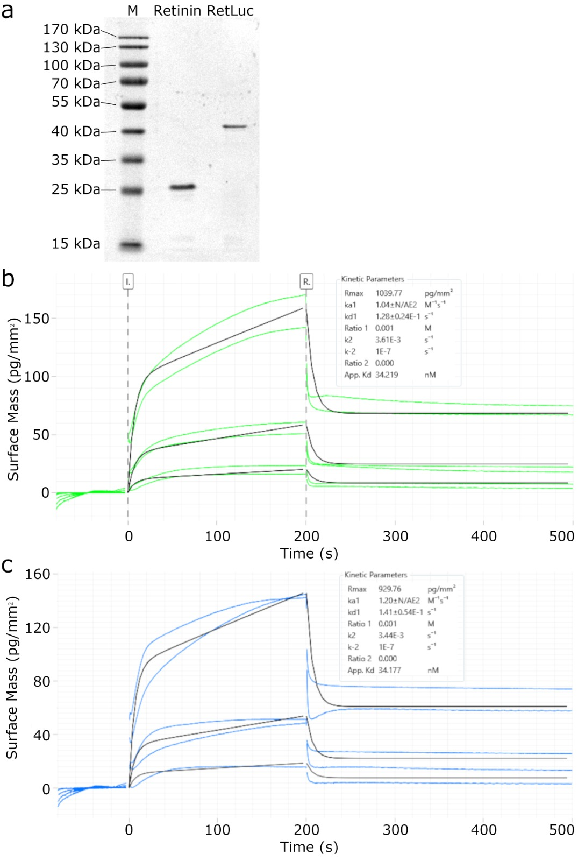
Supplementary Fig. S6. Recombinant production of Retinin and RetLuc and their reaction coefficients. (a) SDS-PAGE illustrating the purity and the expected sizes of Retinin and RetLuc after recombinant production and purification. (b, c) Wave-guide interferometry of the interaction between Retinin (b) or RetLuc (c) with decanoic acid demonstrates almost identical properties of these proteins.

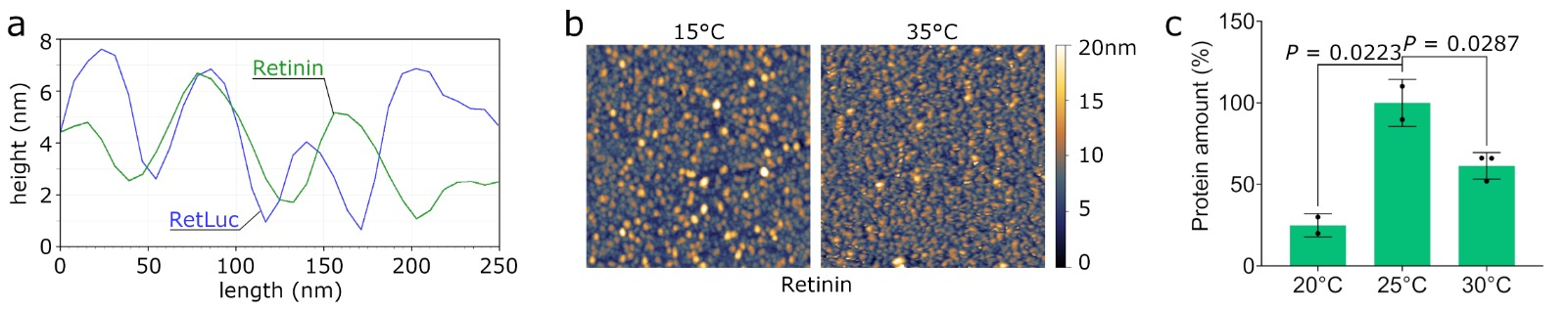
Supplementary Fig. S7. Characterization of Retinin- and RetLuc-based artificial nanocoatings. (a) Representative AFM data cross-sections of artificial nanocoatings show that the RetLuc-based nanostructures (blue line) are more narrow and have tighter spaces between them than the Retinin-based ones (green line). Note the similarity with the Luciola and Lampyris corneal nanocoatings, respectively (Supplementary Fig. S2d). (b) Representative AFM scans of the Retinin-based nanocoatings made at 15°C and 35°C. Topography of the Retinin-based nanocoatings stays rather stable at the two temperatures. Each square is 2x2μm. (c) For the RetLuc-based nanocoatings formed at different temperatures, the total amount of protein remaining after wash-out correlates with the luminescence data in Fig. 4c. The protein amount is quantified through SDS-PAGE and normalized to the levels at 25°C. The data are presented as mean ± SD, n=2-3, statistical analysis with a two-tailed t-test.

Supplementary Table S6. Equations used for the Reaction-Diffusion simulation of artificial nanostructures with their variable parameters.
$\left\{\begin{aligned}\frac{∂a}{∂t}=max\left(0, min\left(a_{a}∙a+b_{a}∙b, F_{max}\right)\right)-d_{a}∙a+D_{a}∙Δa+d∙adu+e∙agu \\ \frac{∂b}{∂t}=max\left(0, min\left(a_{b}∙a+b_{b}∙b, G_{max}\right)\right)-d_{b}∙b+D_{b}∙Δb+d∙agv+e∙agv\end{aligned}\right.$ Eq. 26,
where adu and adv are the concentrations of the Activator and Inhibitor in the solution, respectively; and agu and agv – the adsorption rate constants of the Activator and the Inhibitor on the glass, respectively.
T° | 15°C | 20°C | 25°C | 30°C | 35°C
$$a_{a}$$ | 0.0284 | 0.04526 | 0.071 | 0.10973 | 0.16721
$$b_{a}$$ | -0.032 | -0.051 | -0.08 | -0.12364 | -0.18841
$$d_{a}$$ | 0.012 | 0.01912 | 0.03 | 0.04637 | 0.07065
$$D_{a}$$ | 0.00655 | 0.00812 | 0.01 | 0.01223 | 0.01485
$$a_{b}$$ | 0.036 | 0.05737 | 0.09 | 0.1391 | 0.21196
$$b_{b}$$ | -0.028 | -0.04462 | -0.07 | -0.108189 | -0.16486
$$d_{b}$$ | 0.032 | 0.051 | 0.08 | 0.12364 | 0.18841
$$D_{b}$$ | 0.16379 | 0.20309 | 0.25 | 0.30564 | 0.37123
timestep | 0.1 | 0.1 | 0.1 | 0.1 | 0.1
$$F_{max}$$ | 0.2 | 0.2 | 0.2 | 0.2 | 0.2
$$G_{max}$$ | 0.5 | 0.5 | 0.5 | 0.5 | 0.5
$$adu$$ | 1.53 | 1.53 | 1.53 | 1.53 | 1.53
$$agv$$ | 4.3 | 4.3 | 4.3 | 4.3 | 4.3
$$agu$$ | 0.04658 | 0.06909 | 0.10223 | 0.14618 | 0.20877
$$agv$$ | 0.13184 | 0.16347 | 0.20123 | 0.24602 | 0.29881

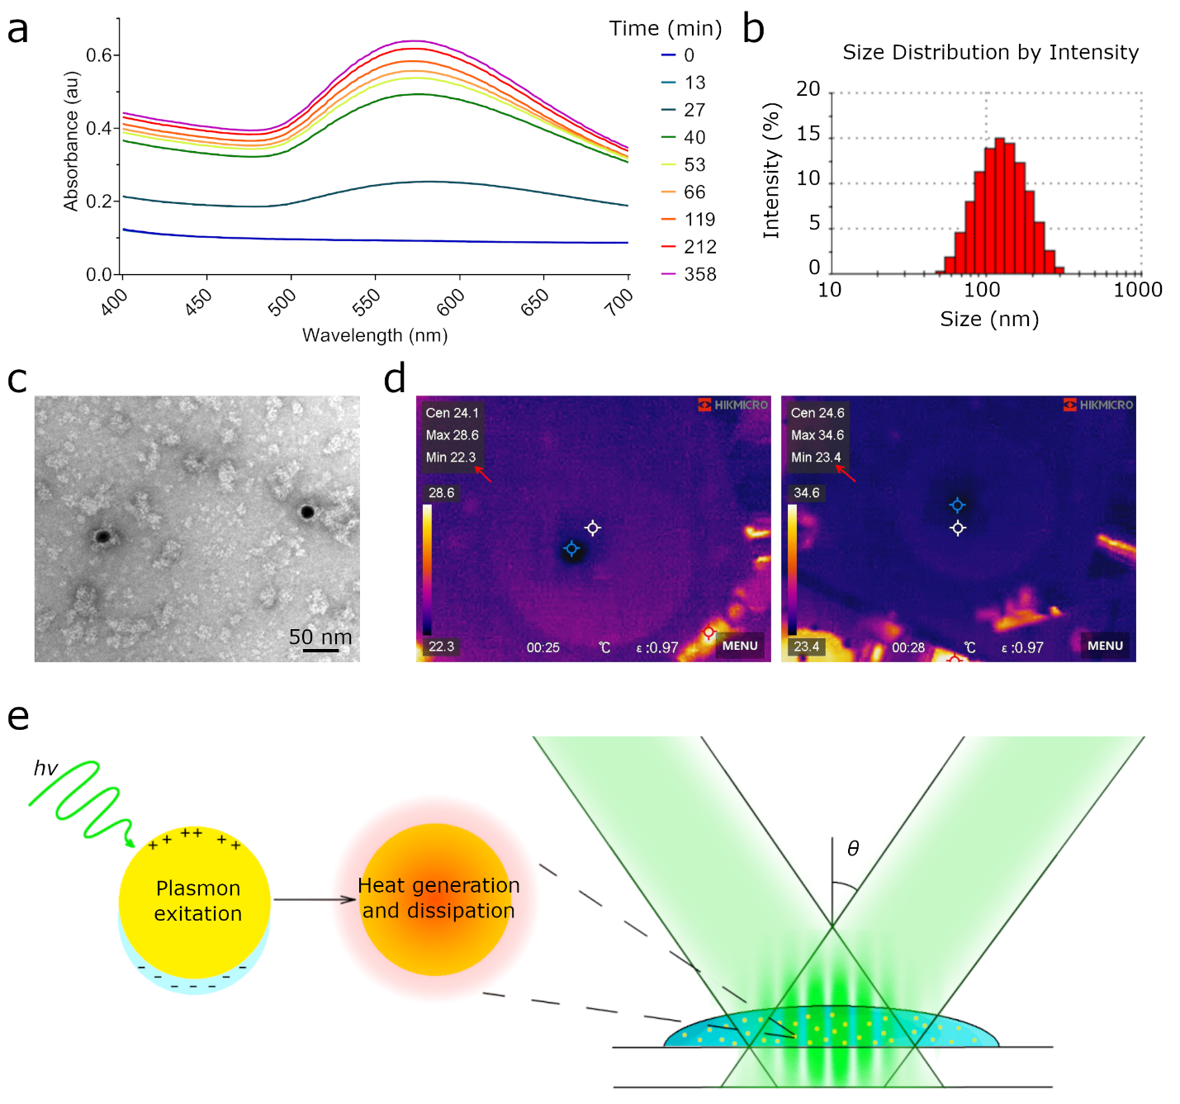
Supplementary Fig. S8. Temperature control using gold nanoparticles and laser illumination. (a) Absorbance spectra showing the kinetics of the gold nanoparticles synthesis. (b) Gold nanoparticles size distribution measured by light scattering. (c) TEM image of gold nanoparticles. (d) Infrared spectra images taken before (left) and after (right) 1min-exposure by a laser beam of the droplet containing gold nanoparticles. Aqueous droplets show minimal temperature (blue markers) due to the evaporation process. The increase in their temperature can be seen in the left upper corner of images (red arrows). The color scale is shown on the left side of each image; ε – emissivity. (e) Schematic representation of temperature patterning, obtained using plasmon resonance and light interference phenomena. Following $p=λ/{2\sin{θ}}$, two laser beams’ interference can create a pattern with steps equal to p, where ϴ is the incoming angle. The resultant local maxima of light intensity produce temperature differences that will pattern the RetLuc protein-based nanocoating.
Supplemental Methods
In-house generated Wolfram Mathematica script used the mathematical analysis:
aa=0.071;ba=-0.08;da=0.03;Da=0.02;ab=0.09;bb=-0.07;db=0.08;Db=0.25;Fmax=0.2;Gmax=0.5;
VA[A_,B_]:=Piecewise[{{-A $\sqrt{da/Da}$,aa A+ba B<0},
{-(A-Fmax/da) $\sqrt{da/Da}$,aa A+ba B>Fmax},{0,aa A+ba B>=0&&aa A+ba B<=Fmax}}];
VB[A_,B_]:=Piecewise[{{0,aa A+ba B>=0&&aa A+ba B<=Fmax},{-B$\sqrt{db/Db}$ ,ab A+bb B<0},{-(B-Gmax/db) $\sqrt{db/Db}$,ab A+bb B>Gmax},
{-A $\sqrt{da/Da}$ ab Da/(Da db-Da bb-Db da)-(B-ab A Da/(Da db-Da bb-Db da)) $\sqrt{(db-bb)/Db}$,ab A+bb B>=0&&ab A+bb B<=Gmax&&aa A+ba B<0},
{-$\sqrt{da/Da}$ab Da(A-Fmax/da) / (Da db-Da bb-Db da)-$\sqrt{(db-bb)/Db}$(B-ab Fmax/(da(db-bb ))-ab Da(A-Fmax/da) / (Da db-Da bb-Db da)),ab A+bb B>=0&&ab A+bb B<=Gmax&&aa A+ba B>Fmax}}]
xmin=-0.0;xmax=0.3;ymin=-0.0;ymax=0.3;
DEA:=x1'[t]==VA[x1[t],y1[t]];
DEB:=y1'[t]==VB[x1[t],y1[t]];
Reg1=NDSolve[{DEA,DEB,x1[0]==0.75`,y1[0]==0.80625`},{x1,y1},{t,0,5}];
Reg2=NDSolve[{DEA,DEB,x1[0]==1.0`,y1[0]==0.80625`},{x1,y1},{t,0,5}];
Show[ContourPlot[aa x+ba y,{x,xmin,xmax},{y,ymin,ymax},Contours->{0,Fmax},ContourShading->{White,Green,White}],ContourPlot[ab x+bb y,{x,xmin,xmax},{y,ymin,ymax},Contours->{0,Gmax},ContourShading->None],ListStreamPlot[Table[{VA[x,y],VB[x,y]},{x,xmin,xmax,0.05},{y,ymin,ymax,0.05}],DataRange->{{xmin,xmax},{ymin,ymax}}],
ParametricPlot[Evaluate[{x1[t],y1[t]}/.{Reg1},{t,0,10},
PlotStyle->Directive[Blue,Thickness[.01]],PlotRange->{{xmin,xmax},{ymin,ymax}}]],
ParametricPlot[Evaluate[{x1[t],y1[t]}/.{Reg2},{t,0,10},PlotStyle->Directive[Red,Thickness[.01]]
,PlotRange->{{xmin,xmax},{ymin,ymax}}]],
Axes->True,AxesLabel->{A,B}]

Supplementary References
1 Mishra, M. & Meyer-Rochow, V. B. Eye ultrastructure in the pollen-feeding beetle, Xanthochroa luteipennis (Coleoptera: Cucujiformia: Oedemeridae). J Electron Microsc (Tokyo) 55, 289-300, doi:10.1093/jmicro/dfl035 (2006).
2 Blagodatski, A. et al. Under- and over-water halves of Gyrinidae beetle eyes harbor different corneal nanocoatings providing adaptation to the water and air environments. Sci Rep 4, 6004, doi:10.1038/srep06004 (2014).
3 Blagodatski, A., Sergeev, A., Kryuchkov, M., Lopatina, Y. & Katanaev, V. L. Diverse set of Turing nanopatterns coat corneae across insect lineages. Proc Natl Acad Sci U S A 112, 10750-10755, doi:10.1073/pnas.1505748112 (2015).
4 Bello, E., Chen, Y. & Alleyne, M. Staying Dry and Clean: An Insect&rsquo;s Guide to Hydrophobicity. Insects 14, 42 (2023).
5 Kryuchkov, M., Blagodatski, A., Cherepanov, V. & Katanaev, V. L. in Functional Surfaces in Biology III: Diversity of the Physical Phenomena (eds S. N. Gorb & E. V. Gorb) 29-52 (Springer International Publishing, 2017).
6 Kryuchkov, M., Bilousov, O., Lehmann, J., Fiebig, M. & Katanaev, V. L. Reverse and forward engineering of Drosophila corneal nanocoatings. Nature 585, 383-389, doi:10.1038/s41586-020-2707-9 (2020).
7 Anderson, M. S. & Gaimari, S. D. Raman-atomic force microscopy of the ommatidial surfaces of Dipteran compound eyes. J Struct Biol 142, 364-368, doi:S1047847703000261 (2003).
8 Nickerl, J., Tsurkan, M., Hensel, R., Neinhuis, C. & Werner, C. The multi-layered protective cuticle of Collembola: a chemical analysis. J R Soc Interface 11, doi:10.1098/rsif.2014.0619 (2014).
9 Drelich, J. W. Contact angles: From past mistakes to new developments through liquid-solid adhesion measurements. Advances in Colloid and Interface Science 267, 1-14, doi:https://doi.org/10.1016/j.cis.2019.02.002 (2019).
10 Turing, A. M. The Chemical Basis of Morphogenesis. Vol. 237 (1952).
11 Kondo, S. & Miura, T. Reaction-diffusion model as a framework for understanding biological pattern formation. Science 329, 1616-1620, doi:10.1126/science.1179047 (2010).
12 Blagodatski, A., Sergeev, A., Kryuchkov, M., Lopatina, Y. & Katanaev, V. L. Diverse set of Turing nanopatterns coat corneae across insect lineages. Proceedings of the National Academy of Sciences of the United States of America 112, 10750-10755, doi:10.1073/pnas.1505748112 (2015).
13 Buscher, T. H., Kryuchkov, M., Katanaev, V. L. & Gorb, S. N. Versatility of Turing patterns potentiates rapid evolution in tarsal attachment microstructures of stick and leaf insects (Phasmatodea). J R Soc Interface 15, doi:10.1098/rsif.2018.0281 (2018).
14 Ritchie, M. E. Reaction and diffusion thermodynamics explain optimal temperatures of biochemical reactions. Scientific Reports 8, 11105, doi:10.1038/s41598-018-28833-9 (2018).
15 Craig, N. Effect of temperature on protein and immunoglobulin synthesis and secretion in two mouse myeloma cell lines. Journal of Cellular Physiology 100, 323-334, doi:https://doi.org/10.1002/jcp.1041000213 (1979).
16 Lee, J. & Lentz, B. R. Secretory and viral fusion may share mechanistic events with fusion between curved lipid bilayers. Proc Natl Acad Sci U S A 95, 9274-9279, doi:10.1073/pnas.95.16.9274 (1998).
17 Small, D. M. Role of ABC transporters in secretion of cholesterol from liver into bile. Proceedings of the National Academy of Sciences 100, 4-6, doi:10.1073/pnas.0237205100 (2003).
18 Bonnemaison, M. The Adaptor Protein 1 (AP-1) Complex at the Heart of Post-Golgi Trafficking in a Corticotrope Tumor Cell Line. (2014).
19 Kazantsev, S. Fireflies of Russia and adjacent territories (Coleoptera: Lampyridae). Russian Entomological Journal 19, 187-208, doi:10.15298/rusentj.19.3.06 (2010).
20 Koval, A. et al. First-in-class small molecule selective antagonists of Frizzled in triple-negative breast cancer. Nature Cancer (submitted).

