Supplementary files

Supplementary figure 1 Machine learning classification algorithms including the data selection process.
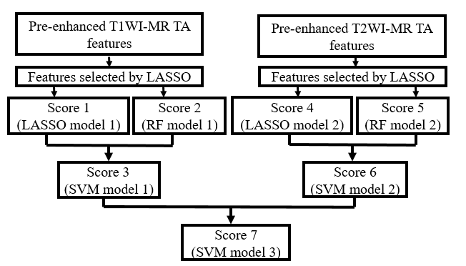

Abbreviations: T1WI: T1-weighted images; T2WI: T2-weighted images; TA: textural analysis; LASSO: least absolute shrinkage and selection operator; RF: random forest; SVM: support vector machine.

Supplementary Figure 2 Patients sorted for the radiomic model.
Abbreviations: SVM: support vector machine; GS: gliosarcoma; GBM: glioblastoma multiforme.

Supplementary Table 1. Ranking of feature importance (important features on top)
Ranking | Feature
1 | Adjuvant therapy
2 | Skewness-T2
3 | S(0,5)AngScMom-T2
4 | Age
5 | S(5,0)SumOfSqs-T2
6 | S(3,0)SumOfSqs-T1
7 | GeoYo-T2
8 | GeoAox-T2
9 | S(1,1)Correlat-T1
10 | S(0,5)InvDfMom-T2
11 | S(2,2)SumOfSqs-T1
12 | S(5,5)Correlat-T2
13 | Gender
14 | Cyst subtype
15 | Surgery

Supplementary Table 2. Results of multivariate Cox regression for survival analysis in patients with gliosarcoma

Feature | coef | expr(coef) | se(coef) | z | p | Lower 0.95 | Upper 0.95
Adjuvant therapy | -1.86 | 0.16 | 0.54 | -3.43 | 0.0006 | -2.92 | -0.8
Skewness-T2 | 1.6 | 4.95 | 0.82 | 1.94 | 0.0521 | -0.01 | 3.21
S(0,5)AngScMom-T2 | -0.15 | 0.86 | 0.72 | -0.21 | 0.8351 | -1.55 | 1.26
Abbreviation: coef: coefficient.

