E-Table 1A: scores throughout the training program
 | A0 | A1 | Pre-A2 | A2 | Pre-A3 | A3 | Pre-A4 | A4
Capsulorhexis
Median (IQR) | 0 (0 - 52)° | 20 (0 - 54) | 19 (0 - 60) | 54 (30 - 77) | 47 (0 - 80) | 78 (58 - 92) | 85 (64 - 91) | 86 (83 - 92)
Range | 0 - 83 | 0 - 88 | 0 - 76 | 0 - 91 | 0 - 91 | 0 - 96 | 22 - 98 | 67 - 99
Hydromaneuver
Median (IQR) | 36 (0 - 75) | 84 (50 - 90) |  | 86 (81 - 90) |  | 86 (53 - 91) |  | 90 (84 - 94)
Range | 0 - 90 | 0 - 90 |  | 56 - 100 |  | 0 - 100 |  | 55 - 100
Phacoemulsification
Median (IQR) | 0 (0 - 0) | 38 (0 - 59) |  | 34 (0 - 56) |  | 84 (41 - 92) |  | 86 (60 - 94)
Range | 0 - 72 | 0 - 91 |  | 0 - 84 |  | 0 - 96 |  | 15 - 98
Irrigation and aspiration
Median (IQR) | 0 (0 - 40) | 64 (0 - 92) |  | 92 (52 - 96) |  | 94 (88 - 96) |  | 98 (96 - 100)
Range | 0 - 81 | 0 - 100 |  | 40 - 100 |  | 46 - 100 |  | 64 - 100
IOL insertion
Median (IQR) | 0 (0 - 38) | 34 (0 - 73) |  | 68 (39 - 86) |  | 83 (57 - 90) |  | 90 (81 - 95)
Range | 0 - 64 | 0 - 95 |  | 0 - 95 |  | 0 - 98 |  | 18 - 100
Overall procedure
Median (IQR) | 95 (53 - 147) | 242 (136 - 314) |  | 300 (252 - 349) |  | 394 (298 - 430) |  | 425 (411 - 451)
Range | 25 - 295 | 0 - 386 |  | 204 - 428 |  | 156 - 471 |  | 337 - 490
Abbreviations: A0, assessment at the beginning of the first session; A1, assessment at the end of the first session; A2, assessment at the end of the second session; A3, assessment at the end of the third session; A4, assessment at the end of the fourth session; IQR, interquartile range; pre-A2, assessment at the beginning of the second session; pre-A3, assessment at the beginning of the third session; pre-A4, assessment at the beginning of the fourth session; °, one missing data

E-Table 1B: completion time (in minutes) throughout the training program
 | A0 | A1 | Pre-A2 |  |  | A2 | Pre-A3 | A3 | Pre-A4 | A4
Capsulorhexis
Median (IQR) | 3.6 (2.8 - 5.3)° | 2.87 (1.97 - 3.08) |  | 2.71 (2.31 - 3.39)° | 2.75 (2.26 - 3.35) |  | 2.72 (2.26 - 3.19) | 2.30 (1.98 - 2.51) | 2.33 (2.11 - 3.18) | 2.22 (1.88 - 2.69)
Range | 1.9 - 23.5 | 0.49 - 6.77 |  | 1.06 - 3.74 | 1.65 - 5.43 |  | 1.88 - 4.81 | 1.16 - 4.26 | 1.56 - 5.73 | 1.29 - 4.24
Hydromaneuver
Median (IQR) | 1.68 (1.09 - 3.03) | 0.95 (0.60 - 1.90) |  |  | 1.32 (0.88 - 1.41) |  |  | 1.06 (0.71 - 1.47) |  | 1.02 (0.87 - 1.34)
Range | 0.50 - 4.97 | 0.27 - 4.76 |  |  | 0.59 - 2.48 |  |  | 0.49 - 3.31 |  | 0.73 - 2.53
Phacoemulsification
Median (IQR) | 9.1 (6.1 - 10.6) | 8.0 (6.3 - 9.5)° |  |  | 8.7 (5.7 - 10.4) |  |  | 7.96 (6.39 - 10.78) |  | 8.45 (6.49 - 10.66)
Range | 4.0 - 14.9 | 4.3 - 19.5 |  |  | 3.5 - 19.0 |  |  | 3.42 - 15.63 |  | 3.52 - 21.93
Irrigation and aspiration
Median (IQR) | 2.86 (1.91 - 3.92) | 2.82 (1.82 - 3.82) |  |  | 2.57 (2.07 - 3.14) |  |  | 1.70 (1.29 - 2.43) |  | 1.85 (1.48 - 2.62)
Range | 1.55 - 5.85 | 1.12 - 6.68 |  |  | 1.54 - 4.37 |  |  | 1.03 - 3.51 |  | 0.96 - 3.68
IOL insertion
Median (IQR) | 2.11 (1.85 - 2.34)* | 2.46 (2.03 - 3.22) |  |  | 2.23 (1.62 - 2.66) |  |  | 2.30 (1.80 - 2.88) |  | 2.67 (2.01 - 3.15)
Range | 0.75 - 5.21 | 1.76 - 4.47 |  |  | 0.93 - 4.19 |  |  | 1.22 - 3.64 |  | 1.30 - 3.73
Overall procedure
Median (IQR) | 19 (16 - 25) | 18.1 (12.4 - 21.3) |  |  | 17.5 (14.2 - 21.0) |  |  | 15.4 (13.3 - 18.9) |  | 17.6 (13.1 - 20.7)
Range | 12 - 37 | 10.8 - 30.4 |  |  | 9.7 - 30.6 |  |  | 9.7 - 27.4 |  | 8.7 - 33.3
Abbreviations: A0, assessment at the beginning of the first session; A1, assessment at the end of the first session; A2, assessment at the end of the second session; A3, assessment at the end of the third session; A4, assessment at the end of the fourth session; IQR, interquartile range; pre-A2, assessment at the beginning of the second session; pre-A3, assessment at the beginning of the third session; pre-A4, assessment at the beginning of the fourth session; °, one missing data
E-Table 1C: odometer (in millimetres) throughout the training program
 | A0 | A1 | Pre-A2 | A2 | Pre-A3 | A3 | Pre-A4 | A4
Capsulorhexis
Median (IQR) | 318 (224 - 379)° | 254 (191 - 305) | 276 (182-320)° | 224 (208 - 282) | 269 (192 - 309) | 206 (184 - 252) | 232 (184 - 278) | 200 (175 - 237)
Range | 185 - 611 | 55 - 533 | 157 - 380 | 162 - 382 | 128 - 440 | 170 - 374 | 136 - 349 | 130 - 312
Hydromaneuver
Median (IQR) | 169 (137 - 370) | 128 (58 - 227) |  | 156 (115 - 202) |  | 131 (91 - 226) |  | 151 (100 - 175)
Range | 53 - 451 | 31 - 901 |  | 57 - 268 |  | 49 - 633 |  | 77 - 366
Phacoemulsification
Median (IQR) | 2,020 (1,674 - 2,711) | 1,918 (1,530 - 3,123)° |  | 1,940 (1,784 - 2,636) |  | 2,038 (1,541 - 2,345) |  | 1,807 (1,597 - 2,116)°
Range | 1,022 - 3,576 | 1,139 - 4,432 |  | 81 - 5,036 |  | 1,037 - 4,026 |  | 938 - 5,432
Irrigation and aspiration
Median (IQR) | 344 (250 - 393) | 286 (180 - 465) |  | 237 (161 - 374) |  | 164 (146 - 182) |  | 144 (132 - 182)
Range | 191 - 886 | 97 - 1,272 |  | 128 - 424 |  | 100 - 204 |  | 99 - 325
IOL insertion
Median (IQR) | 196 (128 - 296)° | 244 (164 - 398) |  | 212 (142 - 235) |  | 187 (158 - 224) |  | 186 (154 - 254)
Range | 78 - 566 | 102 - 666 |  | 116 - 310 |  | 108 - 286 |  | 137 - 346
Overall procedure
Median (IQR) | 3,091 (2,691 - 3,562) | 3,006 (2,567 - 4,261) |  | 2,854 (2,571 - 3,544) |  | 2,698 (2,334 - 3,036) |  | 2,438 (2,262 - 2,855)
Range | 2,205 - 4,472 | 847 - 6,045 |  | 1,036 - 6,157 |  | 1,943 - 5,345 |  | 608 - 6,311
Abbreviations: A0, assessment at the beginning of the first session; A1, assessment at the end of the first session; A2, assessment at the end of the second session; A3, assessment at the end of the third session; A4, assessment at the end of the fourth session; IQR, interquartile range; pre-A2, assessment at the beginning of the second session; pre-A3, assessment at the beginning of the third session; pre-A4, assessment at the beginning of the fourth session; °, one missing data

E-Table 1D: US Power throughout the training program (phamacoemulsification)
 | A0 | A1 | A2 | A3 | A4
Median (IQR) | 470 (365 - 763) | 451 (410 - 481)° | 522 (377 - 662) | 466 (328 - 563) | 542 (390 - 619)
Range | 154 - 2,146 | 225 - 1,179 | 302 - 771 | 290 - 1,090 | 263 - 1,600
Abbreviations: A0, assessment at the beginning of the first session; A1, assessment at the end of the first session; A2, assessment at the end of the second session; A3, assessment at the end of the third session; A4, assessment at the end of the fourth session; IQR, interquartile range; °, one missing data
E-Table 2: Posterior capsular rupture rate throughout the training program
 | A0 | A1 | A2 | A3 | A4
Phacoemulsification | 75.0% [47.4 - 91.7] | 50.0% [28.0 - 72.0] | 43.8% [20.8 - 69.4] | 25.0% [8.3 - 52.6] | 12.5% [2.2 - 39.6]
Irrigation and aspiration | 68.8% [41.5 - 87.9] | 37.5% [16.3 - 64.1] | 18.8% [5.0 - 46.3] | 6.2% [0.3 - 32.3] | 0.0% [0.0 - 24.1]
Phacoemulsification or Irrigation and aspiration | 93.8% [67.7 - 99.7] | 62.5% [35.9 - 83.7] | 50.0% [28.0 - 72.0] | 31.2% [12.1 - 58.5] | 12.5% [2.2 - 39.6]
The rupture rate corresponds to the percentage of ophthalmology residents experiencing a posterior capsular rupture during the corresponding surgical step. The 95% confidence interval of each rupture rate is given in parentheses.
Abbreviations: A0, assessment at the beginning of the first session; A1, assessment at the end of the first session; A2, assessment at the end of the second session; A3, assessment at the end of the third session; A4, assessment at the end of the fourth session; IQR, interquartile range
E-Table 3: Success rate for each step throughout the training program
 | A0 | A1 | A2 | A3 | A4
Step
Capsulorhexis | 13.3% [2.3 - 41.6] | 12.5% [2.2 - 39.6] | 25.0% [8.3 - 52.6] | 37.5% [16.3 - 64.1] | 87.5% [60.4 - 97.8]
Phacoemulsification | 0.0% [0.0 - 24.1] | 6.2% [0.3 - 32.3] | 12.5% [2.2 - 39.6] | 56.2% [30.6 - 79.2] | 56.2% [30.6 - 79.2]
Hydromaneuver | 18.8% [5.0 - 46.3] | 62.5% [35.9 - 83.7] | 81.2% [53.7 - 95.0] | 56.2% [30.6 - 79.2] | 81.2% [53.7 - 95.0]
IOL insertion | 0.0% [0.0 - 24.1] | 25.0% [8.3 - 52.6] | 31.2% [12.1 - 58.5] | 62.5% [35.9 - 83.7] | 75.0% [47.4 - 91.7]
Irrigation and aspiration | 6.2% [0.3 - 32.3] | 43.8% [20.8 - 69.4] | 62.5% [35.9 - 83.7] | 87.5% [60.4 - 97.8] | 93.8% [67.7 - 99.7]
Total
Overall score ≥ 400/500 | 0.0% [0.0 - 24.1] | 0.0% [0.0 - 24.1] | 6.2% [0.3 - 32.3] | 43.8% [20.8 - 69.4] | 75.0% [47.4 - 91.7]
Score ≥ 80/100 at each step | 0.0% [0.0 - 24.1] | 0.0% [0.0 - 24.1] | 0.0% [0.0 - 24.1] | 12.5% [ 2.1 - 39.6] | 25.0% [8.3 - 52.6]
The success rate corresponds to the percentage of ophthalmology residents reaching the performance threshold (80/100 for each step, 400/500 for the overall procedure). The 95% confidence interval of each success rate is given in parentheses.
Abbreviations: A0, assessment at the beginning of the first session; A1, assessment at the end of the first session; A2, assessment at the end of the second session; A3, assessment at the end of the third session; A4, assessment at the end of the fourth session; IQR, interquartile range
E-Figure 1: Overlaid individual learning curves for the capsulorhexis step
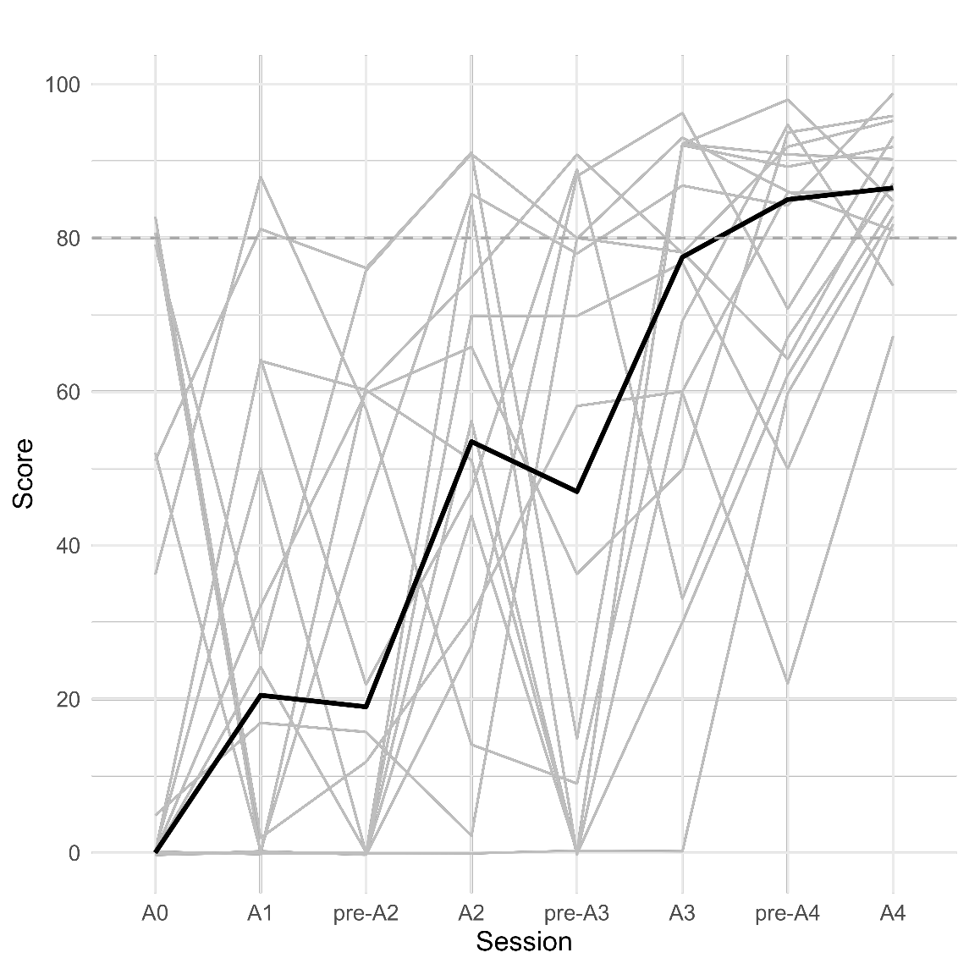
The grey lines represent the score changes for each resident. The dotted horizontal line indicates the performance threshold (80/100). The bold black line shows the evolution of the median score.

E-Figure 2: Multidimensional learning curve showing changes in score, completion time and odometer for hydromaneuver and intra ocular lens insertion steps
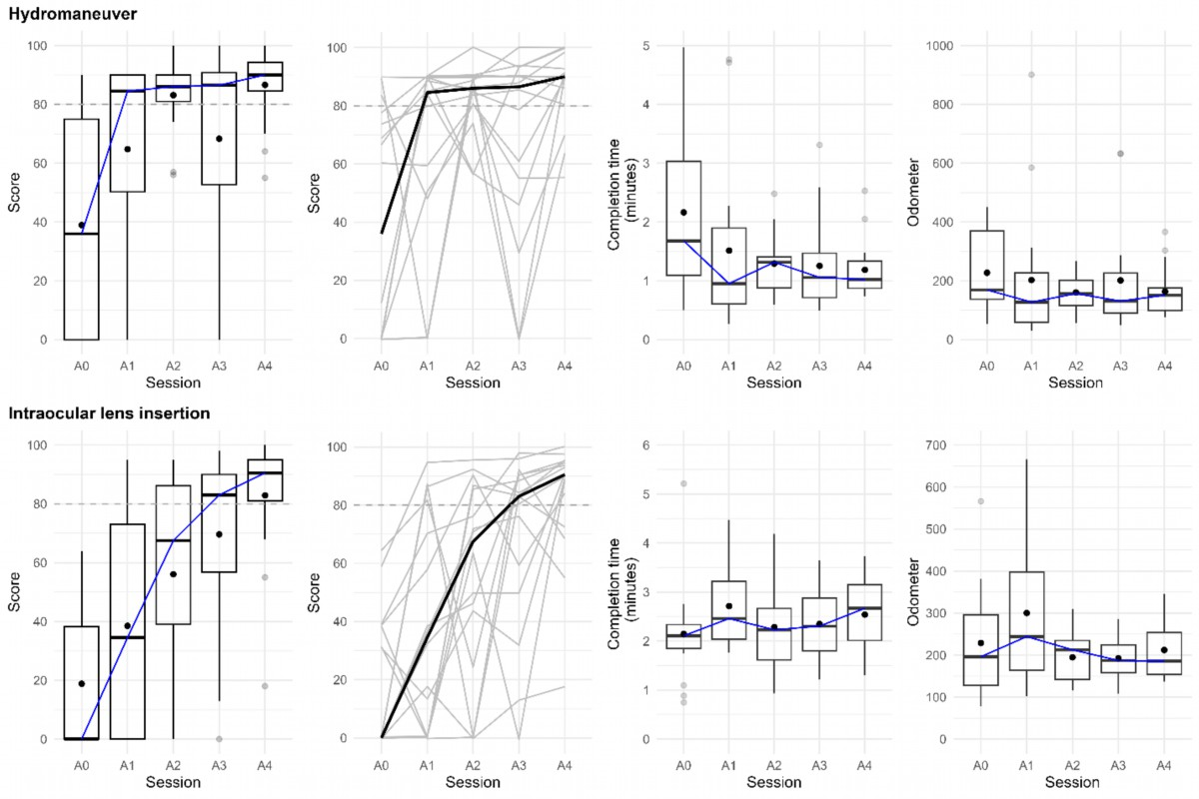

In the box plots (columns 1, 3 and 4), the edge of the box indicates the 25th and 75th percentiles, the black line within the box indicates the median. The upper whiskers extend from the edges of the box to the highest and lowest values up to 1.5 times the IQR. Data beyond the end of the whiskers are plotted individually as grey circles. The blue lines connect the medians across sessions. In column 2, the individual overlaid curves show each ophthalmology resident’s score changes across sessions (grey lines). The bold black line shows the evolution of the median score across sessions

