Supplementary Material
Evaluation of microbial community in various saline-alkaline soils driven by soil factors of Hetao Plain, Inner Mongolia
Xiaoyu Zhao^{1,2}, Xiaofang Yu^{1*}, Julin Gao^{1*}, Qinggeer Borjigin ¹, Jiawei Qu¹, Bizhou Zhang², Sainan Zhang¹, Qiang Li ², Jiangan Gu ², Dongbo Li¹
¹ Inner Mongolia Autonomous Region Engineering Research Center for in-situ maize stalk returning microbiology, Inner Mongolia Agricultural University, Huhehaote, China
² Institute of Maize Research, Inner Mongolia Academy of Agricultural & Animal Husbandry Sciences, Huhehaote, China

* Correspondence:
Xiaofang Yu
nmyuxiaofang@imau.edu.cn
Julin Gao
nmgaojulin@imau.edu.cn

Supplementary Table 1 Sequence number and base number for each sample.
Sample ID | Bacteria |  |  | Fungi
Sample ID | Sequence number | Base number |  | Sequence number | Base number
T01_1 | 37106 | 15345692 |  | 70874 | 17315279
T01_2 | 43602 | 18144173 |  | 74470 | 19056639
T01_3 | 43565 | 18071445 |  | 69187 | 16015332
T02_1 | 47147 | 19715625 |  | 72226 | 18011596
T02_2 | 51831 | 21701042 |  | 84464 | 20516566
T02_3 | 40519 | 16953816 |  | 92130 | 21783116
T03_1 | 31018 | 12907756 |  | 66820 | 16933874
T03_2 | 37807 | 15725917 |  | 64553 | 16584712
T03_3 | 34244 | 14192323 |  | 63794 | 16963841
T04_1 | 42947 | 17832461 |  | 99874 | 24115734
T04_2 | 50300 | 20906615 |  | 87005 | 20718244
T04_3 | 40906 | 17006327 |  | 84820 | 20727457
T05_1 | 43225 | 18099167 |  | 95032 | 24381615
T05_2 | 37306 | 15657073 |  | 48470 | 14330240
T05_3 | 34410 | 14429690 |  | 60634 | 16221594
T06_1 | 35489 | 14807228 |  | 78463 | 20742603
T06_2 | 41156 | 17188288 |  | 73876 | 18786925
T06_3 | 41620 | 17333456 |  | 76146 | 20043818
T07_1 | 30050 | 12533886 |  | 105990 | 24072259
T07_2 | 33282 | 13842507 |  | 98766 | 23608471
T07_3 | 61454 | 25594846 |  | 96505 | 22051732
T08_1 | 34437 | 14373788 |  | 50966 | 13746651
T08_2 | 33962 | 14223895 |  | 53623 | 13589610
T08_3 | 84218 | 35224357 |  | 63447 | 16883448
T09_1 | 35382 | 14963374 |  | 64831 | 15767391
T09_2 | 37284 | 15808933 |  | 77169 | 18299198
T09_3 | 33176 | 14009750 |  | 85402 | 17595283
T10_1 | 41065 | 17121721 |  | 71382 | 18114064
T10_2 | 42168 | 17621027 |  | 81093 | 19501678
T10_3 | 41714 | 17461897 |  | 79633 | 18621973
T11_1 | 38832 | 16210023 |  | 79581 | 19752900
T11_2 | 40782 | 17007446 |  | 83731 | 19989543
T11_3 | 36786 | 15329609 |  | 76804 | 19205739
T12_1 | 45240 | 18881566 |  | 81262 | 20686369
T12_2 | 48718 | 20317512 |  | 72956 | 18796580
T12_3 | 40507 | 16911661 |  | 79621 | 20176611
T13_1 | 38621 | 16030782 |  | 96583 | 23500118
T13_2 | 40739 | 16946284 |  | 78313 | 19718984
T13_3 | 69456 | 28872624 |  | 77349 | 19784773
T14_1 | 51647 | 21569232 |  | 95700 | 21536075
T14_2 | 48628 | 20300890 |  | 96231 | 20882784
T14_3 | 48619 | 20253204 |  | 95307 | 20914827
T15_1 | 42503 | 17755580 |  | 70661 | 18324601
T15_2 | 50270 | 20884211 |  | 71681 | 19003546
T15_3 | 41328 | 17267034 |  | 79107 | 20703416
T16_1 | 50310 | 20946321 |  | 90655 | 21284670
T16_2 | 53649 | 22329744 |  | 76301 | 20499209
T16_3 | 47336 | 19726202 |  | 75869 | 18523207
T17_1 | 49563 | 20544279 |  | 82807 | 18887309
T17_2 | 52496 | 21767280 |  | 78426 | 18418581
T17_3 | 53454 | 22192361 |  | 80316 | 18970945
T18_1 | 69558 | 28982980 |  | 70267 | 17161632
T18_2 | 76748 | 32004338 |  | 78499 | 19252914
T18_3 | 57354 | 23899466 |  | 70680 | 17054892
T19_1 | 47473 | 19714103 |  | 155065 | 37942265
T19_2 | 48266 | 20029984 |  | 124283 | 30559271
T19_3 | 40986 | 16998874 |  | 145556 | 35214713
T20_1 | 59425 | 24742244 |  | 69352 | 17543791
T20_2 | 56733 | 23666463 |  | 64901 | 15849482
T20_3 | 53013 | 22123443 |  | 70438 | 17205522
T21_1 | 46487 | 19273645 |  | 91076 | 19857340
T21_2 | 57110 | 23722092 |  | 74955 | 16860650
T21_3 | 50827 | 21115283 |  | 74521 | 17155932
T22_1 | 51802 | 21629083 |  | 83758 | 19947841
T22_2 | 53553 | 22325599 |  | 82051 | 18690264
T22_3 | 47907 | 19964952 |  | 76909 | 18300231
T23_1 | 50955 | 21186369 |  | 82494 | 18582680
T23_2 | 51012 | 21207768 |  | 89701 | 19727466
T23_3 | 49623 | 20625267 |  | 89046 | 19666591
T24_1 | 58272 | 24316771 |  | 113370 | 24591359
T24_2 | 56169 | 23408519 |  | 87719 | 19044856
T24_3 | 50686 | 21159478 |  | 80414 | 18664539
Total | 3365833 | 1402938641 |  | 5885961 | 1423535961

Supplementary Table 2 Changes of chemical properties of different salinized soils
Sample | Latitude | Longitude | pH | AN  (mg/kg) | AP  (mg/kg) | AK  (mg/kg) | SOM  (g/kg) | Cl⁻  (g/kg) | SO₄²⁻  (g/kg) | HCO₃⁻  (g/kg) | CO₃²⁻  (g/kg) | Ca²⁺  (g/kg) | Mg²⁺  (g/kg) | Na⁺  (g/kg) | K⁺  (g/kg） | EC  (ms/cm) | Main vegatation types
Wbf1 | 40.571 | 109.406 | 10.23a | 10.84j | 27.21d | 365.85a | 3.34g | 0.40c | 1.57d | 0.63a | 0.51b | 0.14e | 0.18d | 0.74c | 0.15b | 2.46b | Aster subulatus
Wbf2 | 40.573 | 109.260 | 8.53c | 58.10b | 59.14a | 354.01a | 8.16b | 0.33d | 0.51f | 0.29c | 0.08e | 0.10e | 0.03f | 0.39e | 0.08c | 0.90f | Maize
Wbf3 | 40.581 | 109.257 | 10.41a | 21.54h | 38.27c | 328.02b | 3.51g | 0.23e | 0.48f | 0.36b | 0.42b | 0.21d | 0.11e | 0.07g | 0.13b | 2.71b | Aster subulatus
Wwy1 | 40.780 | 108.587 | 9.45b | 16.42i | 21.27e | 87.79j | 2.05h | 0.24e | 0.95e | 0.79a | 0.10e | 0.17e | 0.11e | 0.50d | 0.11b | 2.02c | Sunflower
Wwy2 | 40.782 | 108.601 | 8.94c | 7.57k | 6.28j | 92.42j | 0.36i | 0.31d | 1.67d | 0.24c | 0.28c | 0.30d | 0.20d | 0.38e | 0.15b | 2.23c | Salsola soda Linn
Wwy3 | 40.772 | 108.366 | 9.10b | 38.34e | 12.27h | 122.16h | 5.27e | 1.98b | 6.12b | 0.22c | 0.14d | 2.10a | 0.68b | 0.61c | 0.12b | 1.76d | Maize
Wsx1 | 41.030 | 108.360 | 9.15b | 39.96d | 13.56h | 151.04g | 5.16e | 4.48a | 2.02c | 0.23c | 0.31c | 0.86c | 0.79a | 1.49a | 0.09c | 1.80d | Maize
Wsx2 | 41.043 | 108.383 | 9.27b | 18.06i | 23.63e | 245.09e | 3.04g | 0.13f | 0.69f | 0.29c | 0.12d | 0.23d | 0.11e | 0.05g | 0.21a | 2.43b | Sunflower
Wsx3 | 41.038 | 108.374 | 10.51a | 2.68l | 7.27j | 331.65b | 0.64i | 0.48c | 1.29d | 0.39b | 0.71a | 0.15e | 0.22d | 0.48d | 0.18b | 4.10a | Salsola soda Linn
Wxr1 | 41.058 | 108.314 | 8.80c | 36.80f | 13.84h | 149.10g | 4.86f | 0.37d | 0.40f | 0.29c | 0.08e | 0.10e | 0.05f | 0.34e | 0.15b | 0.69f | Maize
Wxr2 | 41.055 | 108.312 | 8.78c | 39.70d | 18.95f | 216.47e | 5.48e | 1.03b | 7.55a | 0.27c | 0.09e | 2.70a | 0.63b | 0.09g | 0.13b | 1.50d | Sunflower
Wxr3 | 41.055 | 108.307 | 8.57c | 53.10b | 19.36f | 248.16e | 7.44c | 0.25e | 0.30f | 0.29c | 0.08e | 0.09e | 0.03f | 0.26f | 0.10c | 0.36h | Sunflower
Wsm1 | 40.922 | 108.240 | 8.82c | 33.42g | 28.56d | 303.37c | 5.40e | 0.59c | 0.93e | 0.31b | 0.08e | 0.06e | 0.13e | 0.65c | 0.13b | 1.37e | Sunflower
Wsm2 | 40.933 | 108.234 | 8.83c | 59.22b | 14.78h | 186.33f | 8.38b | 0.29e | 0.96e | 0.15d | 0.09e | 0.30d | 0.05f | 0.26f | 0.05c | 0.35h | Maize
Wsm3 | 40.933 | 108.213 | 9.05b | 45.66c | 10.60i | 310.48c | 7.16c | 0.25e | 7.34a | 0.19d | 0.08e | 2.38a | 0.48c | 0.10g | 0.05c | 1.41d | Sunflower
Lnl1 | 40.827 | 107.587 | 8.36c | 37.75f | 9.52i | 137.44g | 5.88e | 0.25e | 0.13g | 0.26c | 0.08e | 0.14e | 0.04f | 0.10g | 0.23a | 0.91f | Maize
Lnl2 | 40.817 | 107.582 | 8.57c | 34.63g | 16.76g | 90.80j | 5.21e | 0.47c | 0.67f | 0.27c | 0.09e | 0.07e | 0.06f | 0.55d | 0.10c | 1.12e | Sunflower
Lnl3 | 40.819 | 107.583 | 8.46c | 37.04f | 28.37d | 140.33g | 5.60e | 1.02b | 1.02d | 0.14d | 0.09e | 0.18e | 0.10e | 0.80b | 0.05c | 0.21h | Sunflower
Hsc1 | 40.962 | 107.224 | 8.88c | 47.33c | 42.24b | 140.78g | 6.19d | 0.16f | 0.14g | 0.45b | 0.08e | 0.10e | 0.02f | 0.21f | 0.03c | 0.37h | Maize
Hsc2 | 40.964 | 107.224 | 8.78c | 38.82e | 36.07c | 110.91i | 4.71f | 0.41c | 1.13d | 0.47b | 0.10e | 0.10e | 0.01f | 0.88b | 0.05c | 0.21h | Maize
Hsc3 | 40.960 | 107.229 | 8.38c | 38.45e | 12.14h | 202.50f | 5.53e | 0.19f | 0.13g | 0.44b | 0.10e | 0.09e | 0.07f | 0.10g | 0.05c | 1.36e | Sunflower
Hsd1 | 40.835 | 106.939 | 8.33c | 73.05a | 56.00a | 191.04f | 9.04a | 0.20e | 0.13g | 0.32b | 0.09e | 0.10e | 0.03f | 0.26f | 0.25a | 0.55f | Maize
Hsd2 | 40.831 | 106.940 | 8.27c | 39.27d | 20.20e | 195.28f | 5.51e | 0.18f | 0.15g | 0.36b | 0.08e | 0.09e | 0.02f | 0.15g | 0.10c | 0.20h | Maize
Hsd3 | 40.829 | 106.941 | 8.52c | 45.89c | 35.20c | 262.99d | 6.39d | 1.48b | 2.24c | 0.40b | 0.19d | 1.06b | 0.29d | 0.41d | 0.11b | 1.88d | Sunflower
EC: electrical conductivity. Different letters indicate significant differences in P-value at the 0.05 level.

Supplementary Table 3 The proportion of the top ten bacterial groups in the richness of bacteria and fungi in different saline-alkali land soil at phylum level.
 | Phylum species | L | M | H
Bacteria | Proteobacteria | 22% | 26% | 30%
Bacteria | Actinobacteriota | 19% | 19% | 17%
Bacteria | Chloroflexi | 18% | 16% | 11%
Bacteria | Acidobacteriota | 16% | 13% | 9%
Bacteria | Firmicutes | 5% | 6% | 9%
Bacteria | Gemmatimonadota | 6% | 5% | 8%
Bacteria | Bacteroidota | 3% | 4% | 6%
Bacteria | Myxococcota | 2% | 2% | 1%
Bacteria | Methylomirabilota | 2% | 1% | 1%
Bacteria | Desulfobacterota | 1% | 1% | 1%
Bacteria | others | 6% | 7% | 7%
Fungi | Ascomycota | 83% | 86% | 76%
Fungi | Basidiomycota | 3% | 5% | 14%
Fungi | Mortierellomycota | 8% | 4% | 5%
Fungi | unclassified_k__Fungi | 4% | 3% | 3%
Fungi | Chytridiomycota | 2% | 2% | 1%
Fungi | Olpidiomycota | - | - | 1%
Fungi | Rozellomycota | - | - | -
Fungi | Glomeromycota | - | - | -
Fungi | Blastocladiomycota | - | - | -
Fungi | Calcarisporiellomycota | - | - | -
Fungi | others | - | - | -

Supplementary Table 4 ASVs classification of soil center network with different degrees of salinization
 |  |  | Phlya | Class | Order | Family | Genus
Bacteria | L treatmen | ASV198 | Acidobacteriota | Vicinamibacteria | Vicinamibacterales | Vicinamibacterales | Vicinamibacterales
Bacteria | L treatmen | ASV152 | Chloroflexi | OLB14 | norank_c__OLB14 | OLB14 | OLB14
Bacteria | L treatmen | ASV692 | Acidobacteriota | Vicinamibacteria | Vicinamibacterales | Vicinamibacteraceae | Vicinamibacteraceae
Bacteria | L treatmen | ASV1675 | Methylomirabilota | Methylomirabilia | Rokubacteriales | Rokubacteriales | Rokubacteriales
Bacteria | L treatmen | ASV209 | Acidobacteriota | Vicinamibacteria | Vicinamibacterales | Vicinamibacteraceae | Vicinamibacteraceae
Bacteria | L treatmen | ASV1596 | Proteobacteria | Alphaproteobacteria | Tistrellales | Geminicoccaceae | Geminicoccaceae
Bacteria | L treatmen | ASV149 | Acidobacteriota | Vicinamibacteria | Vicinamibacterales | Vicinamibacteraceae | Vicinamibacteraceae
Bacteria | L treatmen | ASV425 | Gemmatimonadota | Gemmatimonadetes | Gemmatimonadales | Gemmatimonadaceae | Gemmatimonadaceae
Bacteria | L treatmen | ASV559 | Unclassified | Unclassified | Unclassified | Unclassified | Unclassified
Bacteria | L treatmen | ASV1639 | Chloroflexi | KD4-96 | KD4-96 | KD4-96 | KD4-96
Bacteria | M treatment | ASV1433 | Actinobacteriota | Acidimicrobiia | Actinomarinales | Actinomarinales | Actinomarinales
Bacteria | M treatment | ASV348 | Entotheonellaeota | Entotheonellia | Entotheonellales | Entotheonellaceae | Entotheonellaceae
Bacteria | M treatment | ASV1452 | Methylomirabilota | Methylomirabilia | Rokubacteriales | Rokubacteriales | Rokubacteriales
Bacteria | M treatment | ASV1411 | Chloroflexi | Chloroflexia | Chloroflexales | Roseiflexaceae | Roseiflexaceae
Bacteria | M treatment | ASV90 | Chloroflexi | Dehalococcoidia | S085 | S085 | S086
Bacteria | M treatment | ASV108 | Myxococcota | bacteriap25 | bacteriap25 | bacteriap25 | bacteriap26
Bacteria | M treatment | ASV1423 | Proteobacteria | Alphaproteobacteria | Tistrellales | Geminicoccaceae | Geminicoccaceae
Bacteria | M treatment | ASV2436 | Proteobacteria | Gammaproteobacteria | Steroidobacterales | Steroidobacterales | Steroidobacterales
Bacteria | M treatment | ASV569 | Gemmatimonadota | Gemmatimonadetes | Gemmatimonadales | Gemmatimonadales | Gemmatimonadales
Bacteria | M treatment | ASV9 | Proteobacteria | Alphaproteobacteria | Azospirillales | Azospirillales | Azospirillales
Bacteria | H treatment | ASV2325 | Proteobacteria | Alphaproteobacteria | Alphaproteobacteria | Alphaproteobacteria | Alphaproteobacteria
Bacteria | H treatment | ASV81 | Proteobacteria | Alphaproteobacteria | Tistrellales | Geminicoccaceae | Geminicoccaceae
Bacteria | H treatment | ASV13 | Chloroflexi | Chloroflexia | Thermomicrobiales | AKYG1722 | AKYG1723
Bacteria | H treatment | ASV1523 | Actinobacteriota | Actinobacteria | Propionibacteriales | Nocardioidaceae | Nocardioidaceae
Bacteria | H treatment | ASV248 | Methylomirabilota | Methylomirabilia | Rokubacteriales | Rokubacteriales | Rokubacteriales
Bacteria | H treatment | ASV2204 | Actinobacteriota | Actinobacteria | Propionibacteriales | Nocardioidaceae | Nocardioides
Bacteria | H treatment | ASV47 | Proteobacteria | Alphaproteobacteria | Alphaproteobacteria | Alphaproteobacteria | Alphaproteobacteria
Bacteria | H treatment | ASV19 | Gemmatimonadota | Gemmatimonadetes | Gemmatimonadales | Gemmatimonadales | Gemmatimonadales
Bacteria | H treatment | ASV806 | Proteobacteria | Alphaproteobacteria | Azospirillales | Azospirillaceae | Skermanella
Bacteria | H treatment | ASV373 | Chloroflexi | Chloroflexia | Thermomicrobiales | JG30-KF-CM45 | JG30-KF-CM45
Fungi | L treatmen | ASV1209 | Mortierellomycota | Mortierellomycetes | Mortierellales | Mortierellaceae | Mortierella
Fungi | L treatmen | ASV1173 | Mortierellomycota | Mortierellomycetes | Mortierellales | Mortierellaceae | Mortierella
Fungi | L treatmen | ASV475 | Ascomycota | Sordariomycetes | Hypocreales | Nectriaceae | Gibberella
Fungi | L treatmen | ASV998 | Ascomycota | Sordariomycetes | Glomerellales | Plectosphaerellaceae | Plectosphaerella
Fungi | L treatmen | ASV1399 | Ascomycota | Dothideomycetes | Pleosporales | Phaeosphaeriaceae | Setophoma
Fungi | L treatmen | ASV37 | Mortierellomycota | Mortierellomycetes | Mortierellales | Mortierellaceae | Mortierella
Fungi | L treatmen | ASV133 | Ascomycota | Dothideomycetes | Pleosporales | Cucurbitariaceae | Pyrenochaetopsis
Fungi | L treatmen | ASV1191 | Ascomycota | Sordariomycetes | Hypocreales | Nectriaceae | Neocosmospora
Fungi | L treatmen | ASV76 | Ascomycota | Dothideomycetes | Pleosporales | Pleosporaceae | Alternaria
Fungi | L treatmen | ASV188 | Ascomycota | Leotiomycetes | Helotiales | Helotiales | Cadophora
Fungi | M treatment | ASV151 | Mortierellomycota | Mortierellomycetes | Mortierellales | Mortierellaceae | Mortierella
Fungi | M treatment | ASV159 | Ascomycota | Dothideomycetes | Pleosporales | Pleosporaceae | Alternaria
Fungi | M treatment | ASV166 | Mortierellomycota | Mortierellomycetes | Mortierellales | Mortierellaceae | Mortierella
Fungi | M treatment | ASV849 | Ascomycota | Sordariomycetes | Hypocreales | Nectriaceae | Haematonectria
Fungi | M treatment | ASV47 | Ascomycota | Leotiomycetes | Thelebolales | Pseudeurotiaceae | Pseudogymnoascus
Fungi | M treatment | ASV158 | Ascomycota | Sordariomycetes | Hypocreales | Nectriaceae | Gibberella
Fungi | M treatment | ASV842 | Ascomycota | unclassified | unclassified | unclassified | unclassified
Fungi | M treatment | ASV1023 | Ascomycota | Sordariomycetes | Microascales | Microascaceae | Lophotrichus
Fungi | M treatment | ASV224 | Unclassified | unclassified | unclassified | unclassified | unclassified
Fungi | M treatment | ASV173 | Rozellomycota | unclassified | unclassified | unclassified | unclassified
Fungi | H treatment | ASV4172 | Basidiomycota | Tremellomycetes | Tremellales | Trimorphomycetaceae | Saitozyma
Fungi | H treatment | ASV1903 | Ascomycota | Dothideomycetes | Pleosporales | Didymellaceae | Didymella
Fungi | H treatment | ASV30 | Ascomycota | Leotiomycetes | Thelebolales | Pseudeurotiaceae | Pseudogymnoascus
Fungi | H treatment | ASV23 | Ascomycota | Sordariomycetes | Hypocreales | Clavicipitaceae | Metarhizium
Fungi | H treatment | ASV619 | Ascomycota | Dothideomycetes | Pleosporales | Phaeosphaeriaceae | Paraphoma
Fungi | H treatment | ASV32 | Mortierellomycota | Mortierellomycetes | Mortierellales | Mortierellaceae | Mortierella
Fungi | H treatment | ASV70 | Mortierellomycota | Mortierellomycetes | Mortierellales | Mortierellaceae | Mortierella
Fungi | H treatment | ASV20 | Ascomycota | Sordariomycetes | Sordariales | Chaetomiaceae | _Chaetomium
Fungi | H treatment | ASV164 | Ascomycota | Sordariomycetes | Sordariales | Lasiosphaeriaceae | Lasiosphaeriaceae
Fungi | H treatment | ASV1192 | Ascomycota | Sordariomycetes | Hypocreales | Nectriaceae | Neocosmospora

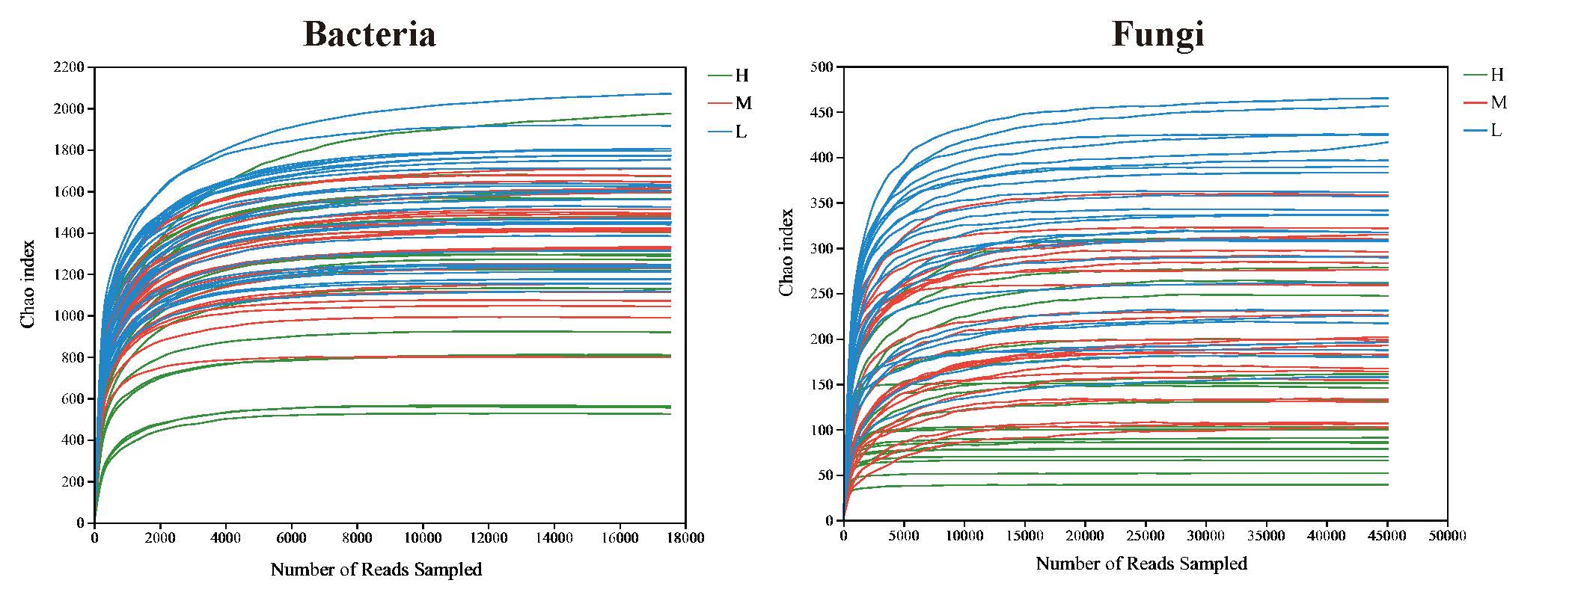
Supplementary Fig 1. The rarefaction curves of bacteria and fungi for different samples.

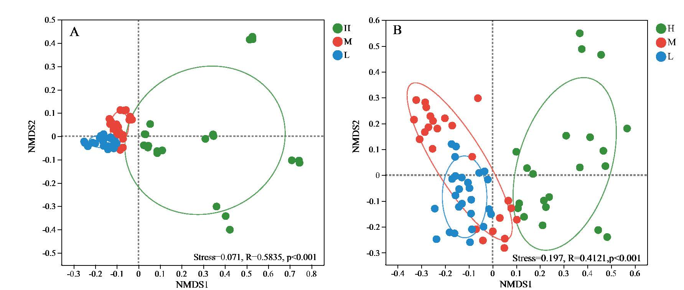
Supplementary Fig 2. The NMDS analysis of bacterial (A) and fungal (B) communities in various saline-alkaline soils at the ASV level.

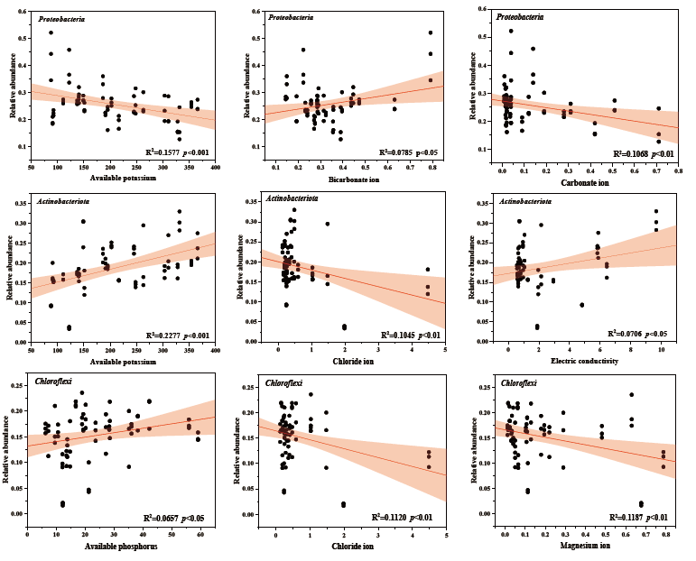
Supplementary Fig 3 The linear correlation between bacteria and core communities Acidobacteriota, Proteobacteria, Chloroflexi and soil factors (AK, AP, Cl⁻, HCO₃⁻, CO₃²⁻, Mg²⁺, EC)
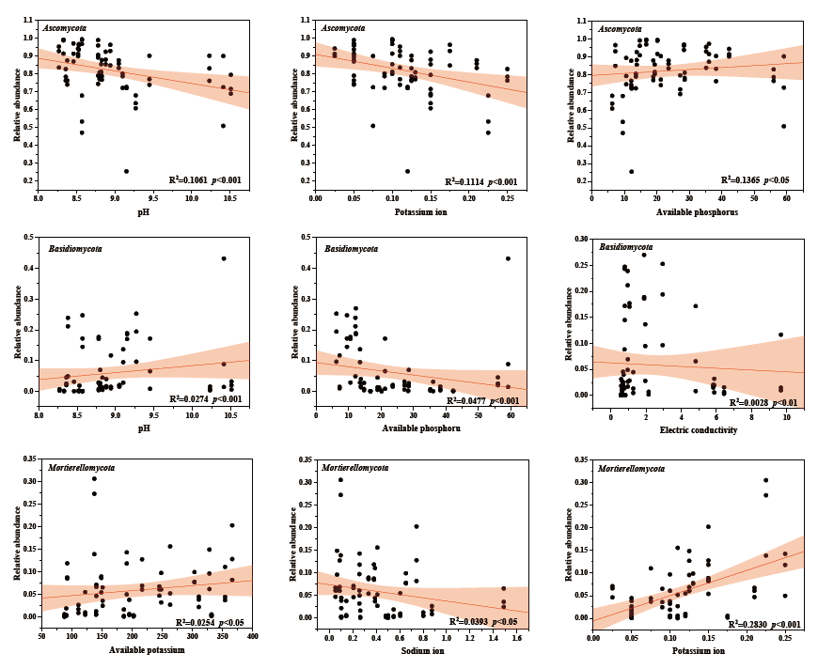
Supplementary Fig 4 The linear correlation between fungi and core communities Ascomycota, Basidiomycota , Mortierellomycota and soil factors (pH, AK, AP, Na⁺, K⁺, EC)

