Overall Accuracy= (47807/51304) = 93.1838% Kappa Coefficient = 0.8876
Reference
 | Class | BU | VC | BL | FL | Total | UA% | Com.E%
Classification | BU | 15496 | 455 | 7 | 31 | 15989 | 96.92 | 3.08
 | VC | 122 | 25709 | 1 | 132 | 25964 | 99.02 | 0.98
 | BL | 113 | 453 | 1753 | 45 | 2364 | 74.15 | 25.85
 | FL | 197 | 1933 | 8 | 4849 | 6987 | 69.4 | 30.6
 | Total | 15928 | 28550 | 1769 | 5057 | 51304 | 339.49 | 60.51
PA% |  | 96.92 | 99.02 | 74.15 | 69.4 | 382.33
Om.E% |  | 2.71 | 2.71 | 2.71 | 2.71 | 17.67
Accuracy assessment using confusion matrix for the year 1990

Accuracy assessment using confusion matrix for the year 2005
Overall Accuracy = (36778/38873) =94.6107% Kappa Coefficient = 0.9192
Reference
 | Class | BU | VC | BL | FL | Total | UA% | Com.E%
Classification | BU | 11836 | 51 | 11 | 173 | 12071 | 98.05 | 1.95
 | VC | 22 | 8525 | 0 | 628 | 9175 | 92.92 | 7.08
 | BL | 177 | 40 | 822 | 454 | 1493 | 55.06 | 44.94
 | FL | 139 | 395 | 5 | 15595 | 16134 | 96.66 | 3.34
 | Total | 12174 | 9011 | 838 | 16850 | 38873 | 342.69 | 57.31
PA% |  | 97.22 | 94.61 | 98.09 | 92.55 | 382.47
Om.E% |  | 2.78 | 5.39 | 1.91 | 7.45 | 17.53

Accuracy assessment using confusion matrix for the year 2021
Overall Accuracy = (48884/49600) = 98.5565% Kappa Coefficient = 0.9667
Reference
 | Class | BU | VC | BL | FL | Total | UA% | Com.E%
Classification | BU | 35174 | 131 | 0 | 14 | 35319 | 99.59 | 0.41
 | VC | 87 | 11289 | 0 | 2 | 11378 | 99.22 | 0.78
 | BL | 168 | 26 | 552 | 16 | 762 | 72.44 | 27.56
 | FL | 215 | 41 | 16 | 1869 | 2141 | 87.3 | 12.7
 | Total | 35644 | 11487 | 568 | 1901 | 49600 | 358.55 | 12.7
PA% |  | 98.68 | 98.28 | 97.18 | 98.32 | 392.46
Om.E% |  | 1.32 | 1.72 | 2.82 | 1.68 | 7.54
UA, user’s accuracy; PA; producer’s accuracy, Com. E, commission error; Om.E E, omission error., ⁕Value which represent in the diagonal were correctly classified pixel Values of each class.

Estimation of LST for sub-cities in Addis Ababa
Estimated LST (ºC) Value By increment of NDBI & NDVI
Sub City | Variable | 5% | 10% | 15% | 20% | 25%
Akaki | NDBI | 33.50 | 35.10 | 36.70 | 38.30 | 39.90
 | NDVI | 30.50 | 29.10 | 27,70 | 26.30 | 24.90
Lafto | NDBI | 32.62 | 34.22 | 35.82 | 37.42 | 39.02
 | NDVI | 29.62 | 28.22 | 26.82 | 25.42 | 24.02
Kolfe | NDBI | 30.44 | 32.04 | 33.64 | 35.24 | 36.84
 | NDVI | 27.44 | 26.04 | 24.64 | 23.24 | 21.84
Gulele | NDBI | 26.65 | 29.25 | 30.85 | 32.45 | 34.05
 | NDVI | 24.65 | 23.25 | 21.85 | 20.45 | 19.05
Ldeta | NDBI | 31.79 | 32.39 | 34.99 | 36.59 | 38.19
 | NDVI | 28.79 | 27.39 | 25.99 | 24.59 | 23.19
Chirkos | NDBI | 32.20 | 33.80 | 35.40 | 37.00 | 38.60
 | NDVI | 29.20 | 27.80 | 26.40 | 25.00 | 23.60
Arada | NDBI | 31.84 | 33.44 | 35.04 | 36.64 | 38.24
 | NDVI | 28.84 | 27.44 | 26.04 | 24.64 | 23.24
Addis/K | NDBI | 32.52 | 34.12 | 35.72 | 37.32 | 38.92
 | NDVI | 29.52 | 28.12 | 26.72 | 25.32 | 23.92
Bole | NDBI | 32.90 | 34.50 | 36.10 | 37.70 | 39.30
 | NDVI | 29.90 | 28.50 | 27.10 | 25.70 | 24.30
Yeka | NDBI | 29.64 | 31.24 | 32.84 | 34.44 | 36.04
 | NDVI | 26.64 | 25.24 | 23.84 | 22.44 | 21.04
Source: (Authors own Processing, 2021)

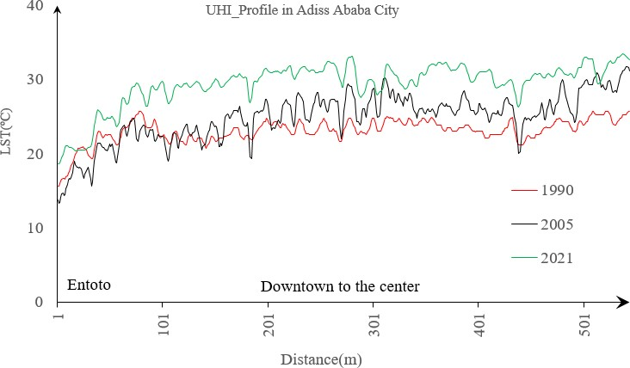
Graph of UHI _Profile in Addis Ababa City in the years 1990, 2005, and 2021

