atRA mitigates high salt-driven EAE by stabilizing Treg cell mediated the inhibition of IL-23R and the repairment of compromised endogenous RA signaling
Jiale Tian^{1#}, Yong Wang^{1#}, Haolin Li^{2#}, Yating Li^{1#}, Xiaofeng Wei³, Youquan Gu⁴, Haidong Wang⁴, Yang Luo ^{1, 3, 4, 5*}
¹ The First Clinical Medical College, Lanzhou University, Lanzhou 730000, Gansu, China
² Rheumatic Bone Disease Center, Gansu Hospital of Traditional Chinese Medicine; Gansu University of Chinese Medicine, Lanzhou 730000, Gansu, China
³ Key Laboratory of Biotherapy and Regenerative Medicine, Lanzhou 730000, Gansu, China
⁴ Department of Neurology, The First Hospital of Lanzhou University, Lanzhou, 730000 Gansu, China;
⁵ Division of Rheumatology, Department of Medicine, Penn State College of Medicine, Hershey, PA, USA
# These authors contributed equally to this work.
*Correspondence and requests for reprints should be addressed to:
Yang Luo, Address: Department of Neurology, The First Hospital of Lanzhou University, Lanzhou; Key Laboratory of Biotherapy and Regenerative Medicine, Lanzhou 730000, Gansu, China; E-mail: ldyy_yluo@lzu.edu.cn

Supplementary Figure 1.
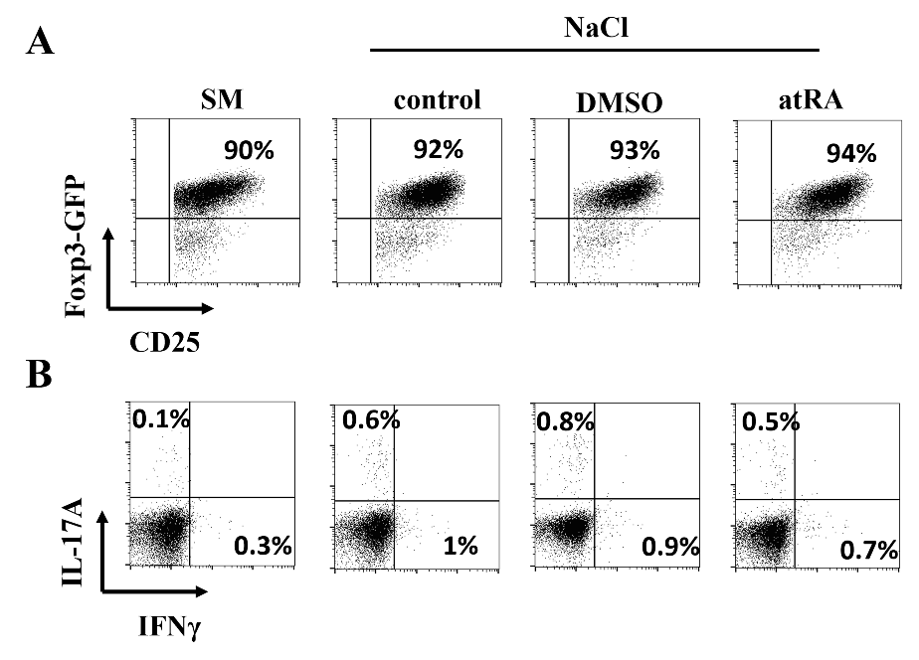
Fig S1. High salt has little impact on in-vitro Treg cell stability with or without atRA stimulation. sorted thymic Treg cells from naïve B6 Foxp3^{-GFP} mice were firstly expanded to a certain amount. Then these cells were cultured in the standard media (SM) or enriched with additional NaCl (40 mM) for another 48h. Some wells DMSO or atRA was added initially as indicated. After 48h culture, GFP expression was examined by flow cytometry, cells were gated on CD4 (A). Intracellular IL-17A and IFN-γ expression on total Treg cells were shown (B). One representative experiment of six is shown. Plots with no statistical significance were not shown. Statistical analyses were performed using one-way ANOVA. ns, not significant. *p < 0.05; **p < 0.01.

Supplementary Figure 2
Fig S2. SGK1 expression is increased in tTreg Cells after atRA stimulation. In-vitro-stimulated thymic Treg cells (tTreg) were cultured in either standard media or in high salt media (NaCl 40 mM), in some plates atRA was initially. After 48h culture, cells were harvested for qPCR and WB. at-Treg terms as atRA-stimulated tTreg cells, at-Treg+Na terms as atRA-stimulated tTreg cells under high salt condition. The mRNA level of Sgk1 gene is shown (A). The protein levels of SGK1 (B, C) and pSGK1 (B, D) are shown. Data are representative of three independent experiments. Error bars represent SEM. *p < 0.05, **p < 0.01, ***p < 0.001 (Student’s t test, error bars, SD).

Supplementary Figure 3
Fig S3. anti-IL-23R mAb administration exhibits partial anti-inflammatory activity in NSD-fed EAE mice. Mice were injected intraperitoneally with 20 μg/mice anti-IL-23R mAb or vehicle control Ab IgG every other day, starting from the day 4 after immunization. Clinical scores were assessed dynamically (A). Infiltrating cells from the brains and spinal cords were harvested. IL-17A- and INFγ- producing CD4⁺ T cells were analyzed by flow cytometry. The representative flow diagrams are from the spinal cords (B). Data are representative of at least six mice per group (C). Staining of indicated statistical analyses were performed using one-way ANOVA. *p < 0.05; **p < 0.01; ***p < 0.001. ns, not significant.

