A
Panel A represents Western blot analysis shown in Fig. 3A. Every lane in every protein image was a same group of cells. The first lane was normal control. The sencond lane was model control. The third lane was low dose of FGF21 treatment. The fourth lane was high dose of FGF21treatment. The data of manuscript was cropped from these original data
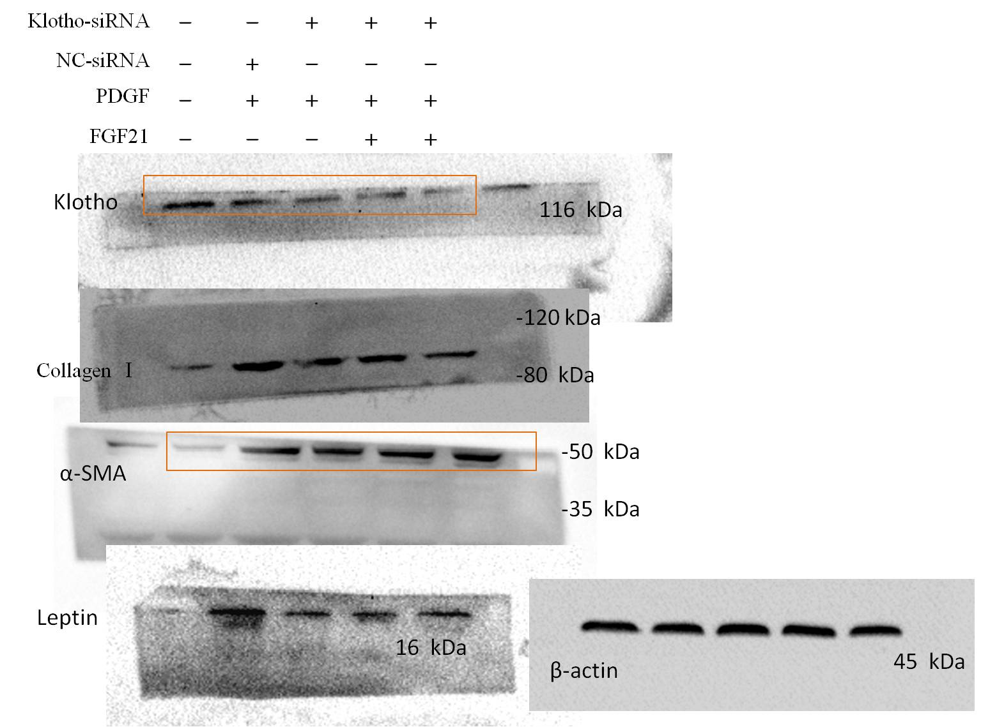
B
Panel B represents Western blot analysis shown in Fig. 3B. The box panes were target lanes. Every lane in every protein image was a same group of cells. The first lane was normal control. The sencond lane was model control (transfected NC-siRNA). The third lane was model control (transfected Klotho-siRNA). The fourth lane was low dose of FGF21 treatment (transfected Klotho-siRNA). The fifth lane was high dose of FGF21 treatment(transfected Klotho-siRNA). The data of manuscript was cropped from these original data .
Panel C represents Western blot analysis shown in Fig. 3C. The box panes were target lanes. Every lane in every protein image was a same group of cells. The first lane was normal control. The sencond lane was model control. The third lane was low dose of FGF21 treatment. The fourth lane was high dose of FGF21treatment. The data of manuscript was cropped from these original data.
C
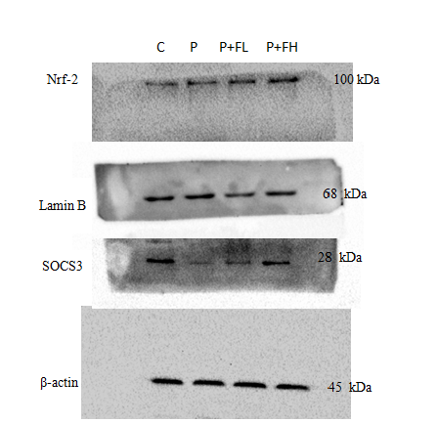
D
Panel D represents Western blot analysis shown in Fig. 3D. The box panes were target lanes. Every lane in every protein image was a same group of cells. The first lane was normal control. The sencond lane was model control. The third lane was low dose of FGF21 treatment. The fourth lane was high dose of FGF21treatment. The data of manuscript was cropped from these original data.
E
Panel E represents Western blot analysis shown in Fig. 4G. The box panes were target lanes. Every lane in every protein image was a same group of cells. The first lane was normal control. The sencond lane was model control. The third lane was low dose of FGF21 treatment. The fourth lane was high dose of FGF21treatment. The data of manuscript was cropped from these original data.

