Seasonal changes of brown carbon in an industrial city of central China: Importance of water-insoluble BrC
Guangxuan Yan^{a,*},Ziyi Wangª, Mingyang Houª, Jieqi Wangª, Sai Shangª, Ziyang Shangª, Jiayi Liª, Hao Yuª, Zhiguo Caoª, Zirui Liu^{b,*}
ª Key Laboratory for Yellow River and Huai River Water Environment and Pollution Control, Ministry of Education, School of Environment, Henan Normal University, Xinxiang 453007, China.
^{b} Institute of Atmospheric Physics, Chinese Academy of Sciences, Beijing 100029, China.
* Corresponding author, e-mail address: guangxuan.yan@htu.edu.cn (G. Yan); liuzirui@mail.iap.ac.cn (Z. Liu)

Table S1 Detailed reference values for A_{λ} and B_{λ} in Eq. (4) (Chen et al., 2015)
Wavelength/nm | A_{λ} | B_{λ}
405 | 0.1007 | 0.0447
450 | 0.1045 | 0.0456
635 | 0.1261 | 0.0555
780 | 0.1443 | 0.0546
808 | 0.1475 | 0.0479
980 | 0.1666 | 0.0528

Table S2 Meteorological factors during the 2018-2019 sampling period
 | spring | summer | autumn | winter
Relative humidity (%) | 43.39±20.75 | 58.21±16.50 | 54.10±20.58 | 46.65±18.01
Pressure (hPa) | 976.52±5.16 | 967.03±2.70 | 983.56±2.62 | 988.97±6.15
Temperature (°C) | 15.79±4.59 | 26.86±2.52 | 11.81±3.62 | 1.58±3.68
Wind speed (m/s) | 3.48±1.03 | 2.75±0.68 | 3.29±0.94 | 3.03±0.83
Mixing layer height (m) | 603.27±95.39 | 583.83±123.77 | 315.76±115.04 | 298.16±69.43

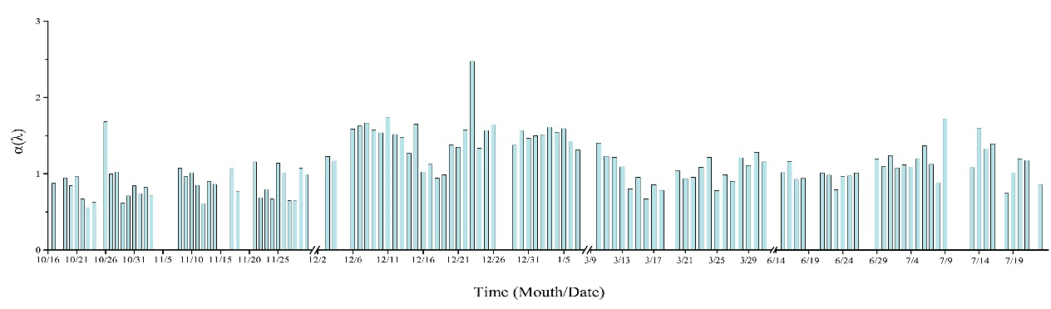
Fig. S1 Daily α(λ) values calculated following Eq. (3)

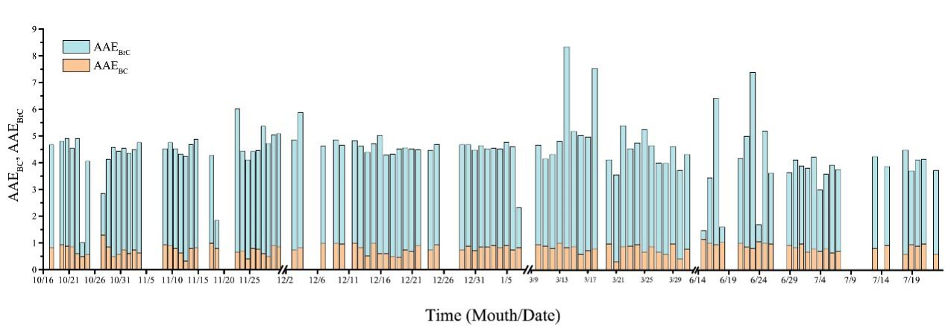
Fig. S2 Daily AAE_{BC} and AAE_{BrC} values calculated following Eq. (8)

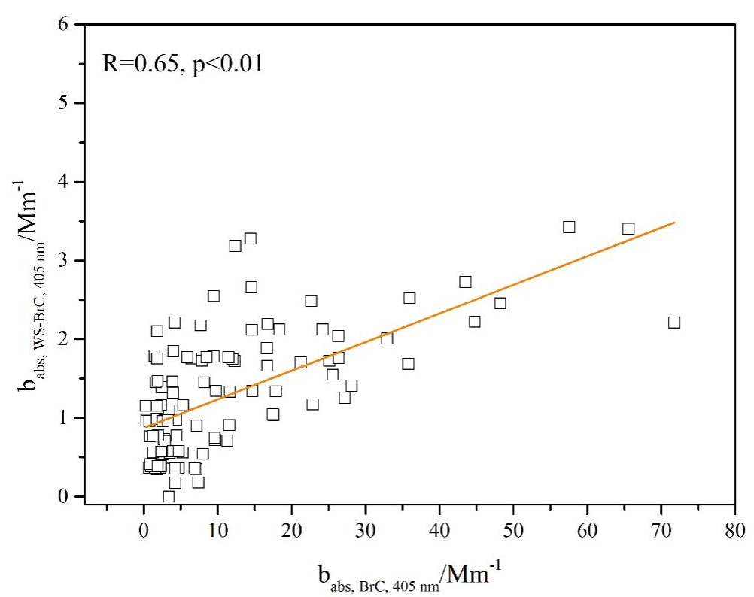
Fig. S3 b_{abs, BrC, 405nm} and b_{abs, WS-BrC, 405nm} scatter plot

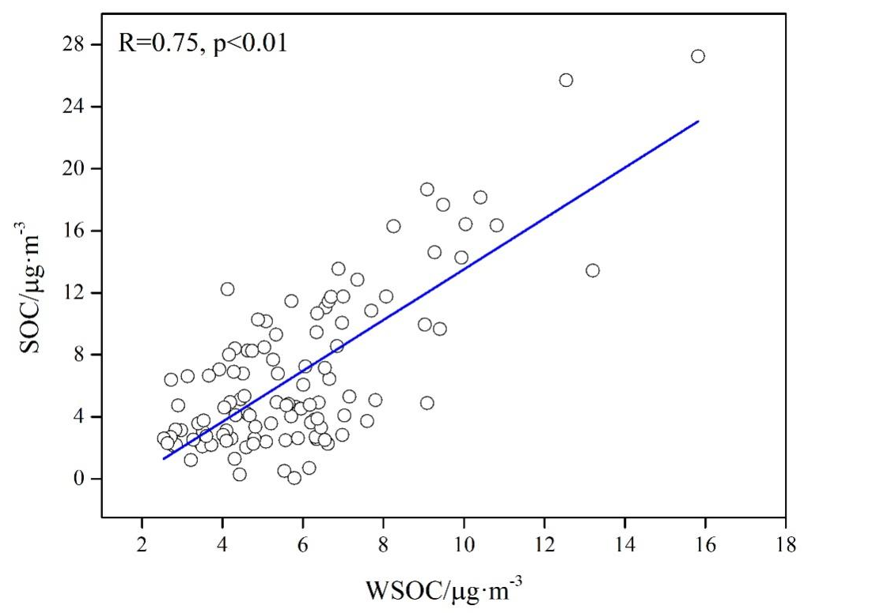
Fig. S4 WSOC and SOC scatter plot

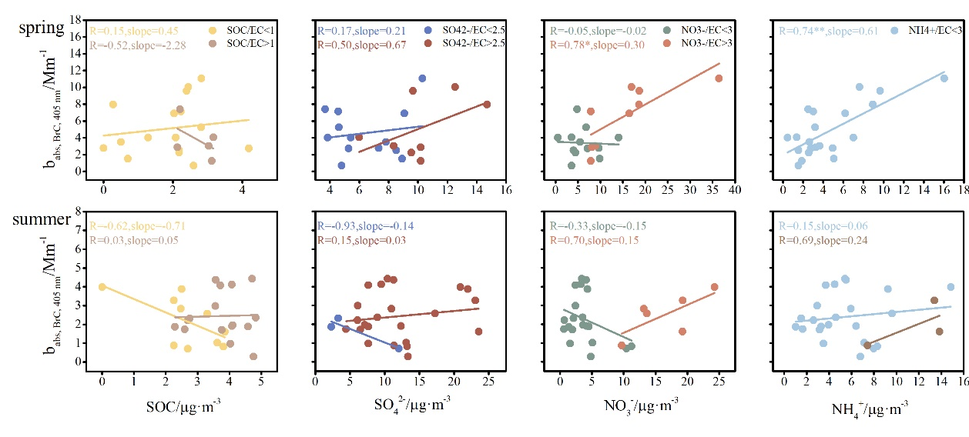
Fig. S5 Relationship between SOC, SO₄²⁻, NO₃⁻, NH₄⁺ and b_{abs,BrC,405nm} using secondary components/EC as color scales in autumn and winter.

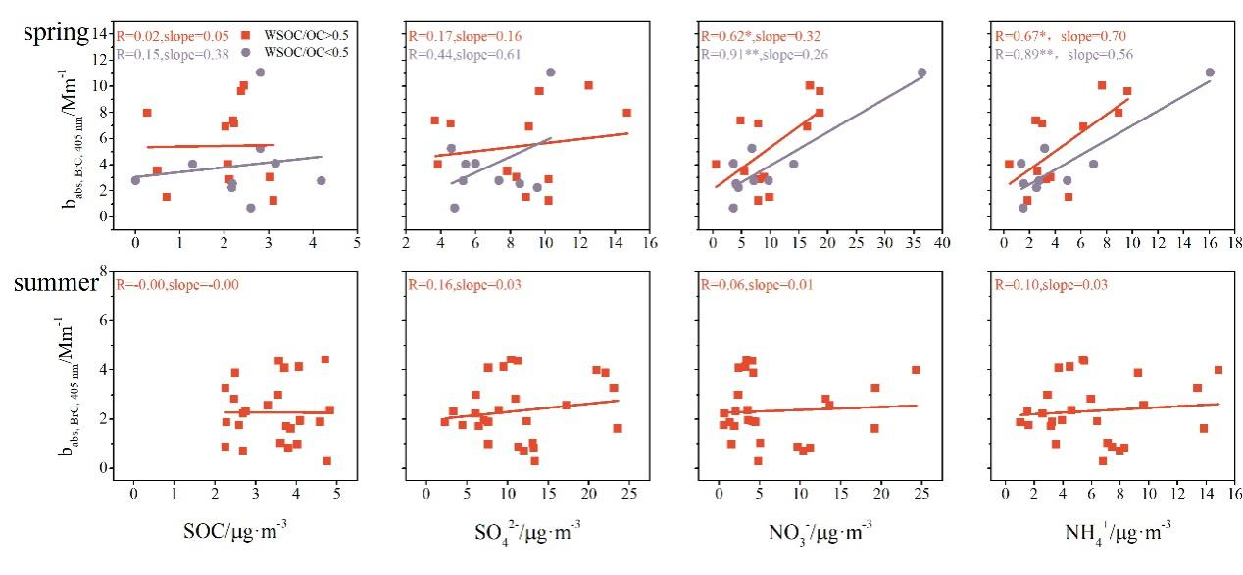
Fig. S6 Relationship between SOC, SO₄²⁻, NO₃⁻, NH₄⁺ and b_{abs,BrC,405nm} using WSOC/OC as color scales in autumn and winter.

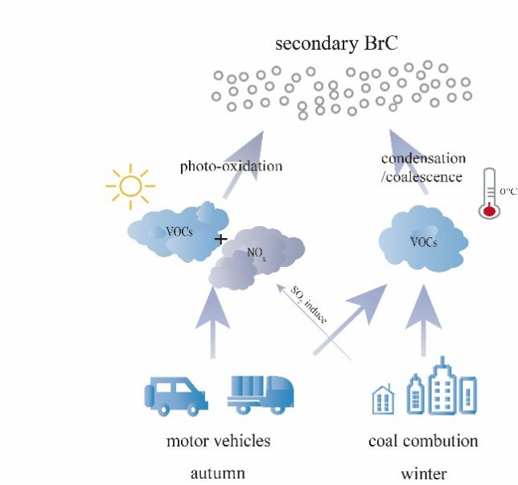
Fig. S7 Graphical abstract

References
Chen, L.W.A., Chow, J.C., Wang, X.L., Robles, J.A., Sumlin, B.J., Lowenthal, D.H., et al., 2015. Multi-wavelength optical measurement to enhance thermal/optical analysis for carbonaceous aerosol. Atmos. Meas. Tech. 8, 451-461. https://doi.org/10.5194/amt-8-451-2015.

