Additional file 3:
Figure S4. Venn diagram of the distribution of pathogen, human, wildlife and vector in selected articles.
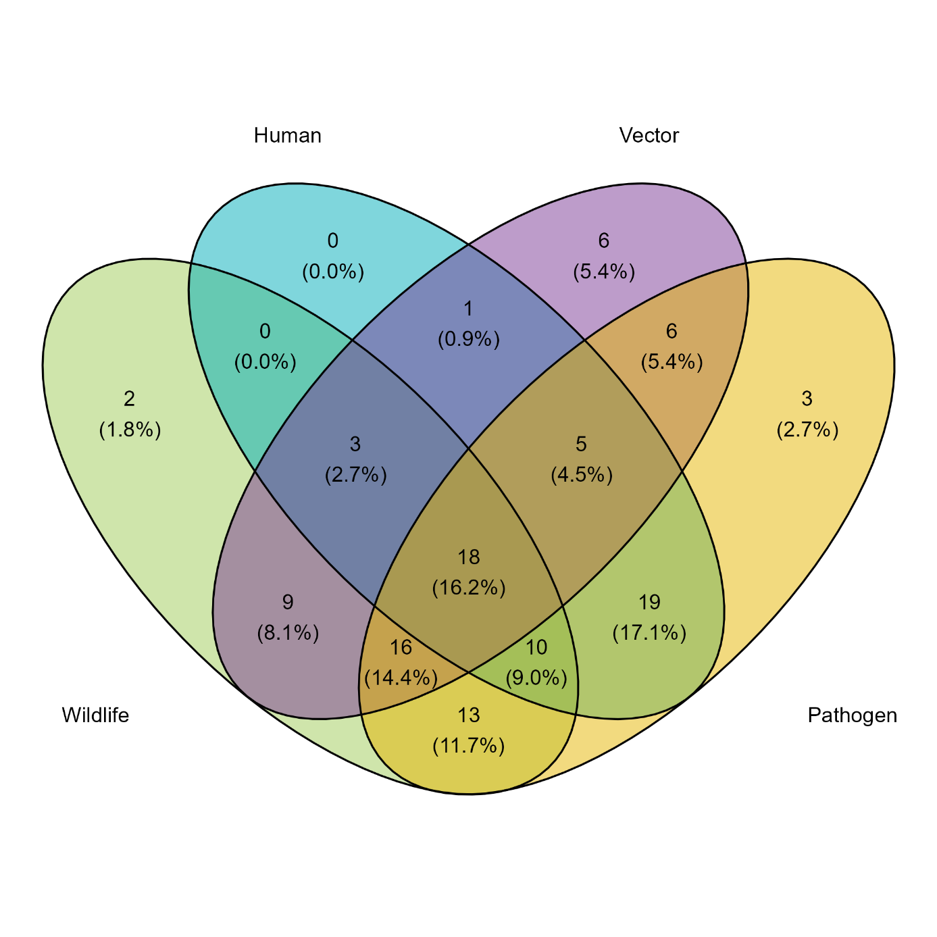

Figure S5. Distribution of forest impacts on the vector presence when considering all collected articles n=111(A) and when considering only empirical studies n=73 (B)

