Contrasting effect of different crowding agents on pseudoknot RNA stability
Sagar Satpathi,^{1,2‡} Tamaki Endoh,^{1‡*} and Naoki Sugimoto^{1,3*}

¹ Frontier Institute for Biomolecular Engineering Research (FIBER), Konan University, 7-1-20 Minatojima-minamimachi, Kobe, 650-0047, Japan
² Present Address: School of Physics and Astronomy and The Astbury Centre for Structural Molecular Biology, University of Leeds, Leeds, LS2 9JT UK
³ Graduate School of Frontiers of Innovative Research in Science and Technology (FIRST), Konan University, 7-1-20 Minatojima-minamimachi, Kobe, 650-0047, Japan

* To whom correspondence should be addressed. Tel: +81-78-303-1416; Fax: +81-78-303-1495;
Email: t-endoh@konan-u.ac.jp; sugimoto@konan-u.ac.jp

Materials and Methods
Oligonucleotides and chemical reagents
All the PK and HP RNA sequences of HPLC purification grade listed in Table 1 and Table S1 were procured from Fasmac Co., Ltd., Kanagawa, Japan. The concentrations of these RNA oligonucleotides were determined within the temperature range of 80–90 °C by measuring their absorbance at 260 nm using their respective single-strand molar extinction coefficients. Sodium chloride (NaCl) and disodium hydrogen phosphate (Na₂HPO₄) were acquired from FUJIFILM Wako Pure Chemical Corporation, Osaka, Japan. Polyethylene glycols (PEGs) were obtained from FUJIFILM Wako Pure Chemical Corporation or MP Biomedical, Irvine, CA, USA. Disodium ethylenediaminetetraacetate (Na₂EDTA) was obtained from Dojindo Molecular Technologies, Kumamoto, Japan. To establish a pH of 7.0 for the Na₂HPO₄ buffer, HCl from FUJIFILM Wako Pure Chemical Corporation was employed for pH adjustment.

Circular dichroism (CD) measurements
Circular dichroism (CD) measurements were carried out using a JASCO J-1500 spectropolarimeter, which was equipped with a temperature controller. CD spectra of RNA oligonucleotides at a concentration of 5 μM were recorded in a buffer solution containing 10 mM Na₂HPO₄ (pH 7.0), 0.1 M NaCl, and 1 mM Na₂EDTA. The measurements were performed in cuvettes with a path length of 0.1 cm. Melting profiles of the RNA oligonucleotides were monitored at 210 nm by heating the RNA samples at a rate of 0.5 °C/min. Before CD measurements, RNA oligonucleotides were initially incubated at 70 °C for 5 minutes and gradually cooled at a rate of 1 °C/min to allow them to refold into their native structure.

Analysis of thermodynamic parameters
Thermodynamic parameters for the S2 stem region in the PK structure were evaluated from CD melting profiles. The ellipticity signal of the corresponding hairpin (Table S1) was subtracted from the signal of PK to extract a typical 2-state sigmoidal curve for the melting of the S2 stem region (Figure S1). The thermodynamic parameters for the S2 stem region were calculated by fitting the melting profile, in which range was from 10 to 90 °C, by using Equation (1).
$S=\left(a×T+b\right)+\frac{(\left(c×T+d\right)-\left(a×T+b\right))}{1 + \exp^{(\frac{{∆S}^{°}}{R} - \frac{{∆H}^{°}}{R×T})} }$ (1)
where S is the ellipticity signal of PK at measured temperature after subtraction of the signal of the hairpin, a and b are slope and intercept of the lower baseline, respectively, c and d are slope and intercept of the upper base line, respectively, ΔH° and ΔS° are enthalpy and entropy changes associated with the melting of S2 stem region, respectively, T is temperature in Kelvin, and R is gas constant.

The free energy change for the S2 stem region at 37 °C (ΔG°₃₇) was obtained from the calculated ΔH° and ΔS° using Equation (2).
${∆G}_{37}^{°}={∆H}^{°}-{T∆S}^{°}$ (2)
The melting temperature in °C (T_{m}) was obtained using Equation (3).
$T_{m}=\frac{{∆H}^{°}}{{∆S}^{°}}-273.15$ (3)

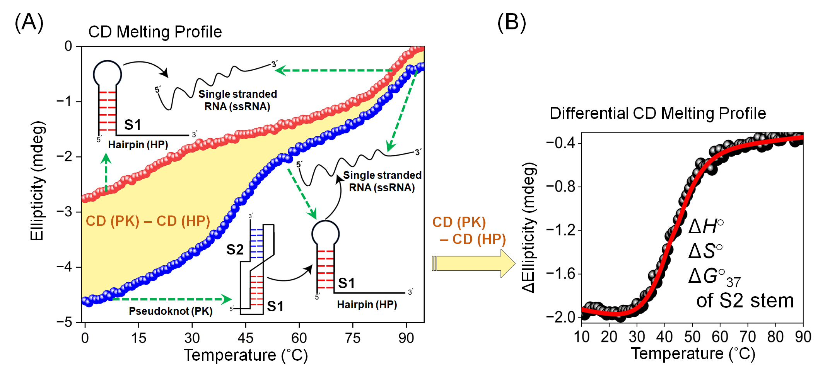
Figure S1. Calculation process of the thermodynamic parameters for the S2 stem region in the pseudoknot structure. (A) Schematic representation of different conformational states during melting of pseudoknot (blue) and hairpin (red) conformers. Pseudoknot (PK) dissociate to single stranded RNA through hairpin (HP) conformer. (B) Schematic outline to calculate the thermodynamic parameter of the S2 stem region. Melting profile of the S2 stem region is extracted by subtracting the melting profile of hairpin. A typical 2-state sigmoidal curve for the S2 stem region is fitted to calculate the thermodynamic parameters.

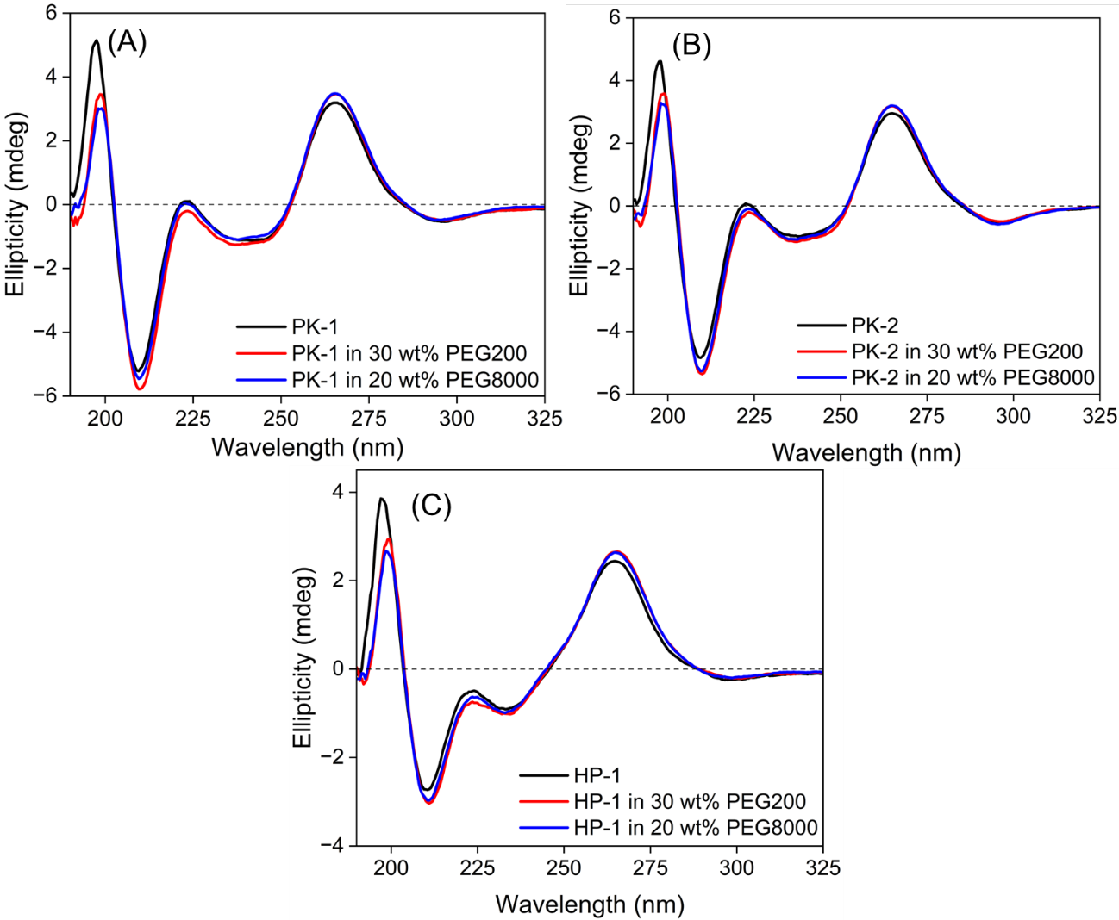
Figure S2. Circular dichroism (CD) spectra of (A) PK-1, (B) PK-2 and (C) HP-1 in the absence of crowder (black), presence of 30 wt% PEG200 (red) and 20 wt% PEG8000 (blue). All the experiments were carried out at 10 °C with 5 μM RNA oligonucleotide in a buffer containing 10 mM Na₂HPO₄ (pH 7), 100 mM NaCl, and 1 mM Na₂EDTA.

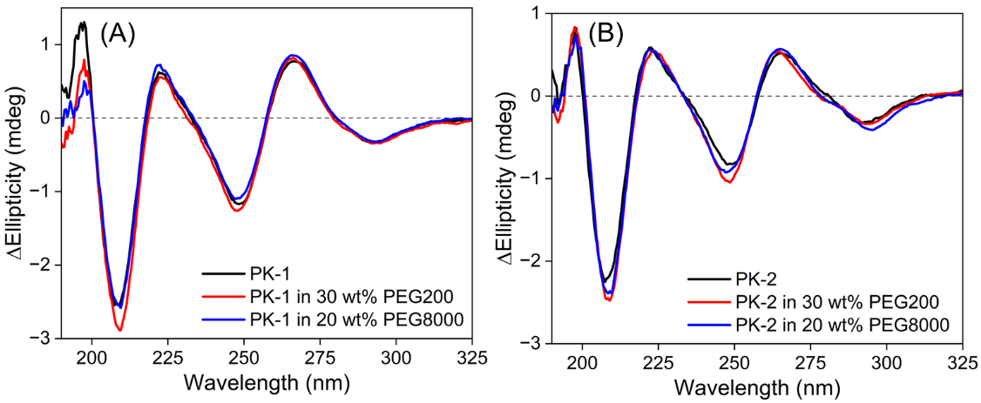
Figure S3. Differential circular dichroism spectra of (A) PK-1 and (B) PK-2. Spectrum of HP-1 was subtracted from the spectrum of PK structure. All the experiments were carried out at 10 °C with 5 μM RNA oligonucleotide in a buffer containing 10 mM Na₂HPO₄ (pH 7), 100 mM NaCl, and 1 mM Na₂EDTA in the absence (black) and presence of co-solute molecule, 30 wt% PEG200 (red) or 20 wt% PEG8000 (blue).

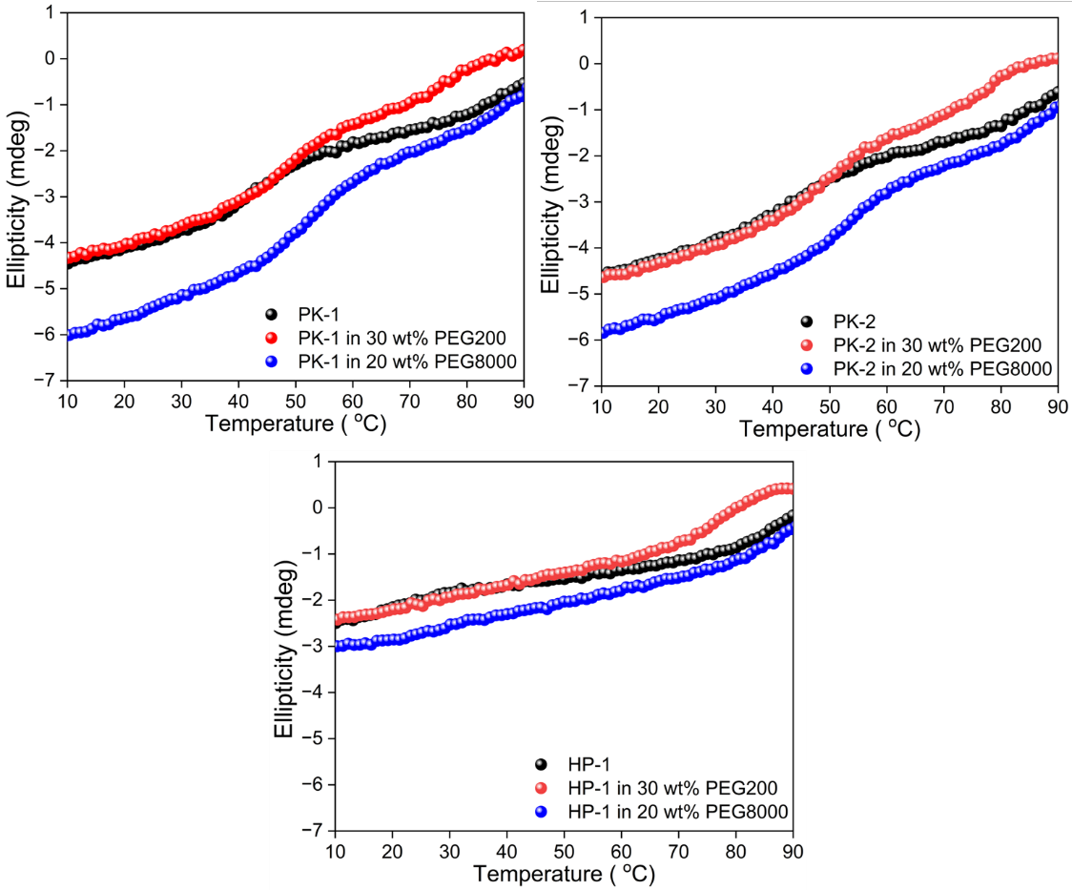
Figure S4. CD melting profiles of (A) PK-1, (B) PK-2 and (A) HP-1 recorded at 210 nm. Melting profiles were recorded with 5 μM RNA oligonucleotide in a buffer containing 10 mM Na₂HPO₄ (pH 7), 100 mM NaCl, and 1 mM Na₂EDTA in the absence (black) and presence of co-solute molecule, 30 wt% PEG200 (red) or 20 wt% PEG8000 (blue).

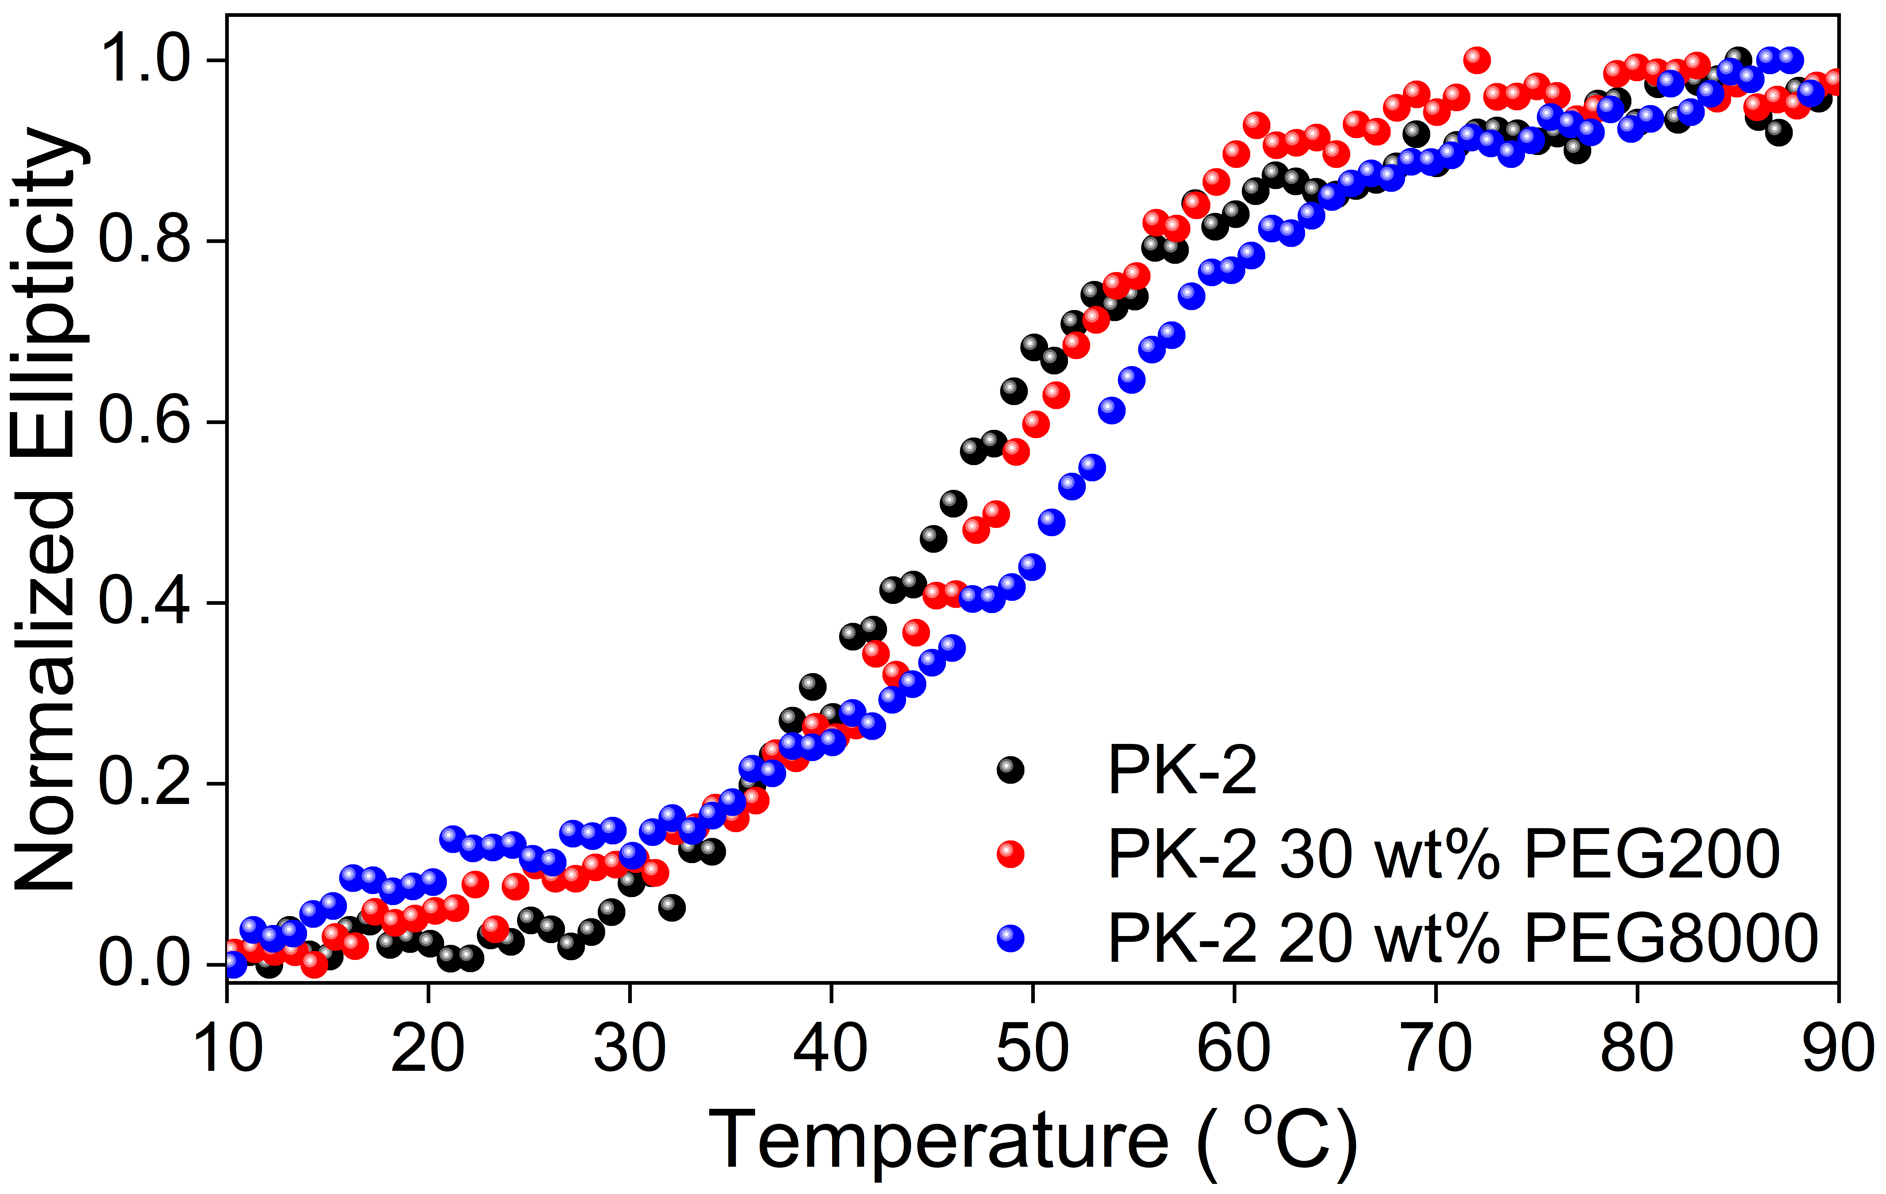
Figure S5. Normalized CD melting profiles of the S2 stem region of PK-2 (5 µM) in a buffer containing 10 mM Na₂HPO₄ (pH 7), 100 mM NaCl, and 1 mM Na₂EDTA in the absence (black) and presence of co-solute molecule, 30 wt% PEG200 (red) or 20 wt% PEG8000 (blue). The signals recorded at 210 nm were normalized after subtraction of the signals of HP-1.

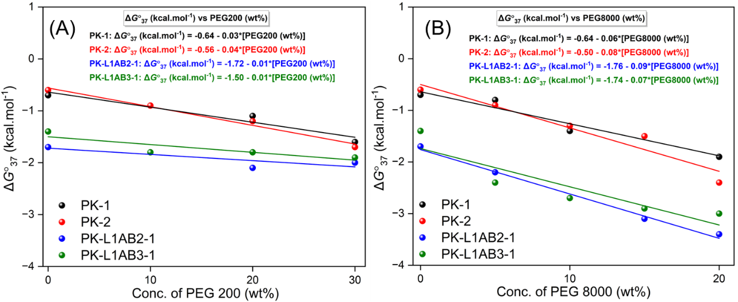
Figure S6. Experimentally obtained ΔG°₃₇ (kcal.mol⁻¹) of the S2 stem region of the PK structures depending on the concentration of (A) PEG 200 (0-30 wt%) and (B) PEG 8000 (0-20 wt%). Slopes and intercepts obtained by fitting to the linear correlation equation are shown in the panels.

Table S1. Sequences of HP RNA oligonucleotides used in this work.
RNA Name | RNA Sequences (5´ to 3´) ª
HP-1 | GGCGCAGUGCGUCAGCGCCACU
HP-L1AB2-1 | GGCGCXXUGCGUCAGCGCCACU
HP-L1AB3-1 | GGCGCXXXUGCGUCAGCGCCACU
a. Red, blue and green colours denote the S1 stems, and S2 stems and incorporated abasic site instead of L1 nucleobases, respectively.

