Bioactive compounds of the Actinomycetes isolated from Garmsar Saline River, Iran
E. Salehghamari^{1,4*}, M. Sardabi¹, F. Bahrami¹, E. Fallah Mobarakeh¹, A. Seddighi¹, Sh. Panahi Eghtedar¹, A. Haghinavand¹, F. Jafary¹, F. Ghanbari¹, P. Alemi¹, M. Lotfi¹, F. Hallaj Rezapour¹, N. Jafari Deez¹, A. Ghasemi¹, B. Saeedmoaddab¹, K. Kargar¹, S. A. Etesami², N. Hajiabdolhosseini³, S. Khorashadi³, A. Salehi-Najafabadi³
¹ Department of Cell and Molecular Biology, Faculty of Biological Sciences, Kharazmi University, Karaj, Iran.
² Department of Cell and Molecular Science, Roshd Azma company, Karaj, Iran.
³ Extremophiles Laboratory, Department of Microbiology, School of Biology, College of Science, University of Tehran, Tehran, Iran.
⁴ Department Cell and Molecular Biology, Faculty of Engineering and Science, Kosar University of Bojnord, Bojnort, Iran.
*Corresponding author is Ensieh Salehghamari; E. mail address: esaleh@khu.ac.ir; ORCID: https://orcid.org/0000-0001-6879-0051

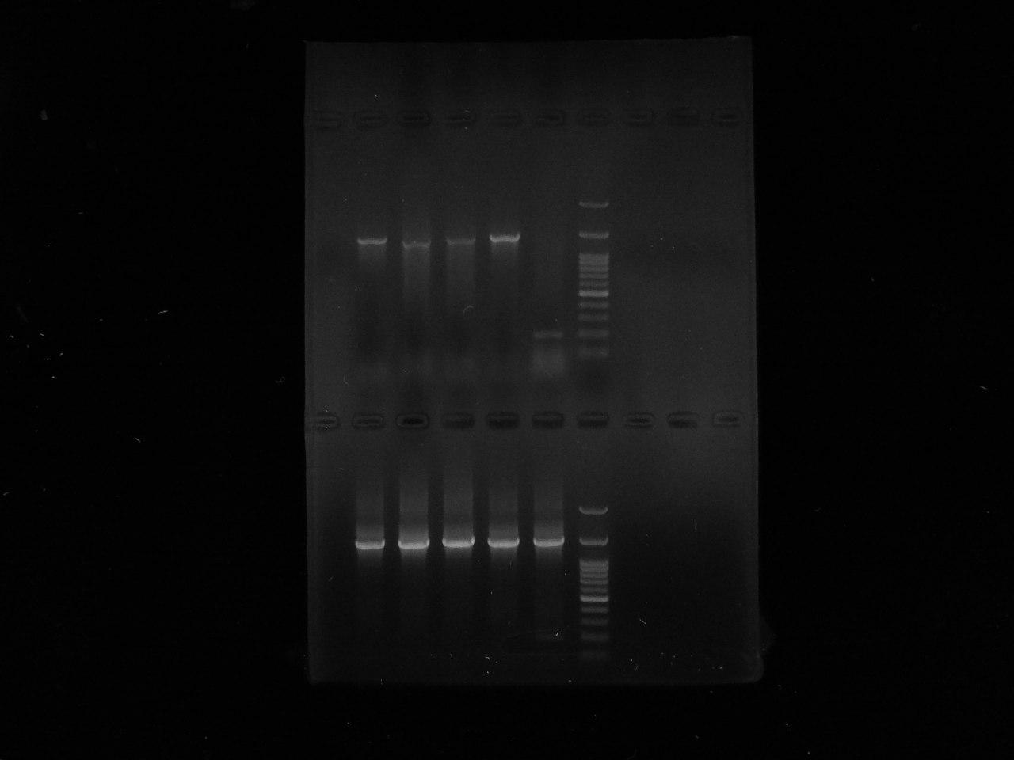

Fig. S1 the full uncropped Gels of 16SrRNA amplification.

Fig. S2. GC-MS analysis of Strain 16 ethyl acetate extract.

