Supplementary Materials for
Measuring and Manipulating Density of States in Two-Dimensional Materials with Electrochemical Capacitance

Mengyu Yan^{1†‡}, Mitchell Kaiser^{2†}, Maria L. Sushko⁵, Yang Zhou³, Ying Xia¹, Hao Tang¹, Chun-Chih Tseng⁴, Matthew Yankowitz^{4,1}, Jihui Yang^{1*}, Jun Liu^{1*}
Affiliations:
¹Department of Materials Science and Engineering, University of Washington, Seattle, Washington 98105, USA.
²Department of Chemistry, University of Washington, Seattle, Washington 98105, USA.
³Department of Mechanical Engineering, University of Washington, Seattle, Washington 98105, USA.
⁴Department of Physics, University of Washington, Seattle, Washington 98105, USA.⁵Pacific Northwest National Laboratory, 902 Battelle Boulevard P.O. Box 999, Richland, Washington 99352, USA.
*Corresponding authors. Email: jihuiy@uw.edu, jliuuw1@uw.edu
† These authors contributed equally to this work
‡ Now faculty at Wuhan University of Technology, Wuhan 430070, Hubei, China

This PDF file includes:
Materials and Methods
Figs. S1 to S11

Materials and Methods
Device Fabrication
The natural monolayer MoS₂ flakes were prepared via mechanical exfoliation from a bulk MoS₂ single crystal using scotch tape. Then, the MoS₂ nanosheet was transferred to a clean silicon wafer with a 285 nm oxide layer. The photoresist 495 PMMA A4 was spun on the silicon wafer at 800 rpm for 10 s and then 4000 rpm for 40 s. Afterward, the coated wafer was dried at 180 ºC on a hot plate for 5 min. The same procedure was used to spin coat 950 PMMA A4. The electrodes were drawn by electron beam lithography (TESCAN VEGA scanning electron microscope with lithography package) on the silicon wafer with the two precoated PMMA layers. The PMMA layers are developed by using a pre-refrigerated 3:7 water/IPA aqueous developer. The typical developing time is 30 seconds but varies with the electron dose and beam intensity of the electron-beam lithography procedure. A 5 nm Ti wetting layer and a 50 nm Au were deposited using an electron beam evaporator at a pressure of 5 × 10⁻⁶ Torr. The deposition rates for Ti and Au are ~0.2 and 0.8 nm/s, respectively. The PMMA layers and excess deposited metals are removed by soaking the device in acetone at 50ºC for 1 hour. An optical microscope is used to inspect the device and ensure only the Ti/Au electrodes and the target MoS₂ flake are left on the Si wafer. The soaking time of the nanodevice in acetone is extended if the extra Ti/Au isn’t totally removed in 1 hour. After lift-off, the sample is washed with isopropanol and dried with the N₂ three times. Afterward, a new layer of 950 PMMA A4 was spun on the silicon wafer as the resistive layer at 800 rpm for 10 s and then 4000 rpm for 40 s. The wafer was dried as before (at 180ºC on a hot plate for 5 mins). 495 PMMA A4 was then spun on the 950 PMMA A4 layer with the same spin and baking procedure. The well in the layered PMMA film was etched using electron-beam lithography and a 3:7 water/IPA aqueous developer to expose the interest area of the monolayer MoS₂ flake. Finally, a plastic electrolyte container (10 – 15 mL) was attached over the PMMA well to ensure a stable electrochemical environment during the electrochemical measurements.
The monolayer MoS₂ device on PET substrate is fabricated with a similar procedure to the one on silicon wafers with a 285 nm oxide layer. The monolayer MoS₂ was mechanically exfoliated on the PET substrate and searched under the optical microscope. One layer of PMMA A4 495 and two layers of PMMA A4 950 are spin-coated and dried on the PET substrate in turn. Then a 50nm layer of Cr was coated using a magnetron sputtering system for improving the conductivity in the coming electron beam lithography. Afterward, the electrodes are written with electron beam lithography. The coated Cr is removed with the chromium etchant and the PMMA is developed with a 3:7 water/IPA aqueous developer. A 5/50 nm Ti/Au electrode is further thermal evaporated on the developed area. At the last, the whole device was stuck to designed biaxial beams for applying tensile strains.
For the device measured using Raman spectroscopy, the monolayer MoS₂ flakes were prepared by mechanical exfoliation onto clean silicon wafer with a 285 nm oxide layer. From here, the flake was placed onto a polyimide film coated as described previously with a 5/50 nm Ti/Au using the dry-transfer technique. This was done to ensure a flake large enough for the Raman measurement could be obtained. The film was coated with PMMA and then subjected to the EBL process to open a well using the procedure mentioned earlier. The film was then mounted on the center of a PET cross using a cyanoacrylate glue.

Measuring the capacitance and electrochemical window of ionic liquids
The capacitance and electrochemical window of ionic liquids were measured in a three-electrode electrochemical cell, in which the Pt-wire acts as the counter electrode, the glassy carbon electrode serves as the working electrode, and the Ag/AgCl/[BMIM][Cl] works as the reference electrode. Electrochemical impedance spectroscopy (EIS) is used to measure the ionic liquid capacitance within the frequency range of 10⁶ to 0.1 Hz. Ten points were recorded per decade at a sinusoidal amplitude of 10 mV. The electrochemical window of ionic liquids is determined using cyclic voltammetry at a scan rate of 10 mV/s.

Electrochemical capacitance spectrum and electrochemical tunneling spectrum
A graphite carbon counter electrode and an Ag/AgCl reference electrode were integrated into the previously fabricated nanodevice to form a three-electrode electrochemical system, in which the monolayer MoS₂ flake acts as the working electrode. For the Ag/AgCl reference electrode, 1-Butyl-3-methylimidazolium chloride was dissolved in [BMIM][BF₄] with a final concentration of 0.1 M. This served the electrolyte in the reference electrode to stabilize the silver chloride concentration. During the electrochemical measurements, the ionic liquids, including [BMIM][BF4], [BMIM][PF6], and [EMIM][DCA] (Purchased from Sigma-Aldrich), were applied as the electrolyte. Electrochemical measurements were carried out by combining an electrochemical workstation (BioLogic SP-300) and a probe station. Staircase potentio electrochemical impedance spectroscopy (SPEIS) was used to measure the capacitance (C_{total}) at the MoS₂-electrolyte interface and the tunneling current (I) as a function of electrochemical potential. An electrochemical capacitance spectrum and electrochemical tunneling spectrum can be plotted using C_{total} vs. potential and I vs. potential, respectively.
In a typical experiment, we scanned the working electrode potential using SPEIS from its open circuit potential to -1.5 V vs. Ag/AgCl with a step potential of 5 mV. -1.0 V vs. Ag/AgCl corresponds to 3.23 eV vs. vacuum, which is ~0.5 eV higher than the MoS₂ conduction band minimum (CBM) as predicted by the calculation. Thus, the electrons fill the MoS₂ CBM during this procedure. For each potential step, a one-second waiting time is set to decrease the influence of electrochemical kinetics. The impedance is excited under a single sine mode at 5 Hz with a sinusoidal amplitude of 50 mV. Each capacitance was averaged with five measurements. When the working electrode potential approaches -1.5 V vs. Ag/AgCl, we directly scan back to 2.5 V vs. Ag/AgCl with the same frequency, amplitude, step potential, and step waiting time. During the scanning, C_{total} and I were recorded at each electrochemical potential.
The hydrogen evolution reaction polarization curve is measured with a 3-electrode electrochemical system, in which a saturated calomel electrode served as the reference electrode, a graphite electrode as the counter electrode, the monolayer MoS₂ as the working electrode, and 0.5 M H₂SO₄ as the electrolyte. The polarization curve is cycled with a scan rate of 5 mV/s.

Confocal Raman spectroscopy
Raman spectra were acquired using a Renishaw inVia Confocal Raman Microscope equipped with a 532 nm laser and a 50x objective. The laser power was set to 1%, the grating to 1200 l/mm, and each spectrum was measured with four 10 second accumulations with an extended range from 200-600 cm⁻¹.
For the unstrained device, the PET cross with the monolayer MoS₂ flake was placed directly on the microscope stage. For the intermediate and large strain spectra, the same cross was mounted to the respective strain holder and the assembly was placed onto the microscope stage. For each measurement, the laser was centered in the middle of the well in the PMMA coating.

Atomic force microscopy (AFM)
The low magnification AFM image of the 2D MoS₂ device was captured in air with amplitude modulation mode on a Jupiter AFM (Asylum Research, CA) with RFESPA-75 probes from Bruker. The probes typically have a resonance frequency of 75 kHz and a spring constant of 3 N/m. The lattice-resolved AFM image of monolayer MoS₂ was captured in air with contact mode on a Jupiter AFM (Asylum Research, CA) with ARROW-UHFAuD probes from NanoWorld. The amplitude and deflection setpoint were controlled to maintain image quality without changing the surface topography. Offline data processing was done using Gwyddion SPM data analysis software.
Commercial AFM probes typically feature square pyramidal tips with a radius in the range of 2-10 nm. These probes are adept at resolving lattice structures on flat surfaces, such as the central areas of 2D MoS₂, where the probe is perpendicular to the sample surface^{S1}. However, in regions where the surface topology transitions sharply, like at the edges of 2D MoS₂ where perpendicular planes meet, the standard probe's inability to maintain an optimal angle with both planes hinders the resolution of edge features with accuracy, preventing
the acquisition of an atomically resolved image of the MoS₂ edge under these experimental conditions.

Computational details
Single-layer MoS₂ with zigzag and armchair edges were modeled using 3D periodic model as 2D ribbons periodic in the direction along the edges and with at least 10 Å vacuum gap between the edges and a 15 Å vacuum gap between images of the basal planes was used to avoid interactions between periodic images. Point Mo- and S-defects were introduced either in the basal plane or on the edges. All atoms were fully relaxed during structural optimization.
Density functional theory (DFT) simulations of the electronic structure of MoS₂ ribbons were performed using periodic plane wave DFT implemented in VASP code ^{S2, S3}. Generalized gradient approximation and projected augmented wave (PAW) potentials ^{S4} were used with PBE exchange correlation functional ^{S5} and the D2 Grimme dispersion correction ^{S6}. Spin polarization was included in all calculations: 6 × 6 × 1 Gamma centred Monkhorst–Pack grid was used for k-point sampling of the Brillouin zone. Plane wave cutoff of 400 eV was used. The convergence criterion for geometric relaxation was set to 0.01 eV/ Å.
A periodic slab model was used for hydrogen chemisorption calculations. A single-layer MoS₂ slab with a S vacancy in the basal plane and hydrogen atoms decorating the vacancy was optimized using the convergence criterion of 0.01 eV/ Å. The free energy of the adsorbed state was calculated as
ΔG = ΔE_{H*} - ΔE_{ZPE} -TΔS_{H,}
where ΔE_{H*} is the hydrogen chemisorption energy, and ΔE_{ZPE} is the difference of the zero-point energy between the adsorbed state and the gas phase. Considering that the vibrational entropy of H* in the adsorbed state is very small, the entropy of 1/2 H₂ adsorption, ΔS_{H,} can be approximated as 1/2 of the entropy of H₂ in the gas phase at standard conditions. The hydrogen chemisorption energy was calculated as
∆E_{H*} = E(MoS₂+nH) – E(MoS₂+(n-1)H) –1/2 E(H₂),
where E(MoS₂+nH) is the total DFT energy for the MoS₂ layer with n hydrogen atoms adsorbed on the S vacancy, E(MoS₂+(n-1)H) is the total DFT energy for (n-1) hydrogen atoms adsorbed on the V_{S} and E(H₂) is the DFT energy for a hydrogen molecule in the gas phase.

Determining the bandgap and the position of VBM and CBM of monolayer MoS₂ basal plane

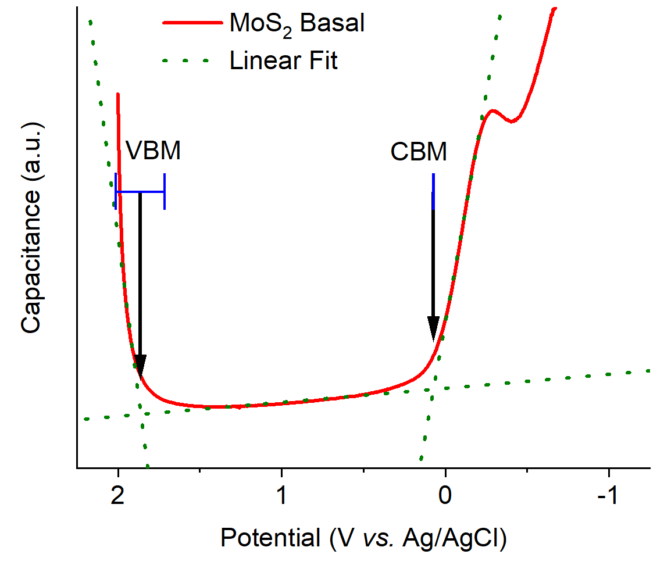
Figure S1. Determining the VBM, CBM, and bandgap of MoS₂ basal plane. To find the valence and conduction band edges, a linear fit is applied to the near-linear regions of the QCS on the left-hand side, band gap, and right-hand side (green dotted lines). The VBM and CBM were determined as the x-coordinate of the intersection of the left-hand and band gap lines of fit and the right-hand and band gap lines of fit, respectively.

Linear Fit | VBM (line 1) | CBM (line 2) | Bandgap
Equation | $$y_{1}=m_{1}x_{1}+b_{1}$$ | $$y_{1}=m_{1}x_{1}+b_{1}$$ | $$y_{2}=m_{2}x_{2}+b_{2}$$
Intercept | -12.0 ± 0.8 | 1.288 ± 0.004 | 0.934 ± 0.002
Slope | 6.9 ± 0.4 | -4.98 ± 0.04 | -0.076 ± 0.002
Residual Sum of Squares | 0.019 | 0.0092 | 0.015
R-Square (COD) | 0.96 | 0.99 | 0.91

If the equations for line 1 and line 2 are
$$y_{1}=m_{1}x_{1}+b_{1}$$
and
$$y_{2}=m_{2}x_{2}+b_{2}$$
The x-coordinate of point of intersection is found by setting y₁ = y_{2.}
$$m_{1}x+b_{1}=m_{2}x+b_{2}$$
Rearranging to solve for x gives
$$x=\frac{{ b}_{2}-b_{1}}{{ m}_{1}-m_{2}}$$
The error in x is calculated using the Gaussian propagation of error method using the equation
$$σ_{x}=\sqrt{{\frac{dx}{{db}_{1}}}^{2}{σ_{b_{1}}}^{2}+{\frac{dx}{{db}_{2}}}^{2}{σ_{b_{2}}}^{2}+{\frac{dx}{{dm}_{1}}}^{2}{σ_{m_{1}}}^{2}+{\frac{dx}{{dm}_{2}}}^{2}{σ_{m_{2}}}^{2}}$$
The standard error in the fitting parameters is calculated automatically by the fitting routine.
The band gap is then calculated as the difference between the CBM and VBM.
$$Bandgap=CBM-VBM$$
The error in the bandgap is calculated using the Gaussian propagation, with the formula being,
$$σ_{x}=\sqrt{{σ_{CBM}}^{2}+{σ_{VBM}}^{2}}$$
The calculated values are summarized in the table below.
VBM | CBM | Bandgap
1.86 ± 0.15 V | 0.072 ± 0.001 V | 1.79 ± 0.15 V

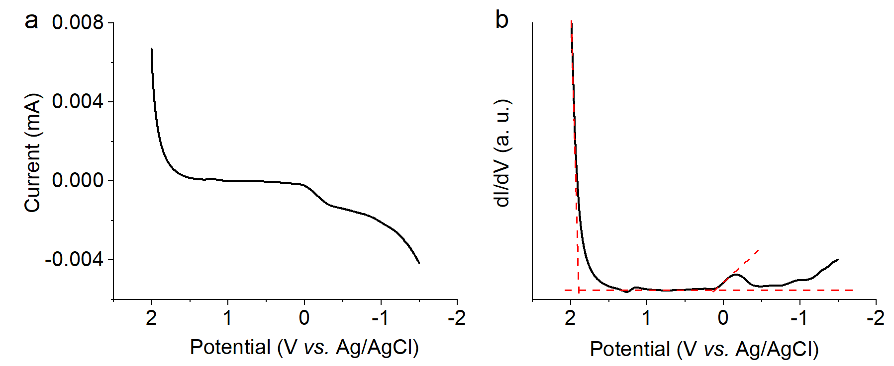
Figure S2. a. The electrochemical tunneling current as a function of the applied potential. b. The dI/dV-V spectrum corresponding to the I-V spectrum shown in Figure S1a.

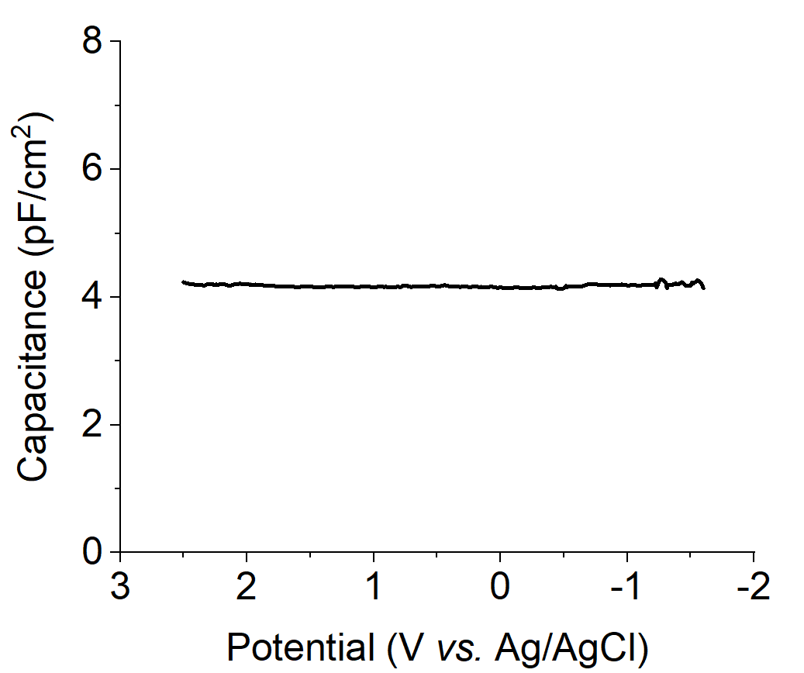
Figure S3. The electrochemical capacitance of the PMMA insulating layer at 5 Hz. To evaluate the contribution of PMMA in the quantum capacitance measurement, a bilayer PMMA is spin-coated on a pre-made Ti/Au (5 nm/50 nm) coated silicon wafer and dried at 180ºC. The capacitance of PMMA is around 4 pF/cm² in a wide potential range of -1.6 to 2.5 V vs. Ag/AgCl. It is much smaller than the capacitance of MoS₂ (as shown in Figure 1b), thus contributes little to the measured quantum capacitance. Different from the quantum capacitance spectra of MoS₂, no obvious peak is observed for the PMMA layer.

Figure S4. Calculated DOS of single-layer MoS₂ ribbons with zigzag edges. a. DOS of stoichiometric ribbon; b. DOS of the ribbon with Mo vacancy in the basal plane, and (c) DOS of the ribbon with S vacancy in the basal plane. d-f. The corresponding optimized structures. The red circle in f. denotes the position of S vacancy.
Figure S5. Calculated DOS of single-layer MoS₂ ribbons with armchair edges. a. DOS of stoichiometric ribbon; b. DOS of the ribbon with Mo vacancy in the basal plane, and c. DOS of the ribbon with S vacancy in the basal plane. d-f. The corresponding optimized structures. The red circle in f. denotes the position of S vacancy.

Figure S6. Calculated DOS of single-layer MoS₂ ribbons with armchair edges. a. DOS of the ribbon with Mo vacancy at the edge, and b. DOS of the ribbon with S vacancy at the edge. c-d. The corresponding optimized structures.

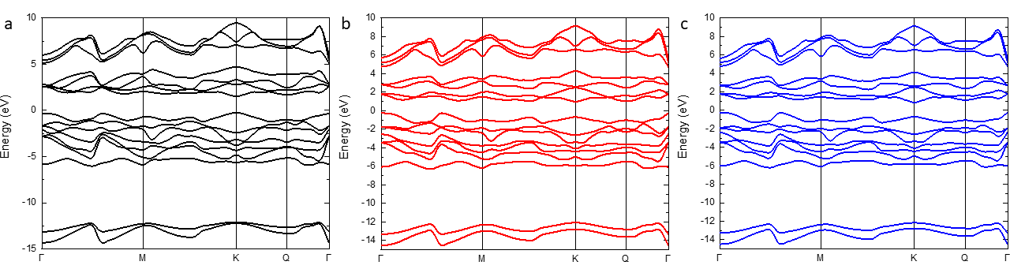
Figure S7. Calculated band structures of single-layer MoS₂ slabs under a. 0% biaxial strain, b. 1% biaxial strain, and c. 2% biaxial strain. The Fermi energy is shifted to 0 eV.

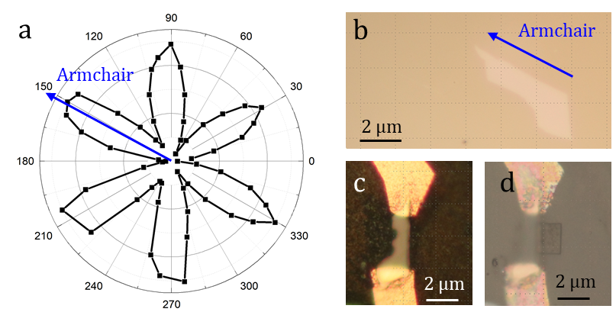
Figure S8. a. The resonant SHG intensity parallel to the incident laser polarization as a function of the crystal orientation shown in Figure S3B. b-d. The microscope images of the monolayer MoS₂ and the fabricated device. The armchair (blue arrow) edge of the monolayer sample is determined by the SHG.

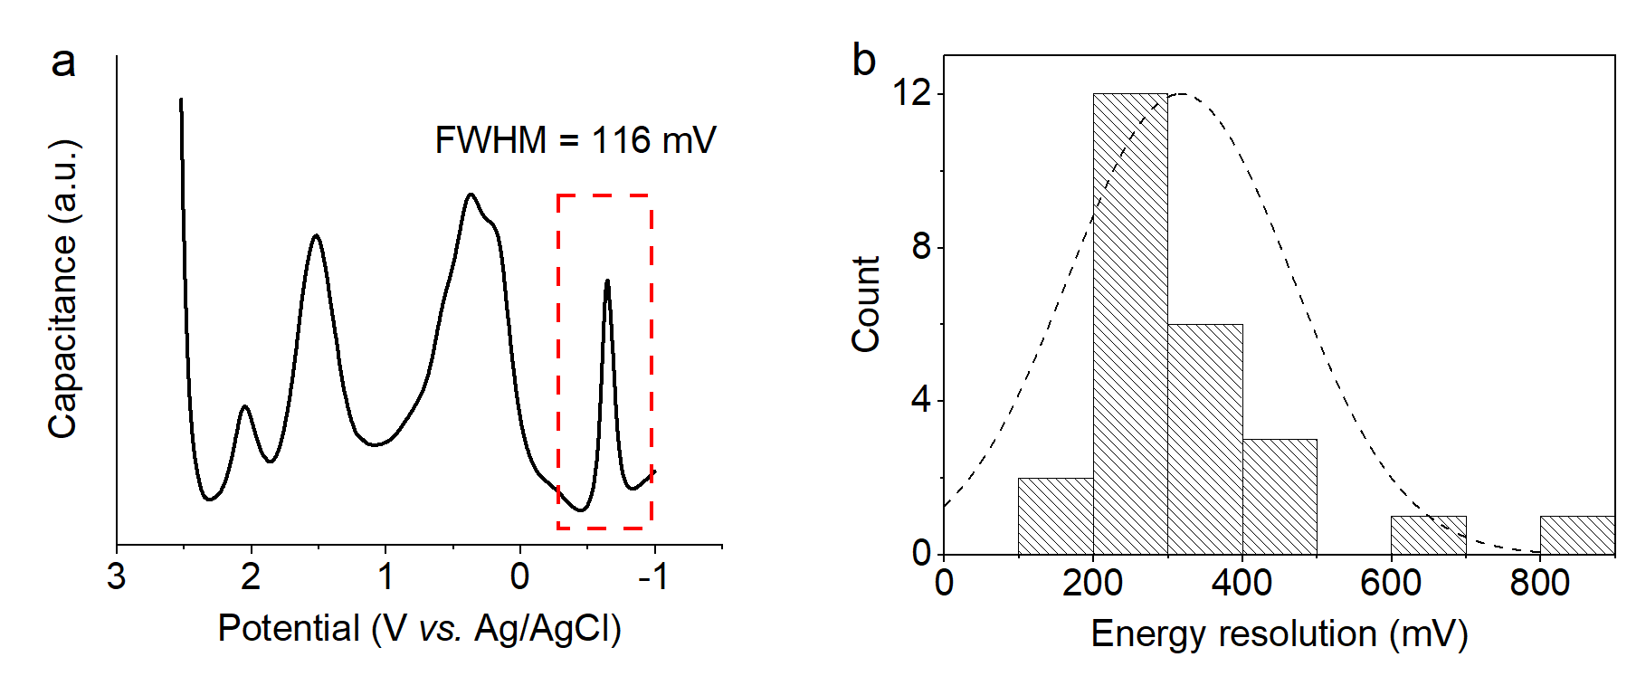
Figure S9. a. One of the peaks in the MoS₂ electrochemical capacitance spectrum (framed in red) has an FWHM of 116 mV. b. The FWHMs of 25 peaks in the 5 electrochemical capacitance spectra are measured and summarized. The mean energy resolution is 317 mV, the highest is 116 mV.

Quantifying Strain Using Raman Spectroscopy
Figure S10. Raman spectra with linear baseline subtraction and Gaussian peak fitting to quantify the strain felt by the monolayer MoS₂ flake for when a. unstrained, b. under intermediate strain, and c. under high strain. The color of each curve corresponds to the entry in the legend. The green curves are contributed by the polyimide and PET substrates and the cyanoacrylate glue.

Expected Biaxial Strain | Gaussian Fit | E_{2g} | A_{1g}
0% Strain | Equation | $$y=\frac{Ae^{\frac{-4ln⁡(2){(x-x_{c})}^{2}}{w^{2}}}}{w\sqrt{\frac{π}{4ln⁡(2)}}}$$ | $$y=\frac{Ae^{\frac{-4ln⁡(2){(x-x_{c})}^{2}}{w^{2}}}}{w\sqrt{\frac{π}{4ln⁡(2)}}}$$
0% Strain | A | 1909.1 ± 591.4 | 2572.6 ± 1453.2
0% Strain | x_{c} | 384.0 ± 0.45 | 403.0 ± 0.5
0% Strain | w | 5.7 ± 1.3 | 6.5 ± 1.9
0% Strain | R-Square (COD) | 0.9457
0% Strain | Residual Sum of Squares | 155557
1% Strain | Equation | $$y=\frac{Ae^{\frac{-4ln⁡(2){(x-x_{c})}^{2}}{w^{2}}}}{w\sqrt{\frac{π}{4ln⁡(2)}}}$$ | $$y=\frac{Ae^{\frac{-4ln⁡(2){(x-x_{c})}^{2}}{w^{2}}}}{w\sqrt{\frac{π}{4ln⁡(2)}}}$$
1% Strain | A | 3088.3 ± 619.8 | 4364.8 ± 1589.8
1% Strain | x_{c} | 382.2 ± 0.2 | 403.3 ± 0.3
1% Strain | w | 4.0 ± 0.6 | 5.7 ± 1.0
1% Strain | R-Square (COD) | 0.9807
1% Strain | Residual Sum of Squares | 148835
2% Strain | Equation | $$y=\frac{Ae^{\frac{-4ln⁡(2){(x-x_{c})}^{2}}{w^{2}}}}{w\sqrt{\frac{π}{4ln⁡(2)}}}$$ | $$y=\frac{Ae^{\frac{-4ln⁡(2){(x-x_{c})}^{2}}{w^{2}}}}{w\sqrt{\frac{π}{4ln⁡(2)}}}$$
2% Strain | A | 2761.5 ± 2581.4 | 408.6 ± 290.7
2% Strain | x_{c} | 381.7 ± 1.6 | 404.4 ± 0.9
2% Strain | w | 8.1 ± 2.6 | 3.7 ± 2.6
2% Strain | R-Square (COD) | 0.9343
2% Strain | Residual Sum of Squares | 118079

Ordinarily, strain can be extracted from the shift of the E¹_{2g} or A_{1g} peak position under strain from its unstrained position using a calibration factor^{S7}. However, for these measurements, an arbitrary linear baseline was applied during the Gaussian peak fitting. This means that the absolute peak position can no longer be used to quantify strain. Instead, the separation between the E¹_{2g} and A_{1g} peaks, $∆ϑ$, can be used. The difference between the two peaks is given by:
$${∆ϑ}_{unstrained}=ϑ_{A_{1g}}-ϑ_{E_{2g}^{1}}$$
Where $ϑ$ is the peak position of the mode given in the subscript. Under strain, the E¹_{2g} peak red shifts at a faster rate than the A_{1g} peak so that the peak separation increases. This increased separation can be quantified as:
$${∆ϑ}_{strained}={∆ϑ}_{unstrained}+({δϑ}_{E_{2g}^{1}}-δϑ_{A_{1g}})$$
Where $δϑ$is the shift with strain from the unstrained peak position of the mode in the subscript. $δϑ$is related to the strain by the rate of peak shift per stain percent for the appropriate Raman mode:
$$δϑ=rate×x$$
This rate is calibrated experimentally and can be found in the literature. Substituting the third expression into the second gives:
$${∆ϑ}_{strained}={∆ϑ}_{unstrained}+({rate}_{E_{2g}^{1}}×x-{rate}_{A_{1g}}×x)$$
Rearranging to solve for x gives:
$$x=\frac{{∆ϑ}_{strained}-{∆ϑ}_{unstrained}}{{rate}_{E_{2g}^{1}}-{rate}_{A_{1g}}}$$
Where x is the strain. For this work, ${rate}_{E_{2g}^{1}}$and ${rate}_{A_{1g}}$ are equal to the literature values 4.48 cm⁻¹/% and 1.02 cm⁻¹/%, respectively^{S7}. The extracted values of strain are given in the table below.

Expected Biaxial Strain | 0% | 1% | 2%
Measured Biaxial Strain | 0% | 0.6 ± 0.2 % | 1.0 ± 0.6 %

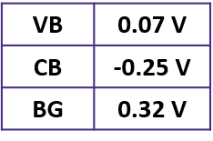
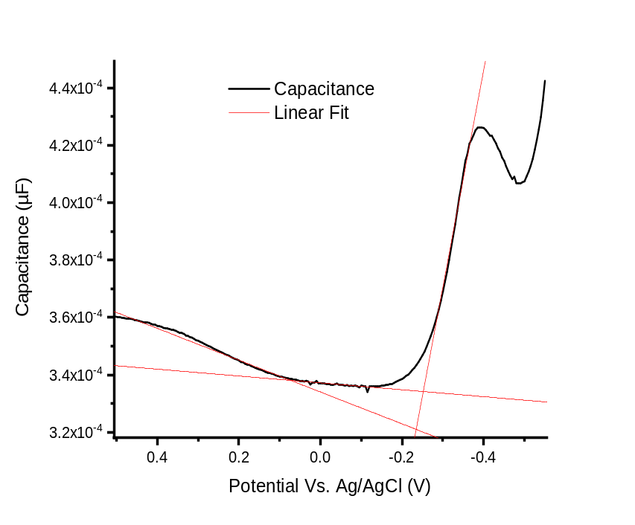
Figure S11. Electrochemical quantum capacitance spectra of bulk black phosphorous. The extracted VBM, CBM, and BG for each material are shown in the inset tables. Notably, the extracted values for the bandgap of bulk black phosphorous matches well with the literature value of ~0.3^{S8} eV.
References
S1. Eaton, Peter, and Paul West. Atomic force microscopy. (Oxford university press, 2010)
S2. Kresse, G. & Furthmuller, J. Efficient iterative schemes for ab initio total-energy calculations using a plane-wave basis set. Phys. Rev. B 54, 11169–11186 (1996).
S3. Kresse, G. & Furthmuller, J. Efficiency of ab-initio total energy calculations for metals and semiconductors using a plane-wave basis set. Comput. Mater. Sci., 6, 15–50 (1996).
S4. Kresse, G. & Joubert, D. From ultrasoft pseudopotentials to the projector augmented-wave method. Phys. Rev. B 59, 1758–1775 (1999).
S5. Perdew, J. P., Burke, K. & Ernzerhof, M. Generalized gradient approximation made simple. Phys. Rev. Lett. 77, 3865–3868 (1996).
S6. Grimme, S., Antony, J., Ehrlich, S. & Krieg, H. A consistent and accurate ab initio parametrization of density functional dispersion correction (DFT-D) for the 94 elements H-Pu. J. Chem. Phys. 132, 154104 (2010).
S7. Li, H. et al. Kinetic study of hydrogen evolution reaction over strained MoS₂ with sulfur vacancies using scanning electrochemical microscopy. Journal of the American Chemical Society 138, 5123-5129 (2016).
S8. Das, S. et al. Tunable transport gap in phosphorene. Nano Letters 14, 5733–5739 (2014).

