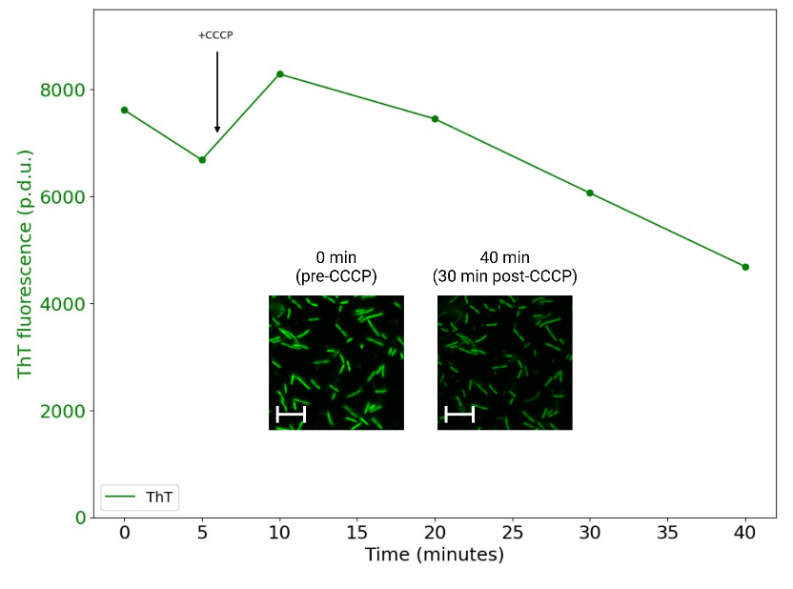
Figure S1. Thioflavin T fluorescence (ThT) over time. To demonstrate that the lack of membrane potential drop following CCCP injection in Figure 5 was not due to faulty technique or damaged CCCP, we imaged S. oneidensis MR-1 +Bdh in aerobic M5 minimal media with 20mM lactate in the same manner as all other injections in this work. As expected, CCCP decreased ThT fluorescence.

