Table 1. Characteristics of Study Participants (n=114)
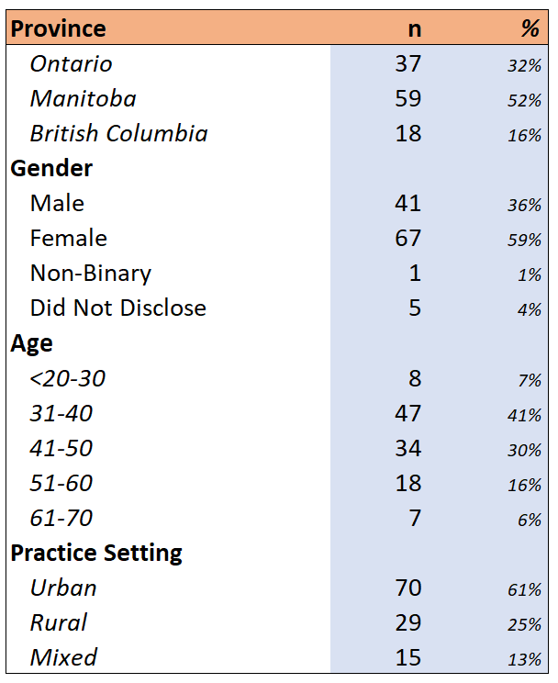

Table 2. Clinical and Non-Clinical Activities and Hours
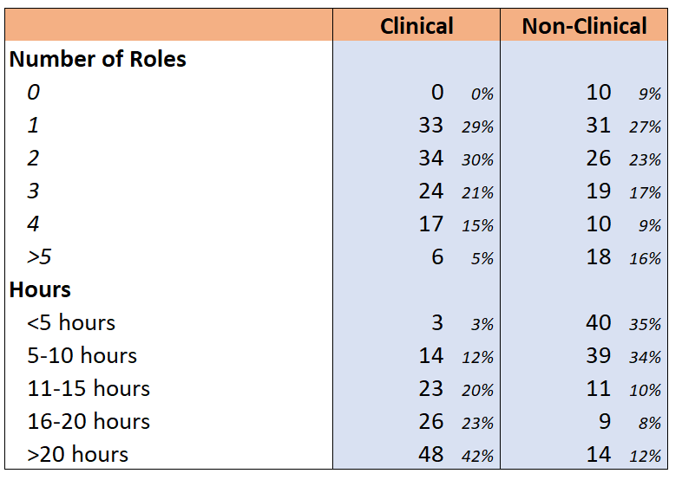

Table 3. Correlation Summaries
Table 3. Correlation Summary
 | Clinical Hours | Non-Clinical Roles
MBI Emotional Exhaustion | 0.124 | -0.233
MiniZ Supportive Work Environment | -0.152 | 0.133
MiniZ Workpace | -0.189 | 0.212
MiniZ Total (Joyful Workplace) | -0.180 | 0.21
*Highlighted fields reflect Spearman Correlations significant at the 0.05 level

Table 4. Reliability of Burnout Measures
 | Cronbach's Alpha | # of Items
MBI Scales
MBI-Emotional Exhaustion | 0.924 | 9
MBI-Depersonalization | 0.796 | 5
MBI-Personal Accomplishment | 0.819 | 8
Mini-Z 2.0 Scales
MiniZ-Supportive Work Environment | 0.650 | 4
MiniZ-Workpace | 0.700 | 5
MiniZ-Total Score | 0.785 | 9

