Table 1. The photo, surface temperature photo and color of 1 kg peanuts at different RF roasting time
RF-roasting time |  | 4.5 min | 6.5 min | 8.5 min | 10.5 min
Picture | 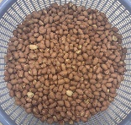 |  | 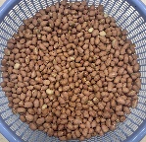 | 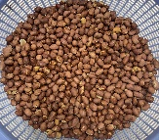 | 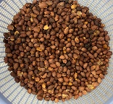
IR thermal  image | 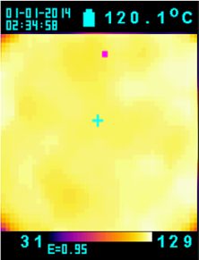 |  | 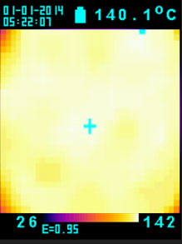 | 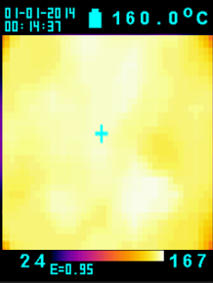 | 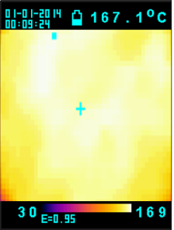
L* | 27.66±1.56^{c} |  | 26.12±2.13^{c} | 23.71±2.74^{b} | 21.68±0.81ª
a* | 3.14±0.68ª |  | 3.81±0.89ª | 4.62±0.13^{b} | 5.27±0.44^{c}
b* | 7.56±0.94ª |  | 7.92±0.68ª | 8.69±0.67^{b} | 9.09±0.74^{c}
1. Data are expressed as mean ± S.D. (n = 3)
2. ^{a-c} Means with different letter in the same row were significant difference (p< 0.05).

Table 2. The acid value, peroxide value and MDA content of 1 kg peanuts by different RF roasting time
RF roasting time  (min) | Acid value  (mg KOH/g) | Peroxide value (meq/kg) | MDA  (μg/g)
Raw | 0.01±0.00e | - | -
4.5 | 0.10±0.01^{d} | 2.10±0.14^{c} | 0.11±0.04ª
6.5 | 0.14±0.03^{c} | 2.74±0.33^{b} | 0.12±0.02ª
8.5 | 0.16±0.02^{b} | 3.08±0.29ª | 0.13±0.01ª
10.5 | 0.20±0.03ª | 3.47±0.25ª | 0.14±0.00ª
1. Data are expressed as mean ± S.D. (n = 3)
2. ^{a-e} Means with different letter in the same column were significant difference (p< 0.05).

Table 4. The photo and color of 1 kg peanuts at different RF roasting time and expression temperatures at different stages
RF time (min) | Expression  temperature | L* | a* | b* | Picture
4.5 | 60℃ | 26.81±2.51^{c} | -0.75±0.12ª | 4.16±0.57^{b} | 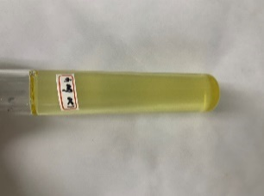
4.5 | 120℃ | 24.18±1.92^{b} | -0.18±0.20^{d} | 5.65±1.22^{c} | 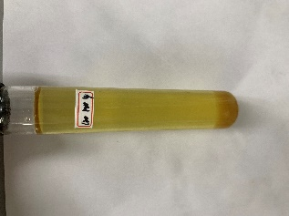
6.5 | 60℃ | 26.61±3.44^{c} | -0.65±0.19^{b} | 4.04±0.98^{b} | 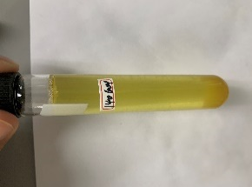
6.5 | 120℃ | 23.92±2.68^{b} | -0.06±0.00^{d} | 5.41±0.49^{c} | 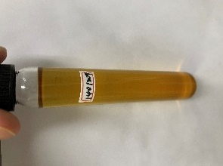
8.5 | 60℃ | 26.14±1.66^{c} | -0.51±0.08^{c} | 3.91±0.66ª | 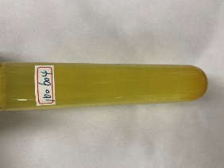
8.5 | 120℃ | 23.58±1.79^{b} | 0.11±0.00e | 5.06±0.68^{c} | 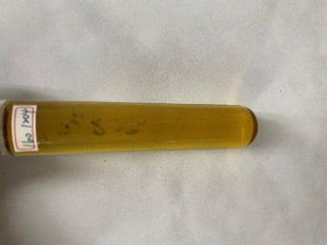
10.5 | 60℃ | 22.07±0.88ª | 0.23±0.01^{f} | 5.89±0.74^{c} | 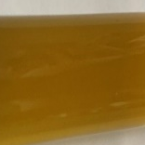
10.5 | 120℃ | 21.64±0.51ª | 0.37±0.04^{g} | 6.32±0.77^{d} | 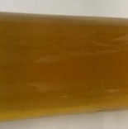
1. Data are expressed as mean ± S.D. (n = 3)
2. ^{a-g} Means with different letter in the same column were significant difference (p< 0.05).

Table 5. The acid value, peroxide value and MDA content of peanut oil extracted from 1 kg peanuts at different RF roasting time and expression temperature
RF roasting  time (min) | Expression  temperature | Acid value  (mg KOH/g) | Peroxide value  (meq/kg) | MDA  (μg/g)
4.5 | 60℃ | 0.13±0.03e | 2.31±0.07e | 0.12±0.01^{d}
4.5 | 120℃ | 0.20±0.02^{c} | 3.82±0.39^{d} | 0.12±0.01^{d}
6.5 | 60℃ | 0.16±0.04^{d} | 3.16±0.15^{d} | 0.13±0.04^{c}
6.5 | 120℃ | 0.28±0.03^{b} | 4.17±0.12^{b} | 0.13±0.02^{c}
8.5 | 60℃ | 0.18±0.01^{c} | 3.49±0.54^{c} | 0.14±0.03^{b}
8.5 | 120℃ | 0.34±0.09ª | 4.54±0.79ª | 0.15±0.02ª
10.5 | 60℃ | 0.21±0.03^{c} | 3.96±0.41^{c} | 0.15±0.01ª
10.5 | 120℃ | 0.37±0.01ª | 4.62±0.37ª | 0.15±0.03ª
1. Data are expressed as mean ± S.D. (n = 3)
2. ^{a-e} Means with different letter in the same column were significant difference (p< 0.05).

