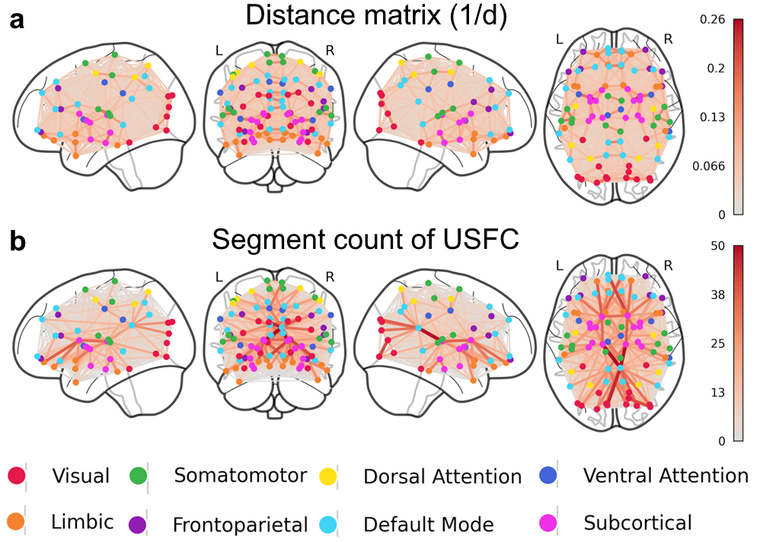
Supplementary Figure 1. Brain views indicate of the Euclidian distance matrix (a) of AAL atlas and the average “traffic map” weighted by the count of the usage of each segment (b). Node colors indicate the relevant network defined by the Yeo Atlas.

Please find the Supplementary Table 1 entitled “Overall load of each region within the segments and average USFC values of corresponding network” attached as an excel file.

Supplementary Table 2. List of the top ten heavily used segments of an effective “traffic map” / “route system”. Abbreviations: USFC = Unified structural and functional connectivity, L = Left, R = Right, DMN = Default mode network.

Segment | Region  (Network) | Region  (Network) | Round Count Value | Absolute  USFC value
1 | Posterior Cingulate Gyrus, R (DMN) | Thalamus, R  (Subcortical) | 49.23 | 9.32
2 | Posterior Cingulate Gyrus, R (DMN) | Thalamus, L  (Subcortical) | 50.02 | 9.17
3 | Calcarine Cortex, R  (Visual) | Inferior Occipital Gyrus, R (Visual) | 40.80 | 8.98
4 | Posterior Cingulate Gyrus, R (DMN) | Cuneus, L  (Visual) | 46.64 | 8.86
5 | Orbital part of Superior Medial Frontal Gyrus, L (DMN) | Caudate, R  (Subcortical) | 41.87 | 8.83
6 | Posterior Cingulate Gyrus, R (DMN) | Superior occipital gyrus, R  (Visual) | 36.83 | 7.49
7 | Orbital part of Superior Frontal Gyrus, L (Limbic) | Caudate, L  (Subcortical) | 37.21 | 8.13
8 | Orbital part of Superior Medial Frontal Gyrus, R (DMN) | Caudate, L  (Subcortical) | 36.36 | 7.98
9 | Thalamus, R  (Subcortical) | Caudate, R  (Subcortical) | 36.49 | 6.83
10 | Posterior Cingulate Gyrus, R (DMN) | Calcarine Cortex, L  (Visual) | 35.23 | 6.47

