Supplementary file 1. Search strategy and key terms

(tirzepatide or LY3298176 or "dual GIP and GLP-1RA" or " dual glucagon-like peptide and glucose-dependent insulinotropic polypeptide" or Zepbound) AND (Random or RCT or RCTs or "randomized controlled trial" or trial* or "clinical trial*")

Figure S1: PRISMA flow diagram of study screening and selection.
Identification
Studies screened (n = 418)
Studies sought for retrieval (n = 22)
Studies assessed for eligibility (n = 22)
References removed (n = 185)
Duplicates identified manually (n = 3)
Duplicates identified by Covidence (n = 182)
Marked as ineligible by automation tools (n = 0)
Other reasons (n = 0)
Studies excluded (n = 396)
Studies not retrieved (n = 0)
Studies excluded (n = 19)
Poster (n = 1)
Phase 1 (n = 2)
Duplication (n = 3)
Wrong outcomes (n = 2)
Wrong population (n=11)
Included
Studies included in review (n = 3)
Screening
Studies from databases/registers (n = 603)
The Cochrane Library (n = 259)
PubMed (n = 200)
Embase (n = 144)

Figure S2: Comparison of tirzepatide versus placebo for participants reached weight reduction goals.
- 5% weight loss:
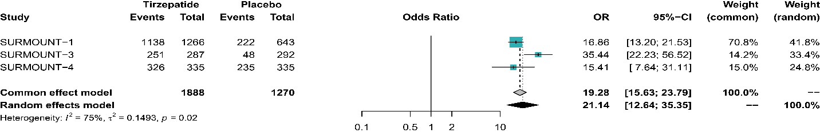
- 10% weight loss:
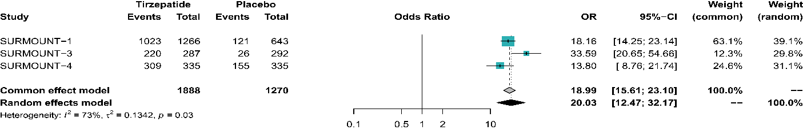
- 15% weight loss:
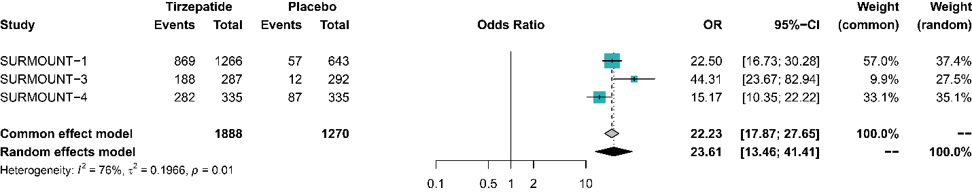
- 20% weight loss:
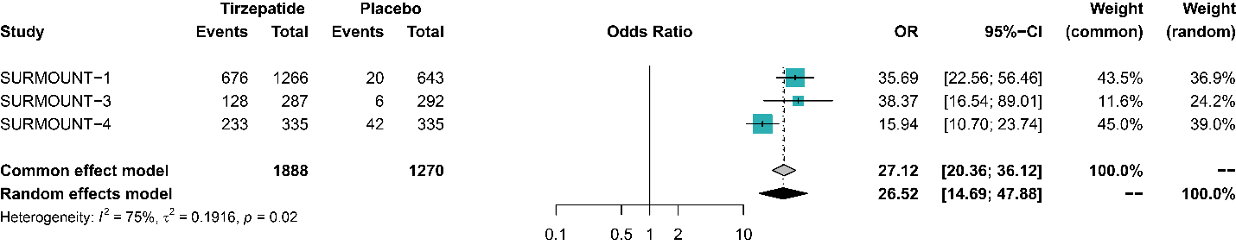
- 25% weight loss:
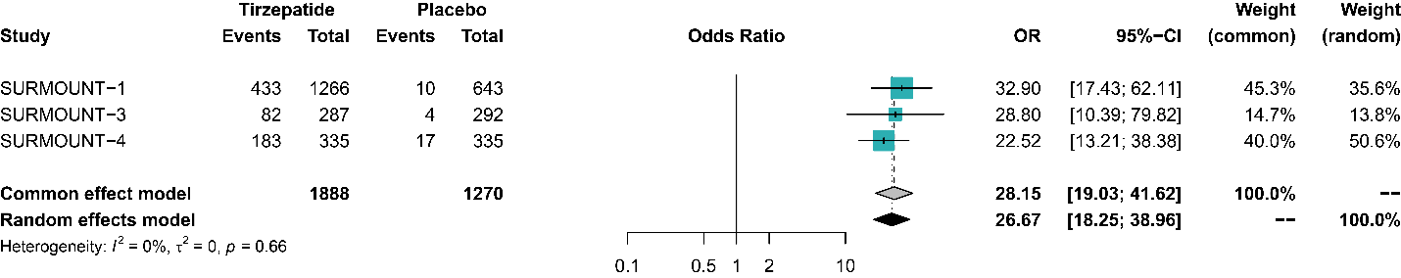

Figure S3: Comparison of tirzepatide versus placebo for change in body weight (%), BMI, Waist circumference, and A1c.

1) Weight loss (%):
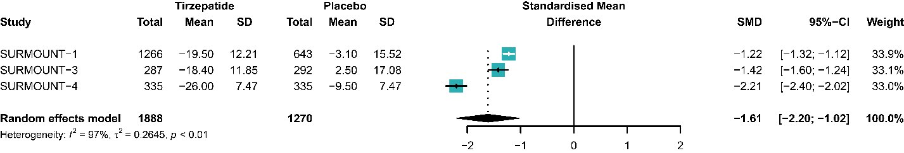
2) BMI reduction (kg/m²):
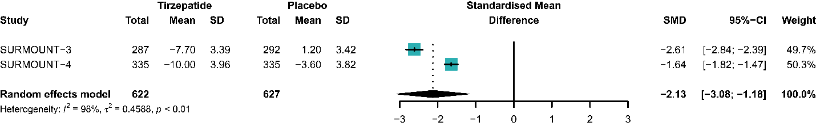

3) Waist circumference (cm):
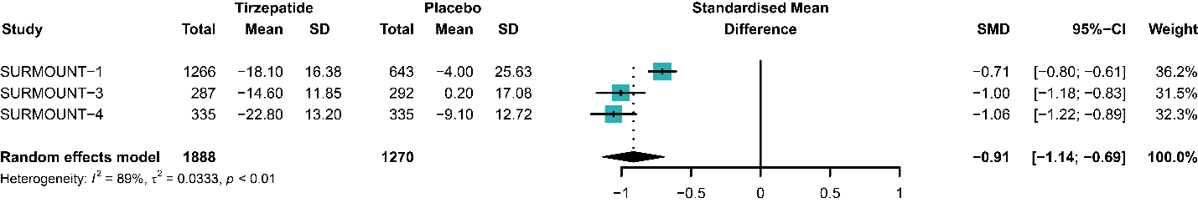

4) A1c reduction (%):
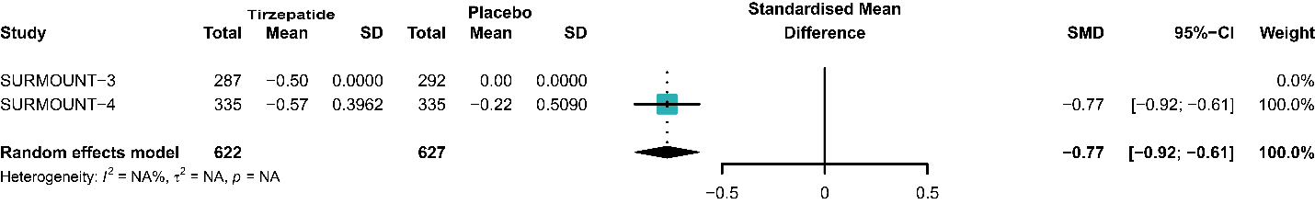

Figure S4: Comparison of tirzepatide versus placebo for quality-of-life changes
1) IWQOL score:
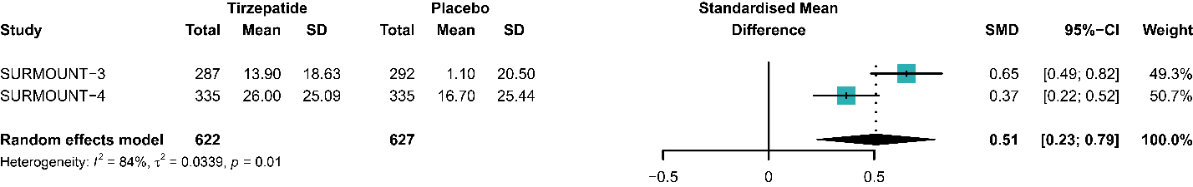
2) SF-36 PF score:
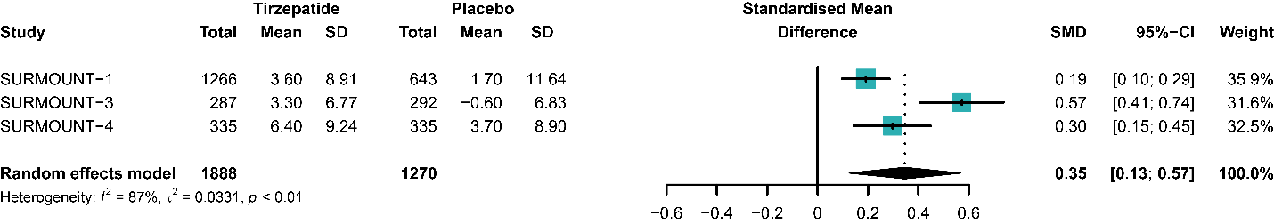

Figure S5: Comparison of tirzepatide versus placebo for incidence of adverse events.
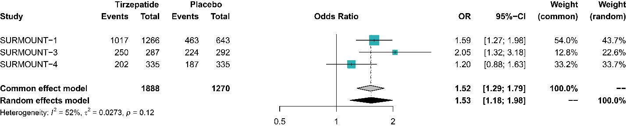

Table S1. The risk of bias assessment of included studies.
Study | Year | Bias arising from randomization process | Bias due to deviations from intended interventions | Bias due to missing outcome data | Bias in measurement of the outcome | Bias in selection of the reported result | Overall
SURMOUNT 1 | 2022 | + | + | + | + | + | +
SURMOUNT 3 | 2023 | + | + | + | + | + | +
SURMOUNT 4 | 2024 | + | + | + | + | + | +

+
Low risk of bias

