Supplementary data
Table A1: Calibrated model statistics and parameters with human behavior on (HB_{on}) and off (HB_{off}).
 |  | Units | Model HB_{on} | Model HB_{off}
 | NSE (runoff) | - | 0.59 | 0.54
 | PBIAS (runoff) | % | 2.76 | -1.19
 | NSE (groundwater) | - | 0.65 | 0.55
 | Parameter | Units | Value HB_{on} (Calibrated) | Value HB_{off} (Calibrated)
Aquifer | Aquifer Depth | m | 22.47 | 23.07
Aquifer | Aquifer specific yield | % | 0.012 | 0.011
Aquifer | Baseflow threshold | mm | 300.00 | 300.00
 | Runoff recession coefficient | - | 0.04 | 0.06
 | Return flow fraction | - | 0.10 | 0.15
Top soil layer | Soil Field capacity | m³ m⁻³ | 0.24 | 0.29
Top soil layer | Wilting point | m³ m⁻³ | 0.16 | 0.22
Top soil layer | Saturation capacity | m³ m⁻³ | 0.37 | 0.42
Top soil layer | Hydraulic conductivity | m day⁻¹ | 0.16 | 0.16
Bottom soil layer | Soil Field capacity | m³ m⁻³ | 0.27 | 0.28
Bottom soil layer | Wilting point | m³ m⁻³ | 0.17 | 0.18
Bottom soil layer | Saturation capacity | m³ m⁻³ | 0.29 | 0.30
Bottom soil layer | Hydraulic conductivity | m day⁻¹ | 0.08 | 0.10
 | Root wilting point fraction | - | 0.87 | 0.86
 | Groundnut irrigation fraction (GN_{irr}) | - | 0.70 | 0.59
 | Capillary rise (Cap) | mm day-1 | 0.016 | 0.05

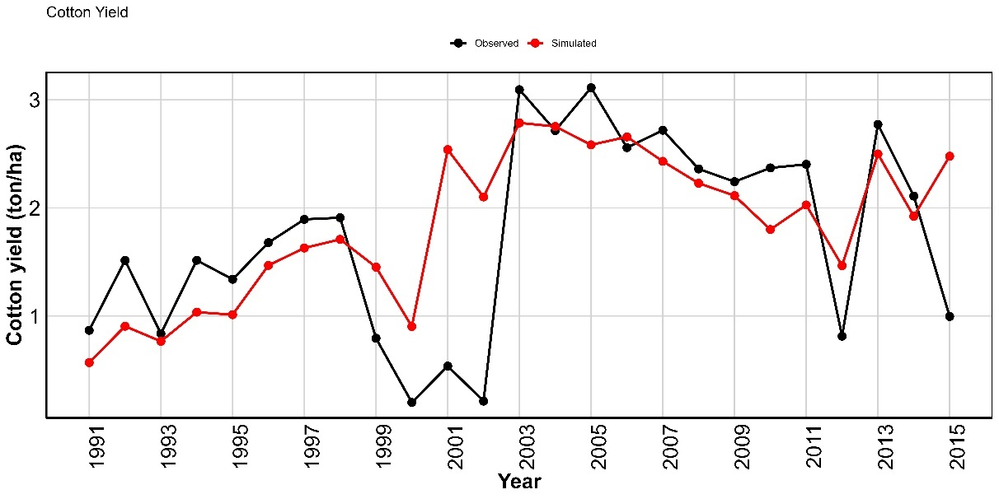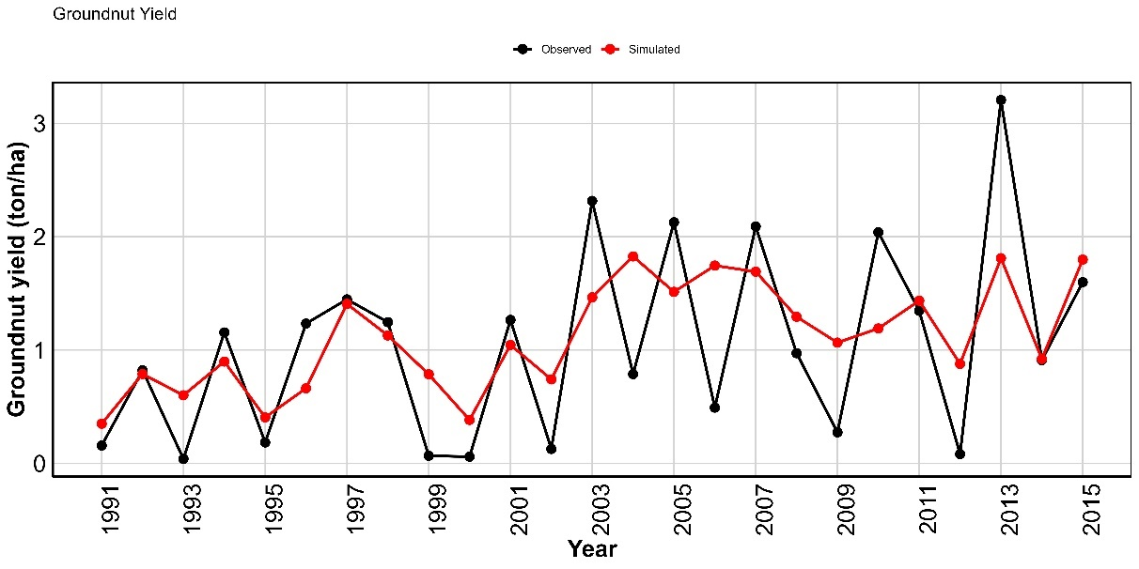
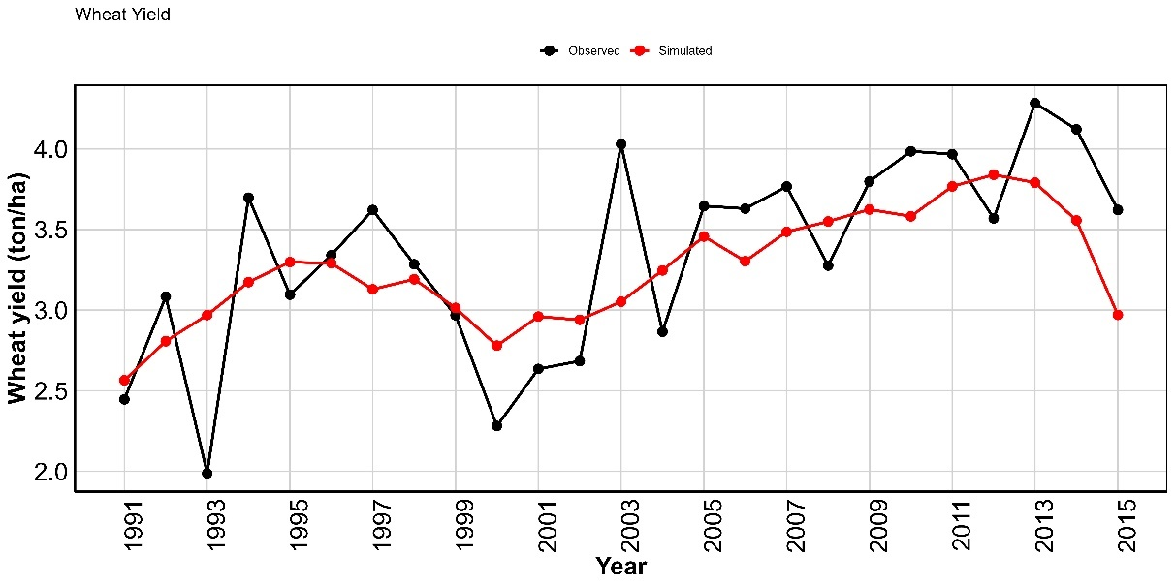
Figure A1: Cotton, groundnut and wheat observed and calibrated yields
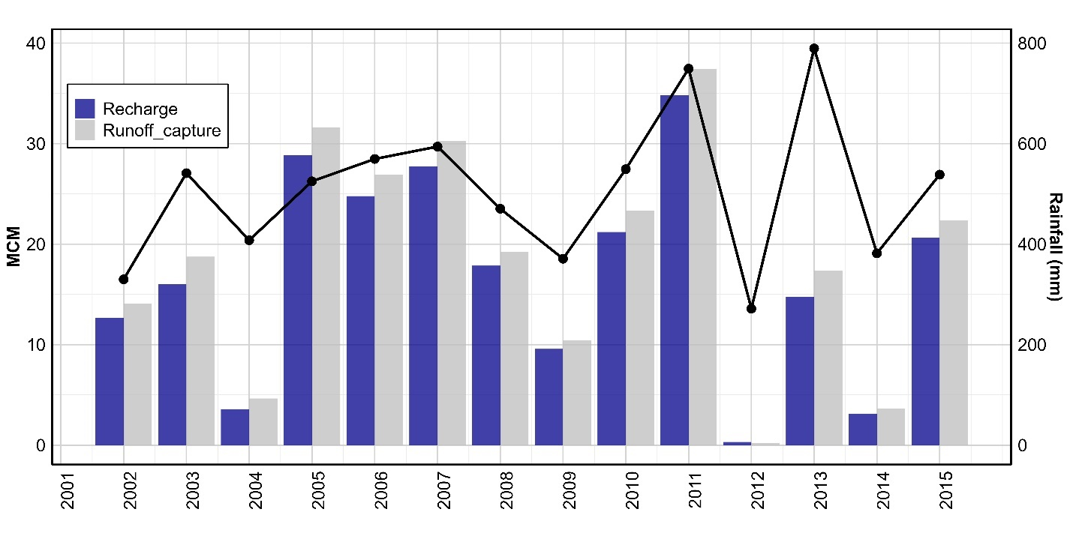
Figure A2: Runoff capture (MCM) and recharge (MCM) by check dams in the catchment in comparison with rainfall.

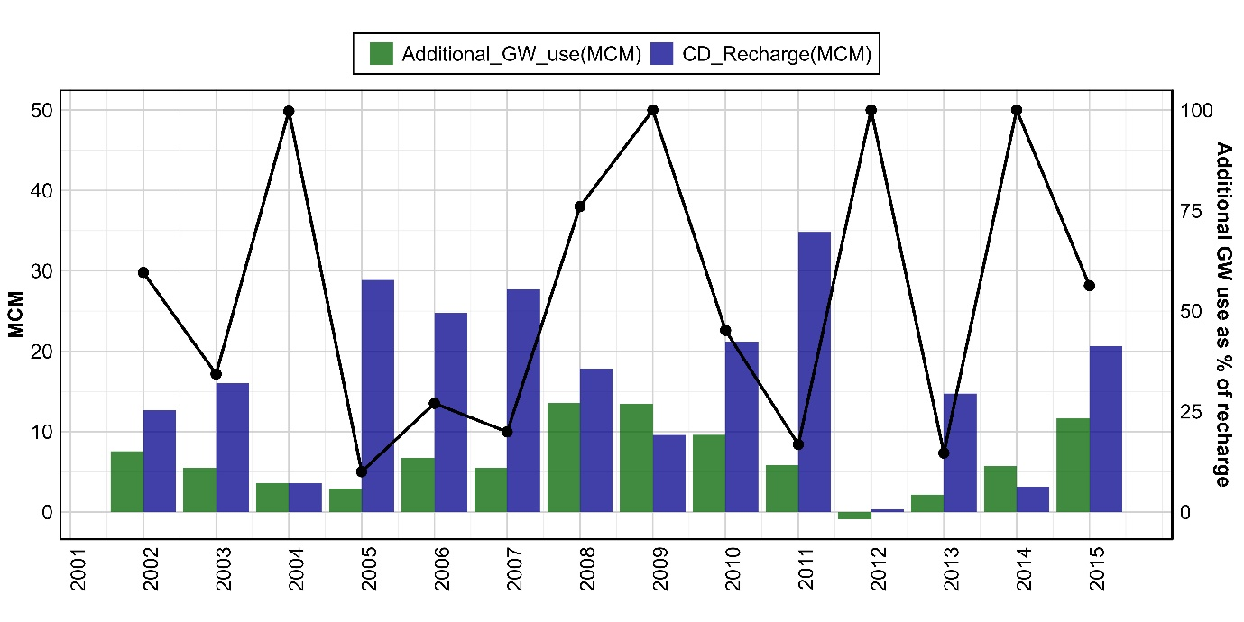
Figure A3: Additional GW use in model HB_{on} (compared to HB_{off} with no human behavior) relative to check dam recharge

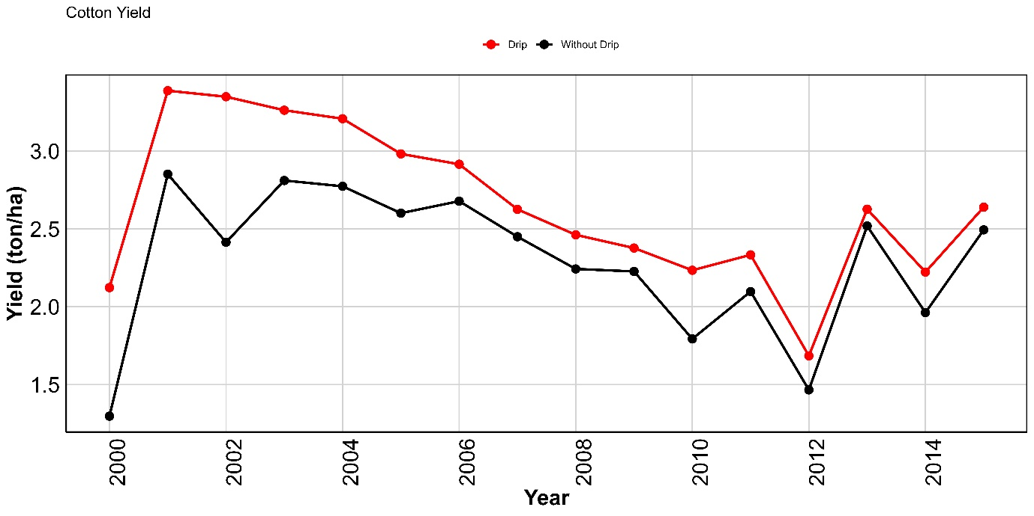
Figure A4: Comparison of cotton yield of farmers with and without drip

Specifics of the AWM-ABM model applied to the case study area
Hydrological module
The spatially distributed hydrological module operates at 1 km² resolution with 1319 such grid grids within the study area. In the model, runoff is generated through saturation excess overland flow (Hewlettian runoff)¹ from the first soil layer, which also contributes to lateral flow estimated based on slope, soil field and saturation capacities, and soil hydraulic conductivities. Water percolates, based on soil field capacity and saturation capacity, from the top rootzone layer to the bottom subzone soil layer, and from the subzone to the groundwater layer, the latter considered as recharge. Soil moisture is depleted from topsoil (root zone) via root soil moisture uptake by the crops. Groundwater storage is characterized by the depth of the aquifer and specific yield. Groundwater storage above a storage threshold (BF_{thresh}) is added to the baseflow². The total runoff for each grid cell is the sum of saturation excess flow, lateral flow, and baseflow which is routed using a flow direction network. Figure A5 gives the conceptual workflow of the hydrological module. Table A2 summarizes the climate and biophysical data employed in the model. Refer to SPHY model² for more information on the hydrological model and equations.
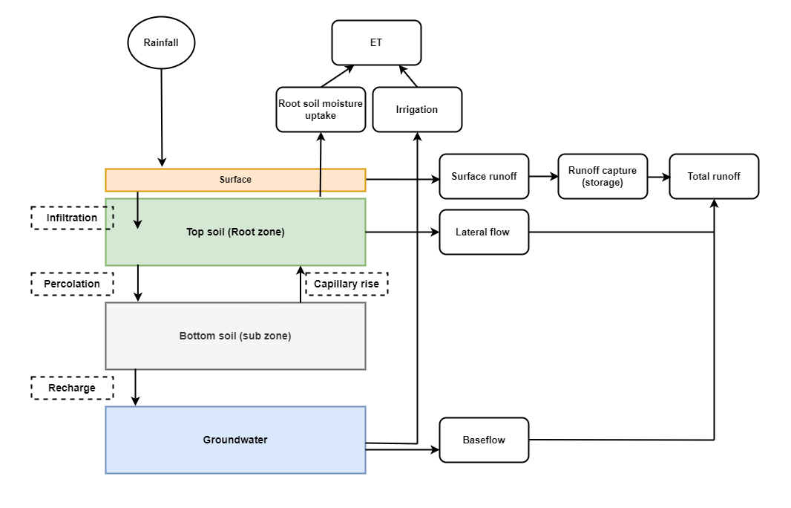
Figure A5: Conceptual workflow of the hydrological module
The catchment is delineated using the Shuttle Radar Topography Mission (SRTM) digital elevation model data³, which is also used for generating slope and flow direction maps. The model integrates gridded daily rainfall derived from rainfall gauge stations in the watershed⁴ and gridded temperature (mean, minimum, and maximum)⁵. Runoff routing employs a recession coefficient (Kx) as a calibration parameter, with values ranging between 0 and 1 where values approaching 1 correspond to a slow responding catchment². Soil data, including texture and organic content, were taken from global soil data, Soil Grids, provided by the International Soil Reference and Information Centre⁶. Based on the soil properties, soil water characteristics such as field capacity (FC), saturation capacity (SAT), wilting point (WP), and saturated hydraulic conductivity (k_{sat}) were estimated using the pedo-transfer function⁷. Soil water characteristics were adjusted during calibration by multiplying them with a scaling parameter ranging between 0.7 to 1.3.
The area's aquifers, mainly comprising Deccan Trap basalt, have low porosity and hydraulic conductivity⁸, and are confined to water-bearing zones in the upper 15-30 m of weathered and fractured rock^{9,10}. The water availability in deeper aquifers is limited and relies on natural joints and fractures. Aquifer characteristics such as depth (D_{gw}), specific yield (S_{Y}), and hydraulic conductivity (K_{gw}) were calibrated with initial values sourced from the national hydrogeological dataset¹¹.
Recharge and runoff capture from check dams were simulated using the recharge empirical equations¹², refined for the region¹³. This approach presumes an underlying impermeable layer (bedrock in the area) beneath the aquifers. CD data, including number and storage per village, were derived from secondary data and social surveys^{8,14,15}. In total 575 CDs distributed in 453 grid cells (~ 34 % of total grid cells) with combined storage of 12.9 MCM were incorporated in the model. Each check dam was modeled with a 15 m width⁸, and the riverbed’s slope, determined from SRTM DEM data, informed the water height and spread area calculations¹³. Refer to check storge model¹³ for more information on the check dam model and equations.
Table A2: Summary of data and parameters used and its sources in the hydrological module
Data | Unit | Average | Source
Rainfall | mm | 478 | State water resource department⁴
Temperature | ^{O}C | 27ᵒC | India Meteorological Department⁵
Slope | % | 0.56 | SRTM³
Runoff recession coefficient (K_{x}) | - | 0.05 | Calibrated.
Parameters | Unit | Average | Source
Baseflow recession coefficient (α_{gw}) | - | 0.53 | Calibrated.
Baseflow threshold (BF_{thresh}) | mm | 300.00 | Calibrated.
Topsoil depth (D₁) | mm | 650.00 | Calibrated. Initial values based from the pedo-transfer function⁷
Bottom soil depth (D₂) | mm | 400.00
Soil Field capacity (FC) | m³ m⁻³ | 0.30
Soil Wilting Point (WP) | m³ m⁻³ | 0.18
Soil Saturation capacity (SAT) | m³ m⁻³ | 0.41
Soil hydraulic conductivity (K_{sat}) | m day⁻¹ | 0.08
Rootdrain velocity (v_{lat}) | mm day-¹ | 0.88 | Derived based on soil parameters².
Root lateral flow travel time (TT_{lag}) | d | 0.49 | Derived based on soil parameters².
Root wilting point (RWP) | fraction | 0.70 | Calibrated.
Capillary rise (Cap) | mm day-¹ | 0.05 | Calibrated.
Aquifer Depth (D_{GW}) | m | 20.00 | Calibrated. Alam et al., (2022b)
Aquifer specific yield (S_{y}) | % | 0.35 | Calibrated. Initial values from GEC¹¹
Aquifer conductivity (K_{gw}) | m day⁻¹ | 0.10 | GEC¹¹ and CGWB⁹
Check dam number (& location) | # | 453 | Secondary data and social surveys^{8,14,15}  Alam et al., (2022b)
Check dam location, number, and storage | MCM | 12.90
Check dam width | m | 15.00

Crop module
In the model, crop water requirements, irrigation needs, and yields. It employs the FAO four-stage crop coefficient approach to estimate crop potential evapotranspiration (ET_{c})¹⁷, with reference evapotranspiration (ETo) determined via the Hargreaves method¹⁸. Crop water needs (ET_{c}) are first met by root soil water uptake from the rootzone soil layer. Soil water uptake reduces as a function of available moisture in the rootzone soil layer following a linear equation as used in SPHY² based on the Feddes equation¹⁸. The difference between ET_{c} and root-soil water uptake is considered as the net irrigation water requirement (NIR), and gross irrigation requirements (GIR) are estimated based on irrigation efficiency (NIR/ irrigation efficiency). For rainfed farmers, crop water needs are met solely through root water uptake, while irrigated farmers can also access groundwater.
The primary crops cultivated in this region include cotton and groundnut during the kharif season (the monsoon season, from June to October) and chickpea and wheat during the rabi season (the post-monsoon season, from November to February/March)¹⁹. The kharif crops were modeled separately, whereas the rabi crops were simulated as one crop, i.e. wheat, for which long-term time series data are available. For estimating crop evapotranspiration and yields, crop-specific data on sowing day, growing period, crop coefficients (Kc), and crop yield reduction factor (K_{y}) are obtained from the literature^{17,20,21} (Table A3).
Table A3: Crop coefficients and duration of crops
Crop stage |  | K_{c}^{a,b} |  |  | Duration (days) ^{a,b} |  |  | Ky
 |  | Cotton | Groundnut | Wheat | Cotton | Groundnut | Wheat | Cotton | Groundnut | Wheat
Initial | 1 | 0.4 | 0.5 | 0.4 | 30 | 25 | 20 | 1.2 | 1.2 | 1.1
Development | 2 | 0.7 | 0.8 | 0.8 | 50 | 35 | 25 | 1.2 | 1.2 | 1.1
Mid-season | 3 | 1.05 | 1.1 | 1.2 | 60 | 35 | 45 | 1.2 | 1.2 | 1.1
Late season | 4 | 0.65 | 0.55 | 0.75 | 55 | 25 | 30 | 1.2 | 1.2 | 1.1
ª Allen et al., (1998).
^{b} Kar et al., (2014).
The net cultivated area in each grid cell was based on the land use land cover (LULC) map from 2015, which gives the percentage of agricultural land in each grid cell²². The net cultivated area (NCA) from the LULC map (summed over the Kamadhiya catchment) was compared with NCA for each year from reported administrative data^{15,23,24} and a correction factor (Actual NCA/LULC NCA) was applied uniformly across the grid. The distribution of net cultivated area between crops in the model is based on farmer decisions.
Crop irrigation is assumed to be groundwater-dependent⁸. The percentage of farmers having access to irrigation is set equal to the proportion of cotton area irrigated^{8,24}, and this increases over the years (Figure A6). To meet irrigation needs, farmers access shallow groundwater through large-diameter open dugwells^{8,19}. Groundwater storage availability for each day, simulated by the hydrological module, is distributed equally among all the irrigated farmers in a grid cell. Farmers can abstract groundwater but are limited by available groundwater storage and pumping and well capacities, to meet the gross irrigation requirement. The daily abstraction is limited by the maximum possible abstraction (GW_{D(max)} = 525 m³ day⁻¹) constrained by the pump and well capacities (Table A5). Also, farmers can access deeper groundwater using borewells, and again daily abstraction is limited by maximum possible abstraction (GW_{B(max)} = 80 m³ day⁻¹) (Table A4). A part of the applied irrigation water recharges groundwater based on a return flow coefficient.
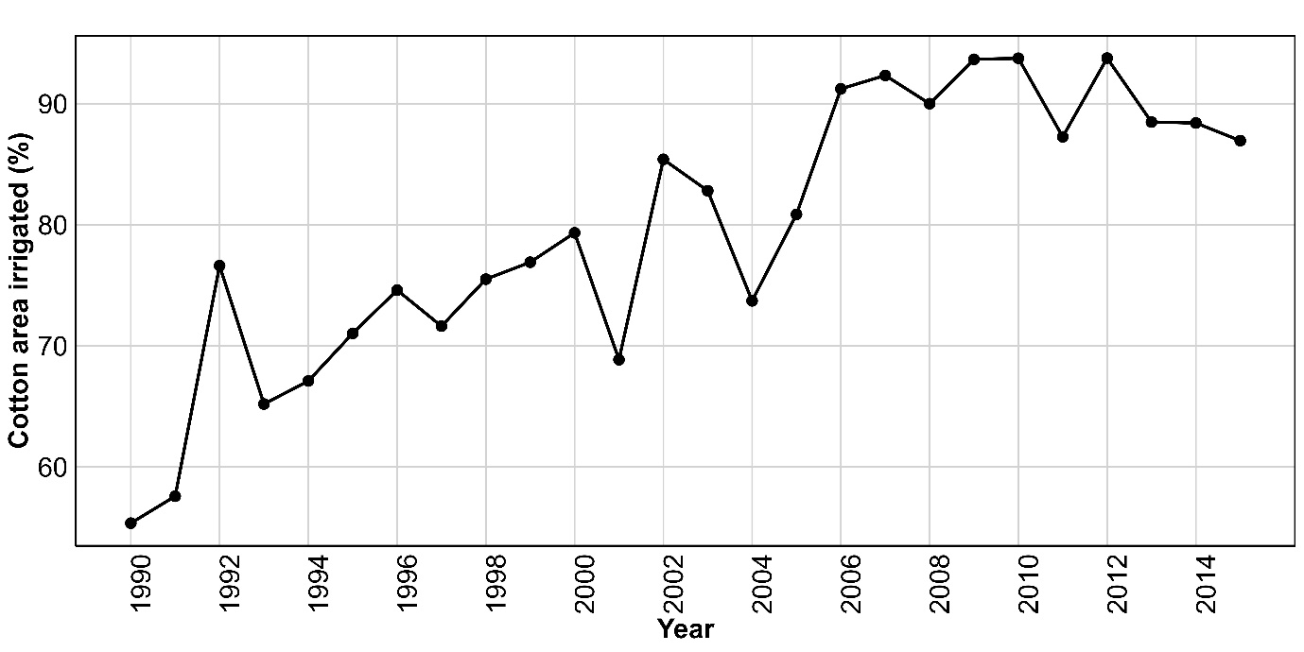
Figure A6: Time series of cotton irrigated area (%)
Table A4: Maximum groundwater abstraction rates
Data | Unit | Value | Source
Maximum dugwell groundwater abstraction (GW_{D(max)}) | m³ day⁻¹ | 525 | For a 25 m well (depth) and 4 m wide well, storage is around 350 m³. Maximum abstraction is taken as 1.5 times the storage giving 525 m³ day⁻¹
Maximum dugwell groundwater abstraction (GW_{D(max)}) | m³ day⁻¹ | 80 | Based on deep tubewell abstraction rate of 10m3/hr and average power supply of 8 hr/day, maximum abstraction is set to 8 hour 80 m3.

From the groundwater storage, the model first meets the irrigation needs of cotton and then groundnut in the kharif season. This is because groundnut is a rainfed crop²⁴. However, survey data¹⁹ showed that farmers irrigate groundnut crops when needed and this was also observed during field visits (November and December 2021). This is simulated by applying partial irrigation to groundnut by applying a deficit irrigation coefficient (GN_{Irr}) which ranges from 0 (no irrigation is applied) to 1 (full irrigation is applied). Irrigation efficiency is taken as 0.6 unless a farmer has adopted drip irrigation, in which case the irrigation efficiency is set to 0.9^{25,26}. At the end of the season, crop water needs met (AET) from root soil moisture uptake and irrigation, as a fraction of potential crop water needs, i.e. ET_{c}, is calculated and is used with crop stage-specific crop yield reduction factor (K_{y})²⁰ and potential yield (Y_{p}) to estimate each farmer’s yield (equation 1). This is multiplied by crop price²⁷ and then the cost of cultivation is subtracted from it²⁸ (see Table A5) to estimate profit that is accumulated as capital over time.
$\frac{Y}{Y_{p}}=\prod_{j=1}^{J}{\sum_{i∈s_{j}}^{I_{s_{j}}}{[{1- K}_{Y}\left(1-\frac{AET}{ET_{c}}\right)]}}$ Equation 1
Where, $K_{Y}$ is crop yield reduction factor, AET^{i}, ET_{c}^{i} are AET and ET_{c} for day i in a growth stage s_{j} with I_{sj} number of days, and there are (s₁,..,s_{j},..s_{J}) growth stages with J = 4 stages. Y_{p} is the potential yield and Y is the actual yield.
Table A5: Crop cultivation cost, price and sowing dates
 | Crop cultivation cost (per ton)²⁸ | Price (per ton)²⁷ | Sowing date
Cotton | 23160 | 41000 | 15th June
Groundnut | 20390 | 40300 | 15th June
Wheat | 7440 | 15250 | 15th November
# For the season 2015
Farmers module
The farmers module models the daily, seasonal, and annual behavior of the farmers. The farmer behavior is based on the combination RANAS behavior model²⁹ and data-driven rules to integrate human decisions. The RANAS (i.e., R-risk, A-attitude, N-norm, A-ability, and S-self-regulation) behavioral model assumes that multiple sociopsychological factors (i.e., risk, attitude, norm, ability, and self-regulation) impact behavioral outcomes (i.e., behavior, intention, use, and habit). The RANAS behavior rules were derived from household surveys¹⁹ and data-driven rules based on the analysis of crop and hydrological data in the catchment⁸.
Each farmer is characterized by her socio-economic characteristics (land area, financial resources, access to irrigation) and assigned a location (i.e. a grid cell). The farmer co-occupies the space with other farmers in the specific grid cell and bi-directionally interacts with the biophysical resources (as modeled by the hydrological module) through decisions on crop choices and methods of irrigation. The farmers also interact with each other through norms, from the RANAS model.
The farmers module characterizes farmers with a set of decision rules. This characterization represents population's heterogeneity, which is crucial for modelling inequalities in cost and benefit sharing. In the model, farmers are differentiated based on socio-economic characteristics and biophysical endowments. They are stratified by land size into four categories: marginal (<1 ha), small (1-2 ha), medium (2-4 ha), and large (>4 ha)¹⁹. The proportions of these groups in the region and the average area per type (total area/number of holdings) are derived from the agricultural census data (Table A6).
Table A6: Distribution, number and area of each category of farmers in the blocks covering Kamadhiya catchment
 | %age of farmers ª | Total holdings ª | Total area (ha) ª | Average area (ha)
Marginal | 7.8% | 40173 | 27350 | 0.68
Small | 28.6% | 68673 | 99690 | 1.45
Medium | 35.1% | 45162 | 121395 | 2.69
Large | 28.5% | 15320 | 95491 | 6.23
ª Agricultural census 2015-16³⁰
Subsequently, the number of each type of farmer in each grid cell is derived based on the total cultivated area in each cell (see crop module), the proportion of each farmer group (Table A6), and the average area of each group (Table A6). Overall, this results in a simulation of 38,447 farmers in the watershed. The percentage of farmers with irrigation access, assigned randomly to unirrigated farmers at start of the year and which they retain over the time, grows annually based on the catchment's irrigation coverage (Figure A6). Farmer locations within the watershed determine their access to amenities such as check dams. Additionally, farmers are characterized by their access to drip irrigation and borewells, which are simulated based on behavioral rules.

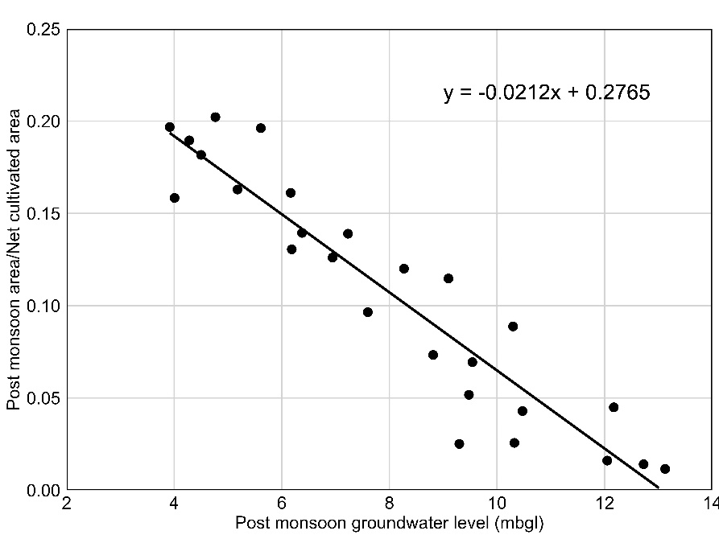
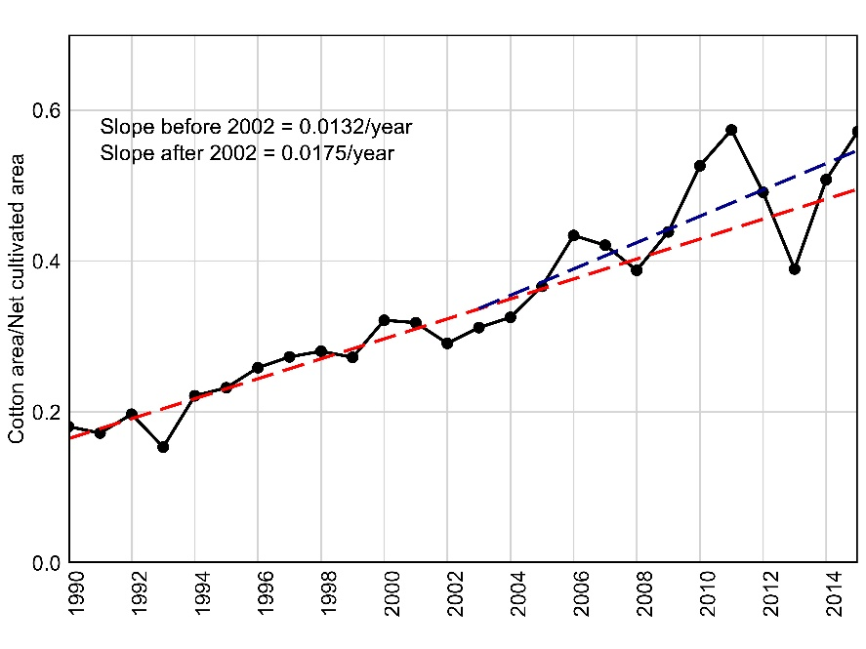
Decision rules for the distribution of Kharif crop areas
b)
a)

Figure A7: a) Fitted line showing cotton area per unit net cultivated area before and after 2002 (i.e. pre-CD and post-CD periods respectively); b) Relationship between wheat area per unit net cultivated area (post monsoon area) and spatially averaged post-monsoon groundwater levels
Decisions rules for investment in drip and borewell
Table A7: Results of binary logistic regression of farmer's decision to adopt drip irrigation
Regression coefficient | Estimate | Significance ª | Min | Max
(Intercept) | -3.046 | *** | -3.149 | -2.943
Farming experience | 0.034 | * | 0.032 | 0.036
Higher education | -1.235 |  | -1.370 | -1.100
Primary Education | 0.486 |  | 0.415 | 0.556
Secondary Education | 0.066 |  | -0.014 | 0.145
Proximity to water | -0.285 |  | -0.333 | -0.237
Ability | 0.865 | *** | 0.838 | 0.893
Risk (perceived) | -0.621 | *** | -0.644 | -0.598
Risk (severity) | -0.420 | * | -0.446 | -0.394
Attitude | 0.562 | * | 0.528 | 0.596
Norm | 0.462 | ** | 0.443 | 0.481
ª *p ≤ 0.05, **p ≤ 0.01, ***p ≤ 0.001
# Threshold: 0.35: Accuracy: 85.9; Sensitivity: 58.9 and Specificity: 91.4
# Threshold: 0.40: Accuracy: 85.9; Sensitivity: 52.0 and Specificity: 93.4
Table A8: Results of binary logistic regression of farmer's decision to adopt borewells.
Regression coefficient | Estimate | Significance ª | Min | Max
(Intercept) | -2.30 | *** | -2.34 | -2.261
Self_regulation | 0.386 | *** | 0.372 | 0.401
Attitude | 0.455 | ** | 0.435 | 0.476
Norm | 0.449 | ** | 0.431 | 0.469
Farmer area | 0.011 | . | 0.01 | 0.013
Livestock ownership | 0.076 | * | 0.072 | 0.081
Proximity to water | 0.748 | * | 0.711 | 0.785
ª *p ≤ 0.05, **p ≤ 0.01, ***p ≤ 0.001
# Threshold: 0.25: Accuracy: 65.9; Sensitivity: 72.9 and Specifity: 57.6
# Threshold: 0.21: Accuracy: 65.9; Sensitivity: 80.3 and Specifity: 50
RANAS variables were linked with model variables
Dynamically simulated RANAS variables were linked with model variables (Figure A8). This linking involved estimating RANAS variables in equation 4 and 5 (e.g., risk, ability) based on the simulated model variables (e.g., drought occurrence, crop yield, farmers capital) for each year. All RANAS variables were then updated annually for each farmer based on the simulated values of the linked modeled variables. The responses to RANAS related questions were on a likert scale ranging from 0 to 4 and the regression coefficients in equation in 4 and 5 were derived based on this scaling. Therefore, the modeled variables that the RANAS variables link up with were also scaled between 0 to 4. This was done using min-max scaling ((variable – min)/(max-min)) and multiplying it by 4. The scaled modeled variable was then assigned to the corresponding RANAS variable.
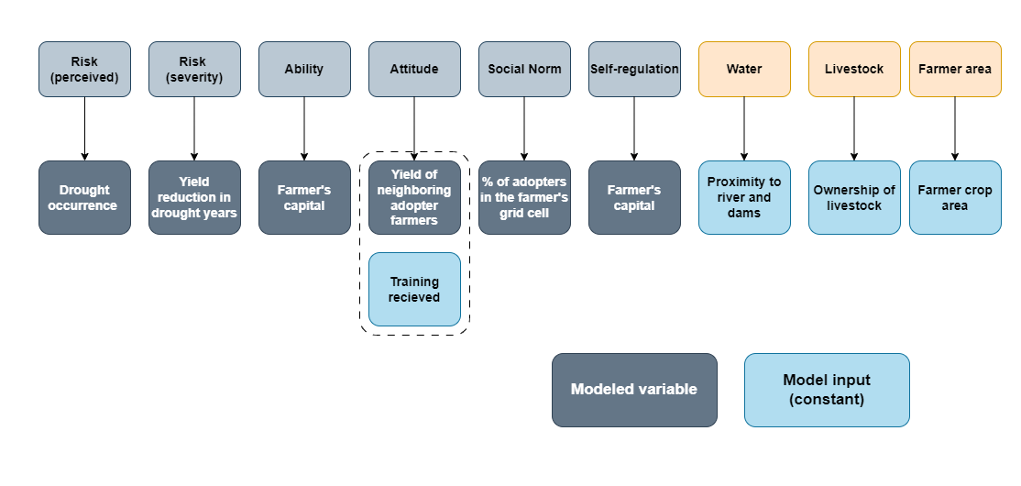
Figure A8: Linking of RANAS and socio-economic variable with the model variables and inputs

For example, the household survey¹⁹ measured perceived risk with the question “How high is the risk of drought in the coming 5 years?” and the risk severity with the question “How severe will be the impact of drought on your crop production?” on a scale of 0 to 4. Thus, the RANAS variable risk (perceived) was estimated based on a modeled variable occurrence of a drought year (annual rainfall < 400 mm) and RANAS variable risk (severity) was based on the modeled effect of drought on crop yields. For both risks, the model uses the principle of drought memory which considers the accumulative nature of farmers' experience and accounts for memory decreasing over time in non-drought (non-disaster) years^{31,32}. For every drought year, a farmer's risk (perceived) memory was updated (starting with 0, each drought year adds 1 to it) and risk (severity) memory by adding a decrease in yield relative to potential yield (starting with 0, each drought year adds a decrease in yield to the farmers' memory) (Equation 7 and 8). Both drought and impact memory reduce over time with memory decay of 20% each year. This is based on the household survey¹⁹, which showed that on average farmers report 1.25 drought years (23% reported 0 drought years and 40% reported 1 drought year) in the last 10 years as compared to the observed three drought years (the year 2012, 2014, and 2018). Applying decay rate of 20% (per year) for the population (over 10 years) gives drought memory value at the end of the simulation period (year 2021) of 1.2 (shown in Table A9). This is close to the average reported value of 1.25 drought years. At the end of a simulation year, risk and impact values were scaled from 0 to 4 and given as input to equation 4.
${risk(p)}_{f,t}= {drought}_{f,t}+ {risk(p)}_{f,t-1}-d*{risk(p)}_{f,t-1}$ Equation 6
${risk(s)}_{f,t}= {drought}_{f,t}*(\frac{{Yield\left(p\right)}_{t}- {Yield\left(f\right)}_{t}}{{Yield\left(p\right)}_{t}})+ {risk(s)}_{f,t-1}-d*{risk(s)}_{f,t-1}$ Equation 7
Where risk(p) and risk(s) is the risk (perceived) and risk (severity) for a farmer f in year t; ${drought}_{f,t}$ is the occurrence of drought (1 if rainfall < 400 mm else 0) at the farmer’s location; ${Yield\left(p\right)}_{t}$ is the potential yield of crops and ${Yield\left(f\right)}_{t}$ is the actual yield of the farmer in year t and d is the memory decay rate. Potential and farmer yields are derived by taking the corresponding averages of all the crops farmer grows.
Table A9: Estimation of residual drought memory for the period stating 2011 based decay rate of 20 % per year
Year | Drought occurrence | Drought value | Risk memoryª
2011 | No | 0 | 0
2012 | Yes | 1 | 1
2013 | No | 0 | 0.8
2014 | Yes | 1 | 1.6
2015 | No | 0 | 1.4
2016 | No | 0 | 1.2
2017 | No | 0 | 1
2018 | D | 1 | 1.8
2019 | No | 0 | 1.6
2020 | No | 0 | 1.4
2021 |  |  | 1.2
ª ${risk(p)}_{f,t}= {drought}_{f,t}+ {risk(p)}_{f,t-1}-d*{risk(p)}_{f,t-1}$
##assuming decay rate of 20 % per year
Similarly, the ability was linked to farmers’ accumulated capital in the model as this was measured in the household survey¹⁹ with the answer to the question “How confident are you in your financial capability to afford the drip system/borewell?”. Attitude in the survey was measured with the answer to the question “How beneficial drip/borewell is for crop production?” and in the model it was assumed to be influenced by incremental yield benefits achieved by neighboring farmers (living within the same grid) who have adopted drip irrigation or borewell (Equation 8). For drip irrigation, the effect of the drip subsidy scheme after 2005 is also added through the training and awareness component with an assumption that 5% of the farmers randomly received the training at the start of each year. This is based on the survey data¹⁹ which showed that, though in total 21% of the farmers have received information from the government or NGOs, they give less importance to their opinion. With training an important factor in shaping attitudes^{33,34}, after 2005 it was assumed that the attitudes were influenced in equal proportions by yield benefits achieved by neighboring farmers and training.
${Yield_benefit}_{f,t}=\left[\frac{ {Yield\left(a\right)}_{f\left(g\right),t}}{{Yield\left(p\right)}_{t}}- \frac{ {Yield\left(na\right)}_{f\left(g\right),t}}{{Yield\left(p\right)}_{t}}\right]*100$ Equation 8
where ${Yield\left(a\right)}_{f\left(g\right),t}$and ${Yield\left(na\right)}_{f\left(g\right),t}$is the yield of adopters and non-adopters, respectively living in the same grid (g) as the farmer (f) in year t and ${Yield\left(p\right)}_{t}$ is the potential yield of crops.
Norm was measured with the answer to the question “What proportion of people in your village have a drip?”. This was directly linked in the model to the percent of adopters in the grid cell where the farmer is located. This was estimated at the end of each year for each grid cell by dividing number of adopters by the total number of farmers living in the grid cell. Self-regulation was measured in the household survey¹⁹ with the answer to the question “Do you have a plan to acquire the required personnel and material it takes to drill a BW?”, and there was no direct model variable associated with it. We assume that action planning reflects intention to adopt which is related to farmers capital^{35,36} and thus self-regulation was linked to the farmers accumulated capital.
Overall workflow of the model
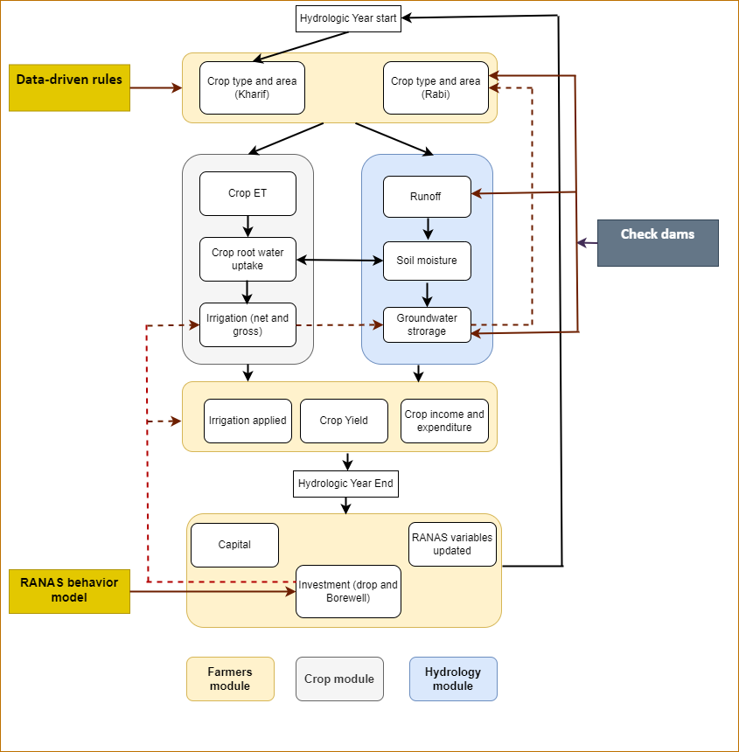
Figure A8: Conceptual workflow of the ABM-AWM model. Dotted lines show the feedbacks between the modules.
Table A11: Parameter set for latin hypercube sampling
Parameter | Mean | Min | Max
Capillary rise (Cap) [mm day⁻¹] | 0.10 | 0 | 0.31
Top soil: Field capacity [m³ m⁻³]ª | 0.79 | 0.49 | 0.90
Top soil: Saturation capacity [m³ m⁻³]ª | 0.88 | 0.70 | 0.91
Bottom soil: Field capacity [m³ m⁻³]ª | 0.87 | 0.76 | 0.99
Bottom soil: Saturation capacity [m³ m⁻³]ª | 0.70 | 0.57 | 0.82
(Intercept)_{drip} | -3.046 | -3.149 | -2.943
Risk (perceived)_{drip} | -0.621 | -0.644 | -0.598
Risk (severity) _{drip} | -0.42 | -0.446 | -0.394
Ability _{drip} | 0.865 | 0.838 | 0.893
Attitude _{drip} | 0.562 | 0.528 | 0.596
Norm _{drip} | 0.462 | 0.443 | 0.481
Adoption_prob_threshold_{drip} | 0.375 | 0.35 | 0.4
(Intercept)_{BW} | -2.30 | -2.34 | -2.261
Self_regulation_{bw} | 0.386 | 0.372 | 0.401
Attitude _{BW} | 0.455 | 0.435 | 0.476
Norm _{BW} | 0.449 | 0.431 | 0.469
Proximity to water_{BW} | 0.748 | 0.711 | 0.785
Farmer area_{BW} | 0.011 | 0.01 | 0.013
Livestock ownership_{BW} | 0.077 | 0.072 | 0.081
Adoption_prob_threshold^{BW} | 0.32 | 0.3 | 0.35
Cotton slope | 0.017 | 0.016 | 0.018
ª Soil water characteristics were adjusted during calibration by multiplying them with a scaling parameter

References
- Hewlett, J.: Soil moisture as a source of base flow from steep mountain watershed, Tech. rep., US forest Service, Southeastern Forest Experiment Station, Asheville, North Carolina, 1961.
- Terink, W., Lutz, A.F., Simons, G.W.H., Immerzeel, W.W., Droogers, P., 2015. SPHY v2.0: Spatial Processes in HYdrology. Geosci. Model Dev. 8, 2009–2034. https://doi.org/10.5194/gmd-8-2009-2015
- Jarvis, A., H.I. Reuter, A. Nelson, E. Guevara. 2008. Hole-filled SRTM for the globe Version 4, available from the CGIAR-CSI SRTM 90m Database: https://srtm.csi.cgiar.org.
- SWRD, 2021
- Pai, D.S., Latha, Sridhar, Rajeevan, M., Sreejith, O.P., Satbhai, N.S., Mukhopadhyay, B., 2014. Development of a new high spatial resolution (0.25◦ X 0.25◦) Long period (1901-2010) daily gridded rainfall data set over India and its comparison with existing data sets over the region. MAUSAM 65, 1–18, 1(January 2014).
- ISRIC 2023. ISRIC Soil Data Hub. Available at: https://www.isric.org/explore/isric-soil-data-hub; https://gee-community-catalog.org/projects/isric/
- Saxton, K.E., Rawls, W.J., 2006. Soil Water Characteristic Estimates by Texture and Organic Matter for Hydrologic Solutions. Soil Science Soc of Amer J 70, 1569–1578. https://doi.org/10.2136/sssaj2005.0117
- Alam, M.F., Pavelic, P., Villholth, K.G., Sikka, A., Pande, S., 2022. Impact of high-density managed aquifer recharge implementation on groundwater storage, food production and resilience: A case from Gujarat, India. Journal of Hydrology: Regional Studies 44, 101224. https://doi.org/10.1016/j.ejrh.2022.101224
- Mohapatra, B., 2013. District Groundwater Brochure, Rajkot district, Gujarat. Central Ground Water Board West Central Region, Ministry of Water Resources. Government of India,, Ahmedabad
- Kulkarni, H., Deolankar, S.B., Lalwani, A., Joseph, B., Pawar, S., 2000. Hydrogeological framework of the Deccan basalt groundwater systems, west-central India. Hydrogeology Journal 8, 368–378. https://doi.org/10.1007/s100400000079
- MoWR, RD & GR, 2017. Report of the Ground Water Resource Estimation Committee (GEC-2015) Ministry of Water Resources, River Development & Ganga Rejuvenation (MoWR, RD & GR), Government of India (GoI). New Delhi, India, 2017.
- Bouwer, H., 2002. Artificial recharge of groundwater: hydrogeology and engineering. Hydrogeology Journal 10, 121–142. https://doi.org/10.1007/s10040-001-0182-4
- Mozzi, G., Pavelic, P., Alam, M.F., Stefan, C., Villholth, K.G., 2021. Hydrologic Assessment of Check Dam Performances in Semi-Arid Areas: A Case Study From Gujarat, India. Front. Water 3. https://doi.org/10.3389/frwa.2021.628955
- Patel, M. S. (2007). Impact of check dams on ground water regime and existing irrigation project of Rajkot district, Saurashtra region of Gujarat state. Doctoral thesis. Civil Engineering Department, Faculty of Technology and Engineering, M.S. University of Baroda, Vadodara. Retrieved from https://shodhganga.inflibnet.ac.in/ handle/10603/59887.
- Alam, M.F., Pavelic, P., Villholth, K.G., Sikka, A., Pande, S., 2022. Impact of high-density managed aquifer recharge implementation on groundwater storage, food production and resilience: A case from Gujarat, India. Journal of Hydrology: Regional Studies 44, 101224. https://doi.org/10.1016/j.ejrh.2022.101224
- Kamboj, S., Mul, M., van der Zaag, P., Verma, S., 2011. Small Reservoir Big Impact: Impact of Rainwater Harvesting Structures on River Flow Regime.
- Allen, R.G., Pereira, L.S., Raes, D., Smith, M., 1998. Crop Evapotranspiration — Guidelines for Computing Crop Water Requirements. FAO Irrigation and Drainage. Food and Agriculture Organization, Rome.
- Feddes, R., Kowalik, P., and Zaradny, H.: Simulation of field water use and crop yield. Simulation Monographs, Pudoc, Wageningen University, 1978.
- Alam, M.F., McClain, M.E., Sikka, A., Daniel, D., Pande, S., 2022. Benefits, equity, and sustainability of community rainwater harvesting structures: An assessment based on farm scale social survey. Frontiers in Environmental Science 10.
- Steduto, P., Hsiao, T.C., Fereres, E., Raes, D., 2012. Crop Yield Response to Water. Food and Agriculture Organization of the United Nations, Rome, Italy.
- Kar, G., Singh, R., Kumar, A., Sikka, A.K., 2014. Farm level water footprints of crop production: concept and accounting. Research Bulletin No. 67. Dir. Water Manag., Indian Counc. Agric. Res. Bhubaneswar.
- Buchhorn, M., Smets, B., Bertels, L., Roo, B. D., Lesiv, M., Tsendbazar, N.-E., Herold, M., & Fritz, S. (2020). Copernicus Global Land Service: Land Cover 100m: collection 3: epoch 2015: Globe (Version V3.0.1) [Data set]. Zenodo.
- ICRISAT, 2021. Village dynamics in South Asia (Meso dataset). Available at: 〈http://vdsa.icrisat.ac.in/vdsa-database.aspx〉 (accessed on 12-Jan-2022).
- DoA, 2021. Area, production and yield. directorate of agriculture (DoA), Gujarat State, Gandhinagar. Agric., Farmers Welf. Co. -Oper. Dep. (Available at) 〈https://dag. gujarat.gov.in/estimate.htm〉.
- Rogers, D.H., Lamm, F.R., Alam, M., Trooien, T.P., Clark, G.A., Barnes, P.L., and Mankin, K. (1997).EFFICIENCIES AND WATER LOSSES OF IRRIGATION SYSTEMS.Kansas State University, Research and Extension Engineer, Available at: https://s3.wp.wsu.edu/uploads/sites/2166/2018/01/Efficiencies-and-Water-Losses-of-Irrigation-Systems.pdf
- Howell, T. A. (2003). Irrigation Efficiency. Encyclopedia of Water Science, 467–472. doi:10.1081/E-EWS 120010252
- MoA&FW, 2021. Statement Showing Minimum Support Prices - Fixed by Government (Rs.quintal). Available at: https://farmer.gov.in/mspstatements.aspx (accessed on 22 Nov, 2023)
- DoES, 2015. COST OF CULTIVATION/PRODUCTION & RELATED DATA. Directorate of Economics and Statistics, Department of Agriculture, Cooperation and Farmers Welfare, Ministry of Agriculture and Farmers Welfare. Available at: https://eands.dacnet.nic.in/Cost_of_Cultivation.htm (accessed on 22 Nov, 2023)
- Mosler, H.-J., 2012. A systematic approach to behavior change interventions for the water and sanitation sector in developing countries: a conceptual model, a review, and a guideline. International Journal of Environmental Health Research 22, 431–449. https://doi.org/10.1080/09603123.2011.650156
- DoAC&FW., 2019. Agriculture Census 2015-16. Agriculture census division, Department of Agriculture, Co-operation & Farmers Welfare, Ministry of Agriculture & Farmers Welfare, Government of India.
- Wens, M., Johnson, J.M., Zagaria, C., Veldkamp, T.I.E., 2019. Integrating human behavior dynamics into drought risk assessment—A sociohydrologic, agent‐based approach. WIREs Water e1345. https://doi.org/10.1002/wat2.1345
- Di Baldassarre, G. et al., 2013. Socio-hydrology: conceptualising human-flood interactions. 636 Hydrology and Earth System Sciences, 8, Volume 17, pp. 3295-3303
- Gautam, S., Schreinemachers, P., Uddin, Md.N., Srinivasan, R., 2017. Impact of training vegetable farmers in Bangladesh in integrated pest management (IPM). Crop Protection 102, 161–169. https://doi.org/10.1016/j.cropro.2017.08.022
- Nakano, Y., Tanaka, Y., Otsuka, K., 2018. Impact of training on the intensification of rice farming: evidence from rainfed areas in Tanzania. Agricultural Economics 49, 193–202. https://doi.org/10.1111/agec.12408
- Wens, M., Veldkamp, T.I.E., Mwangi, M., Johnson, J.M., Lasage, R., Haer, T., Aerts, J.C.J.H., 2020. Simulating Small-Scale Agricultural Adaptation Decisions in Response to Drought Risk: An Empirical Agent-Based Model for Semi-Arid Kenya. Front. Water 2. https://doi.org/10.3389/frwa.2020.00015
- Nguyen, N., Drakou, E.G., 2021. Farmers intention to adopt sustainable agriculture hinges on climate awareness: The case of Vietnamese coffee. Journal of Cleaner Production 303, 126828. https://doi.org/10.1016/j.jclepro.2021.126828

