Supporting Information
Adsorption Properties and CO oxidation on Higher Tungsten Boride from First Principles
Aleksandra D. Radina¹, Viktor S. Baidyshev¹, Ilya V. Chepkasov¹, Nikita A. Matsokin¹, Tariq Altalhi², Boris I. Yakobson^{3,2} and Alexander G. Kvashnin¹
¹ Skolkovo Institute of Science and Technology, 121205, Bolshoi Blv. 30, Building 1, Moscow, Russia
² Chemistry Department, Taif University, Al Hawiyah, Taif, 26571, Saudi Arabia
³ Department of Materials Science and NanoEngineering, Rice University, Houston, Texas, 77005, United States

1. Stable surfaces and morphology of WB₅ 2
2. Energy barriers of adsorption of O₂ and CO on surfaces of WB₅ 5
3. Adsorption sites and energies 6
References 17

Stable surfaces and morphology of WB₅
Boron-terminated or boron-rich (001) surface can be described with complex armchair-like structure along [010] direction, while W-terminated (001) surface is relatively flat without large differences in height on the surface (see Figure S1a). (010) surface has either atomically flat graphene-like layer of boron atoms or tungsten layer with inclusion of boron triangles (see Figure S1b) due to the structural peculiarity, i.e. boron triangles in bulk WB₅ occupied one third of 2b Wyckoff positions of W in the tungsten (see Ref. ¹ for details).
Table S1. Structural information about considered surfaces of WB₅. Miller indices, type of surface termination (mixed termination means that there are both W and B atoms present on the surface), number of tungsten and boron atoms in the slab, lattice parameters of considered slab, calculated surface energies in meV/Å² and J/m².
Miller indices | Surface termination | N_{W} | N_{B} | Lattice parameters, Å |  | Surface energy, meV/Å² | Surface energy, J/m²
001 | W | 7 | 34 | 5.2 | 12.737 | 0.122 | 1.958
001 | B | 10 | 60 | 5.196 | 12.748 | 0.051 | 0.811
010 | W | 12 | 48 | 8.994 | 10.400 | 0.134 | 2.153
010 | B | 9 | 57 | 8.994 | 10.400 | 0.070 | 1.127
100 | W | 12 | 44 | 6.368 | 17.986 | 0.135 | 2.164
100 | B | 9 | 59 | 6.368 | 17.986 | 0.095 | 1.526
101 | W | 18 | 90 | 10.387 | 12.748 | 0.046 | 0.734
101 | B | 14 | 90 | 10.387 | 12.748 | 0.084 | 1.349
110 | W | 16 | 69 | 8.221 | 17.986 | 0.170 | 2.722
110 | B | 14 | 90 | 8.221 | 17.986 | 0.100 | 1.606
111 | mixed | 12 | 60 | 8.221 | 22.039 | 0.187 | 2.991
130 | mixed | 30 | 150 | 16.849 | 17.986 | 0.203 | 3.250
201 | mixed | 24 | 120 | 18.722 | 12.737 | 0.101 | 1.610

Schematic views of (100) surfaces with boron and tungsten terminations are shown in Figure S1c where the graphene-like boron layers located perpendicular to the surfaces. Here we have also distinguished B-terminated and W-terminated surfaces, where W-terminated (100) surface contains of only tungsten atoms (see Figure S1c) and is potentially interesting for catalysis.
Boron terminated (101) surface is like (001) with only exception related to mutual arrangement of boron triangles (see Figure S1d). In the structure of B-(001) surfaces all the triangles on the surface have similar orientation, while in the structure of B-(101) surface there is an alternation of upward and downward oriented boron triangles. Such local changes in the surface may significantly influence the surface energy, stability, and the equilibrium morphology of WB₅ single crystal.
The B-(110) surface has a saw-like structure where graphene-like boron layers are directed 45 degrees with respect to the surface (see Figure S1e). W-terminated surface in this case contains of almost flat layers of tungsten atoms. The rest of considered surfaces, namely (111), (130), (201) cannot be directly attributed to W-, or B-termination (see Figure S1f-h) due to their complex surface structure. In these slabs, different complex structures made of boron and tungsten atoms are interspersed rather chaotically.
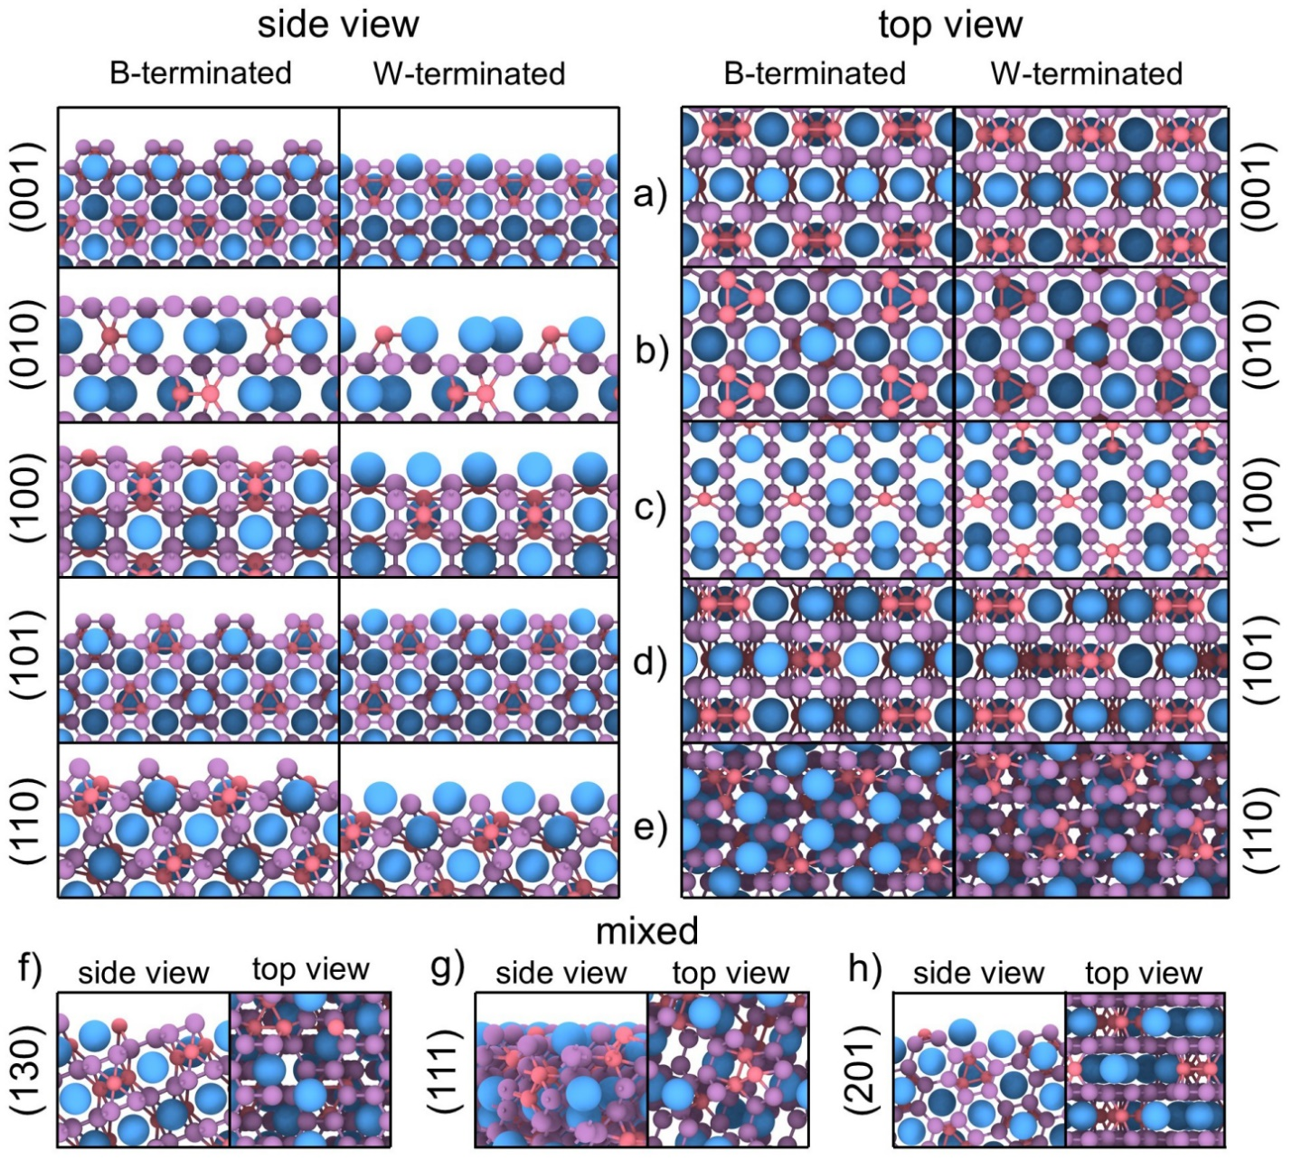
Figure S1. Schematic side and top views of considered surfaces of WB₅, namely a) (001), b) (010), c) (100), d) (110), e) (101), f) (111), g) (130), and h) (201). For all surfaces except the mixed ones both terminations with W and B atoms are shown. Tungsten atoms are shown by big blue balls, while boron atoms are shown by small pink and orange balls corresponding to atoms of hexagonal layer and boron triangles respectively.
For each of considered surfaces we have calculated the surface energy presented in Table S1.
We considered here the surfaces cut from the WB₅ single crystal of Pmmn space group, predicted to be stable and comprehensively studied earlier^{11,20,32}. Slabs of various crystallographic orientations constructed, with thickness 10-16 Å. The (001), (010), (100), (110), (101), (111), (130), and (201) surfaces were constructed for further consideration. For each of (001), (010), (100), (110), (101), two slabs were considered having either B or W termination. Structural information about considered surfaces and descriptions of each surface are presented in the Table S1 and Figure S1.
This data was used in the Wulff construction, for the thermodynamic equilibrium crystal shape at its minimized surface energy³⁷. We note that for low symmetry crystals Eq. (1) fails and, moreover, surface energy γ is fundamentally undefinable; but recent theory shows how to circumvent the energy gauge invariance, and to predict crystal morphology, even with unknowable surface energy⁴⁰. The Wulff construction identifies surfaces composition that would be more exposed and the shape of a WB₅ single crystal, as shown in Fig. S2.
In order to get more information about the stable surfaces and shape of the considered crystals, the influence of the chemical potential was considered by Eq. (2). It should be noted that the shape with μ(B)=-6.89 eV could be obtained only by synthesis with excess amount of tungsten, however these conditions are impossible because WB₅ phase could be synthesized only in case of excess amount of boron, otherwise the WB₂ phase would be obtained. Therefore, the phase with μ(B)= -6.68 eV is the closest to reality and would be used for further investigation.

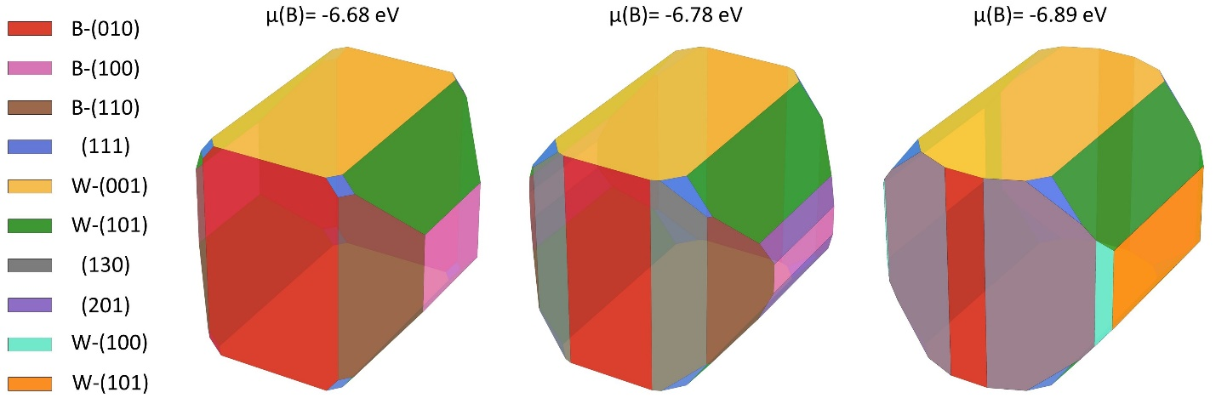
Figure S2. Wulff constructions of WB₅ single crystal with denoted stable surfaces. Tungsten atoms are shown by big blue balls, while boron atoms are small pink balls.

It should be noted that many of the stable surfaces have similar percent from whole surface area of a crystal: B-(010) – 27.74%, W-(101) – 22.01%, B-(110) – 21.02%, W-(001) – 20.81%, B-(100) – 5.59%, and mixed (111) – 2.83%. In the present study, we considered two surfaces with the highest area. No stable reconstructions were found for these surfaces, which is rational given the honeycomb-like boron structures of the B-(010) surface are very stable and the W-(101) surface is flat enough to be stable. The W-(101) surface contains a high concentration of tungsten atoms and may be more active. However, it is important to consider the surface with high boron content to determine the influence of the boron sublattice on the adsorption and reaction processes. Additionally, the boron content on the surface has a positive effect on the activity in HER and CO₂ reduction reactions. Therefore, the B-(010) surface could be a potential catalyst for the CO oxidation process.

Energy barriers of adsorption of O₂ and CO on surfaces of WB₅
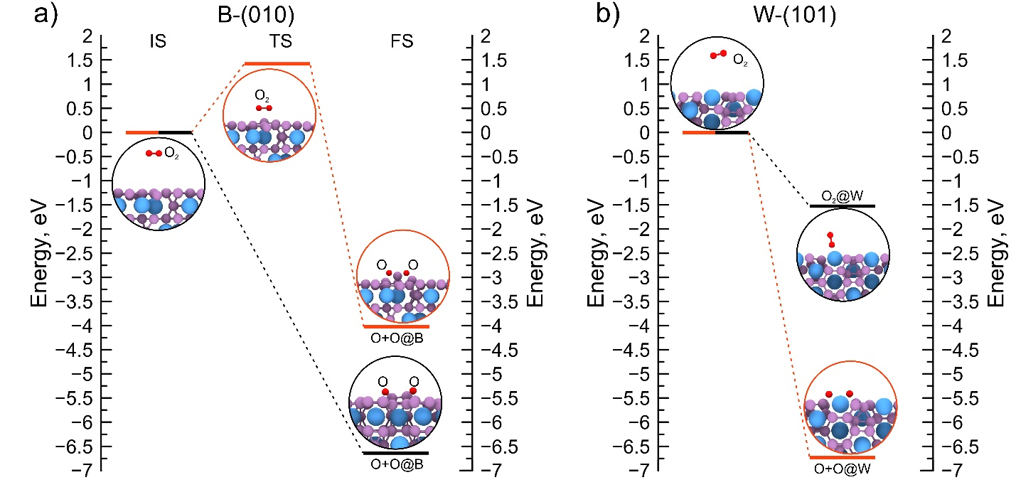
Figure S3. Energy barriers for adsorption of O₂ molecule on the a) B-(010) and b) W-(101) surfaces. Two possible pathways for each surface are shown by black and red colors

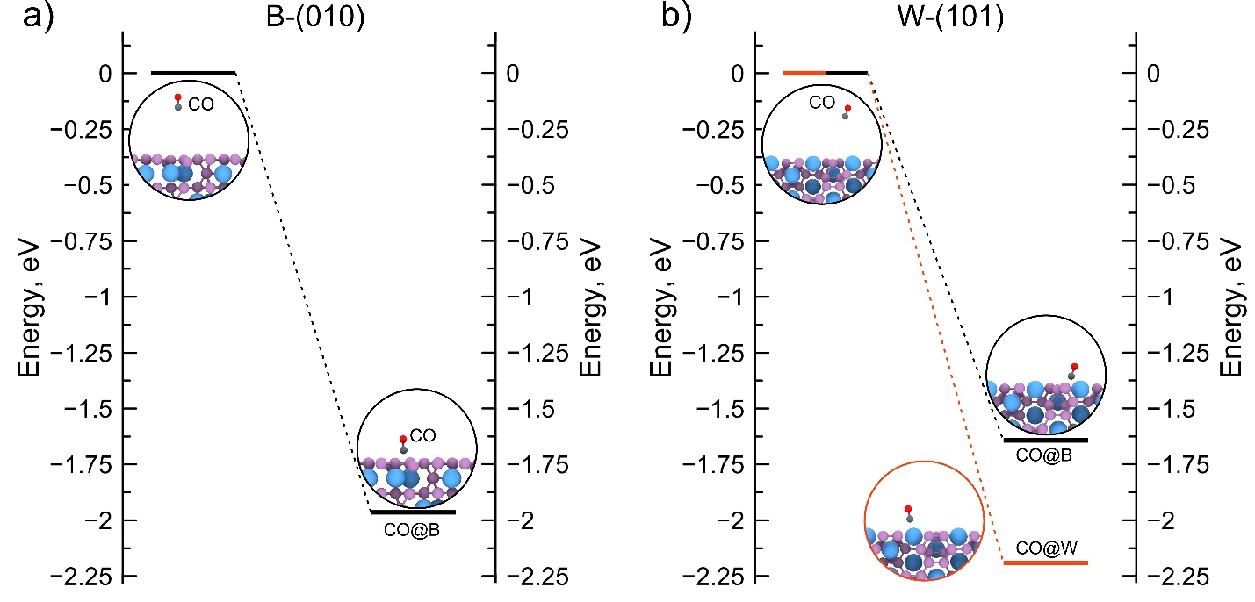
Figure S4. Energy barriers for adsorption of CO molecule on the a) B-(010) and b) W-(101) surfaces. The only barrierless option is shown for B-(010). while two possible pathways are shown by black and red colors for W-(101) surface.

Adsorption sites and energies
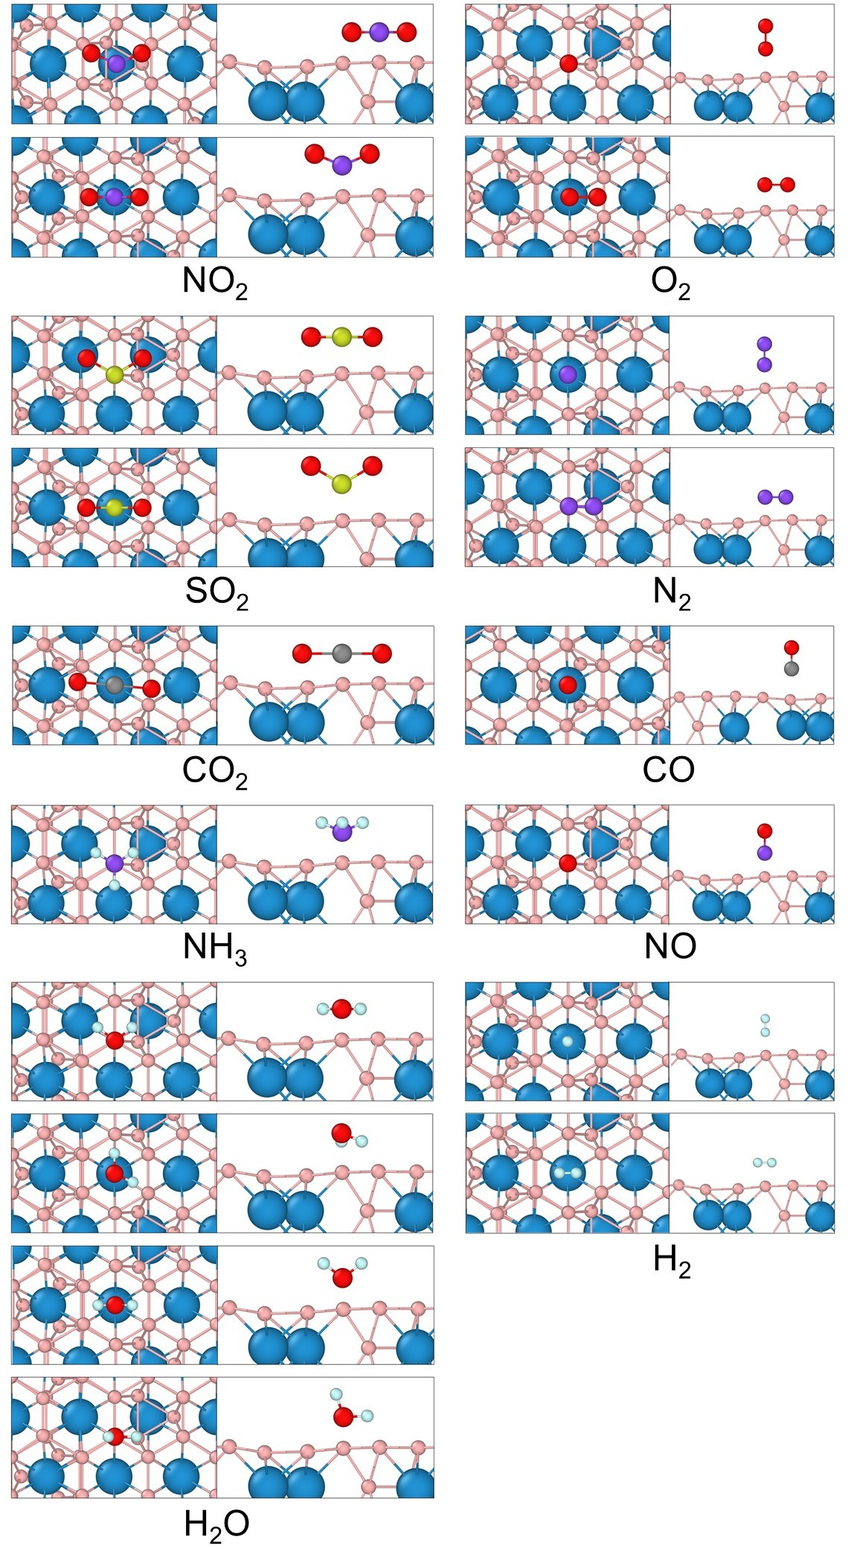
Figure S5. Possible adsorption configurations of the different molecules.

Table S2. Adsorption energies and sites of considered molecules on the surface B-(010) of WB_{5-x}. Atomic structure of each configuration can be found at GitHub (https://github.com/AlexanderKvashnin/WB5_surfaces.git) using the filename
Molecule | № sample | Filename |  | E_{ads}
Molecule | № sample | Input | Output | E_{ads}
CO | 1 | CO_1_010_start.vasp | CO_1_010_end.vasp | -1.917
CO | 2 | CO_2_010_start.vasp | CO_2_010_end.vasp | -1.968
CO | 3 | CO_3_010_start.vasp | CO_3_010_end.vasp | -1.970
CO | 4 | CO_4_010_start.vasp | CO_4_010_end.vasp | -2.255
CO | 5 | CO_5_010_start.vasp | CO_5_010_end.vasp | -2.066
CO | 6 | CO_6_010_start.vasp | CO_6_010_end.vasp | -2.060
CO | 7 | CO_7_010_start.vasp | CO_7_010_end.vasp | -1.829
CO₂ | 1 | CO2_1_010_start.vasp | CO2_1_010_end.vasp | -0.243
CO₂ | 2 | CO2_2_010_start.vasp | CO2_2_010_end.vasp | 0.739
CO₂ | 3 | CO2_3_010_start.vasp | CO2_3_010_end.vasp | 0.734
CO₂ | 4 | CO2_4_010_start.vasp | CO2_4_010_end.vasp | -0.201
CO₂ | 5 | CO2_5_010_start.vasp | CO2_5_010_end.vasp | -1.797
CO₂ | 6 | CO2_6_010_start.vasp | CO2_6_010_end.vasp | -0.809
CO₂ | 7 | CO2_7_010_start.vasp | CO2_7_010_end.vasp | -1.931
CO₂ | 8 | CO2_8_010_start.vasp | CO2_8_010_end.vasp | -0.872
CO₂ | 9 | CO2_9_010_start.vasp | CO2_9_010_end.vasp | -1.923
CO₂ | 10 | CO2_10_010_start.vasp | CO2_10_010_end.vasp | 2.780
CO₂ | 11 | CO2_11_010_start.vasp | CO2_11_010_end.vasp | -0.796
CO₂ | 12 | CO2_12_010_start.vasp | CO2_12_010_end.vasp | -2.037
CO₂ | 13 | CO2_13_010_start.vasp | CO2_13_010_end.vasp | -0.308
CO₂ | 14 | CO2_14_010_start.vasp | CO2_14_010_end.vasp | 3.978
CO₂ | 15 | CO2_15_010_start.vasp | CO2_15_010_end.vasp | -0.799
CO₂ | 16 | CO2_16_010_start.vasp | CO2_16_010_end.vasp | -0.536
CO₂ | 17 | CO2_17_010_start.vasp | CO2_17_010_end.vasp | 0.707
CO₂ | 18 | CO2_18_010_start.vasp | CO2_18_010_end.vasp | -0.105
CO₂ | 19 | CO2_19_010_start.vasp | CO2_19_010_end.vasp | -0.750
CO₂ | 20 | CO2_20_010_start.vasp | CO2_20_010_end.vasp | -0.583
CO₂ | 21 | CO2_21_010_start.vasp | CO2_21_010_end.vasp | -0.564
CO₂ | 22 | CO2_22_010_start.vasp | CO2_22_010_end.vasp | -0.489
CO₂ | 23 | CO2_23_010_start.vasp | CO2_23_010_end.vasp | -0.377
CO₂ | 24 | CO2_24_010_start.vasp | CO2_24_010_end.vasp | -0.539
CO₂ | 25 | CO2_25_010_start.vasp | CO2_25_010_end.vasp | 0.794
CO₂ | 26 | CO2_26_010_start.vasp | CO2_26_010_end.vasp | -1.760
CO₂ | 27 | CO2_27_010_start.vasp | CO2_27_010_end.vasp | -0.540
CO₂ | 28 | CO2_28_010_start.vasp | CO2_28_010_end.vasp | -0.548
H₂ | 1 | H2_1_010_start.vasp | H2_1_010_end.vasp | -4.928
H₂ | 2 | H2_2_010_start.vasp | H2_2_010_end.vasp | -4.583
H₂ | 3 | H2_3_010_start.vasp | H2_3_010_end.vasp | -4.630
H₂ | 4 | H2_4_010_start.vasp | H2_4_010_end.vasp | -4.942
H₂ | 5 | H2_5_010_start.vasp | H2_5_010_end.vasp | -4.960
H₂ | 6 | H2_6_010_start.vasp | H2_6_010_end.vasp | -4.580
H₂ | 7 | H2_7_010_start.vasp | H2_7_010_end.vasp | -4.921
H₂ | 8 | H2_8_010_start.vasp | H2_8_010_end.vasp | -6.380
H₂ | 9 | H2_9_010_start.vasp | H2_9_010_end.vasp | -7.415
H₂ | 10 | H2_10_010_start.vasp | H2_10_010_end.vasp | -4.586
H₂ | 11 | H2_11_010_start.vasp | H2_11_010_end.vasp | -4.627
H₂ | 12 | H2_12_010_start.vasp | H2_12_010_end.vasp | -7.371
H₂ | 13 | H2_13_010_start.vasp | H2_13_010_end.vasp | -6.298
H₂ | 14 | H2_14_010_start.vasp | H2_14_010_end.vasp | -6.691
H₂ | 15 | H2_15_010_start.vasp | H2_15_010_end.vasp | -4.988
H₂ | 16 | H2_16_010_start.vasp | H2_16_010_end.vasp | -6.313
H₂ | 17 | H2_17_010_start.vasp | H2_17_010_end.vasp | -7.035
H₂ | 18 | H2_18_010_start.vasp | H2_18_010_end.vasp | -6.431
O₂ | 1 | O2_1_010_start.vasp | O2_1_010_end.vasp | -6.499
O₂ | 2 | O2_2_010_start.vasp | O2_2_010_end.vasp | -3.995
O₂ | 3 | O2_3_010_start.vasp | O2_3_010_end.vasp | 1.532
O₂ | 4 | O2_4_010_start.vasp | O2_4_010_end.vasp | -2.689
O₂ | 5 | O2_5_010_start.vasp | O2_5_010_end.vasp | -4.709
O₂ | 6 | O2_6_010_start.vasp | O2_6_010_end.vasp | -3.809
O₂ | 7 | O2_7_010_start.vasp | O2_7_010_end.vasp | 0.775
O₂ | 8 | O2_8_010_start.vasp | O2_8_010_end.vasp | -5.697
O₂ | 9 | O2_9_010_start.vasp | O2_9_010_end.vasp | -5.894
O₂ | 10 | O2_10_010_start.vasp | O2_10_010_end.vasp | -4.309
O₂ | 11 | O2_11_010_start.vasp | O2_11_010_end.vasp | -4.309
O₂ | 12 | O2_12_010_start.vasp | O2_12_010_end.vasp | -4.790
O₂ | 13 | O2_13_010_start.vasp | O2_13_010_end.vasp | -4.867
O₂ | 14 | O2_14_010_start.vasp | O2_14_010_end.vasp | -2.277
O₂ | 15 | O2_15_010_start.vasp | O2_15_010_end.vasp | -2.502
O₂ | 16 | O2_16_010_start.vasp | O2_16_010_end.vasp | -5.404
O₂ | 17 | O2_17_010_start.vasp | O2_17_010_end.vasp | -5.000
O₂ | 18 | O2_18_010_start.vasp | O2_18_010_end.vasp | -4.040
O₂ | 19 | O2_19_010_start.vasp | O2_19_010_end.vasp | -4.040
O₂ | 20 | O2_20_010_start.vasp | O2_20_010_end.vasp | -5.132
O₂ | 21 | O2_21_010_start.vasp | O2_21_010_end.vasp | -5.011
NO | 1 | NO_1_010_start.vasp | NO__010_end.vasp | -9.875
NO | 2 | NO_2_010_start.vasp | NO__010_end.vasp | -8.477
NO | 3 | NO_3_010_start.vasp | NO__010_end.vasp | -9.177
NO | 4 | NO_4_010_start.vasp | NO__010_end.vasp | -9.750
NO | 5 | NO_5_010_start.vasp | NO__010_end.vasp | -9.809
NO | 6 | NO_6_010_start.vasp | NO__010_end.vasp | -9.886
NO | 7 | NO_7_010_start.vasp | NO__010_end.vasp | -8.581
NH₃ | 1 | NH3_1_010_start.vasp | NH3_1_010_end.vasp | -1.327
NH₃ | 1.1 | NH3_1-1_010_start.vasp | NH3_1-1_010_end.vasp | -1.532
NH₃ | 2 | NH3_2_010_start.vasp | NH3_2_010_end.vasp | -0.542
NH₃ | 3 | NH3_3_010_start.vasp | NH3_3_010_end.vasp | -0.493
NH₃ | 4 | NH3_4_010_start.vasp | NH3_4_010_end.vasp | -2.088
NH₃ | 5 | NH3_5_010_start.vasp | NH3_5_010_end.vasp | -2.090
NH₃ | 6 | NH3_6_010_start.vasp | NH3_6_010_end.vasp | -0.358
NH₃ | 7 | NH3_7_010_start.vasp | NH3_7_010_end.vasp | -1.856
N₂ | 1 | N2_1_010_start.vasp | N2_1_010_end.vasp | 0.123
N₂ | 2 | N2_2_010_start.vasp | N2_2_010_end.vasp | -0.041
N₂ | 3 | N2_3_010_start.vasp | N2_3_010_end.vasp | -0.128
N₂ | 4 | N2_4_010_start.vasp | N2_4_010_end.vasp | -0.838
N₂ | 5 | N2_5_010_start.vasp | N2_5_010_end.vasp | -0.681
N₂ | 6 | N2_6_010_start.vasp | N2_6_010_end.vasp | -0.079
N₂ | 7 | N2_7_010_start.vasp | N2_7_010_end.vasp | -0.482
N₂ | 8 | N2_8_010_start.vasp | N2_8_010_end.vasp | -0.377
N₂ | 8.1 | N2_8-1_010_start.vasp | N2_8-1_010_end.vasp | -0.051
N₂ | 9 | N2_9_010_start.vasp | N2_9_010_end.vasp | -0.818
N₂ | 9.1 | N2_9-1_010_start.vasp | N2_9-1_010_end.vasp | 0.414
N₂ | 10 | N2_10_010_start.vasp | N2_10_010_end.vasp | 0.400
N₂ | 11 | N2_11_010_start.vasp | N2_11_010_end.vasp | -0.039
N₂ | 12 | N2_12_010_start.vasp | N2_12_010_end.vasp | 0.297
N₂ | 13 | N2_13_010_start.vasp | N2_13_010_end.vasp | -0.131
N₂ | 14 | N2_14_010_start.vasp | N2_14_010_end.vasp | -0.770
N₂ | 15 | N2_15_010_start.vasp | N2_15_010_end.vasp | -0.497
N₂ | 16 | N2_16_010_start.vasp | N2_16_010_end.vasp | -0.491
N₂ | 17 | N2_17_010_start.vasp | N2_17_010_end.vasp | -0.500
N₂ | 18 | N2_18_010_start.vasp | N2_18_010_end.vasp | 0.625
N₂ | 19 | N2_19_010_start.vasp | N2_19_010_end.vasp | 0.570
N₂ | 20 | N2_20_010_start.vasp | N2_20_010_end.vasp | 0.411
N₂ | 21 | N2_21_010_start.vasp | N2_21_010_end.vasp | 1.085
NO₂ | 1 | NO2_1_010_start.vasp | NO2_1_010_end.vasp | -1.329
NO₂ | 2 | NO2_2_010_start.vasp | NO2_2_010_end.vasp | -1.250
NO₂ | 3 | NO2_3_010_start.vasp | NO2_3_010_end.vasp | -4.575
NO₂ | 4 | NO2_4_010_start.vasp | NO2_4_010_end.vasp | -5.592
NO₂ | 5 | NO2_5_010_start.vasp | NO2_5_010_end.vasp | -4.315
NO₂ | 6 | NO2_6_010_start.vasp | NO2_6_010_end.vasp | -7.673
NO₂ | 7 | NO2_7_010_start.vasp | NO2_7_010_end.vasp | -7.830
NO₂ | 8 | NO2_8_010_start.vasp | NO2_8_010_end.vasp | -7.166
NO₂ | 9 | NO2_9_010_start.vasp | NO2_9_010_end.vasp | -6.919
NO₂ | 10 | NO2_10_010_start.vasp | NO2_10_010_end.vasp | -4.094
NO₂ | 11 | NO2_11_010_start.vasp | NO2_11_010_end.vasp | -5.080
NO₂ | 12 | NO2_12_010_start.vasp | NO2_12_010_end.vasp | -5.075
NO₂ | 13 | NO2_13_010_start.vasp | NO2_13_010_end.vasp | -7.611
NO₂ | 14 | NO2_14_010_start.vasp | NO2_14_010_end.vasp | -4.781
NO₂ | 15 | NO2_15_010_start.vasp | NO2_15_010_end.vasp | -2.267
NO₂ | 16 | NO2_16_010_start.vasp | NO2_16_010_end.vasp | -1.821
NO₂ | 17 | NO2_17_010_start.vasp | NO2_17_010_end.vasp | 0.070
NO₂ | 18 | NO2_18_010_start.vasp | NO2_18_010_end.vasp | -0.251
NO₂ | 19 | NO2_19_010_start.vasp | NO2_19_010_end.vasp | -2.771
NO₂ | 20 | NO2_20_010_start.vasp | NO2_20_010_end.vasp | -4.472
NO₂ | 21 | NO2_21_010_start.vasp | NO2_21_010_end.vasp | -2.237
NO₂ | 22 | NO2_22_010_start.vasp | NO2_22_010_end.vasp | -2.529
NO₂ | 23 | NO2_23_010_start.vasp | NO2_23_010_end.vasp | -1.341
NO₂ | 24 | NO2_24_010_start.vasp | NO2_24_010_end.vasp | -2.854
NO₂ | 25 | NO2_25_010_start.vasp | NO2_25_010_end.vasp | -0.802
NO₂ | 26 | NO2_26_010_start.vasp | NO2_26_010_end.vasp | -3.007
NO₂ | 27 | NO2_27_010_start.vasp | NO2_27_010_end.vasp | -2.181
NO₂ | 28 | NO2_28_010_start.vasp | NO2_28_010_end.vasp | -0.845
H₂O | 1 | H2O_1_010_start.vasp | H2O_1_010_end.vasp | -0.366
H₂O | 1.1 | H2O_1-1_010_start.vasp | H2O_1-1_010_end.vasp | 1.122
H₂O | 2 | H2O_2_010_start.vasp | H2O_2_010_end.vasp | -1.520
H₂O | 2.1 | H2O_2-1_010_start.vasp | H2O_2-1_010_end.vasp | -0.527
H₂O | 3 | H2O_3_010_start.vasp | H2O_3_010_end.vasp | -0.487
H₂O | 4 | H2O_4_010_start.vasp | H2O_4_010_end.vasp | -0.614
H₂O | 5 | H2O_5_010_start.vasp | H2O_5_010_end.vasp | -0.660
H₂O | 6 | H2O_6_010_start.vasp | H2O_6_010_end.vasp | -2.530
H₂O | 7 | H2O_7_010_start.vasp | H2O_7_010_end.vasp | -2.384
H₂O | 8 | H2O_8_010_start.vasp | H2O_8_010_end.vasp | -1.162
H₂O | 9 | H2O_9_010_start.vasp | H2O_9_010_end.vasp | -0.991
H₂O | 10 | H2O_10_010_start.vasp | H2O_10_010_end.vasp | -1.307
H₂O | 11 | H2O_11_010_start.vasp | H2O_11_010_end.vasp | -0.519
H₂O | 12 | H2O_12_010_start.vasp | H2O_12_010_end.vasp | -0.547
H₂O | 13 | H2O_13_010_start.vasp | H2O_13_010_end.vasp | -1.848
H₂O | 14 | H2O_14_010_start.vasp | H2O_14_010_end.vasp | -1.013
H₂O | 15 | H2O_15_010_start.vasp | H2O_15_010_end.vasp | -0.539
H₂O | 16 | H2O_16_010_start.vasp | H2O_16_010_end.vasp | -1.520
H₂O | 17 | H2O_17_010_start.vasp | H2O_17_010_end.vasp | -0.512
H₂O | 18 | H2O_18_010_start.vasp | H2O_18_010_end.vasp | -0.579
H₂O | 19 | H2O_19_010_start.vasp | H2O_19_010_end.vasp | -0.646
H₂O | 20 | H2O_20_010_start.vasp | H2O_20_010_end.vasp | -0.711
H₂O | 21 | H2O_21_010_start.vasp | H2O_21_010_end.vasp | -0.790
H₂O | 22 | H2O_22_010_start.vasp | H2O_22_010_end.vasp | -1.159
H₂O | 23 | H2O_23_010_start.vasp | H2O_23_010_end.vasp | -1.164
H₂O | 24 | H2O_24_010_start.vasp | H2O_24_010_end.vasp | -1.306
H₂O | 25 | H2O_25_010_start.vasp | H2O_25_010_end.vasp | -0.521
H₂O | 26 | H2O_26_010_start.vasp | H2O_26_010_end.vasp | -0.542
H₂O | 27 | H2O_27_010_start.vasp | H2O_27_010_end.vasp | -0.525
H₂O | 28 | H2O_28_010_start.vasp | H2O_28_010_end.vasp | -1.282
H₂O | 29 | H2O_29_010_start.vasp | H2O_29_010_end.vasp | -0.581
H₂O | 30 | H2O_30_010_start.vasp | H2O_30_010_end.vasp | -0.594
H₂O | 31 | H2O_31_010_start.vasp | H2O_31_010_end.vasp | -0.607
H₂O | 32 | H2O_32_010_start.vasp | H2O_32_010_end.vasp | -0.201
H₂O | 33 | H2O_33_010_start.vasp | H2O_33_010_end.vasp | -0.716
H₂O | 34 | H2O_34_010_start.vasp | H2O_34_010_end.vasp | -0.342
H₂O | 35 | H2O_35_010_start.vasp | H2O_35_010_end.vasp | -0.691
H₂O | 36 | H2O_36_010_start.vasp | H2O_36_010_end.vasp | -1.118
H₂O | 37 | H2O_37_010_start.vasp | H2O_37_010_end.vasp | -1.148
H₂O | 38 | H2O_38_010_start.vasp | H2O_38_010_end.vasp | -1.306
H₂O | 39 | H2O_39_010_start.vasp | H2O_39_010_end.vasp | -0.682
H₂O | 40 | H2O_40_010_start.vasp | H2O_40_010_end.vasp | -0.079
H₂O | 41 | H2O_41_010_start.vasp | H2O_41_010_end.vasp | -0.512
H₂O | 42 | H2O_42_010_start.vasp | H2O_42_010_end.vasp | -1.063
H₂O | 43 | H2O_43_010_start.vasp | H2O_43_010_end.vasp | -0.515
H₂O | 43.1 | H2O_43-1_010_start.vasp | H2O_43-1_010_end.vasp | -0.528
H₂O | 44 | H2O_44_010_start.vasp | H2O_44_010_end.vasp | -1.041
H₂O | 44.1 | H2O_44-1_010_start.vasp | H2O_44-1_010_end.vasp | -0.463
H₂O | 45 | H2O_45_010_start.vasp | H2O_45_010_end.vasp | -0.576
H₂O | 46 | H2O_46_010_start.vasp | H2O_46_010_end.vasp | -0.264
H₂O | 47 | H2O_47_010_start.vasp | H2O_47_010_end.vasp | -0.696
H₂O | 48 | H2O_48_010_start.vasp | H2O_48_010_end.vasp | -2.226
H₂O | 49 | H2O_49_010_start.vasp | H2O_49_010_end.vasp | -2.484
H₂O | 50 | H2O_50_010_start.vasp | H2O_50_010_end.vasp | -1.087
H₂O | 51 | H2O_51_010_start.vasp | H2O_51_010_end.vasp | -1.165
H₂O | 52 | H2O_52_010_start.vasp | H2O_52_010_end.vasp | -1.304
H₂O | 52.1 | H2O_52-1_010_start.vasp | H2O_52-1_010_end.vasp | -1.296
H₂O | 53 | H2O_53_010_start.vasp | H2O_53_010_end.vasp | -0.537
H₂O | 54 | H2O_54_010_start.vasp | H2O_54_010_end.vasp | -0.212
H₂O | 55 | H2O_55_010_start.vasp | H2O_55_010_end.vasp | -1.276
H₂O | 56 | H2O_56_010_start.vasp | H2O_56_010_end.vasp | -1.281
H₂O | 56.1 | H2O_56-1_010_start.vasp | H2O_56-1_010_end.vasp | -0.530
SO₂ | 1 | SO2_1_010_start.vasp | SO2_1_010_end.vasp | 1.809
SO₂ | 1.1 | SO2_2_010_start.vasp | SO2_2_010_end.vasp | 0.545
SO₂ | 2 | SO2_3_010_start.vasp | SO2_3_010_end.vasp | 1.362
SO₂ | 2.1 | SO2_4_010_start.vasp | SO2_4_010_end.vasp | 1.595
SO₂ | 3 | SO2_5_010_start.vasp | SO2_5_010_end.vasp | 2.234
SO₂ | 4 | SO2_6_010_start.vasp | SO2_6_010_end.vasp | -0.237
SO₂ | 5 | SO2_7_010_start.vasp | SO2_7_010_end.vasp | 0.047
SO₂ | 6 | SO2_8_010_start.vasp | SO2_8_010_end.vasp | -2.218
SO₂ | 7 | SO2_9_010_start.vasp | SO2_9_010_end.vasp | 1.303
SO₂ | 8 | SO2_10_010_start.vasp | SO2_10_010_end.vasp | -0.732
SO₂ | 9 | SO2_11_010_start.vasp | SO2_11_010_end.vasp | 1.458
SO₂ | 10 | SO2_12_010_start.vasp | SO2_12_010_end.vasp | -0.067
SO₂ | 11 | SO2_13_010_start.vasp | SO2_13_010_end.vasp | -1.103
SO₂ | 12 | SO2_14_010_start.vasp | SO2_14_010_end.vasp | -2.009
SO₂ | 13 | SO2_15_010_start.vasp | SO2_15_010_end.vasp | 2.207
SO₂ | 14 | SO2_16_010_start.vasp | SO2_16_010_end.vasp | 1.536
SO₂ | 15 | SO2_17_010_start.vasp | SO2_17_010_end.vasp | 2.010
SO₂ | 16 | SO2_18_010_start.vasp | SO2_18_010_end.vasp | 1.722
SO₂ | 17 | SO2_19_010_start.vasp | SO2_19_010_end.vasp | 2.465
SO₂ | 18 | SO2_20_010_start.vasp | SO2_20_010_end.vasp | 2.379
SO₂ | 19 | SO2_21_010_start.vasp | SO2_21_010_end.vasp | 2.303
SO₂ | 20 | SO2_22_010_start.vasp | SO2_22_010_end.vasp | 1.529
SO₂ | 21 | SO2_23_010_start.vasp | SO2_23_010_end.vasp | 1.906
SO₂ | 22 | SO2_24_010_start.vasp | SO2_24_010_end.vasp | 1.943
SO₂ | 23 | SO2_25_010_start.vasp | SO2_25_010_end.vasp | 1.715
SO₂ | 24 | SO2_26_010_start.vasp | SO2_26_010_end.vasp | 1.334
SO₂ | 25 | SO2_27_010_start.vasp | SO2_27_010_end.vasp | 2.453
SO₂ | 26 | SO2_28_010_start.vasp | SO2_28_010_end.vasp | 2.374
SO₂ | 27 | SO2_29_010_start.vasp | SO2_29_010_end.vasp | 1.935
SO₂ | 28 | SO2_30_010_start.vasp | SO2_30_010_end.vasp | 2.029

Table S3. Adsorption energies and sites of considered molecules on the surface W-(101) of WB_{5-x}. Atomic structure of each configuration can be found at GitHub (https://github.com/AlexanderKvashnin/WB5_surfaces.git) using the filename
Molecule | № sample | Filename |  | E_{ads}
Molecule | № sample | Input | Output | E_{ads}
CO | 1 | CO_1_101_start.vasp | CO_1_101_end.vasp | -2.683
CO | 2 | CO_2_101_start.vasp | CO_2_101_end.vasp | -1.415
CO | 3 | CO_3_101_start.vasp | CO_3_101_end.vasp | -2.680
CO | 4 | CO_4_101_start.vasp | CO_4_101_end.vasp | -2.686
CO | 5 | CO_5_101_start.vasp | CO_5_101_end.vasp | -0.804
CO | 6 | CO_6_101_start.vasp | CO_6_101_end.vasp | -1.151
CO | 7 | CO_7_101_start.vasp | CO_7_101_end.vasp | -1.245
CO | 8 | CO_8_101_start.vasp | CO_8_101_end.vasp | -1.417
CO | 9 | CO_9_101_start.vasp | CO_9_101_end.vasp | -1.146
CO | 10 | CO_10_101_start.vasp | CO_10_101_end.vasp | -1.339
NH₃ | 1 | NH3_1_101_start.vasp | NH3_1_101_end.vasp | -6.780
NH₃ | 2 | NH3_2_101_start.vasp | NH3_2_101_end.vasp | -5.063
NH₃ | 3 | NH3_3_101_start.vasp | NH3_3_101_end.vasp | -5.055
NH₃ | 4 | NH3_4_101_start.vasp | NH3_4_101_end.vasp | -6.837
NH₃ | 5 | NH3_5_101_start.vasp | NH3_5_101_end.vasp | -5.904
NH₃ | 6 | NH3_6_101_start.vasp | NH3_6_101_end.vasp | -6.641
NH₃ | 7 | NH3_7_101_start.vasp | NH3_7_101_end.vasp | -6.395
NH₃ | 8 | NH3_8_101_start.vasp | NH3_8_101_end.vasp | -6.643
NH₃ | 9 | NH3_9_101_start.vasp | NH3_9_101_end.vasp | -5.087
NH₃ | 10 | NH3_10_101_start.vasp | NH3_10_101_end.vasp | -6.836
N₂ | 1 | N2_1_101_start.vasp | N2_1_101_end.vasp | -1.511
N₂ | 2 | N2_2_101_start.vasp | N2_2_101_end.vasp | -0.078
N₂ | 3 | N2_3_101_start.vasp | N2_3_101_end.vasp | -0.067
N₂ | 4 | N2_4_101_start.vasp | N2_4_101_end.vasp | -1.537
N₂ | 5 | N2_5_101_start.vasp | N2_5_101_end.vasp | 0.217
N₂ | 6 | N2_6_101_start.vasp | N2_6_101_end.vasp | -0.375
N₂ | 7 | N2_7_101_start.vasp | N2_7_101_end.vasp | -0.855
N₂ | 8 | N2_8_101_start.vasp | N2_8_101_end.vasp | -0.078
N₂ | 9 | N2_9_101_start.vasp | N2_9_101_end.vasp | -0.093
N₂ | 10 | N2_10_101_start.vasp | N2_10_101_end.vasp | -0.066
N₂ | 11 | N2_11_101_start.vasp | N2_11_101_end.vasp | -0.514
N₂ | 12 | N2_12_101_start.vasp | N2_12_101_end.vasp | -0.086
N₂ | 13 | N2_13_101_start.vasp | N2_13_101_end.vasp | -0.089
N₂ | 14 | N2_14_101_start.vasp | N2_14_101_end.vasp | -1.529
N₂ | 15 | N2_15_101_start.vasp | N2_15_101_end.vasp | -1.508
N₂ | 16 | N2_16_101_start.vasp | N2_16_101_end.vasp | -0.629
N₂ | 17 | N2_17_101_start.vasp | N2_17_101_end.vasp | -0.628
N₂ | 18 | N2_18_101_start.vasp | N2_18_101_end.vasp | -0.127
N₂ | 19 | N2_19_101_start.vasp | N2_19_101_end.vasp | -0.079
N₂ | 20 | N2_20_101_start.vasp | N2_20_101_end.vasp | 0.906
N₂ | 21 | N2_21_101_start.vasp | N2_21_101_end.vasp | -0.087
N₂ | 22 | N2_22_101_start.vasp | N2_22_101_end.vasp | 0.677
N₂ | 23 | N2_23_101_start.vasp | N2_23_101_end.vasp | 2.024
N₂ | 24 | N2_24_101_start.vasp | N2_24_101_end.vasp | -0.112
N₂ | 25 | N2_25_101_start.vasp | N2_25_101_end.vasp | -0.099
N₂ | 26 | N2_26_101_start.vasp | N2_26_101_end.vasp | -0.090
N₂ | 27 | N2_27_101_start.vasp | N2_27_101_end.vasp | -0.095
N₂ | 28 | N2_28_101_start.vasp | N2_28_101_end.vasp | -0.092
O₂ | 1 | O2_1_101_start.vasp | O2_1_101_end.vasp | -3.657
O₂ | 2 | O2_2_101_start.vasp | O2_2_101_end.vasp | -4.222
O₂ | 3 | O2_3_101_start.vasp | O2_3_101_end.vasp | -3.660
O₂ | 4 | O2_4_101_start.vasp | O2_4_101_end.vasp | -9.935
O₂ | 5 | O2_5_101_start.vasp | O2_5_101_end.vasp | -9.935
O₂ | 6 | O2_6_101_start.vasp | O2_6_101_end.vasp | -9.935
O₂ | 7 | O2_7_101_start.vasp | O2_7_101_end.vasp | -9.178
O₂ | 8 | O2_8_101_start.vasp | O2_8_101_end.vasp | -4.890
O₂ | 9 | O2_9_101_start.vasp | O2_9_101_end.vasp | -9.200
O₂ | 10 | O2_10_101_start.vasp | O2_10_101_end.vasp | -9.521
O₂ | 11 | O2_11_101_start.vasp | O2_11_101_end.vasp | -9.221
O₂ | 12 | O2_12_101_start.vasp | O2_12_101_end.vasp | -9.116
O₂ | 13 | O2_13_101_start.vasp | O2_13_101_end.vasp | -9.976
O₂ | 14 | O2_14_101_start.vasp | O2_14_101_end.vasp | -9.976
O₂ | 15 | O2_15_101_start.vasp | O2_15_101_end.vasp | -9.267
CO₂ | 1 | CO2_1_101_start.vasp | CO2_1_101_end.vasp | 1.200
CO₂ | 2 | CO2_2_101_start.vasp | CO2_2_101_end.vasp | -0.159
CO₂ | 3 | CO2_3_101_start.vasp | CO2_3_101_end.vasp | -1.331
CO₂ | 4 | CO2_4_101_start.vasp | CO2_4_101_end.vasp | -2.531
CO₂ | 5 | CO2_5_101_start.vasp | CO2_5_101_end.vasp | -0.197
CO₂ | 6 | CO2_6_101_start.vasp | CO2_6_101_end.vasp | -2.148
CO₂ | 7 | CO2_7_101_start.vasp | CO2_7_101_end.vasp | -2.082
CO₂ | 8 | CO2_8_101_start.vasp | CO2_8_101_end.vasp | -0.586
CO₂ | 9 | CO2_9_101_start.vasp | CO2_9_101_end.vasp | -0.160
CO₂ | 10 | CO2_10_101_start.vasp | CO2_10_101_end.vasp | -0.195
CO₂ | 11 | CO2_11_101_start.vasp | CO2_11_101_end.vasp | -2.331
CO₂ | 12 | CO2_12_101_start.vasp | CO2_12_101_end.vasp | -2.897
CO₂ | 13 | CO2_13_101_start.vasp | CO2_13_101_end.vasp | -1.983
CO₂ | 14 | CO2_14_101_start.vasp | CO2_14_101_end.vasp | -1.983
CO₂ | 15 | CO2_15_101_start.vasp | CO2_15_101_end.vasp | -0.487
CO₂ | 16 | CO2_16_101_start.vasp | CO2_16_101_end.vasp | -0.073
CO₂ | 17 | CO2_17_101_start.vasp | CO2_17_101_end.vasp | -0.148
CO₂ | 18 | CO2_18_101_start.vasp | CO2_18_101_end.vasp | -0.171
CO₂ | 19 | CO2_19_101_start.vasp | CO2_19_101_end.vasp | -0.114
CO₂ | 20 | CO2_20_101_start.vasp | CO2_20_101_end.vasp | -0.073
CO₂ | 21 | CO2_21_101_start.vasp | CO2_21_101_end.vasp | -0.181
CO₂ | 22 | CO2_22_101_start.vasp | CO2_22_101_end.vasp | -0.102
CO₂ | 23 | CO2_23_101_start.vasp | CO2_23_101_end.vasp | -0.123
CO₂ | 24 | CO2_24_101_start.vasp | CO2_24_101_end.vasp | -0.172
CO₂ | 25 | CO2_25_101_start.vasp | CO2_25_101_end.vasp | -0.157
CO₂ | 26 | CO2_26_101_start.vasp | CO2_26_101_end.vasp | -0.189
CO₂ | 27 | CO2_27_101_start.vasp | CO2_27_101_end.vasp | -0.193
CO₂ | 28 | CO2_28_101_start.vasp | CO2_28_101_end.vasp | -0.121
NO₂ | 1 | NO2_1_101_start.vasp | NO2_1_101_end.vasp | -3.942
NO₂ | 2 | NO2_2_101_start.vasp | NO2_2_101_end.vasp | -2.940
NO₂ | 3 | NO2_3_101_start.vasp | NO2_3_101_end.vasp | -3.023
NO₂ | 4 | NO2_4_101_start.vasp | NO2_4_101_end.vasp | -2.705
NO₂ | 5 | NO2_5_101_start.vasp | NO2_5_101_end.vasp | -2.738
NO₂ | 6 | NO2_6_101_start.vasp | NO2_6_101_end.vasp | -3.403
NO₂ | 7 | NO2_7_101_start.vasp | NO2_7_101_end.vasp | -4.866
NO₂ | 8 | NO2_8_101_start.vasp | NO2_8_101_end.vasp | -3.586
NO₂ | 9 | NO2_9_101_start.vasp | NO2_9_101_end.vasp | -3.023
NO₂ | 10 | NO2_10_101_start.vasp | NO2_10_101_end.vasp | -6.940
NO₂ | 11 | NO2_11_101_start.vasp | NO2_11_101_end.vasp | -3.326
NO₂ | 12 | NO2_12_101_start.vasp | NO2_12_101_end.vasp | -3.283
NO₂ | 13 | NO2_13_101_start.vasp | NO2_13_101_end.vasp | -2.706
NO₂ | 14 | NO2_14_101_start.vasp | NO2_14_101_end.vasp | -2.614
NO₂ | 15 | NO2_15_101_start.vasp | NO2_15_101_end.vasp | -2.707
NO₂ | 16 | NO2_16_101_start.vasp | NO2_16_101_end.vasp | -1.657
NO₂ | 17 | NO2_17_101_start.vasp | NO2_17_101_end.vasp | -1.627
NO₂ | 18 | NO2_18_101_start.vasp | NO2_18_101_end.vasp | -0.490
NO₂ | 19 | NO2_19_101_start.vasp | NO2_19_101_end.vasp | 0.021
NO₂ | 20 | NO2_20_101_start.vasp | NO2_20_101_end.vasp | -1.719
NO₂ | 21 | NO2_21_101_start.vasp | NO2_21_101_end.vasp | -1.720
NO₂ | 22 | NO2_22_101_start.vasp | NO2_22_101_end.vasp | -2.235
NO₂ | 23 | NO2_23_101_start.vasp | NO2_23_101_end.vasp | -1.442
NO₂ | 24 | NO2_24_101_start.vasp | NO2_24_101_end.vasp | -2.537
NO₂ | 25 | NO2_25_101_start.vasp | NO2_25_101_end.vasp | -3.073
NO₂ | 26 | NO2_26_101_start.vasp | NO2_26_101_end.vasp | -2.941
NO₂ | 27 | NO2_27_101_start.vasp | NO2_27_101_end.vasp | -0.369
NO₂ | 28 | NO2_28_101_start.vasp | NO2_28_101_end.vasp | -2.614
NO₂ | 29 | NO2_29_101_start.vasp | NO2_29_101_end.vasp | -2.670
NO₂ | 30 | NO2_30_101_start.vasp | NO2_30_101_end.vasp | -2.707
H₂O | 1 | H2O_1_101_start.vasp | H2O_1_101_end.vasp | -1.292
H₂O | 2 | H2O_2_101_start.vasp | H2O_2_101_end.vasp | -1.136
H₂O | 3 | H2O_3_101_start.vasp | H2O_3_101_end.vasp | -0.216
H₂O | 4 | H2O_4_101_start.vasp | H2O_4_101_end.vasp | -0.168
H₂O | 5 | H2O_5_101_start.vasp | H2O_5_101_end.vasp | -1.303
H₂O | 6 | H2O_6_101_start.vasp | H2O_6_101_end.vasp | -1.351
H₂O | 7 | H2O_7_101_start.vasp | H2O_7_101_end.vasp | -0.178
H₂O | 8 | H2O_8_101_start.vasp | H2O_8_101_end.vasp | -1.180
H₂O | 9 | H2O_9_101_start.vasp | H2O_9_101_end.vasp | -0.216
H₂O | 10 | H2O_10_101_start.vasp | H2O_10_101_end.vasp
H₂O | 11 | H2O_11_101_start.vasp | H2O_11_101_end.vasp | -0.699
H₂O | 12 | H2O_12_101_start.vasp | H2O_12_101_end.vasp | -1.207
H₂O | 13 | H2O_13_101_start.vasp | H2O_13_101_end.vasp | -0.388
H₂O | 14 | H2O_14_101_start.vasp | H2O_14_101_end.vasp | -0.276
H₂O | 15 | H2O_15_101_start.vasp | H2O_15_101_end.vasp | -0.373
H₂O | 16 | H2O_16_101_start.vasp | H2O_16_101_end.vasp | -1.075
H₂O | 17 | H2O_17_101_start.vasp | H2O_17_101_end.vasp | -1.303
H₂O | 18 | H2O_18_101_start.vasp | H2O_18_101_end.vasp | -0.139
H₂O | 19 | H2O_19_101_start.vasp | H2O_19_101_end.vasp | -0.168
H₂O | 20 | H2O_20_101_start.vasp | H2O_20_101_end.vasp | -1.350
H₂O | 21 | H2O_21_101_start.vasp | H2O_21_101_end.vasp | -1.350
H₂O | 22 | H2O_22_101_start.vasp | H2O_22_101_end.vasp | -0.113
H₂O | 23 | H2O_23_101_start.vasp | H2O_23_101_end.vasp | -0.282
H₂O | 24 | H2O_24_101_start.vasp | H2O_24_101_end.vasp | -0.147
H₂O | 25 | H2O_25_101_start.vasp | H2O_25_101_end.vasp
H₂O | 26 | H2O_26_101_start.vasp | H2O_26_101_end.vasp | -0.254
H₂O | 27 | H2O_27_101_start.vasp | H2O_27_101_end.vasp | -0.291
H₂O | 28 | H2O_28_101_start.vasp | H2O_28_101_end.vasp | -0.390
H₂O | 29 | H2O_29_101_start.vasp | H2O_29_101_end.vasp | -0.284
H₂O | 30 | H2O_30_101_start.vasp | H2O_30_101_end.vasp | -0.374
H₂O | 31 | H2O_31_101_start.vasp | H2O_31_101_end.vasp | -1.232
H₂O | 32 | H2O_32_101_start.vasp | H2O_32_101_end.vasp | -1.131
H₂O | 33 | H2O_33_101_start.vasp | H2O_33_101_end.vasp | -0.195
H₂O | 34 | H2O_34_101_start.vasp | H2O_34_101_end.vasp | -0.159
H₂O | 35 | H2O_35_101_start.vasp | H2O_35_101_end.vasp | -0.363
H₂O | 36 | H2O_36_101_start.vasp | H2O_36_101_end.vasp | -1.347
H₂O | 37 | H2O_37_101_start.vasp | H2O_37_101_end.vasp | -0.171
H₂O | 38 | H2O_38_101_start.vasp | H2O_38_101_end.vasp | -1.176
H₂O | 39 | H2O_39_101_start.vasp | H2O_39_101_end.vasp | -0.203
H₂O | 40 | H2O_40_101_start.vasp | H2O_40_101_end.vasp | -0.205
H₂O | 41 | H2O_41_101_start.vasp | H2O_41_101_end.vasp | -1.334
H₂O | 42 | H2O_42_101_start.vasp | H2O_42_101_end.vasp | -1.200
H₂O | 43 | H2O_43_101_start.vasp | H2O_43_101_end.vasp | -0.383
H₂O | 44 | H2O_44_101_start.vasp | H2O_44_101_end.vasp | -0.272
H₂O | 45 | H2O_45_101_start.vasp | H2O_45_101_end.vasp | -0.367
H₂O | 46 | H2O_46_101_start.vasp | H2O_46_101_end.vasp
H₂O | 47 | H2O_47_101_start.vasp | H2O_47_101_end.vasp | -0.182
H₂O | 48 | H2O_48_101_start.vasp | H2O_48_101_end.vasp | -1.149
H₂O | 49 | H2O_49_101_start.vasp | H2O_49_101_end.vasp | -1.153
H₂O | 50 | H2O_50_101_start.vasp | H2O_50_101_end.vasp | -0.155
H₂O | 51 | H2O_51_101_start.vasp | H2O_51_101_end.vasp | -0.210
H₂O | 52 | H2O_52_101_start.vasp | H2O_52_101_end.vasp | -0.174
H₂O | 53 | H2O_53_101_start.vasp | H2O_53_101_end.vasp | -0.197
H₂O | 54 | H2O_54_101_start.vasp | H2O_54_101_end.vasp | -3.324
H₂O | 55 | H2O_55_101_start.vasp | H2O_55_101_end.vasp | -0.251
H₂O | 56 | H2O_56_101_start.vasp | H2O_56_101_end.vasp | -0.185
H₂O | 57 | H2O_57_101_start.vasp | H2O_57_101_end.vasp | -0.161
H₂O | 58 | H2O_58_101_start.vasp | H2O_58_101_end.vasp | -0.298
H₂ | 1 | H2_1_101_start.vasp | H2_1_101_end.vasp | -1.281
H₂ | 2 | H2_2_101_start.vasp | H2_2_101_end.vasp | -0.060
H₂ | 3 | H2_3_101_start.vasp | H2_3_101_end.vasp | -0.066
H₂ | 4 | H2_4_101_start.vasp | H2_4_101_end.vasp | -1.297
H₂ | 5 | H2_5_101_start.vasp | H2_5_101_end.vasp | -0.063
H₂ | 6 | H2_6_101_start.vasp | H2_6_101_end.vasp | -2.119
H₂ | 7 | H2_7_101_start.vasp | H2_7_101_end.vasp | -2.691
H₂ | 8 | H2_8_101_start.vasp | H2_8_101_end.vasp | -0.061
H₂ | 9 | H2_9_101_start.vasp | H2_9_101_end.vasp | -0.043
H₂ | 10 | H2_10_101_start.vasp | H2_10_101_end.vasp | -0.056
H₂ | 11 | H2_10_101_start.vasp | H2_10_101_end.vasp | -1.281
H₂ | 12 | H2_10_101_start.vasp | H2_10_101_end.vasp | -0.065
H₂ | 13 | H2_10_101_start.vasp | H2_10_101_end.vasp | -0.065
H₂ | 14 | H2_10_101_start.vasp | H2_10_101_end.vasp | -1.297
H₂ | 15 | H2_10_101_start.vasp | H2_10_101_end.vasp | -0.061
H₂ | 16 | H2_10_101_start.vasp | H2_10_101_end.vasp | -0.056
H₂ | 17 | H2_10_101_start.vasp | H2_10_101_end.vasp | -0.050
H₂ | 18 | H2_10_101_start.vasp | H2_10_101_end.vasp | -0.072
H₂ | 19 | H2_10_101_start.vasp | H2_10_101_end.vasp | -0.053
H₂ | 20 | H2_10_101_start.vasp | H2_10_101_end.vasp | -0.065
NO | 1 | NO_1_101_start.vasp | NO_1_101_end.vasp | -3.211
NO | 2 | NO_2_101_start.vasp | NO_2_101_end.vasp | -0.648
NO | 3 | NO_3_101_start.vasp | NO_3_101_end.vasp | -0.894
NO | 4 | NO_4_101_start.vasp | NO_4_101_end.vasp | -3.217
NO | 5 | NO_5_101_start.vasp | NO_5_101_end.vasp | -0.385
NO | 6 | NO_6_101_start.vasp | NO_6_101_end.vasp | -1.739
NO | 7 | NO_7_101_start.vasp | NO_7_101_end.vasp | -1.673
NO | 8 | NO_8_101_start.vasp | NO_8_101_end.vasp | -2.144
NO | 9 | NO_9_101_start.vasp | NO_9_101_end.vasp | -1.577
NO | 10 | NO_10_101_start.vasp | NO_10_101_end.vasp | -0.745
SO₂ | 1 | SO2_1_101_start.vasp | SO2_1_101_end.vasp | -3.277
SO₂ | 2 | SO2_2_101_start.vasp | SO2_2_101_end.vasp | -2.066
SO₂ | 3 | SO2_3_101_start.vasp | SO2_3_101_end.vasp | -4.347
SO₂ | 4 | SO2_4_101_start.vasp | SO2_4_101_end.vasp | -6.185
SO₂ | 5 | SO2_5_101_start.vasp | SO2_5_101_end.vasp | -2.591
SO₂ | 6 | SO2_6_101_start.vasp | SO2_6_101_end.vasp | -2.048
SO₂ | 7 | SO2_7_101_start.vasp | SO2_7_101_end.vasp | -3.792
SO₂ | 8 | SO2_8_101_start.vasp | SO2_8_101_end.vasp | -2.083
SO₂ | 9 | SO2_9_101_start.vasp | SO2_9_101_end.vasp | -2.581
SO₂ | 10 | SO2_10_101_start.vasp | SO2_10_101_end.vasp | -1.894
SO₂ | 11 | SO2_11_101_start.vasp | SO2_11_101_end.vasp | -2.088
SO₂ | 12 | SO2_12_101_start.vasp | SO2_12_101_end.vasp | -2.916
SO₂ | 13 | SO2_13_101_start.vasp | SO2_13_101_end.vasp | -5.056
SO₂ | 14 | SO2_14_101_start.vasp | SO2_14_101_end.vasp | -6.013
SO₂ | 15 | SO2_15_101_start.vasp | SO2_15_101_end.vasp | -4.964
SO₂ | 16 | SO2_16_101_start.vasp | SO2_16_101_end.vasp | -1.723
SO₂ | 17 | SO2_17_101_start.vasp | SO2_17_101_end.vasp | -1.664
SO₂ | 18 | SO2_18_101_start.vasp | SO2_18_101_end.vasp | -1.409
SO₂ | 19 | SO2_19_101_start.vasp | SO2_19_101_end.vasp | -0.284
SO₂ | 20 | SO2_20_101_start.vasp | SO2_20_101_end.vasp | -0.234
SO₂ | 21 | SO2_21_101_start.vasp | SO2_21_101_end.vasp | -1.713
SO₂ | 22 | SO2_22_101_start.vasp | SO2_22_101_end.vasp | -0.209
SO₂ | 23 | SO2_23_101_start.vasp | SO2_23_101_end.vasp | -0.181
SO₂ | 24 | SO2_24_101_start.vasp | SO2_24_101_end.vasp | -1.937
SO₂ | 25 | SO2_25_101_start.vasp | SO2_25_101_end.vasp | -0.542
SO₂ | 26 | SO2_26_101_start.vasp | SO2_26_101_end.vasp | -0.625
SO₂ | 27 | SO2_27_101_start.vasp | SO2_27_101_end.vasp | -0.374
SO₂ | 28 | SO2_28_101_start.vasp | SO2_28_101_end.vasp | -0.338
SO₂ | 29 | SO2_29_101_start.vasp | SO2_29_101_end.vasp | -0.229
SO₂ | 30 | SO2_30_101_start.vasp | SO2_30_101_end.vasp | -0.356

References
(1) Kvashnin, A. G.; Rybkovsky, D. V.; Filonenko, V. P.; Bugakov, V. I.; Zibrov, I. P.; Brazhkin, V. V.; Oganov, A. R.; Osiptsov, A. A.; Zakirov, A. Y. WB_{5−x}: Synthesis, Properties, and Crystal Structure—New Insights into the Long-Debated Compound. Advanced Science 2020, 2000775. https://doi.org/10.1002/advs.202000775.

