Supplementary Table 1: Analysis of variance of line × tester mating design for different traits of okra.
Source of Variation | Replications | Parents | Female | Male | Male  Vs.  Female | Crosses | Parents vs. Crosses | Error | Total
df | 2 | 12 | 9 | 2 | 1 | 29 | 1 | 84 | 128
DF | 3.49 | 35.40* | 35.97* | 50.04* | 0.94 | 42.98* | 176.23 | 8.87
FF | 0.52 | 3.45* | 3.86* | 3.20* | 0.26 | 2.45* | 0.32 | 0.24
PH | 4.15 | 1621.12* | 2036.55* | 343.69* | 437.12* | 1619.98* | 1179.09 | 23.20
IL | 0.54 | 29.78* | 38.43* | 4.56* | 2.41 | 21.76* | 1.30 | 0.72
BP | 0.00018 | 1.11* | 0.98* | 2.23* | 0.02 | 0.46* | 0.69 | 0.01
PL | 0.04 | 5.91* | 5.84* | 7.93* | 2.47 | 7.74* | 1.48 | 0.52
PD | 1.25* | 0.06* | 0.06* | 0.07* | 0.08* | 0.05* | 0.06 | 0.00
PP | 2.54 | 45.00* | 33.43* | 97.44* | 44.25 | 31.35* | 102.54 | 6.08
PW | 0.80 | 7.08* | 9.25* | 0.87 | 0.03 | 7.83* | 1.28 | 0.60
PYP | 349.09 | 10468.82* | 10011.10* | 15058.47* | 5409.01 | 8262.42* | 7941.14 | 876.03
FP | 6.78 | 54.01* | 63.54* | 20.33 | 35.57 | 44.09* | 82.64 | 6.53
HD | 6.83 | 69.22* | 76.54* | 70.78* | 0.28 | 75.05* | 20.71 | 12.43
SP | 4.09 | 64.28* | 78.22* | 32.66* | 2.12 | 63.61* | 0.67 | 4.77
SW | 0.0003 | 1.74* | 1.72* | 2.71* | 0.07 | 1.60* | 0.06 | 0.02
DW | 0.001 | 0.16* | 0.15* | 0.22* | 0.15* | 0.10* | 0.06 | 0.001
TS | 0.000017 | 3.07* | 3.73* | 0.78* | 1.64* | 3.45* | 0.38 | 0.000028
TPP | 0.000006 | 0.52* | 0.48* | 0.92* | 0.08* | 0.32* | 0.15 | 0.000047
TP | 0.60 | 56.51* | 43.79* | 41.89* | 200.25* | 114.63* | 74.98 | 0.29
TN | 0.0001 | 1.45* | 1.12* | 1.08* | 5.14* | 2.96* | 1.95 | 0.00034
MC | 0.00013 | 0.06* | 0.07* | 0.04* | 0.02* | 0.03* | 0.02 | 0.0001
*Significant at 5% level of significance.
Where, DF: days to 50 per cent flowering, FF: first flowering node, PH: plant height, IL: inter-nodal distance, BP: number of primary branches per plant, PL: pod length, PD: pod diameter, PP: number of pods per plant, PW: average pod weight, PYP: pod yield per plant, FP: days to first picking, HD: harvest duration, SP: number of seeds per pod, SW: hundred seed weight, DW: average dry weight of pod. TS: total sugars, TPP: total polyphenol, TP: total protein, TN: total nitrogen and MC: mucilage content.

Supplementary Table 2: List of parents and crosses used under current study
Sr. No. | Parents/Crosses |  | Source | Sr. No. | Crosses
1. | UHFO-2 | Lines | Dr Yashwant Singh Parmar University of Horticulture and Forestry, Solan, Himachal Pradesh, India | 23. | UHFO-4 × HU
2. | UHFO-3 | Lines |  | 24. | UHFO-5 × AA
3. | UHFO-4 | Lines |  | 25. | UHFO-5 × PB
4. | UHFO-5 | Lines |  | 26. | UHFO-5 × HU
5. | UHFO-6 | Lines |  | 27. | UHFO-6 × AA
6. | UHFO-7 | Lines |  | 28. | UHFO-6 × PB
7. | UHFO-8 | Lines |  | 29. | UHFO-6 × HU
8. | UHFO-9 | Lines |  | 30. | UHFO-7 × AA
9. | UHFO-10 | Lines |  | 31. | UHFO-7 × PB
10. | UHFO-14 | Lines |  | 32. | UHFO-7 × HU
11. | AA  (Arka Anamika) | Testers | Indian Institute of Horticultural Research (Bengaluru, Karnataka, India) | 33. | UHFO-8 × AA
12. | PB-5  (Pusa Bhindi-5) | Testers | Indian Agricultural Research Institute (New Delhi, India) | 34. | UHFO-8 × PB
13. | HU  (Hisar Unnat) | Testers | CCS Haryana Agricultural University (Hisar, Haryana, India) | 35. | UHFO-8 × HU
14. | P-8 (Punjab-8: Standard Check) |  | Punjab Agricultural University (Ludhiana, Punjab, India) | 36. | UHFO-9 × AA
15. | UHFO-2 × AA |  | - | 37. | UHFO-9 × PB
16. | UHFO-2 × PB |  | - | 38. | UHFO-9 × HU
17. | UHFO-2 × HU |  | - | 39. | UHFO-10 × AA
18. | UHFO-3 × AA |  | - | 40. | UHFO-10 × PB
19. | UHFO-3 × PB |  | - | 41. | UHFO-10 × HU
20. | UHFO-3 × HU |  | - | 42. | UHFO-14 × AA
21. | UHFO-4 × AA |  | - | 43. | UHFO-14 × PB
22. | UHFO-4 × PB |  | - | 44. | UHFO-14 × HU

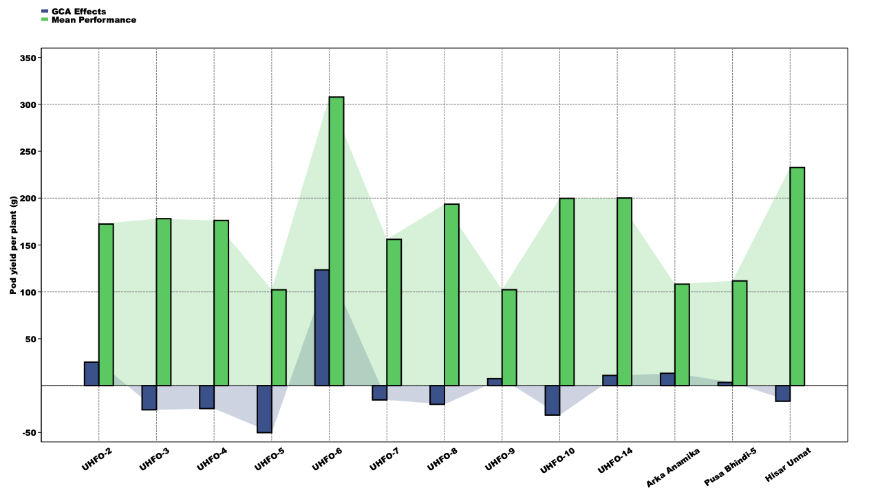Supplementary Figure 1: Graphical representation of GCA effects and mean performance of parents for pod yield per plant
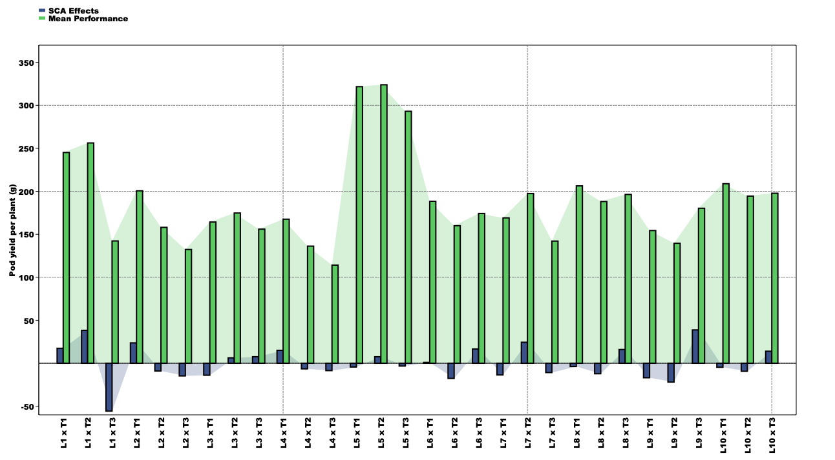
Supplementary Figure 2: Graphical representation of SCA effects and mean performance of hybrids for pod yield per plant.

