Extended data figures
Extended Data Fig. 1 | Patients, samples, and assay.
a, Flow chart depicting patient selection process. b, Distribution of cfDNA inputs in nanograms from the 895 patients included in this study. cfDNA values are log-transformed. c, TMeF distribution plot by sample type (cancer vs non-cancer) of all tested participant sample replicates near LOD95 and all non-cancer sample replicates from the limit of blank study. Color was customized for each participant with cancer and unicolor was applied for all non-cancer participants. d, Targeted methylation-based prognostic assay analytical validation results. Analytical sensitivity at LOD95 (140 replicates from 5 LUAD participants at empirical LOD95 level) and analytical specificity (66 replicates from 62 non-cancer participants) were presented.
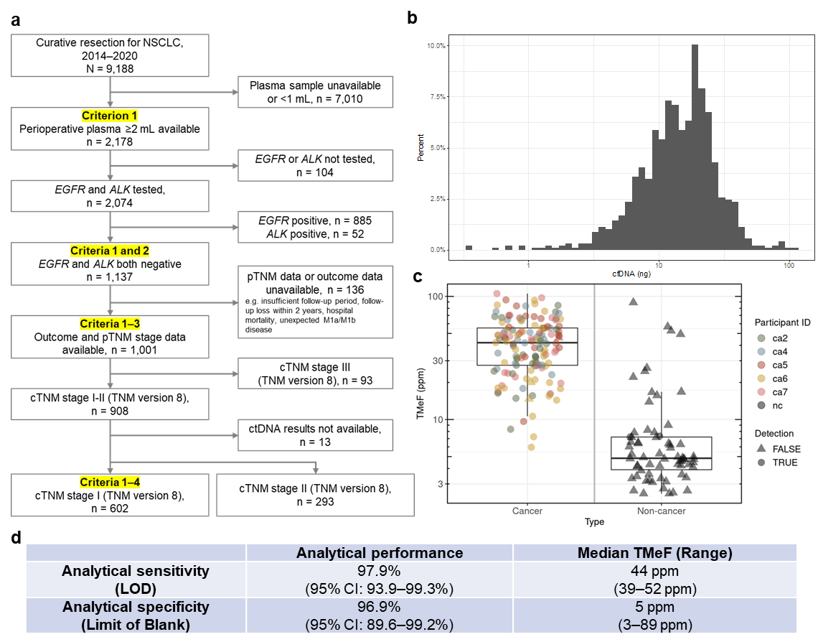
ca, cancer; cfDNA, cell-free DNA; ctDNA, circulating tumor DNA; LOD, limit of detection; LUAD, lung adenocarcinoma; nc, non-cancer; NSCLC, non-small-cell lung cancer; ppm, parts per million; TMeF, tumor methylated fraction; (c)/(p)TNM, (clinical)/(pathologic) tumor-node-metastasis.

Extended Data Fig. 2 | RFS by clinical stage and ctDNA status.
Kaplan–Meier analysis of RFS in clinical stage I LUAD (stratified by ctDNA status) and clinical stage II LUAD (all comers).
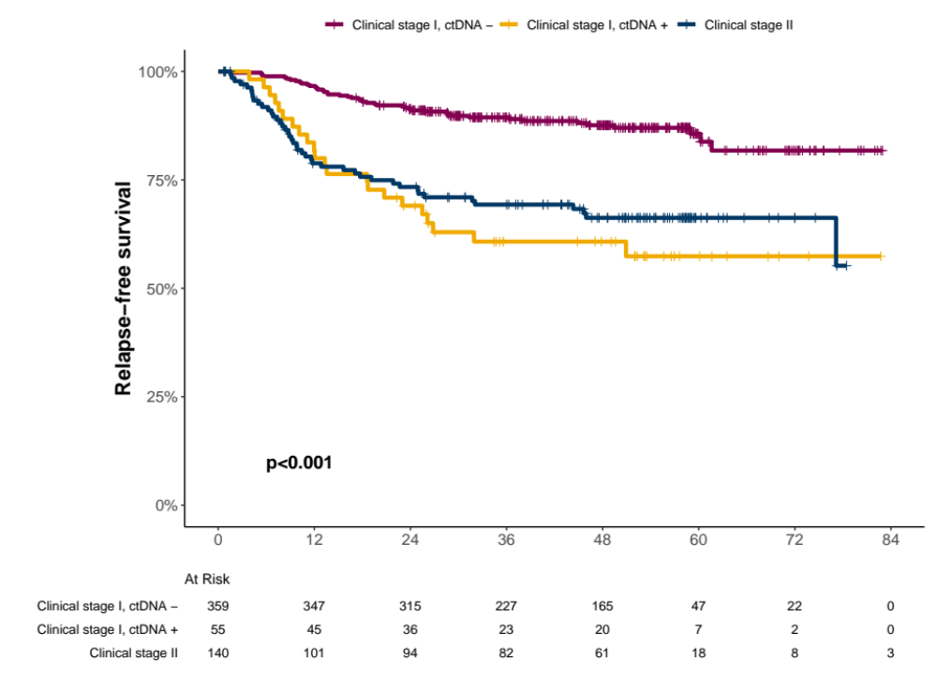
ctDNA, circulating tumor DNA; LUAD, lung adenocarcinoma; RFS, relapse-free survival.

Extended Data Fig. 3 | Pre-surgical ctDNA associations with clinical outcome in clinical stage I or II non-LUAD histologies.
a,b, RFS and c,d, OS were associated with pre-surgical ctDNA status. Of 188 patients with clinical stage I non-LUAD analyzed, 133/188 were ctDNA positive. Of 153 patients with clinical stage II non-LUAD analyzed, 143/153 were ctDNA positive. P-values on Kaplan–Meier graphs represent log-rank P-values. e,f, RFS and g,h, OS were also associated with TMeF level (above or below the median in ctDNA-positive cases, median TMeF = 52 ppm).
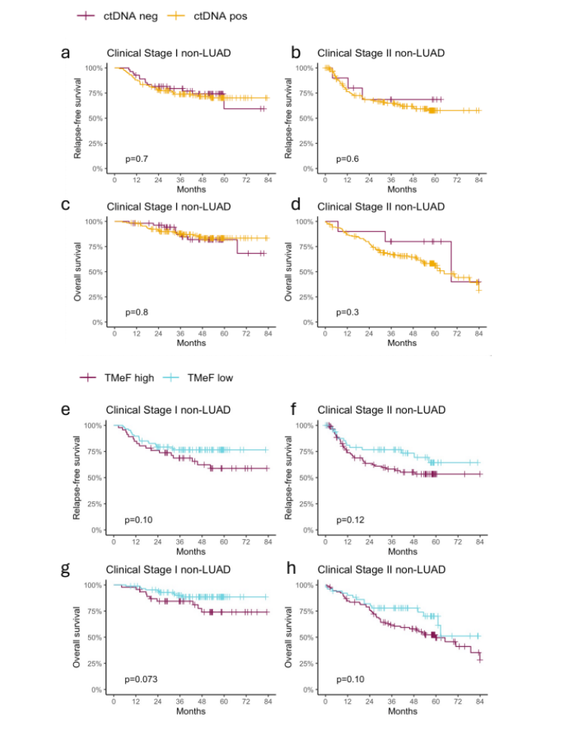
ctDNA, circulating tumor DNA; LUAD, lung adenocarcinoma; OS, overall survival; RFS, relapse-free survival; TMeF, tumor methylated fraction.
Extended Data Fig. 4 | RFS, OS, and clinical stage I patients by histologic grade.
IASLC histologic grade (G1‒3) associations with a, RFS and b, OS in 345 patients with pathologically confirmed stage I invasive LUAD. P-values on Kaplan–Meier graphs represent log-rank P-values. c, Bar chart showing that pre-surgical ctDNA-positive status enriches in grade 3 histology.
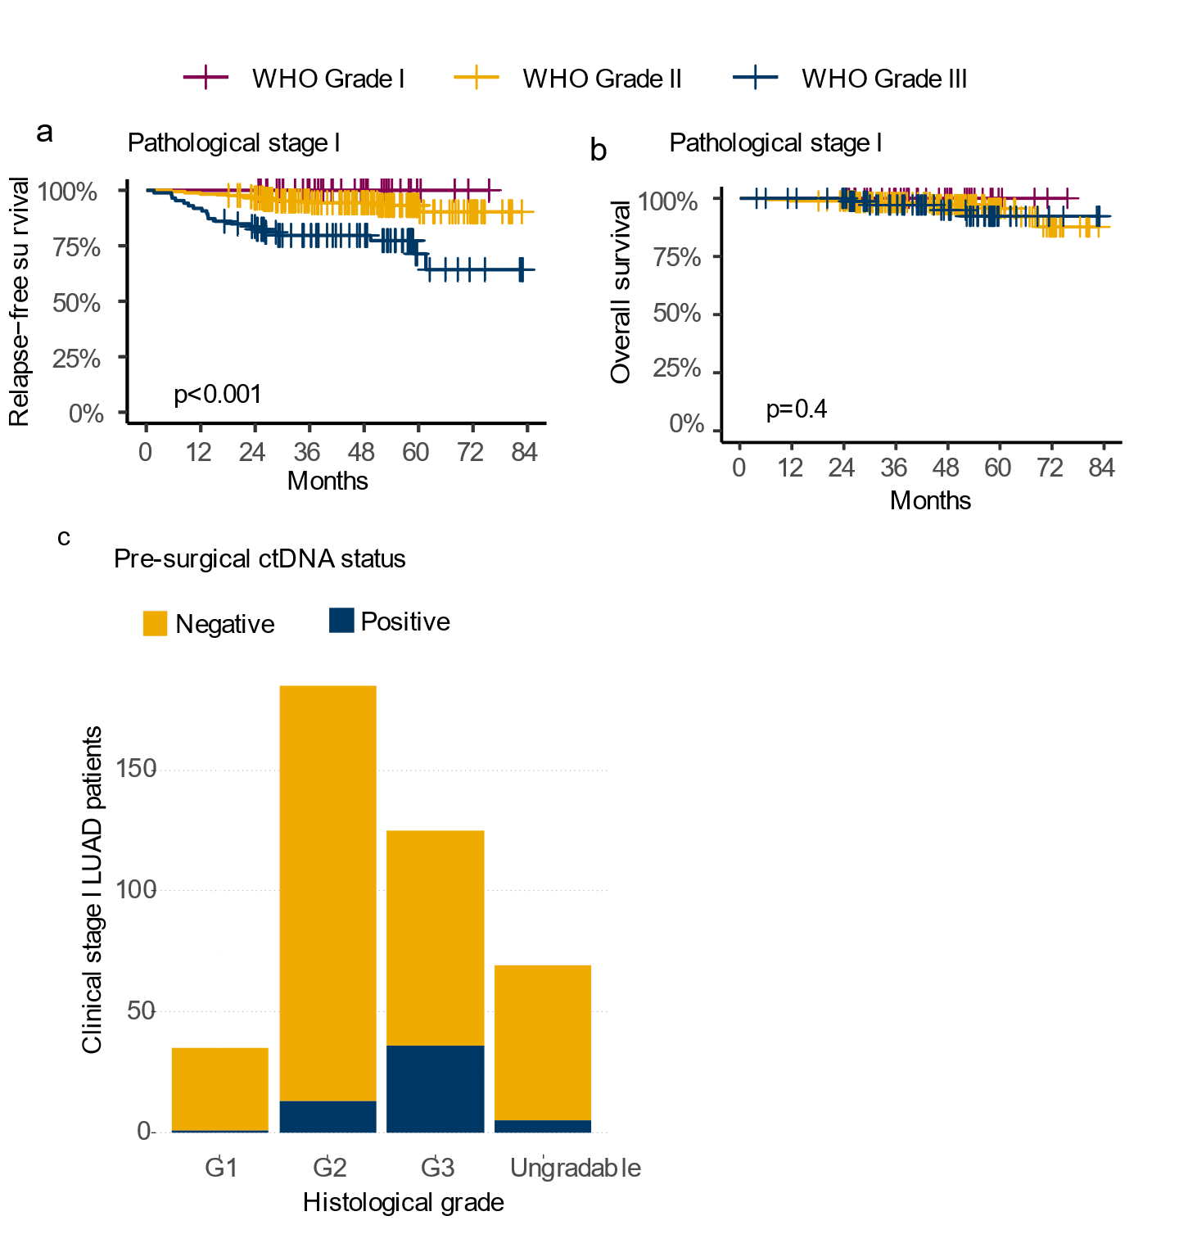
ctDNA, circulating tumor DNA; G, grade; IASLC, International Association for the Study of Lung Cancer; LUAD, lung adenocarcinoma; OS, overall survival; RFS, relapse-free survival.
Extended Data Table 1 | Logistic regression of ctDNA-positive status on tumor volume and avidity.
Characteristic | OR | 95% CI | P-value
Histology
LUAD | — | —
Non-LUAD | 5.42 | 3.35–8.83 | <0.001
Tumor volume (cm³) | 1.03 | 1.01–1.04 | 0.001
SUV_{max} | 1.22 | 1.16–1.29 | <0.001
CI, confidence interval; ctDNA, circulating tumor DNA; LUAD, lung adenocarcinoma; OR, odds ratio; SUV, standardized uptake value.

Extended Data Table 2 | Associations between ctDNA status and upstaging in clinical stage I–II NSCLC.
 |  |  | Upstaged
 | Histology | ctDNA test | Yes | No | Sensitivity (95% CI) | Specificity (95% CI) | P-value
Clinical stage I | All | Positive | 70 | 118 | 0.58 (0.49–0.67) | 0.75 (0.71–0.79) | <0.001
Clinical stage I | All | Negative | 51 | 363 | 0.58 (0.49–0.67) | 0.75 (0.71–0.79) | <0.001
Clinical stage I | LUAD | Positive | 20 | 35 | 0.31 (0.20–0.44) | 0.90 (0.86–0.93) | <0.001
Clinical stage I | LUAD | Negative | 44 | 315 | 0.31 (0.20–0.44) | 0.90 (0.86–0.93) | <0.001
Clinical stage I | Non-LUAD | Positive | 50 | 83 | 0.88 (0.76–0.95) | 0.37 (0.28–0.46) | 0.0014
Clinical stage I | Non-LUAD | Negative | 7 | 48 | 0.88 (0.76–0.95) | 0.37 (0.28–0.46) | 0.0014
Clinical stage II | All | Positive | 63 | 146 | 0.74 (0.63–0.83) | 0.30 (0.24–0.37) | 0.59
Clinical stage II | All | Negative | 22 | 62 | 0.74 (0.63–0.83) | 0.30 (0.24–0.37) | 0.59
Clinical stage II | LUAD | Positive | 17 | 49 | 0.49 (0.31–0.66) | 0.53 (0.43–0.63) | 1
Clinical stage II | LUAD | Negative | 18 | 56 | 0.49 (0.31–0.66) | 0.53 (0.43–0.63) | 1
Clinical stage II | Non-LUAD | Positive | 46 | 97 | 0.92 (0.81–0.98) | 0.06 (0.02–0.12) | 0.87
Clinical stage II | Non-LUAD | Negative | 4 | 6 | 0.92 (0.81–0.98) | 0.06 (0.02–0.12) | 0.87
CI, confidence interval; ctDNA, circulating tumor DNA; LUAD, lung adenocarcinoma; NSCLC, non-small-cell lung cancer.

Extended Data Table 3 | Multivariable Cox regression analyses of pre-surgical ctDNA status, adjusted for stage sub-category, age, gender, and smoking status, and association with RFS and OS in clinical stage I LUAD. N = 414 patients subject to analysis.
 |  | RFS |  |  | OS
Characteristic | N | HR | 95% CI | P-value | HR | 95% CI | P-value
Pre-surgical ctDNA |  |  |  | <0.001 |  |  | <0.001
Negative | 359 | — | — |  | — | —
Positive | 55 | 2.83 | 1.63–4.92 |  | 6.17 | 2.57–14.80
Clinical stage |  |  |  | <0.001 |  |  | 0.060
IA1 | 46 | — | — |  | — | —
IA2 | 99 | 1.76 | 0.20–15.70 |  | 0.35 | 0.02–5.68
IA3 | 165 | 7.83 | 1.06–57.70 |  | 2.11 | 0.27–16.70
IB | 104 | 13.60 | 1.84–101 |  | 2.95 | 0.36–24.20
Age | 414 | 1.02 | 0.99–1.04 | 0.2 | 1.00 | 0.96–1.05 | >0.9
Sex |  |  |  | 0.4 |  |  | 0.3
Female | 186 | — | — |  | — | —
Male | 228 | 1.34 | 0.63–2.85 |  | 1.86 | 0.54–6.40
Smoking |  |  |  | 0.4 |  |  | 0.10
Current smoker | 79 | — | — |  | — | —
Former smoker | 114 | 1.61 | 0.81–3.20 |  | 3.35 | 0.96–11.7
Never smoker | 221 | 1.53 | 0.65–3.61 |  | 3.67 | 0.81–16.6
CI, confidence interval; ctDNA, circulating tumor DNA; HR, hazard ratio; LUAD, lung adenocarcinoma; NSCLC, non-small-cell lung cancer; OS, overall survival; RFS, relapse-free survival.

