Supplementary Table 1. Mean (mean ± SD) physico-chemical parameters of the seawater over 8 weeks under different experimental conditions (10 °C, 13 °C and 15 °C).
Condition | Temperature (°C) | pH | Salinity (psu) | Oxygen (% sat.)
10 °C | 10.1 ± 0.2 | 8.16 ± 0.05 | 37.9 ± 0.5 | 96.4 ± 3.3
13 °C | 12.9 ± 0.2 | 8.17 ± 0.05 | 37.9 ± 0.5 | 96.2 ± 3.2
15 °C | 14.9 ± 0.2 | 8.20 ± 0.07 | 37.8 ± 0.6 | 97.4 ± 3.1

Supplementary Table 2. Average polyp linear growth rates ± s.d. (mm yr⁻¹) of L. pertusa for all, apical and subapical polyps, under different temperature conditions after 8 weeks of experiment. The numbers in brackets represent the number of replicates.
 | all polyps (mm y⁻¹) | apical polyps (mm y⁻¹) | subapical polyps (mm y⁻¹)
all | 2.9 ± 2.5 (44) | 2.5 ± 1.9 (9) | 3.0 ± 2.7 (35)
10 °C | 2.6 ± 2.3 (12) | 1.2 ± 0.0 (2) | 2.8 ± 2.4 (10)
13 °C | 2.2 ± 1.7 (11) | 2.5 ± 0.0 (1) | 2.2 ± 1.8 (10)
15 °C | 3.5 ± 2.9 (21) | 3.0 ± 2.2 (6) | 3.7 ± 3.2 (15)

Supplementary Table 3. Biovolumes (mm³) and surface (mm²) of coral nubbins obtained by 3D scanner at the start of the experiment (T0) and after 8 weeks (T4), and the calculated growth in biovolume and surface.
Analyzed nubbin | Colony | Temperature | Scan biovolume T0 (mm³) | Scan biovolume T4 (mm³) | Growth in biovolume (mm³) | Scan surface T0 (mm²) | Scan surface T4 (mm²) | Growth in surface (mm²)
L5_C10_1 | L5 | 10 | Unusable scan | 3097.44 | / | Unusable scan | 3153.9 | /
L6_C10_1 | L6 | 10 | 435.59 | 427.496 | -8.094 | 872.041 | 1198.48 | 326.439
L6_C10_2 | L6 | 10 | 232.307 | 226.794 | -5.513 | 495.062 | 789.429 | 294.367
L7_C10_1 | L7 | 10 | 1301.99 | 1137.29 | -164.7 | 1701.3 | 1856.36 | 155.06
L8_C10_1 | L8 | 10 | 1242.86 | 1187.94 | -54.92 | 2306.7 | 1655.74 | -650.96
L8_C10_2 | L8 | 10 | Unusable scan | Unusable scan | / | Unusable scan | Unusable scan | /
L5_C13_1 | L5 | 13 | 596.595 | 509.332 | -87.263 | 806.664 | 912.827 | 106.163
L5_C13_2 | L5 | 13 | 1406.36 | 1274.08 | -132.28 | 2152.07 | 3267.67 | 1115.6
L6_C13_1 | L6 | 13 | 750.804 | 760.317 | 9.513 | 1001.04 | 1046.28 | 45.24
L6_C13_2 | L6 | 13 | 804.916 | 760.804 | -44.112 | 972.527 | 1000.49 | 27.963
L7_C13_1 | L7 | 13 | 974.569 | 865.162 | -109.407 | 1166.31 | 1189.25 | 22.94
L7_C13_2 | L7 | 13 | 587.249 | 593.805 | 6.556 | 863.841 | 958.735 | 94.894
L9_C13_1 | L9 | 13 | 1073.19 | 1107.9 | 34.71 | 1321.01 | 1337.54 | 16.53
L5_C15_1 | L5 | 15 | 1044.78 | 966.255 | -78.525 | 1486.05 | 1608.76 | 122.71
L5_C15_2 | L5 | 15 | 1344.75 | 1259.4 | -85.35 | 1300.63 | 1493.75 | 193.12
L7_C15_1 | L7 | 15 | 1318.9 | 1488.13 | 169.23 | 2061.5 | 1857.44 | -204.06
L7_C15_2 | L7 | 15 | 1966.33 | Unusable scan | / | 3279.25 | Unusable scan | /
L8_C15_1 | L8 | 15 | 1103.86 | 1028.35 | -75.51 | 1574.44 | 1617.65 | 43.21
L8_C15_2 | L8 | 15 | 718.696 | 661.919 | -56.777 | 990.956 | 1110.2 | 119.244
L9_C15_1 | L9 | 15 | 1183.17 | 1072.79 | -110.38 | 1433.94 | 1483.06 | 49.12
L9_C15_2 | L9 | 15 | 883.06 | 788.079 | -94.981 | 1330.94 | 2088.23 | 757.29

Supplementary Table 4. Summary statistics of the pairwise PERMANOVA testing the effect of temperature and time on microbial community composition.
Time | Comparisons | R | F | p-value
T0 | 10 vs 13 | 0.100 | 2.450 | 0.001
 | 10 vs 15 | 0.119 | 2.826 | 0.001
 | 13 vs 15 | 0.155 | 3.853 | 0.001
2 weeks | 10 vs 13 | 0.063 | 1.414 | 0.084
 | 10 vs 15 | 0.126 | 2.601 | 0.001
 | 13 vs 15 | 0.149 | 2.973 | 0.002
4 weeks | 10 vs 13 | 0.223 | 3.223 | 0.005
 | 10 vs 15 | 0.447 | 6.460 | 0.026
 | 13 vs 15 | 0.288 | 2.020 | 0.097
6 weeks | 10 vs 13 | 0.254 | 2.717 | 0.013
 | 10 vs 15 | 0.244 | 2.582 | 0.010
 | 13 vs 15 | 0.406 | 2.738 | 0.100
8 weeks | 10 vs 13 | 0.229 | 3.273 | 0.003
 | 10 vs 15 | 0.260 | 3.162 | 0.003
 | 13 vs 15 | 0.148 | 2.098 | 0.002

Supplementary Table 5. List of targeted genes involved in type 1 and 3 secretion systems (T1SS and T3SS), and flagella and pili construction in the microbiome of the corals incubated at 10°C, 13°C, and 15°C.
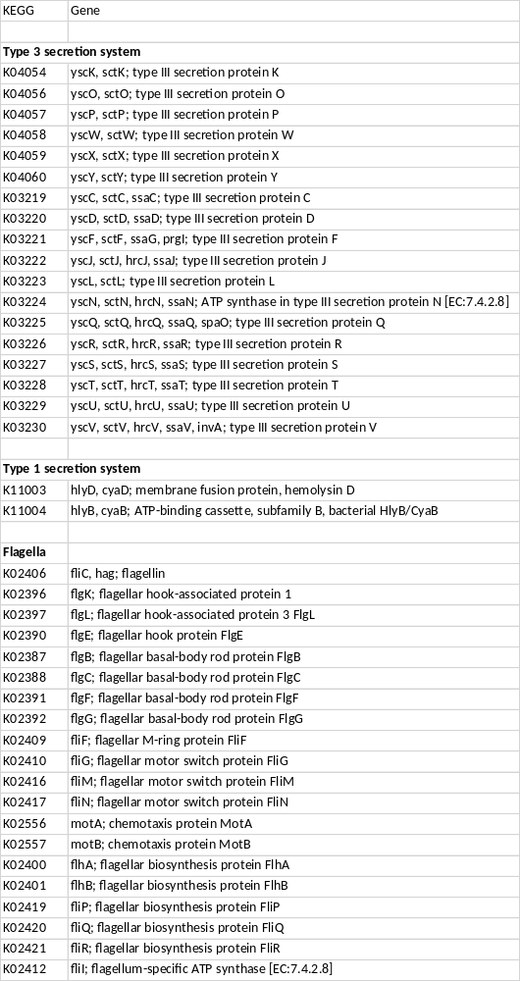

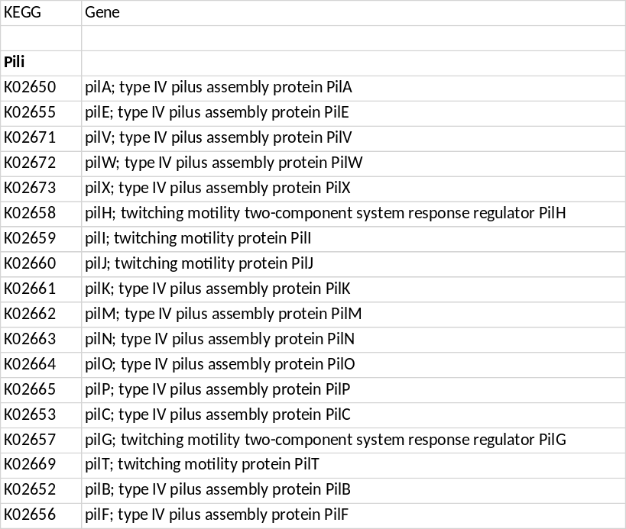

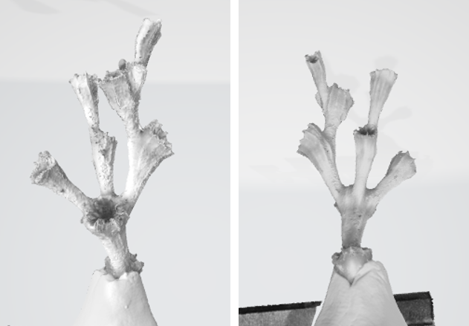
Supplementary Figure 1. Pictures of a scanned nubbin used for growth measurement, using AutoScan Inspec 3D scanner.

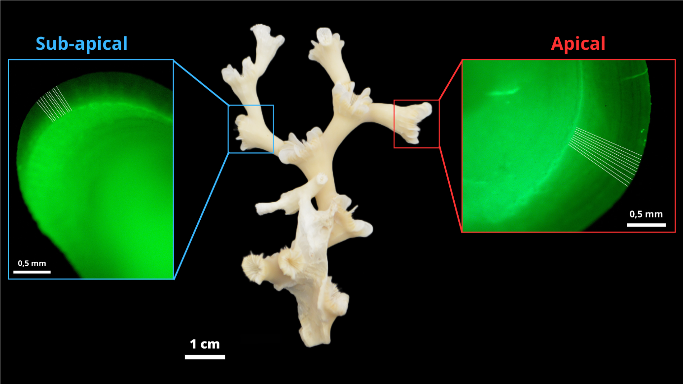
Supplementary Figure 2. Nubbin of L. pertusa with apical (red square) and subapical (blue squares) polyps with the major septum observed under fluorescence revealing the calcein staining (thickest green line). The white lines perpendicular to the calcein staining correspond to the linear extension measurements taken with the software Image J.
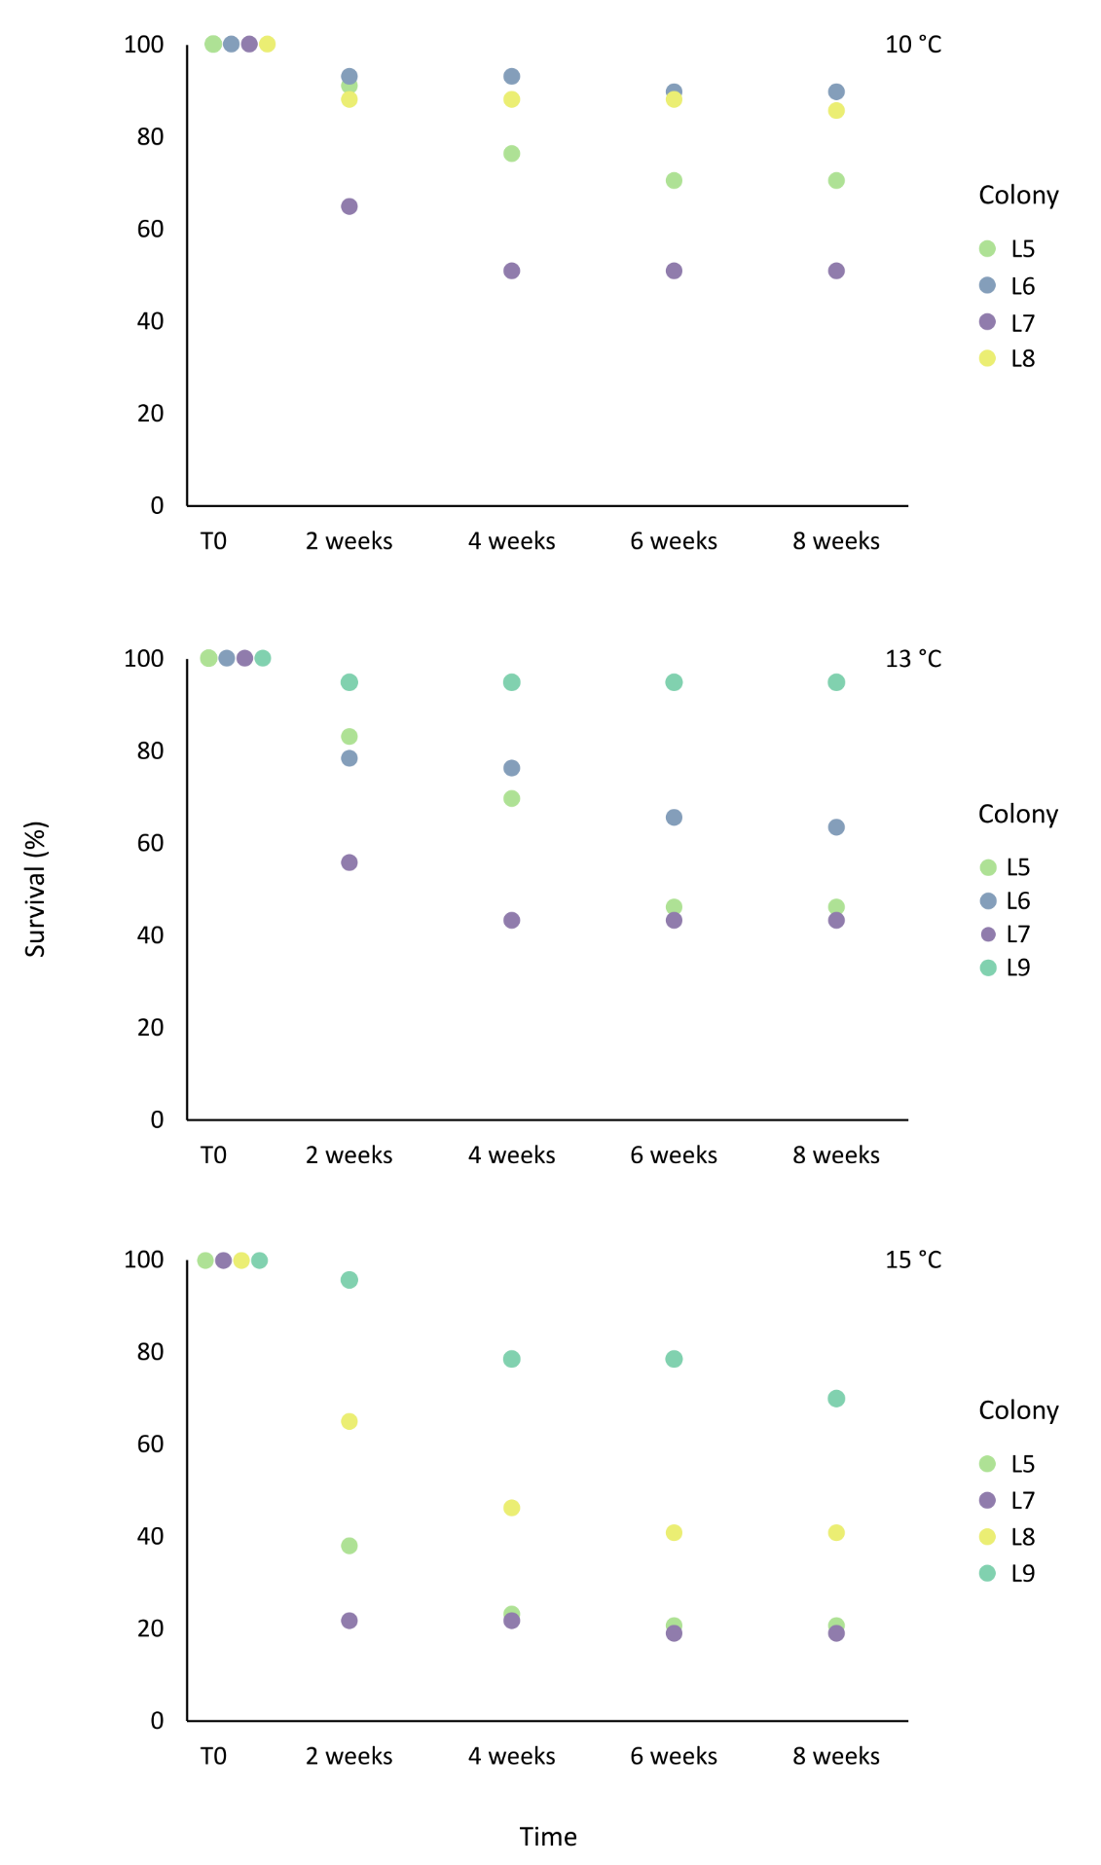
Supplementary Figure 3. Polyp survival rate (%) of L. pertusa for each colony in each temperature condition (10°C, 13°C and 15°C) during eight weeks of experiment.
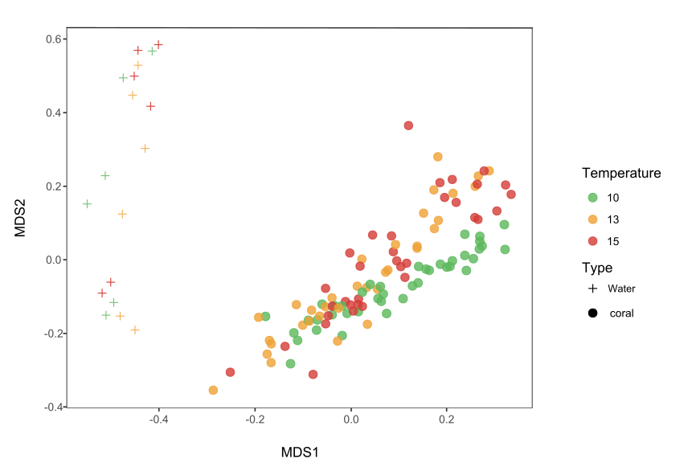
Supplementary Figure 4. Multi-dimensional scaling plot (NMDS) based on the Bray-Curtis similarity index showing the similarity between bacterial community compositions of L. pertusa and seawater during eight weeks of experiment at 10°C, 13°C and 15°C.
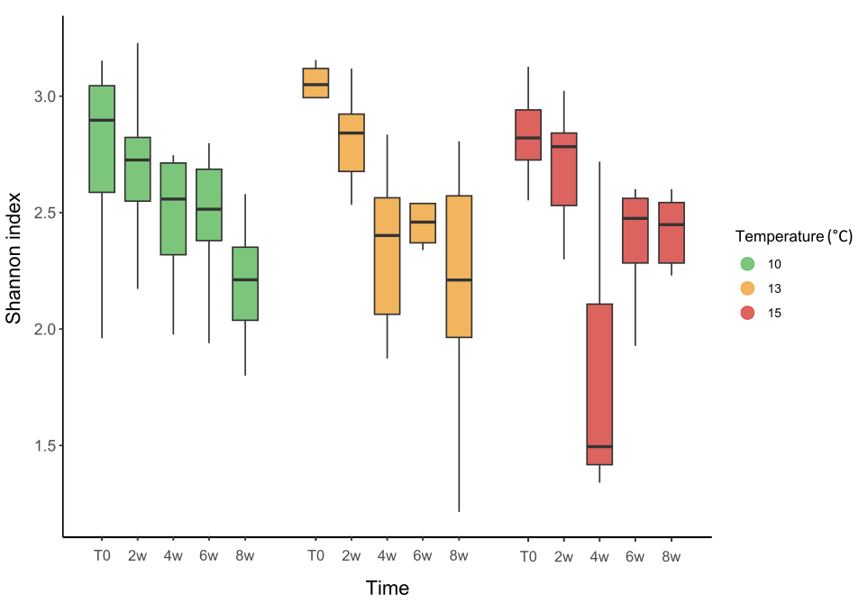
Supplementary Figure 5. Shannon diversity index of L. pertusa bacterial communities in each experimental condition (10°C, 13°C and 15°C) at the start of the experiment (T0) and after 2 weeks (2w), 4 weeks (4w), 6 weeks (6w) and 8 weeks (8w). Values presented in the box plot correspond to the median and quartile.

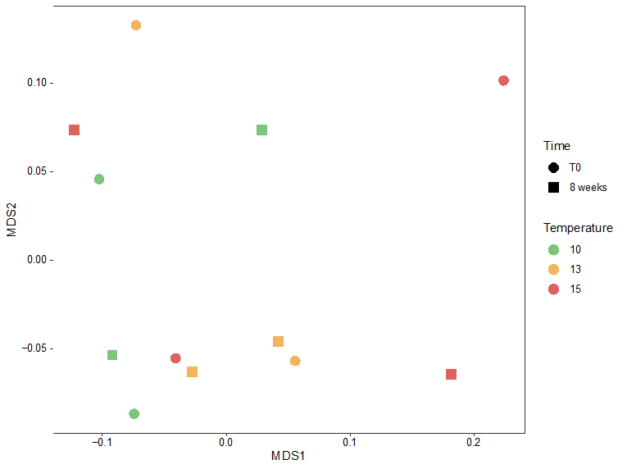
Supplementary Figure 6. Multi-dimensional scaling plot (NMDS) based on the relative abundance of all bacterial genes at the beginning of the experiment (T0) and after 8 weeks for corals incubated at 10°C, 13°C and 15°C.

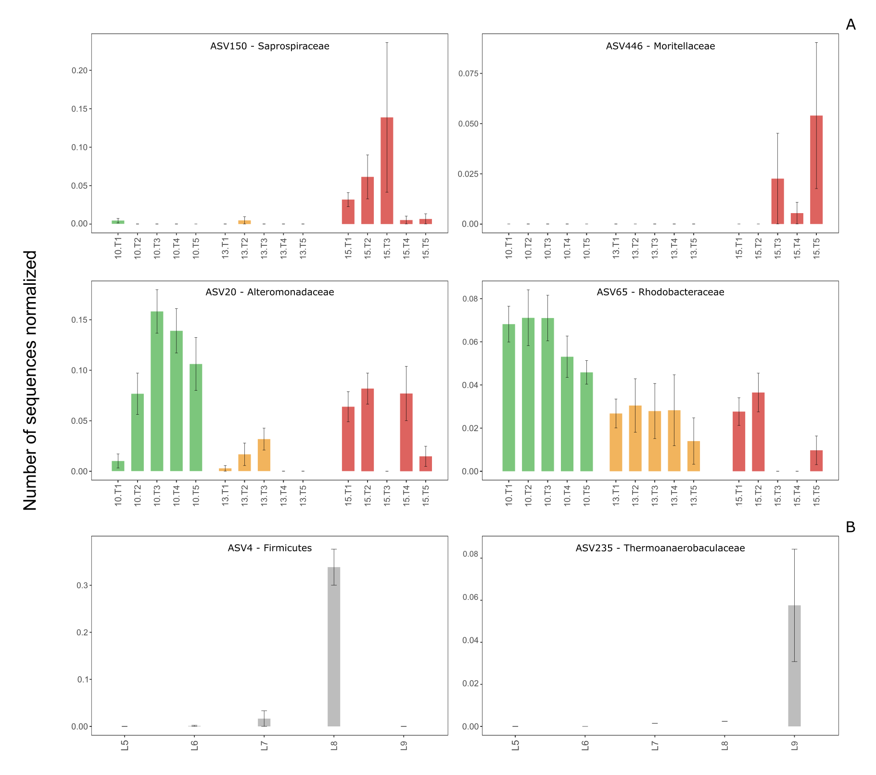
Supplementary Figure 7. Relative sequence abundance of ASVs of interest characterizing L. pertusa bacterial communities under different experimental conditions (10°C, 13°C and 15°C) at the start of the experiment (T0), and after 2 weeks (2w), 4 weeks (4w), 6 weeks (6w) and 8 weeks (8w) (A), and unique ASVs that characterize specific colonies of L. pertusa during the experiment (B). The affiliation of the ASVs at the family level is given, except for ASV4 for which the affiliation at the phylum level is available. Mean values and standard deviations are presented.

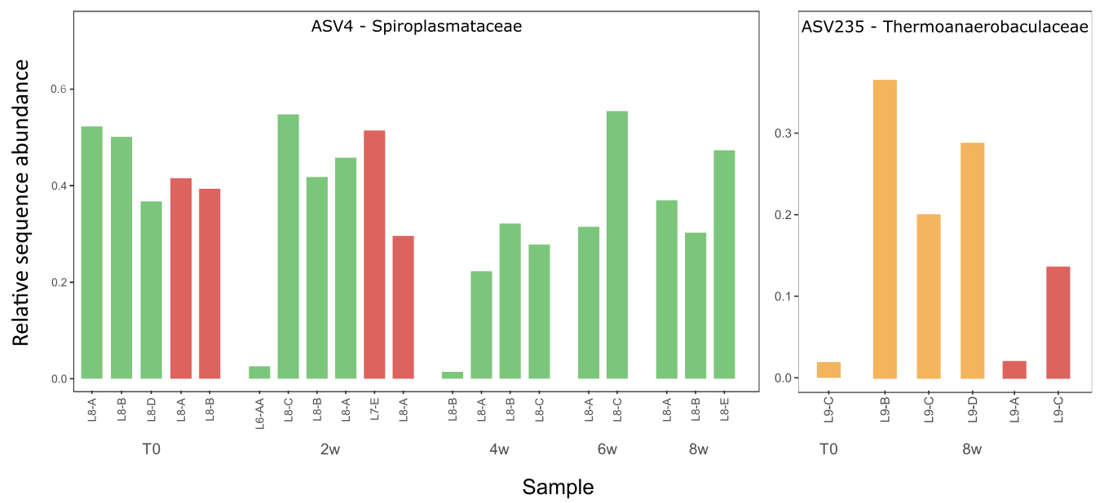
Supplementary Figure 8. Detailed abundance of unique ASVs that characterize specific colony of L. pertusa in the different temperature conditions (10°C, 13°C and 15°C) at the start of the experiment (T0), and after 2 weeks (2w), 4 weeks (4w), 6 weeks (6w) and 8 weeks (8w) of experiment.

