Supporting Information

Biomineralized bacterial outer membrane vesicles exert pleiotropic immunoferroptotic effects on immune-deserted liver cancer

Ying Luo, Zhongsheng Xu, Qianying Du, Lian Xu, Yi Wang, Jie Xu, Junrui Wang, Sijin Chen, Wenli Zhang, Bo Liu, Jia Liu, Dajing Guo*, Yun Liu*

Department of Radiology, Second Affiliated Hospital of Chongqing Medical University, Chongqing, 400010, P.R. China

*Corresponding author
E-mail address: yunliu@cqmu.edu.cn (Yun Liu); guodaj@hospital.cqmu.edu.cn (Dajing Guo).

Figure S1. Loading capacity of OPCM in relation to different input of Cu and Mn.

Figure S2. The average diameter of OMV, OP, OCM, and OPCM.

Figure S3. The XRD pattern of OPCM.
Figure S4. The plots of Δj recorded at 0.35 V as a function of the scan rate for OP@Cu, OP@Mn, and OPCM.
Figure S5. (a) The POD-like activity of different concentration of OPCM. (b) The CAT-like activity of different concentration of OPCM. (c) The GPX-like activity of OPCM.

Figure S6. (a) The accumulative Cu and (b) Mn release rate in pH 7.4, pH 6.0, and pH 5.0 buffer.

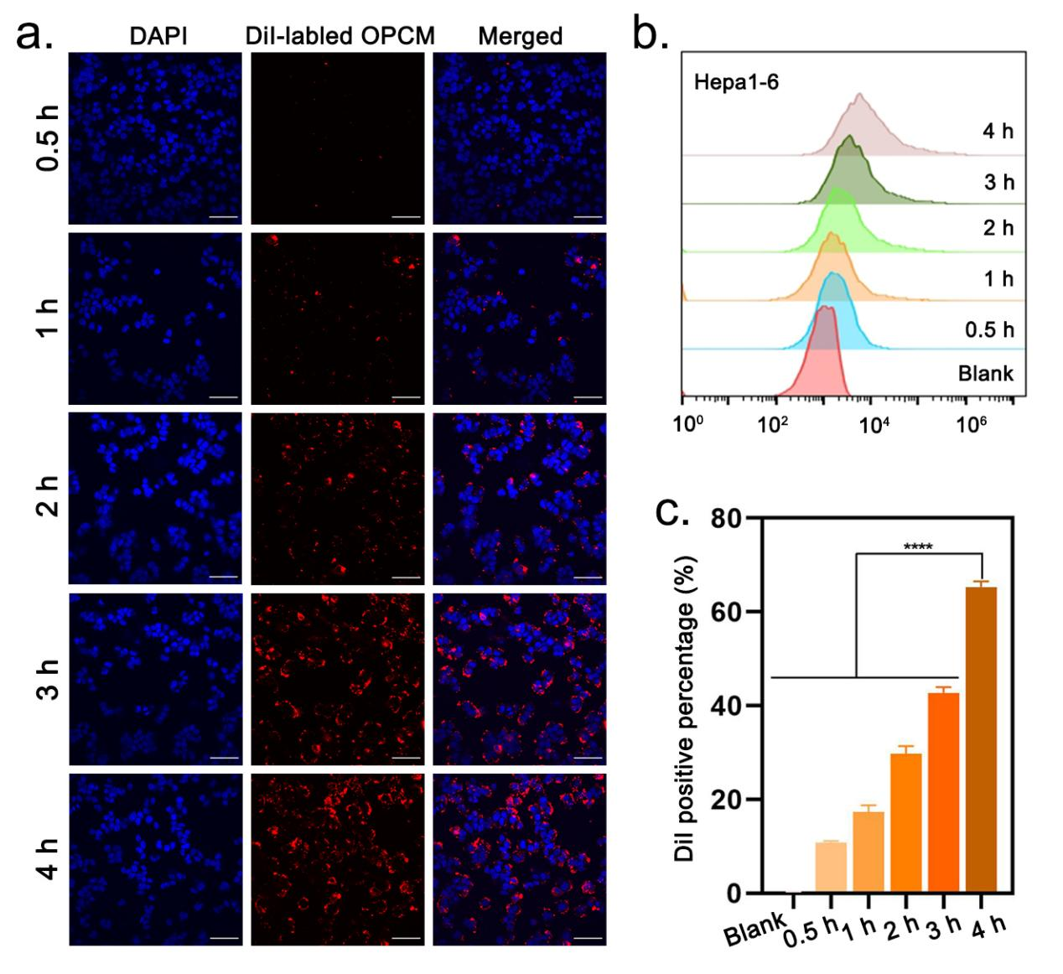
Figure S7. (a) CLSM images of intracellular uptake of DiI-labeled OPCM after different incubation times with Hepa1-6 cells. Scale bar: 50 μm. (b, c) FCM analysis of DiI-positive Hepa1-6 cells after different incubation times with DiI-labeled OPCM and the corresponding statistical analysis. Data are shown as the mean values ± SD (n = 3). All the statistical significance was analyzed by ANOVA. ∗ p < 0.05, ∗∗ p < 0.01, ∗∗∗ p < 0.001, ∗∗∗∗ p < 0.0001, ns, not significant.

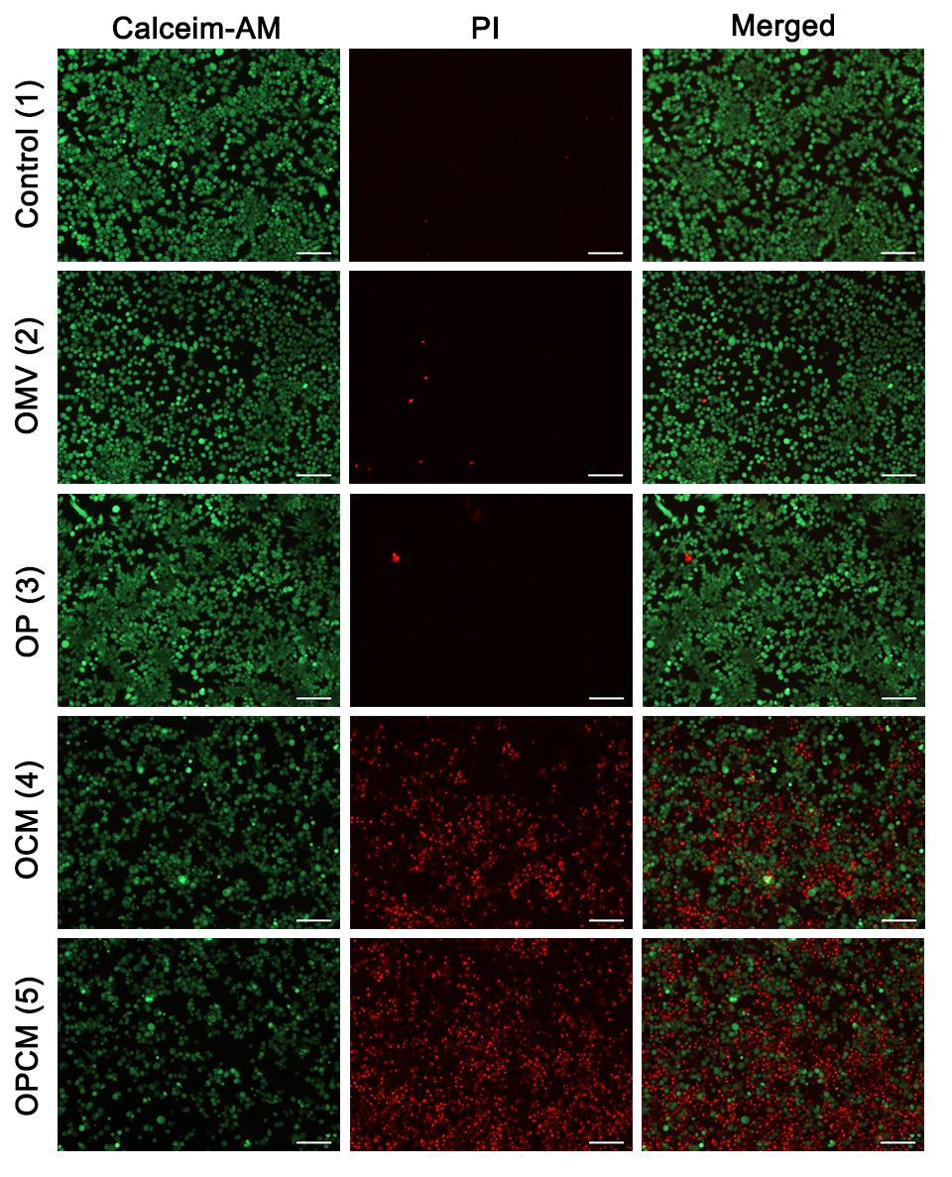
Figure S8. Live/dead cells staining of Hepa1-6 cells after treatments with PBS, OMV, OP, OCM, and OPCM respectively under a FL microscope. Scale bar: 50 μm.
Figure S9. FCM of ROS analysis induced by PBS, OMV, OCM, OPCM, and OPCM+Fer respectively.

Figure S10. The intracellular GSH assay in different treatment groups. Data are shown as the mean values ± SD (n = 3). All the statistical significance was analyzed by ANOVA. ∗ p < 0.05, ∗∗ p < 0.01, ∗∗∗ p < 0.001, ∗∗∗∗ p < 0.0001, ns, not significant.

Figure S11. The quantitative analysis of intracellular GPX4 expression in different treatment groups. Data are shown as the mean values ± SD (n = 3). All the statistical significance was analyzed by ANOVA. ∗ p < 0.05, ∗∗ p < 0.01, ∗∗∗ p < 0.001, ∗∗∗∗ p < 0.0001, ns, not significant.

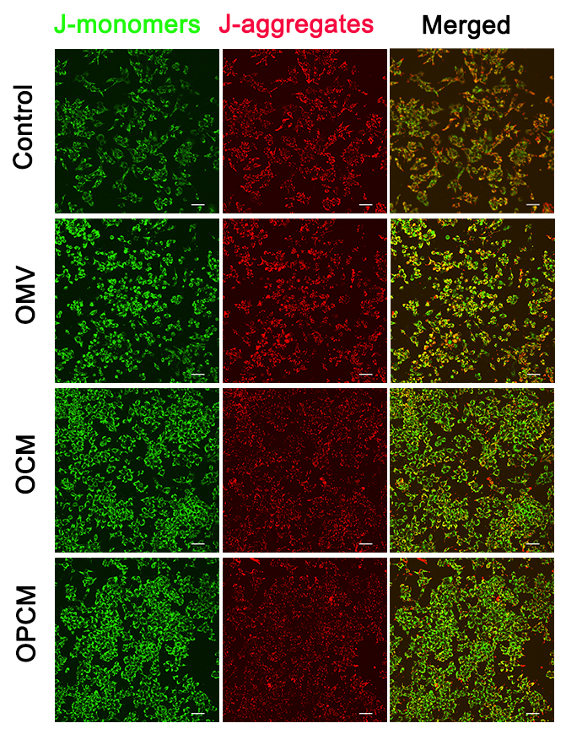
Figure S12. CLSM of mitochondrial potential change after treatment with PBS, OMV, OCM, or OPCM respectively. Scale bar: 50 μm.

Figure S13. The FCM analysis of MMP in different treatment groups.

Figure S14. The corresponding statistical analysis of γ-H2AX FL intensity. Data are shown as the mean values ± SD (n = 3).
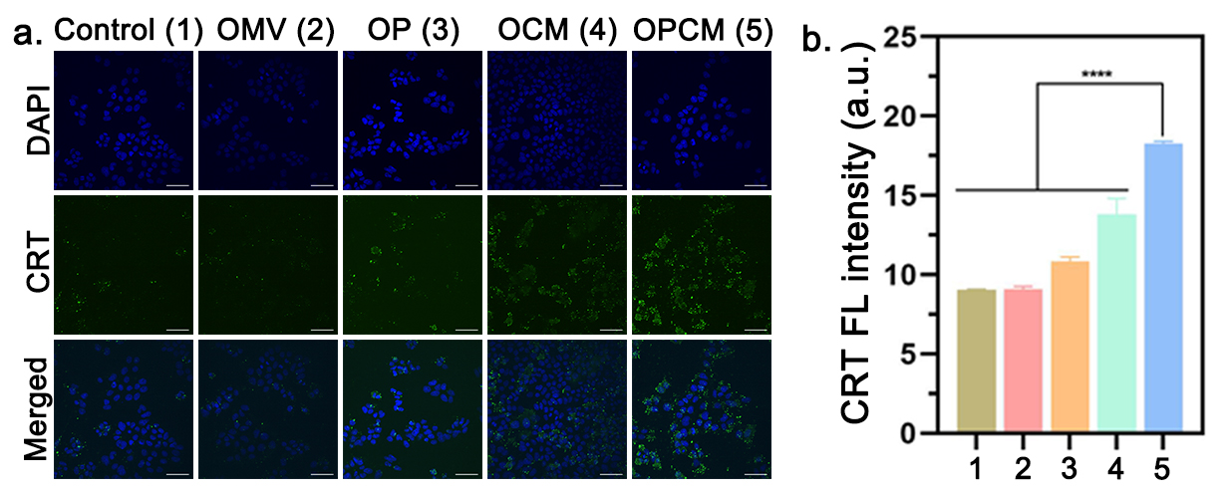
Figure S15. (a) CLSM images of γ-H2AX expression in Hepa1-6 cells after treatment with PBS, OMV, OP, OCM, or OPCM. Scale bar: 50 μm. (b) The corresponding statistical analysis of CRT FL intensity. Data are shown as the mean values ± SD (n = 3).

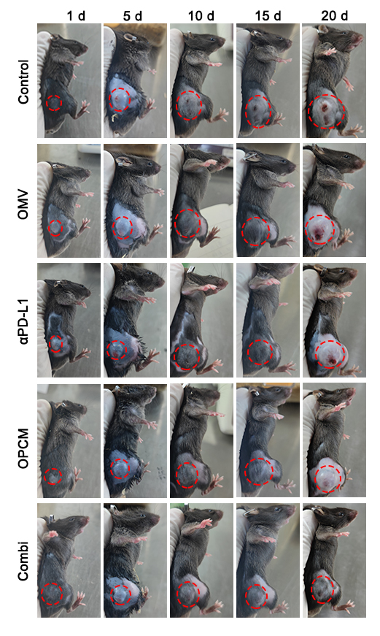
Figure S16. The representative digital photos of mice at different time points since first treatment.
Figure S17. (a) The average tumor weight and (b) tumor inhibition rate after various treatments. Data are shown as the mean values ± SD (n = 5). All the statistical significance was analyzed by ANOVA. ∗ p < 0.05, ∗∗ p < 0.01, ∗∗∗ p < 0.001, ∗∗∗∗ p < 0.0001, ns, not significant.

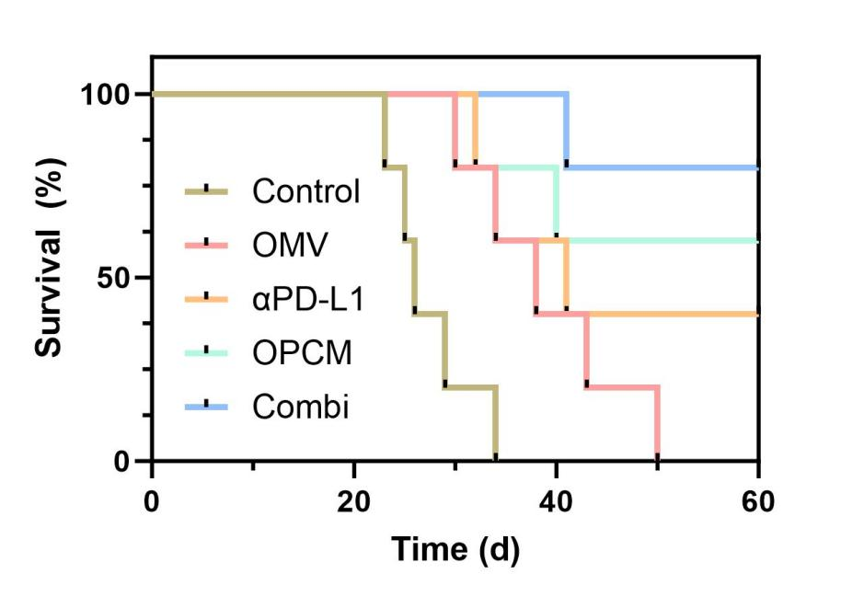
Figure S18. The long-term survival observation in different treatment groups. Data are shown as the mean values ± SD (n = 5).
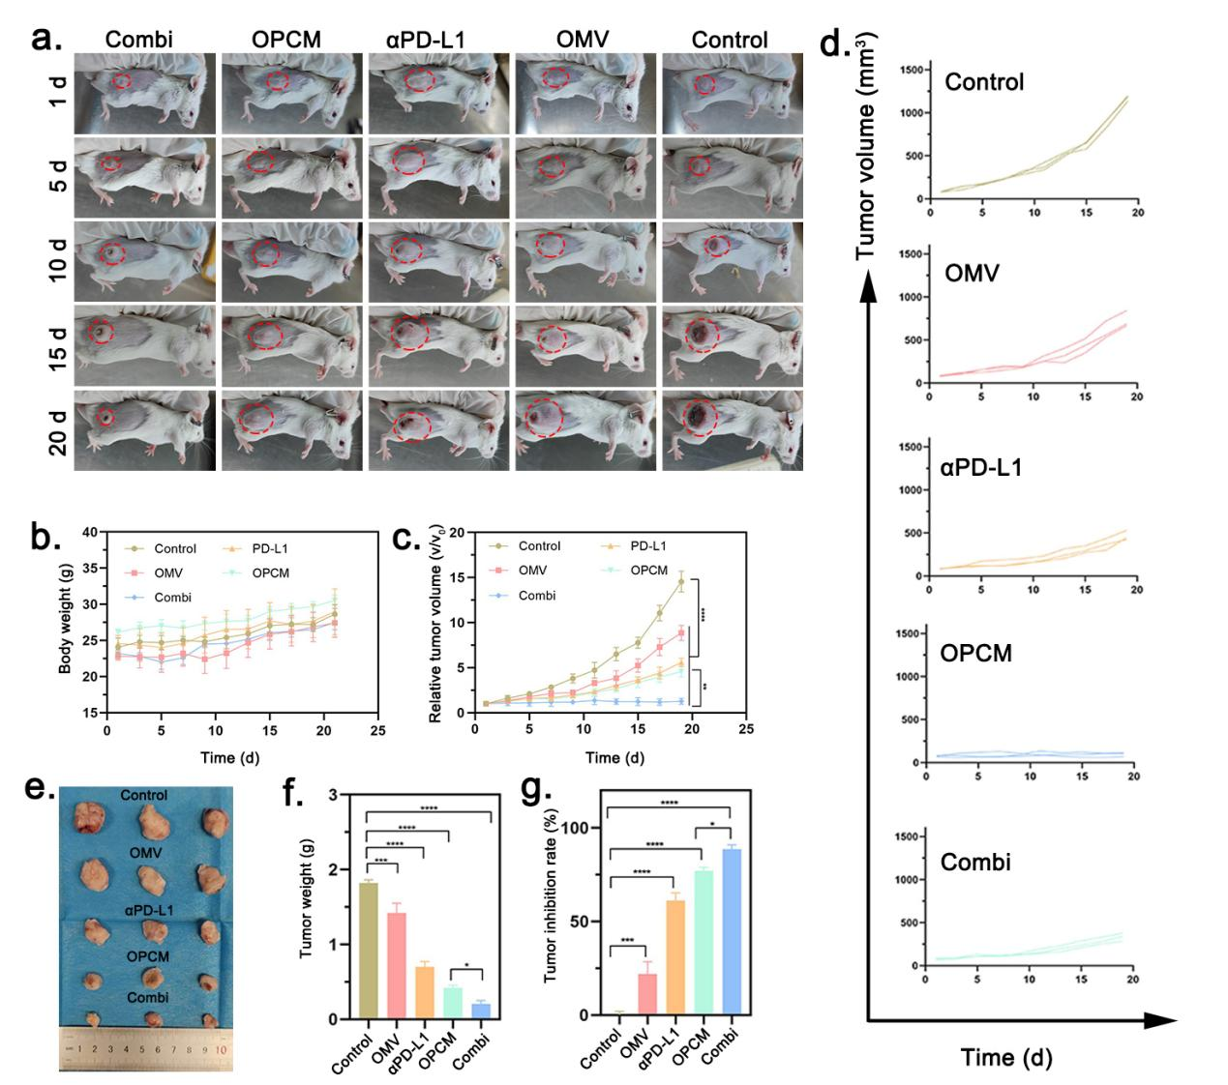
Figure S19. (a) The representative digital photos of mice at different time points since first treatment. (b) The average change of mice body weight in different treatment groups. Data are shown as the mean values ± SD (n = 3). (c) The relative tumor volume change in different treatment groups. Data are shown as the mean values ± SD (n = 3). (d) The individual mice tumor volume change in each group. Data are shown as the mean values ± SD (n = 3). (e) The photograph of extracted tumor tissues after different treatments in each group. (f). The average tumor weight in each group. Data are shown as the mean values ± SD (n = 3). (g) The corresponding tumor inhibition rate is calculated by the average tumor weight. Data are shown as the mean values ± SD (n = 3). All the statistical significance was analyzed by ANOVA. ∗ p < 0.05, ∗∗ p < 0.01, ∗∗∗ p < 0.001, ∗∗∗∗ p < 0.0001, ns, not significant.

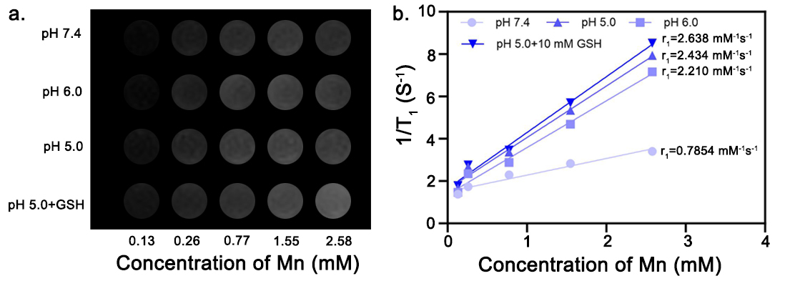
Figure S20. (a) The T₁-weighted MRI gray images of different concentrations of OPCM in pH 7.4, pH 6.0, pH 5.0, and pH 5.0 + 10 mM GSH buffer. (b) the relative T₁ relaxation rates calculated by T₁ mapping.
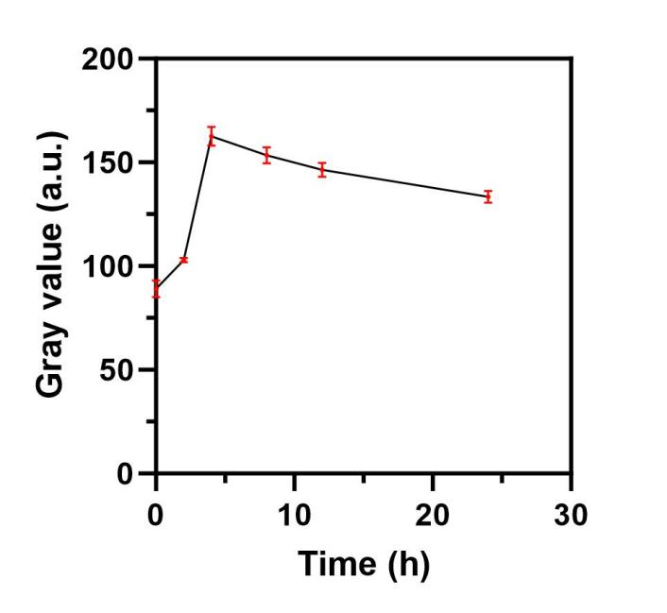
Figure S21. The change of average gray value of tumor tissue at different time intervals in T₁-weighted MRI. Data are shown as the mean values ± SD (n = 3). All the statistical significance was analyzed by ANOVA. ∗ p < 0.05, ∗∗ p < 0.01, ∗∗∗ p < 0.001, ∗∗∗∗ p < 0.0001, ns, not significant.

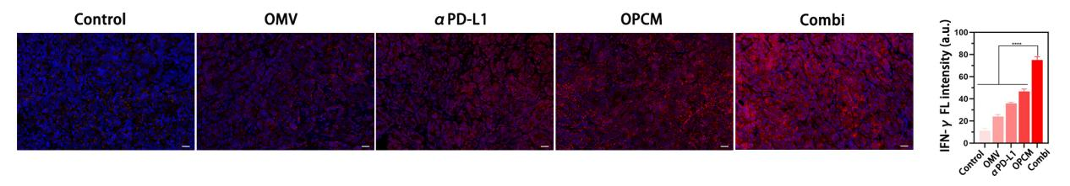
Figure S22. The IF staining of IFN-γ in tumor tissues from different treatment groups and the corresponding quantitative analysis. Scale bar: 20 μm. Data are shown as the mean values ± SD (n = 3). All the statistical significance was analyzed by ANOVA. ∗ p < 0.05, ∗∗ p < 0.01, ∗∗∗ p < 0.001, ∗∗∗∗ p < 0.0001, ns, not significant.

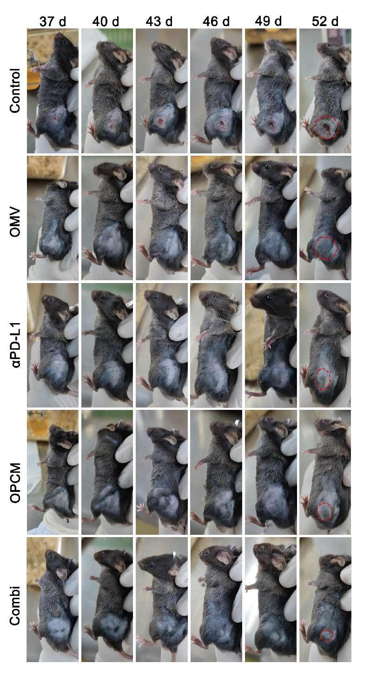
Figure S23. The representative digital photos of rechallenged mice models at different time points.

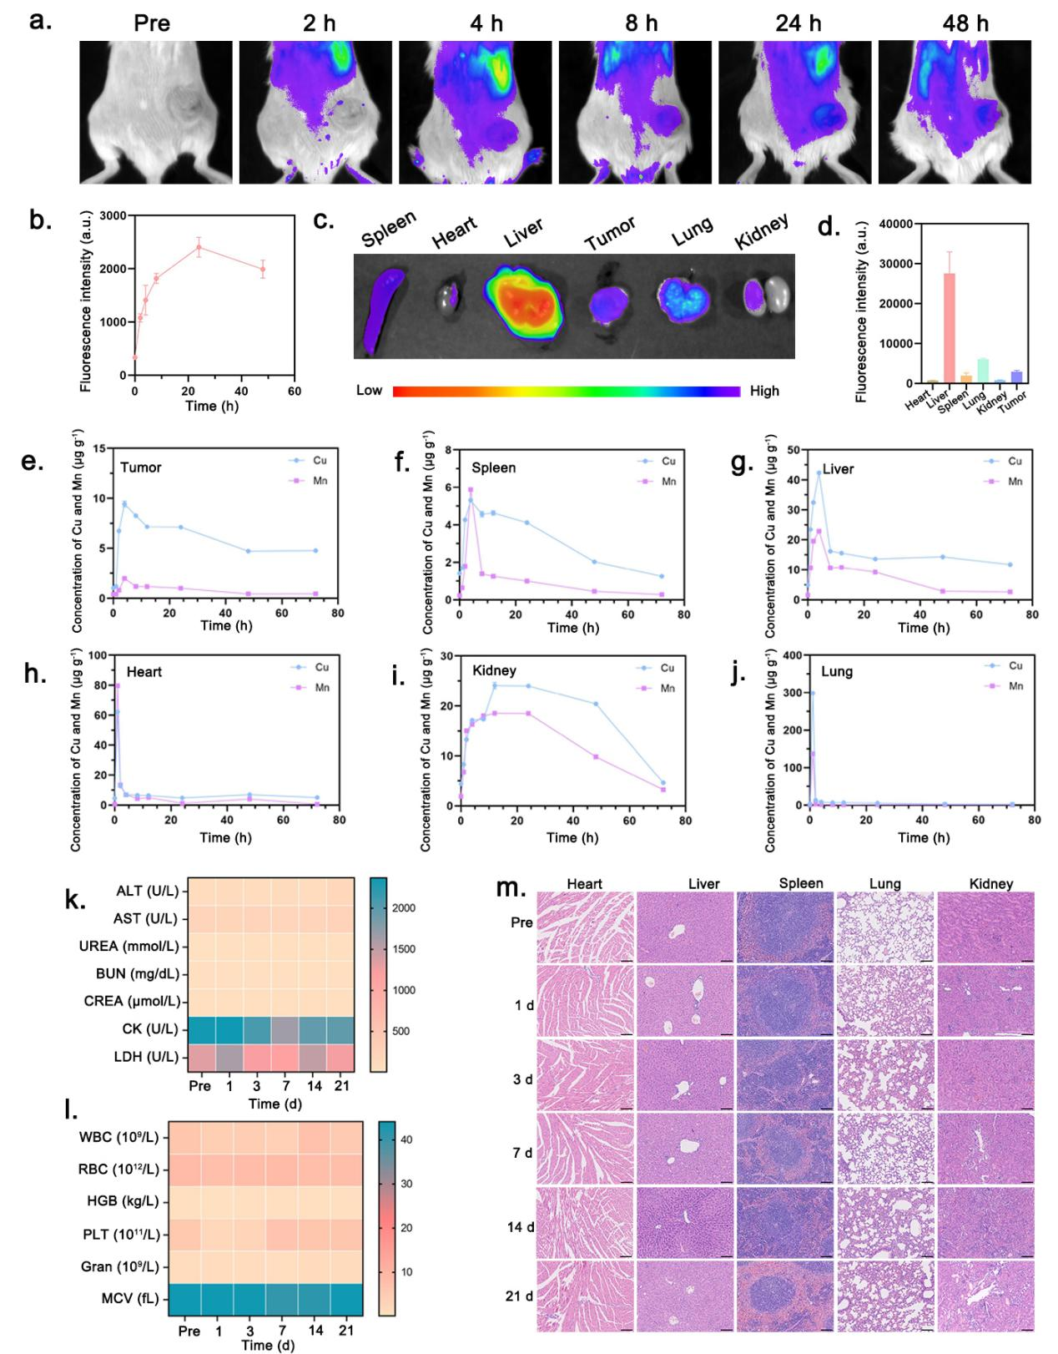
Figure S24. (a, b) In vivo FL images of mice captured at different time intervals after the injection of DiR-labeled OPCM and the corresponding quantitative FL analysis. Data are shown as the mean values ± SD (n = 3). (c, d) The ex vivo FL images of the extracted tumors and major organs (Spleen, heart, liver, lung, kidney) and the corresponding quantitative FL analysis. Data are shown as the mean values ± SD (n = 3). (e, f, g, h, I, j) The in vivo Cu and Mn pharmaceutical kinetics in tumor and major organs (spleen, liver, heart, kidney, and lung). All the statistical significance was analyzed by ANOVA. ∗ p < 0.05, ∗∗ p < 0.01, ∗∗∗ p < 0.001, ∗∗∗∗ p < 0.0001, ns, not significant. (k, l) Blood biochemical parameters and blood routine examination of mice 21 days after intravenous injection of OPCM. Data are shown as the mean values ± SD (n = 3). (m) HE staining of the major organs at corresponding time intervals (n=3). Scale bar: 50 μm. All the statistical significance was analyzed by ANOVA. ∗ p < 0.05, ∗∗ p < 0.01, ∗∗∗ p < 0.001, ∗∗∗∗ p < 0.0001, ns, not significant.

