Supplementary Material
Figure S1: Bacterial counts in the cecum, distal colon, mesenteric lymph nodes, spleen, and liver of C57BL/6 mice infected with S. Tm and mock-infected control mice.
Figure S2: Comparable percentages (a) and distribution (b) of matrisome subcategories in the four groups healthy mucosa, inflamed mucosa, healthy muscularis externa, and inflamed muscularis externa.
Figure S3: Mucosal FnBPA5 and SHG signal on day 3 p.i. with S. Tm in C57BL/6 mice shows no spatial correlation between collagen bundles and relaxed fibronectin fibers.
FigureS4: Additional representative images of neutrophil clusters and the spatially correlated relaxed fibronectin fibers on day 3.
Figure S5: TAILS analysis of cecum tissue from S. Tm infected (day 3 p.i.) and mock-infected C57BL/6 mice.

Figure S1: Bacterial counts in the cecum, distal colon, mesenteric lymph nodes, spleen, and liver of C57BL/6 mice infected with S. Tm and mock-infected control mice. Colony forming units (CFU) were counted in the cecum content (A), feces (B), mesenteric lymph nodes (mLN) (C), the spleen (D), and the liver (E) and the indicated timepoints post infection. Marker points represent individual mice (n=5 in each group).
Figure S2: Comparable distribution of matrisome subcategories in the four groups healthy mucosa, inflamed mucosa, healthy muscularis externa, and inflamed muscularis externa. Musc. Ext, muscularis externa.

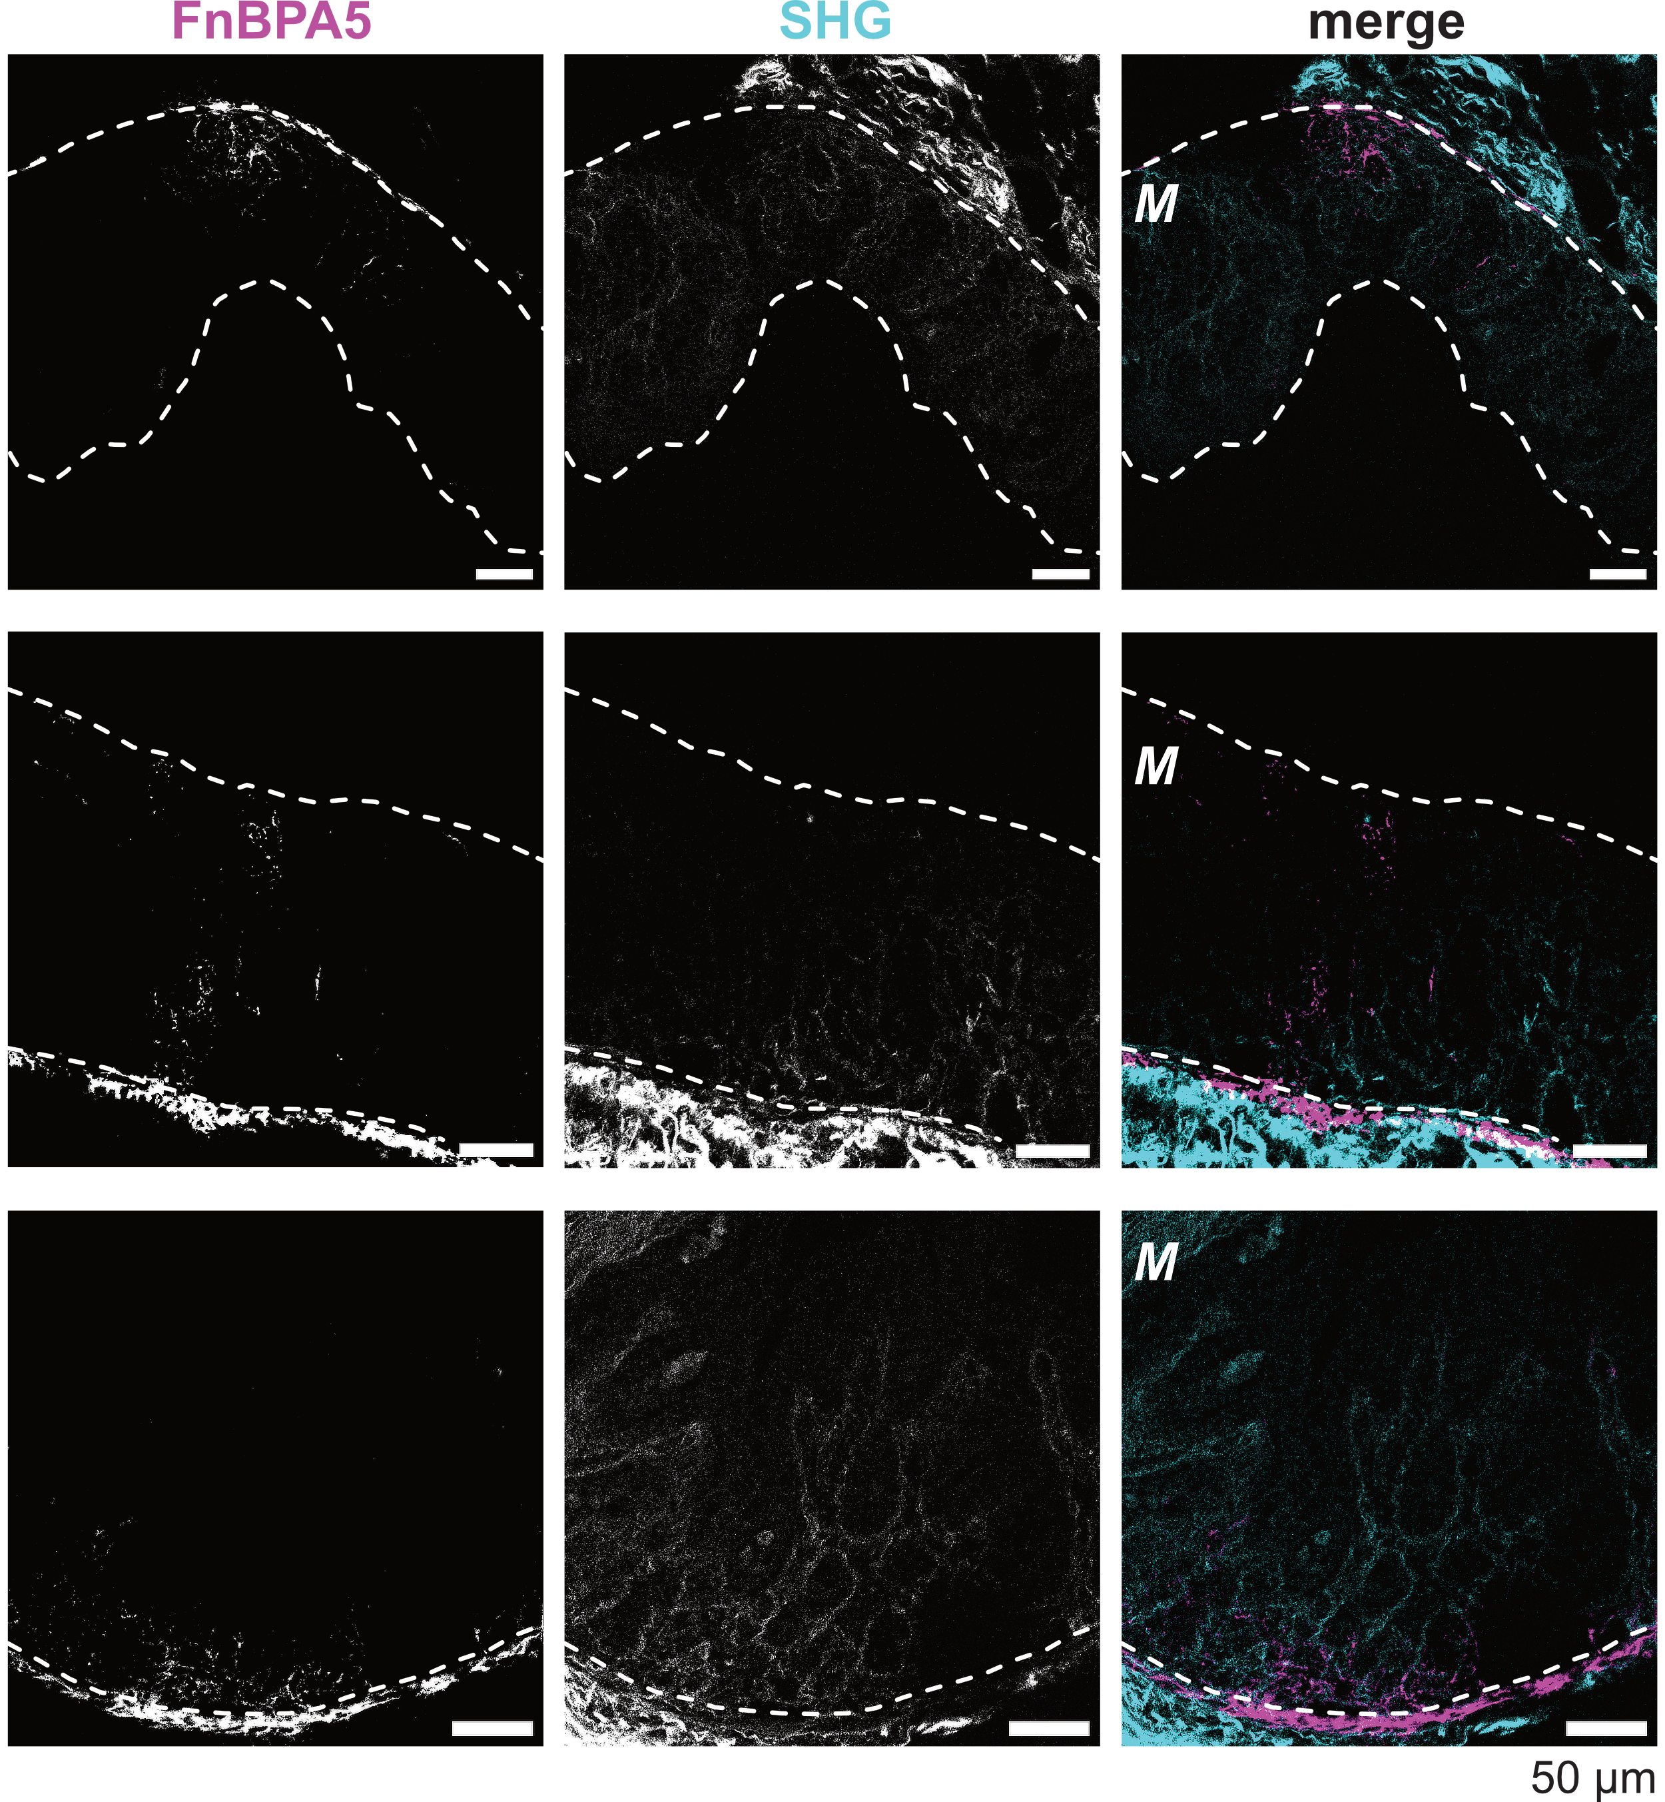
Figure S3: Mucosal FnBPA5 and SHG signal on day 3 p.i. with S. Tm in C57BL/6 mice shows no spatial correlation between collagen bundles and relaxed fibronectin fibers. Each row represents a region of interest with a cluster of relaxed fibronectin signal (magenta) and the corresponding SHG signal (cyan). White dashed lines indicate mucosal areas in the cecal cross-sections. Scale bar: 50 µm. M: mucosa.

Figure S4: Additional representative images of neutrophil clusters and the spatially correlated relaxed fibronectin fibers on day 3 , but not yet on day 2. Additional zoomed-in images of cecal cryosections showing no relaxed fibronectin fibers in the areas of neutrophil clusters on day 2 post infection (a), whereas strong spatial correlation is observed on day 3 post infection (b).

Figure S5: TAILS Analysis of Cecum Tissue from S. Tm infected (day 3 p.i.) and mock-infected C57BL/6 mice. A: Numbers of proteins, peptide and N-termini identified with high confidence are shown. B: PCA analysis separates the healthy and inflamed tissues. C: Distribution of N-termini and their post-translational modifications of peptides and proteins identified after N-terminal enrichment including distribution of acetylated versus non-acetylated N termini. D: Cluster map visualizing differences in the N-terminome between the healthy and S. Tm infected cecum tissue. E: Reactome pathway enrichment analysis of upregulated N-termini in the inflamed condition. Met, methionine.

