Recessive variants in MYO1C as a potential novel cause of proteinuric kidney disease.

Supplementary data

- MATERIALS AND METHODS
WES was performed as previously described [11-13]. In brief, genomic DNA was isolated from blood lymphocyte or saliva samples and subjected to exome capture using Agilent SureSelect™ human exome capture arrays (Life technologies™) followed by next-generation sequencing on the Illumina HighSeq™ sequencing platform. Sequence reads were mapped to the human reference genome assembly (NCBI build 37/hg19) using CLC Genomics Workbench™ (version 6.5.2) software (CLC bio, Aarhus, Denmark). Following alignment to the human reference genome (GRCh37/hg19), variants were filtered for most likely non-deleterious variants as previously described [14, 15]. In the first step, variants with minor allele frequencies >1% in the dbSNP (version 142) or in the 1,000 Genomes Project (1,094 subjects of various ethnicities; May 2011 data release) databases were excluded as they were unlikely to be deleterious. Next, synonymous variants and intronic variants that were not located within splice site regions were excluded. The remaining variants were ranked based on their probable impact on the function of the encoded protein considering evolutionary conservation among orthologues across phylogeny using ENSEMBL Genome Browser and assembled using Clustal Omega, as well as web-based prediction programs PolyPhen-2 [16], SIFT [17, 18], and Mutation Taster [19]. We excluded variants if their biallelic frequency in the Genome Aggregation Database (gnomAD) was 5 or higher [20]. Variant calling was performed by clinician-scientists/geneticists in our laboratory, who had knowledge of the clinical phenotypes and pedigree structure, as well as experience with WES evaluation. Remaining variants were confirmed in patient DNA by Sanger sequencing as previously described [10]. Finally, pathogenicity value was assigned to each variant using ACMG criteria [21].
Variant calling in known SRNS genes: We applied the filtering steps described above in our evaluation of WES data for deleterious variants in 65 genes which are known to cause SRNS if mutated. We used manual inspection for the p.R229Q variant in the NPHS2 gene which is reported to be deleterious with other variants, which has a high frequency in the population and would be filtered out using this method [22]. If no causative variant was identified in these genes, we also evaluated for variants in 15 genes that may represent phenocopies of SRNS (COL4A3, COL4A4, COL4A5, DGKE, FN1, MEFV, NOTCH3, THBD, ADAMTS13, C3, CD46, CDK20, CFH, CFHR5, and CFI). Variants were evaluated as above. A correlation of genotype and phenotype was examined and, if congruent, the genetic variant was deemed likely causative.
Variant calling to identify novel causes of SRNS: If no likely causative variant was found in a known SRNS gene or a phenocopy gene, we explored remaining variants as described above, using conservation across phylogeny and web-based prediction programs as to their impact on protein function. Variants were confirmed in original patient and parental DNA by Sanger sequencing as previously described [10].
Homozygosity mapping: Homozygosity mapping was performed based on WES data. Binary Alignment Map files were processed using Picard and SAMtools4 as previously described [23]. Single-nucleotide variant calling was carried out using Genome Analysis Tool Kit [24]. Homozygosity mapping data and visual outputs were generated using HomozygosityMapper [25].

- SUPPLEMENTARY TABLE AND FIGURES

Supplementary Table 1. The solve rate of published multicohort studies of monogenic causes of nephrotic syndrome

Research Publication | Age Group (Adult/Pediatric) | Molecular Methodology | Disease Classification | Total Genes Analyzed | Genes with Causative Variants | Number of Cases  Solved / Total Participants [F:Families; I:Individuals] | Percent age of Cases Solved
Santin, CJASN 6:1139,  2011 | Pediatric/ Adult | Panel Sequencing | SRNS | 8 | 8 | 37/125 I | 34%
Sadowski, JASN 26:1279,  2015 | Pediatric | Panel Sequencing | SRNS | 27 | 21 | 526/1783 F | 29.50%
Sampson, JASN 27:1070,  2016 | Pediatric/ Adult | Panel Sequencing | NS | 21 | 7 | 13/312 I | 4.20%
Sen, JMG 54:795, 2017 | Pediatric/ Adult | Panel Sequencing | SRNS/Alport | 37 | 15 | 71/302 I | 23%
Bierzynska, KI 91:937,  2017 | Pediatric | Exome  Sequencing | SRNS | 53 | 17 | 49/187 I | 26.20%
Gribouval, KI 94:1013,  2018 | Adult | Exome  Sequencing | SRNS/FSGS | 35 | 15 | 16/135 I | 11.80%
Warejko, CJASN 13:53,  2018 | Pediatric/ Adult | Exome  Sequencing | SRNS | 33 | 20 | 74/300 F | 24.60%
Tan, Ped Nephrol 33:305,  2018 | Pediatric | Panel Sequencing | SRNS | 24 | 6 | 8/72 F | 11.10%
Schapiro , NDT 34:474,  2019 | Pediatric | Exome  Sequencing | SRNS/Alport | 34 | 18 | 51 /362 F | 14.10%
Nagano , Sci Rep 10:270,  2020 | Pediatric/ Adult | Exome  Sequencing | SRNS | 60 | 19 | 60/230 F | 30%
Wang , Ped Nephrol  32:1181, 2017 | Pediatric | Panel Sequencing | SRNS | 28 | 10 | 34/120 F | 28.50%
Braunisch , EJHG 29:262,  2021 | Adult | Exome  Sequencing | SRNS | ~60 | 6 | 2/24 F | 29%
Varner , Front Pediatr  6:307, 2018 | Pediatric/ Adult | Panel/Exome  Sequencing | SRNS | ~60 | 12 | 40/181 F | 22.10%
Bogyo , AJMG C Semin  Med Genet 190:289, 2022 | Adult | Exome  Sequencing | SRNS/Alport | ~60 | 7 | 29/117 I | 24.70%

SRNS, Steroid-Resistant Nephrotic Syndrome; NS, Nephrotic Syndrome; FSGS, Focal Segmental Glomerulosclerosis; I, Individual; F, Family.

a
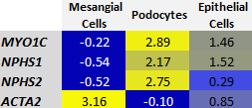

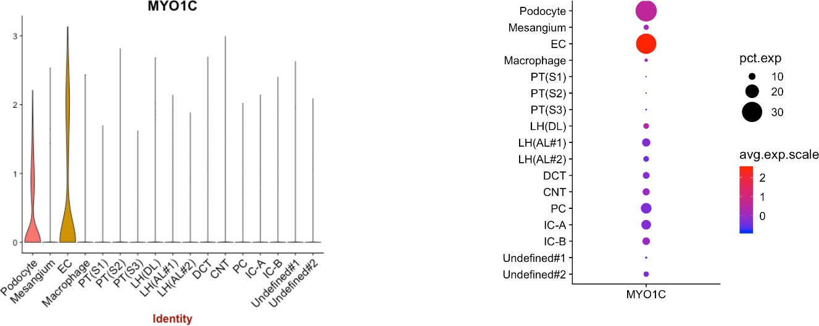
b
Supplementary Figure 1

Supplementary Figure 1. MYO1C is highly expressed in podocytes.
- Single-cell RNA Sequencing data (from: Cebrian Development 145:16, 2018) shows strong MYO1C podocyte expression when compared to positive controls (NPHS1, NPHS2) and negative control (ACTA2).
- Violine plots generated by single-cell RNA Sequencing of human adult kidney (from: Wu and Uchimura Cell Stem Cell 23:869, 2018) show high MYO1C expression in podocytes and epithelial cells (EC).

Lys758Met Arg98Trp
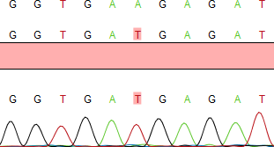
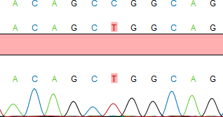
B4943 B4913_23A

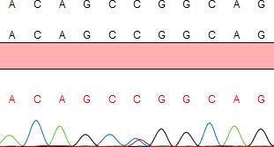

Supplementary figure 2
B4913_12B

Supplementary figure 2: Sanger sequencing confirming the respective variants of MYO1C in genomic DNA of affected patients. The mother (_12B) of proband (_23A) in family B3913 is shown heterozygous for MYO1C variant Arg98Trp.

