Supplementary Information for
Sectoral investments to achieve water, energy and land Sustainable Development Goals and enhance climate resilience
SDG | Literature max range [Billions USD/year] | MESSAGEix-GLOBIOM-Nexus range (long-term, after 2040) [Billion USD/year]
SDG7* | 9.4 – 299.1 | 11.6 – 17.9 (6.4 – 8.2)
SDG6 | 12.0 – 561.5 | 47.0 – 75.8 (127.7 – 128.2)
SDG 2,15** | 89.7 – 193.2 | -26.1 – -13.1 (-47.3 – -38.9)
Total | (sum) 111.1 – 1143.8 | (model) 20.9 – 63.7 (17.1 – 100.7)
Table 1: Annual average investment and O&M cost comparison between MESSAGEix model outputs and the literature relative to water infrastructure and energy supply. * for SDG7 the model only shows investment in the energy supply and water management sectors to fulfill cooling demand. ** The literature shows investment in the land sector, MESSAGEix-GLOBIOM results are still related to energy and water sectors. Unit, USD 2010

Scenario name | SDG | Climate impact | Water reliability (quantile)
noSDG_rcpref | No | historical |  | High, q90
noSDG_rcpref_lowrel | No | historical |  | Low, q50
noSDG_rcpref_medrel | No | historical |  | Medium, q70
noSDG_rcp6p0 | No | WEL, RCP 6.0 |  | High, q90
noSDG_rcp6p0_AC_HY | No | Energy, RCP 6.0 |  | High, q90
noSDG_rcp6p0_land | No | Land, RCP 6.0 |  | High, q90
noSDG_rcp6p0_lowrel | No | WEL, RCP 6.0 |  | Low, q50
noSDG_rcp6p0_medrel | No | WEL, RCP 6.0 |  | Medium, q70
noSDG_rcp6p0_noland_lowrel | No | Water-Energy , RCP 6.0 |  | Low, q50
noSDG_rcp6p0_noland_medrel | No | Water-Energy , RCP 6.0 |  | Medium, q70
noSDG_rcp6p0_noland | No | Water-Energy , RCP 6.0 |  | High, q90
noSDG_rcp6p0_wat_cool | No | Water , RCP 6.0 |  | High, q90
SDG_rcpref | WEL | historical |  | High, q90
SDG_rcpref_lowrel | WEL | historical |  | Low, q50
SDG_rcpref_medrel | WEL | historical |  | Medium, q70
SDG_rcp6p0 | WEL | WEL, RCP 6.0 |  | High, q90
SDG_rcp6p0_lowrel | WEL | WEL, RCP 6.0 |  | Low, q50
SDG_rcp6p0_medrel | WEL | WEL, RCP 6.0 |  | Medium, q70
SDG_AC_rcp6p0_AC_HY | Energy | WEL, RCP 6.0 |  | High, q90
SDG_AC_rcpref | Energy | historical |  | High, q90
SDG_land_rcp6p0_land | Land | WEL, RCP 6.0 |  | High, q90
SDG_land_rcpref | Land | historical |  | High, q90
SDG_wat_rcp6p0_wat | Water | WEL, RCP 6.0 |  | High, q90
SDG_wat_rcpref | Water | historical |  | High, q90
SDG_rcp6p0_noland | WEL | Water-Energy , RCP 6.0 |  | High, q90
SDG_rcp6p0_noland_lowrel | WEL | Water-Energy , RCP 6.0 |  | Low, q50
SDG_rcp6p0_noland_medrel | WEL | Water-Energy , RCP 6.0 |  | Medium, q70
Table 2: Full set of scenarios

S1.a
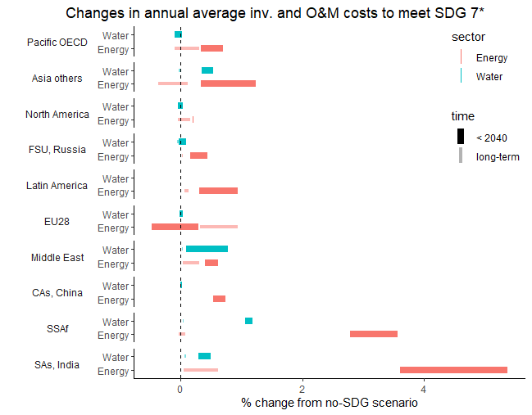
S1b
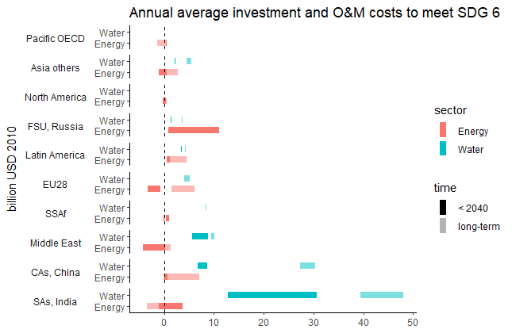

S1c
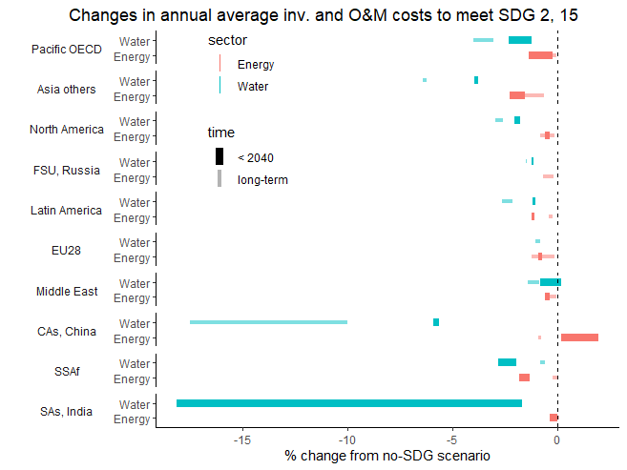
Figure 1: Changes in annual average investment and O&M costs across model regions and energy supply and water infrastructure to achieve energy (a), water (b), and land (c) sector SDG targets, for short-term (before 2040) and long-term (until 2100) time horizons. The bars are delimited by several scenarios with or without RCP 6.0 climate feedback and different reliability levels (See Table 2). The size of the bars indicates the uncertainty resulting from the selected set of scenarios. Positive values indicate increases in costs.

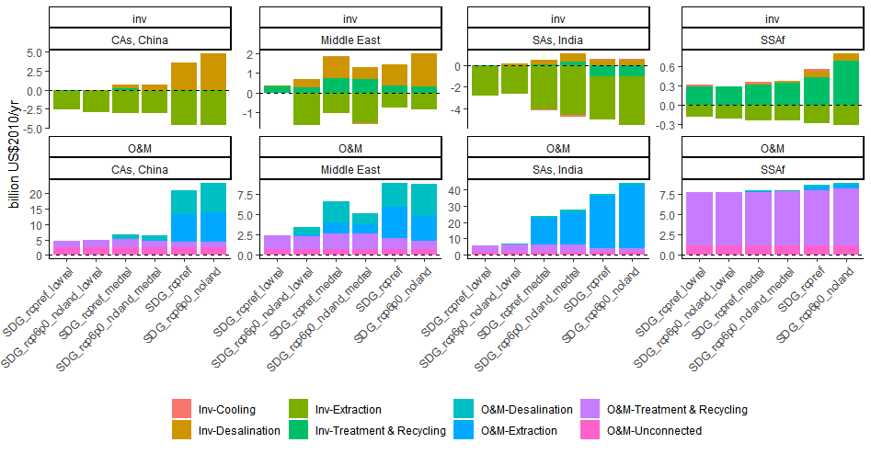
Figure 2 Differentiation between long-term average annual Investments and Operational & Maintenance (O&M) costs to achieve WEL SDGs. The bars show the sectoral split in water investments (left panels) and O&M costs (right) for three explanatory regions, Central Asia and China, Middle East, South Asia and South Saharan Africa. The values already represent the difference between the scenarios and their respective “noSDG” versions.

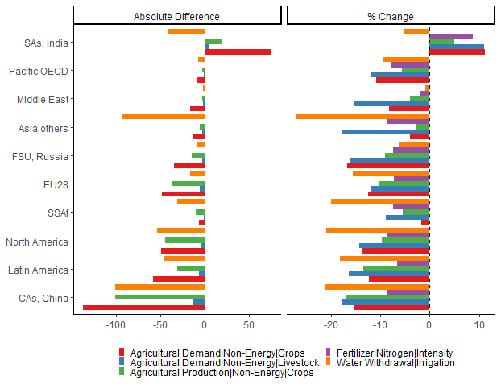
Figure 3: Effect of nutrition, food waste and biodiversity policies (SDG 2,15) on agriculture demand for non-energy crops, livestock [million t DM/yr], agricultural crop production million t DM/yr], use of Nitrogen-based fertilizers [t N/ha/yr], and water withdrawals for irrigation

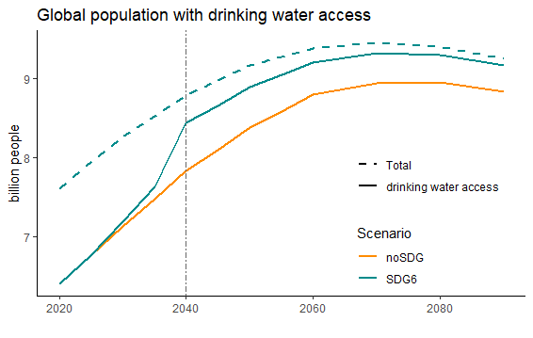
Figure 4: Trends of the population with drinking water access in scenarios with and without water SDG targets under the SSP2 assumption compared to the total population (dotted line, same for the two scenarios)

Land impact uncertainty

Rpc 6 – rcp ref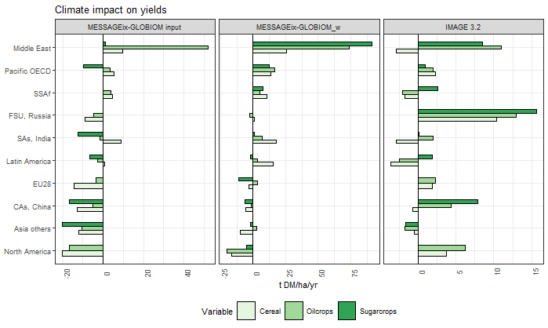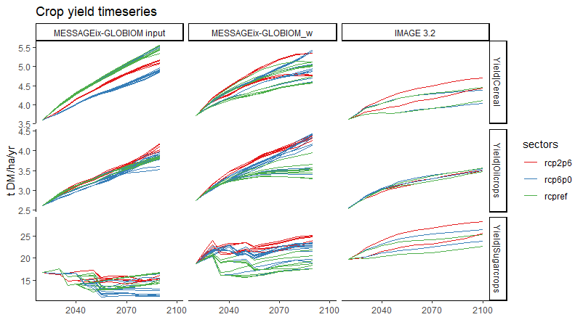
Figure 5: Crop yields change (a) and time-series (b) as climate impacts (MESSAGEix-GLOBIOM input and IMAGE 3.2) and as a result of the adaptation measures (MESSAGEix-GLOBIOM_w panel) for three crop types, cereal, oil crops and sugar crops.. Panel (a) shows the absolute changes in yearly average crop yields until 2100 comparing a scenario with RCP6.0 impacts to a no-impact, rcpref. Panel (b) shows time-series values until 2100 and also includes RCP2.6 values.

Energy impacts

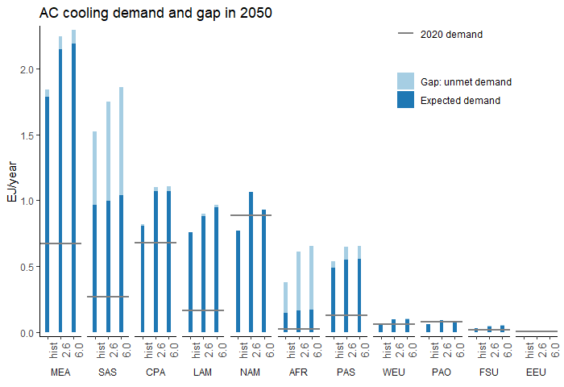
Figure 6: Estimated demand for thermal cooling in EJ/year for the MESSAGEix-GLOBIOM macro-regions for historical climate conditions and RCP 2.6 and 6.0. The light and dark blue bars represent respectively the demand that is expected to lack or to be met with current trend of development. Values for 2020 are signed by a grey horizontal line. Source (Mastrucci et al., 2021)

Water impacts
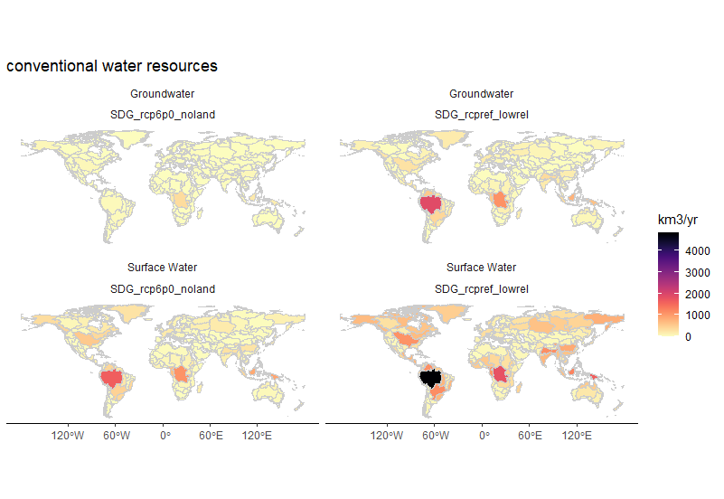
Figure 7: Renewable water resources in two SDG scenarios with different climate assumptions, namely historical or RCP 6.0 climate.

