Supplementary Information for
A microenvironment-modulating dressing with proliferative degradants for the healing of diabetic wounds
Lianghui Cheng, Zhiyong Zhuang, Mingming Yin, Yuan Lu, Sujuan Liu, Liyuan Zhao, Zhenyan He, Fanlin Meng*, Sidan Tian*, Liang Luo*

Supplementary figures
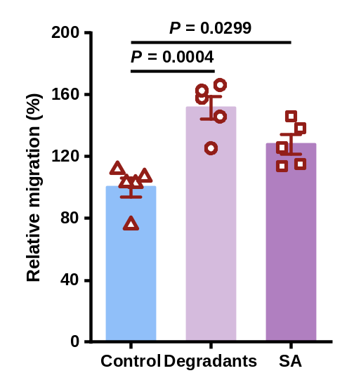
Supplementary Fig. 1 Quantification of HUVECs migration following 24 h incubation with the degradants and SA (n = 5).

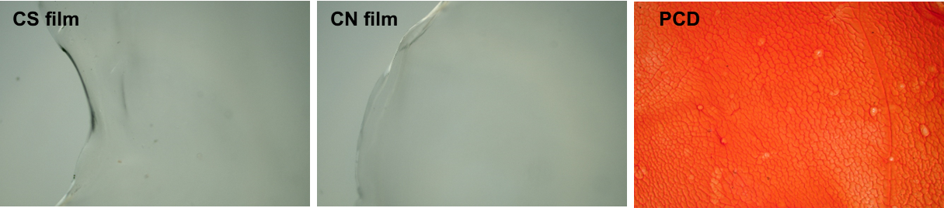
Supplementary Fig. 2 Microscope images of the surface of CS film, CN film, and PCD.

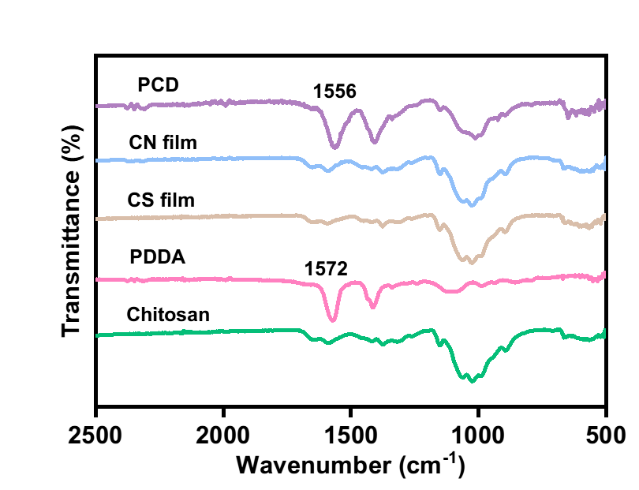Supplementary Fig. 3 FTIR spectra of PDDA, Chitosan, CS film, CN film and PCD.

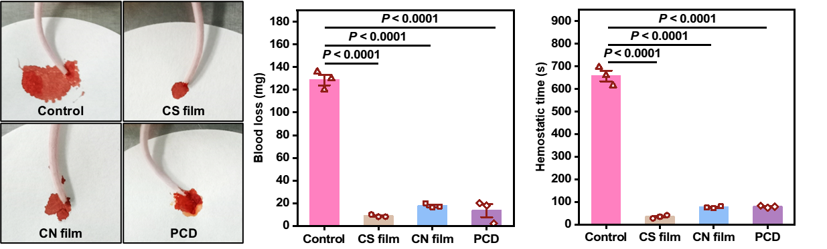Supplementary Fig. 4 Representative image of in vivo hemostasis of dressings in mice tail bleeding and the corresponding blood loss and hemostasis time.

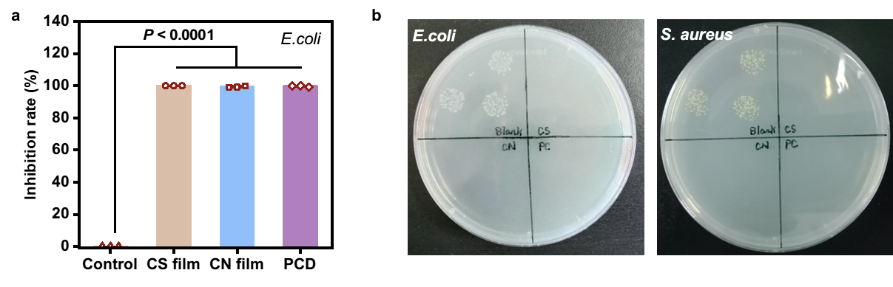
Supplementary Fig. 5 Anti-bacterial effect of extract solution against E.coli (n=3) (a) and representative picture of bacterial inhibition effects on E.coli and S.aureus (b).

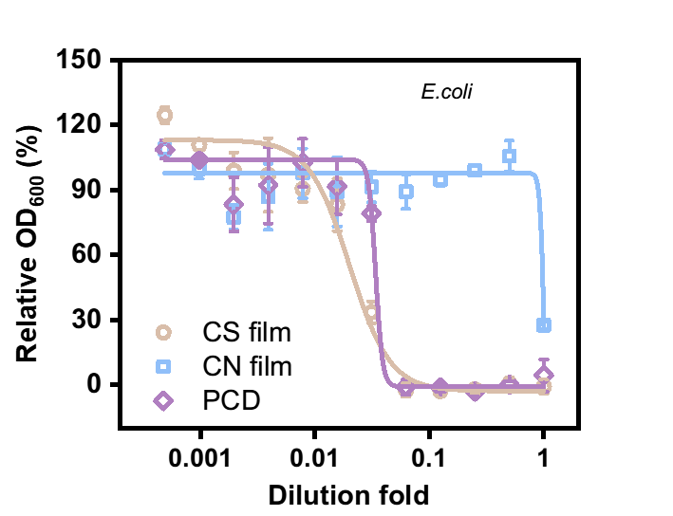
Supplementary Fig. 6 Anti-bacterial effect of extract solution against E.coli as a function of dilution fold (n=3).

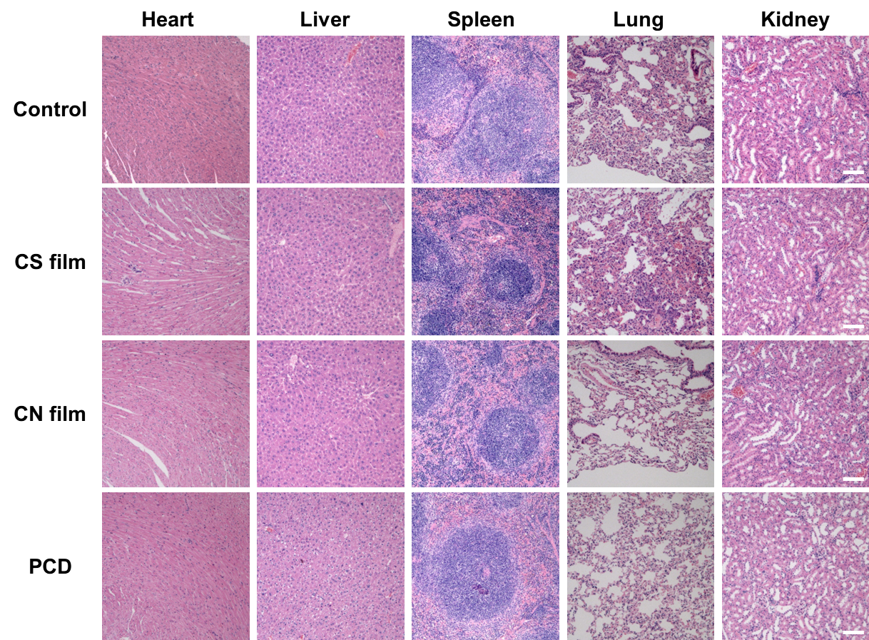
Supplementary Fig. 7 H&E staining of major organs in mice. Scale bar: 100 µm.

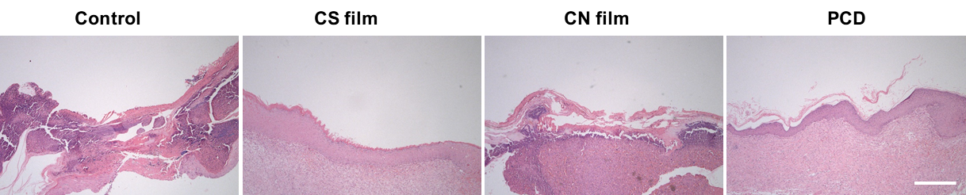
Supplementary Fig. 8 Representative H&E staining of wound tissue with different treatments on Day 12. Scale bar: 200 μm.

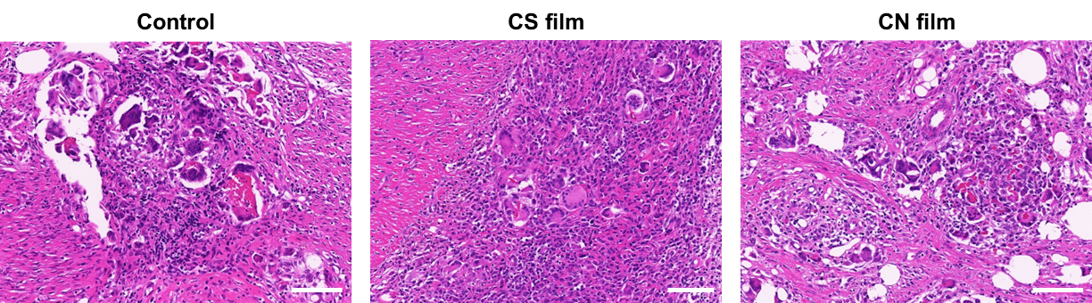Supplementary Fig. 9 Magnified picture of the clusters of inflammatory infiltrates of Control, CS, and CN groups. Scale bar: 100 μm.

Table S1. Wound healing scoring rubric. Rubric was used in the blinded, semi-quantitative assessment of H&E and Masson images of wound dressing-treated porcine skin wounds.
 | Neovascularization | Granulation tissue maturation | Epithelialization | Inflammation | Collagen
1 | Little evidence of endothelial cell ingrowth into wound site. | Little evidence of mesenchymal cell infiltration eschar predominant. | Little migration of epidermis from wound edges over granulation tissue. | Mostly resolved inflammatory response. No foreign body giant cells. | Little or no evidence of collagen fibers. Provisional matrix consists of fibrin.
2 | Angiogenic response at the wound margins and base; some extravasation. | Active expansion of mesenchymal infiltration from the base and margins of the wound, accompanied by neutrophils and mononuclear cells. | Initial progression of epidermal resurfacing with less than 50% coverage and hyperplasia. | Residual inflammatory infiltrate with some giant cells and mild mononuclear cell infiltrate. | Initial signs of collagen accumulation consisting of very fine fibrils in a random orientation.
3 | > 50% of granulation tissue shows neovascularization | Continued filling of the wound site and displacement of the eschar above the wound surface | 50-90% coverage of wound site. Clear polarized differentiation of epidermis | Substantial inflammatory infiltrate dominated by mononuclear cells but significant persistence of polymorphonuclear cells, frequently near wound surface | Moderate amount of collagen deposition
4 | Extensive vascularization with pruning and maturation of neovessels | Accumulation of extracellular matrix, reduced density of fibroblasts, and evidence of collagen fiber organization | 90-100% coverage of wound site with initiation of rete peg formation and advanced epidermal  differentiation | Heavy inflammatory infiltrate resulting in impairment of healing progression, and invasion of adjacent unwounded tissue. | Loosely assembled parallel collagen fibers
5 | Advanced vascular maturation with thinning of capillary networks | Extensive reconstruction of dermal architecture with absence of inflammatory infiltrate | Full keratinized epidermis with rete pegs and return of epidermal hyperplasia to thickness of adjacent, unwounded skin | Wound site dominated by inflammatory cells, including neutrophils, with consequent retardation of either granulation tissue or epidermal development. | Highly aligned collagen fiber networks with tendency to form reticular arrays. Reduced fibroblast density.

