Table 3: Extended summaries of personas (insert the table at the end of the results)
PERSONA | DEMOGRAPHICS | BRIEF DESCRIPTION | NEEDS
1. LUCA  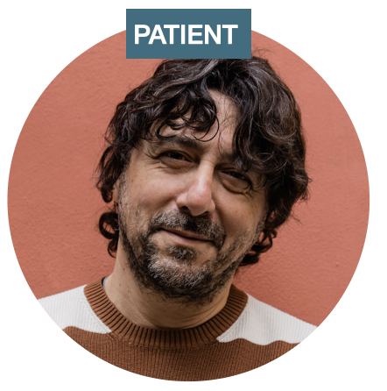 | Age: 40-49 years  Work: full-time  Family status: single, no children | Quote: It is difficult for people to understand our illness because they see us [without external symptoms], "this one is dreaming" [they think], and maybe internally we are dying.  - First to be diagnosed in the family due to strong attacks  - Started the diagnosis chain in his family  - Severe attacks  - Prophylactic treatment | - Psychological support: someone to talk to during difficult moments.  - Increasing awareness of HAE among local healthcare professionals as he is tired of trying to explain HAE. He had struggles when renewing his driving licence due to issues concerning disability benefits.  - Law 104. Luca has 70% of disability benefits. Living with HAE could be debilitating both physically and mentally. Therefore, more than economic support, he would like to have three-day permits under Law 104.
2. ESTHER  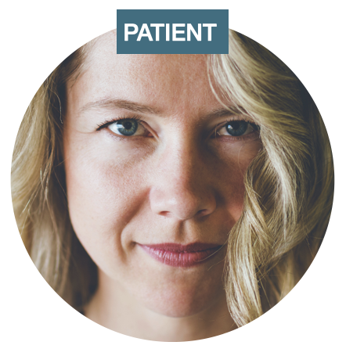 | Age: 30-39 years  Work: part-time  Family status: married, with a small child not diagnosed yet | Quote: One of the 800,000 doctors I went to...because I went to all kinds of doctors, I went at one point to the angiologist, to the rheumatologist, to any [specialist], until the last one suggested that I get an immunological examination prescribed.  - Experienced years of diagnosis delay that left her traumatised  - Not aware of family members affected  - Mild to moderate attacks  - Attack treatment only | - Psychological support: years of diagnosis delay traumatised her.  - Increasing awareness of HAE among regional and local healthcare providers (ER, GP, paediatricians, pharmacists, gynaecologists, gastroenterologists, etc).  - More information for women about inherited disorders like HAE and pregnancy, and motherhood.
3. ANTONIO  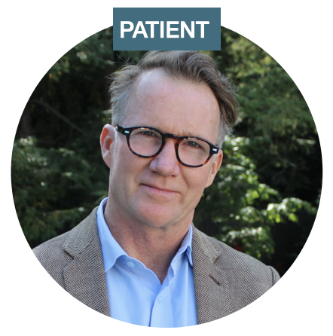 | Age: 50-59 years  Work: full-time  Family status: married, with 2 adult children | Quote: I always lived my life, since it's a psychological thing, even if I swelled up I did sports so my body was stressed no matter what. However, occasionally I am terrified of having a throat attack even though it hasn't yet happened.  - Got diagnosed accidentally as HAE didn't limit his life  - Family members and children affected by HAE  - Mild and less frequent attacks  - Attack treatment only | - Email newsletter: information about the latest treatment options, research advances and events, as well as opportunities to take part in studies could be shared with people with HAE.
4. MIRTA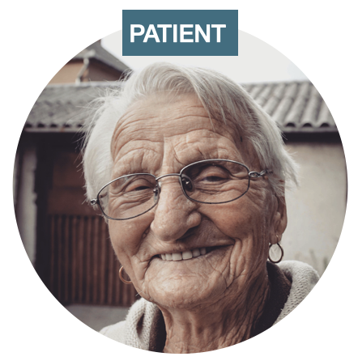 | Age: 80-89 years  Work: retired  Family status: widow, with 3 adult children | Quote: It was enough to say "I have angioedema" that they didn't do anything to you anymore, they treated you like a plague victim, no one wanted to give you medicine anymore, they didn't know how to do it. I often and willingly denied that I had angioedema.  - A senior lady who suffered a lot in the past due to HAE, including the trauma of finding her father dead, suffocated due to HAE  - Has adult children affected by HAE  - Age-related comorbidities  - Severe attacks in the past, now mild  - Attack treatment only | - Improve HAE ID cards. ID cards are a great way to let people know in cases of emergency about the condition of the person especially when they cannot talk or breathe.  - List of specialists: a list should be made available with all the local specialists that know about HAE that a person with HAE can go to for other health issues.  - More HAE centres. There is no centre in my region. She would like more specialist centres so that people affected with HAE don’t have to travel far for a visit.
5. GIUSY  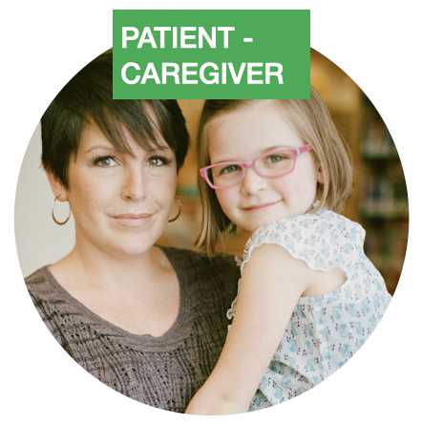 | Age: 30-39 years  Work: full-time  Family status: married, with one child diagnosed with HAE | Quote: I try to teach, as much as I can, a 7-year-old girl. I try to do it by calming her down, saying, "Do you see Mommy [how Mommy injects medicine]?"  - Diagnosed at paediatric age with her entire family  - Her child has HAE  - Moderate attacks  - Prophylactic treatment | - 24 hrs call centre: a dedicated emergency number available 24 hrs for people to call when needed rather than having to call their specialists at their private mobile number (clinicians may not be available).  - More defined paediatric care pathway: a more defined care pathway and regular checkups should be put in place, especially for children.  - Increasing awareness among kindergarten and school teachers about rare diseases like HAE (ex. Information brochures)
6. DAVIDE  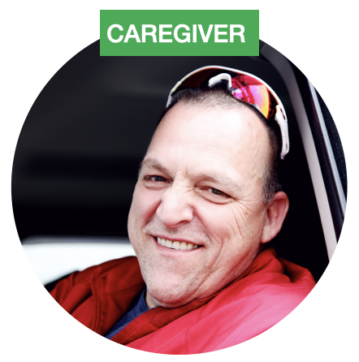 | Age: 30-39 years  Work: full-time  Family status: married, with one child diagnosed with HAE | Quote: With [the child] I can define the attack in the sense that I just had to see... one day my dad brought [the child] home he says "I don't know if she has a stomachache". I saw her in the bathroom, I looked at her face and I knew she had an angioedema attack.  - A non-affected caregiver  - His wife and daughter are affected by HAE | - Information for caregivers and parents about the latest therapies (to be secure about the future of their child).  - Psychological support. Over the years he learned to manage his anxiety and fear for his family, but he wishes he managed better past difficult moments.

