Supplementary Information: Emissions leakage and economic losses could limit the effectiveness of deforestation-linked oil crop import restrictions

Contents
S1 Literature review, gaps, and our modeling approach 2
S2 Methodology and scenario design 8
S2.1 Reference scenario 12
S2.2 Import restriction scenarios 13
S2.3 Land protect scenario 14
S2.4 Uncertainty in our scenarios 14
S3 Additional results 16
Supplementary Information References 24

S1 Literature review, gaps, and our modeling approach
Several methods have been used to analyze the implications of import restrictions on deforestation and land-use change (LUC) emissions. Here, we distinguish between two main groups of methods: impact assessments on deforestation regulation policies (Table S1) and global economic modeling studies (Table S2).
Several impact assessments (Table S1) were conducted prior to the enactment of EU deforestation regulations, considering various policy mechanisms. These assessments provide baseline estimates of how much deforestation and LUC emissions could be reduced with EU import restrictions in place. However, they rely on simplified assumptions about how future imports and demand could grow (e.g. using a static annual growth rate based on historical trends^{1,2}). These trends might not hold in the future, given changes in socioeconomics, prices, and interactions between different regions’ demands. For example, the most recent assessment of EU’s deforestation regulations projected an annual growth rate of 1.42% for oil palm imports in EU through 2030 based on historical trends¹. However, our study finds that EU import demand for oil palm could decline in future years in our Reference scenario (Table S3; see S2.1). Levels of future import demand could be a key factor in determining how effective import-side restrictions (enacted by specific importer regions) are in reducing deforestation and LUC emissions. Other simplified assumptions included in these impact assessments, such as static or historical deforestation intensities, LUC emissions intensities, or yield improvements, could also have significant implications for representing future dynamics.
Economic models that include land-use sector representation or are coupled to a detailed land model offer significant advantages in understanding the implications of changes in policy (e.g. import restrictions on deforestation-linked crops) on deforestation and LUC emissions³. Such models represent interactions between agricultural demands, trade, land-use allocation, and resulting LUC emissions. These models can endogenously consider international market switching, agricultural commodity substitution in consumption, factor substitution in production, and land-use reallocation. Several peer reviewed studies (Table S2) used global economic models to project changes in trade flows, land-use changes, and LUC emissions. We note that many of these studies used computable general equilibrium (CGE) models, mostly GTAP-based. CGE models offer significant benefits in tracing monetary-based trade flows in a way that is consistent with macroeconomic closures. However, challenges may arise in tracing physical flows or in translating CGE results into physical units, which is especially crucial for evaluating land-use change and its associated emissions⁴.
In this study, we use a modified version of the Global Change Analysis Model (GCAM) v7, an integrated multi-sectoral model. Using GCAM offers another perspective in understanding the implications of import restrictions on land-use changes and LUC emissions and can be a useful point of comparison with previous studies using global economic models. In contrast to CGE models, GCAM represents commodity trade in terms of physical primary equivalent units, therefore providing a more direct connection of trade flows to land use. Furthermore, while many CGE models represent implications of import restrictions in a historical counterfactual context, GCAM simulates them in a forward-looking context. Thus, using GCAM can help fill an important gap in understanding future land and economic implications of import restriction policies. GCAM, like other global economic models, uses a “consequential” (as opposed to “attributional”) approach in comparing scenarios (e.g., between a reference scenario and a policy scenario). This approach allows us to understand policy-included land- use changes and resulting LUC emissions, which account for both direct and indirect land- use change.
Table S1. Summary of previous EU deforestation impact assessments. Adapted from Table 7.15 in Bougas et al. (2023), with details added.
Study | Commodity | Policy region | Producing region | Study period | Methodology/Assumptions | Metrics evaluated
Bougas et al. (2023)¹ | All commodities covered in EU’s deforestation regulation: Palm oil, cattle (beef), cocoa, coffee, soy, and wood products | EU | Global | 2009-2019 (historical analysis) and projections to 2030 | 1. Uses import data as a proxy for consumption  2. Uses static annual growth rate for EU commodity demand  3. Uses static deforestation (ha/tonne) and emissions (tCO₂/tonne) intensity of imports  4. Leakage not considered | 1. Land-use changes  2. LUC emissions
IDH (2020)² | Palm oil and soy | 12 countries in EU | Global | 2018-2030 | 1. Uses static annual growth rates for EU commodity demand and sustainably sourced share  2. Estimates land needed to satisfy future demand, with country-specific (historical trend) yield improvements  3. Uses static emissions intensity of imports  4. Leakage not considered | 1. Land-use changes  2. LUC emissions
Heflich (2018)⁵ | Beef, soy, palm oil, maize, sugar, rapeseed | EU | Global | 1970-2016 (historical analysis) and projections to 2030 | 1. Estimates import price increases due to regulations and use the E3ME model to project annual growth rates for each commodity through 2030  2. Uses static share of EU imports in total consumption  3. Uses static deforestation and emissions intensity  4. Leakage not considered | 1. Land-use changes  2. LUC emissions  3. EU GDP and employment
COWI (2018)⁶ | Meat/beef, maize/corn, cocoa, coffee, palm oil, rubber, timber and wood products, bioethanol, and biodiesel | EU, UK | Global | 2015-2030 | 1. Uses simple demand growth rate projections and land use assumptions for commodities and regions to estimate additional land use requirements and deforestation  2. Leakage not considered | 1. Land-use changes
Cuypers et al. (2013)⁷ | Several ag products, services, textiles, wood products, manufacturing, energy, chemicals, mining, and transport | EU, UK | Global | 1990-2008 (historical analysis) and projections to 2030 | 1. Uses LANDFLOW (a physical-units trade model) and GTAP-MRIO (a monetary value trade model) to assess global trade flows of agricultural and forest commodities with embodied deforestation historically  2. Makes demand projection assumptions for 2020 and 2030 (e.g., based on diet changes and bioenergy plans)  3. Leakage not considered | 1. Trade flows [physical] and [$]  2. Land-use changes

Table S2. Summary of previous global economic modeling studies on deforestation-linked oil crop trade restrictions.
Study | Model | Commodity | Policy region | Producing region | Study period | Scenarios | Metrics evaluated
Villoria et al. (2022)⁸ | GTAP-AEZ | Soybean | EU, China | Brazil (spatially explicit, and with market shares of each company), displacement to Bolivia, Argentina, Paraguay | 2011-2016  (Historical counterfactual) | 1. Amazon Soy Moratorium (voluntary zero-deforestation commitment by companies)  2. ASM + pledged, yet to be implemented, global voluntary zero deforestation commitments in Brazil’s soy supply chain  3. Adoption of zero-deforestation by all companies exporting to EU  4. Zero-deforestation by all companies exporting to China  5. (3) + (4) | 1. Trade flows [$]  2. Land-use change  3. LUC GHG emissions
Busch et al. (2022)⁹ | GTAP-BIO and OSIRIS | Palm | EU, China, US, global | Indonesia (spatially explicit: high vs. low deforestation) | 2000-2015  (Historical counterfactual) | 1. Base scenario (all Indonesian palm oil treated equally, single global price)  2. Primary policy scenario: Europe imposed bans on high-deforestation palm oil  3. Secondary policy scenarios: expand ban to EU + US, EU + US + China, all other countries outside Indonesia and Malaysia | 1. Trade flows [$]  2. Prices  3. Land-use change  4. LUC GHG emissions  5. Equivalent carbon prices
Taheripour et al. (2019)¹⁰ | GTAP-BIO | Palm | domestic (Malaysia and Indonesia), global | Malaysia and Indonesia | 2011-2016  (Historical counterfactual) | 1. Regulation policy that freezes production of oil palm in M&I at 2011 levels via domestic production tax  2. (1) + an economic incentive (subsidy) to freeze forest area in M&I at the 2011 level  3. Uniform international tariff on the world imports of palm oil that freezes production of oil palm in M&I at 2011 levels along with freeze in forest area in M&I | Environmental metrics:  1. Land-use change  2. LUC GHG emissions  Economic metrics:  1. Consumer price index of vegetable oil  2. Wage rate  3. Welfare  Climate mitigation metrics:  1. Cost of abatement
Leijten et al., (2023)¹¹ | GTAP-AEZ | Palm | global | global | 2014-2030 | 1. Business as usual (BAU)  2. Full implementation of ZDCs globally across sectors | 1. Land-use changes
Delzeit et al., (2021)¹² | DART-BIO | Palm oil biofuel | EU | global | 2011-2030 | 1. Reference: no biofuel policies from 2019 onwards  2. Minimum of 2018 biofuel consumption shares; palm oil biodiesel reduced to 0% between 2022 and 2030  3. 7% of total consumption in transport until 2030; palm oil biodiesel reduced to 0% between 2022 and 2030  4. 7% of total consumption in transport until 2030; no restriction on palm oil biodiesel | 1. Agricultural commodity production and consumption, trade flows, and prices ($)  2. Land-use change
Valin et al. (2015)¹³ | GLOBIOM | Palm oil biofuel | EU | global | 2010-2030 | 1. Reference: biofuel consumption in EU (3.2%) and globally  2. Feedstock scenarios  3. Policy scenarios:  a. EU biofuel mix in 2020  b. EU biofuel mix in 2020 with 7% cap  4. Explorative scenarios, including lower/higher deforestation levels | 1. Land-use changes  2. LUC emissions

S2 Methodology and scenario design

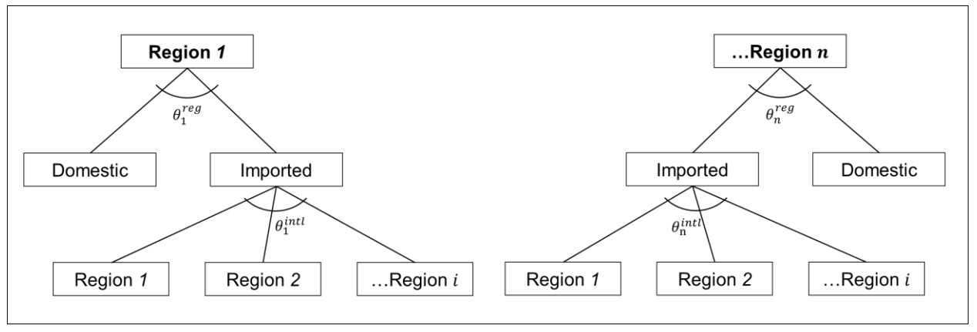
Figure S1. Logit-based Armington bilateral trade framework. Bilateral trade flows from region i to region n are observed. Adapted from Fig S3 in Zhao et al. (2022)¹⁴.

Table S3. Agricultural commodity mapping between GCAM commodity and FAO. GCAM staple crops include Wheat, Rice, Corn, OtherGrain, and RootTuber. GCAM also uses the primary roundwood data from FAOSTAT for forestry representation.
GCAM commodity | FAO primary item (240)
Wheat | Wheat
Rice | Rice, paddy
Corn | Maize
OtherGrain | Barley; Buckwheat; Canary seed; Cereals nes; Fonio; Grain, mixed; Oats; Quinoa; Rye; Triticale; Millet; Sorghum
Soybean | Soybeans
OilPalm (Tree) | Oil palm fruit
OilCrop | Castor oil seed; Hempseed; Jojoba seed; Linseed; Melonseed; Mustard seed; Oilseeds nes; Poppy seed; Rapeseed; Safflower seed; Sesame seed; Sunflower seed
OilCrop (Tree) | Coconuts; Kapok fruit; Karite nuts (sheanuts); Olives; Tallowtree seed; Tung nuts
RootTuber | Cassava; Potatoes; Roots and tubers nes; Sweet potatoes; Taro (cocoyam); Yams; Yautia (cocoyam);
FiberCrop | Fibre crops nes; Flax fibre and tow; Hemp tow waste; Jute; Manila fibre (abaca); Ramie; Seed cotton; Sisal
NutsSeeds | Groundnuts, with shell
NutsSeeds (Tree) | Almonds, with shell; Areca nuts; Brazil nuts, with shell; Cashew nuts, with shell; Chestnut; Hazelnuts, with shell; Kola nuts; Nuts nes; Pistachios; Walnuts, with shell
Legumes | Bambara beans; Beans, dry; Broad beans, horse beans, dry; Chick peas; Cow peas, dry; Lentils; Lupins; Peas, dry; Pigeon peas; Pulses nes; Vetches
SugarCrop | Sugar cane; Sugar beet; Sugar crops nes
Vegetables | Artichokes; Asparagus; Beans, green; Cabbages and other brassicas; Carobs; Carrots and turnips; Cassava leaves; Cauliflowers and broccoli; Chicory roots; Chillies and peppers, dry; Chillies and peppers, green; Cucumbers and gherkins; Eggplants (aubergines); Garlic; Leeks, other alliaceous vegetables; Lettuce and chicory; Maize, green; Melons, other (inc.cantaloupes); Mushrooms and truffles; Okra; Onions, dry; Onions, shallots, green; Peas, green; Pumpkins, squash and gourds; Spinach; String beans; Tomatoes; Vegetables, fresh nes; Vegetables, leguminous nes; Watermelons
Fruits | Berries nes; Blueberries; Cranberries; Currants; Gooseberries; Grapes; Pineapples; Raspberries; Strawberries
Fruits (Tree) | Apples; Apricots; Avocados; Bananas; Cashewapple; Cherries; Cherries, sour; Dates; Figs; Fruit, citrus nes; Fruit, fresh nes; Fruit, pome nes; Fruit, stone nes; Fruit, tropical fresh nes; Grapefruit (inc. pomelos); Kiwi fruit; Lemons and limes; Mangoes, mangosteens, guavas; Oranges; Papayas; Peaches and nectarines; Pears; Persimmons; Plantains and others; Plums and sloes; Quinces; Tangerines, mandarins, clementines, satsumas
MiscCrop | Anise, badian, fennel, coriander; Ginger; Hops; Pepper (piper spp.); Peppermint; Pyrethrum, dried; Spices nes; Tea; Tobacco, unmanufactured; Vanilla
MiscCrop (Tree) | Cinnamon (cannella); Cloves; Cocoa, beans; Coffee, green; Mate; Nutmeg, mace and cardamoms; Rubber, natural;
FodderGrass | forage Products; Grasses Nes for forage; Grasses Nes for forage; Rye grass for forage & silage
FodderHerb | Alfalfa for forage and silage; Beets for Fodder; Cabbage for Fodder; Carrots for Fodder; Clover for forage and silage; Green Oilseeds for Silage; Leguminous for Silage; Swedes for Fodder; Turnips for Fodder; Vegetables Roots Fodder; Maize for forage and silage; Sorghum for forage and silage
Beef | Meat, cattle; Meat, buffalo
Dairy | Milk, whole fresh cow; Milk, whole fresh camel; Milk, whole fresh buffalo; Milk, whole fresh goat; Milk, whole fresh sheep
Pork | Meat, pig
Poultry | Meat, duck; Meat, goose and guinea fowl; Meat, turkey; Meat, chicken; Meat, chicken; Eggs, other bird, in shell; Eggs, hen, in shell;
SheepGoat | Meat, sheep; Meat, goat
OtherMeat  &Fish | Freshwater Fish; Fish, Body Oil; Fish, Liver Oil; Demersal Fish; Pelagic Fish; Marine Fish, Other; Crustaceans; Cephalopods; Molluscs, Other; Aquatic Animals, Others; Aquatic Plants; Meat, Aquatic Mammals; Meat, rabbit; Meat, camel; Meat, other camelids; Meat, horse; Meat, ass; Meat, mule; Meat, other rodents; Meat, bird nes; Meat, game; Meat nes; Offals, edible, cattle; Offals, edible, buffaloes; Offals, pigs, edible; Offals, sheep,edible; Offals, edible, goats; Offals, horses; Offals, edible, camels; Offals, liver chicken; Offals, liver geese; Offals, liver duck; Offals, liver turkeys; Offals nes; Liver prep.; Fat, cattle; Fat, buffaloes; Fat, sheep; Fat, goats; Fat, pigs; Fat, camels; Fat, other camelids; Oils, fats of animal nes; Degras; Grease incl. lanolin wool; Fat nes, prepared; Honey, natural; Snails, not sea

Table S4. Scenario design with import demand summary statistics. ‘Deforesting regions’ are defined as regions deforesting in REF between 2015 and 2050 (see Figure S3 for details). % values are calculated on the basis of palm and soy import demand volumes (Mt).
Scenario | Policy | Import restricting regions | - % share of 2020 import demand represented by the set of import restricting regions |  | - % change in import demand between 2020 and 2050 (in REF scenario) for the set of import restricting regions
Scenario | Policy | Import restricting regions | Palm | Soy | Palm | Soy
REF | None | n/a | 0% | 0%
EU freeze | Ceiling on imports from deforesting regions at 2020 levels | EU | 20% | 18% | -15% | 38%
HighInc freeze | Ceiling on imports from deforesting regions at 2020 levels | EU, rest of Europe (EFTA and Europe_Non_EU), Argentina, Australia_NZ, Brazil, Canada, China, Japan, Mexico, Middle East, Russia, South Korea, Taiwan, USA | 51% | 77% | 13% | 50%
EU/Top 5 freeze | Ceiling on imports from deforesting regions at 2020 levels | EU and top 5 net importers for oil palm and soy:  For oil palm: EU, India, China, Pakistan, Middle East, Australia_NZ  For soybean: EU, China, rest of Southeast Asia, Middle East, Africa_Northern, Indonesia | 64% | 78% | 33% | 61%
EU ban | Full ban on imports from deforesting regions | EU | 20% | 18% | -15% | 38%
Land protect | Protect forest land in each deforesting region equivalent to land reduced from oil palm and soy production in HighInc freeze - REF | n/a

A key insight from our study is that EU-only policy (EU freeze scenario) has minimal impact in reducing oil palm and soy production from deforesting regions relative to our REF scenario, and consequently, minimal impacts on land-use changes, LUC emissions, and economic impacts. The key reason driving this outcome is that the EU region alone makes up a small fraction of demand for palm and soy (see column (A) in Table S4 above). In contrast, when additional regions impose import restrictions (as in the HighInc freeze and EU/Top5 freeze scenarios), larger fractions of import demand are constrained. Furthermore, the EU region has smaller increases in soy demand and has decreases in palm demand, compared to the set of import-restricting regions in the HighInc freeze and EU/Top5 freeze scenarios (see column (B) in Table S4 above).
EU’s small and diminishing share of global demand for palm and soy is driven by underlying demographic changes, as high-income regions in the EU are projected to have declining population in the coming decades, leading to decreased demand for oil crops. Furthermore, given the EU’s stringent NDC targets, our scenarios project increased electrification and therefore lower demand for 1G-based bio-liquids. These underlying trends, which are already reflected in our baseline REF scenario explain why the EU freeze scenario has minimal impact.

S2.1 Reference scenario
Our baseline REF scenario is consistent with limiting warming to 2°C by 2100. This scenario includes emission constraints on FFI emissions for each GCAM region, consistent with “NDC++” pathways in Iyer et al. (2022)¹⁵. Further, we included a global bioenergy constraint, limiting 1st and 2nd generation bioenergy to less than 33.4 EJ in 2020, increasing linearly to 41.7 EJ in 2030 and 58.4 EJ in 2050 (100 EJ in 2100).
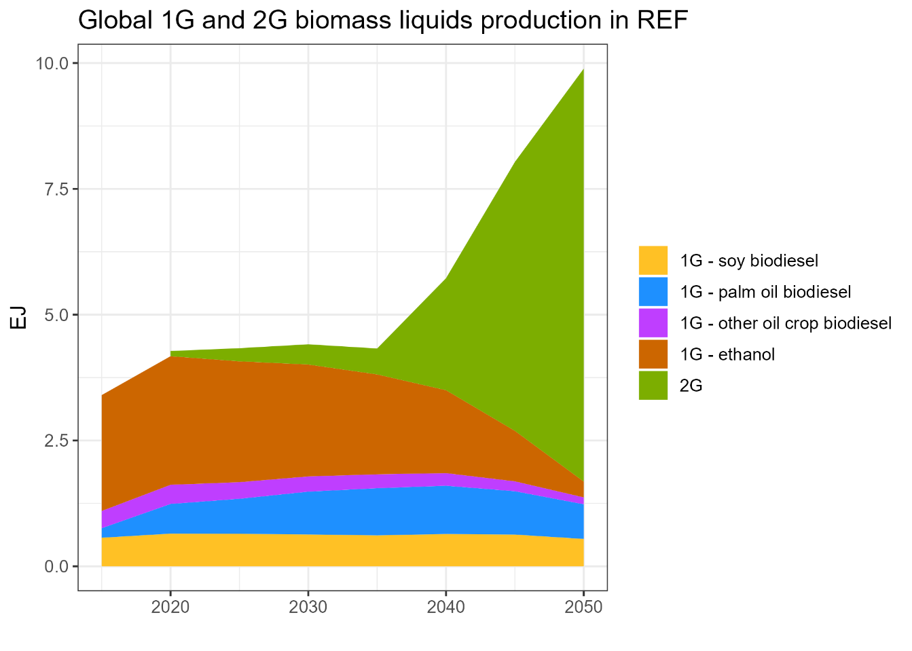
Figure S2. Global 1G and 2G biomass liquids production in REF scenario.
The trajectory of first- versus second-generation liquid biofuels in our REF scenario (Figure S2) has important implications for near-term versus longer-term (i.e., 2030 versus 2050) in our results (see discussion in section S3 below). Changes in production of first-generation biodiesel from oil crops (soy, palm oil, or other oil crops) are minimal over the coming decades, with small declines in 2050 relative to 2020 levels. In contrast, production of second-generation liquid biofuels grows significantly from 2035 onward.

S2.2 Import restriction scenarios
The import restriction scenarios were modeled by including import constraints between source and destination markets for oil palm and soybean trade. Restricted export markets were defined as regions deforesting between 2015-2050 in the REF scenario (Figure S3).
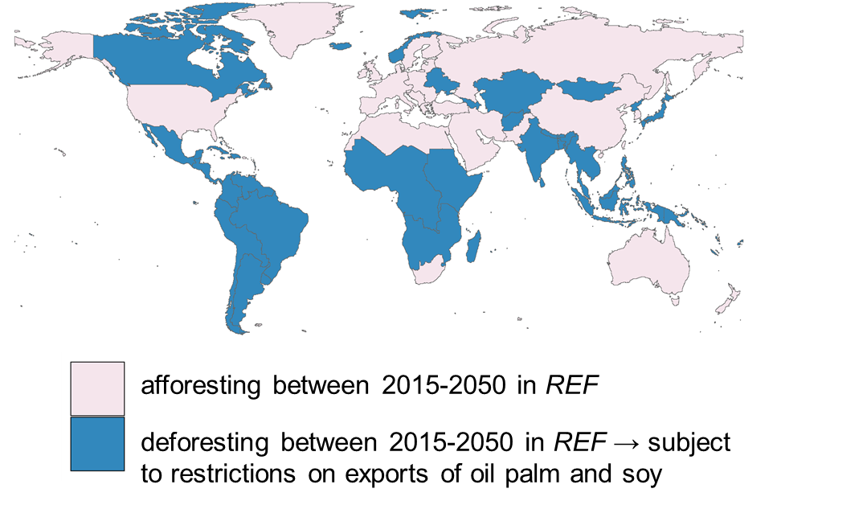
Figure S3. Restricted export market regions under import restriction scenarios (shown in blue). These regions are defined as those GCAM regions that had net deforestation between 2015 and 2050 in the REF scenario. These regions are Africa_Eastern, Africa_Southern, Africa_Western, Argentina, Brazil, Canada, Central America and Caribbean, Central Asia, Colombia, Europe_Eastern, European Free Trade Association, India, Indonesia, Japan, Mexico, South America_Northern, South America_Southern, South Asia, rest of Southeast Asia
EU’s currently enacted deforestation regulations restrict the specific imports (at a supply-chain level) linked to deforestation¹⁶. In this analysis, we do not consider the impact of import restrictions on finer-spatial scale regions or targeting specific producers, which could be considered a more direct interpretation of EU’s current policy. Given that our trade flows are modeled at a regional level, we therefore interpret the existing regulation as a “freeze”, holding exports from these deforesting regions constant at 2020 levels, thus preventing future deforestation and land- use changes to accommodate increased exports to import-restricting regions. The current EU regulation is modeled as the EU freeze scenario, with extensions to other import-restricting regions in the HighInc freeze and EU/Top 5 freeze scenarios. Meanwhile, the EU ban scenario represents an extension along another dimension, in which the EU fully bans all imports of oil palm and soy from deforesting regions.

S2.3 Land protect scenario
The Land Protect scenario is intended to be a policy of comparable magnitude to the HighInc freeze scenario. This scenario was modeled by calculating the reduction in oil palm or soybean land in each deforesting (export-restricted) region under the HighInc freeze scenario. This value was added to forest land value in the REF scenario in each region to form a set of explicit land protection constraints for each deforesting region from 2025 to 2050.
In comparing the cumulative economic impact changes (Figure 4) under import restriction scenarios and the Land Protect scenario, we note that economic impacts on agricultural producers and consumers are just one aspect of the economic costs of each policy. Import restriction policies or direct land protection policies could have other economic costs, such as those related to measurement, reporting, and verification (MRV). A full comparison of the costs of import restriction policies versus direct forest protection policies is outside the scope of this study. However, we note that import restrictions (as currently structured in the EU), which rely on deforestation-free certification of specific commodity supply chains (from specific regions) in order to allow imports could also face issues with MRV, comparable to those of direct land protection policies.

S2.4 Uncertainty in our scenarios
There are several dimensions of uncertainty that could be important in affecting the magnitudes of changes in outcomes we report in this study. For example, different choices in land-based mitigation strategies¹⁷ could have significant uncertainty in biofuel trajectories, which could have important implications for our results in import restriction scenarios. If growth of second-generation biofuels is lower than assumed in our REF baseline (section S2.1), there would be higher levels of first-generation biofuels in the REF scenario. Consequently, there would be larger changes in oil crop trade flows and higher effectiveness in reducing deforestation and LUC emissions under import restriction scenarios relative to REF.
Given the high rates of land-switching leakage under import restriction scenarios observed in our results (see ‘Land-use and emissions implication of import restrictions’ section in Results), another key area of uncertainty in our REF baseline relates to land-switching logit parameters. If these parameters maintained more rigidity in land use allocation, land-switching leakage rates might be lower, resulting in higher effectiveness in reducing deforestation and LUC emissions under import restriction scenarios.
GCAM accounts for land intensification exogenously over time (i.e., increasing agricultural yields), as well as endogenous land intensification in response to prices (i.e., increase in yield due to higher-cost inputs like irrigation and fertilizer). However, our scenario construction does not assume additional explicit policies focused on intensification of existing oil crop land in deforestation-linked oil crop exporting regions in response to import restrictions, which could allow for increased production without expanding of land footprint. Accounting for such land intensification policies explicitly could reduce market-switching leakage and land-switching leakage and reduce overall deforestation and LUC emissions. Thus, in the absence of such land intensification policies, our scenarios can be considered an upper bound to the level of global emissions leakage possible and a lower bound to how much benefit import restriction policies can provide, in reducing deforestation and LUC emissions.
Other sources of uncertainty, such as broader socioeconomic trends, could also play a role in determining the exact magnitudes of changes in oil crop production and trade volumes, land-use changes, and LUC emissions. Overall, the key takeaways from our study are not the exact magnitudes, but rather the broad trends and insights that result under each of the policy scenarios compared to REF. A more detailed uncertainty quantification of multiple parameters could be considered for future work. Nevertheless, we believe that the key insights observed in our scenario results reveal important considerations for broader policymaking.

S3 Additional results
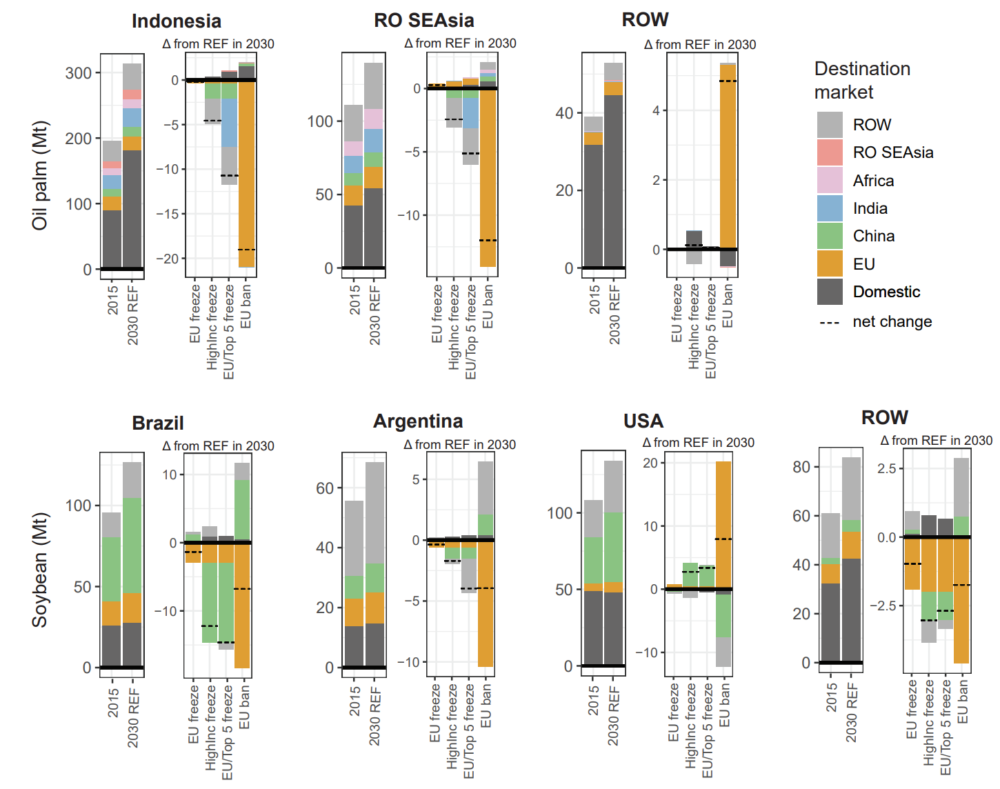
Figure S4. Oil palm and soybean production (domestic and bilaterally traded flows). Top) oil palm and bottom) soybean production volumes by region across scenarios (million tons). The left panel for each region shows total production in 2015 and 2030 REF and the right panel for each region shows the change in production between each import restriction scenario and REF in 2030. Domestic production volumes are consumed within the indicated producing region.
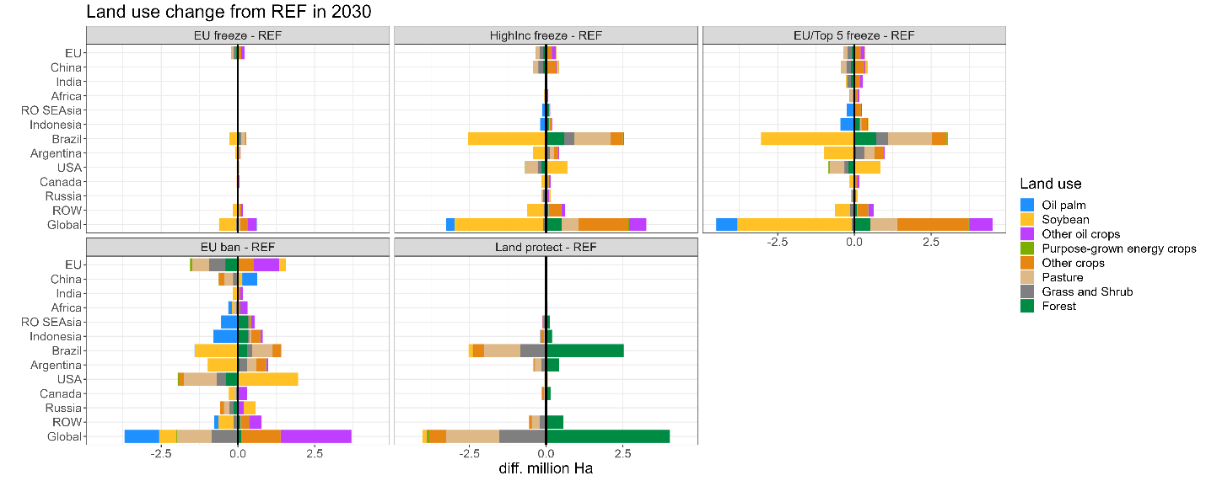
Figure S5. Land-use change. The panels show changes in land use across scenarios relative to REF in 2030 (million ha).
In the near term (2030), the EU substitutes other oil crops (e.g., rapeseed and sunflower oils) to meet biofuel demands, grown domestically or imported from other regions, particularly in the EU ban case in which there is a total phaseout of palm and soybean imports from deforesting regions (Figure S3). By 2050, land substituted for other oil crops is greatly reduced as the use of all first-generation biofuels in the EU is reduced in the baseline REF scenario (Figure 2).

Table S5. Cumulative LUC emissions changes. Percent change in cumulative LUC emissions (a) 2020-2050, (b) 2020-2075, (c) 2020-2100) in key deforestation-prone oil crop exporting regions and globally compared to REF.
- Cumulative 2020-2050 | EU freeze | HighInc freeze | EU/Top 5 freeze | EU ban | Land protect
Indonesia | +0.04% | -0.6% | -1.2% | -1.6% | -1.5%
RO SEAsia | +0.07% | -1.7% | -0.5% | -2.1% | -1.8%
Brazil | -0.7% | -6.4% | -8.3% | -1.8% | -11%
Argentina | -0.1% | -1.2% | -4.6% | -2.8% | -4.5%
Global | -0.05% | -0.6% | -0.8% | -0.00% | -2.2%
- Cumulative 2020-2075 | EU freeze | HighInc freeze | EU/Top 5 freeze | EU ban | Land protect
Indonesia | +0.03% | -0.7% | -1.5% | -1.5% | -1.7%
RO SEAsia | +0.05% | -2.0% | -1.1% | -1.9% | -2.0%
Brazil | -0.8% | -6.6% | -8.8% | -1.8% | -12%
Argentina | -0.00% | -1.0% | -4.3% | -2.5% | -4.4%
Global | -0.04% | -0.6% | -0.7% | +0.05% | -2.4%
- Cumulative 2020-2100 | EU freeze | HighInc freeze | EU/Top 5 freeze | EU ban | Land protect
Indonesia | +0.02% | -0.7% | -1.6% | -1.5% | -1.7%
RO SEAsia | +0.04% | -2.1% | -1.2% | -1.9% | -2.1%
Brazil | -0.8% | -6.6% | -8.8% | -1.8% | -12%
Argentina | 0.00% | -1.0% | -4.3% | -2.5% | -4.5%
Global | -0.04% | -0.6% | -0.7% | +0.08% | -2.5%

Table S6. Losses in cumulative agricultural revenue divided by reductions in cumulative LUC emissions reductions (2020$/tCO2). This metric (A/B; shaded in blue) represents agricultural revenue loss per ton of land carbon sequestration (emissions avoided) induced by the extended import restriction policies (relative to REF). This metric is shown for key deforestation-linked oil crop-exporting regions, which experience losses in cumulative agricultural revenue and reductions in cumulative LUC emissions in extended import restriction scenarios. All cumulative values are from 2020-2050.
 | HighInc freeze - REF |  |  | EU/Top 5 freeze - REF |  |  | EU ban - REF
 | (A) Δ cum. total primary agricultural revenue (billion $2020) | (B) Δ cum. LUC emissions (MtCO2) | (A/B) 2020$/tCO2 | (A) Δ cum. total primary agricultural revenue (billion $2020) | (B) Δ cum. LUC emissions (MtCO2) | (A/B) 2020$/tCO2 | (A) Δ cum. total primary agricultural revenue (billion $2020) | (B) Δ cum. LUC emissions (MtCO2) | (A/B) 2020$/tCO2
Indonesia | -18.9 | -52.3 | $362 | -32.1 | -97.7 | $329 | -58.7 | -131 | $447
RO SEAsia | -24.8 | -114 | $217 | -20.1 | -33.3 | $602 | -43.4 | -145 | $300
Brazil | -223 | -1067 | $209 | -276 | -1376 | $201 | -89.1 | -311 | $287
Argentina | -23.1 | -30.7 | $752 | -67.2 | -111 | $603 | -54.2 | -69.2 | $782

This metric should be interpreted with caution. The “loss” of agricultural production revenue experienced is not a pure loss for producers since revenue does not equal profit or welfare. Therefore, this “loss” cannot be directly compared to the “benefit” of LUC emissions reduction. Furthermore, this price does not represent the price at which this level of LUC CO2 emissions reduction could be feasibly achieved— there may not be a dollar-for-dollar equivalency between agricultural production revenue and credit for LUC emissions mitigation, and such carbon storage policies could also have other implementation costs. Future work is needed to do a more sophisticated cost-benefit analysis in this context. Nevertheless, this puts the LUC emission reductions that can be achieved in each region into context with losses in agricultural production revenue, giving an indication of the level of redistribution that would be needed to counteract inequities on producers resulting from extended import restrictions. For context, the fossil fuel and industrial process (FFI) carbon prices for these four regions ranged $104-$175 (2020$/tCO2) in 2025.

This metric also reveals some interesting insights, in comparing values across regions and scenarios. In general, this metric is lower in Brazil than other key exporting regions, implying that there is higher “policy efficiency” in import restrictions in Brazil than other key exporting regions, in having lower cost per ton-CO2 mitigated. For most regions (except rest of Southeast Asia), a complete EU ban on palm and soy from deforesting regions represents the most inefficient policy among the extended import restrictions modeled here.
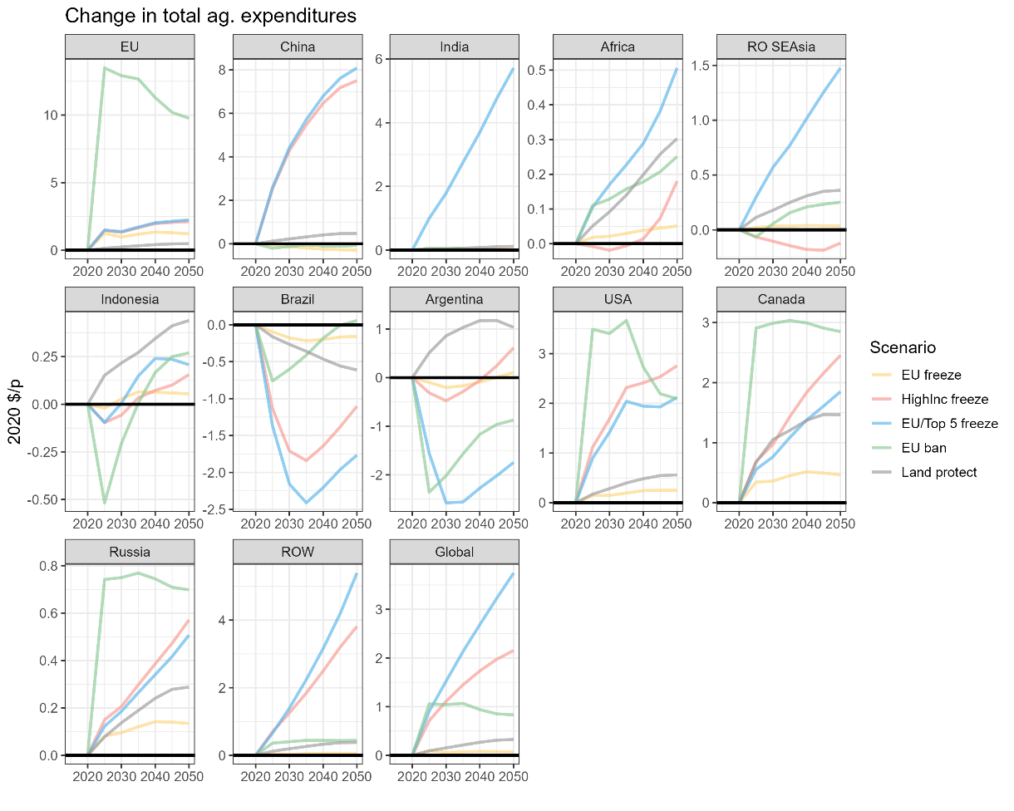
Figure S6. Change in per capita annual total primary agricultural expenditures over time. This metric is calculated as total primary agricultural expenditure in each year divided by population in each year.
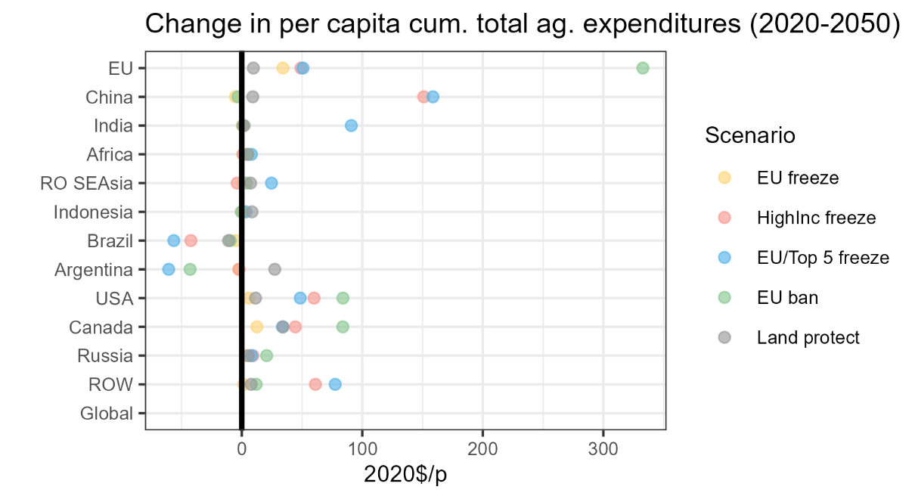
Figure S7. Change in per capita cumulative total primary agricultural expenditure in 2050. This metric is calculated as cumulative total primary agricultural expenditure (2020-2050) divided by the mean population over 2020-2050.
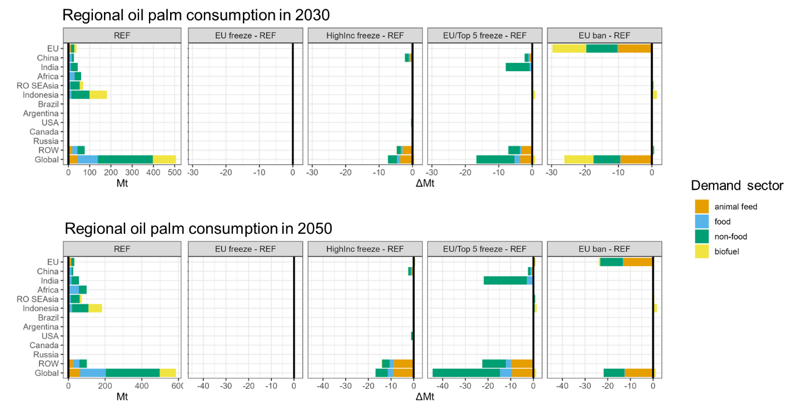
Figure S8. Regional oil palm consumption. The leftmost panels show REF oil palm consumption in 2030 (top) and 2050 (bottom) across demand sectors: animal feed, food, non-food, and biofuel. The right panels show changes in oil palm consumption relative to REF in 2030 (top) and 2050 (bottom). Units are in million tons (Mt).

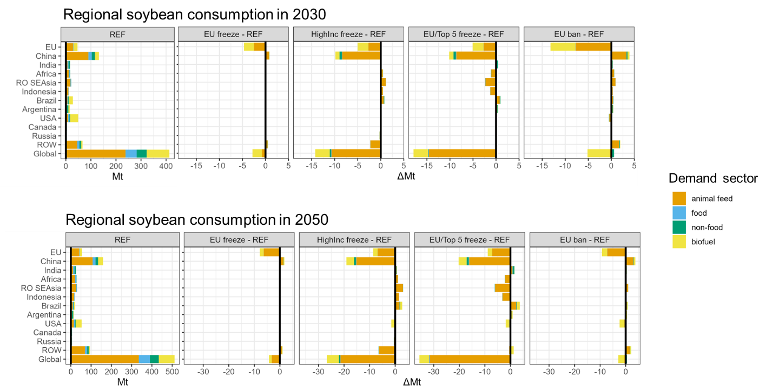
Figure S9. Regional soybean consumption. The leftmost panels show REF soybean consumption in 2030 (top) and 2050 (bottom) across demand sectors: animal feed, food, non-food, and biofuel. The right panels show changes in soybean consumption relative to REF in 2030 (top) and 2050 (bottom). Units are in million tons (Mt).

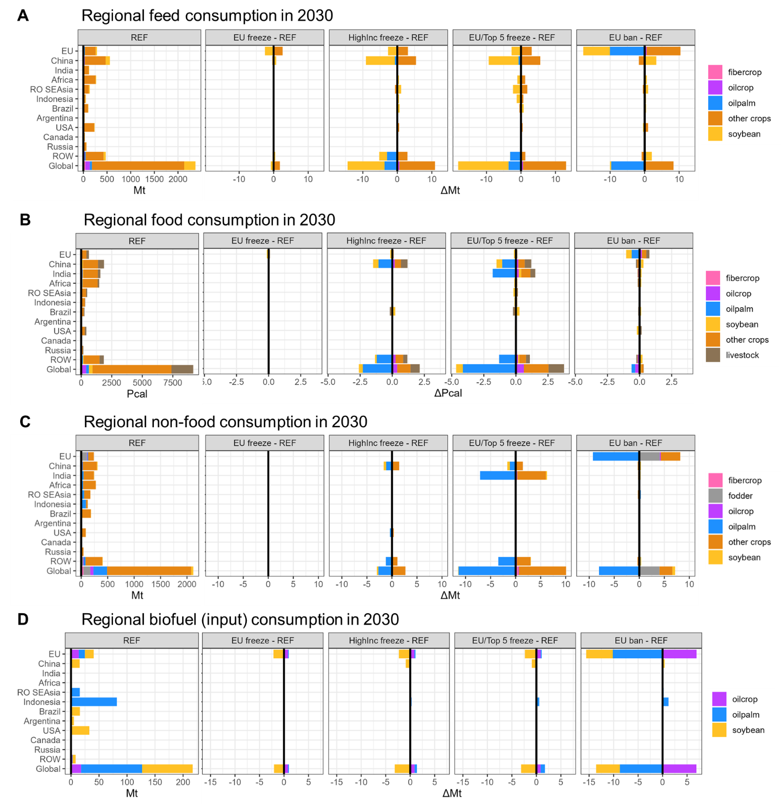
Figure S10. Regional agricultural consumption by demand sector in 2030. A) animal feed (Mt), B) food (Pcal), C) Non-food (Mt), D) biofuel input (Mt). The leftmost panels show REF consumption of agricultural commodities. The right panels show changes in agricultural consumption relative to REF.

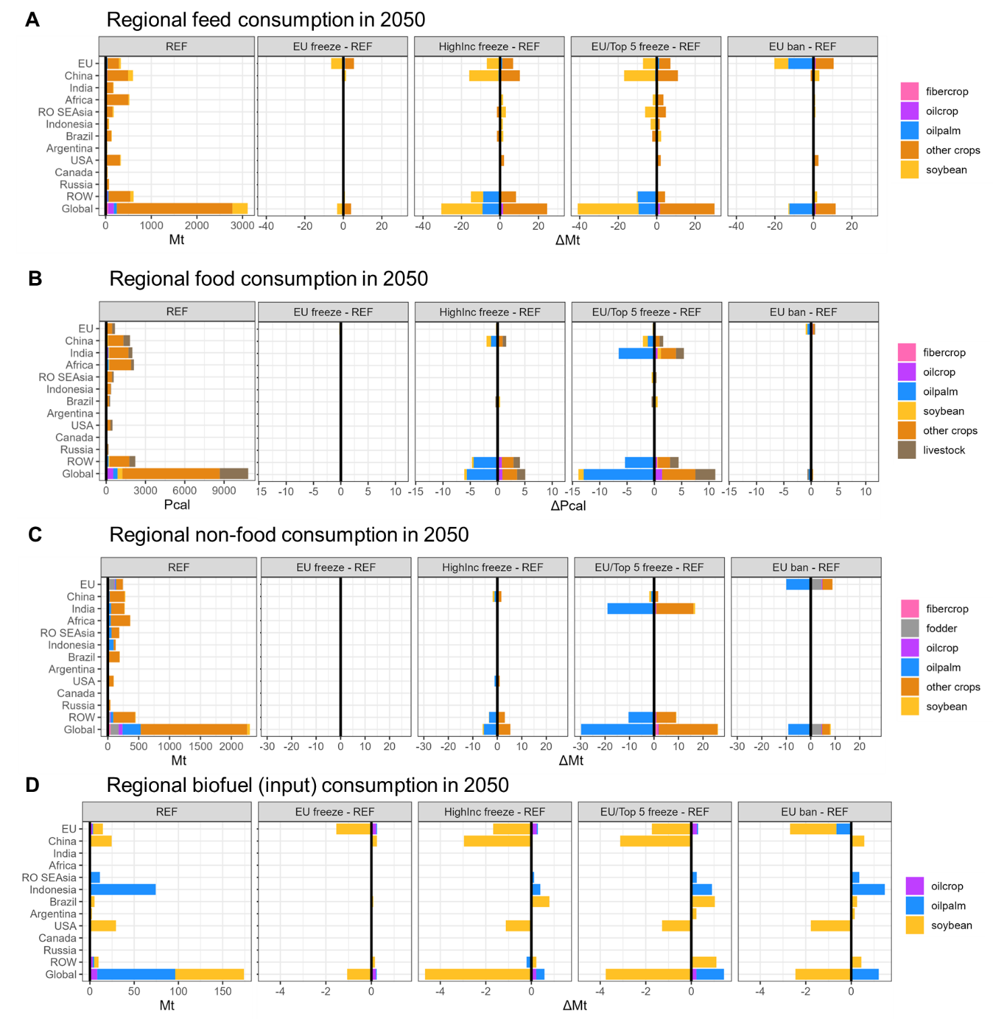
Figure S11. Regional agricultural consumption by demand sector in 2050. A) animal feed (Mt), B) food (Pcal), C) Non-food (Mt), D) biofuel input (Mt). The leftmost panels show REF consumption of agricultural commodities. The right panels show changes in agricultural consumption relative to REF.

Supplementary Information References
1. Bougas, K. et al. Service Contract on EU Policy on Forest Products and Deforestation Task 3 - Impact Assessment on Demand-Side Measures to Address Deforestation. https://circabc.europa.eu/ui/group/34861680-e799-4d7c-bbad-da83c45da458/library/5d098237-8bab-48a6-a6c8-2a907d80c791/details?download=true (2023).
2. IDH. The Urgency of Action to Tackle Tropical Deforestation: Protecting Forests and Fostering Sustainable Agriculture. https://www.idhsustainabletrade.com/uploaded/2020/02/IDH_The-UoA-to-Tackle-Tropical-Deforestation_2020-web.pdf (2020).
3. Model Comparison Exercise Technical Document. https://nepis.epa.gov/Exe/ZyPDF.cgi?Dockey=P1017P9B.pdf (2023).
4. Zhao, X., van der Mensbrugghe, D. Y., Keeney, R. M. & Tyner, W. E. Improving the way land use change is handled in economic models. Econ. Model. 84, 13–26 (2020).
5. Heflich, A. An EU Legal Framework to Halt and Reverse EU-Driven Global Deforestation: European Added Value Assessment. (Publications Office, LU, 2020).
6. COWI. Feasibility Study on Options to Step up EU Action against Deforestation: PART I, Background Analysis, Scale and Trends of Global Deforestation and Assessment of EU Contribution and PART II, a Potential EU Initiative on Deforestation, Possible Interventions. (Publications Office, LU, 2018).
7. Cuypers, D. et al. The Impact of EU Consumption on Deforestation: (2013).
8. Villoria, N., Garrett, R., Gollnow, F. & Carlson, K. Leakage does not fully offset soy supply-chain efforts to reduce deforestation in Brazil. Nat. Commun. 13, 5476 (2022).
9. Busch, J. et al. Effects of demand-side restrictions on high-deforestation palm oil in Europe on deforestation and emissions in Indonesia. Environ. Res. Lett. 17, 014035 (2022).
10. Taheripour, F., Hertel, T. W. & Ramankutty, N. Market-mediated responses confound policies to limit deforestation from oil palm expansion in Malaysia and Indonesia. Proc. Natl. Acad. Sci. 116, 19193–19199 (2019).
11. Leijten, F., Baldos, U. L. C., Johnson, J. A., Sim, S. & Verburg, P. H. Projecting global oil palm expansion under zero-deforestation commitments: Direct and indirect land use change impacts. iScience 26, (2023).
12. Delzeit, R., Heimann, T., Schünemann, F. & Söder, M. Who benefits really from phasing out palmoil-based biodiesel in the EU?
13. Valin, H. et al. The land use change impact of biofuels consumed in the EU. (2015).
14. Zhao, X. et al. The impact of agricultural trade approaches on global economic modeling. Glob. Environ. Change 73, 102413 (2022).
15. Iyer, G. et al. Ratcheting of climate pledges needed to limit peak global warming. Nat. Clim. Change 12, 1129–1135 (2022).
16. Texts Adopted - Deforestation Regulation. (2023).

