Supporting figure captions
Fig. S1 Design of the field experimental platform of N addition in an evergreen broadleaved forest at Shimentai National Nature Reserve of Guangdong Province, southern China. CK, control; CN25 and CN50, canopy addition of 25 and 50 kg N ha⁻¹ yr⁻¹, respectively; UN25 and UN50, understory addition of 25 and 50 kg N ha⁻¹ yr⁻¹, respectively.

Fig. S2 Classification of silicon (Si) fractions using CaCl₂, H₂O₂ and sodiumacetate buffer, NH₂OH·HCl, NaOH extractions. Adapted from Georgiadis et al. (2013) and Song et al. (2014).

Fig. S3 Effects of nitrogen (N) addition on leaf phytolith: carbon (C) ratio. For statistical main effects and interactions, A refers to N−addition form, and R refers to N−addition rate. CK, control without N addition; CN25 and CN50, canopy addition of 25 and 50 kg N ha⁻¹ yr⁻¹, respectively; UN25 and UN50, understory addition of 25 and 50 kg N ha⁻¹ yr⁻¹, respectively. Values followed by different lowercase letters are significantly different among treatments at p < 0.05 with LSD multiple comparison. *, **, *** and ns indicate significance at p < 0.05, p < 0.01, p < 0.001 and p > 0.05, respectively.

Fig. S4 Correlations of rhizosheath citric acid exudation rate with (a) soil pH, (b) plant−available soil phosphorus (P) concentration and correlations of rhizosheath malic acid exudation rate with (c) soil pH, (d) plant−available P concentration at 0−10 cm soil depth. The red line refers to a linear fitting curve at 0−5 cm soil depth, and the blue line refers to a linear fitting curve at 5−10 cm soil depth. *, **, *** and ns indicate significance at p < 0.05, p < 0.01, p < 0.001 and p > 0.05, respectively.

Fig. S5 Correlations of amorphous silicon (Si) with (a) rhizosheath citric acid exudation rate, (b) rhizosheath malic acid exudation rate at 0−10 cm soil depth. The red line refers to a linear fitting curve at 0−5 cm soil depth, and the blue line refers to a linear fitting curve at 5−10 cm soil depth. *, **, *** and ns indicate significance at p < 0.05, p < 0.01, p < 0.001 and p > 0.05, respectively.

Fig. S1
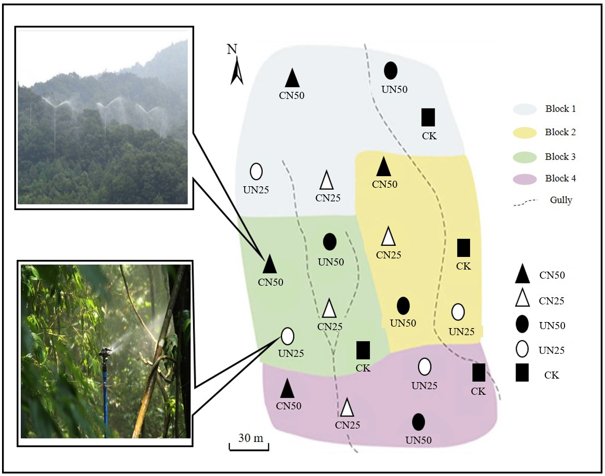
Fig. S2
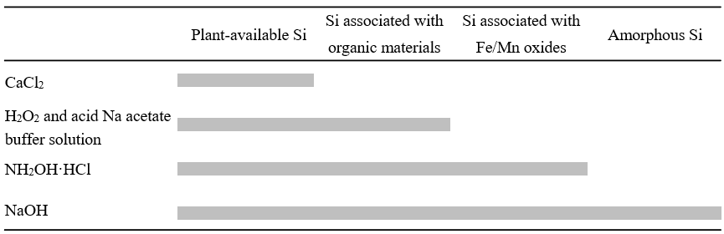
Fig. S3
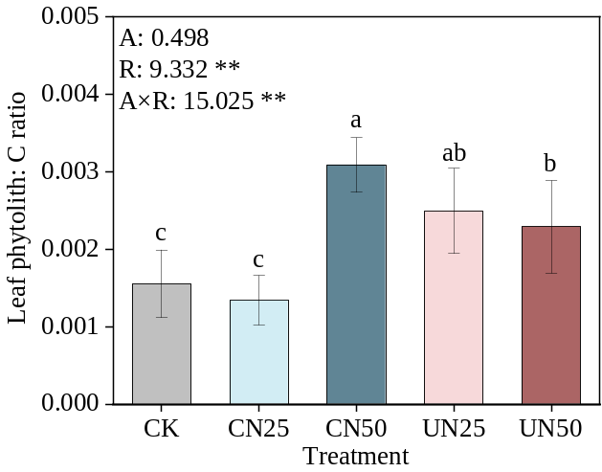
Fig. S4
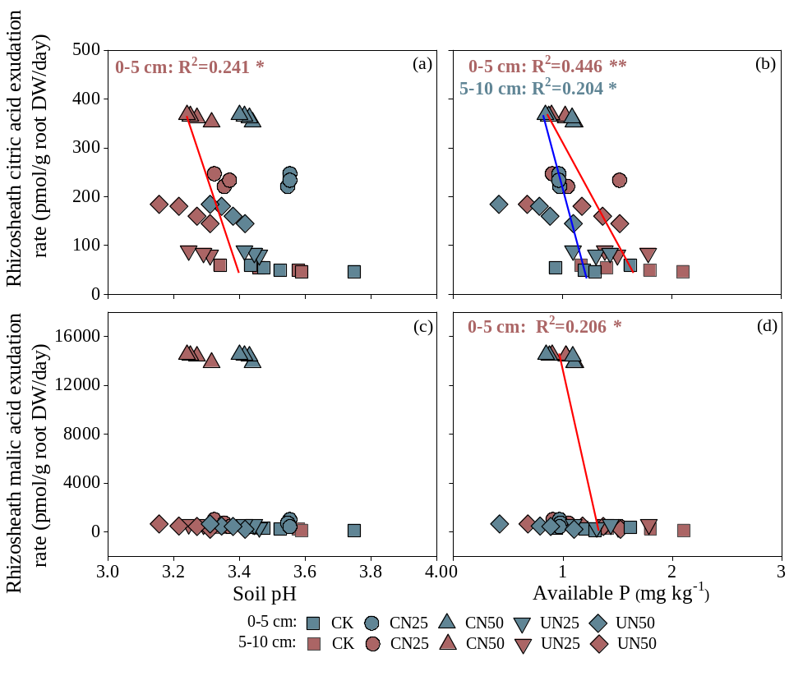
Fig. S5
