Journal of Applied Phycology

Supplementary material data summary

Microbial communities associated with the nursery stage of commercially cultivated seaweed Saccharina japonica in Southern China
Yingrui Zhuang^{a,b}, Mahasweta Saha^{c}, Suhelen Egan^{d}, Yixiao Han^{a,b}, Qiying Qiu^{e}, Defu Chen^{e}, Gaoge Wang^{a,b*}
ª College of Marine Life Science, Ocean University of China, Qingdao, 266003, China
^{b} Institute of Evolution & Marine Biodiversity, Ocean University of China, Qingdao, 266003, China
^{c} Marine Ecology and Biodiversity, Plymouth Marine Laboratory, Prospect Place, PL1 3DH Plymouth, United Kingdom
^{d} Centre for Marine Science and Innovation, School of Biological, Earth and Environmental Sciences, The University of New South Wales, Sydney, NSW, Australia
^{e} Fujian Lianjiang Guanwu Seafood Developing Product Co., Ltd., Guanwu, 350511, China
* Corresponding author:
Prof. Gaoge Wang
wgaoge@ouc.edu.cn

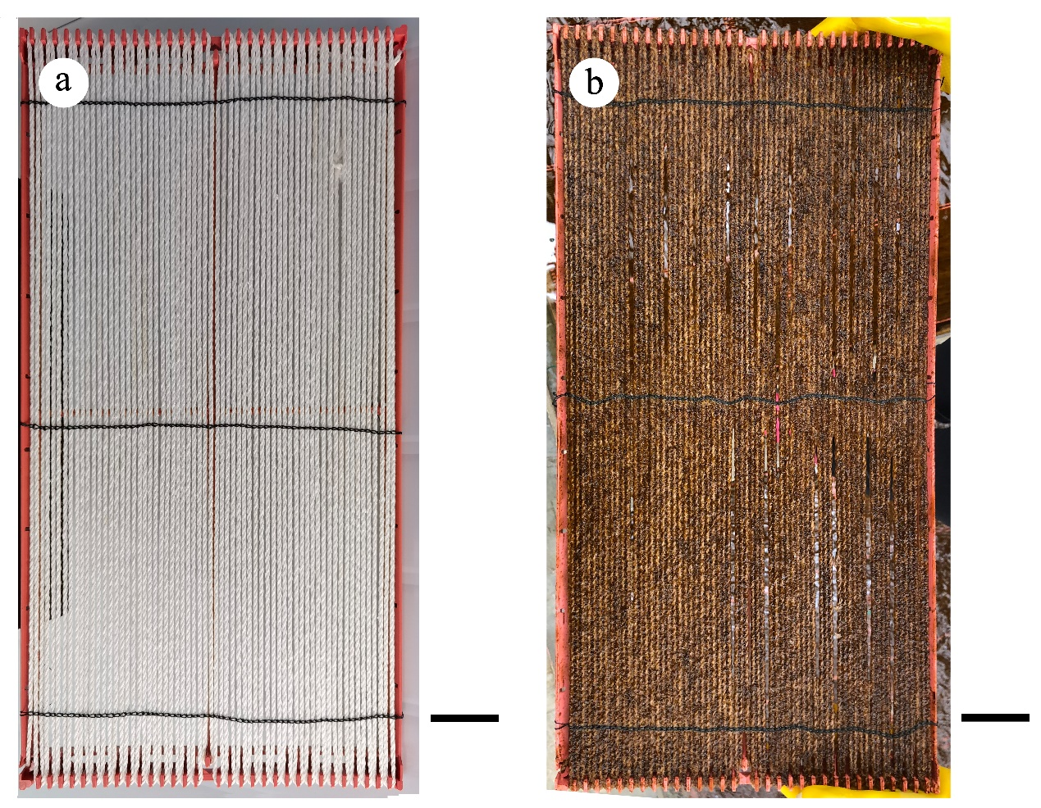

Fig S1. Substratum curtain for farmed S. japonica. (a) substratum curtain (bar = 5 cm); (b) substratum curtain covered by sporelings (bar = 5 cm). The size of the substratum curtains was 57.5 × 28 cm

Fig S2. Rarefaction analysis of sequencing data obtained from epimicrobiota. Each line represents one sample (total 24 samples). MS, mature sporophytes (n = 6); S-1, 6-week-old sporelings (n = 6); S-2, 7-week-old sporelings (n = 6); S-3, 8-week-old sporelings (n = 6).

Fig S3. Bar plot of the mean relative abundance of top 10 bacterial phyla of epimicrobiota. MS, mature sporophytes (n = 6); S-1, 6-week-old sporelings (n = 6); S-2, 7-week-old sporelings (n = 6); S-3, 8-week-old sporelings (n = 6).

Fig S4. Alpha diversity of the epimicrobiota associated with S. japonica at different developmental stages. (a) Chao1 species richness; and (b) Shannon diversity index. MS, mature sporophytes (n = 6); S-1, 6-week-old sporelings (n = 6); S-2, 7-week-old sporelings (n = 6); S-3, 8-week-old sporelings (n = 6). Labelled letters indicate significant differences (p < 0.05).

Fig S5. Venn diagram showing the distribution of OTUs at different nursery stages in epimicrobiota. Among these OTUs, core OTUs were defined as OTUs presented in 100 % of samples. In this study, a total of 130 OTUs were defined as core OTUs. MS, mature sporophytes (n = 6); S-1, 6-week-old sporelings (n = 6); S-2, 7-week-old sporelings (n = 6); S-3, 8-week-old sporelings (n = 6).

Fig S6. Z-P plots showing the distribution of bacterial taxa based on their topological roles. Each symbol represents an OTU in co-occurrence network. The topological role of each taxon was determined according to the scatter plot of within-module connectivity (Zi) and among-module connectivity (Pi). Z-P plots: (a) MS; (b) S-1; (c) S-2; (d) S-3. MS, mature sporophytes (n = 6); S-1, 6-week-old sporelings (n = 6); S-2, 7-week-old sporelings (n = 6); S-3, 8-week-old sporelings (n = 6).

Table S1. A list of core OTUs in epimicrobiota (a total of 130 OTUs). OTUs with green background are top core OTUs (8 OTUs). (Excel data file) MS, mature sporophytes (n = 6); S-1, 6-week-old sporelings (n = 6); S-2, 7-week-old sporelings (n = 6); S-3, 8-week-old sporelings (n = 6).

Table S2. Topological properties of the empirical molecular ecological networks (MENs) of epimicrobiota in comparison to its random network
 | Topological properties | Empirical network | Random network
MS | Average path distance (GD) | 1.891 | 2.354 ± 0.071
 | Average clustering coefficient (avgCC) | 0.574 | 0.258 ± 0.036
 | Modularity (M) | 0.449 | 0.242 ± 0.014
S-1 | Average path distance (GD) | 3.381 | 2.413 ± 0.022
 | Average clustering coefficient (avgCC) | 0.600 | 0.117 ± 0.012
 | Modularity (M) | 0.594 | 0.247 ± 0.008
S-2 | Average path distance (GD) | 3.876 | 3.164 ± 0.057
 | Average clustering coefficient (avgCC) | 0.455 | 0.056 ± 0.013
 | Modularity (M) | 0.703 | 0.396 ± 0.011
S-3 | Average path distance (GD) | 2.790 | 2.109 ± 0.018
 | Average clustering coefficient (avgCC) | 0.621 | 0.255 ± 0.016
 | Modularity (M) | 0.412 | 0.183 ± 0.009
MS, mature sporophytes (n = 6); S-1, 6-week-old sporelings (n = 6); S-2, 7-week-old sporelings (n = 6); S-3, 8-week-old sporelings (n = 6).

Table S3. Keystone taxa of epimicrobiota
 | OTU ID | Phylum | Order | Genus | Zi | Pi
S-1 | OTU9 | Proteobacteria | Rhodobacterales | Loktanella | -0.465 | 0.631
 | OTU192 | Proteobacteria | Rhodobacterales | Unclassified Rhodobacteraceae | -1.575 | 0.625
S-2 | OTU324 | Proteobacteria | Unclassified Alphaproteobacteria | Unclassified Alphaproteobacteria | -1.788 | 0.625
S-3 | OTU128 | Planctomycetes | Planctomycetales | Planctomicrobium | -0.061 | 0.642
 | OTU375 | Verrucomicrobia | Verrucomicrobiales | Roseibacillus | -0.247 | 0.663
 | OTU728 | Planctomycetes | Planctomycetales | Unclassified Rubinisphaeraceae | -1.028 | 0.667
MS, mature sporophytes (n = 6); S-1, 6-week-old sporelings (n = 6); S-2, 7-week-old sporelings (n = 6); S-3, 8-week-old sporelings (n = 6).

Table S4. The summary of drivers’ node properties. Drivers were selected by high NESH- score and positive DelBet value
 | OTU ID | Phylum | Order | Genus | NESH- score | DelBet
S-1 & S-2 | OTU53 | Proteobacteria | Sphingomonadales | Sphingorhabdus | 2.400 | 0.144
S-1 & S-2 | OTU68 | Proteobacteria | Rhodobacterales | Unclassified Rhodobacteraceae | 2.036 | 0.985
 | OTU71 | Planctomycetes | Phycisphaerales | SM1A02 | 2.444 | 0.767
 | OTU101 | Proteobacteria | Caulobacterales | Litorimonas | 2.125 | 0.392
 | OTU164 | Proteobacteria | Caulobacterales | Unclassified Hyphomonadaceae | 2.000 | 0.116
S-2 & S-3 | OTU2 | Verrucomicrobia | Verrucomicrobiales | Rubritalea | 2.217 | 1.000
S-2 & S-3 | OTU23 | Proteobacteria | Moraxellales | Psychrobacter | 2.422 | 0.056
 | OTU35 | Proteobacteria | Rhizobiales | Pseudahrensia | 2.103 | 0.031
 | OTU43 | Proteobacteria | Rhodobacterales | Unclassified Rhodobacteraceae | 2.333 | 0.277
 | OTU47 | Proteobacteria | Rhizobiales | Lentilitoribacter | 2.067 | 0.068
 | OTU55 | Proteobacteria | Rhodobacterales | Thalassobius | 2.012 | 0.079
 | OTU80 | Proteobacteria | Unclassified Alphaproteobacteria | Unclassified Alphaproteobacteria | 2.333 | 0.064
 | OTU112 | Verrucomicrobia | Verrucomicrobiales | Roseibacillus | 2.257 | 0.617
 | OTU128 | Planctomycetes | Planctomycetales | Planctomicrobium | 2.358 | 0.567
 | OTU134 | Proteobacteria | Rhodobacterales | Unclassified Rhodobacteraceae | 2.882 | 0.284
 | OTU138 | Proteobacteria | Rhodobacterales | Sedimentitalea | 2.310 | 0.048
 | OTU216 | Planctomycetes | Planctomycetales | Unclassified Gimesiaceae | 2.150 | 0.351
 | OTU236 | Bacteroidetes | Flavobacteriales | Croceitalea | 2.500 | 0.072
 | OTU375 | Verrucomicrobia | Verrucomicrobiales | Roseibacillus | 2.067 | 0.138
S-1 & S-3 | OTU1 | Proteobacteria | Alteromonadales | Pseudoalteromonas | 2.222 | 0.263
S-1 & S-3 | OTU13 | Proteobacteria | Rhodobacterales | Litoreibacter | 2.016 | 0.030
 | OTU16 | Proteobacteria | Rhodobacterales | HIMB11 | 2.528 | 0.324
 | OTU64 | Proteobacteria | Rhodobacterales | Loktanella | 2.556 | 0.193
 | OTU68 | Proteobacteria | Rhodobacterales | Unclassified Rhodobacteraceae | 2.222 | 0.465
 | OTU79 | Proteobacteria | Vibrionales | Vibrio | 2.528 | 0.692
 | OTU89 | Proteobacteria | Rhodobacterales | Unclassified Rhodobacteraceae | 2.333 | 0.017
 | OTU138 | Proteobacteria | Rhodobacterales | Sedimentitalea | 2.525 | 0.597
NESH-score: neighbor shift score; DelBet: delta betweenness value (ΔB). MS, mature sporophytes (n = 6); S-1, 6-week-old sporelings (n = 6); S-2, 7-week-old sporelings (n = 6); S-3, 8-week-old sporelings (n = 6).

