Supplementary Materials
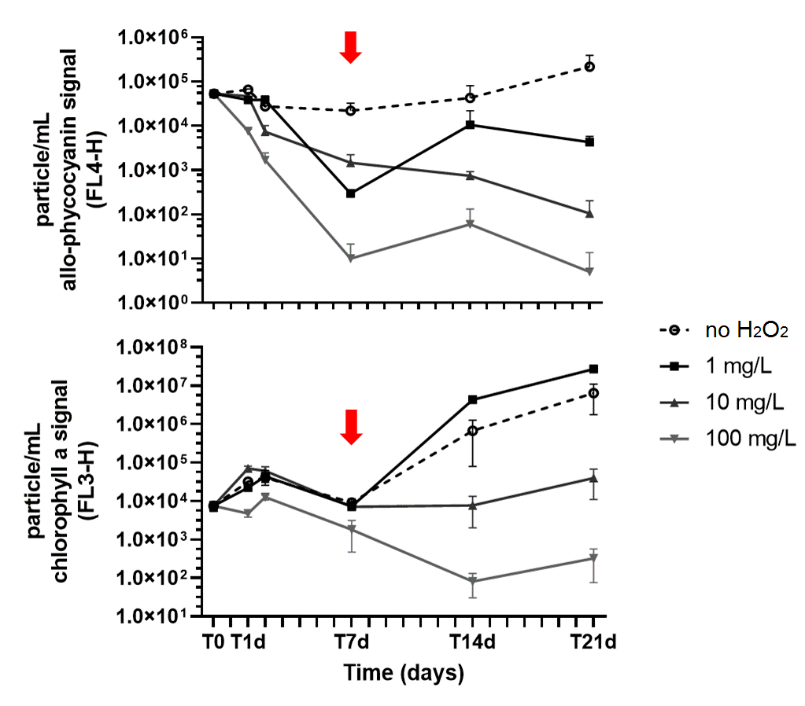

Supplementary Figure 1: Particle density (particle per mL) estimated from the fluorescence signal measured by flow cytometry of allophycocyanin (FL4-H) to monitor cyanobacteria (A) and chlorophyll b (FL3-H) to monitor phytoplankton components (B). The data are shown as the mean and standard deviation (n=3).

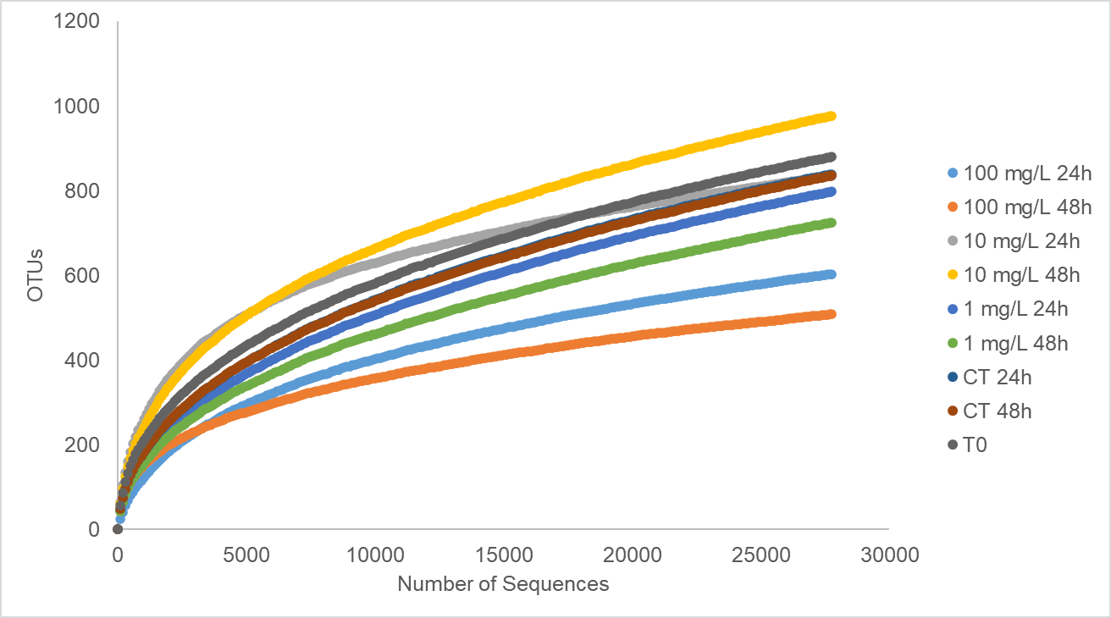
Supplementary Figure 2: Rarefaction curves of all sequenced samples after subsampling to the minimum equal number of sequences for the classified OTUs.

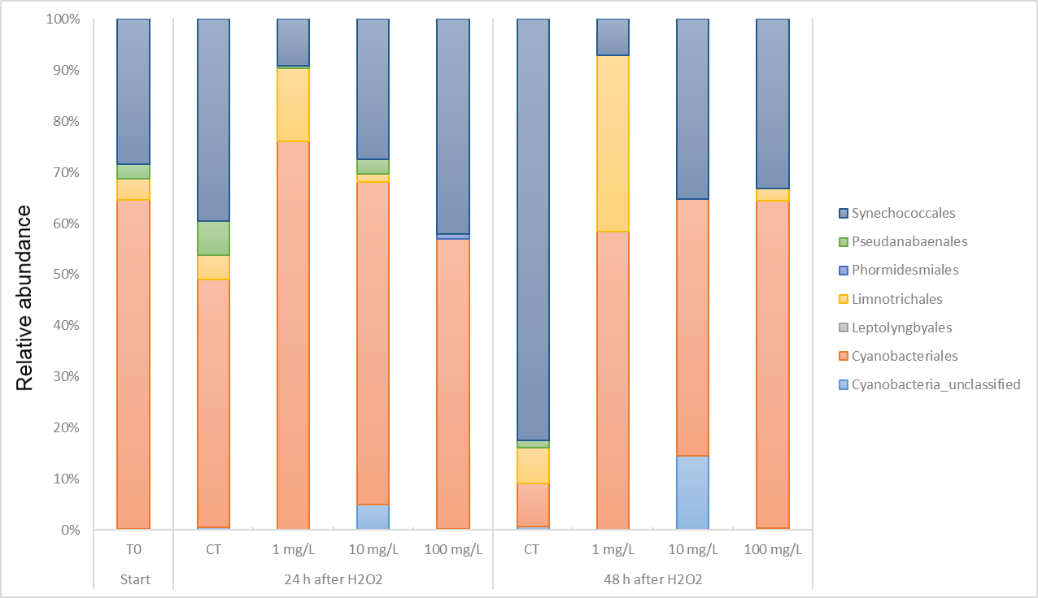
Supplementary Figure 3: Relative abundance of Cyanobacteria orders in the original community (T0) and under each experimental condition.

Supplementary Table 1: Limnological characteristics of the reservoir water (December 2018) at sampling time and of the experimental samples at the start of incubation in the laboratory for assessing the effect of H₂O₂ on phytoplankton and bacterioplankton. DOC, dissolved organic carbon; Chl, chlorophyll. DOC and Chl values are presented as the average and standard deviation, respectively (n=3).
 | pH | Conductivity  µS/cm² | Dissolved O₂  mg L⁻¹ | Temperature  °C | DOC  mg L⁻¹ | Chl (cyano)  µg L⁻¹ | Chl  (green)  µg L⁻¹
Environment | 9.26 | 58.8 | 8.84 | 31 | 14.6±1.4 | 20.7±1.7 | 10.6±0.8
Laboratory | 7.70 | 58.2 | 9.53 | 27 | 13.04±1.9 | 28.7±3.8 | 14.3±3.6

Supplementary Table 2: Bioassay conditions for Daphnia similis and Danio rerio.
Requirement |  | Daphnia | Danio
Optimal water | Salinity | - | -
Optimal water | pH | 7.0 – 7.6 | 7.0 – 7.6
Optimal water | OD | ≥ 4.0 mg/L | ≥ 1.0 mg/L
Water hardness |  | 40-48 | 40-48
Test mode |  | Static | Static
Duration time of bioassay test |  | 48 h | 48 h
Age or life stage |  | Length size 1-3 cm | Neonate 6-24 h
Culture media |  | Natural mineral water or reconstituted | Natural mineral water or reconstituted
Number of organisms per biological replicate |  | 6 | 4
Total organism tested per condition and time |  | 18 | 12
Temperature |  | 23-27 °C | 18-22 °C
Photoperiod |  | 12 h/12 h light/dark | Dark
Aeration |  | No | No
Endpoint |  | Death or immobilization | Death or immobilization

Supplementary Table 3: H₂O₂ concentrations in the two experimental setups.
 | Remaining concentration of H₂O₂ (mg L⁻¹)
Condition | 3 h | 16 h | 24 h | 48 h | 7 days | 14 days
Phytoplankton and Bacterioplankton assays (Dec 2018)
1 mg L⁻¹ | 0.5<x<2 | 0.5<x<2 | < 0.5 | < 0.5 | < 0.5 | < 0.5
10 mg L⁻¹ | ~10 | ~10 | ~5 | ~2 | < 0.5 | < 0.5
100 mg L⁻¹ | >25 | >25 | >25 | >25 | 10<x<25 | < 0.5
Ecotoxicological assays (Aug 2019)
1 mg L⁻¹ | 0.5<x<2 | - | <0.5 | - | - | -
10 mg L⁻¹ | 5<x<10 | - | ~2 | - | - | -
100 mg L⁻¹ | >25 | - | >25 | - | - | -

Supplementary Table 4: Complementary information of metabarcoding 16S rRNA sequencing, including the DNA concentration and the original number of sequences (Nseqs ori.) and after subsampling (Nseqs. sub. ), coverage, number of OTUs observed (Sobs) and diversity metrics.
group | [ ] DNA (ng/uL) | Nseqs ori. | Nseqs. sub | coverage | sobs | simpson | shannon | Evenness
T0 | 8.1 | 100297 | 27752 | 0.988001 | 880 | 0.020476 | 4.7281 | 0.6974
CT24 | 15.1 | 92204 | 27752 | 0.988001 | 839 | 0.033638 | 4.341906 | 0.6449
CT48 | 5.9 | 102972 | 27752 | 0.987713 | 836 | 0.030999 | 4.37432 | 0.6501
1 mg24 | 5.4 | 27752 | 27752 | 0.988037 | 798 | 0.044012 | 4.101811 | 0.6138
1 mg48 | 3.5 | 53874 | 27752 | 0.988577 | 725 | 0.039006 | 4.082273 | 0.6198
10 mg24 | 5 | 39150 | 27752 | 0.991712 | 835 | 0.0208 | 5.035741 | 0.7485
10 mg48 | 7.9 | 311561 | 27752 | 0.98692 | 977 | 0.029605 | 4.841326 | 0.7032
100 mg24 | 4.2 | 135152 | 27752 | 0.992181 | 603 | 0.462368 | 2.121477 | 0.3314
100 mg48 | 8.1 | 31244 | 27752 | 0.994163 | 508 | 0.069211 | 3.850972 | 0.6181

Supplementary Table 5: Relative abundance (%) of identified bacterial phyla in the original community (T0) and under each experimental condition.
 | T0 | Control condition |  | 1 mg/L H₂O₂ |  | 10 mg/L H₂O₂ |  | 100 mg/L H₂O₂
Phylum (%) | T0 | 24 h | 48 h | 24 h | 48 h | 24 h | 48 h | 24 h | 48 h
Actinobacteria | 15.1 | 10.9 | 5.6 | 6.7 | 3.6 | 6.9 | 5.2 | 3.9 | 14.1
Armatimonadetes | 2.6 | 0.8 | 0.2 | 0.9 | 0.1 | 2.6 | 2.4 | 0.2 | 0.2
Bacteria_unclassified | 0.4 | 0.3 | 0.4 | 0.3 | 0.3 | 0.9 | 1.1 | 0.2 | 0.6
Bacteroidetes | 15.3 | 19.8 | 23.9 | 18.3 | 21.0 | 17.3 | 11.5 | 1.0 | 2.7
Bdellovibrionota | 1.1 | 0.3 | 0.9 | 0.2 | 0.0 | 1.2 | 0.8 | 0.0 | 0.0
Chloroflexi | 1.3 | 0.6 | 0.4 | 0.2 | 0.2 | 0.3 | 0.2 | 0.0 | 0.4
Cyanobacteria | 18.8 | 6.1 | 1.6 | 4.3 | 0.9 | 1.4 | 0.7 | 1.5 | 1.8
Firmicutes | 0.1 | 0.2 | 0.1 | 0.1 | 0.2 | 4.7 | 5.3 | 8.9 | 31.9
Planctomycetes | 11.1 | 11.1 | 12.3 | 11.1 | 11.6 | 16.4 | 22.2 | 2.1 | 3.8
Proteobacteria | 26.1 | 44.8 | 50.6 | 53.0 | 58.5 | 36.1 | 34.2 | 81.5 | 42.2
Verrucomicrobiota | 7.3 | 4.0 | 2.6 | 3.8 | 2.4 | 11.0 | 15.2 | 0.7 | 1.6
Others | 0.9 | 1.0 | 1.3 | 1.1 | 1.2 | 1.2 | 1.1 | 0.1 | 0.8

Supplementary Table 6: Relative abundance (%) of Cyanobacteria genera in the original community (T0) and under each experimental condition

 | T0 | Control condition |  | 1 mg/L H₂O₂ |  | 10 mg/L H₂O₂ |  | 100 mg/L H₂O₂
Phylum (%) | T0 | 24 h | 48 h | 24 h | 48 h | 24 h | 48 h | 24 h | 48 h
Synechocystis sp. | 0.0% | 0.0% | 0.0% | 0.0% | 0.0% | 0.0% | 5.4% | 0.2% | 0.0%
Microcystis sp. | 31.1% | 47.0% | 7.9% | 68.3% | 54.6% | 46.3% | 7.9% | 5.0% | 0.8%
Cylindrospermospsis sp./Raphidiopsis sp. | 0.0% | 0.1% | 0.0% | 0.0% | 1.3% | 8.4% | 4.9% | 23.3% | 0.2%
Dolichospermum sp. | 16.8% | 0.1% | 0.0% | 0.0% | 0.0% | 0.3% | 0.0% | 0.0% | 0.0%
Mastigocladopsis sp. | 0.0% | 0.7% | 0.2% | 0.1% | 1.3% | 0.0% | 7.4% | 21.6% | 28.2%
Nostocaceae_unclassified | 16.3% | 0.1% | 0.0% | 0.3% | 0.0% | 0.3% | 0.0% | 1.4% | 15.7%
Planktothrix sp. | 0.1% | 0.1% | 0.2% | 0.3% | 0.8% | 6.1% | 18.7% | 3.1% | 18.4%
Limnothrix | 4.1% | 4.6% | 7.0% | 14.2% | 34.2% | 1.5% | 0.0% | 0.0% | 2.3%
Pseudanabaena sp. | 2.9% | 6.8% | 1.3% | 0.6% | 0.0% | 2.8% | 0.0% | 0.0% | 0.0%
Cyanobium sp. | 28.2% | 39.0% | 81.9% | 9.1% | 7.1% | 26.3% | 29.6% | 42.0% | 31.3%
Obscuribacteraceae_unclassified | 0.1% | 0.3% | 0.2% | 0.2% | 0.8% | 0.0% | 8.9% | 0.0% | 0.0%
Unclassified | 0.2% | 0.5% | 0.7% | 6.0% | 0.0% | 4.8% | 12.8% | 0.2% | 0.4%
Other | 0.2% | 0.8% | 0.4% | 1.0% | 0.0% | 3.3% | 4.4% | 3.1% | 2.7%

Supplementary Table 7: Relative abundance (%) of the top 20 most abundant bacterial genera in the original community (T0) and under each experimental condition.
 | Start | 24 h after H₂O₂ |  |  |  | 48 h after H₂O₂
Genus | T0 | CT | 1 mg/L | 10 mg/L | 100 mg/L | CT | 1 mg/L | 10 mg/L | 100 mg/L
hgcI_clade | 10.0 | 7.1 | 3.7 | 2.5 | 0.2 | 3.3 | 1.9 | 1.9 | 0.3
Microcystis | 5.8 | 2.8 | 2.9 | 0.7 | 0.1 | 0.1 | 0.5 | 0.1 | 0.0
Cyanobium | 5.3 | 2.4 | 0.4 | 0.4 | 0.6 | 1.3 | 0.1 | 0.2 | 0.6
Comamonadaceae_unclassified | 4.5 | 13.1 | 11.9 | 3.6 | 0.4 | 11.3 | 18.7 | 3.2 | 1.4
Terrimicrobium | 4.3 | 2.4 | 2.3 | 1.8 | 0.2 | 1.1 | 0.7 | 2.1 | 0.4
Kapabacteriales_ge | 3.2 | 1.0 | 0.4 | 1.9 | 0.1 | 0.3 | 0.2 | 1.5 | 0.0
Dolichospermum | 3.2 | 0.0 | 0.0 | 0.0 | 0.0 | 0.0 | 0.0 | 0.0 | 0.0
Nostocaceae_unclassified | 3.1 | 0.0 | 0.0 | 0.0 | 0.0 | 0.0 | 0.0 | 0.0 | 0.3
Armatimonas | 2.5 | 0.7 | 0.8 | 2.5 | 0.2 | 0.1 | 0.1 | 2.3 | 0.1
DSSD61 | 1.6 | 0.9 | 0.3 | 2.5 | 0.0 | 1.7 | 0.1 | 2.0 | 0.0
Novosphingobium | 1.1 | 7.7 | 0.8 | 1.3 | 0.0 | 3.5 | 1.0 | 1.0 | 0.0
Gammaproteobacteria_unclassified | 1.0 | 0.7 | 1.3 | 1.8 | 0.1 | 1.5 | 3.1 | 3.0 | 0.5
Caulobacter | 0.3 | 1.9 | 3.7 | 0.3 | 0.2 | 3.3 | 3.3 | 0.0 | 0.0
Emticicia | 0.3 | 5.4 | 7.6 | 0.2 | 0.1 | 8.0 | 4.1 | 0.0 | 0.1
Rheinheimera | 0.0 | 5.3 | 7.5 | 0.6 | 0.2 | 2.2 | 2.1 | 0.0 | 0.7
Flavobacterium | 0.8 | 4.2 | 4.7 | 0.4 | 0.1 | 7.9 | 7.7 | 0.1 | 0.1
Flectobacillus | 0.2 | 2.6 | 0.7 | 0.1 | 0.0 | 1.4 | 5.4 | 0.1 | 0.0
Luteimonas | 0.8 | 1.3 | 1.6 | 0.1 | 0.0 | 6.5 | 7.0 | 0.1 | 0.0
Massilia | 0.0 | 0.9 | 10.6 | 0.4 | 0.1 | 0.8 | 5.4 | 0.3 | 0.4
Staphylococcus | 0.0 | 0.1 | 0.0 | 2.5 | 4.3 | 0.1 | 0.1 | 3.5 | 22.1
Pseudomonas | 0.0 | 0.0 | 0.0 | 1.7 | 2.1 | 0.0 | 0.1 | 2.0 | 8.6
Craurococcus-Caldovatus | 0.0 | 0.0 | 0.0 | 0.0 | 69.4 | 0.0 | 0.0 | 0.0 | 0.0
MM2 | 0.5 | 0.8 | 0.2 | 0.2 | 0.0 | 3.6 | 0.1 | 0.2 | 0.0
Delftia | 0.0 | 0.0 | 0.0 | 1.0 | 0.9 | 0.0 | 0.0 | 0.9 | 5.6
Acinetobacter | 0.0 | 0.0 | 0.5 | 1.4 | 1.1 | 0.2 | 1.6 | 1.1 | 5.6
Enterobacteriaceae_unclassified | 0.2 | 0.1 | 0.1 | 1.0 | 1.3 | 0.0 | 0.1 | 1.5 | 6.1
Corynebacterium | 0.0 | 0.0 | 0.0 | 0.6 | 0.9 | 0.0 | 0.0 | 0.7 | 4.7
Enhydrobacter | 0.0 | 0.0 | 0.0 | 0.4 | 0.5 | 0.0 | 0.0 | 0.2 | 3.1
Chthoniobacteraceae_unclassified | 0.5 | 0.1 | 0.0 | 2.8 | 0.0 | 0.0 | 0.0 | 3.0 | 0.0
Streptococcus | 0.0 | 0.0 | 0.0 | 0.2 | 1.5 | 0.0 | 0.0 | 0.1 | 0.8
Methylobacterium-Methylorubrum | 0.2 | 0.6 | 1.1 | 0.9 | 1.0 | 0.6 | 1.0 | 0.4 | 0.0
Lactobacillus | 0.0 | 0.0 | 0.0 | 0.3 | 0.9 | 0.0 | 0.0 | 0.3 | 2.0
Simkaniaceae_unclassified | 0.3 | 0.3 | 0.3 | 1.2 | 0.0 | 0.6 | 0.5 | 2.2 | 0.5
Polynucleobacter | 0.4 | 0.5 | 0.2 | 1.5 | 0.1 | 0.4 | 0.1 | 2.1 | 0.0
Micrococcus | 0.0 | 0.0 | 0.0 | 0.5 | 0.6 | 0.0 | 0.0 | 0.4 | 2.7
Other | 49.9 | 37.1 | 36.4 | 62.7 | 12.8 | 40.2 | 35 | 63.5 | 33.3

