Appendix
A common occurrence among the events is the presence of a type-III radio burst. We use the time of the detection of the type-III radio burst as a common reference start time of the event, as all other phenomena are either not present in all events (e.g., type-II radio bursts), or not visible with common instrumentation (e.g., X rays from the backside of the Sun as viewed from the Sun-Earth line).
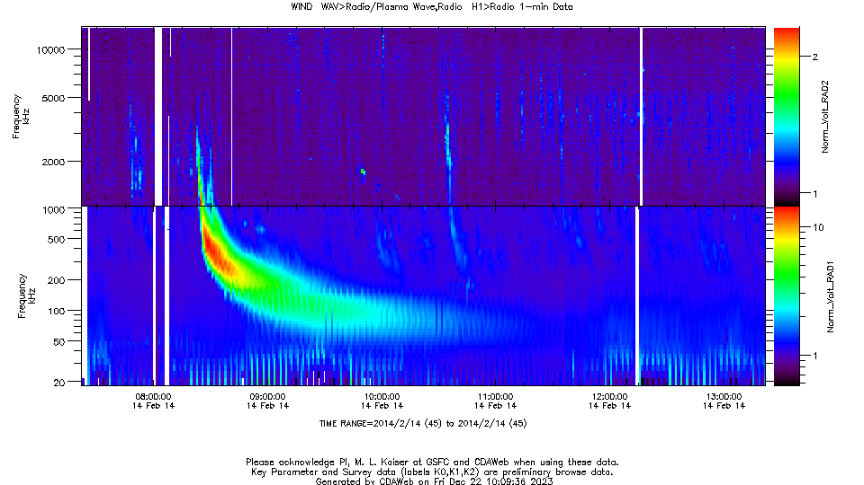
Figure A1: Radio observations on Feb. 14, 2014, by Wind/WAVES. The type-III onset time (0822 UT) has been entered in Table 1. This event corresponds to event #37 in Table 1.
Figure A1 shows the example of a type-III radio burst that is associated with one of the 52 events of Table 1. The onset time of the type-III radio burst can be determined to be within minutes accuracy, although some events have more than one bright type-III, therefore the association itself can be ambiguous. All 52 individual SEP events listed in Table 1 did have significant type-III radio bursts associated with them.
We also looked into the uncertainty of onset times of type-IIIs observed at STEREO-A and B as compared to Wind. A large and representative sample that includes events from all 12 source location sectors of Figure 7 shows that the uncertainty is under 2 minutes for most events, with the largest discrepancy at 7 minutes.

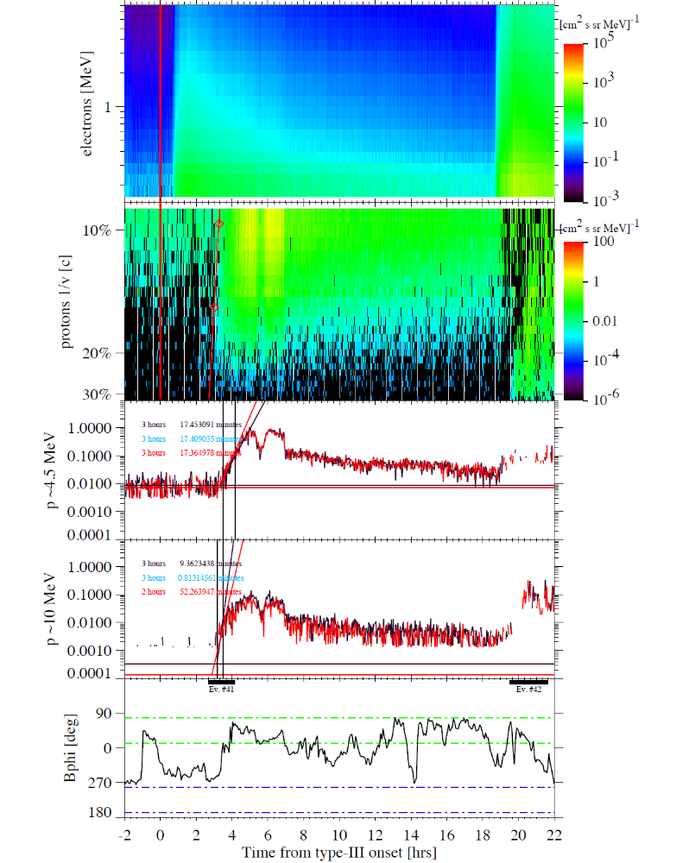
Figure A2: Spectrograms and time-intensity profiles similar to Figure 1, but for events #41 and #42 in Table 1, for 24 hours starting on March 28, 2014, 2122UT. The bottom panel shows the magnetic field azimuth (in GSE coordinates) measured by ACE. Ranges between like-color horizontal lines indicate the SOHO/COSTEP-EPHIN field of view range for field-aligned particles streaming anti-sunward. The approximate onset phases of SEP events 41 and 42 are highlighted by wide bars.
We noticed that for a small number of well-connected events, the orientation of the instrument with respect to the nominal magnetic field direction could affect the onset time and onset duration derivations. An example is that of event #41 in Figure A2. In the figure, a span of 24 hours is shown that includes onsets of two events, #41 and #42 of Table 1. The onset fit method for event #41 on the left suggests a rather brief dispersion feature. However, the intensity-time-profile fit is strongly influenced by the intensity enhancement observed at 0242UT, or 3 hrs 20 min after the type-III onset. This surge in proton intensity is observed in coincidence with the magnetic field direction rotation from ~270ᵒ to within the EPHIN FOV, which is centered about 45ᵒ. The magnetic field is observed at the ACE spacecraft, also in orbit around L1, as SOHO does not carry a magnetometer. This is a well-connected event; therefore, the expectation is that particle focusing would lead the first arriving protons to be nearly field aligned. Both events in this Figure are observed when the instrument FOV is oriented perpendicular to the Parker spiral direction. Therefore, during the early phase of event #41, only a small fraction of arriving protons have sufficient pitch angle to be detected, leading to population 1. After the rotation, the bulk of arriving protons is observed (population 2). The spectrograms that identify the maximum energies to be around 40 MeV suggest that both populations are from the same source. Hence, the actual duration of energy dispersion is underestimated by the fitting method. We assume this effect diminishes with increasing magnetic connection distance as the cross-field diffusion process preferentially affects protons with high pitch angles. The onset dispersion period of event #42 also is affected by a magnetic field fluctuation, occurring at 2002UT (or 20 hrs 40 min after type-III onset of event #41) but in the opposite way. Here, the pre-fluctuation flux of high-energy protons is directed into the instrument, while in the later phase the arriving low-energy protons are deflected away, causing a problem for accurately determination of the low-energy proton onset. Both events resulted in short 4.5-10 MeV dispersion-time outliers of the bottom panels of Figures 4 and 6.

