Diagnostic Accuracy of Stereoscopic Optical Palpation for Tumour Margin Assessment in Breast-Conserving Surgery

Q. Fang^{a,b}, R. W. Sanderson^{a,b}, R. Zilkens^{a,c}, I. Bomanª, K. Y. Foo^{a,b}, D. D. Lakhiani^{a,b}, A. Rijhumal^{d}, M. Hardie^{d,e}, B. F. Dessauvagie^{d,e}, C. M. Saunders^{c,f,g}, and B. F. Kennedy^{a,b,h,i}
ªBRITElab, Harry Perkins Institute of Medical Research, QEII Medical Centre, Nedlands and Centre for Medical Research, The University of Western Australia, Crawley, WA 6009, Australia
^{b}Department of Electrical, Electronic & Computer Engineering, School of Engineering, The University of Western Australia, Crawley, WA, 6009, Australia
^{c}Medical School, The University of Western Australia, Crawley, WA 6009, Australia
^{d}PathWest, Fiona Stanley Hospital, 11 Robin Warren Drive, Murdoch, WA 6150, Australia
^{e}School of Pathology and Laboratory Medicine, The University of Western Australia, Crawley, WA 6009, Australia
^{f}Department of Surgery, Melbourne Medical School, The University of Melbourne, Parkville, Victoria 3010, Australia
^{g}The Royal Melbourne Hospital, 300 Grattan Street, Parkville, Victoria, 3050, Australia
^{h}Australian Research Council Centre for Personalised Therapeutics Technologies, Australia
^{i}Institute of Physics, Faculty of Physics, Astronomy and Informatics, Nicolaus Copernicus University in Toruń, ul. Grudziądzka 5, 87-100 Toruń, Poland

Supplementary

S.1 Working principle of stereoscopic optical palpation

Figure S1(a) shows a photograph of the stereoscopic optical palpation (SOP) setup. The stereo cameras are mounted to a post, which is then secured onto a benchtop setting. The imaging window and light-emitting diode (LED) are attached to a custom 3D-printed holder. During the imaging, the sample and the silicone layer are placed on the stage, which can be raised to compress the sample and layer against the imaging window. Figure S1(b) demonstrates the working principle of SOP. The tissue and the compliant layer with embedded phosphorescent microparticles are placed in the overlapped field of view (FOV) of the stereo cameras. The layer is illuminated with ultraviolet (UV) light and stereoscopic imaging of the microparticles is used to map their depth position across the layer surface. When the tissue and layer are uncompressed, the initial depth positions of the microparticles are recorded. When the tissue and layer are compressed, another depth map is recorded to determine the displacement of the microparticles. The layer deformation varies spatially and is dependent on the mechanical properties of the underlying tissue. For example, the layer compresses more in regions above stiff tissue (tumour) than in regions above soft tissue, as illustrated in Fig. S1(b). Figures S1(c) and S1(d) are the photographs, from the left and right camera respectively, of the tissue and layer with UV light illumination. By combining these two photographs, a displacement map (Fig. S1(e)) of the surface containing the phosphorescent microparticles is generated, which is then converted to a strain map using knowledge of the pre-characterised initial layer thickness. In addition, as the stress-strain curve of this layer is pre-characterised using a custom uniaxial compression tester with a load cell, a two-dimensional (2D) stress map of the layer can be derived from the strain measurement, as shown in Fig. S1(f). In the stress map, regions with higher stress indicate stiffer tissue locations. More detailed information of the working principle can be found in our previous work (1).
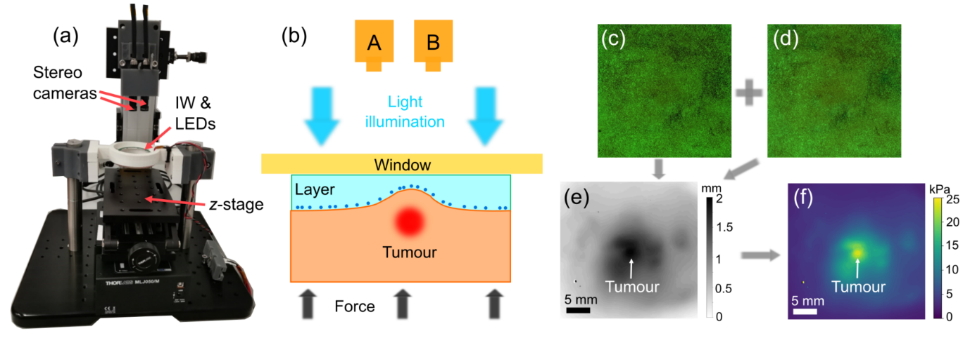
Figure S1 (a) Photograph of the SOP imaging system. (b) Working principle of SOP to measurement displacement of the layer surface through stereoscopic imaging. (c) and (d) Photograph of the tissue and layer with UV illumination taken from the left and right camera, respectively. (e) Displacement map generated by combining (c) and (d) for the tissue containing tumour. (f) Stress map converted from the displacement map (e).

S.2 Calculation of displacement, strain and stress sensitivities

To determine the displacement sensitivity and stress sensitivity, we first study the relationship between the settings of the stereoscopic imaging system and the axial resolution in the depth map. Figure S2 shows a diagram illustrating the relationship between the depth measurement and the pixel location of an object imaged on the camera sensor. In this figure, L1 and L2 are the two lenses that are placed in front of the camera sensors. The distance between the lens plane and the sensor is $t$. An object C is placed at a distance $s$ from the lenses and is imaged at a pixel location on the sensor plane. If the lenses have focal length, f, then the relationship between $s$, $t$ and $f$ is:
$$\frac{1}{s}+\frac{1}{t}=\frac{1}{f} (S1)$$
Assuming the object C moved a distance $d$ along the axial direction and arrived at the position C’, then the same object will have an image at a different pixel location on the sensor plane. On this sensor, the pixel difference between the original and final images is $p$. From trigonometry, and assuming $d « s$, we can express the relationship between $p$ and $d$ as:
$$d=\frac{2p∙s^{2}}{l∙t} (S2)$$
The axial resolution of the depth measurement in SOP is defined as the minimum displacement $d$ that can be calculated from the disparity measurement, i.e., when $p=0.5 pixel.$ The is also the definition of the displacement sensitivity in SOP. For the specific camera sensor used in this initial implementation, the pixel size is 2 µm, so $p=1 µm.$ From Eq. (S2) we know that the axial resolution is higher if $p$ is smaller and $l$ is larger. However, the distance $l$ between the two lenses L1 and L2 cannot be too large as the images acquired from each half of the sensor should have an overlapped FOV.
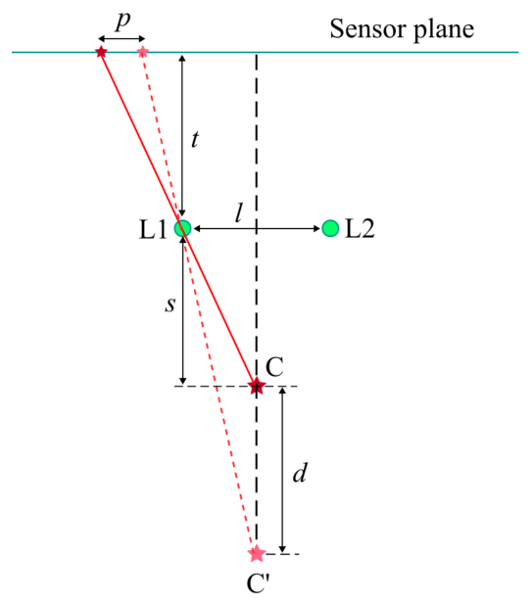
Figure S3 shows a diagram of a perfectly overlapped FOV from the stereoscopic imaging. In this figure, $D_{x}$ is the dimension of the active area of the camera sensor in the horizontal direction. For instance, if we use the selected camera sensor, $D_{x}=7.7 mm$. For the case of perfectly overlapped FOV from the stereoscopic images, according to trigonometry, the relationship between $l$ and $D_{x}$ can be expressed as:
Figure S2. Diagram showing the relationship between the depth of an object and its pixel location on the sensor.
$$\frac{l/2}{\frac{FOV}{2}-l/2}=\frac{\frac{D_{x}}{2}-l/2}{\frac{FOV}{2}+l/2} (S3)$$
Deriving from this equation, $l$ can be expressed as:
$$l=\frac{FOV∙D_{x}}{2FOV+D_{x}} (S4)$$
If $FOV≫D_{x}, l≈D_{x}/2$.
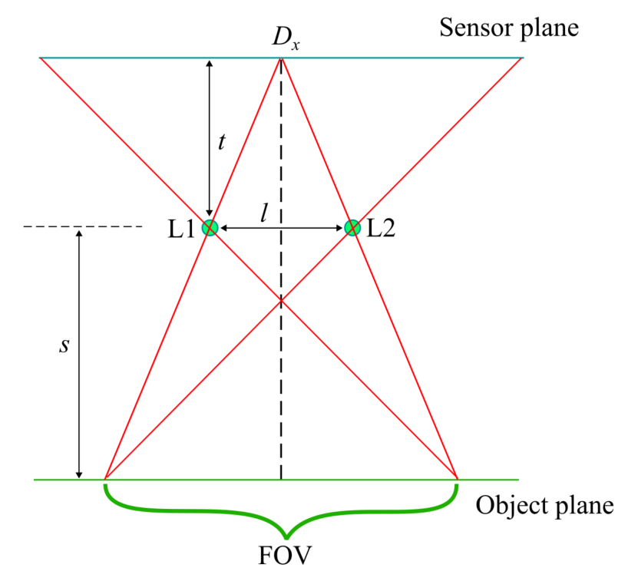
Figure S3. Diagram showing perfectly overlapped FOV with one image at each side of the camera sensor.
We now consider calculation of the parameters of the lenses that are used in this initial setup with the selected camera sensors. If we require the FOV to be 30 mm, according to Eq. (S4), the distance $l$ between the two lenses should be 3.41 mm. Also, $t$ and $s$ have the relationship:
$$\frac{t}{s}=\frac{D_{x}/2}{FOV} (S5)$$
Combining Eqs. (S1) and (S5), we have:
$$s=\frac{D_{x}+2FOV}{D_{x}}f (S6)$$
$$t=\frac{D_{x}+2FOV}{2FOV}f (S7)$$
Substituting Eqs. (S6) and (S7) into Eq. (S2), we have the expression of the displacement:
$$d=\frac{4p∙f∙FOV(D_{x}+2FOV)}{l∙{D_{x}}^{2}} (S8)$$
The displacement sensitivity $δd$ is defined as the displacement when $p=0.5$.
The strain sensitivity can be calculated as:
$$δε=\frac{δd}{T} (S9)$$
where $T=5 mm$ is the thickness of the layer above the embedded phosphorescent particles. The stress sensitivity can be obtained by looking up the stress-strain curve of the layer. As the layer stress-strain curve is non-linear, the stress sensitivity varies as a function of the bulk strain.

S.3 Diagnostic accuracy of tumour detection at various depths from the tissue surface

We have used SOP in a recent pilot study using excised breast tissue to show that high stress corresponds to regions of either invasive (i.e. invasive ductal carcinoma or invasive lobular carcinoma) or non-invasive cancer (i.e. ductal carcinoma in situ) (1). High stress areas in the SOP images corresponded to regions of DCIS up to 3 mm below the tissue surface while normal dense tissue appears to correspond to lower stress. In the present diagnostic accuracy study, we aim to determine the diagnostic accuracy (sensitivity and specificity) of SOP for detecting tumour on or close (≤ 1 mm) to the boundary of fresh specimens from patients undergoing wide local excision. SOP relies on generating a 2D stress map. By lacking 3D capacity, it cannot be used to visualise stress at different depths. Despite this, this study also determines the accuracy of SOP at identifying cancer at varying depths from the tissue surface, specifically 2, 3, 4 and 5 mm. Cross-validation of the automatic classifier was conducted to determine the sensitivity and specificity of SOP in detecting breast cancer at these varying depths in wide local excisions, as shown in Tables S1-S4. According to these results, the general trend is that the diagnostic accuracy at larger depths is degraded compared to smaller depths.

Table S1 Cross-validation results of diagnostic accuracy for cancer depth ≤ 2 mm. TP, true positive. TN, true negative. FP, false positive. FN, false negative. Sens, sensitivity. Spec, specificity. PPV, positive predictive value. NPV, negative predictive value. Acc, accuracy. SD, standard deviation.
Cross-validation  group | Circle diameter  (mm) | Stress threshold  (kPa) | TP | TN | FP | FN | Sens | Spec | PPV | NPV | Acc
1 | 0.2 | 10.87 | 2 | 11 | 7 | 1 | 0.67 | 0.61 | 0.22 | 0.92 | 0.61
2 | 0.2 | 11.51 | 4 | 22 | 2 | 2 | 0.67 | 0.92 | 0.67 | 0.92 | 0.87
3 | 0.2 | 10.87 | 3 | 22 | 0 | 2 | 0.6 | 1 | 1 | 0.92 | 0.93
4 | 0.2 | 10.87 | 4 | 17 | 4 | 1 | 0.8 | 0.81 | 0.5 | 0.94 | 0.81
5 | 0.2 | 10.87 | 3 | 9 | 8 | 1 | 0.75 | 0.53 | 0.27 | 0.9 | 0.57
6 | 0.2 | 10.87 | 1 | 16 | 5 | 2 | 0.33 | 0.76 | 0.17 | 0.89 | 0.71
7 | 1.3 | 10.71 | 1 | 19 | 2 | 2 | 0.33 | 0.90 | 0.33 | 0.9 | 0.83
8 | 0.2 | 10.87 | 1 | 20 | 3 | 1 | 0.5 | 0.87 | 0.25 | 0.95 | 0.84
9 | 0.3 | 6.61 | 2 | 10 | 10 | 1 | 0.67 | 0.5 | 0.17 | 0.91 | 0.52
10 | 0.2 | 10.87 | 5 | 12 | 9 | 0 | 1 | 0.57 | 0.36 | 1 | 0.65
Total |  |  | 26 | 158 | 50 | 13 | 0.667 | 0.76 | 0.342 | 0.924 | 0.745
Mean | 0.32 | 10.49 |  |  |  |  | 0.632 | 0.747 | 0.394 | 0.925 | 0.735
SD | 0.33 | 1.31 |  |  |  |  | 0.194 | 0.172 | 0.25 | 0.031 | 0.131

Table S2 Cross-validation results of diagnostic accuracy for cancer depth ≤ 3 mm.
Cross-validation  group | Circle diameter  (mm) | Stress threshold  (kPa) | TP | TN | FP | FN | Sens | Spec | PPV | NPV | Acc
1 | 1.1 | 6.34 | 7 | 12 | 6 | 0 | 1 | 0.67 | 0.54 | 1 | 0.76
2 | 1 | 10.78 | 4 | 17 | 3 | 1 | 0.8 | 0.85 | 0.57 | 0.94 | 0.84
3 | 1.3 | 6.34 | 6 | 8 | 10 | 1 | 0.86 | 0.44 | 0.38 | 0.89 | 0.56
4 | 1 | 10.78 | 3 | 16 | 2 | 1 | 0.75 | 0.89 | 0.6 | 0.94 | 0.86
5 | 0.3 | 11.51 | 4 | 18 | 3 | 3 | 0.57 | 0.86 | 0.57 | 0.86 | 0.79
6 | 0.7 | 10.87 | 2 | 24 | 2 | 2 | 0.5 | 0.92 | 0.5 | 0.92 | 0.87
7 | 1.3 | 6.34 | 3 | 14 | 6 | 3 | 0.5 | 0.7 | 0.33 | 0.82 | 0.65
8 | 1 | 10.78 | 4 | 16 | 1 | 1 | 0.8 | 0.94 | 0.8 | 0.94 | 0.91
9 | 1.3 | 10.71 | 1 | 16 | 3 | 2 | 0.33 | 0.84 | 0.25 | 0.89 | 0.77
10 | 1.3 | 10.71 | 2 | 17 | 2 | 1 | 0.67 | 0.9 | 0.5 | 0.94 | 0.86
Total |  |  | 36 | 158 | 38 | 15 | 0.706 | 0.806 | 0.486 | 0.913 | 0.785
Mean | 1.03 | 9.52 |  |  |  |  | 0.678 | 0.801 | 0.504 | 0.915 | 0.788
SD | 0.31 | 2.09 |  |  |  |  | 0.191 | 0.146 | 0.147 | 0.048 | 0.103

Table S3 Cross-validation results of diagnostic accuracy for cancer depth ≤ 4 mm.
Cross-validation  group | Circle diameter  (mm) | Stress threshold  (kPa) | TP | TN | FP | FN | Sens | Spec | PPV | NPV | Acc
1 | 0.2 | 10.29 | 6 | 14 | 8 | 2 | 0.75 | 0.64 | 0.43 | 0.88 | 0.67
2 | 4.3 | 7.37 | 3 | 17 | 3 | 4 | 0.43 | 0.85 | 0.5 | 0.81 | 0.74
3 | 4.3 | 4.96 | 3 | 10 | 6 | 1 | 0.75 | 0.63 | 0.33 | 0.91 | 0.65
4 | 4.3 | 4.96 | 5 | 11 | 3 | 0 | 1 | 0.79 | 0.63 | 1 | 0.84
5 | 1.3 | 6.34 | 5 | 13 | 5 | 3 | 0.625 | 0.722222 | 0.5 | 0.8125 | 0.69
6 | 1.3 | 5.93 | 7 | 15 | 4 | 1 | 0.88 | 0.79 | 0.64 | 0.94 | 0.81
7 | 0.2 | 10.29 | 5 | 11 | 6 | 3 | 0.63 | 0.65 | 0.45 | 0.79 | 0.64
8 | 4.3 | 4.96 | 3 | 13 | 10 | 2 | 0.6 | 0.57 | 0.23 | 0.87 | 0.57
9 | 4.3 | 4.96 | 2 | 10 | 8 | 2 | 0.5 | 0.56 | 0.2 | 0.83 | 0.55
10 | 0.2 | 10.57 | 2 | 12 | 4 | 3 | 0.4 | 0.75 | 0.33 | 0.8 | 0.67
Total |  |  | 41 | 126 | 57 | 21 | 0.661 | 0.689 | 0.418 | 0.857 | 0.682
Mean | 2.47 | 7.06 |  |  |  |  | 0.655 | 0.693 | 0.424 | 0.863 | 0.683
SD | 1.87 | 2.3 |  |  |  |  | 0.182 | 0.096 | 0.142 | 0.065 | 0.09

Table S4 Cross-validation results of diagnostic accuracy for cancer depth ≤ 5 mm.
Cross-validation  group | Circle diameter  (mm) | Stress threshold  (kPa) | TP | TN | FP | FN | Sens | Spec | PPV | NPV | Acc
1 | 1.1 | 5.93 | 6 | 12 | 3 | 3 | 0.67 | 0.8 | 0.67 | 0.8 | 0.75
2 | 1.1 | 5.74 | 8 | 8 | 8 | 2 | 0.8 | 0.5 | 0.5 | 0.8 | 0.62
3 | 4.3 | 4.96 | 4 | 14 | 3 | 2 | 0.67 | 0.82 | 0.57 | 0.88 | 0.78
4 | 4.3 | 4.96 | 5 | 8 | 6 | 3 | 0.63 | 0.57 | 0.45 | 0.73 | 0.59
5 | 1.1 | 5.85 | 3 | 9 | 5 | 2 | 0.6 | 0.64 | 0.38 | 0.82 | 0.63
6 | 1.1 | 5.85 | 7 | 14 | 8 | 1 | 0.88 | 0.64 | 0.47 | 0.93 | 0.7
7 | 1.1 | 5.85 | 5 | 11 | 5 | 4 | 0.56 | 0.69 | 0.5 | 0.73 | 0.64
8 | 4.3 | 4.96 | 3 | 14 | 9 | 2 | 0.6 | 0.61 | 0.25 | 0.88 | 0.61
9 | 1.1 | 5.85 | 5 | 10 | 3 | 4 | 0.56 | 0.77 | 0.63 | 0.71 | 0.68
10 | 1.3 | 5.93 | 5 | 10 | 4 | 2 | 0.71 | 0.71 | 0.56 | 0.83 | 0.71
Total |  |  | 51 | 110 | 54 | 25 | 0.671 | 0.671 | 0.486 | 0.815 | 0.671
Mean | 2.08 | 5.59 |  |  |  |  | 0.666 | 0.675 | 0.496 | 0.811 | 0.671
SD | 1.45 | 0.41 |  |  |  |  | 0.099 | 0.098 | 0.115 | 0.068 | 0.061

Reference

1. Fang Q, Choi S, Taba A, Lakhiani DD, Newman K, Zilkens R, et al. Stereoscopic optical palpation for tumour margin assessment in breast-conserving surgery. Optics and Lasers in Engineering. 2023;166:107582.

