Supplementary information
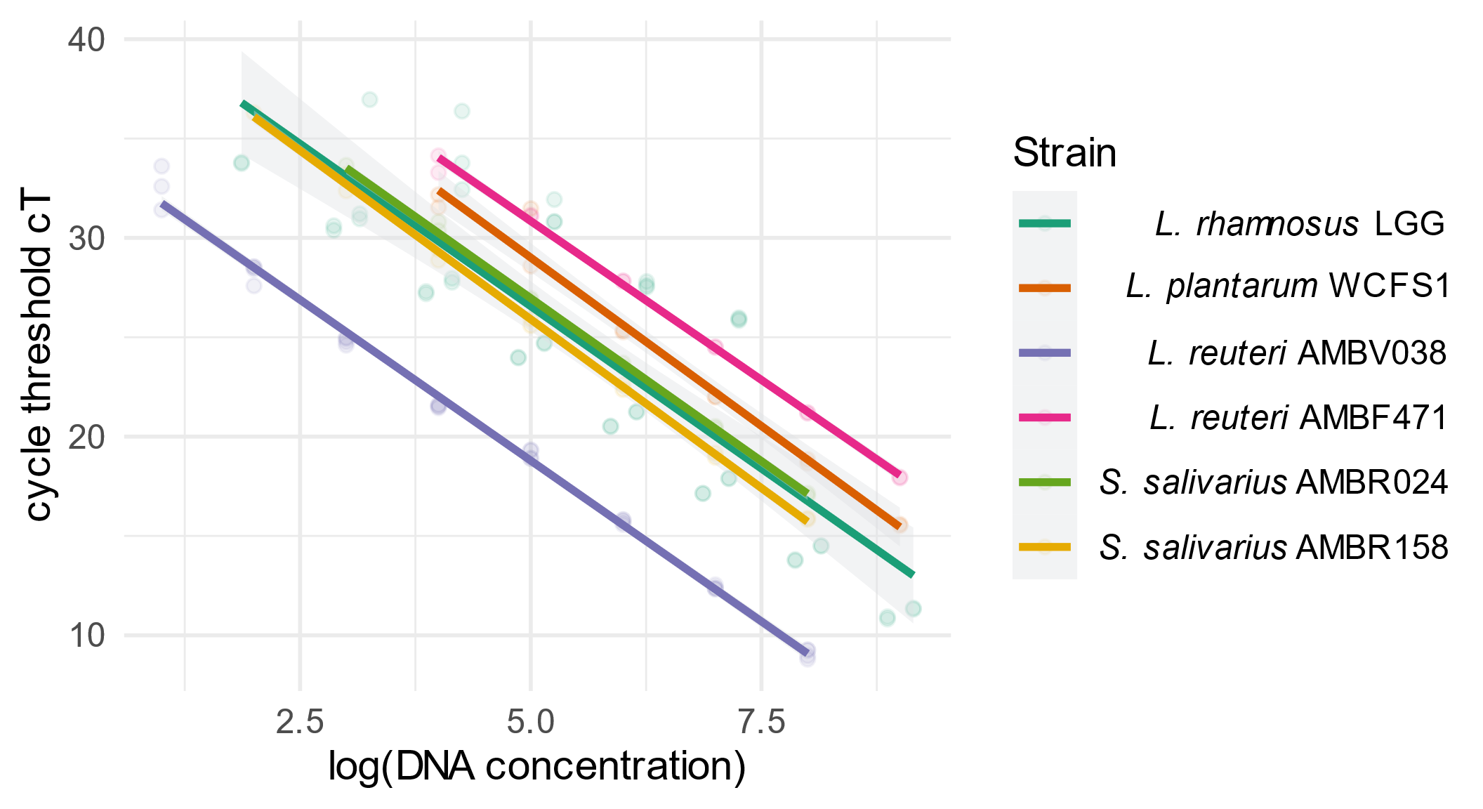
Figure S1: Plotted standard curves for all designed qPCR primers.

Table S1: Overview of the sequenced publicly available genomes that are too similar with their accession number and the average nucleotide identity (ANI) with the reference strain.
accession number | Ani | species | Removed
GCF_000026505.1 | 100 | L. rhamnosus | Reference
GCF_902381635.1 | 100 | L. rhamnosus | TRUE
GCF_003353455.1 | 99.9989 | L. rhamnosus | TRUE
GCF_017795605.1 | 99.9908 | L. rhamnosus | TRUE
GCF_015238575.1 | 99.9903 | L. rhamnosus | TRUE
GCF_000203855.3 | 100 | L. plantarum | Reference
GCF_017798305.1 | 99.9984 | L. plantarum | TRUE

