Supplemental Figure 1. Molecular marker expression profile of CD10, mucins, VEGF-A, TP53, Ki67, β-catenin, and MMRD. (a) CD10 was expressed in a cytoplasmic pattern with membranous accentuation, and MUC2, MUC5AC, and MUC6 were expressed in the cytoplasm. VEGF-A, TP53, and Ki67 were expressed in the cytoplasm, and β-catenin was expressed in the nuclei. (b) When MLH1 was deficient, staining for MLH1 and PMS2 was negative and staining for MSH2 and MSH6 was positive. VEGF-A: vascular endothelial growth factor A

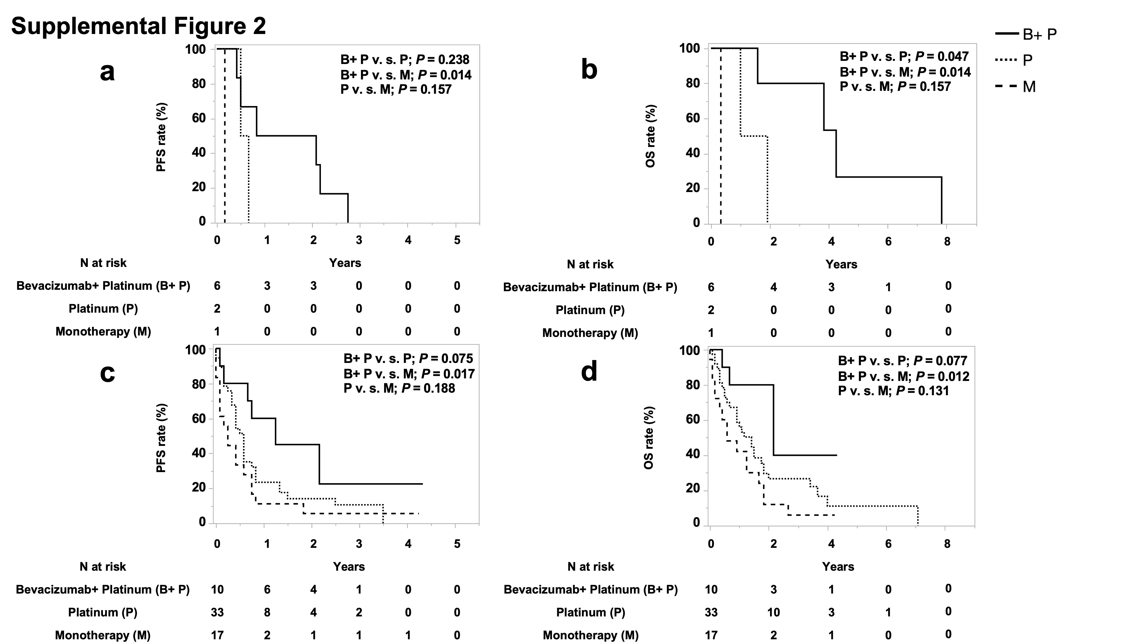
Supplemental Figure 2. Cumulative PFS curve (a) and OS curve (b) of mIA patients and cumulative PFS curve (c) and OS curve (d) of mDJA patients in the Bevacizumab+ Platinum (B+ P) Group, Platinum (P) Group, and Monotherapy (M) Group. In mIA patients, the PFS was longer in the Bevacizumab+ Platinum Group (median [95%CI] 17.5 months [5-33]) than in the Platinum Group (7 months [6-8]; P = 0.238) (a). The OS was significantly longer in the Bevacizumab+ Platinum Group (51 months [19-94]) than in the Platinum Group (17.5 months [12-23]; P = 0.047) (b). In mDJA patients, the PFS did not differ significantly between the Bevacizumab+ Platinum Group (15 months [1-]) and the Platinum Group (7 months [5-9]; P = 0.075) (c). The OS was significantly longer in the Bevacizumab+ Platinum Group (26 months [5-]) than in the Platinum Group (17 months [8-22]; P = 0.077) (d). PFS: progression-free survival, OS: overall survival, mIA: metastatic ileal adenocarcinoma, mDJA: metastatic duodenal and jejunal adenocarcinoma

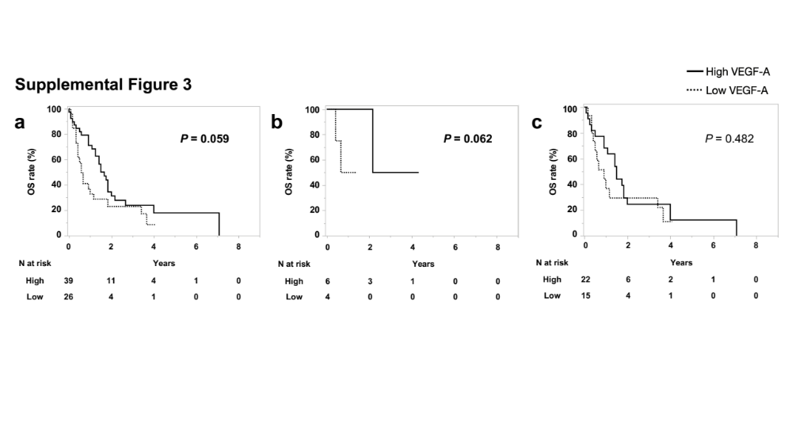

Supplemental Figure 3. Cumulative OS curve of mDJA patients with high VEGF-A expression or low VEGF-A expression (a) in Group A (b) and in Group B (c). The OS tended to be longer in mDJA patients with high VEGF-A expression (median [95%CI] 20 months [15-24]) than in those with low VEGF-A expression (7 months [5-14], P = 0.059) (a). In Group A, the OS tended to be longer in mDJA patients with high VEGF-A expression than in those with low VEGF-A expression (P = 0.062) (b). In Group B, the OS was significantly longer in mDJA patients with high VEGF-A expression (18 months [11-22]) than in those with low VEGF-A expression (11 months [4-41], P = 0.482) (c). OS: overall survival, mDJA: metastatic duodenal and jejunal adenocarcinoma, VEGF-A: vascular endothelial growth factor A

